To compile:

1. make

OR

2. gcc TCPDayTime.c

To run(test example): ./a.out utcnist.colorado.edu wwv.nist.gov

The result: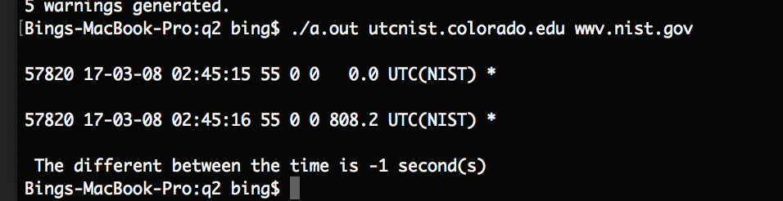

To clean the files:

1. make clean

OR

2. rm -f a.out