To compile:

1. make

OR

2. gcc -o server EchoServer.c

gcc -o client TCPecho.c

To run:

1. Run server: ./server

(May need administrator/root access)

1. Open another terminal
2. Run client: ./client
3. Test example: type “aaa”

The result: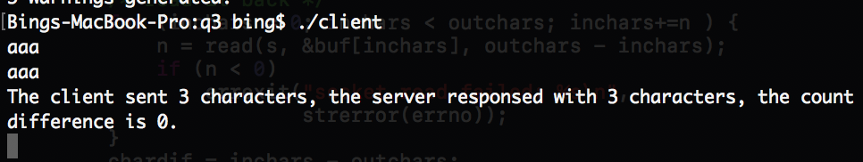

To clean the files:

1. make clean

OR

2. rm -f server client