Jimi mondow test poi

|  |  |  |  |  |
| --- | --- | --- | --- | --- |
| A | B | C | D | E |
| a | b | c | d | e |

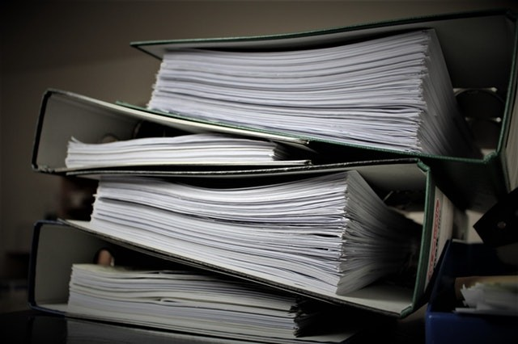

dfgdg