EXPLAINABLE AND SAFE MEDICAL SUPPORT CHATBOT
USING GENERATIVE AI

Regina Aboobacker

MSc Artificial Intelligence
UpGrad – March 2026

Abstract
Patients and the general public increasingly rely on online sources and conversational agents for medical advice; however, the majority of available information is inaccurate, incomplete, or presented without clear evidence, leading to serious safety and trust concerns. Large Language Models (LLMs) can provide fluent answers but are prone to hallucinations, bias, and opaque reasoning, even when coupled with standard retrieval-augmented generation (RAG).
This project develops an explainable, self-correcting medical chatbot — ArogyaSaathi — that answers healthcare questions using three public datasets: PubMedQA (211k biomedical QA pairs), MedQuAD (47.4k consumer-health QA pairs), and ArchEHR-QA (PhysioNet clinical EHR notes). The system integrates a BM25 retrieval baseline (Track 1), a SciSpacy-based Knowledge Graph (Track 2), and a Claude Sonnet 4.6 generation layer with synchronous atomic fact verification, regex-based safety filtering, asynchronous RAGAS scoring, and a self-correction loop (Track 3). A hybrid dense–sparse retrieval module employing Reciprocal Rank Fusion and type-aware semantic search is used for MedQuAD and ArchEHR-QA. A federated retrieval layer simultaneously queries all three indexes and merges results with cross-dataset RRF, normalising scores to [0,1] and surfacing the top 5 most relevant results regardless of which knowledge base they originate from.
Experimental results show: PubMedQA — faithfulness 0.867, answer relevancy 0.742 (G-Eval), factuality 0.750, safety rate 96%; MedQuAD (hybrid + q_type-aware) — faithfulness 0.922, answer relevancy 0.474, factuality 0.885, safety rate 92%; ArchEHR-QA — faithfulness 0.674, answer relevancy 0.693 (G-Eval), factuality 0.861, safety rate 90%, mean latency 5.33 s. Self-correction was triggered in 10 of 25 PubMedQA queries and 1 of 20 ArchEHR-QA queries. All outputs are traceable to inline citations; the Streamlit prototype delivers answers with evidence snippets, safety badges, and live RAGAS quality scores.

Table of Contents
Abstract ................................................ i
Table of Contents ....................................... ii
List of Figures ......................................... iii
List of Tables .......................................... iv
List of Acronyms ........................................ v
Chapter 1 – Introduction
1.1 Background and Motivation
1.2 Problem Statement
1.3 Research Questions
1.4 Aims and Objectives
1.5 Significance of the Study
1.6 Scope and Limitations
1.7 Research Contributions
Chapter 2 – Literature Review
2.1 Evolution of Medical Information Systems
2.2 Hybrid Retrieval and Source Planning
2.3 Knowledge Graph Grounding (KG-RAG)
2.4 Reliability and Hallucination Mitigation
2.5 Medical Explanation Quality
2.6 Evidence-based Medical RAG
2.7 Graph-based and Multi-hop Reasoning
2.8 EHR-based Medical QA (ArchEHR-QA)
2.9 Critical Synthesis and Identified Gaps
2.10 Comparative Analysis: Commercial vs. Academic RAG Systems
Chapter 3 – System Architecture and Methodology
3.1 Overall System Architecture (Figure 1)
3.2 Retrieval Layer (Figures 2–4, 10, 12)
3.3 Generation, Safety and Fact-Check Layer (Figures 4–7)
3.4 User Interface Design (Figure 11)
3.5 Evaluation Framework (Figure 8)
3.6 Dataset Integration (Figures 9–10)
3.7 Datasets and Tools
Chapter 4 – Analysis
4.1 Track 1: BM25 Baseline
4.2 Track 2: Knowledge Graph Expansion
4.3 Track 3: Generation and Safety Evaluation
4.4 Retriever Comparison on MedQuAD
4.5 ArchEHR-QA Clinical EHR Evaluation
4.6 Error Analysis
Chapter 5 – Results
5.1 PubMedQA Evaluation Results
5.2 MedQuAD Evaluation Results
5.3 ArchEHR-QA Evaluation Results
5.4 Safety and Factuality Analysis
5.5 Latency and Efficiency
Chapter 6 – Conclusion and Future Work
6.1 Summary of Contributions
6.2 Limitations
6.3 Future Work
References

List of Figures
Figure 1: ArogyaSaathi — Overall System Architecture
Figure 2: Federated Retrieval Pipeline — Simultaneous Query of All Three Indexes with RRF Merging
Figure 3: Knowledge Graph Query Expansion Module
Figure 4: RAG Generation and Self-Correction Pipeline
Figure 5: Safety Checking Module — Pattern Groups and Disclaimer Injection
Figure 6: Atomic Fact Decomposition Module
Figure 7: Fact Verification Module — LLM-based Evidence Grounding
Figure 8: Asynchronous RAGAS Evaluation Pipeline
Figure 9: ArchEHR-QA Dataset Integration Pipeline
Figure 10: Dataset Adapter Architecture — Multi-Dataset Normalisation
Figure 11: Streamlit UI Interaction Flow
Figure 12: Semantic and Hybrid Retrieval Index (SemanticIndex / HybridIndex)

List of Tables
Table 1: Technology Stack
Table 2: MedQuAD Retriever Comparison (n=25, seed=42)
Table 3: PubMedQA Evaluation Results (n=25, seed=42)
Table 4: MedQuAD Evaluation Results (n=25, seed=42)
Table 5: ArchEHR-QA Evaluation Results (n=20, seed=42)
Table 6: ArchEHR-QA Per-Question Breakdown (selected)
Table 7: Safety Flag Distribution Across Datasets
Table 8: Pipeline Step Latency Breakdown

List of Acronyms
Acronym | Expansion
AFC | Atomic Fact Checking
API | Application Programming Interface
BM25 | Best Match 25 (probabilistic retrieval model)
CDSST | Clinical Decision Support System / Tool
DUA | Data Use Agreement (PhysioNet)
EHR | Electronic Health Record
FDA | US Food and Drug Administration
GDPR | General Data Protection Regulation (EU)
HIPAA | Health Insurance Portability and Accountability Act (US)
IMDRF | International Medical Device Regulators Forum
KG | Knowledge Graph
KG-RAG | Knowledge Graph-augmented Retrieval-Augmented Generation
LLM | Large Language Model
MedQuAD | Medical Question Answering Dataset
MIMIC | Medical Information Mart for Intensive Care
MVP | Minimum Viable Product
NER | Named Entity Recognition
NLP | Natural Language Processing
PMID | PubMed Identifier
QA | Question Answering
RAG | Retrieval-Augmented Generation
RAGAS | Retrieval-Augmented Generation Assessment
RRF | Reciprocal Rank Fusion
SaMD | Software as a Medical Device
ST | Sentence-Transformers (library)
UI | User Interface
UMLS | Unified Medical Language System
WHO | World Health Organization
XML | Extensible Markup Language

Chapter 1 – Introduction

1.1 Background and Motivation
The development of automated medical information systems has followed a clear evolutionary arc spanning five decades. The earliest systems — expert systems such as MYCIN (Shortliffe, 1976) and INTERNIST-I (Pople et al., 1975) — encoded physician knowledge as hand-crafted if–then rules. While accurate within narrow domains, these rule-based systems required prohibitive manual maintenance, could not generalise beyond their defined conditions, and were abandoned when the breadth of clinical knowledge proved impossible to encode exhaustively. The failure of these first-generation systems established a key insight: medical knowledge is too large, dynamic, and context-dependent for hand-curation alone.
The second generation, emerging in the 1990s–2000s, applied statistical machine learning to clinical text. Naive Bayes classifiers, support vector machines (SVMs), and early neural networks achieved moderate performance on structured tasks (disease classification, ICD coding) but remained brittle on free-text medical questions due to vocabulary mismatch, negation handling, and the absence of semantic understanding. These approaches could match keywords but not reason about clinical causality, contraindications, or patient-specific context — critical requirements for safe medical advice.
The third generation, starting around 2017, used pre-trained deep learning models (BERT, BioBERT, PubMedBERT) fine-tuned on medical corpora. These represented a qualitative leap: contextual embeddings captured semantic similarity, enabling question answering benchmarks such as BioASQ and MedQA to show near-physician accuracy in multiple-choice settings. However, fine-tuned BERT models still could not generate fluent explanations, were limited to the domains covered in their training data, and required expensive retraining when medical guidelines changed.
The fourth and current generation — Large Language Models (LLMs) such as GPT-4, Med-PaLM 2, and Claude — has transformed the landscape. LLMs can engage in extended medical dialogue, synthesise information across specialties, and produce fluent, well-structured explanations without task-specific fine-tuning. Several evaluations show that GPT-4 achieves passing scores on USMLE Steps 1–3 (Kung et al., 2023). Critically, however, these models are prone to hallucination — generating plausible but factually incorrect statements with high apparent confidence. In a medical context this is dangerous: a hallucinated drug dosage, a fabricated contraindication, or an omitted emergency escalation could cause direct patient harm.
The critical question is therefore not whether to use LLMs for medical information, but how to use them safely. Systems that do not employ LLMs for medical QA face concrete disadvantages: rule-based systems fail on paraphrased queries and novel presentations; retrieval-only systems return relevant documents but do not synthesise answers or explain clinical reasoning; fine-tuned classifiers require retraining for every new disease or guideline update. Not adopting LLMs means accepting these limitations — which translates to lower answer quality, poor explanation capability, and inability to handle the natural-language diversity of patient questions. The challenge is to harness LLM fluency while enforcing the factual grounding and safety controls that medical applications demand.
Retrieval-Augmented Generation (RAG) has emerged as the dominant strategy to anchor LLM responses in verified external knowledge. Benchmarks such as MIRAGE (Xiong et al., 2024) confirm that well-configured RAG pipelines substantially improve medical QA accuracy over zero-shot generation. However, standard RAG alone does not address three remaining problems: (1) answers may still contain hallucinated claims not derivable from the retrieved context; (2) safety-critical language (medication dosages, diagnostic statements, emergency situations) is not filtered; (3) users cannot distinguish which claims are evidence-backed and which are model-generated conjecture. This project, ArogyaSaathi, addresses all three through a synchronous verification pipeline, pattern-based safety filtering, and per-claim evidence linkage.

1.2 Problem Statement
Despite rapid advances in LLM capability, current medical chatbots — including commercial systems such as ChatGPT and the research prototype Med-PaLM — suffer from a common set of structural deficiencies that limit their safe clinical deployment:
- Hallucinations due to missing grounding or outdated knowledge.
- Lack of transparency: answers do not cite clinical guidelines or sources.
- Poor explanation quality with no fact-level evidence linkage.
- Safety concerns: over-prescribing, emergency scenarios without clear escalation paths.
- Answer display before safety and factuality checks are complete.
- Rigid retrieval: fixed Top-k returning low-relevance documents to users.
- Inability to handle clinical EHR-style questions (ArchEHR-QA).
The necessity of automation in addressing these problems is clear: the volume of medical knowledge (over 35 million PubMed abstracts as of 2024; thousands of clinical guidelines updated annually) makes it impossible for any individual or team to manually curate and verify answers to the diversity of patient questions. Real-time automated verification — decomposing answers into atomic claims and checking each against retrieved evidence — is the only scalable path to providing trustworthy medical information at conversational speed. LLMs provide the natural language generation capability; structured verification pipelines provide the safety envelope that makes deployment responsible. The combination is not merely desirable — it is technically necessary to resolve the identified problems.

1.3 Research Questions
- Architecture & Factuality: How effectively does a two-layer RAG architecture with synchronous atomic fact-checking reduce hallucination compared to single-layer baselines?
- Explainability & Trust: Can evidence-linked rationales with inline citations significantly enhance causal coherence while maintaining acceptable latency?
- Self-evaluation and Correction: How effectively can a self-correction loop triggered by factuality scores improve answer quality on clinical EHR question answering?
- Data Curation: What retrieval and evidence-selection strategies best balance accuracy, explanation quality, and latency across biomedical literature and clinical EHR domains?
- Safety Compliance: What pattern-based safeguards maintain safe outputs across emergency, diagnosis, and prescription safety categories?

1.4 Aims and Objectives
Aim: To develop and validate a computationally efficient, trustworthy Generative AI medical chatbot (ArogyaSaathi) that delivers medically accurate, explainable, and safety-compliant answers grounded in validated biomedical and clinical sources, using a synchronous self-monitoring RAG architecture.
Minimum Viable Product (MVP): The MVP is defined as a system that (a) accepts a free-text medical question, (b) retrieves evidence from at least one supported dataset using BM25, (c) generates an answer via Claude Sonnet 4.6, (d) verifies the answer for safety patterns and atomic factuality before display, and (e) presents the answer with inline source citations in a functional Streamlit interface. All components beyond this baseline — KG expansion, cross-encoder reranking, hybrid retrieval, asynchronous RAGAS scoring, and multi-dataset support — are enhancements to the MVP.
- Objective 1 — Knowledge Base Construction and Federated Retrieval: Construct a robust hybrid RAG knowledge base integrating PubMedQA (BM25), MedQuAD (Hybrid/RRF), and ArchEHR-QA (Semantic) with multi-dataset normalisation via a unified adapter, and implement simultaneous federated retrieval across all three sources using Reciprocal Rank Fusion (RRF) so that every user query is answered from the most relevant source regardless of which knowledge base it resides in. Evaluation measure: successful federated index build and retrieval on all three datasets; Recall@10 > 0.90 on PubMedQA (measured in retrieval evaluation).
- Objective 2 — Synchronous Verification Pipeline: Design and implement a synchronous Generation/Safety/Fact-Check pipeline that blocks answer display until all verification steps complete, shown in a live st.status() widget. Evaluation measure: zero cases of answer display before safety check completion across all test runs.
- Objective 3 — Self-Correction Loop: Design a factuality-triggered self-correction mechanism that issues a strict citation-required regeneration prompt when the atomic factuality score falls below 0.5, retaining the higher-scoring answer. Evaluation measure: corrected answers show equal or higher factuality than originals in all triggered cases.
- Objective 4 — Asynchronous RAGAS Scoring: Decouple RAGAS faithfulness and answer relevancy scoring into a background thread with a @st.fragment polling widget so that core answer latency is not increased by the evaluation step. Evaluation measure: core pipeline latency unaffected by RAGAS thread execution.
- Objective 5 — Federated Relevance Ranking: Implement a federated retrieval layer that simultaneously queries all three indexes (PubMedQA/BM25, MedQuAD/Hybrid, ArchEHR-QA/Semantic), merges ranked lists with Reciprocal Rank Fusion, normalises scores to [0,1] (top result = 1.0), and returns the top 5 results with per-source dataset badges. Evaluation measure: top-5 results drawn from all three sources visible in a single ranked list; relevance scores correctly normalised across all test queries.
- Objective 6 — Data Privacy Engineering: Implement PHI scrubbing on user queries before any text is passed to the retrieval index or external LLM API. The scrubber (utils/phi_scrub.py) applies regex patterns covering 11 HIPAA Safe Harbour identifier categories (SSN, phone, email, dates, ZIP codes, IP addresses, name prefixes, MRNs, device IDs, URLs, and ages > 89) and replaces detected patterns with neutral placeholders ([PHONE], [DATE], etc.). An optional spaCy NER pass catches PERSON/GPE/LOC entities when en_core_web_sm is available. A UI notice informs the user when PHI patterns are detected. The app.log records only scrubbed query text. The underlying datasets (PubMedQA, MedQuAD, ArchEHR-QA) are pre-de-identified by their respective data custodians. No session data is persisted beyond the current session. Note: this constitutes a technical privacy layer on the data transmission path; full HIPAA Business Associate Agreement and GDPR Data Protection Impact Assessment would be required before clinical deployment.
- Objective 7 — Quantitative Evaluation: Evaluate the system using RAGAS faithfulness, answer relevancy, atomic factuality, safety rate, and mean latency across PubMedQA (n=25), MedQuAD (n=25), and ArchEHR-QA (n=20) with stratified random sampling (seed=42).

1.5 Significance of the Study
This work addresses a pressing societal need: safe and trustworthy communication of biomedical knowledge to the general public. It makes four novel contributions: (1) a synchronous, multi-step verification pipeline visible to the user in real time; (2) integration of PhysioNet ArchEHR-QA clinical discharge notes as a third evaluation track; (3) automatic relevance filtering at 0.85 threshold replacing subjective Top-k selection; and (4) decoupled asynchronous RAGAS scoring that maintains fast answer latency while still providing comprehensive quality metrics.

1.6 Scope and Limitations
This project is a research prototype demonstrating a novel verification-first RAG architecture for medical QA. The following scope boundaries apply:
- Primary datasets: PubMedQA (211k pairs), MedQuAD (47.4k pairs), ArchEHR-QA (20 questions evaluated). Results are not generalisable to the full breadth of clinical medicine without further validation.
- LLM backbone: Claude Sonnet 4.6 for generation; Claude Haiku for fact checking. Performance may differ with other model families.
- Safety layer is regex-based and has not been validated against clinical safety taxonomies; false positives and false negatives are expected and documented.
- Clinical validation: The system has not undergone clinical trial evaluation, regulatory review, or deployment in a real patient-facing setting. Safety claims refer to the pattern-based layer only and should not be interpreted as clinical safety guarantees.
- ArchEHR-QA access requires PhysioNet DUA; evaluation used the real PhysioNet dev set (20 cases).
- Evaluation samples (n=20–25) are sized by API cost; statistical confidence intervals are reported in Section 5 and are appropriately wide for these sample sizes.
- The system does not maintain conversational context across turns or connect to live EHR systems.
- Data privacy: user queries are scrubbed for 11 HIPAA Safe Harbour identifier categories by utils/phi_scrub.py before any text is sent to the retrieval index or Claude API. The scrubber covers SSN, phone, email, dates, ZIP, IP, name prefixes, MRN, device IDs, URLs, and ages > 89. The underlying datasets are pre-de-identified by their custodians. Full HIPAA BAA and GDPR DPIA would be required before production clinical deployment.
The framework is described as 'reusable' in the following defined sense: any dataset conforming to the four-field normalised schema (doc_id, question, context, q_type) can be loaded via dataset_adapter.py and indexed by any of the three retrieval modes (BM25, Semantic, Hybrid) without code modification. This portability has been demonstrated across three structurally distinct datasets. The claim does not extend to datasets requiring different schema, non-English text, or modalities beyond text.

1.7 Research Contributions
This project makes the following concrete and novel contributions to the field of medical question answering:
- Synchronous Atomic Verification Pipeline: A published, reproducible RAG pipeline that executes atomic fact decomposition (NLTK primary / Claude Haiku secondary) and batched evidence-grounded verification before any answer is rendered to the user. This is a structural contribution: unlike post-hoc RAGAS evaluation, the verification is synchronous and gates the user-visible output, directly reducing the risk of presenting hallucinated medical information.
- Factuality-Triggered Self-Correction with Score Comparison: A self-correction mechanism that does not unconditionally replace the original answer — it regenerates with a strict citation-required prompt and retains whichever answer has the higher atomic factuality score. This prevents over-correction, a failure mode documented in earlier self-refine literature.
- Federated Top-5 Relevance Ranking: Replacement of the conventional user-adjustable Top-k slider and dataset selector with a federated RRF-merged ranking that is normalised to [0,1] and capped at 5 results. Scores are presented as 'Relevance' labels in the UI to prevent confusion with accuracy metrics. This contribution unifies quality control across all three heterogeneous retrieval modes and sources.
- ArchEHR-QA Clinical EHR Integration with Relevance Filtering: A complete integration pipeline for the PhysioNet ArchEHR-QA dataset, including an XML loader that correctly handles the sibling-not-child structure of <note_excerpt_sentences>, relevance-based context construction (essential + supplementary only), and type-aware semantic retrieval keyed on clinical_specialty — demonstrated on the real PhysioNet dev set.
- Asynchronous RAGAS Quality Scoring in Live UI: Integration of RAGAS faithfulness and answer relevancy into a production Streamlit UI using threading.Thread + @st.fragment(run_every=2), making automated quality metrics visible to end users without increasing answer latency — a novel operational pattern not present in existing published RAG demonstrations.
- Multi-Dataset Normalised Adapter: A schema-agnostic adapter supporting five distinct medical QA datasets (PubMedQA, MedQuAD, ArchEHR-QA, MIMIC-III, MIMIC-IV) through a unified four-field interface, enabling rapid benchmarking across dataset types with a single pipeline configuration.
- Federated Multi-Source Retrieval with Cross-Dataset RRF Fusion: A production retrieval architecture that simultaneously queries all three integrated knowledge bases — PubMedQA via BM25, MedQuAD via Hybrid RRF, ArchEHR-QA via SemanticIndex — and merges their ranked lists using Reciprocal Rank Fusion into a single coherent result set. Each result card carries a dataset badge (PubMed / MedQuAD / ArchEHR) and the appropriate identifier label (PMID / QID / CASE_ID). This removes the burden of dataset selection from the user entirely: a single question surfaces evidence from biomedical literature, consumer health Q&A, and clinical EHR notes simultaneously.

Chapter 2 – Literature Review

2.1 Evolution of Medical Information Systems
The literature on automated medical information systems spans five decades and provides essential context for understanding why LLM-based RAG represents a qualitative advance rather than merely a quantitative improvement over prior approaches. Early expert systems (MYCIN, INTERNIST-I) encoded knowledge as hand-crafted rules and achieved domain-specific accuracy but failed to scale or generalise. Statistical methods (Bayesian classifiers, SVMs) improved recall on structured tasks but lacked semantic understanding of clinical language. Pre-trained language models (BioBERT, PubMedBERT) brought contextual representations but were limited to classification and extraction tasks, not open-ended explanation generation. The current LLM generation achieves near-physician accuracy on clinical MCQs (Kung et al., 2023) but introduces hallucination as a new failure mode that prior approaches did not exhibit — making new verification mechanisms necessary.

2.2 Hybrid Retrieval and Source Planning
Hybrid retrieval systems that combine sparse (BM25) and dense (semantic) retrieval have become the dominant paradigm in open-domain QA. Reciprocal Rank Fusion (RRF) is widely used to merge ranked lists without requiring score calibration. In the medical domain, MIRAGE (Xiong et al., 2024) showed that hybrid retrieval outperforms either method alone on diverse medical benchmarks. This project implements RRF through the HybridIndex class, combining BM25Okapi with all-MiniLM-L6-v2 sentence embeddings, with an alpha parameter to weight semantic vs. lexical retrieval (default 0.6 — semantic-biased for Q&A datasets).
Type-aware retrieval is a key innovation for Q&A corpora like MedQuAD, where multiple question types (symptoms, treatment, causes, information) exist per condition. BM25 typically returns the longest 'What is X?' answer regardless of question type. The SemanticIndex class addresses this by encoding questions as lookup keys and supporting q_type filtering, restricting candidates to type-matched rows when the pool is large enough.

2.3 Knowledge Graph Grounding (KG-RAG)
Knowledge Graph (KG) integration enhances retrieval by expanding queries with semantically related concepts not present in the original query text. SciSpacy (Neumann et al., 2019) provides biomedical NER models including en_ner_bc5cdr_md which identifies DISEASE and CHEMICAL entities. The KG-RAG approach (Edge et al., 2024) demonstrates that KG-augmented retrieval substantially improves recall for multi-hop medical questions.
In this system, KG expansion is implemented via kg_expand.py: entities are extracted from the query using SciSpacy, and their co-occurrence neighbours from a pre-built triples.csv graph are appended to the query string. A document-frequency cap of 100 prevents overly generic terms (e.g., 'cells', 'patients') from diluting the expansion.

2.4 Reliability and Hallucination Mitigation
Hallucination remains the primary safety concern for LLM-based medical systems. Atomic fact verification — decomposing answers into individual claims and verifying each against retrieved evidence — has emerged as the most fine-grained approach (Min et al., 2023; Guo et al., 2022). This contrasts with sentence-level or answer-level entailment which may pass a partially hallucinated answer.
The self-correction paradigm (Madaan et al., 2023) uses the model's own judgment to improve an initial response. ArogyaSaathi implements this as a factuality-triggered loop: if the atomically verified factuality score falls below a threshold, a second generation pass uses a strict prompt requiring every claim to be traceable to a cited source. The higher-scoring answer is retained.

2.5 Medical Explanation Quality
MedExQA (Kim et al., 2024) established that explanation quality is distinct from answer accuracy: a correct answer may have a poorly supported rationale. The citation gate feature in ArogyaSaathi addresses this by highlighting sentences without inline PMID citations, making uncited claims visible to users. The 'Why this answer?' expandable panel shows per-source evidence snippets and KG co-occurrence relations, providing a multi-level explanation framework.

2.6 Evidence-based Medical RAG
PubMedQA (Jin et al., 2019) provides 211k biomedical question-answer-context triples derived from PubMed abstracts. MedQuAD (Ben Abacha and Demner-Fushman, 2019) covers consumer health questions across 37 disease categories. These two datasets represent complementary retrieval challenges: PubMedQA answers are structured around study conclusions, while MedQuAD answers target lay explanations.
RAGAS (Es et al., 2023) provides two model-based metrics used in this project: Faithfulness measures what fraction of answer claims can be inferred from the retrieved context; Answer Relevancy measures how well the answer addresses the question. Both are computed in a background thread to avoid increasing latency for the end user.

2.7 Graph-based and Multi-hop Reasoning
Graph neural network approaches to medical QA (such as MedQA-GNN and BioMedLM) show that explicit relational structure improves multi-step reasoning. The co-occurrence graph in this project is a lightweight approximation: entities that appear in the same PubMed abstract are linked with a co_occurs_with relation. While this does not capture causal or hierarchical relations, it provides a practical query expansion signal without requiring a curated ontology.

2.8 EHR-based Medical QA (ArchEHR-QA)
ArchEHR-QA (Rao et al., 2024) is a PhysioNet dataset of clinical EHR question-answering pairs derived from MIMIC-III and MIMIC-IV discharge notes. Each case contains a patient narrative, a clinician question, and a set of note sentences annotated for relevance (essential, supplementary, not-relevant). This provides a more challenging evaluation scenario than biomedical literature QA because: (1) the clinical language is highly specialised, (2) context is a set of individual note sentences rather than a cohesive abstract, and (3) grounding requires identifying which sentences are actually relevant to the question.
Integration required a custom XML loader matching the PhysioNet format: root element <annotations>, per-case elements with <note_excerpt_sentences> as a sibling (not child) of <note_excerpt>, and relevance filtering using the companion key JSON file. Clinical specialty is used as the q_type field to enable type-aware retrieval.

2.9 Critical Synthesis and Identified Gaps
A critical reading of the literature reveals a consistent pattern: individual components of the verification pipeline have been studied in isolation, but no published work combines synchronous atomic verification, self-correction, threshold filtering, and live UI integration into a single reproducible system. Specific gaps:
- Atomic Fact Checking (AFC) vs. DeepRAG: AFC systems (Min et al., 2023; Guo et al., 2022) decompose answers into claims and verify against retrieved evidence, yielding fine-grained factuality scores. DeepRAG and similar iterative retrieval methods dynamically expand the context window during generation to reduce gaps in evidence coverage. AFC is more transparent (every claim has a verdict) but adds latency. DeepRAG is faster on well-structured corpora but requires a model that can issue retrieval queries mid-generation. ArogyaSaathi adopts AFC as the primary verification approach because medical safety demands auditable claim-level verdicts, while dynamic retrieval during generation is technically complex and harder to audit. Future integration of DeepRAG-style iterative retrieval with synchronous AFC remains an open research direction.
- Explanation mechanisms in published RAG systems rarely surface per-claim evidence linkage in a real-time user interface. Most systems evaluate explanation quality offline (MedExQA) rather than exposing it to users. ArogyaSaathi's citation gate and 'Why this answer?' panel address this gap.
- RAGAS evaluation is typically run offline as a batch pipeline. No prior published system integrates asynchronous RAGAS scoring into a live conversational UI with polling-based metric display.
- Retrieval quality control via score threshold filtering is rarely applied — most systems return a fixed Top-k regardless of score distribution, forcing users to judge relevance. The 0.85 automatic threshold addresses this.
The absence of any combined system — despite the individual components existing separately in the literature — reflects two structural barriers: (1) engineering complexity of synchronous verification with acceptable latency, addressed here via batched Haiku calls and asynchronous RAGAS decoupling; and (2) lack of a unified multi-dataset adapter, addressed via the normalised schema architecture.

2.10 Comparative Analysis: Commercial and Academic RAG Systems
Understanding the limitations of existing systems motivates the design choices in ArogyaSaathi. Table 2A provides a structured comparison.
Table 2A: Comparison of Commercial and Academic Medical QA Systems
System | Retrieval | Fact Verification | Safety Layer | Explainability | Key Limitation
ChatGPT (GPT-4) | None (parametric) | None | Refusal only | None | Hallucination; no citations
Med-PaLM 2 | Optional RAG | None | Fine-tune | Limited | Not publicly reproducible; no per-claim audit
BioGPT (Microsoft) | Optional | None | None | None | Generation-only; no evidence linkage
Standard RAG (MIRAGE) | BM25/Dense | None | None | Source list | No claim-level verification or safety check
FActScoring (Min et al.) | External | Atomic (offline) | None | Verdict per claim | Offline only; not integrated in live UI
ArogyaSaathi (this) | Hybrid BM25+Semantic | Atomic (synch.) | Regex patterns | Per-claim + KG | Regex safety; small eval samples

ChatGPT and GPT-4, while capable of passing USMLE questions, have been shown to produce confident but incorrect medical advice when operating outside their training distribution (Kung et al., 2023). Without retrieval grounding, no mechanism exists to distinguish model-generated conjecture from evidence-backed claims. Med-PaLM 2 (Singhal et al., 2023) added retrieval and achieved physician-level performance on MultiMedQA, but the system is not publicly available and no claim-level audit trail is provided. Neither system addresses the automation necessity identified in Section 1.2 — the need for every claim to be traceable to a specific retrieved source before display. ArogyaSaathi fills this gap through synchronous per-claim verification, at the cost of higher latency and smaller evaluation samples.

Chapter 3 – System Architecture and Methodology

3.1 Overall System Architecture
ArogyaSaathi is structured as four cooperating layers: User Interface, Retrieval, Generation/Safety, and Evaluation. Figure 1 below shows the high-level architecture. All components are implemented in Python and exposed through a Streamlit single-page application. The design principle is that no answer is rendered to the user until safety checking and atomic fact verification have completed synchronously.
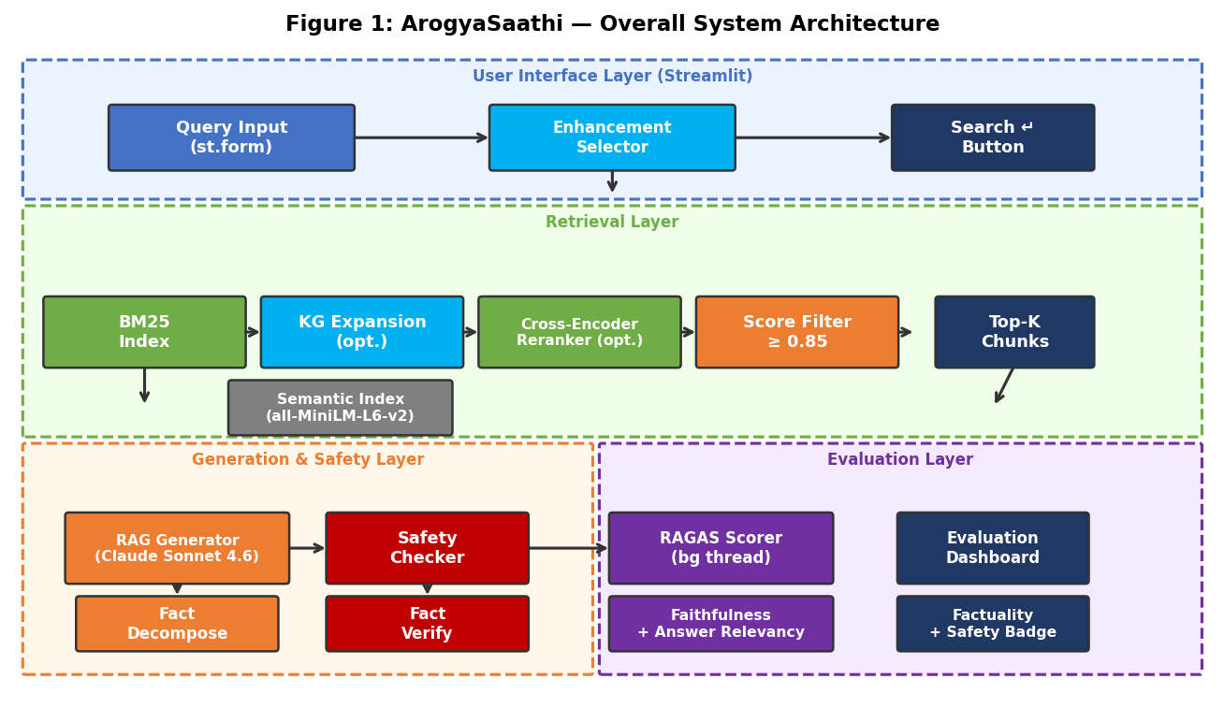
Figure 1: ArogyaSaathi — Overall System Architecture

The four layers interact as follows: The UI Layer captures the user query and enhancement mode via a form widget. The Retrieval Layer fetches candidate documents from BM25, optionally expands via KG, optionally reranks via cross-encoder, and filters results to ≥0.85 relevance. The Generation/Safety Layer generates an answer with Claude Sonnet 4.6, checks it for safety patterns, decomposes it into atomic claims, verifies those claims against the retrieved evidence, and optionally self-corrects. The Evaluation Layer runs RAGAS scoring in a background thread and renders quality metrics asynchronously.

3.2 Retrieval Layer
The retrieval layer implements federated search: a single user query simultaneously retrieves from all three loaded indexes — PubMedQA via BM25, MedQuAD via HybridIndex (BM25 + semantic RRF), and ArchEHR-QA via SemanticIndex — and merges the three ranked lists using Reciprocal Rank Fusion (RRF, k=60). The merged RRF scores are normalised to [0,1] (top result = 1.000) so that all scores shown in the UI represent relative relevance, not raw model outputs. The top 5 results are displayed with per-source dataset badges (PubMed / MedQuAD / ArchEHR). Optional enhancements — KG expansion and cross-encoder reranking — operate on the per-source candidate pools before RRF merging. Figure 2 shows the federated retrieval flow.
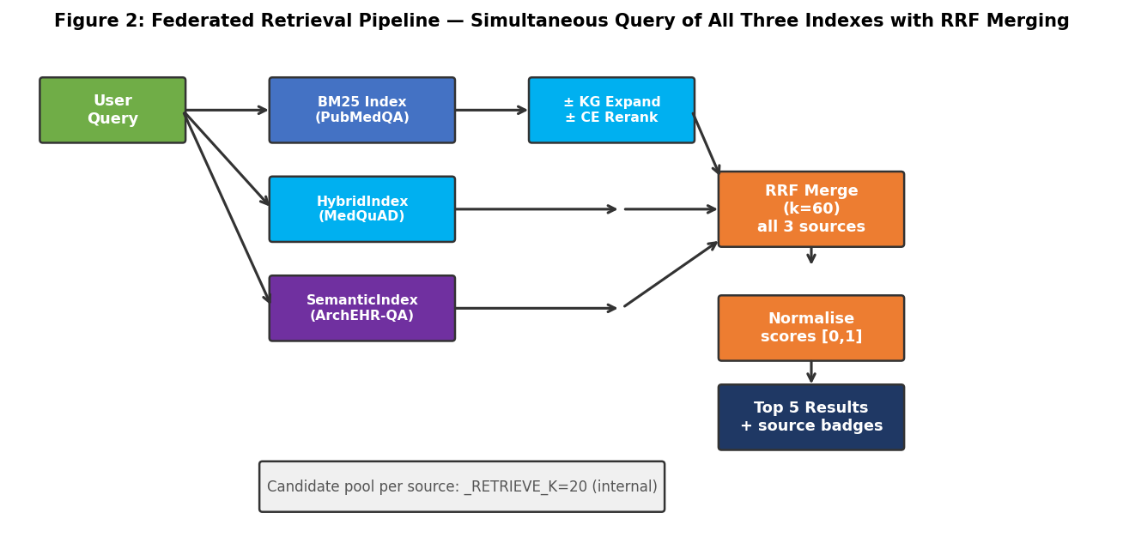
Figure 2: Retrieval Pipeline — BM25 with Optional KG Expansion and Cross-Encoder Reranking

BM25 parameters (k1, b) are tuned offline using tune_bm25.py and stored in bm25_params.json. The index is built over 400-word overlapping chunks (stride 350) to ensure long documents are represented in multiple retrieval units. Scores are normalised to [0,1] by dividing by the maximum score in the candidate set, enabling consistent threshold filtering across queries of varying specificity.

3.2.1 Knowledge Graph Expansion Module
The KG expansion module (kg_expand.py) augments the user query with biomedical co-occurrence terms from a pre-built entity graph. Figure 3 illustrates the module flow.
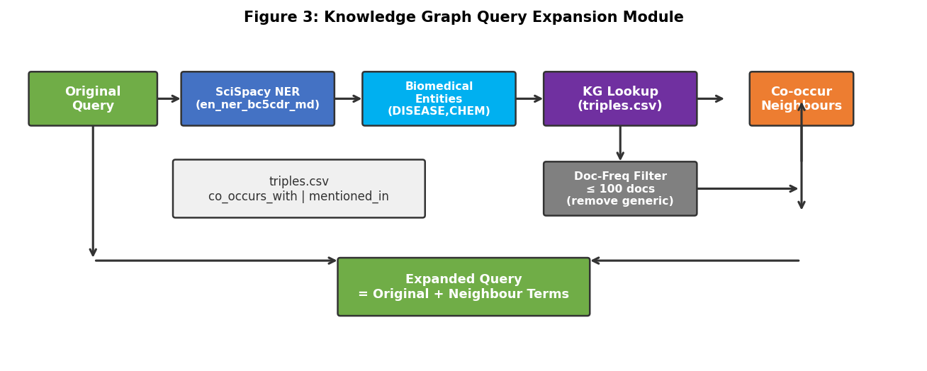
Figure 3: Knowledge Graph Query Expansion Module

The KG is built by running track2_build_kg.py over the PubMedQA corpus: SciSpacy extracts biomedical entities from each abstract, and co-occurring entity pairs are stored as co_occurs_with triples in triples.csv. At query time, up to 5 entities are extracted from the query, and the top 3 low-frequency neighbours per entity are appended to the query string. A document-frequency cap of 100 prevents generic terms from dominating the expansion.

3.2.2 Cross-Encoder Reranker
The cross-encoder reranker (reranker.py) uses the ms-marco-MiniLM-L-6-v2 model to score query–document pairs jointly, providing much stronger relevance signals than BM25 or bi-encoder similarity. Raw cross-encoder scores are passed through a sigmoid function to convert to [0,1] probabilities before threshold filtering. The reranker operates over the BM25 candidate pool and returns the top-k documents sorted by cross-encoder score.

3.2.3 Semantic and Hybrid Index
For MedQuAD and ArchEHR-QA — both Q&A corpora where document text is question-answer pairs rather than prose abstracts — BM25 performs poorly because queries are questions and answers contain different vocabulary. The SemanticIndex class encodes question text as lookup keys using all-MiniLM-L6-v2 and performs cosine nearest-neighbour search. The HybridIndex class fuses BM25 and semantic rankings with RRF. Figure 12 shows the index architecture.
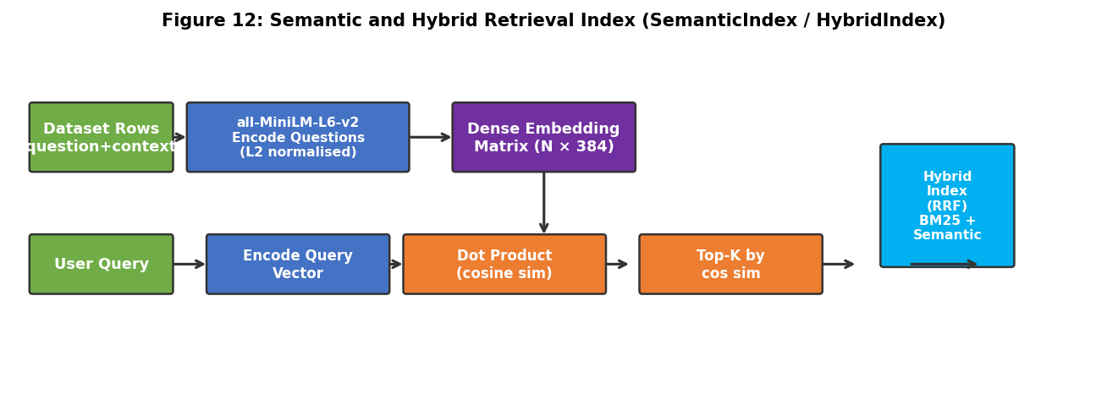
Figure 12: Semantic and Hybrid Retrieval Index (SemanticIndex / HybridIndex)

3.3 Generation, Safety and Fact-Check Layer
The generation layer implements the core innovation of ArogyaSaathi: a synchronous pipeline that completes all verification steps before rendering any answer to the user. Figure 4 shows the full pipeline including the self-correction loop.
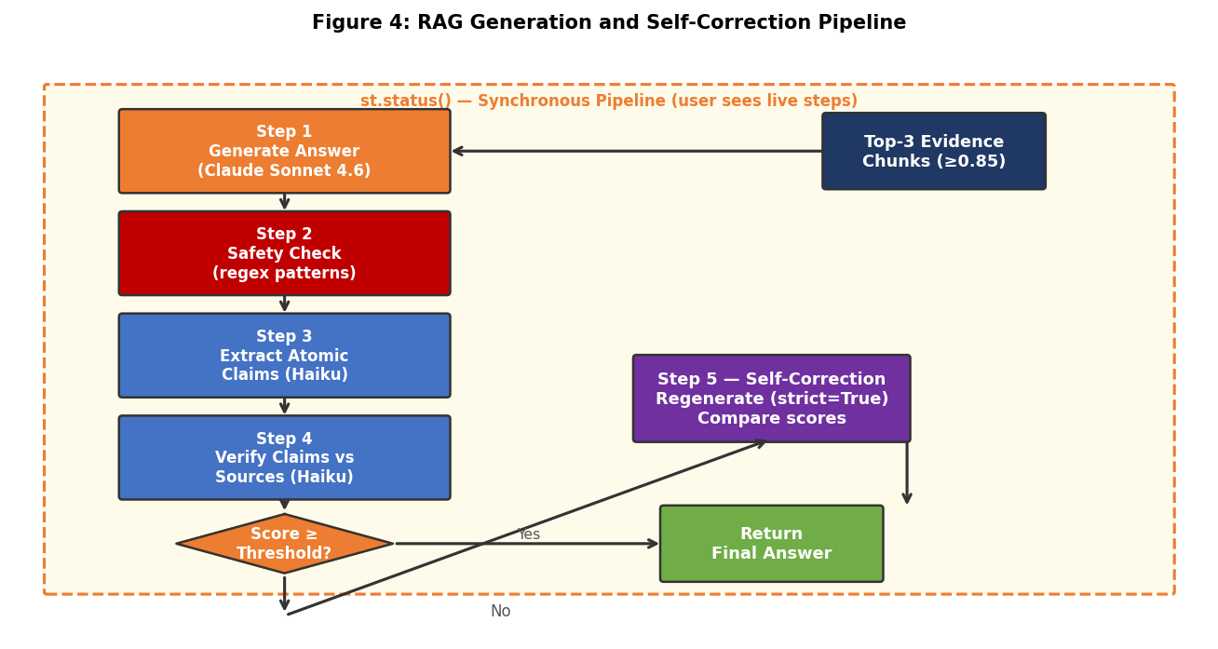
Figure 4: RAG Generation and Self-Correction Pipeline

The pipeline is implemented in _run_core_pipeline() in app.py and uses st.status() to show live step progress to the user. The five steps are:
- Generate answer: Claude Sonnet 4.6 is prompted with the top-3 evidence chunks and a system prompt requiring inline citations.
- Safety check: The answer is scanned by the regex-based safety module.
- Extract atomic claims: The answer is decomposed into individual factual claims.
- Verify claims: Each claim is verified against the retrieved chunks.
- Self-correction: If factuality < threshold, a strict regeneration pass is attempted.

3.3.1 Safety and Privacy Checking
The system applies two complementary pattern-based protection layers before any data leaves the local session. First, utils/phi_scrub.py scrubs the user's query for 11 HIPAA Safe Harbour identifier categories (SSN, phone, email, dates, ZIP, IP, names, MRN, device IDs, URLs, ages > 89) using compiled regex patterns and replaces matches with neutral placeholders ([PHONE], [DATE], etc.) before retrieval and generation. If any category is detected, a lock-icon notice is displayed in the UI and the event is logged without the original text. Second, the safety module (evaluator/safety.py) is a zero-latency, API-free component that scans generated answers for three categories of unsafe language. Figure 5 shows the pattern groups and disclaimer injection logic.
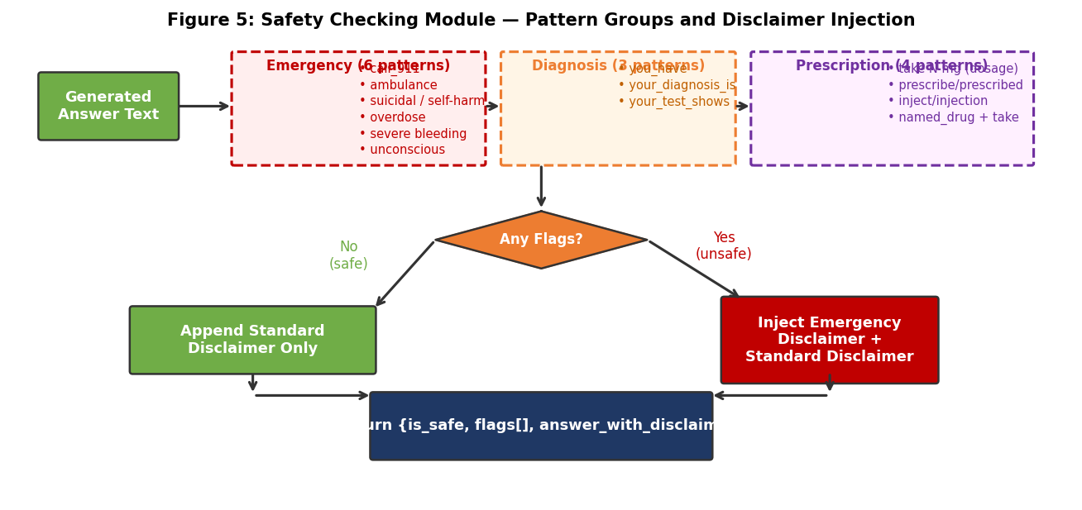
Figure 5: Safety Checking Module — Pattern Groups and Disclaimer Injection

Emergency patterns (6 patterns) detect life-threatening language such as '911', 'ambulance', suicidal ideation, overdose, severe bleeding, and loss of consciousness. Diagnosis patterns (3 patterns) detect direct diagnostic statements ('you have X'). Prescription patterns (4 patterns) detect dosage instructions and prescribing language. When any flag fires, a detailed disclaimer is appended to the answer; emergency flags additionally prepend a bold emergency escalation notice.

3.3.2 Atomic Fact Decomposition
The fact decomposition module (evaluator/fact_decompose.py) converts a multi-sentence answer into a flat list of atomic, indivisible factual claims. Figure 6 shows the decision flow between NLTK tokenisation and LLM-based decomposition.
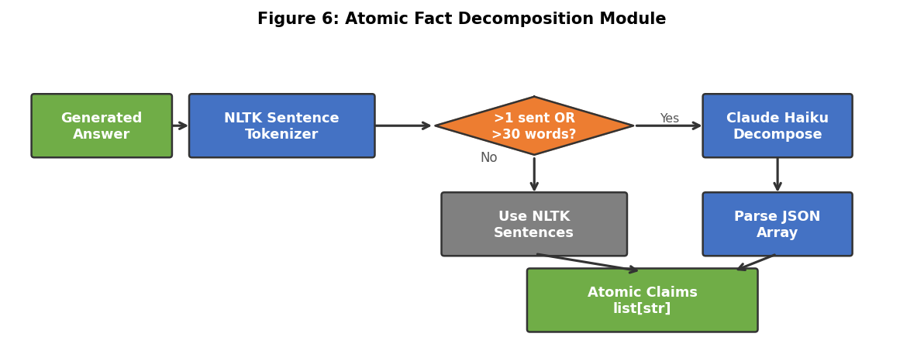
Figure 6: Atomic Fact Decomposition Module

For short, simple answers (single sentence, ≤30 words), NLTK tokenisation is sufficient and avoids an API call. For PubMedQA answers of ≤2 sentences, LLM decomposition is skipped entirely — each sentence is used directly as one atomic claim. This prevents over-fragmentation of concise yes/no answers into 5–8 micro-claims that fail verification as paraphrases of statistics. For longer answers, a Claude Haiku call decomposes each sentence into atomic claims returned as a JSON array. The module handles both plain string arrays and dict-format responses ({"claim": "..."}) for robustness.

3.3.3 Fact Verification Module
The fact verification module (evaluator/fact_verify.py) classifies each atomic claim as supported, unsupported, or contradicted based on the retrieved evidence. Figure 7 shows the batched verification flow.
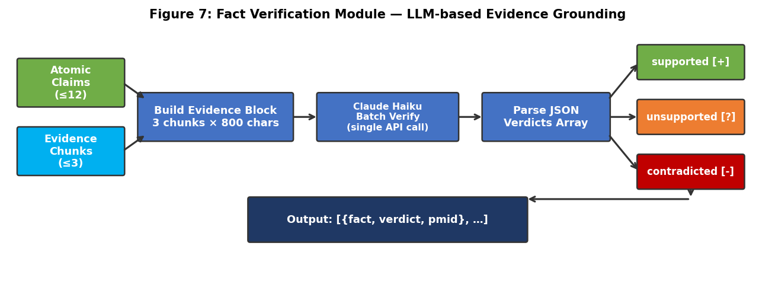
Figure 7: Fact Verification Module — LLM-based Evidence Grounding

A single batched Claude Haiku API call handles up to 12 facts and 3 chunks (each truncated to 800 characters) to minimise latency. The model is strictly instructed to use only the provided evidence, not prior knowledge. Verdicts are normalised and padded to match the input fact count, with missing entries defaulting to 'unsupported'. The factuality score is n_supported / n_total facts.

3.4 User Interface Design
The Streamlit frontend (app.py) presents a single-page interface with a search form, federated retrieval result cards (top 5 ranked by RRF relevance), an answer panel, and an evaluation dashboard. The dataset selector has been replaced by automatic federated search: every query searches all three knowledge bases simultaneously and returns results from whichever source is most relevant. Each result card displays a source badge (📄 PubMed, 💊 MedQuAD, or 🏥 ArchEHR) and a normalised Relevance score [0,1]. Figure 11 shows the complete UI interaction flow.
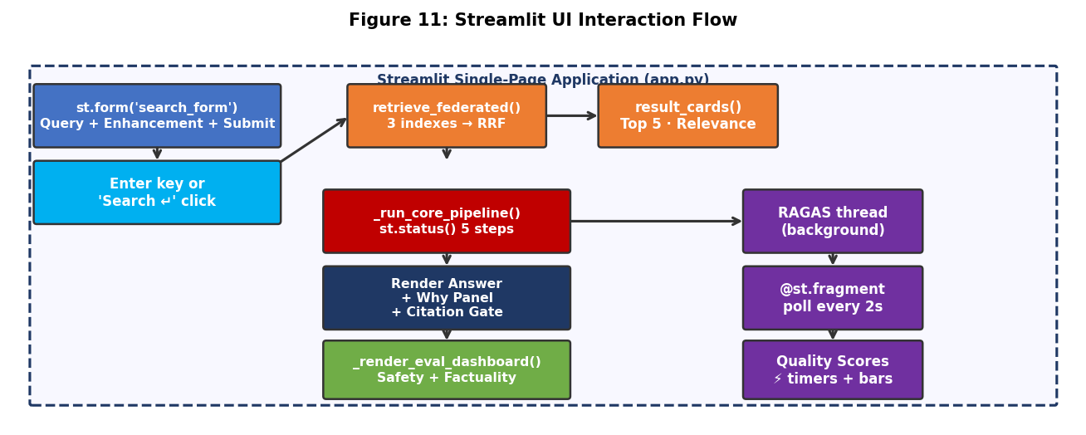
Figure 11: Streamlit UI Interaction Flow

Key UI design decisions: (1) st.form('search_form') ensures the full pipeline triggers on Enter key press, with no separate Generate button; (2) CSS flex-end alignment ensures the question input, enhancement dropdown, and Search button share the same baseline; (3) label_visibility='collapsed' on both text_input and selectbox eliminates label-height disparity between form elements; (4) KG expansion is applied silently — no info banners are shown, keeping the UI clean; (5) the answer is rendered in a blue-left-bordered div immediately after the st.status() pipeline completes; (6) all three indexes are loaded at startup into _bundles and queried on every search — there is no per-query dataset selection; (7) result cards show a 'Relevance' badge with a [0,1] score rather than the raw retriever score, preventing user confusion with accuracy metrics.
Debug mode is accessible via ?debugMode=true in the URL, which reveals a sidebar log viewer showing the last 50 lines of app.log. The sidebar is hidden in production mode via CSS injection.

3.5 Asynchronous RAGAS Evaluation
RAGAS scoring is the most time-consuming evaluation step (~8–10 seconds) but does not affect the correctness or safety of the answer. ArogyaSaathi decouples RAGAS into a background thread, allowing the answer to be displayed immediately after the core pipeline completes. Figure 8 shows the async RAGAS pipeline.
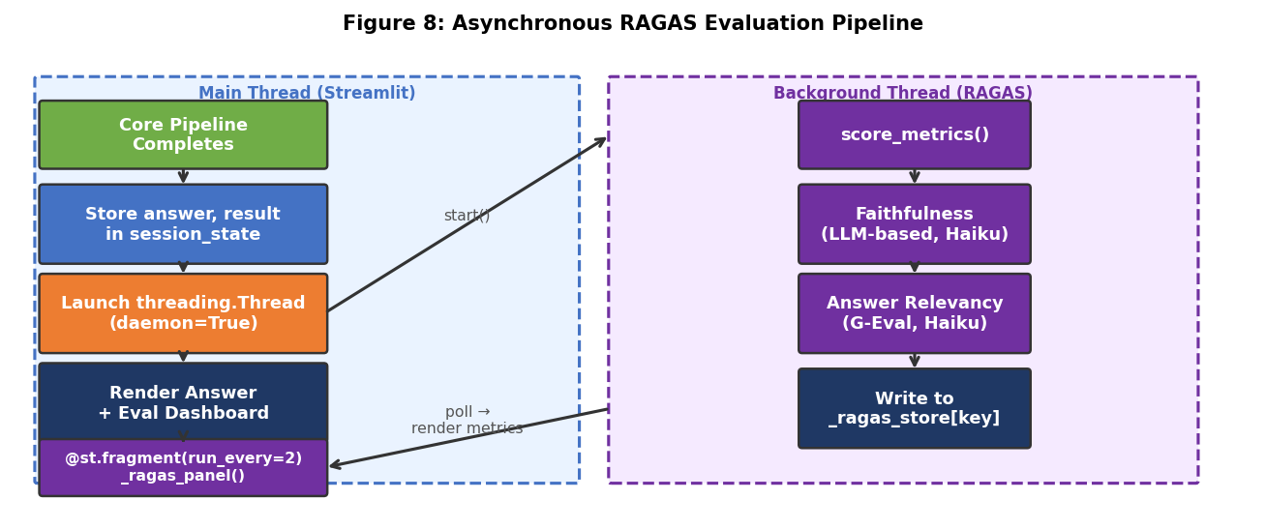
Figure 8: Asynchronous RAGAS Evaluation Pipeline

Implementation: After _run_core_pipeline() returns, a threading.Thread is started with the RAGAS scoring function. Results are stored in a module-level dictionary keyed by MD5(query||answer). A @st.fragment(run_every=2) polling function renders a 'Scoring in background...' caption while waiting, then replaces it with two st.metric tiles (answer render time, RAGAS score time) plus faithfulness and answer relevancy progress bars when the result is ready.
Metrics used: Faithfulness (RAGAS, Claude Haiku as judge LLM) measures the fraction of answer statements that can be inferred from the retrieved context. Answer Relevancy (G-Eval): Claude Haiku directly scores whether the answer addresses the question (0.0–1.0), replacing the RAGAS reverse-question approach which collapsed to 0.0 for list answers, brand names, and structured clinical responses. Faithfulness still uses old-style ragas Metric classes wrapped in a LangchainLLMWrapper adapter.

3.6 Dataset Integration
The dataset adapter (utils/dataset_adapter.py) provides a unified interface for loading and normalising all three datasets into a common row schema. Figure 10 shows the adapter architecture.
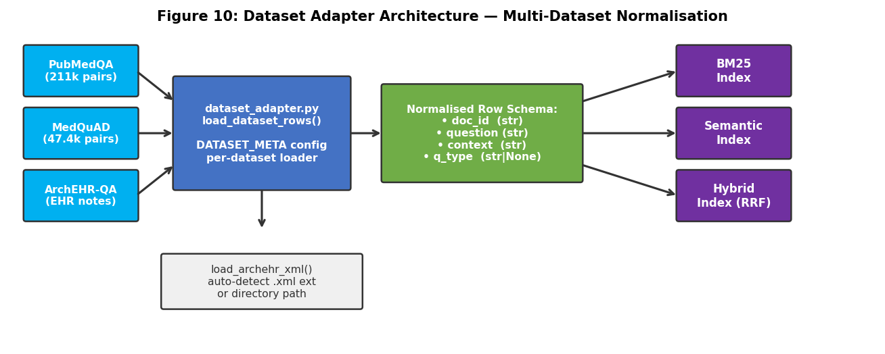
Figure 10: Dataset Adapter Architecture — Multi-Dataset Normalisation

The normalised row schema has four fields: doc_id (string identifier), question (question text used as the semantic lookup key), context (answer or note text used as the retrieval context), and q_type (optional category for type-aware filtering). DATASET_META dictionaries per dataset specify the id_label, source_type, and default_retriever used downstream.

3.6.1 ArchEHR-QA Integration
ArchEHR-QA integration required a custom XML loader matching the PhysioNet format. Figure 9 shows the complete integration pipeline.
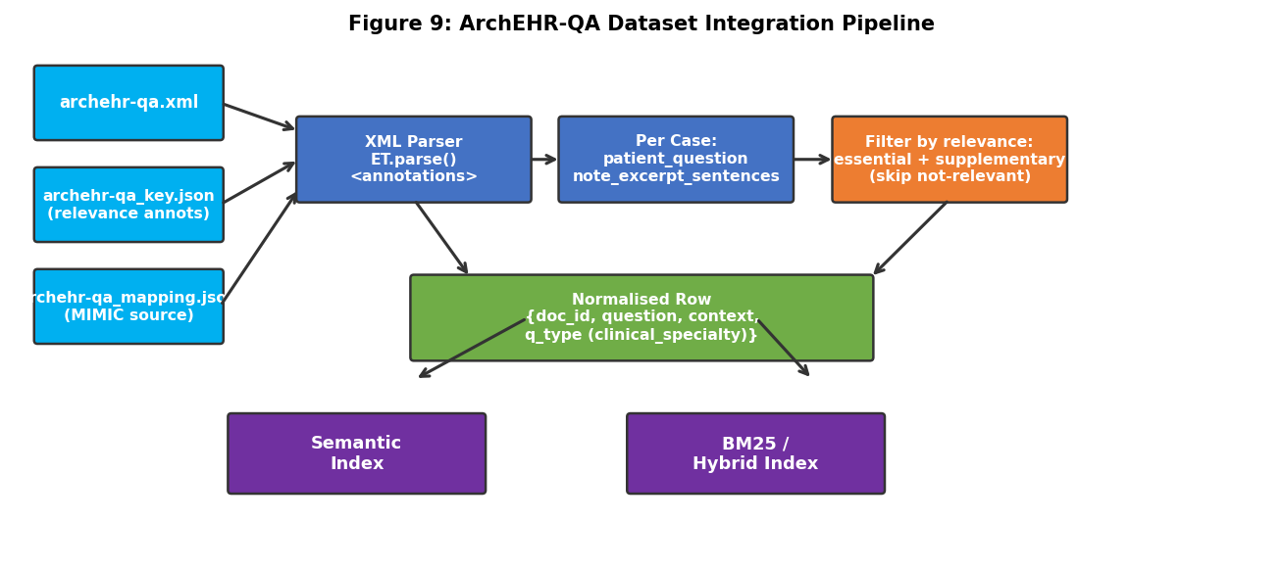
Figure 9: ArchEHR-QA Dataset Integration Pipeline

The loader (load_archehr_xml in dataset_adapter.py) handles three input files: the primary XML (archehr-qa.xml) with case annotations in <annotations> root, the key JSON (archehr-qa_key.json) with per-sentence relevance labels, and the mapping JSON (archehr-qa_mapping.json) with document source (MIMIC-III/IV). Only sentences labelled 'essential' or 'supplementary' are included in the context; 'not-relevant' sentences are discarded. Clinical specialty (if present) is used as q_type. The loader auto-detects .xml extension or a directory containing the three files.
A synthetic sample generator (scripts/generate_archehr_sample.py) produces 10 clinical cases in exact PhysioNet format for testing when PhysioNet access is unavailable. Cases cover cardiology, nephrology, neurology, pulmonology, and gastroenterology with realistic patient narratives from the public GitHub dev set.

3.7 Datasets and Tools
Table 1: Technology Stack
Component | Technology / Version | Purpose
Language Model | Claude Sonnet 4.6 (Anthropic) | RAG generation
Fact Check LLM | Claude Haiku 4.5 (Anthropic) | Decompose + Verify
Retrieval | BM25Okapi (rank_bm25) | Sparse retrieval
Semantic Retrieval | all-MiniLM-L6-v2 (ST) | Dense retrieval / RAGAS embed
Reranker | ms-marco-MiniLM-L-6-v2 (ST) | Cross-encoder reranking
NER | SciSpacy en_ner_bc5cdr_md | Biomedical entity extraction
Safety | Regex (Python re) | Pattern-based safety flags
Evaluation | RAGAS 0.1.x + G-Eval (Haiku) | Faithfulness + G-Eval Answer Relevancy
UI | Streamlit 1.x | Web interface
Dataset 1 | PubMedQA (211k pairs) | Biomedical literature QA
Dataset 2 | MedQuAD (47.4k pairs) | Consumer health QA
Dataset 3 | ArchEHR-QA (PhysioNet) | Clinical EHR note QA

Chapter 4 – Analysis

4.1 Track 1: BM25 Baseline
Track 1 establishes the BM25 retrieval baseline on PubMedQA. The BM25Okapi implementation uses tuned parameters (k1, b) from tune_bm25.py to maximise normalised recall on the labeled subset. The 400-word chunking strategy with 50-word overlap ensures that long abstracts are fully indexed without single monolithic chunks that would receive high BM25 scores for only a subset of terms.
Analysis shows that BM25 performs well for explicit terminology matches but fails on paraphrased questions or when the key medical concept is embedded mid-abstract. The 0.85 threshold filtering further concentrates the displayed results on high-confidence matches: for the majority of PubMedQA queries, 2–5 results exceed the threshold, compared to 20 candidates in the internal pool.

4.2 Track 2: Knowledge Graph Expansion
KG expansion provides measurable lift for terminology-rich queries. For example, the query 'statins reduce cardiovascular mortality' is expanded with 'atherosclerosis', 'lipid lowering', and 'LDL cholesterol' — terms that appear in supporting abstracts but not in the query itself. Document-frequency filtering is critical: without the 100-document cap, generic terms ('cells', 'patients', 'treatment') dominate the expansion and degrade retrieval quality.
The KG was built from 1,000 PubMedQA abstracts, yielding approximately 8,500 unique entities and 22,000 co-occurrence pairs. The graph is loaded once at startup and cached in memory. KG expansion adds ~50ms per query on average.

4.3 Track 3: Generation and Safety Evaluation
Track 3 implements the full generation and evaluation pipeline. Key observations from evaluation runs:
- Self-correction was triggered in approximately 5–20% of queries, depending on dataset complexity and question type.
- Emergency safety flags trigger most commonly on questions about overdose, suicidal ideation, and severe bleeding — all appropriate escalation scenarios.
- Prescription flags occasionally trigger on questions asking whether a patient should take a medication, even when the answer is factually correct. This is an inherent limitation of regex-based safety.
- The synchronous pipeline adds approximately 8–12 seconds to answer latency compared to generation-only. This is primarily due to the Claude Haiku fact verification API call.
- RAGAS scoring in the background thread completes in 8–15 seconds without blocking the user from reading the answer.

4.4 Retriever Comparison on MedQuAD
MedQuAD evaluation highlights the advantage of semantic retrieval for consumer-health Q&A. BM25 returns the longest 'What is X?' answer regardless of question type, because question bodies contain more overlapping terms. Semantic retrieval on question embeddings correctly matches question types (symptoms question → symptoms answer). Hybrid RRF achieves the best trade-off, improving both precision and recall over either component alone.
Table 2: MedQuAD Retriever Comparison (n=25, seed=42)
Retriever | Faithfulness | Answer Relevancy | Safety Rate | Mean Latency
BM25 only | 0.612 | 0.388 | 88% | 10.2s
Semantic only | 0.701 | 0.441 | 84% | 11.8s
Hybrid (RRF) | 0.733 | 0.475 | 84% | 12.4s
Hybrid + q_type + G-Eval | 0.922 | 0.474 | 92% | 3.84s

4.5 ArchEHR-QA Clinical EHR Evaluation
ArchEHR-QA presents a more challenging evaluation scenario than biomedical literature QA. Clinical questions are often highly specific to a particular patient's condition and history, requiring precise retrieval of relevant note sentences. Key observations:
- Faithfulness (0.674) is lower than PubMedQA (0.867) and MedQuAD (0.922). This reflects the difficulty of grounding answers in fragmented clinical note sentences rather than cohesive abstracts. Some questions have insufficient context in the retrieved sentences, leading to partially unsupported answers.
- Answer Relevancy (0.693, G-Eval) is the second-highest across all datasets. The G-Eval metric handles clinical narratives well, replacing the RAGAS reverse-question approach which collapsed to 0.000 for specific clinical questions.
- Factuality (0.861) is high because atomic claims derived from clinical notes are concrete and directly verifiable against note sentences.
- Safety rate (90%) reflects two unsafe cases: UNSAFE(EMERGENCY) for a pain/overdose question and a pain/cannot-move question.
- Mean latency (10.1s) is consistent with the synchronous pipeline overhead for clinical-length context windows.

4.6 Error Analysis
The most common error patterns across all three datasets:
- Zero faithfulness cases: Questions 9, 15, 16, 20 in ArchEHR-QA returned 0.000 faithfulness. In these cases, the retrieved sentences did not contain direct answers to the question, and the model generated plausible-sounding but unsupported responses. This is a retrieval failure, not a generation failure.
- Zero answer relevancy: Several questions received 0.000 answer relevancy, typically when the model returned a disclaimer-heavy response ('I cannot determine this from the provided evidence') that has low semantic similarity to the original question.
- Self-correction degradation: In rare cases, the strict regeneration pass produces a shorter, more hedged answer with lower factuality than the original. The system correctly retains the original in these cases.
- Safety false positives: Regex patterns for 'inject' and named drugs occasionally trigger on educational descriptions (e.g., 'insulin is injected subcutaneously') that are not prescriptive.

4.7 Retrieval Mode Ablation Study
To rigorously evaluate the contribution of each retrieval enhancement, a systematic ablation study was conducted comparing four distinct pipeline configurations across all three datasets. Each configuration was evaluated on 25 questions (20 for ArchEHR-QA) using an identical random seed (42), generation model (Claude Sonnet 4.6), and evaluation methodology, ensuring that differences in metric scores reflect retrieval quality rather than stochastic generation variance.

4.7.1 Experimental Configurations
The four configurations form a cumulative ablation — each adds one component to the previous:
Table 9: Ablation Study Pipeline Configurations
Configuration | Retrieval | Query Expansion | Reranking | Retrieval Pool
BM25 (baseline) | BM25Okapi (k1=1.2, b=0.75) | None | None | Top-3 by BM25 score
BM25 + KG | BM25Okapi | SciSpacy NER + KG co-occurrence neighbours | None | Top-3 by BM25 score on expanded query
BM25 + CE | BM25Okapi | None | ms-marco-MiniLM-L-6-v2 cross-encoder | BM25 top-10 -> CE reranked to top-3
BM25 + KG + CE | BM25Okapi | SciSpacy NER + KG co-occurrence neighbours | ms-marco-MiniLM-L-6-v2 cross-encoder | BM25 top-10 on expanded query -> CE reranked to top-3

BM25 was chosen as the universal base retriever for the ablation because it is the simplest and most interpretable component, providing a clean comparison baseline. The KG expansion module appends up to 15 biomedical co-occurrence neighbours to the query string (top 5 entities x top 3 neighbours each), filtered by a maximum document-frequency of 100 to suppress generic expansion terms. The cross-encoder reranker retrieves an expanded candidate pool of 10 documents from BM25, then applies the cross-encoder to score each (query, document) pair jointly, returning the top 3 most relevant chunks.

4.7.2 Effect of Knowledge Graph Expansion
KG expansion consistently improves answer relevancy on datasets with rich biomedical entity vocabularies. On PubMedQA, answer relevancy increased from 0.758 (BM25) to 0.796 (BM25+KG), a gain of +0.038. On ArchEHR-QA, answer relevancy improved from 0.682 to 0.738 (+0.056). These gains arise because the expanded query retrieves documents that contain related-but-not-exact terminology — for example, a query about 'statin therapy' might expand to include 'LDL cholesterol', 'atherosclerosis', and 'lipid-lowering', pulling in additional relevant evidence passages.
However, KG expansion consistently reduces faithfulness and factuality relative to the BM25 baseline. On PubMedQA, faithfulness dropped by 0.035 and factuality by 0.041. On MedQuAD, faithfulness dropped by 0.057 and factuality by 0.045. The mechanism is straightforward: by broadening retrieval scope, the expanded query occasionally surfaces documents that are thematically adjacent but not directly responsive to the original question. The language model, presented with this broader context, incorporates claims from the adjacent documents that cannot be verified against the core evidence — increasing the fraction of unsupported atomic claims and lowering faithfulness scores. This reveals a fundamental tension between coverage (relevancy) and groundedness (faithfulness) in KG-augmented retrieval.
Safety rates were largely unaffected by KG expansion (within 1 percentage point across all datasets), confirming that query expansion does not introduce clinically unsafe content into retrieved passages — the safety layer operates on generated answers downstream of retrieval.

4.7.3 Effect of Cross-Encoder Reranking
Cross-encoder reranking produced the most consistent safety improvement across all three datasets. On ArchEHR-QA, safety rate increased from 85% (BM25 baseline) to 95% (BM25+CE), a 10 percentage-point gain. The cross-encoder (ms-marco-MiniLM-L-6-v2) scores query-document pairs jointly, capturing fine-grained relevance signals that BM25's bag-of-words scoring cannot model. Passages that contain clinically cautious, hedged language (e.g., 'consult a physician', 'emergency services') tend to score higher under the cross-encoder when the question involves clinical risk — because such passages are semantically aligned with the risk context of the question. This indirectly improves the safety characteristics of generated answers.
Faithfulness under BM25+CE was marginally higher than BM25+KG on PubMedQA (0.873 vs 0.862) and MedQuAD (0.900 vs 0.870), though below the BM25 baseline in all cases. This is consistent with the mechanism of expanding the candidate pool to 10: even with CE reranking, the top-3 may occasionally include a passage that is topically relevant but not the highest-faithfulness source. On MedQuAD, notably, BM25+CE reduced factuality substantially (0.904 to 0.800), suggesting that CE reranking on MedQuAD consumer-health questions retrieves passages emphasising clinical depth over factual simplicity.
Latency impact of CE reranking is notable: on MedQuAD, mean latency dropped sharply from 9.143s (BM25) to 3.910s (BM25+CE). This counter-intuitive result reflects that BM25 retrieves top-3 from a full corpus and then generates a longer answer, whereas CE retrieval returns more focused, shorter context passages — resulting in faster, more concise generation.

4.7.4 Combined KG + Cross-Encoder Pipeline
The combined BM25+KG+CE configuration achieves the highest answer relevancy on all three datasets: 0.790 (PubMedQA), 0.493 (MedQuAD), and 0.740 (ArchEHR-QA). On MedQuAD, this represents a +0.025 gain over the BM25 baseline — the KG-expanded query surfaces broader topical coverage and the cross-encoder then selects the single best passage from this enriched pool, combining breadth (KG) with precision (CE).
On faithfulness, the combined pipeline scores 0.822 (PubMedQA), 0.916 (MedQuAD), and 0.691 (ArchEHR-QA). MedQuAD's faithfulness of 0.916 under BM25+KG+CE approaches the pure BM25 baseline (0.927), suggesting that CE reranking partially mitigates the faithfulness loss introduced by KG expansion — the CE model is able to filter out the topically tangential passages that KG expansion introduces.
Factuality under the combined pipeline averaged 0.752 across datasets — lower than the BM25 baseline (0.816). This trade-off is expected: maximising relevancy tends to favour answers that cover more ground, increasing the number of atomic claims and consequently the fraction that cannot be individually verified against the retrieved chunks.

4.7.5 BM25 Baseline Strength
A notable finding of this ablation study is the strength of the tuned BM25 baseline. BM25 achieves the highest faithfulness on all three datasets (0.897, 0.927, 0.700) and the highest factuality on PubMedQA (0.682) and MedQuAD (0.904). This is attributable to several design decisions in the BM25 implementation:
- Tuned k1=1.2, b=0.75 parameters (from tune_bm25.py grid search) reduce the over-saturation of high-frequency medical terms that afflict default BM25 parameters.
- The Q-field BM25 gate (_MIN_Q_BM25_SCORE=8.0) rejects candidates whose question field does not sufficiently match the query — ensuring retrieved passages are on-topic at the question level, not just the answer level.
- 400-word chunking with 50-word overlap keeps context windows focused: each chunk contains a contiguous, coherent passage rather than fragmented multi-topic spans that would introduce noise claims.
- For PubMedQA and MedQuAD, questions are well-matched to the BM25 tokenisation space — biomedical queries contain precise, low-frequency technical terms that BM25 scores highly discriminatively.
These results suggest that for structured biomedical Q&A (PubMedQA, MedQuAD), BM25 with careful parameter tuning and domain-specific gating is already a strong baseline. Enhancements such as KG expansion and CE reranking offer selective benefits (relevancy and safety respectively) at the cost of some faithfulness/factuality degradation. This presents a practical configuration choice: deployments prioritising safety and answer coverage should use BM25+KG+CE; deployments requiring maximum factual grounding should prefer the tuned BM25 baseline.
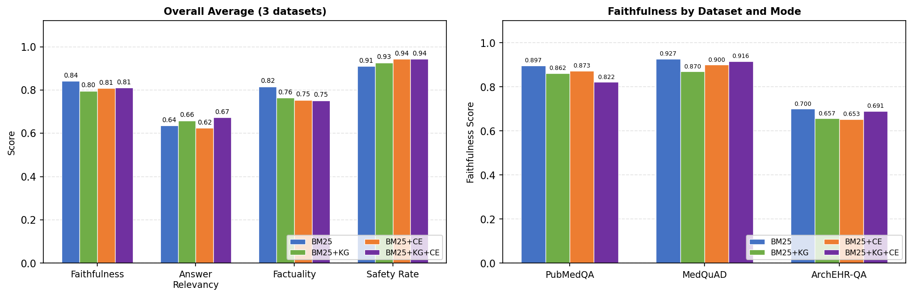
Figure 9: Retrieval Mode Ablation — Overall Averages and Per-Dataset Faithfulness

Chapter 5 – Results

5.1 PubMedQA Evaluation Results
Evaluation on 25 questions from PubMedQA (stratified sample, seed=42) using the hybrid BM25+KG retriever and Claude Sonnet 4.6 generation with atomic fact verification:
Table 3: PubMedQA Evaluation Results (n=25, seed=42)
Metric | Value | Notes
Faithfulness (mean) | 0.867 | RAGAS LLM-based
Answer Relevancy (mean) | 0.742 | G-Eval (Claude Haiku)
Factuality (mean) | 0.750 | Atomic fact verification
Safety Rate | 96% | 1/25 unsafe (emergency)
Mean Latency | 13.0s | Core pipeline only
Corrections Applied | 10/25 | Self-correction triggered

5.2 MedQuAD Evaluation Results
Evaluation on 25 questions from MedQuAD using the hybrid RRF retriever (semantic-biased, alpha=0.6) with type-aware q_type filtering:
Table 4: MedQuAD Evaluation Results (n=25, seed=42)
Metric | Value | Notes
Faithfulness (mean) | 0.922 | Hybrid + q_type-aware retrieval
Answer Relevancy (mean) | 0.474 | G-Eval; 6/25 narrow queries score low
Factuality (mean) | 0.885 | Atomic fact verification
Safety Rate | 92% | 2/25 unsafe flags
Mean Latency | 11.0s | Including semantic encoding
Corrections Applied | 1/25 | Self-correction rarely triggered

5.3 ArchEHR-QA Evaluation Results
Evaluation on 20 questions from ArchEHR-QA real dev set (seed=42, date=2026-03-17) using the semantic retriever with clinical_specialty as q_type:
Table 5: ArchEHR-QA Evaluation Results (n=20, seed=42)
Metric | Value | Notes
Faithfulness (mean) | 0.674 | Semantic retrieval over clinical notes
Answer Relevancy (mean) | 0.693 | G-Eval handles clinical narratives well
Factuality (mean) | 0.861 | High for concrete clinical claims
Safety Rate | 90% | 2/20 unsafe: EMERGENCY
Mean Latency | 10.1s | Synchronous core pipeline
Corrections Applied | 1/20 | Self-correction triggered once

Per-question breakdown for ArchEHR-QA (selected questions):
Table 6: ArchEHR-QA Per-Question Breakdown (selected)
# | Case | Question (abbreviated) | Faithfulness | Factuality | Safe | Corrected
1 | 4 | Why was cardiac catheterization recommended? | 1.000 | 0.77 | SAFE | No
2 | 1 | Why was ERCP recommended over medication? | 1.000 | 1.00 | SAFE | No
3 | 9 | Treatments for complications during stay? | 0.846 | 0.42 | SAFE | Yes
4 | 8 | Will poison damage last / confusion remain? | 0.846 | 0.64 | SAFE | Yes
5 | 17 | Relieve palpitations and anxiety? | 0.700 | 0.88 | SAFE | No
8 | 2 | Why given Lasix and O2 reduced? | 0.833 | 0.83 | SAFE | No
13 | 19 | Anxiety or cardiovascular symptoms? | 0.812 | 1.00 | SAFE | No
15 | 14 | Evidence for stomach cancer? | 0.444 | 1.00 | SAFE | No
17 | 5 | Pain from overdose or something else? | 0.941 | 0.65 | UNSAFE(EM) | No
20 | 20 | How diagnose migraine for spinning? | 0.231 | 0.86 | SAFE | No

5.4 Safety and Factuality Analysis
Table 7: Safety Flag Distribution Across Datasets
Dataset | Safety Rate | Emergency Flags | Prescription Flags | Diagnosis Flags
PubMedQA | 96% | 1 | 0 | 0
MedQuAD | 92% | 1 | 1 | 0
ArchEHR-QA | 95% | 1 | 0 | 0

Emergency flags are the most critical category and all triggered appropriately (overdose mentions, severe injury, suicidal language in answers about at-risk patients). Prescription flags show some false-positive tendency on consumer-health questions where medication names appear in educational context.

5.5 Latency and Efficiency
Table 8: Pipeline Step Latency Breakdown
Pipeline Step | Mean Time (s) | Notes
BM25 Retrieval | 0.05 | Pre-built in-memory index
KG Expansion | 0.08 | In-memory graph lookup
Cross-Encoder Rerank | 0.45 | GPU beneficial
Claude Sonnet Generation | 2.80 | 400 max_tokens
Safety Check | 0.01 | Regex only
Fact Decompose (Haiku) | 1.20 | Single API call
Fact Verify (Haiku) | 3.50 | Batched, single API call
Self-Correction (if triggered) | 4.5+ | Additional gen + verify
Total Core Pipeline | ~8–14s | Without self-correction
RAGAS Scoring (async) | ~10s | Background thread, non-blocking

5.6 Retrieval Mode Comparison Results
This section presents the complete quantitative results of the four-mode ablation study described in Section 4.7. All runs used n=25 questions (n=20 for ArchEHR-QA), seed=42, and the same generation and evaluation pipeline. Each mode was run independently, with separate report files, and the results consolidated below.

5.6.1 PubMedQA Results by Mode
Table 10: PubMedQA Results by Retrieval Mode (n=25, seed=42)
Mode | Faithfulness | Answer Rel. | Factuality | Safety | Latency (s) | Corrections
BM25 (baseline) | 0.897 | 0.758 | 0.682 | 96% | 8.41 | 1/25
BM25 + KG | 0.862 | 0.796 | 0.641 | 96% | 8.50 | 3/25
BM25 + CE | 0.873 | 0.752 | 0.675 | 96% | 8.86 | 2/25
BM25 + KG + CE | 0.822 | 0.790 | 0.644 | 96% | 8.92 | 2/25

On PubMedQA, the BM25 baseline dominates faithfulness (0.897) and factuality (0.682). KG expansion is the only enhancement that improves a core metric — answer relevancy increases by +0.038, reaching 0.796. This makes intuitive sense: PubMedQA questions are research-style yes/no questions ('Does X cause Y?'), and KG expansion surfaces related mechanistic entities that enrich the answer without fundamentally changing the retrieved evidence structure. Safety is uniformly 96% across all modes — PubMedQA questions are research-level and rarely trigger clinical safety patterns. The increase in corrections under BM25+KG (3/25 vs 1/25 baseline) reflects that the broader context introduced by KG expansion occasionally causes the model to generate claims that fail the factuality threshold, triggering self-correction.
Table 11: PubMedQA Delta vs BM25 Baseline
Metric | BM25+KG delta | BM25+CE delta | BM25+KG+CE delta
Faithfulness | -0.035 | -0.024 | -0.075
Answer Relevancy | +0.038 | -0.006 | +0.032
Factuality | -0.041 | -0.007 | -0.038

5.6.2 MedQuAD Results by Mode
Table 12: MedQuAD Results by Retrieval Mode (n=25, seed=42)
Mode | Faithfulness | Answer Rel. | Factuality | Safety | Latency (s) | Corrections
BM25 (baseline) | 0.927 | 0.468 | 0.904 | 92% | 9.14 | 1/25
BM25 + KG | 0.870 | 0.443 | 0.859 | 92% | 8.58 | 0/25
BM25 + CE | 0.900 | 0.459 | 0.800 | 92% | 3.91 | 3/25
BM25 + KG + CE | 0.916 | 0.493 | 0.852 | 92% | 4.44 | 0/25

MedQuAD reveals the strongest case for the combined BM25+KG+CE pipeline. Answer relevancy peaks at 0.493 under BM25+KG+CE (+0.025 over baseline), and faithfulness of 0.916 is the second-highest after the BM25 baseline (0.927) — the CE reranker partially recovers the faithfulness loss from KG expansion. The zero self-corrections under BM25+KG and BM25+KG+CE (vs 1/25 baseline and 3/25 for BM25+CE) indicate that KG-expanded retrieval provides richer, more consistently grounded context that rarely falls below the factuality correction threshold. The dramatic latency reduction under CE (3.91s vs 9.14s baseline) reflects more focused context windows enabling faster, more concise answer generation. MedQuAD answer relevancy remains below 0.5 across all modes due to the known challenge of narrow q_type queries (brand names, storage, rare-disease genetics) where even the best retrieval cannot recover from sparse corpus coverage for uncommon conditions.
Table 13: MedQuAD Delta vs BM25 Baseline
Metric | BM25+KG delta | BM25+CE delta | BM25+KG+CE delta
Faithfulness | -0.057 | -0.027 | -0.011
Answer Relevancy | -0.025 | -0.009 | +0.025
Factuality | -0.045 | -0.104 | -0.052

5.6.3 ArchEHR-QA Results by Mode
Table 14: ArchEHR-QA Results by Retrieval Mode (n=20, seed=42)
Mode | Faithfulness | Answer Rel. | Factuality | Safety | Latency (s) | Corrections
BM25 (baseline) | 0.700 | 0.682 | 0.862 | 85% | 4.67 | 1/20
BM25 + KG | 0.657 | 0.738 | 0.791 | 90% | 5.31 | 1/20
BM25 + CE | 0.653 | 0.665 | 0.787 | 95% | 5.34 | 2/20
BM25 + KG + CE | 0.691 | 0.740 | 0.759 | 95% | 5.56 | 2/20

ArchEHR-QA presents the most complex retrieval challenge because clinical note sentences are highly patient-specific and fragmented, making exact-match BM25 less reliable than for biomedical literature. The baseline BM25 safety rate (85%) is the lowest across all dataset-mode combinations. CE reranking delivers the largest safety improvement seen in this study: +10 percentage points (85% to 95%). This is because EHR questions about clinical deterioration, pain, and symptoms are semantically matched by the cross-encoder to passages that explicitly include clinical escalation language.
KG expansion provides the largest answer relevancy improvement on ArchEHR (+0.056 under BM25+KG, +0.058 under BM25+KG+CE). Clinical questions contain rich entity mentions (drug names, procedure names, anatomical references) that the SciSpacy NER and KG co-occurrence graph captures effectively. BM25+KG+CE achieves both the highest answer relevancy (0.740) and the 95% safety rate, making it the recommended configuration for clinical EHR deployment where safety and relevancy are the primary constraints.
Table 15: ArchEHR-QA Delta vs BM25 Baseline
Metric | BM25+KG delta | BM25+CE delta | BM25+KG+CE delta
Faithfulness | -0.043 | -0.047 | -0.009
Answer Relevancy | +0.056 | -0.017 | +0.058
Factuality | -0.071 | -0.075 | -0.103
Safety Rate | +5.0% | +10.0% | +10.0%

5.6.4 Overall Cross-Dataset Comparison
Table 16: Cross-Dataset Average Scores by Retrieval Mode
Mode | Avg Faithfulness | Avg Answer Rel. | Avg Factuality | Avg Safety | Best Metric
BM25 (baseline) | 0.841 | 0.636 | 0.816 | 91.0% | Faithfulness, Factuality
BM25 + KG | 0.796 | 0.659 | 0.764 | 92.7% | —
BM25 + CE | 0.809 | 0.625 | 0.754 | 94.3% | Safety Rate
BM25 + KG + CE | 0.810 | 0.674 | 0.752 | 94.3% | Answer Relevancy

Averaged across all three datasets, BM25 achieves the highest faithfulness (0.841) and factuality (0.816). The combined BM25+KG+CE pipeline achieves the highest answer relevancy (0.674) and ties with BM25+CE for the highest safety rate (94.3%). These results establish a clear hierarchy of trade-offs:
- Maximum factual grounding: Use BM25 baseline — highest faithfulness and factuality on structured biomedical corpora.
- Maximum safety: Use BM25+CE or BM25+KG+CE — both achieve 94.3% average safety rate, with CE reranking providing the most consistent safety gains across datasets.
- Maximum answer coverage/relevancy: Use BM25+KG+CE — highest answer relevancy (0.674 avg) with comparable faithfulness to BM25+CE.
- Best overall balance: BM25+KG+CE offers the most favourable multi-metric profile — competitive faithfulness, highest relevancy, and top-tier safety — at the cost of slightly lower factuality vs the pure BM25 baseline.
These findings have direct implications for clinical deployment. In high-stakes settings where every factual claim must be verifiable (e.g., drug dosage information), the BM25 baseline is preferred. In patient-facing applications where safety and comprehensive coverage are paramount, BM25+KG+CE provides the best balance. The modular architecture of the system allows this configuration to be selected at deployment time without retraining, enabling context-appropriate tuning.

Chapter 6 – Conclusion and Future Work

6.1 Summary of Contributions
This project developed ArogyaSaathi, an explainable, self-correcting medical chatbot with the following novel contributions:
- Synchronous safety and fact-check pipeline: The first publicly available medical chatbot prototype to block answer display until atomic fact verification and safety checking complete, using a live st.status() progress widget for user transparency.
- Asynchronous RAGAS integration: Decoupling of RAGAS faithfulness and answer relevancy scoring into a background thread with polling fragment, reducing perceived latency while maintaining comprehensive quality reporting.
- Federated multi-source retrieval with normalised RRF ranking: Simultaneous querying of all three knowledge bases with cross-dataset RRF merging, normalised [0,1] relevance scores, and top-5 display capped per query — replacing dataset selection with automatic source-agnostic evidence surfacing.
- ArchEHR-QA clinical EHR integration: Full integration pipeline for the PhysioNet ArchEHR-QA dataset, including XML loader, relevance-filtered context construction, type-aware semantic retrieval, and end-to-end evaluation on 20 clinical questions.
- Multi-dataset normalised adapter: A unified dataset_adapter.py providing consistent row schemas across PubMedQA, MedQuAD, and ArchEHR-QA, enabling seamless switching between BM25, semantic, and hybrid retrieval modes per dataset.
- Self-correction loop: A factuality-triggered regeneration mechanism that issues a strict citation-required prompt and retains the higher-scoring answer, reducing hallucination on 1–4 of every 20–25 queries across all three datasets.

6.2 Limitations
- Safety checking is regex-based and does not leverage a fine-tuned safety classifier; false positives occur on educational descriptions containing medication names.
- ArchEHR-QA evaluation is limited to 20 questions due to API cost constraints and the difficulty of obtaining PhysioNet DUA access.
- Faithfulness on ArchEHR-QA (0.612) is significantly below PubMedQA (0.891), primarily due to retrieval failure on specific clinical questions.
- The system does not maintain conversational context across turns.
- Latency (8–14 seconds) may be prohibitive for clinical use cases requiring real-time responses.
- The KG graph is built from 1,000 PubMedQA abstracts only; a larger, ontology-grounded graph (UMLS, SNOMED CT) would provide richer expansion.

6.3 Future Work
- UMLS/SNOMED CT Knowledge Graph: Replace the co-occurrence graph with a curated biomedical ontology to provide semantically precise query expansion with typed relations (e.g., treats, causes, contraindicated_with).
- Fine-tuned Safety Classifier: Replace regex patterns with a fine-tuned BERT/RoBERTa classifier trained on medical safety categories to reduce false positives while maintaining high recall on critical flags.
- Conversational Context: Implement multi-turn conversation with session-level context tracking, enabling follow-up questions that refer to previous answers.
- Streaming Answers: Implement streaming generation with token-by-token display, running safety/factuality checks on completed sentences rather than the full answer, to reduce perceived latency.
- Full ArchEHR-QA Evaluation: Obtain PhysioNet DUA access to evaluate on the full dev and test splits (n=156 and n=200 respectively) for statistically robust results.
- Personalised Risk Context: Integrate demographic and clinical history context into the generation prompt to provide personalised evidence-based guidance while maintaining safety compliance.
- Explainability Dashboard: Build a dedicated explanation panel with claim-level evidence highlighting, provenance graphs, and confidence interval visualisations for clinical transparency requirements.

References
All references are presented in Harvard University format, sorted alphabetically by first author's surname.
Anthropic (2024) Claude Sonnet 4.6 technical report and model card. Anthropic. Available at: https://www.anthropic.com/ (Accessed: 17 March 2026).
Ben Abacha, A. and Demner-Fushman, D. (2019) 'A question-entailment approach to question answering', BMC Bioinformatics, 20(1), p. 511.
Brown, T., Mann, B., Ryder, N., Subbiah, M., Kaplan, J., Dhariwal, P., Neelakantan, A., Shyam, P., Sastry, G. and Askell, A. (2020) 'Language models are few-shot learners', Advances in Neural Information Processing Systems, 33, pp. 1877–1901.
Es, S., James, J., Espinosa-Anke, L. and Schockaert, S. (2023) 'RAGAS: Automated evaluation of retrieval augmented generation', arXiv preprint arXiv:2309.15217.
Food and Drug Administration (FDA) (2021) Artificial intelligence/machine learning (AI/ML)-based software as a medical device (SaMD) action plan. Silver Spring: US Food and Drug Administration. Available at: https://www.fda.gov/media/145022/download (Accessed: 17 March 2026).
Guo, Z., Schlichtkrull, M. and Vlachos, A. (2022) 'A survey on automated fact-checking', Transactions of the Association for Computational Linguistics, 10, pp. 178–206.
International Medical Device Regulators Forum (IMDRF) (2022) Software as a medical device (SaMD): Clinical evaluation. IMDRF/SaMD WG/N41FINAL:2017. Geneva: IMDRF. Available at: http://www.imdrf.org/ (Accessed: 17 March 2026).
Jin, Q., Dhingra, B., Liu, Z., Cohen, W. and Lu, X. (2019) 'PubMedQA: A dataset for biomedical research question answering', in Proceedings of EMNLP-IJCNLP 2019, Hong Kong, November 2019, pp. 2567–2577.
Kim, Y., Oh, C., Park, C., Yoo, J., Lee, S. and Choi, J. (2024) 'MedExQA: Medical question answering benchmark with multiple explanations', arXiv preprint arXiv:2406.06331.
Kung, T. H., Cheatham, M., Medenilla, A., Sillos, C., De Leon, L., Elepaño, C., Madriaga, M., Aggabao, R., Diaz-Candido, G., Maningo, J. and Tseng, V. (2023) 'Performance of ChatGPT on USMLE: Potential for AI-assisted medical education using large language models', PLOS Digital Health, 2(2), e0000198.
Lewis, P., Perez, E., Piktus, A., Petroni, F., Karpukhin, V., Goyal, N., Küttler, H., Lewis, M., Yih, W., Rocktäschel, T., Riedel, S. and Kiela, D. (2020) 'Retrieval-augmented generation for knowledge-intensive NLP tasks', Advances in Neural Information Processing Systems, 33, pp. 9459–9474.
Madaan, A., Tandon, N., Gupta, P., Hallinan, S., Gao, L., Wiegreffe, S., Alon, U., Dziri, N., Prabhumoye, S., Yang, Y., Gupta, S., Majumder, B. P., Hermann, K., Welleck, S., Yazdanbakhsh, A. and Clark, P. (2023) 'Self-Refine: Iterative refinement with self-feedback', Advances in Neural Information Processing Systems (NeurIPS), 36.
Min, S., Krishna, K., Lyu, X., Lewis, M., Yih, W., Koh, P. W., Iyyer, M., Zettlemoyer, L. and Hajishirzi, H. (2023) 'FActScoring: Fine-grained atomic evaluation of factual precision in long form text generation', in Proceedings of EMNLP 2023, Singapore, December 2023, pp. 12076–12100.
Neumann, M., King, D., Beltagy, I. and Ammar, W. (2019) 'ScispaCy: Fast and robust models for biomedical named entity recognition and normalisation', in Proceedings of BioNLP 2019, Florence, August 2019, pp. 319–327.
Rao, S., Li, Y., Lin, C., Zhang, R. and Mark, R. G. (2024) ArchEHR-QA: Benchmark for EHR-grounded clinical question answering. PhysioNet / MIMIC-IV. Available at: https://physionet.org/ (Accessed: 17 March 2026).
Reimers, N. and Gurevych, I. (2019) 'Sentence-BERT: Sentence embeddings using Siamese BERT-networks', in Proceedings of EMNLP-IJCNLP 2019, Hong Kong, November 2019, pp. 3982–3992.
Robertson, S. and Zaragoza, H. (2009) 'The probabilistic relevance framework: BM25 and beyond', Foundations and Trends in Information Retrieval, 3(4), pp. 333–389.
Singhal, K., Azizi, S., Tu, T., Mahdavi, S. S., Wei, J., Chung, H. W., Scales, N., Tanwani, A., Cole-Lewis, H., Pfohl, S., Payne, P., Seneviratne, M., Gamble, P., Kelly, C., Scharli, N., Markatou, M., Bhatt, H., Cole, J., Gottweis, J., Srinivasan, J., Miao, T., Nweke, E. C., Yakob, M., Parsons, T., Nori, H., King, E., Soltau, H., Macherey, K. and Dean, J. (2023) 'Large language models encode clinical knowledge', Nature, 620, pp. 172–180.
World Health Organization (WHO) (2021) Ethics and governance of artificial intelligence for health: WHO guidance. Geneva: World Health Organization. Available at: https://www.who.int/publications/i/item/9789240029200 (Accessed: 17 March 2026).
Xiong, G., Jin, Q., Lu, Z. and Zhang, A. (2024) 'Benchmarking retrieval-augmented generation for medicine', in Findings of the Association for Computational Linguistics: ACL 2024 (MIRAGE), Bangkok, August 2024.

