public class Exercise31 {

public static void main(String[] args) {

System.out.println("\nJava Version: "+System.getProperty("java.version"));

System.out.println("Java Runtime Version: "+System.getProperty("java.runtime.version"));

System.out.println("Java Home: "+System.getProperty("java.home"));

System.out.println("Java Vendor: "+System.getProperty("java.vendor"));

System.out.println("Java Vendor URL: "+System.getProperty("java.vendor.url"));

System.out.println("Java Class Path: "+System.getProperty("java.class.path")+"\n");

}

}

Output:

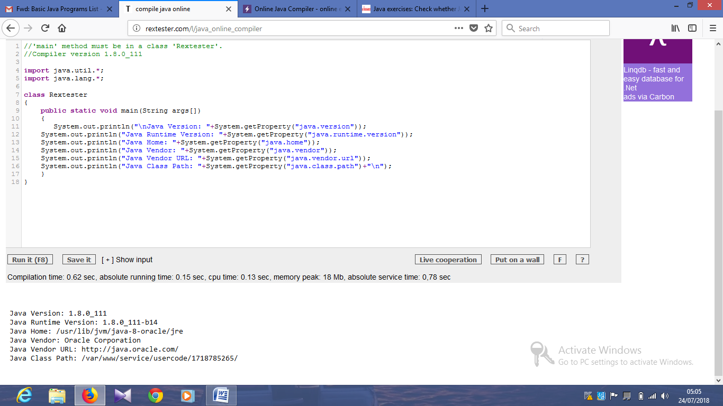

import java.util.Scanner;

public class Exercise32 {

public static void main( String args[] )

{

// create Scanner to obtain input from command window

Scanner input = new Scanner(System.in);

int number1; // first number to compare

int number2; // second number to compare

System.out.print( "Input first integer: " ); // prompt

number1 = input.nextInt(); // read first number from user

System.out.print( "Input second integer: " ); // prompt

number2 = input.nextInt(); // read second number from user

if ( number1 == number2 )

System.out.printf( "%d == %d\n", number1, number2 );

if ( number1 != number2 )

System.out.printf( "%d != %d\n", number1, number2 );

if ( number1 < number2 )

System.out.printf( "%d < %d\n", number1, number2 );

if ( number1 > number2 )

System.out.printf( "%d > %d\n", number1, number2 );

if ( number1 <= number2 )

System.out.printf( "%d <= %d\n", number1, number2 );

if ( number1 >= number2 )

System.out.printf( "%d >= %d\n", number1, number2 );

}

}

import java.util.Scanner;

public class Exercise33 {

public static void main(String[] args) {

Scanner input = new Scanner(System.in);

System.out.print("Input an integer: ");

long n = input.nextLong();

System.out.println("The sum of the digits is: " + sumDigits(n));

}

public static int sumDigits(long n) {

int sum = 0;

while (n != 0) {

sum += n % 10;

n /= 10;

}

return sum;

}

}

import java.util.Scanner;

public class Exercise34 {

public static void main(String[] args) {

Scanner input = new Scanner(System.in);

System.out.print("Input the length of a side of the hexagon: ");

double s = input.nextDouble();

System.out.print("The area of the hexagon is: " + hexagonArea(s)+"\n");

}

public static double hexagonArea(double s) {

return (6*(s*s))/(4*Math.tan(Math.PI/6));

}

}

import java.util.Scanner;

public class Exercise35 {

public static void main(String[] args) {

Scanner input = new Scanner(System.in);

System.out.print("Input the number of sides on the polygon: ");

int ns = input.nextInt();

System.out.print("Input the length of one of the sides: ");

double side = input.nextDouble();

System.out.print("The area is: " + polygonArea(ns, side)+"\n");

}

public static double polygonArea(int ns, double side) {

return (ns * (side * side)) / (4.0 * Math.tan((Math.PI / ns)));

}

}

import java.util.Scanner;

public class Exercise36 {

public static void main(String[] args) {

Scanner input = new Scanner(System.in);

System.out.print("Input the latitude of coordinate 1: ");

double lat1 = input.nextDouble();

System.out.print("Input the longitude of coordinate 1: ");

double lon1 = input.nextDouble();

System.out.print("Input the latitude of coordinate 2: ");

double lat2 = input.nextDouble();

System.out.print("Input the longitude of coordinate 2: ");

double lon2 = input.nextDouble();

System.out.print("The distance between those points is: " + distance_Between_LatLong(lat1, lon1, lat2, lon2) + " km\n");

}

// Points will be converted to radians before calculation

public static double distance_Between_LatLong(double lat1, double lon1, double lat2, double lon2) {

lat1 = Math.toRadians(lat1);

lon1 = Math.toRadians(lon1);

lat2 = Math.toRadians(lat2);

lon2 = Math.toRadians(lon2);

double earthRadius = 6371.01; //Kilometers

return earthRadius * Math.acos(Math.sin(lat1)*Math.sin(lat2) + Math.cos(lat1)*Math.cos(lat2)*Math.cos(lon1 - lon2));

}

}

import java.util.Scanner;

public class Exercise37 {

public static void main(String[] args) {

Scanner scanner = new Scanner(System.in);

System.out.print("Input a string: ");

char[] letters = scanner.nextLine().toCharArray();

System.out.print("Reverse string: ");

for (int i = letters.length - 1; i >= 0; i--) {

System.out.print(letters[i]);

}

System.out.print("\n");

}

}

import java.util.Scanner;

public class Exercise38 {

public static void main(String[] args) {

String test = "Aa kiu, I swd skieo 236587. GH kiu: sieo?? 25.33";

count(test);

}

public static void count(String x){

char[] ch = x.toCharArray();

int letter = 0;

int space = 0;

int num = 0;

int other = 0;

for(int i = 0; i < x.length(); i++){

if(Character.isLetter(ch[i])){

letter ++ ;

}

else if(Character.isDigit(ch[i])){

num ++ ;

}

else if(Character.isSpaceChar(ch[i])){

space ++ ;

}

else{

other ++;

}

}

System.out.println("The string is : Aa kiu, I swd skieo 236587. GH kiu: sieo?? 25.33");

System.out.println("letter: " + letter);

System.out.println("space: " + space);

System.out.println("number: " + num);

System.out.println("other: " + other);

}

}

import java.util.Scanner;

public class Exercise39 {

public static void main(String[] args) {

int amount = 0;

for(int i = 1; i <= 4; i++){

for(int j = 1; j <= 4; j++){

for(int k = 1; k <= 4; k++){

if(k != i && k != j && i != j){

amount++;

System.out.println(i + "" + j + "" + k);

}

}

}

}

System.out.println("Total number of the three-digit-number is " + amount);

}

}

import java.nio.charset.Charset;

public class Exercise40 {

public static void main(String[] args) {

System.out.println("List of available character sets: ");

for (String str : Charset.availableCharsets().keySet()) {

System.out.println(str);

}

}

}

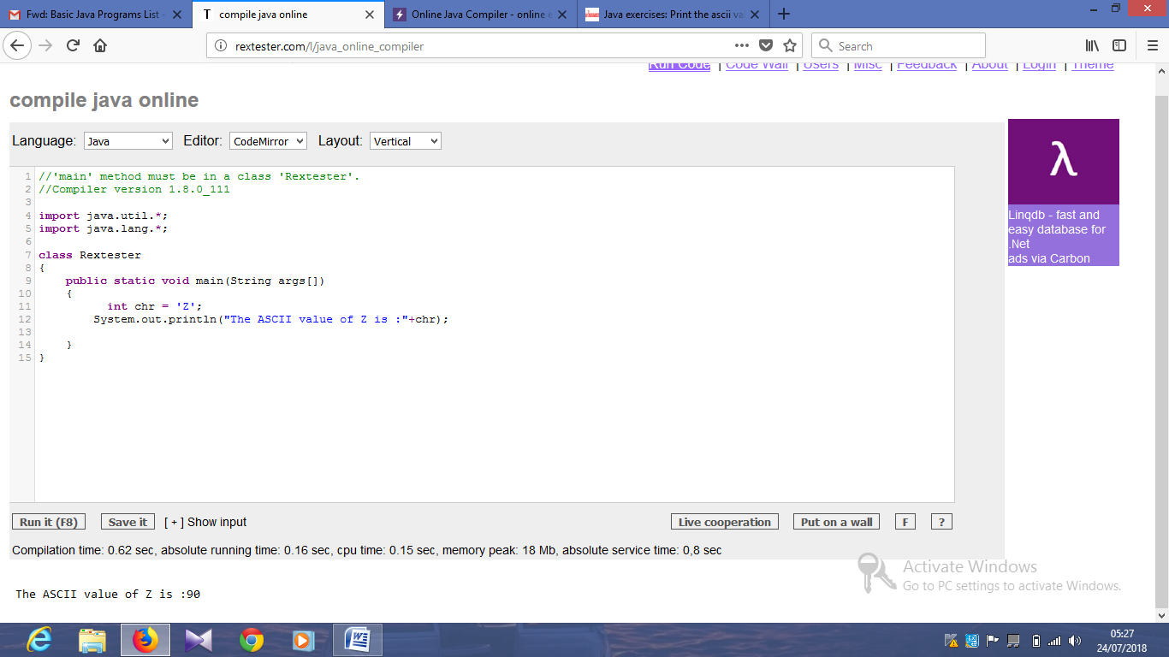

import java.io.Console;

public class Example42 {

public static void main(String[] args) {

Console cons;

if ((cons = System.console()) != null) {

char[] pass_ward = null;

try {

pass_ward = cons.readPassword("Input your Password:");

System.out.println("Your password was: " + new String(pass_ward));

} finally {

if (pass_ward != null) {

java.util.Arrays.fill(pass_ward, ' ');

}

}

} else {

throw new RuntimeException("Can't get password...No console");

}

}

}

public class Example43 {

public static void main(String[] args) {

System.out.println("\nTwinkle, twinkle, little star, \n\tHow I wonder what you are! \n\t\tUp above the world so high, \n\t\tLike a diamond in the sky. \nTwinkle, twinkle, little star, \n\tHow I wonder what you are!\n\n");

}

}

import java.util.Scanner;

public class Exercise44 {

public static void main(String[] args) {

int n;

char s1, s2, s3;

Scanner in = new Scanner(System.in);

System.out.print("Input number: ");

n = in .nextInt();

System.out.printf("%d + %d%d + %d%d%d\n", n, n, n, n, n, n);

}

}

import java.util.Scanner;

import java.io.File;

public class Exercise45 {

public static void main(String[] args) {

System.out.println("/home/students/abc.txt : " + new File("abc.txt").length() + " bytes");

System.out.println("/home/students/test.txt : " + new File("test.txt").length() + " bytes");

}

}

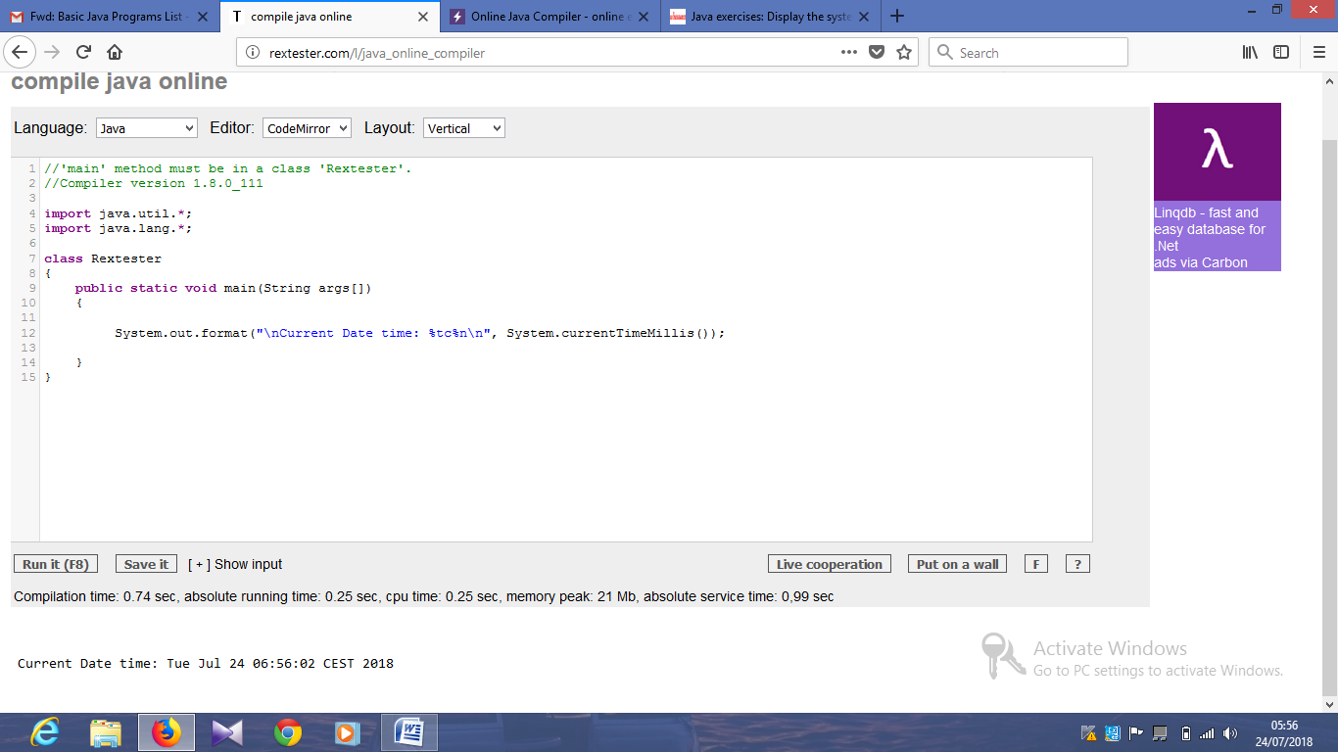

import java.text.SimpleDateFormat;

import java.util.Calendar;

import java.util.TimeZone;

public class Exercise47 {

public static void main(String args[]) {

SimpleDateFormat cdt = new SimpleDateFormat("yyyy/MM/dd HH:mm:ss.SSS");

cdt.setCalendar(Calendar.getInstance(TimeZone.getTimeZone("GMT")));

System.out.println("\nNow: "+cdt.format(System.currentTimeMillis()));

}

}

import java.util.*;

public class Exercise48 {

public static void main(String[] args){

for (int i = 1; i < 100; i++) {

if (i % 2 != 0) {

System.out.println(i);

}

}

}

}

Output:

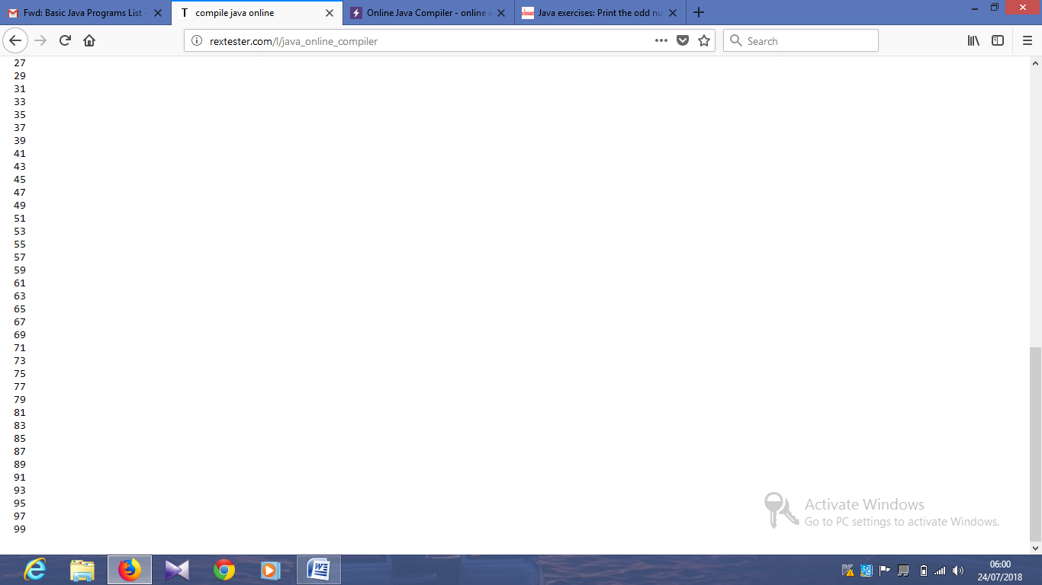

import java.util.*;

public class Exercise49 {

public static void main(String[] args){

Scanner in = new Scanner(System.in);

System.out.print("Input a number: ");

int n = in.nextInt();

if (n % 2 == 0) {

System.out.println(1);

}

else {

System.out.println(0);

}

}

}

public class Exercise50 {

public static void main(String args[]) {

System.out.println("\nDivided by 3: ");

for (int i=1; i<100; i++) {

if (i%3==0)

System.out.print(i +", ");

}

System.out.println("\n\nDivided by 5: ");

for (int i=1; i<100; i++) {

if (i%5==0) System.out.print(i +", ");

}

System.out.println("\n\nDivided by 3 & 5: ");

for (int i=1; i<100; i++) {

if (i%3==0 && i%5==0) System.out.print(i +", ");

}

System.out.println("\n");

}

}

Output:

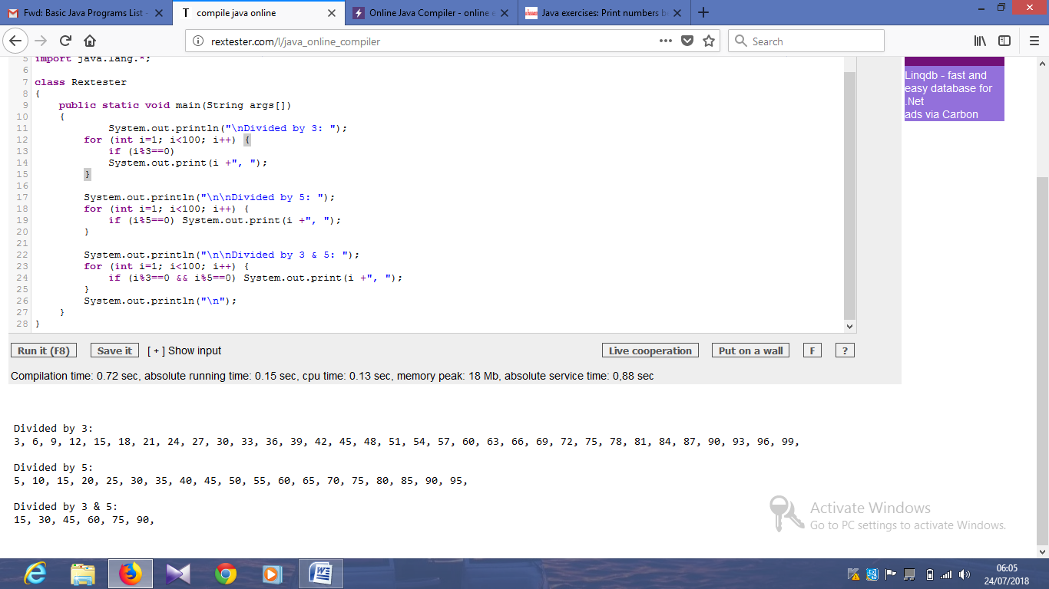

import java.util.*;

public class main {

public static void main(String[] args)

{

Scanner in = new Scanner(System.in);

System.out.print("Input a number(string): ");

String str1 = in.nextLine();

int result = Integer.parseInt(str1);

System.out.printf("The integer value is: %d",result);

System.out.printf("\n");

}

}

Output:

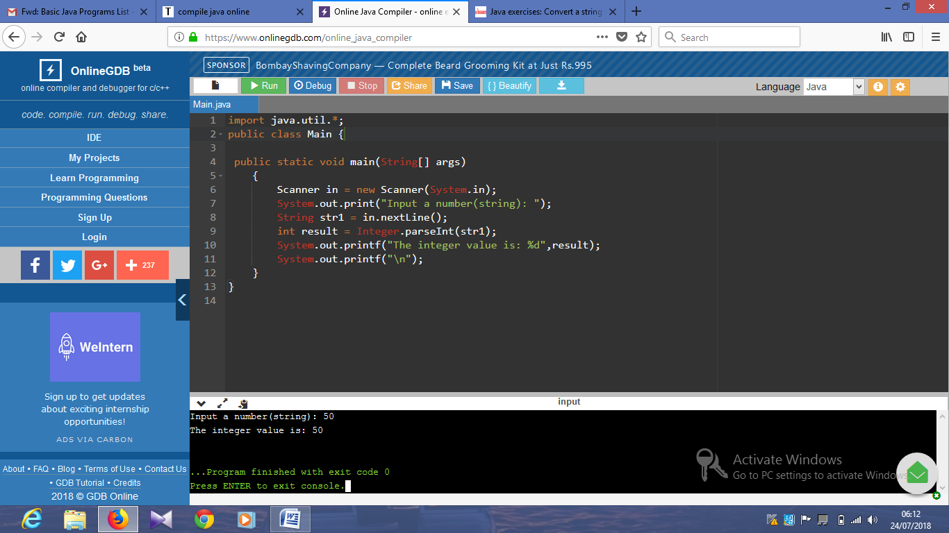

import java.util.*;

public class Main {

public static void main(String[] args)

{

Scanner in = new Scanner(System.in);

System.out.print("Input the first number : ");

int x = in.nextInt();

System.out.print("Input the second number: ");

int y = in.nextInt();

System.out.print("Input the third number : ");

int z = in.nextInt();

System.out.print("The result is: "+sumoftwo(x, y, z));

System.out.print("\n");

}

public static boolean sumoftwo(int p, int q, int r)

{

return ((p + q) == r || (q + r) == p || (r + p) == q);

}

}

Output:

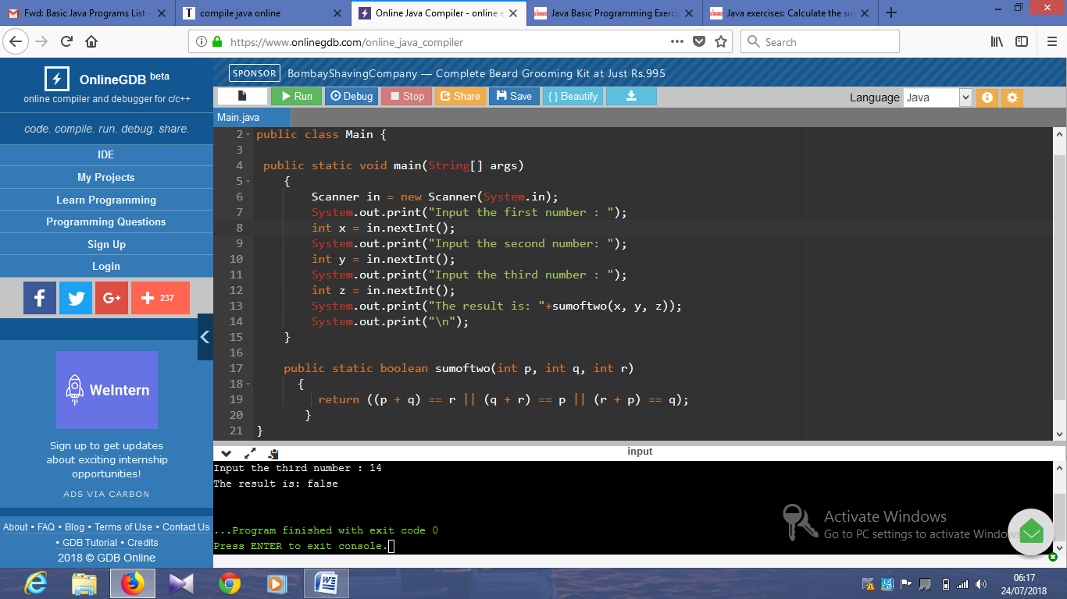

import java.util.*;

public class Main {

public static void main(String[] args)

{

Scanner in = new Scanner(System.in);

System.out.print("Input the first number : ");

int x = in.nextInt();

System.out.print("Input the second number: ");

int y = in.nextInt();

System.out.print("Input the third number : ");

int z = in.nextInt();

System.out.print("The result is: "+abc(x, y, z,true));

System.out.print("\n");

}

public static boolean abc(int p, int q, int r, boolean xyz)

{

if(xyz)

return (r > q);

return (q > p && r > q);

}

}

Output:

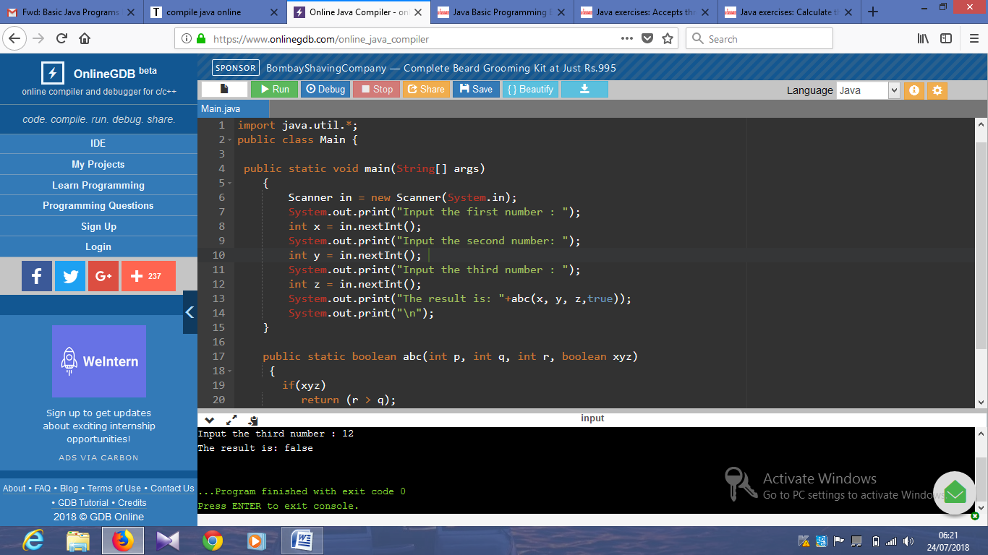

import java.util.*;

public class Main {

public static void main(String[] args)

{

Scanner in = new Scanner(System.in);

System.out.print("Input seconds: ");

int seconds = in.nextInt();

int p1 = seconds % 60;

int p2 = seconds / 60;

int p3 = p2 % 60;

p2 = p2 / 60;

System.out.print( p2 + ":" + p3 + ":" + p1);

System.out.print("\n");

}

}

Output:

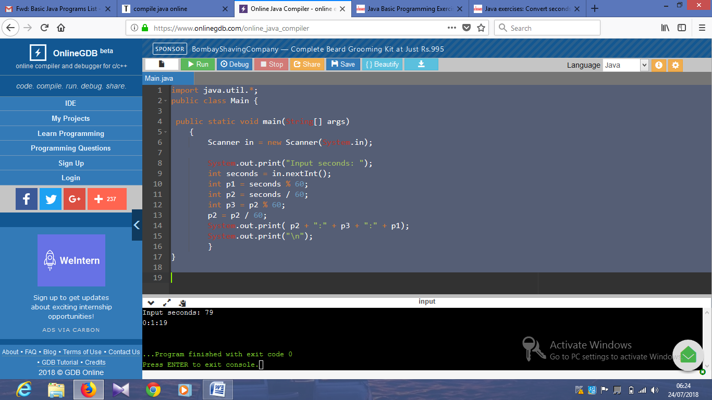

import java.util.*;

public class Main {

public static void main(String[] args)

{

int x = 5;

int y = 20;

int p = 3;

System.out.println(result(x,y,p));

}

public static int result(int x, int y, int p) {

if (x%p == 0)

return( y/pA - x/p + 1);

return(y/p - x/p); }

}

Output:

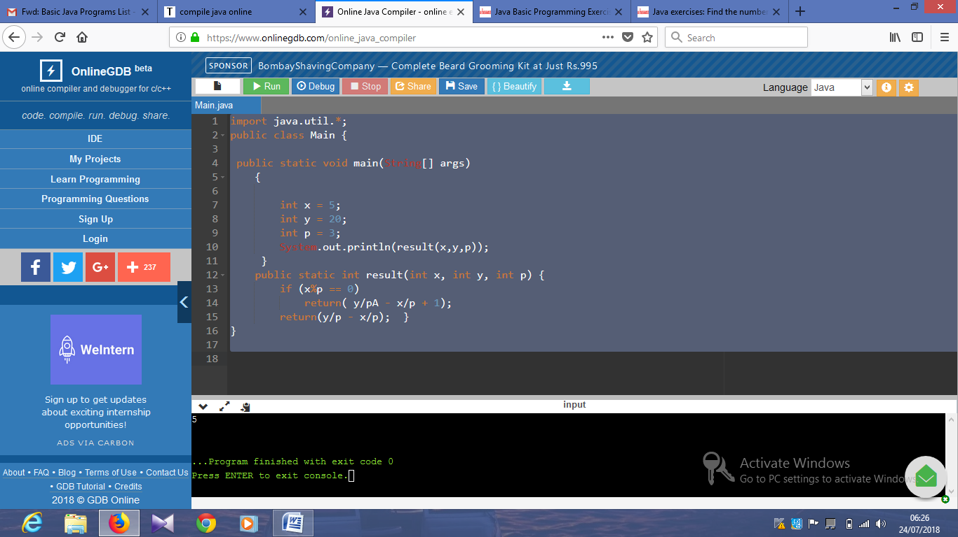

import java.util.*;

public class Main {

public static void main(String[] args)

{

Scanner in = new Scanner(System.in);

System.out.print("Input an integer: ");

int x = in.nextInt();

System.out.println(result(x));

}

public static int result(int num) {

int ctr = 0;

for(int i=1; i<=(int)Math.sqrt(num); i++) {

if(num%i==0 && i*i!=num) {

ctr+=2;

} else if (i*i==num) {

ctr++;

}

}

return ctr;

}

}

Output:

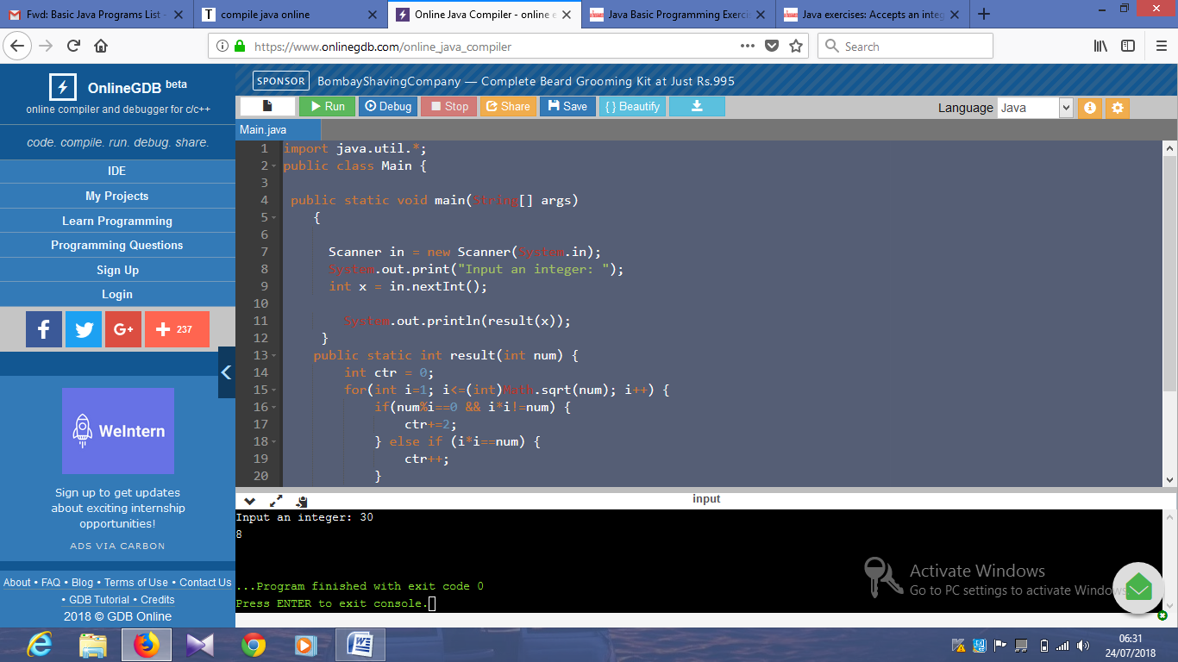

import java.util.*;

public class Main {

public static void main(String[] args)

{

Scanner in = new Scanner(System.in);

System.out.print("Input a Sentence: ");

String line = in.nextLine();

String upper_case_line = "";

Scanner lineScan = new Scanner(line);

while(lineScan.hasNext()) {

String word = lineScan.next();

upper_case_line += Character.toUpperCase(word.charAt(0)) + word.substring(1) + " ";

}

System.out.println(upper_case_line.trim());

}

}

Output:

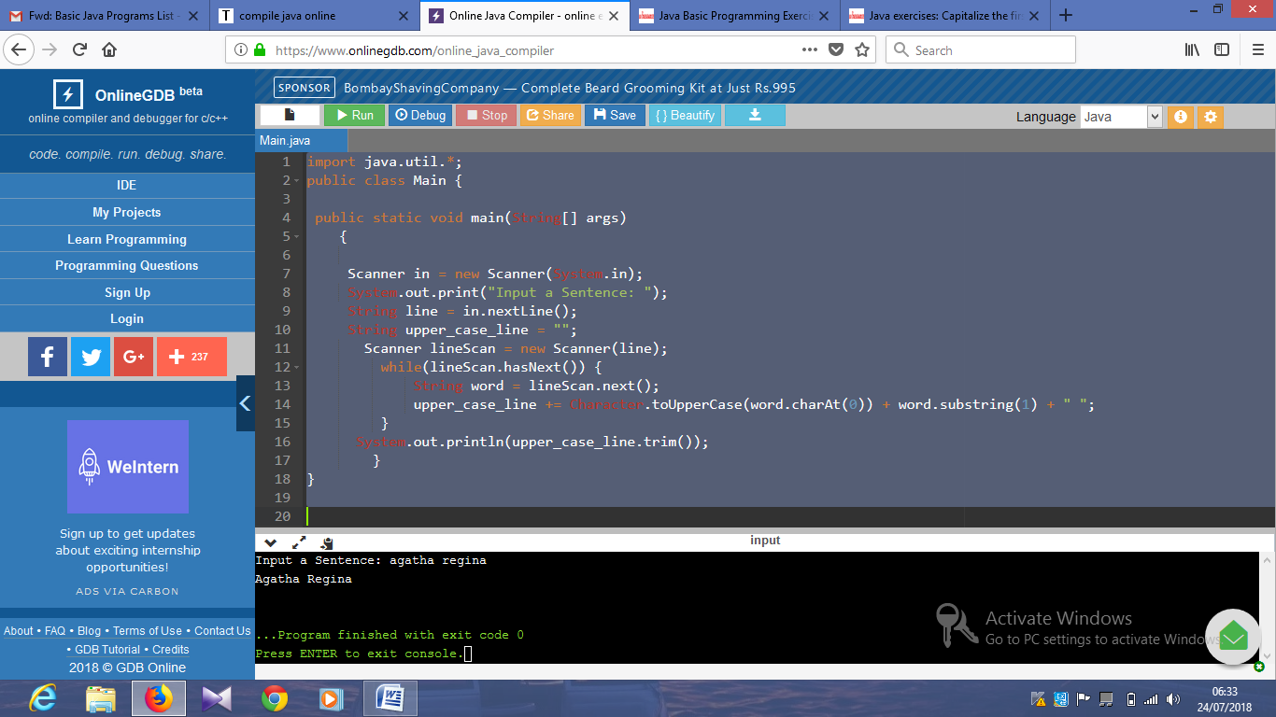

import java.util.*;

public class Exercise59 {

public static void main(String[] args){

Scanner in = new Scanner(System.in);

System.out.print("Input a String: ");

String line = in.nextLine();

line = line.toLowerCase();

System.out.println(line);

}

}

Output:

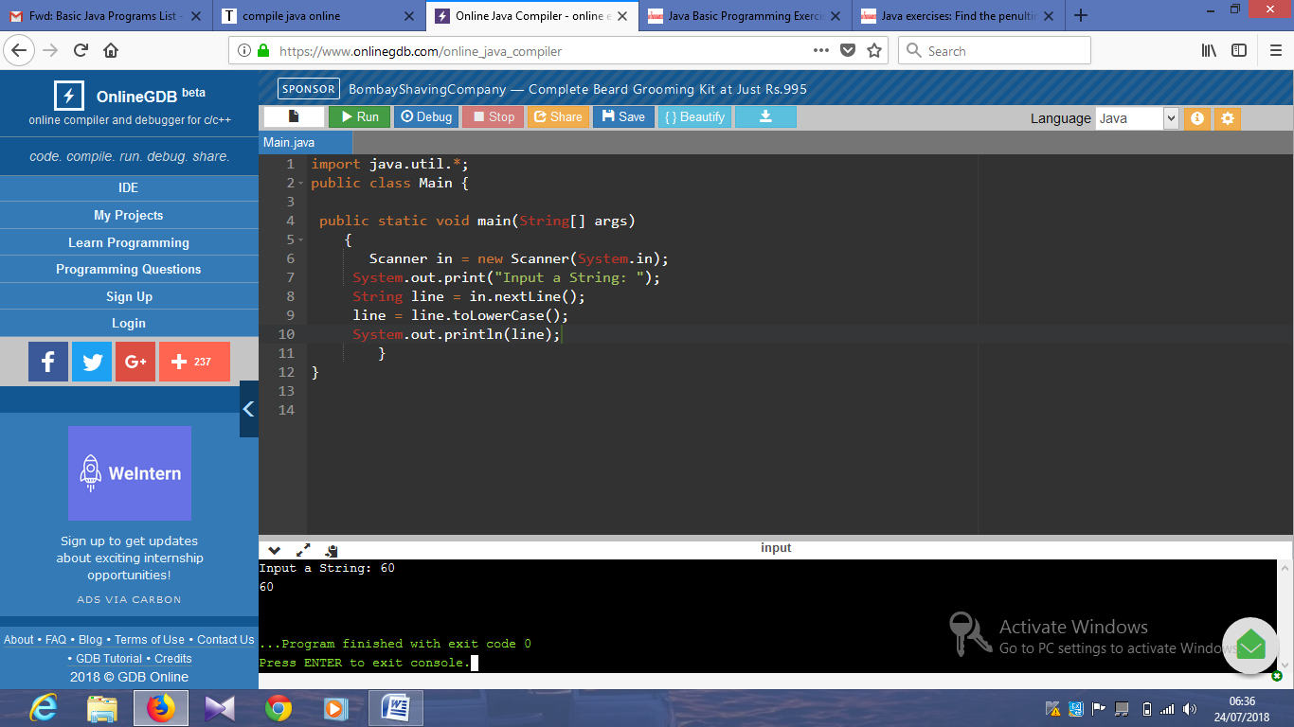

import java.util.*;

public class Exercise60 {

public static void main(String[] args){

Scanner in = new Scanner(System.in);

System.out.print("Input a Sentence: ");

String line = in.nextLine();

String[] words = line.split("[ ]+");

System.out.println("Penultimate word: "+words[words.length - 2]);

}

}

Scanner in = new Scanner(System.in);

System.out.print("\nInput a word: ");

String word = in.nextLine();

word = word.trim();

String result = "";

char[] ch=word.toCharArray();

for (int i = ch.length - 1; i >= 0; i--) {

result += ch[i];

}

System.out.println("Reverse word: "+result.trim());

Output:

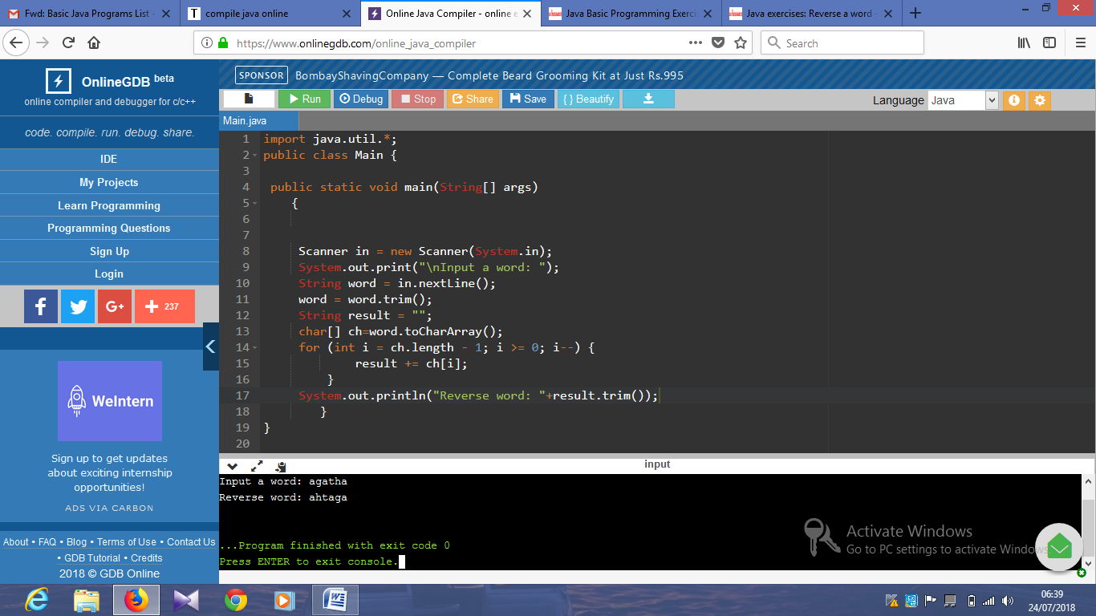

import java.util.*;

public class Exercise62 {

public static void main(String[] args)

{

Scanner in = new Scanner(System.in);

System.out.print("Input the first number : ");

int x = in.nextInt();

System.out.print("Input the second number: ");

int y = in.nextInt();

System.out.print("Input the third number : ");

int z = in.nextInt();

System.out.println((Math.abs(x - y) >= 20 || Math.abs(y - z) >= 20 || Math.abs(z - x) >= 20));

}

}

import java.util.*;

public class Main {

public static void main(String[] args)

{

Scanner in = new Scanner(System.in);

System.out.print("Input the first number : ");

int a = in.nextInt();

System.out.print("Input the second number: ");

int b = in.nextInt();

System.out.println("Result: "+result(a, b));

}

public static int result(int x, int y)

{

if(x == y)

return 0;

if(x % 6 == y % 6)

return (x < y) ? x : y;

return (x > y) ? x : y;

}

}

Output:

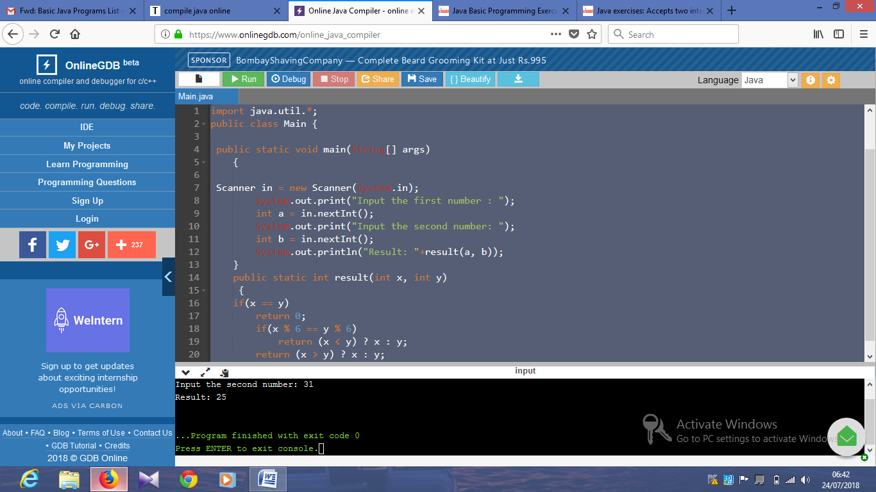

import java.util.*;

public class Main {

public static void main(String[] args)

{

Scanner in = new Scanner(System.in);

System.out.print("Input the first number : ");

int a = in.nextInt();

System.out.print("Input the second number: ");

int b = in.nextInt();

System.out.println("Result: "+common_digit(a, b));

}

public static boolean common_digit(int p, int q)

{

if (p<25 || q>75)

return false;

int x = p % 10;

int y = q % 10;

p /= 10;

q /= 10;

return (p == q || p == y || x == q || x == y);

}

}

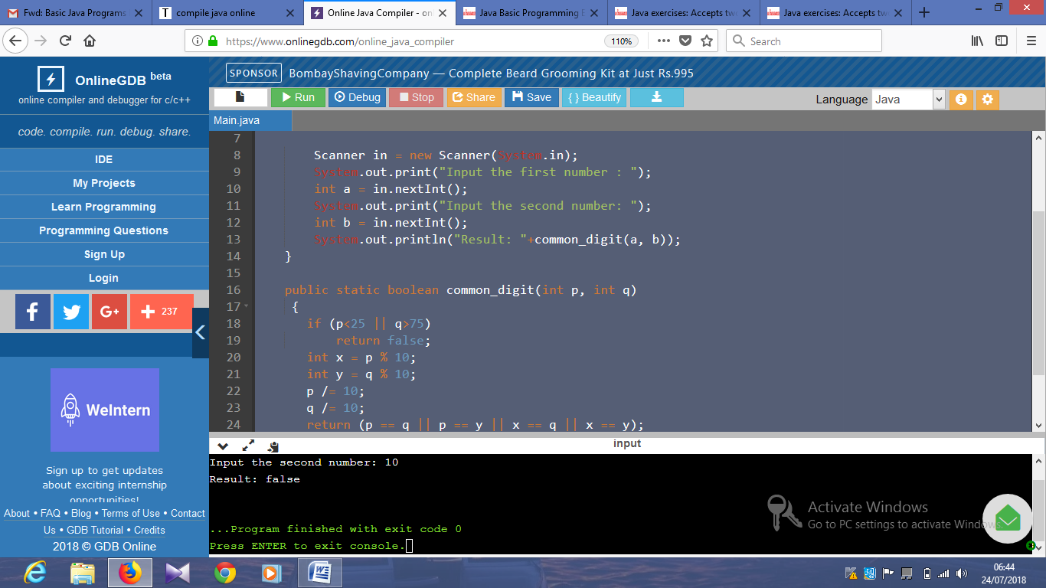

import java.util.*;

public class Main {

public static void main(String[] args)

{

Scanner in = new Scanner(System.in);

System.out.print("Input the first number : ");

int a = in.nextInt();

System.out.print("Input the second number: ");

int b = in.nextInt();

int divided = a / b;

int result = a - (divided * b);

System.out.println(result);

}

}

Output:

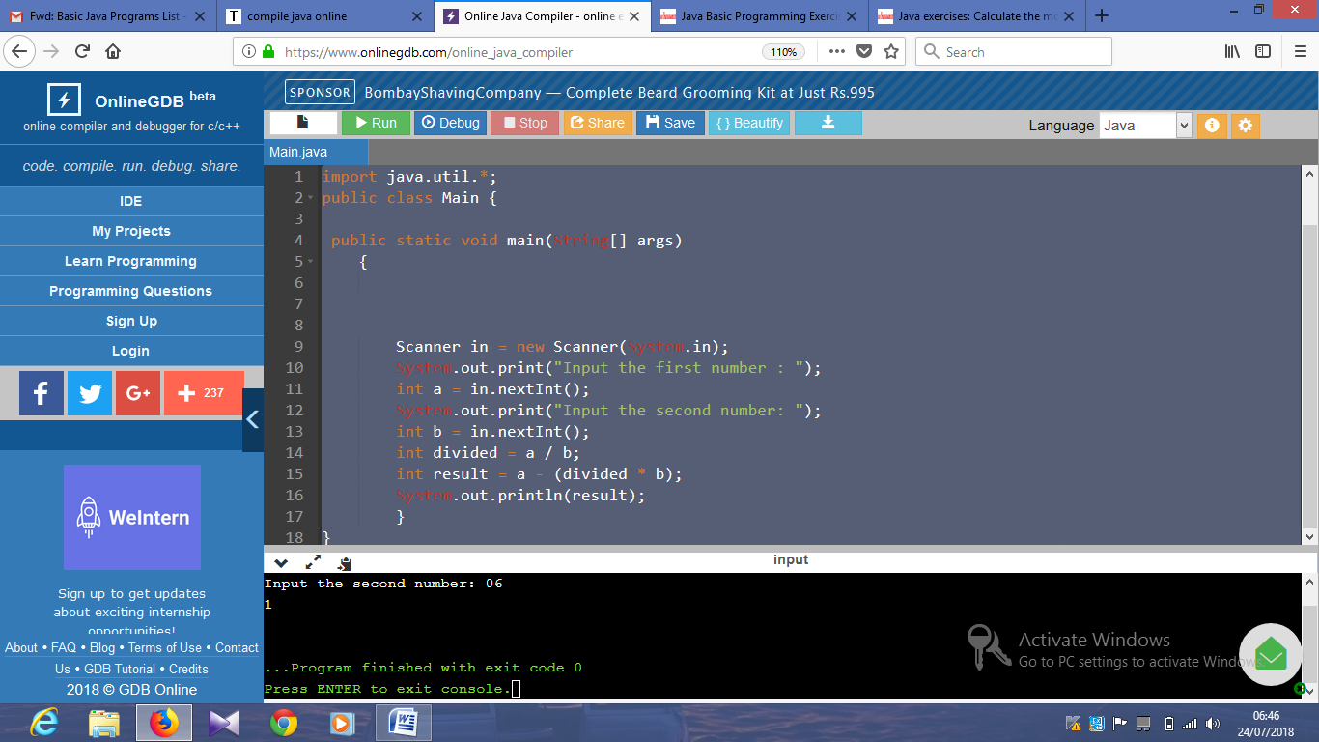

import java.util.*;

public class Main {

public static void main(String[] args)

{

int sum = 1;

int ctr = 0;

int n = 0;

while (ctr < 100) {

n++;

if (n % 2 != 0) {

// check if the number is even

if (is_Prime(n)) {

sum += n;

ctr++;

}

}

}

System.out.println("\nSum of the first 100 prime numbers: "+sum);

}

public static boolean is_Prime(int n) {

for (int i = 3; i * i <= n; i+= 2) {

if (n % i == 0) {

return false;

}

}

return true;

}

}

Output:

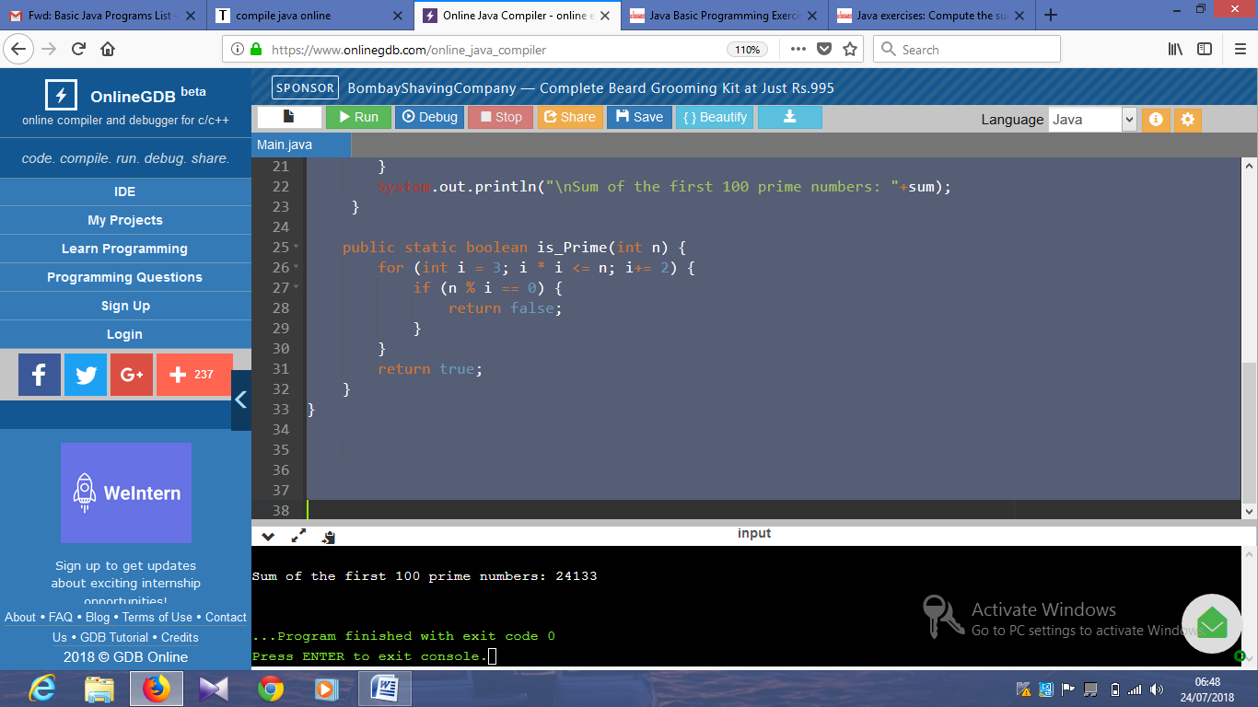

import java.util.*;

public class Main {

public static void main(String[] args)

{

String main_string = "Python 3.0";

String word = "Tutorial";

System.out.println(main_string.substring(0, 7) + word + main_string.substring(6));

}

}

Output:

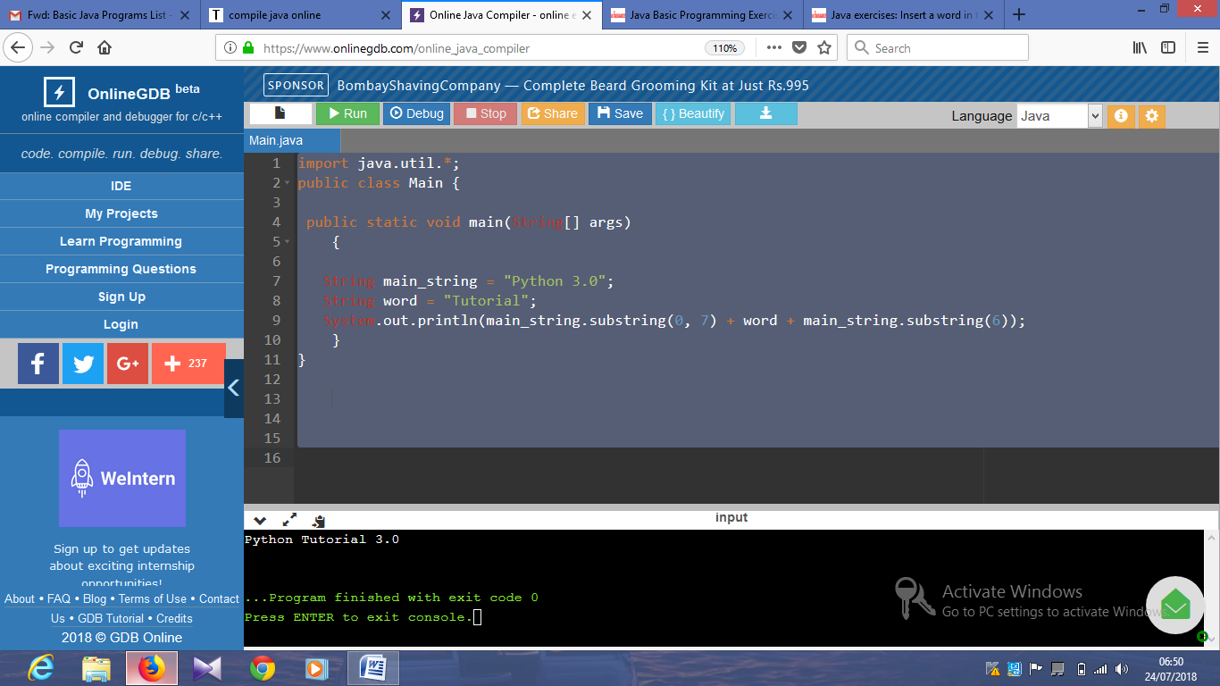

import java.util.*;

public class Main {

public static void main(String[] args)

{

String main_string = "Python 3.0";

String last_three_chars = main_string.substring(main_string.length() - 3);

System.out.println(last_three_chars + last_three_chars + last_three_chars + last_three_chars);

}

}

Output:

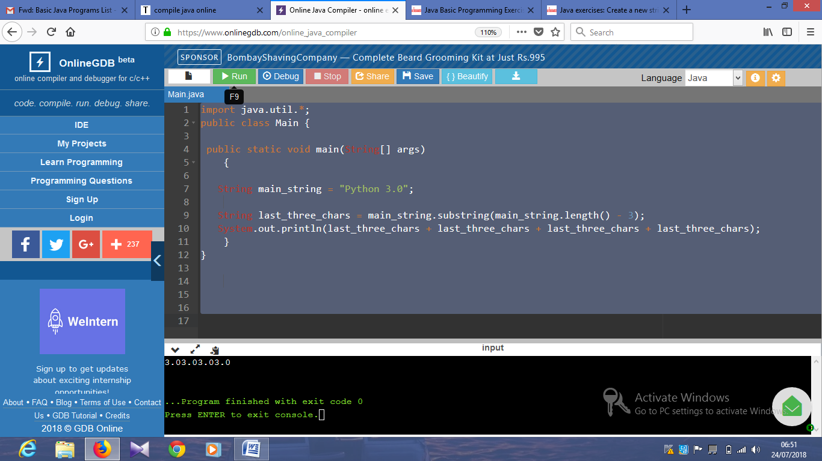

import java.util.*;

public class Main {

public static void main(String[] args)

{

String main_string = "Python";

System.out.println(main_string.substring(0, main_string.length()/2));

}

}

Output:

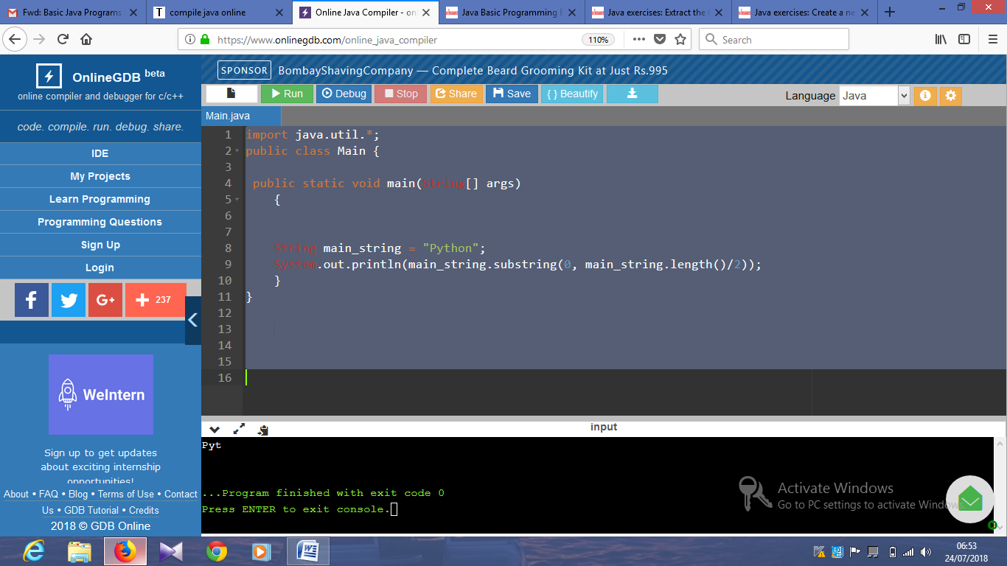

import java.util.*;

public class Main {

public static void main(String[] args)

{

String str1 = "Python";

String str2 = "Tutorial";

if(str1.length() >= str2.length())

System.out.println( str2+str1+str2);

else

System.out.println(str1+str2+str1);

}

}

Output:

