Regina Eckert, Grace Kuo

9/29/17

Machine Learning in Education

Visualizing representations of problems and skills

1. Train a genism skip-gram model of the skills.tsv from the last assignment.

#Read out the "sentences"

sentences=skill_df.iloc[:,1:].values.astype(str)

sentences=sentences.tolist()

#Each student is a "sentence", each skill is a "word"

#size = dimensionality of feature vectors

#window = max distance between current and predicted word within a sentence

#min_count = minimum number of occurrences within dataset

#workers = number of threads used

#sg = 0 (CBOW, default); = 1 (skip-gram)

model = Word2Vec(sentences, size=100, window=5, min_count=10, workers=4, sg=1, iter=30)

1. Use t-sne to reduce dimensionality.

skill_num=model.wv.vocab; #Names of the words (numbers)

skill_vec=model[skill_num] #Access the vectors

tsne=TSNE(perplexity=30) #Instantiate the TSNE model (can change params here)

skill_tsne=tsne.fit_transform(skill_vec) #Run tsne

1. What do you make of the structure of the visualization? Is there a logic to the proximity of skills to one another?

Word2Vec: size=100, window=5, min_count=10, workers=4, sg=1, iter=30

T-Sne: perplexity = 30

While the structure of the graph is not very clustered (with just one main cluster and a few outliers), by inspecting the names of the skills we can find some groups of skills that make sense. These include:

* Plot types: box & whisker, stem & leaf, venn diagram
* Group of fraction-related topics
* Equation solving

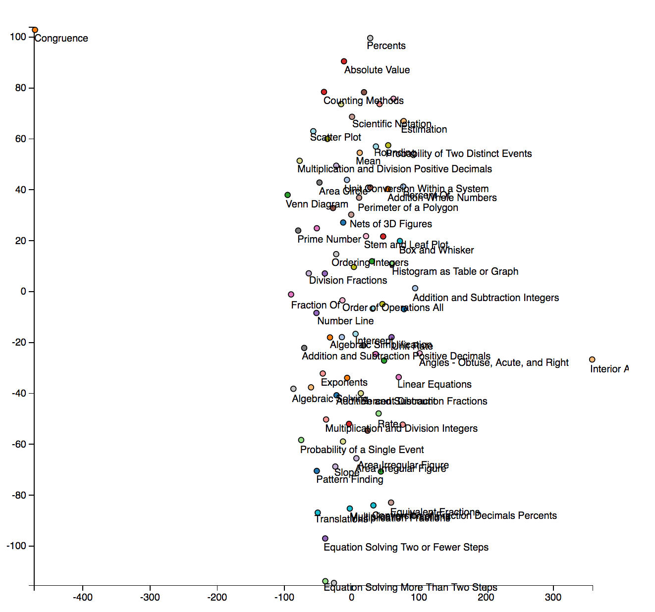

1. Re-train the skip-gram model using different hyperparameters (try a window size of 1). How does the vector size and window size appear to affect the visualization?

We changed a variety of hyperparameters for the skip-gram (changing the feature vector size, the window, and the number of iterations) as well as trying to tune the perplexity of t-sne.

Generally, we found that scaling the feature vector size and window size together generated more meaningful graphs. We theorize that the relationships are more simple when just considering the nearest neighbors (window = 1) and so need fewer features to describe the data (size=50), whereas expanding the context (window = 10) required more features for good description (size=200). That being said, a feature vector size 25 was too low to give any meaningful results regardless of window size.

However, we also found that the “perplexity” of the t-sne reduction made a huge difference in the understandability of the graph relations. For example, with (size = 50, window =1, and iter=100), we get a much more clustered, meaningful graph with perplexity =10 rather than perplexity = 30. However, with (size = 200, window =5, and iter=100), the opposite is true.

Overall, we think this data would be easier to visualize by defining connections between nearest neighbors (say, the 5 most similar vectors are connected) and then doing some graph-based projection to 2D. This way you could see which skills were connected, because the t-sne optimization has many local minima that make it hard to discern underlying connections for this data.

|  |  |  |  |  |
| --- | --- | --- | --- | --- |
| Vector Size | Window | # Iter | T-Sne Perplexity | Observations |
| 100 | 5 | 30 | 30 | Not clustered, but can observe groups:   * Plot types: box & whisker, stem & leaf, venn diagram * Group of fraction-related topics * Equation solving |
| 50 | 1 | 30 | 30 | Less meaningful clustering – hard to pick out groups  Spread out graph |
| 50 | 1 | 100 | 30 | Lots of spreading, but can still discern groups such as:   * Plot types (box & whisker, stem & leaf, circle graph, histogram as table) * Fractions * Linear equations * Ordering |
| 50 | 1 | 100 | 10 | More clustered groups, less random spreading. Groups:   * Fractions * Angles * Equation solving * Plot types |
| 50 | 2 | 100 | 30 | Starting to get spreading again, but can see groups:  - Plots  - Some fractions (though some spread out)  - Mean, median, mode  - Area |
| 50 | 4 | 100 | 30 | Very little meaningful clustering or grouping |
| 50 | 5 | 30 | 30 | Very little meaningful clustering or grouping |
| 50 | 10 | 100 | 30 | Very little meaningful clustering or grouping |
| 25 | 5 | 100 | 30 | Extremely little meaningful clustering or grouping  Data is mostly clustered in one close blob in the center of the graph, and seems randomly mixed in that blob |
| 200 | 5 | 100 | 30 | Fairly spread out graph, but can still pick out groups:   * Ordering * Plot types * Solving systems of equations |
| 200 | 5 | 100 | 10 | Looks more clustered, and some small groups are discernable:   * Area & shapes * Some fractions |
| 200 | 1 | 100 | 10 | Fairly spread out and seemingly mixed, with a few groupings:   * Plot types (box & whisker, circle graph, number line) |
| 200 | 10 | 100 | 30 | Still fairly spread, but can see many groups:   * Angle * Area * Plot types (box & whisker, stem & leaf, venn diagram) * Equations * Order of operations |

Word2Vec: size=50, window=1, min_count=10, workers=4, sg=1, iter=30

T-Sne: perplexity = 30

* Less meaningful clustering – hard to pick out groups

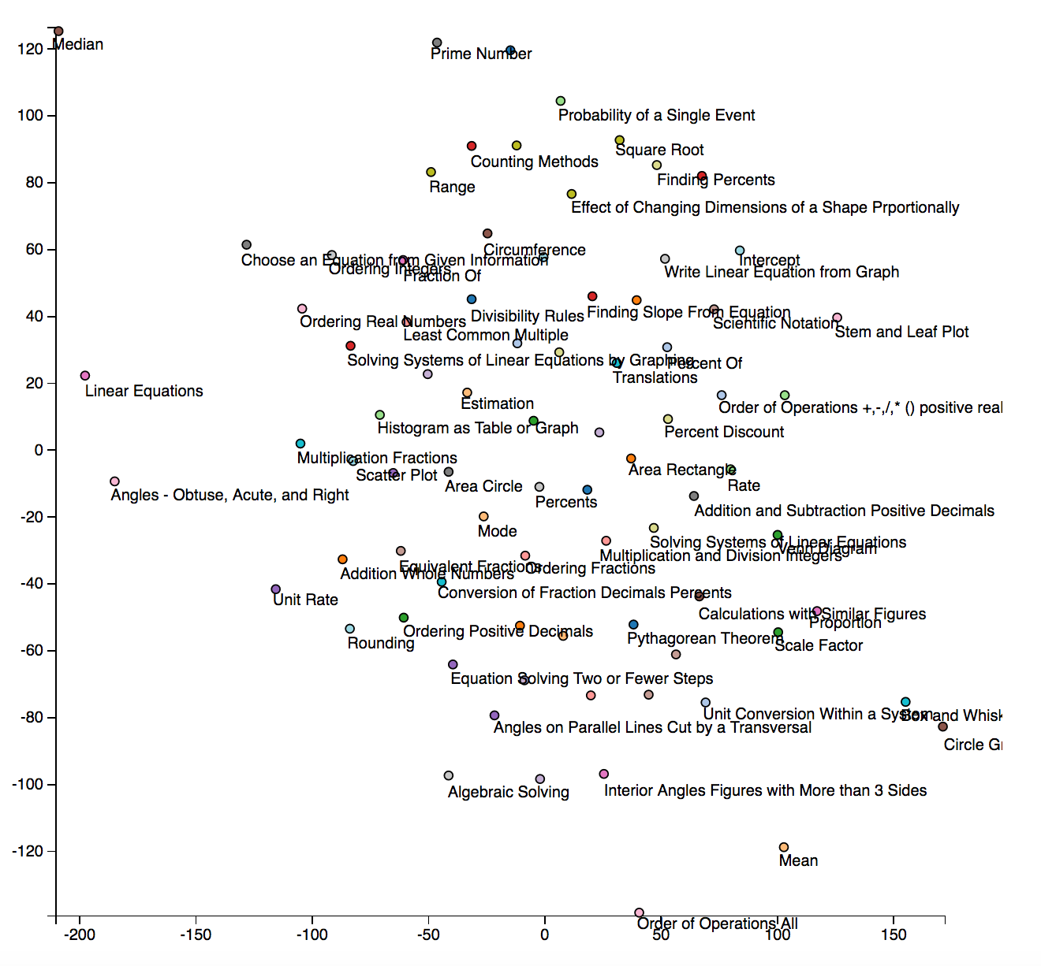

Word2Vec: size=50, window=1, min_count=10, workers=4, sg=1, iter=100

T-Sne: perplexity = 30

Lots of spreading, but can still discern groups such as:

* Plot types (box & whisker, stem & leaf, circle graph, histogram as table)
* Fractions
* Linear equations
* Ordering

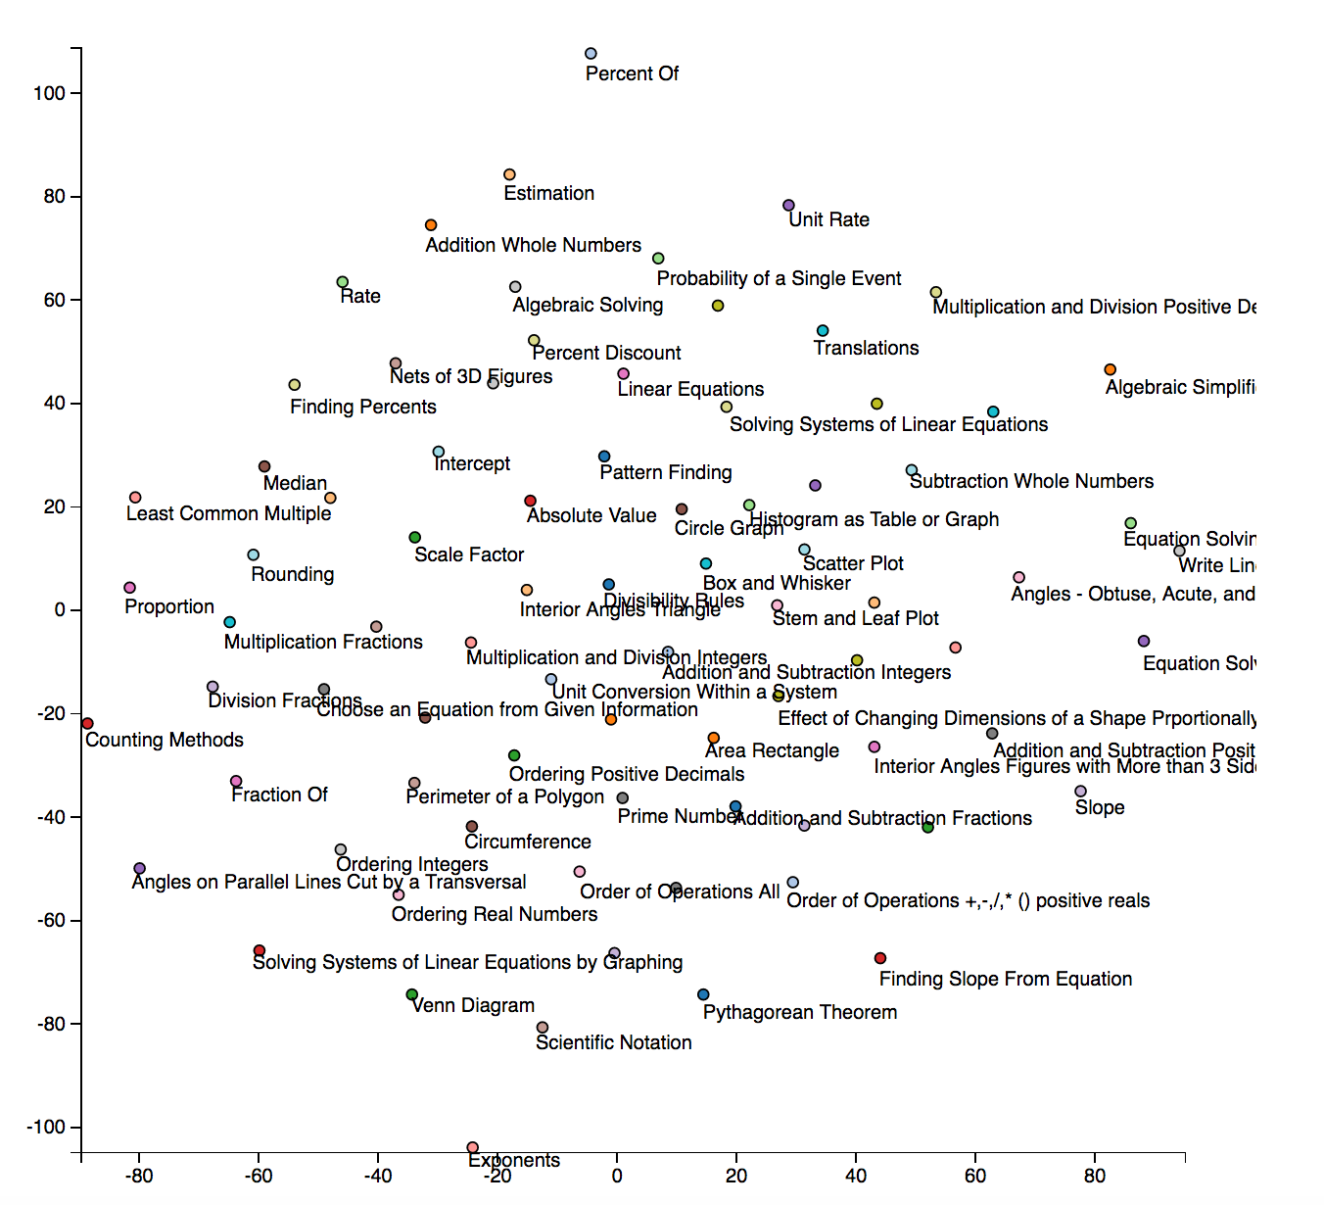

Word2Vec: size=50, window=1, min_count=10, workers=4, sg=1, iter=100

T-Sne: perplexity = 10

More clustered groups:

* Fractions (top)
* Angles
* Equation solving
* Plot types

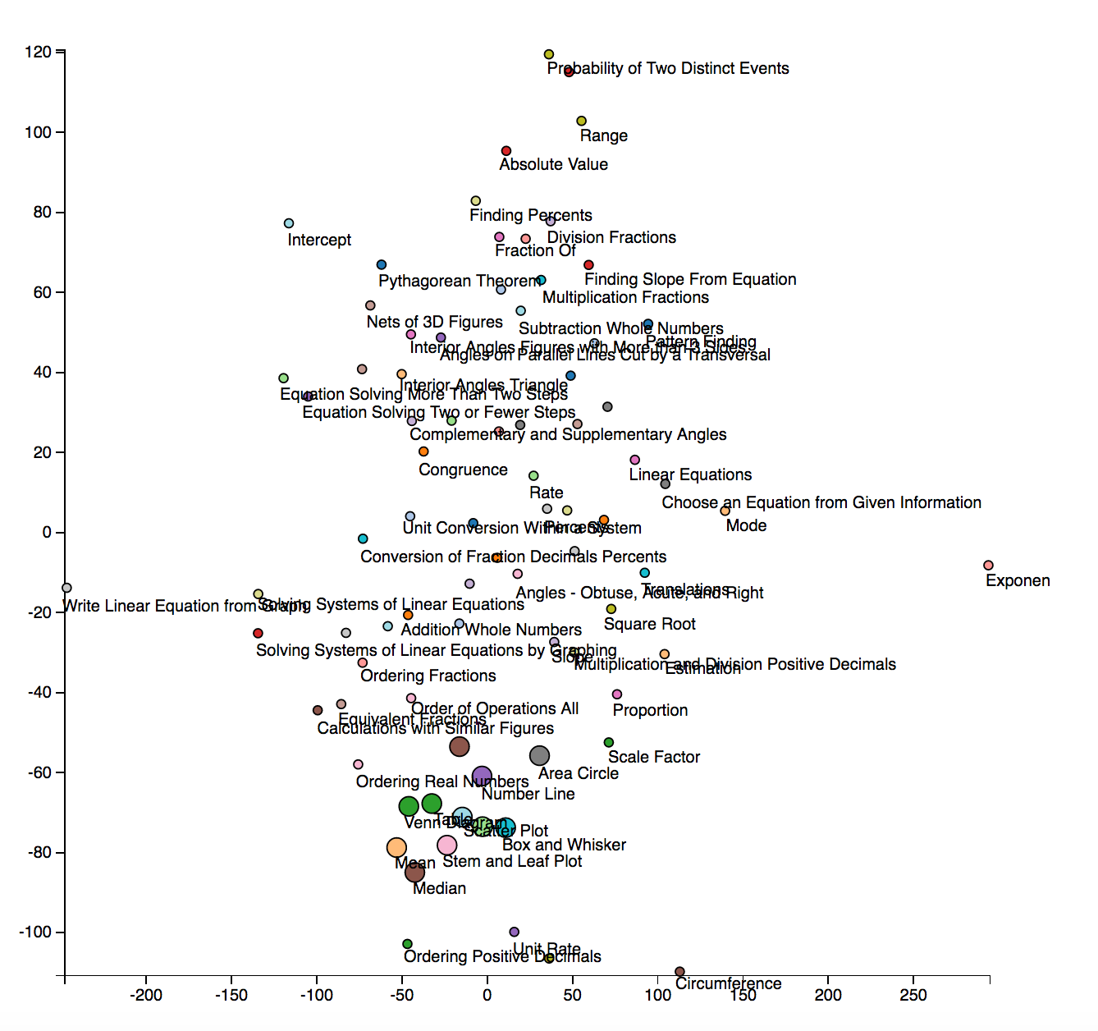

Word2Vec: size=50, window=2, min_count=10, workers=4, sg=1, iter=100

T-Sne: perplexity = 30

Starting to get spreading again, but can see groups:

- Plots

- Some fractions (though some spread out)

- Mean, median, mode

- Area

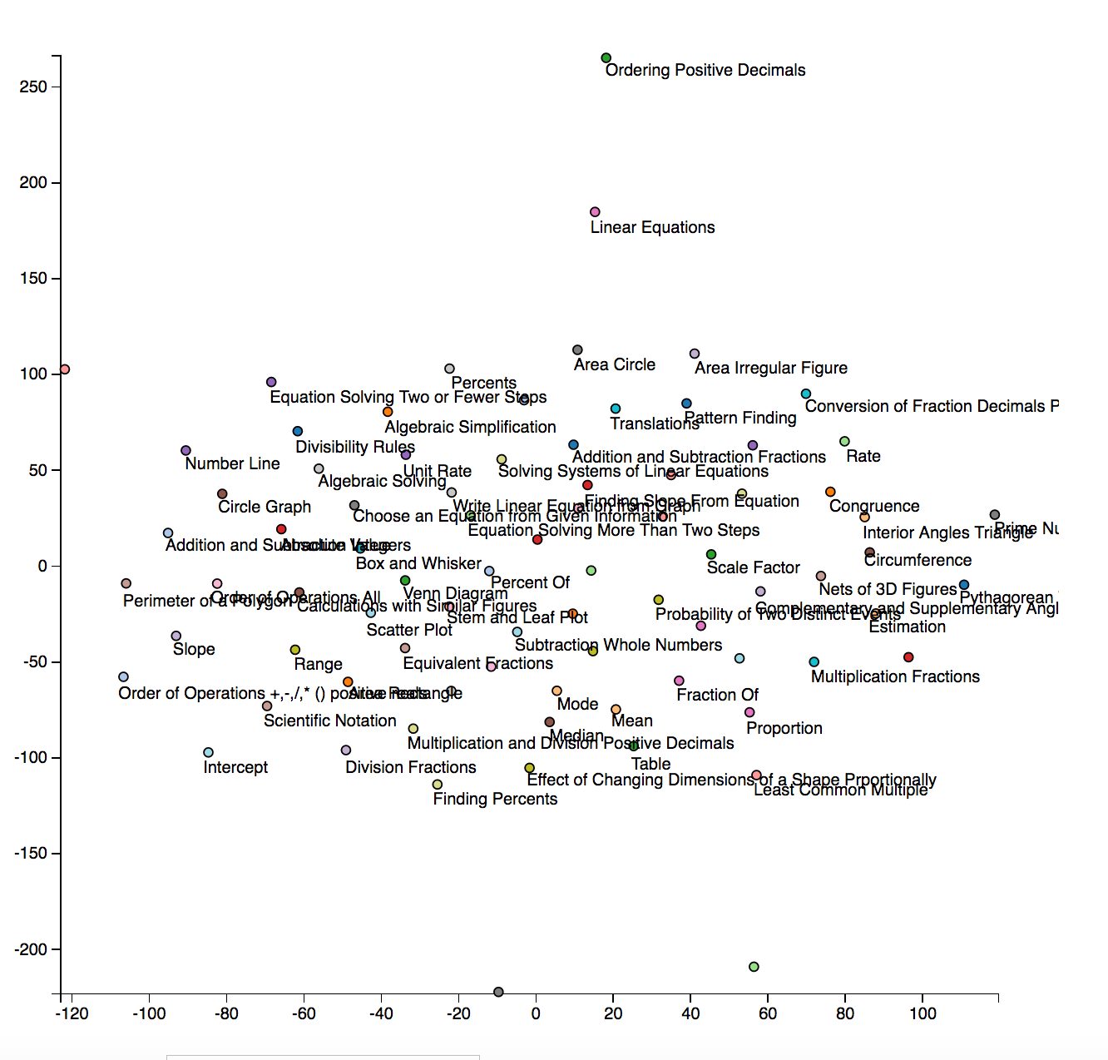

Word2Vec: size=50, window=4, min_count=10, workers=4, sg=1, iter=100

T-Sne: perplexity = 30

* Very little meaningful clustering

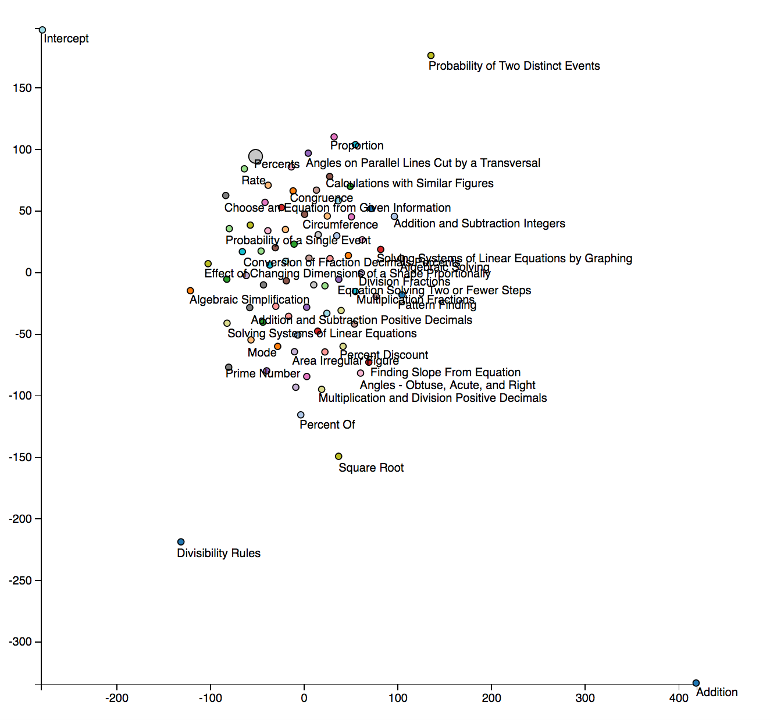

Word2Vec: size=50, window=5, min_count=10, workers=4, sg=1, iter=30

T-Sne: perplexity = 30

* Less meaningful clustering – hard to pick out groups

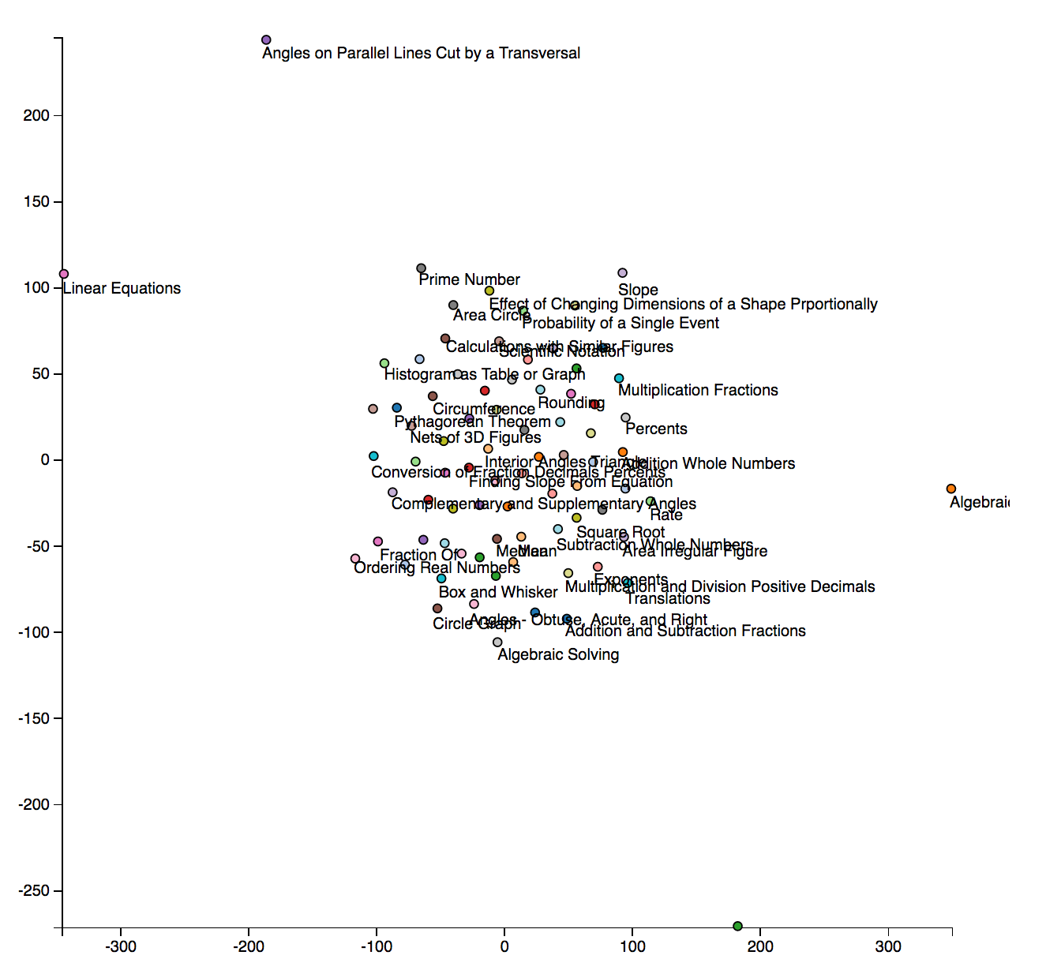

Word2Vec: size=50, window=10, min_count=10, workers=4, sg=1, iter=100

T-Sne: perplexity = 30

* Very little meaningful info

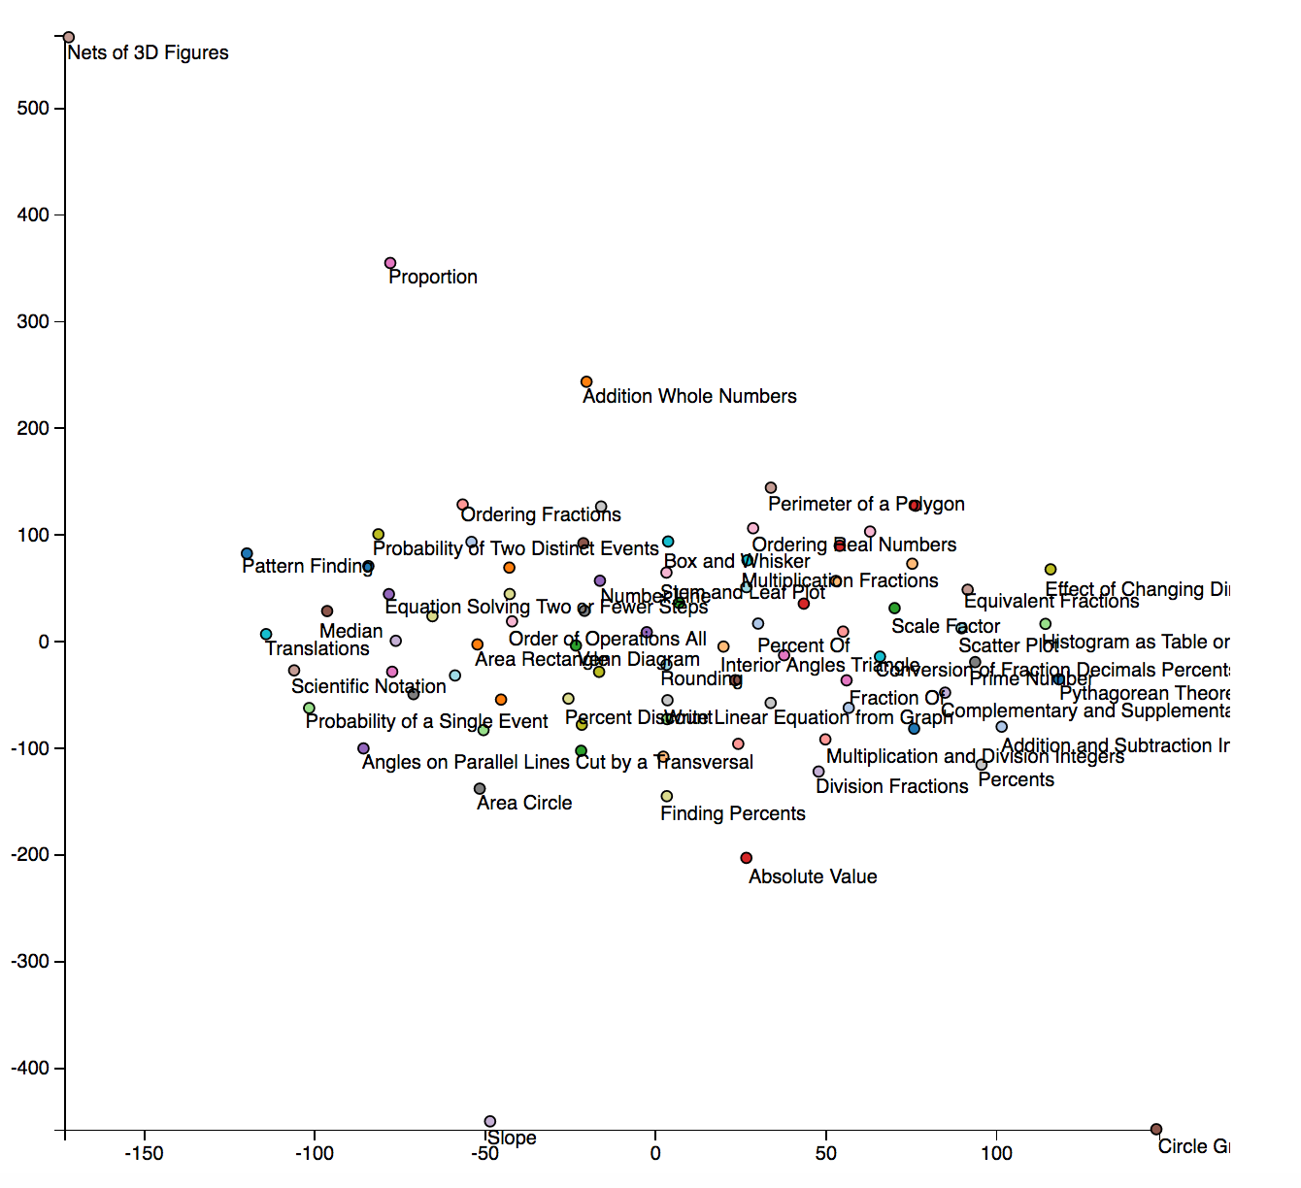

Word2Vec: size=25, window=5, min_count=10, workers=4, sg=1, iter=100

T-Sne: perplexity = 10

* Extremely little meaningful info

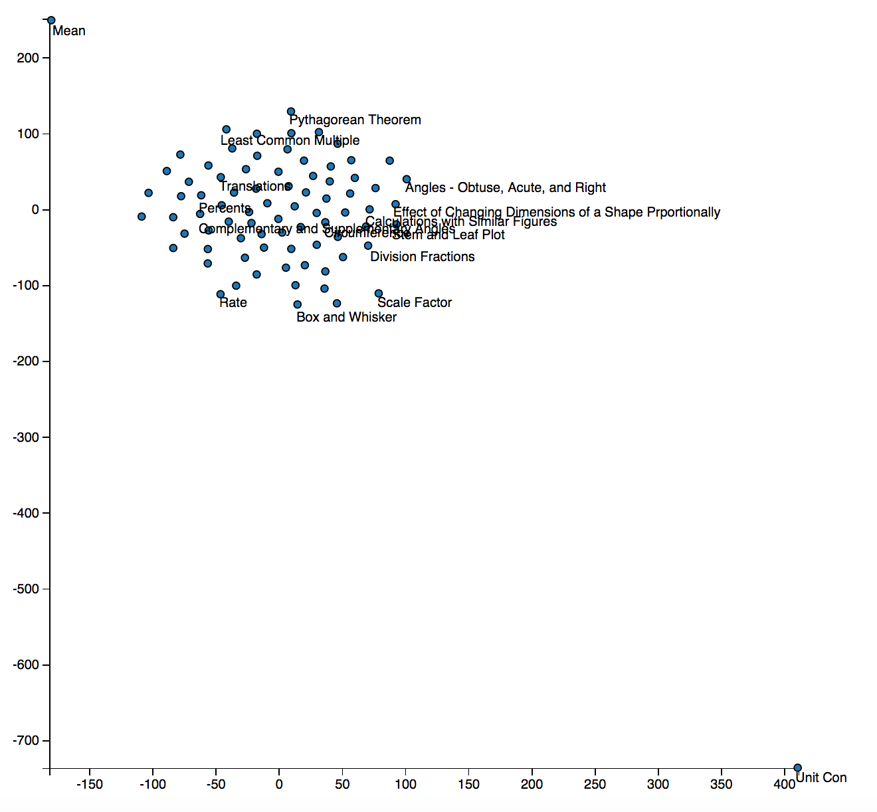

Word2Vec: size=200, window=5, min_count=10, workers=4, sg=1, iter=100

T-Sne: perplexity = 30

Fairly spread out graph, but can still pick out groups:

* Ordering
* Plot types
* Solving systems of equations

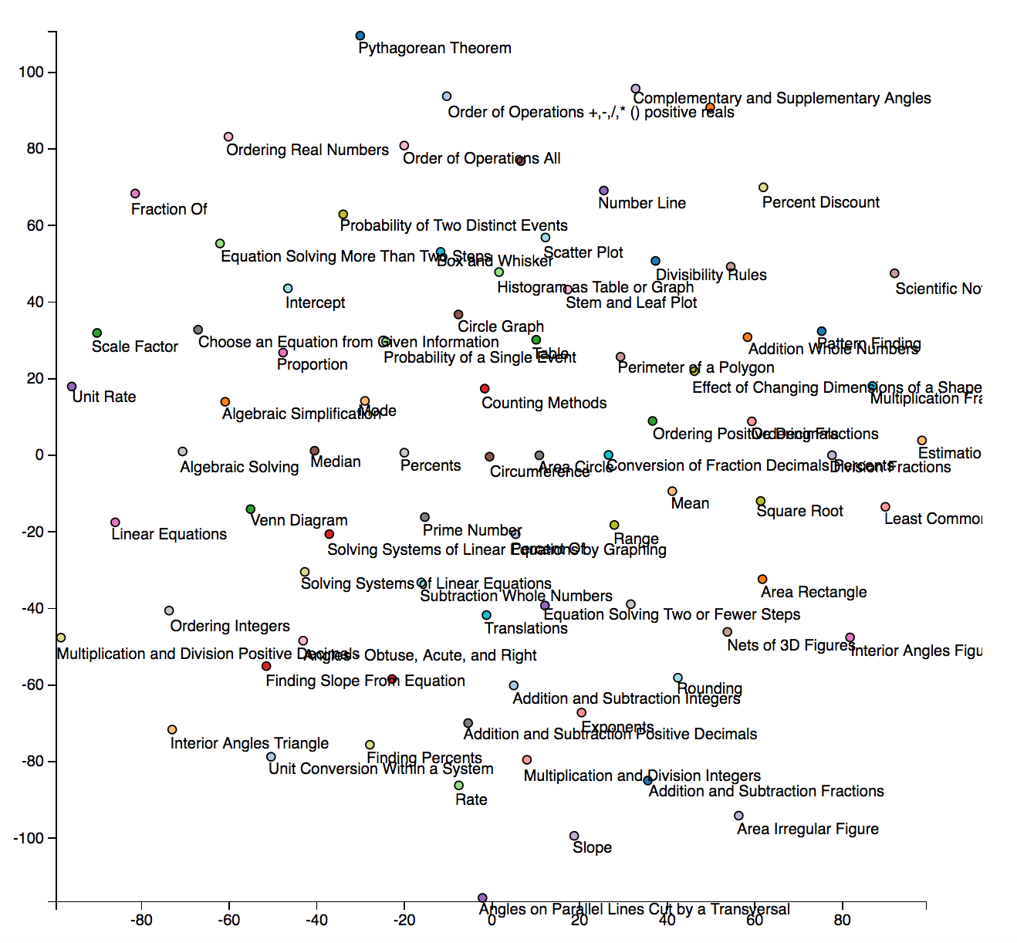

Word2Vec: size=200, window=5, min_count=10, workers=4, sg=1, iter=100

T-Sne: perplexity = 10

Looks more clustered, and some small groups are discernable:

* Area & shapes
* Some fractions

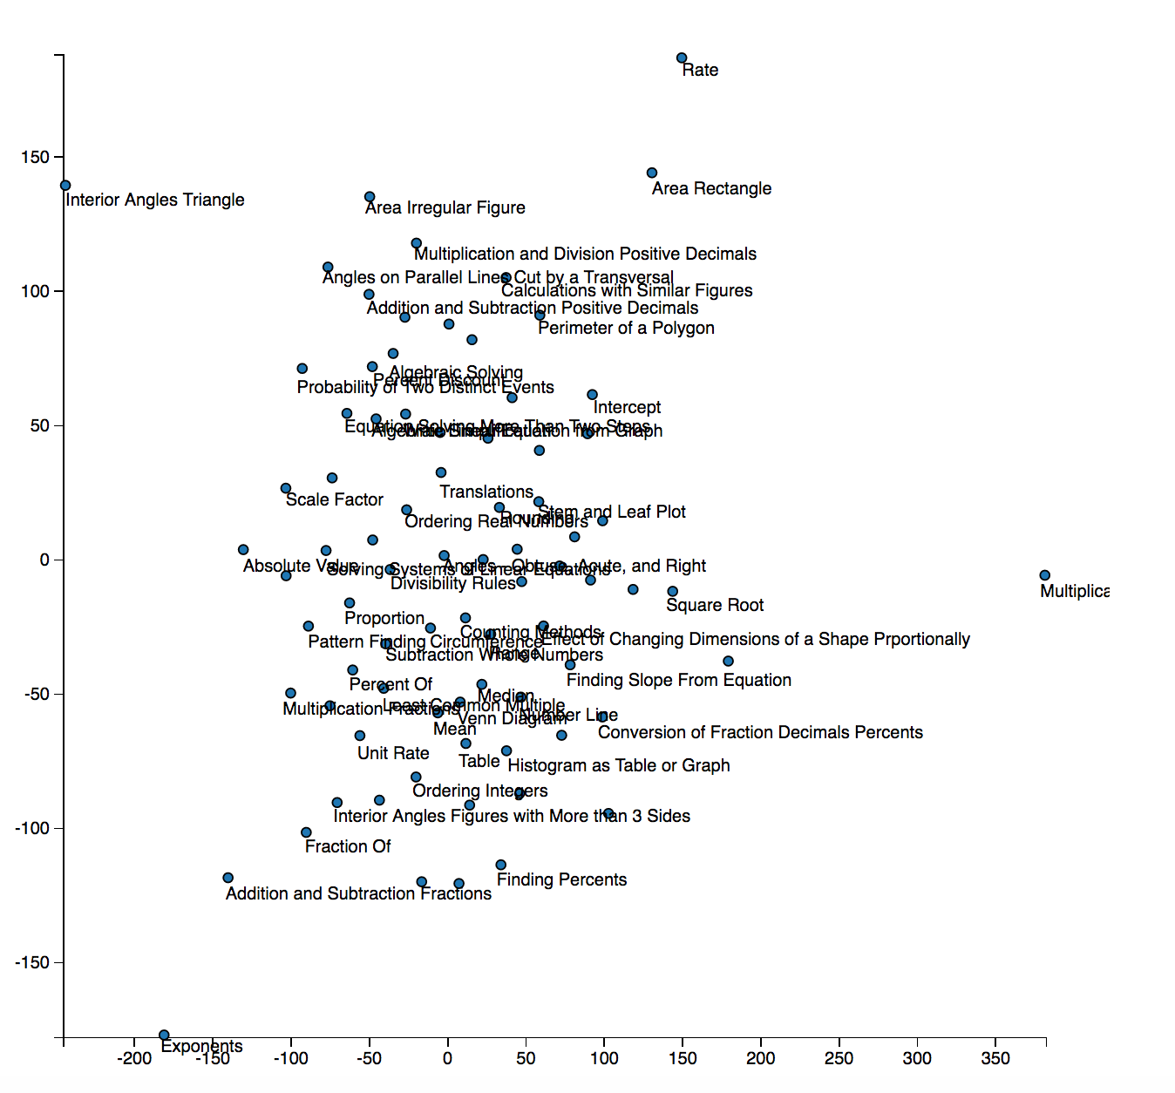

Word2Vec: size=200, window=1, min_count=10, workers=4, sg=1, iter=100

T-Sne: perplexity = 10

Fairly spread out and seemingly mixed, with a few groupings:

* Plot types (box & whisker, circle graph, number line)

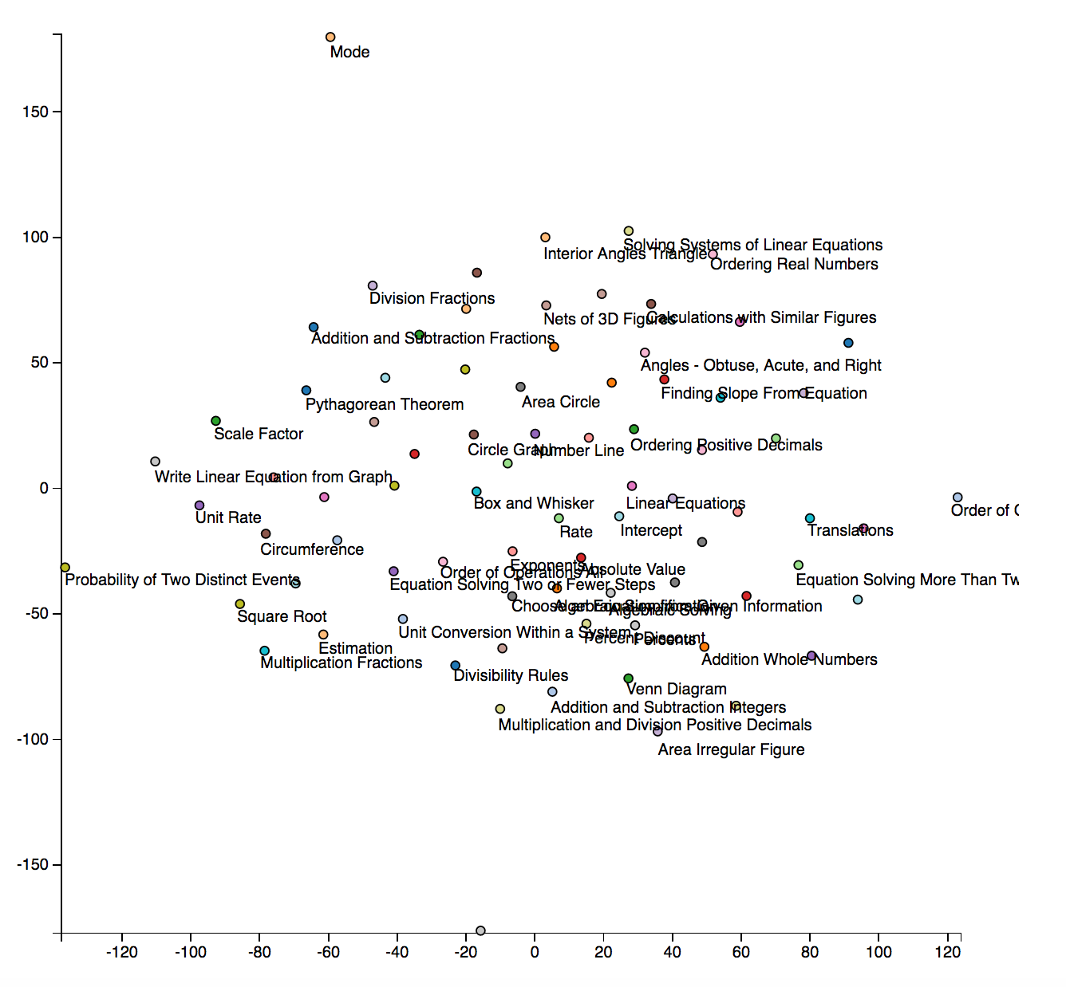

Word2Vec: size=200, window=10, min_count=10, workers=4, sg=1, iter=100

T-Sne: perplexity = 30

Still fairly spread, but can see many groups:

* Angle
* Area
* Plot types (box & whisker, stem & leaf, venn diagram)
* Equations
* Order of operations

