1 Задание

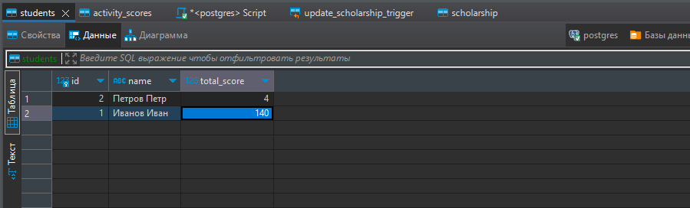

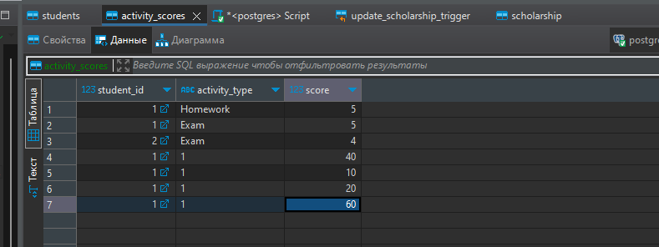

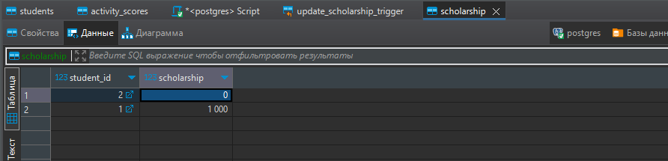

Функция

**create** **or** **replace** **FUNCTION** calculate_scholarship()

**RETURNS** **TRIGGER** **AS**

**$BODY$**

**declare**

cur record;

cur1 record;

**begin**

**for** cur **in** (**select** student_id, **sum**(score) **as** score **from** activity_scores **group** **by** student_id) **loop**

**UPDATE** students **set** total_score = cur.score **where** id=cur.student_id;

**end** **loop**;

**for** cur1 **in** (**select**

s.id **as** id,

**case** **when** total_score >=90 **then** 1000

**when** total_score>=80 **and** total_score <90 **then** 500

**else** 0

**end** **as** scholarship

**from** students s) **loop**

**INSERT** **INTO** scholarship **VALUES**

(cur1.id, cur1.scholarship)

**ON** **CONFLICT** (student_id) **DO** **UPDATE** **SET** scholarship = EXCLUDED.scholarship;

**end** **loop**;

**return** **null**;

**end**;

**$BODY$**

**LANGUAGE** plpgsql;

Триггер

**create** **trigger** update_scholarship_trigger **after**

**insert**

**or**

**update**

**on**

public.activity_scores **for** **each** **row** **execute** **function** calculate_scholarship()

Задание 2

Функция 1

**create** **or** **replace** **FUNCTION** update_total_score(stud_id **INTEGER**)

**RETURNS** **void** **AS**

**$BODY$**

**declare**

cur record;

**begin**

**for** cur **in** (**select** s.student_id, **sum**(score) **as** score **from** activity_scores s **where** s.student_id = stud_id **group** **by** s.student_id ) **loop**

**UPDATE** students **set** total_score = cur.score **where** id=cur.student_id;

**end** **loop**;

**end**;

**$BODY$**

**LANGUAGE** plpgsql;

Функция 2

**create** **or** **replace** **FUNCTION** update_total_score_trigger()

**RETURNS** **trigger** **AS**

**$BODY$**

**begin**

**perform** update_total_score(**new**.student_id) ;

**return** **null**;

**end**;

**$BODY$**

**LANGUAGE** plpgsql;

Триггер:

**create** **trigger** update_total_score_trigger **after**

**insert**

**on**

public.activity_scores **for** **each** **row** **execute** **function** update_total_score_trigger()

Было:

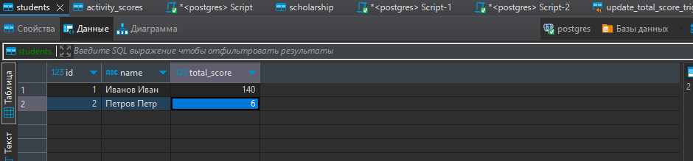

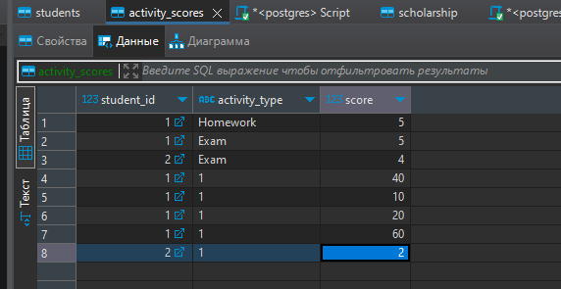

Добавляем студентов:

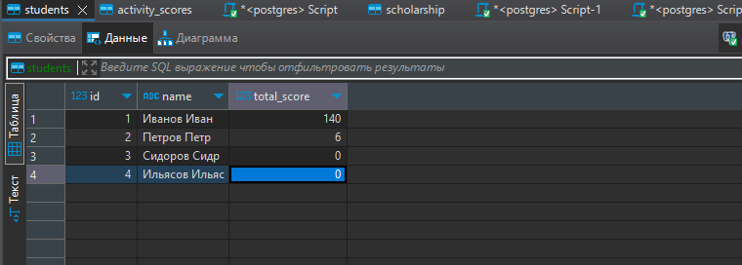

Добавляем данные в activity_scores:

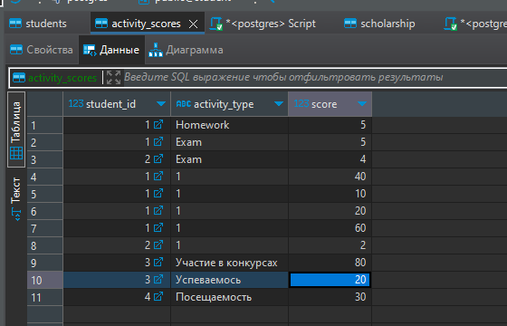

Проверяем результат:

