Personal Portfolio Contacts Projects About

Welcome to my page!!!

University About Projects

Contact details:

Gmail Facebook Cellphone

Personal Portfolio Contacts Projects About

**Recommendation letter**

**10.01.2022**

To whom it may concern:

I had a pleasure of teaching Ruslanov Almaz from 2014 to 2019 at H. Karasaev High School. During that time, I have come to know him as a strong student and a role model for his peers. Almaz took English from me and earned superior grades in that class. Based on his grades, attendance, and class participation, I would rate Almaz's academic performance in my class as superior.

Almaz is a rare type of student who combines exceptional natural ability with a willingness and eagerness to learn. He is able to help his peers with difficult English concepts, but does so in a way that is both practical and non-condescending. Although he is aware of his natural ability in the area of English, he constantly challenges himself. He plays defense in our school's soccer team. Moreover, he is interested in software engineering and media.

While studying, he demonstrated himself as a responsible, diligent student. In addition, he was an enthusiastic participant in class discussions, activities and helped make the courses rewarding experience for everyone. He always supported his peers. His caring nature and personality allow him to work well with others in a team setting as he always respects others' opinions even when they differ from his own.

Almaz’s personal strengths are as impressive as his intellectual accomplishments. He is an active, outgoing student with great sense of humor. He is a perfect person to get a group project rolling, but he also knows how to sit back and let others take the lead. His cheerful nature and openness to feedback, which is an impressive strength that will continue to serve him well in college and beyond, shows his constant will towards learning and growing as a learner.

Another thing I want to mention is his wide range of interests. Besides the main subjects, he goes to courses in science and computing, in learning of which he achieved very good results. Therefore, without any hesitation, I can recommend Ruslanov Almaz for the position of a student in your university.

Your faithfully,

Jakeshov Zhyrgal.

Contact details:

Gmail Facebook Cellphone

Personal Portfolio Contacts Projects About

The game is played on a [board](https://en.wikipedia.org/wiki/Board_game) of [squares](https://en.wikipedia.org/wiki/Square), where each square is a floor or a wall. Some floor squares contain boxes, and some floor squares are marked as storage locations.

The player is confined to the board and may move horizontally or vertically onto empty squares (never through walls or boxes). The player can move a box by walking up to it and push it to the square beyond. Boxes cannot be pulled, and they cannot be pushed to squares with walls or other boxes. The number of boxes equals the number of storage locations. The puzzle is solved when all boxes are placed at storage locations.

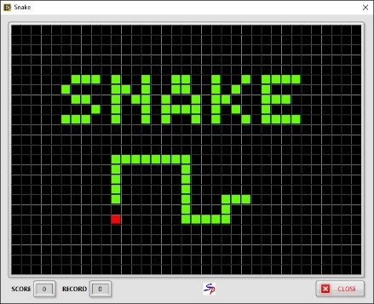 The player controls a long, thin creature, resembling a snake, which roams around on a bordered plane, picking up food (or some other item), trying to avoid hitting its own tail or the edges of the playing area. Each time the snake eats a piece of food, its tail grows longer, making the game increasingly difficult. The user controls the direction of the snake's head (up, down, left, or right), and the snake's body follows.

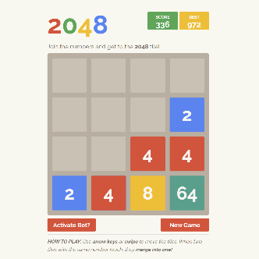

2048 is a game where you combine numbered tiles in order to gain a higher numbered tile. In this game you start with two tiles, the lowest possible number available is two. Then you will play by combining the tiles with the same number to have a tile with the sum of the number on the two tiles. A lot of strategies have been devised in order to obtain the 2048 and be a winner in this game.

Contact details:

Gmail Facebook Cellphone

[](https://www.youtube.com/embed/wGpfo-who0k?feature=oembed)Personal Portfolio Contacts Projects About

Hash Code is a team programming competition, organized by Google, for students and professionals around the world. You pick your team and programming language and we pick an engineering problem for you to solve. This year’s contest kicks off with a Qualification Round, where your team can compete virtually from wherever you’d like, alongside your virtual Hub. Top teams will then be invited to compete from our virtual World Finals. Our team took 6599th place.

[](https://www.youtube.com/embed/as0vORidirc?feature=oembed)

JunctionX Budapest is organized this year by a Hungarian IT event management company, named CraftHub to bring together developers, designers, and entrepreneurs to create exciting projects and solve intriguing challenges within 48 hours.

CraftHub’s aim is to provide the participants networking opportunities with other tech-minded individuals in an international community and to create the spirit of a fast-paced hacking marathon. Teams will have the chance to choose from numerous challenges defined by great companies and win the grand prize of 3000 €! My team also participated in this event and deserved some prices.

Contact details:

Gmail Facebook Cellphone