# [Development Environment](http://confluence.rt.ipnt.de/display/TECX/Development+Environment)

## Common agreements

In general, we use Eclipse based IDE for development.

* <https://eclipse.org/>
* <https://spring.io/tools>

Of course, any other IDE can be used as long as the guidelines are met.  
Please do us a favor and provide necessary documentation. Other developers will appreciate

# HowTo setup IDE

## Apply formatter settings

We want to improve readability of our java code and prepare the introduction of common metrics ( e.g. checkstyle ) within our products.

### Steps

1. Open Eclipse Preferences
2. Filter by "Formatter"
3. Import profile.
4. Activate profile
5. Apply changes

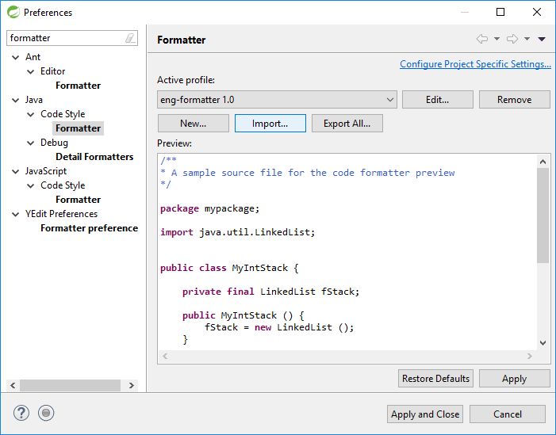

## Apply Clean Up settings

### Steps

1. Open Eclipse Preferences
2. Filter by "Clean Up"
3. Import profile.
4. Activate profile
5. Apply changes

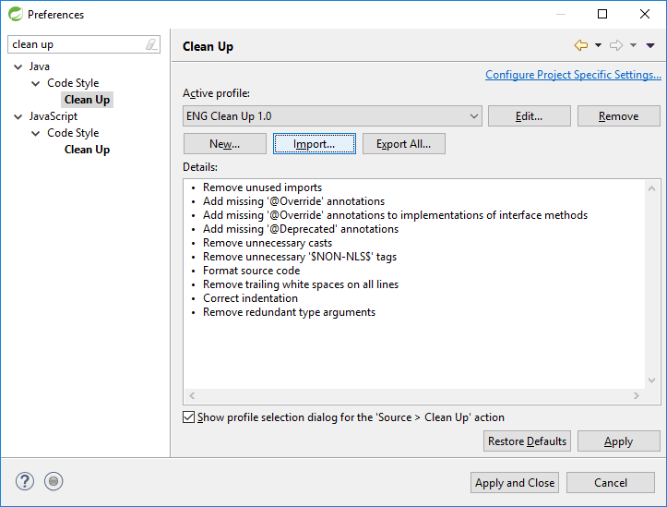

## Apply Code Template settings

### Steps

1. Open Eclipse Preferences
2. Filter by "Code Templates"
3. Import code templates.
4. Apply changes

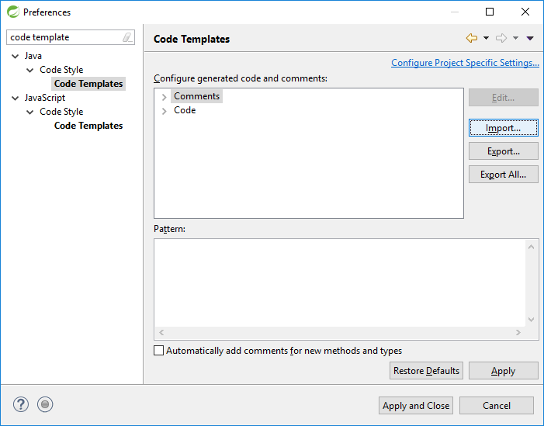

## Adjust Compiler Error / Warnings

We want to prepare Java 8 Lambda Expressions. Therefore we decided to ignore Boxing / Unboxing conversion problems.

### Steps

1. Open Eclipse Preferences
2. Filter by "Compiler"
3. In tab Errors / Warnings filter by "Boxing"
4. Change settings to Ignore
5. Apply changes

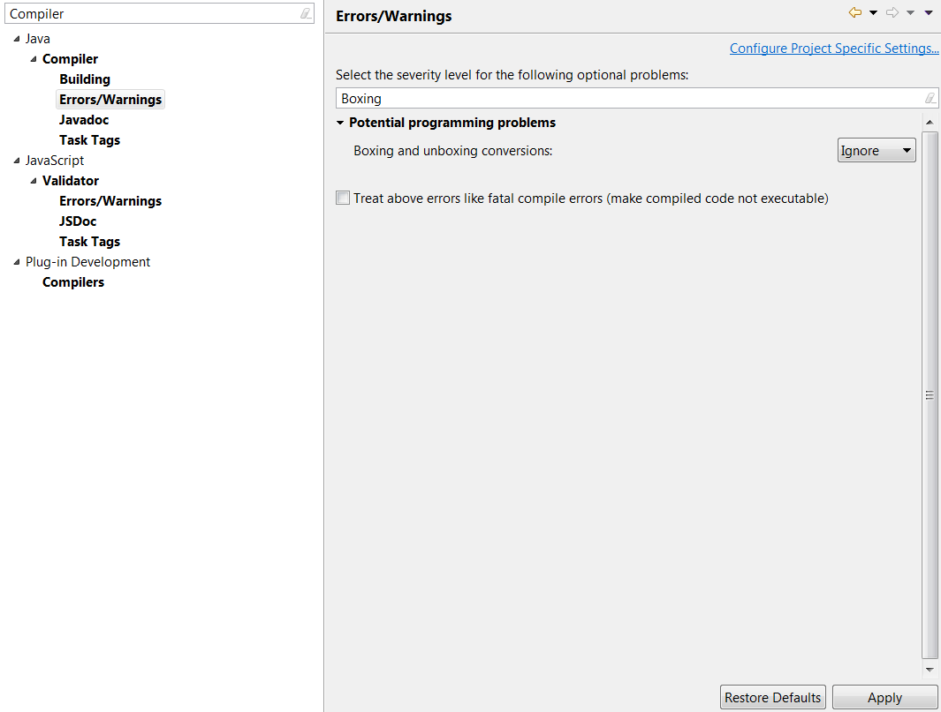

## Adjust Save Actions

In order to improve the integration process we want to reduce code formatting changes. So only edited lines should be formatted.

To keep our code clean, we activate eclipse`s standard save actions

* Organize Import
* Remove unused imports
* Add missing '@Override' annotations
* Add missing '@Override' annotations to implementations of interface methods
* Add missing '@Deprecated' annotations
* Remove unnecessary casts
* Remove trailing white spaces on all lines TBD
* Correct indentation

### Steps

1. Open Eclipse Preferences
2. Filter by "Save Actions"
3. Modify settings as shown in the screen above
   1. Check "Format source code", Select "Format edited lines"
   2. Check "Organize imports"
   3. Check "Additional actions"
4. Apply changes

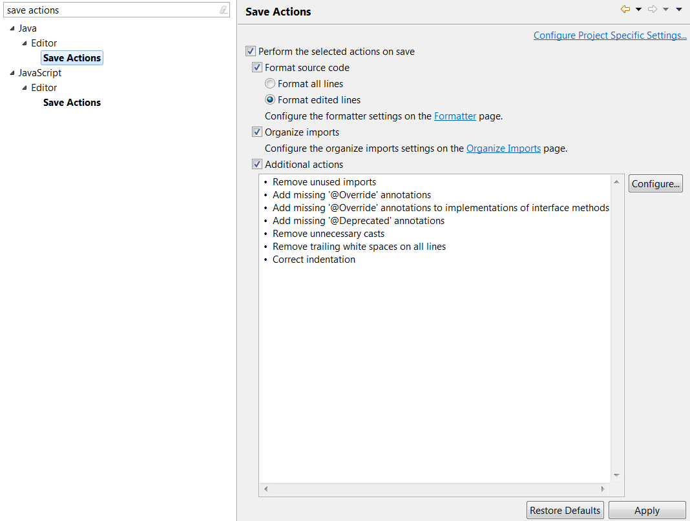

## Adjust Resource Bundle Editor

We plan to migrate all property files to UTF-8 encoding within the products. Property files can optionally be edited via [Resource Bundle Editor.](http://essiembre.github.io/eclipse-rbe/)

### Steps

1. Open Eclipse Preferences
2. Filter by "Formatting"
3. Adjust settings as shown in the screens above
4. Apply changes

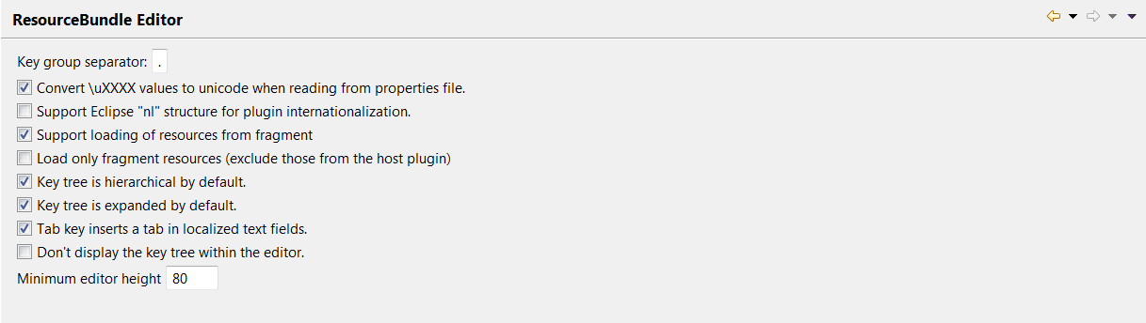

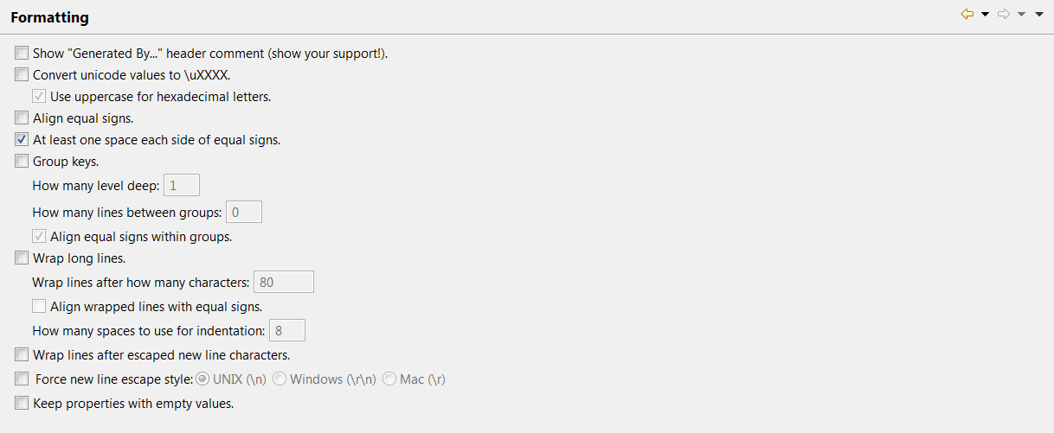

## Coding Guidelines

TO BE DECIDED, PLEASE FOR NOW IGNORE THIS CHAPTER.

In addition please dont forget to check **Insert spaces for tabs.**

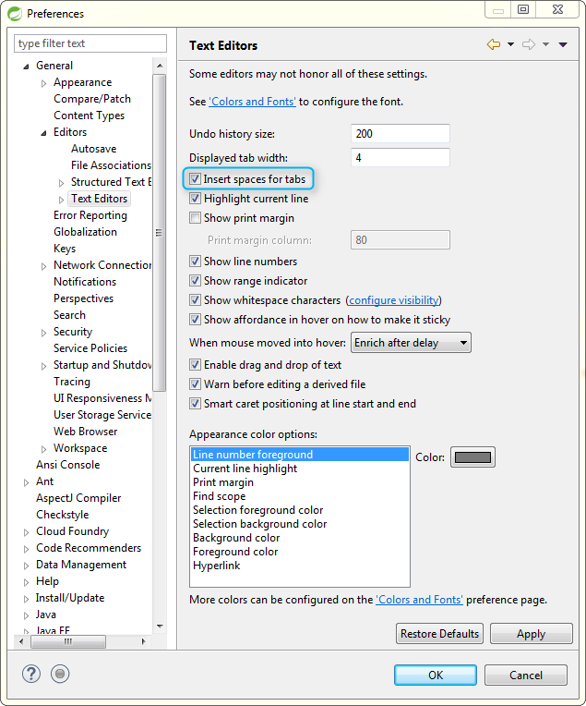

## Text File Encoding

To ensure correct Encoding of multi-lingual properties files, please set the **Default Encoding to UTF-8** on these.

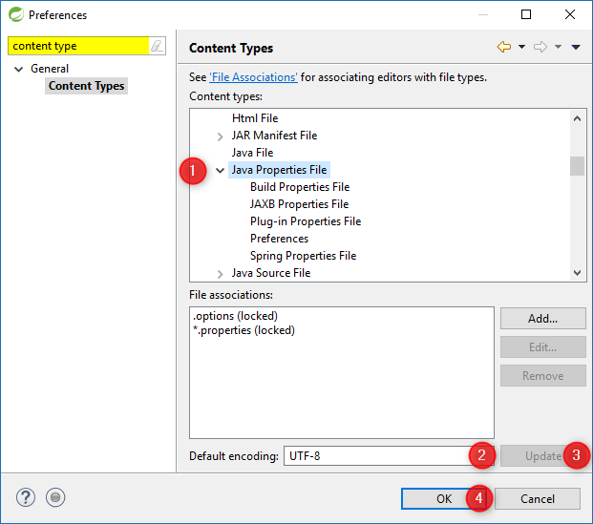

## Errors in Eclipse STS Version: 3.8.3

|  |  |
| --- | --- |
| **Problem** | **Lösung** |
| Type Attribute value (Post) uses wrong case character Type: HTML Problem | Windows → Preferences → Web → Html Files → Validation → Attributes → Attribute value using wrong case character: Ignore. |
| src-resolve: Cannot resolve the name '***' to a(n) 'type definition' component. | Windows → Preferences → Validation → uncheck manual and build XML Schema Validator and XML Validator. |
| Invalid derived query! Spring Data Problem. | Windows → Preferences → Spring → Validation → uncheck Data Validator. |
| The type *** is already defined Type: Java Problem | right click Project → Preferences → Java Compiler → Annotation Processing. uncheck "Enable project specific settings". |
| ...\target\m2e-wtp\web-resources\META-INF\MANIFEST.MF (The system cannot find the path specified) | Preferences > Maven > Java EE Integration and uncheck "Maven Archiver generates files under the build directory" |

## Validators

To improve the performance of STS it is helpful to disable various validators. This is done as follows (can also be done for each project individually)

|  |
| --- |
| Window -> Preferences -> Validation -> Suspend all validators |

## Maven

After you have installed Maven (Windows), the repository server needs to be configured in the settings.xml **(C:\Users\<username>\.m2\settings.xml).**

If the directory is not created automatically, it can also be created manually in Windows Explorer. Create the new folder as "**.m2.**" (note the last **.** ), Windows will rename it automatically.

## Maven Lifecycle Mapping in Eclipse

When adding a new Maven plugin to the pom in Eclipse, sometimes an error will be displayed on the executions tag in the pom.xml. This can be solved by calling the corresponding Quick-Fix in the marker view in Eclipse. To do this, you can first search for a Maven connector for Eclipse. The second option is to ignore lifecycle mapping.

# Others

For every other information don't afraid to ask Lollino.