Set up and connect to your target cluster

1. Make sure the Azure CLI is installed
2. Install Kubectl

az aks install-cli

1. Verify the connection to the cluster

az aks create -g myResourceGroup -n myAKSCluster --enable-managed-identity --node-count 2 --enable-addons monitoring --enable-msi-auth-for-monitoring --generate-ssh-keys

kubectl get nodes

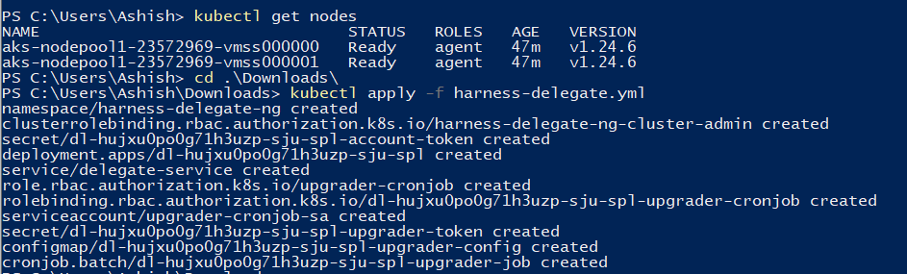

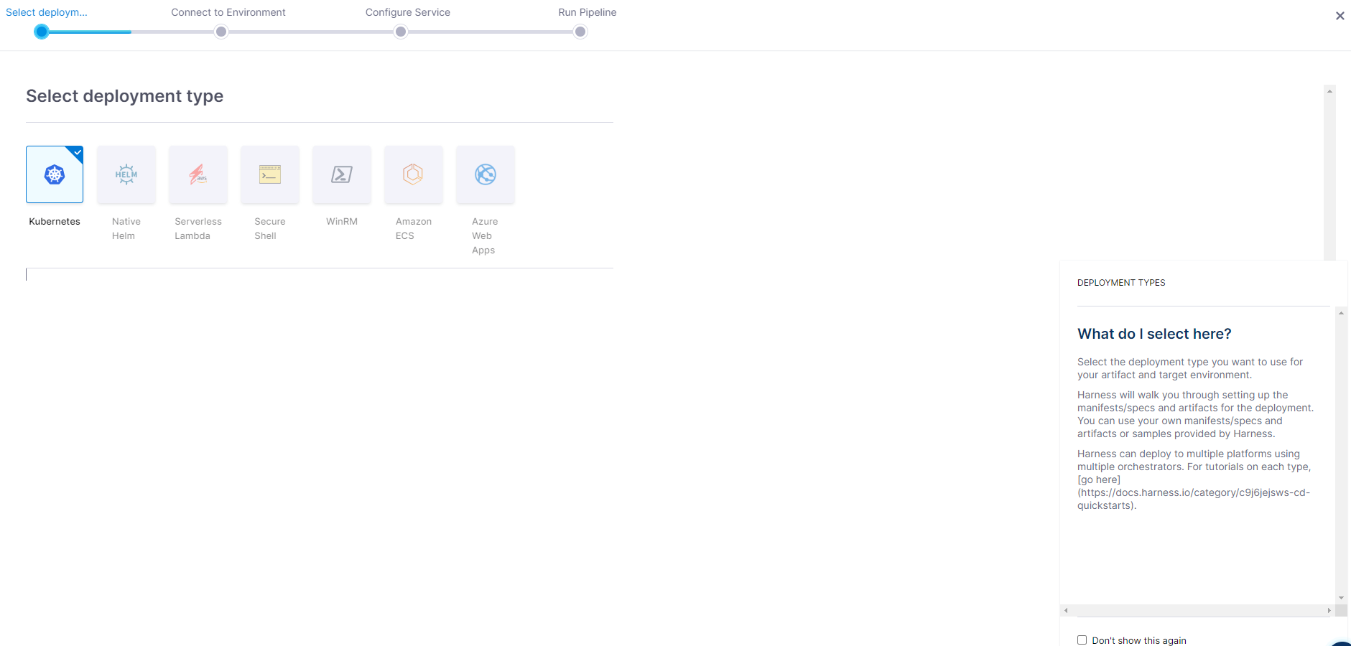

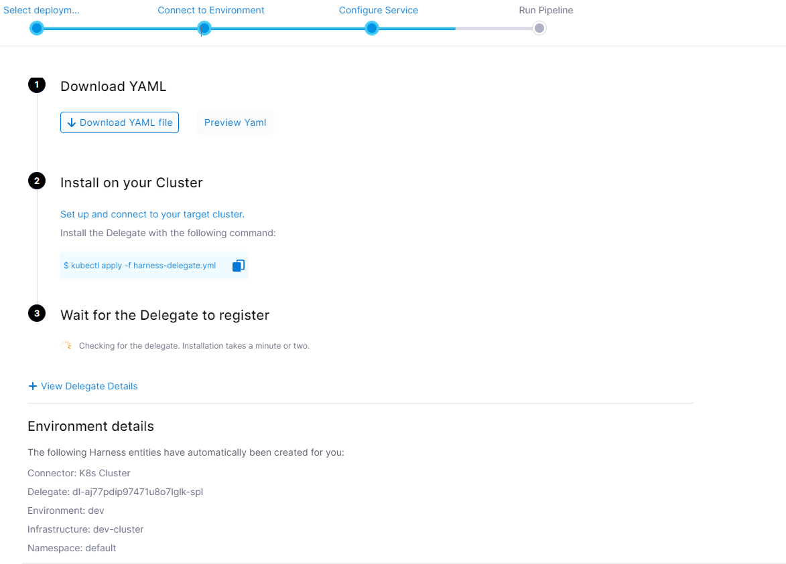

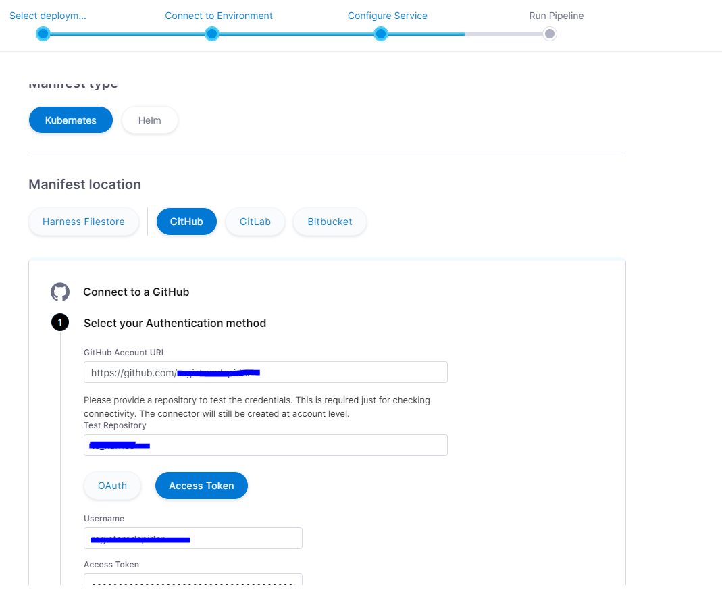

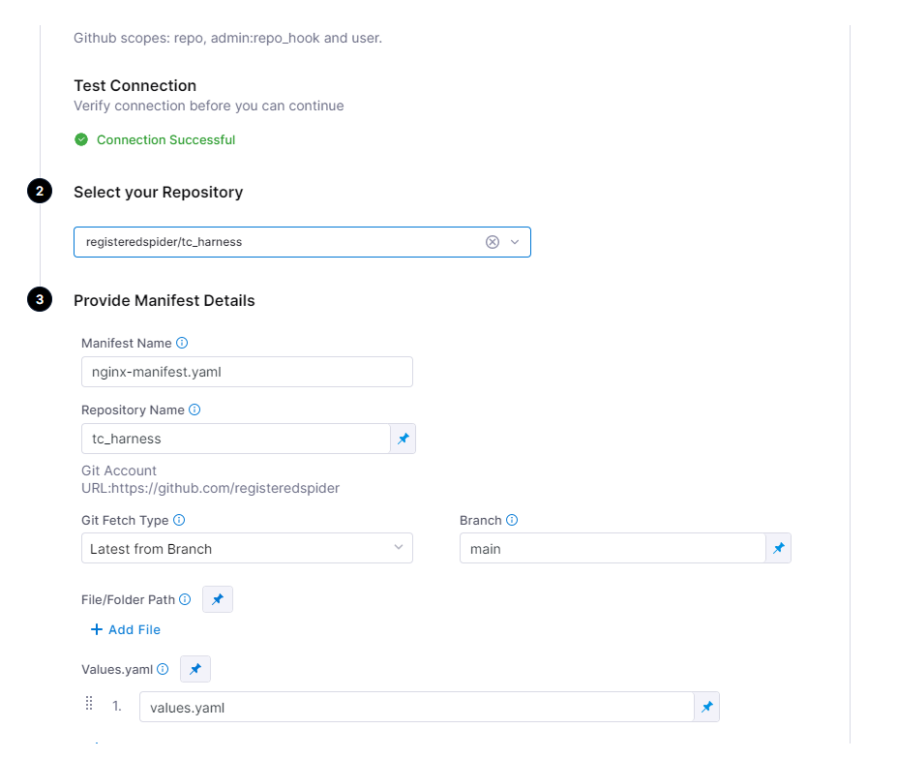

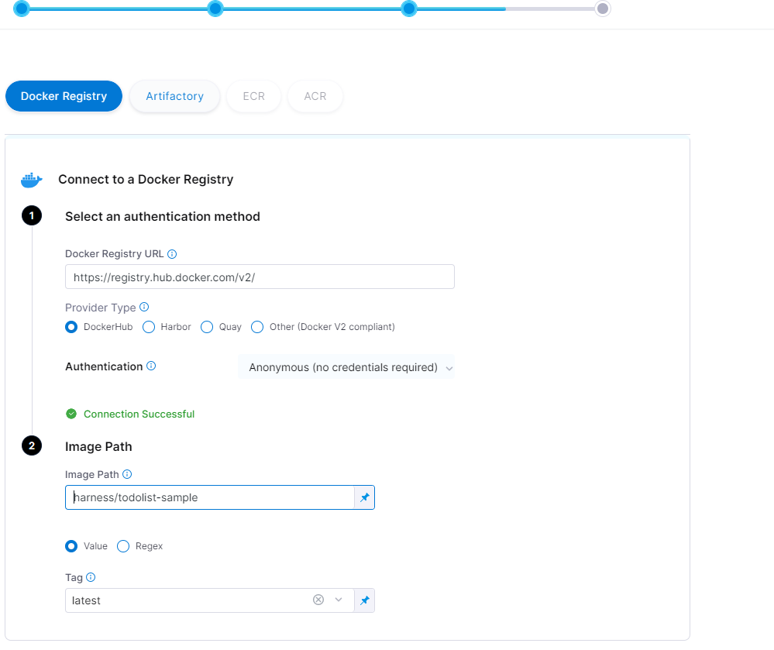

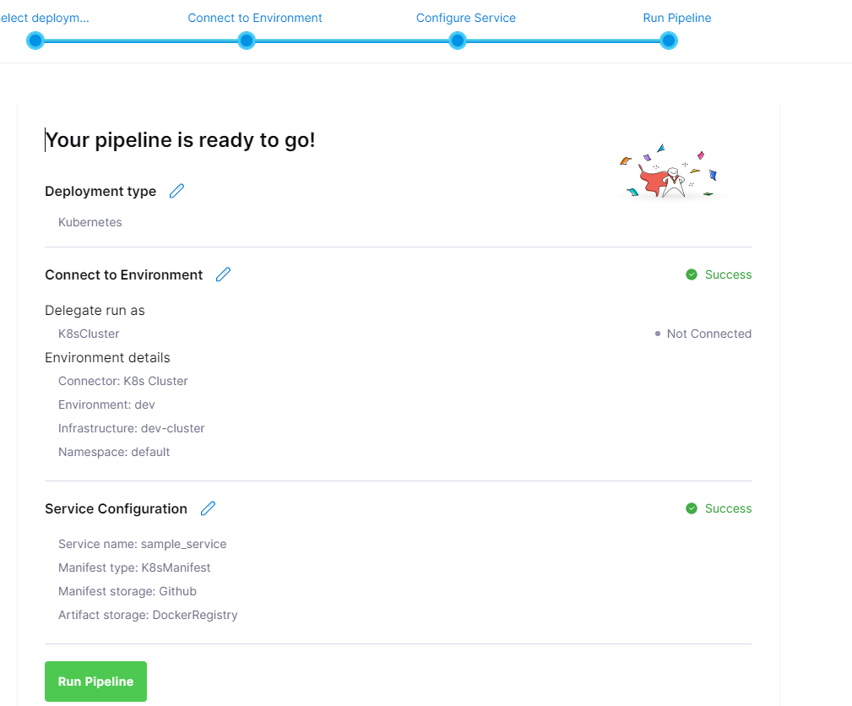

<https://github.com/harness/harness-cd-community>

<https://developer.harness.io/docs/continuous-delivery/onboard-cd/cd-quickstarts/kubernetes-cd-quickstart>

<https://developer.harness.io/docs/continuous-delivery/onboard-cd/cd-quickstarts/kubernetes-cd-quickstart>

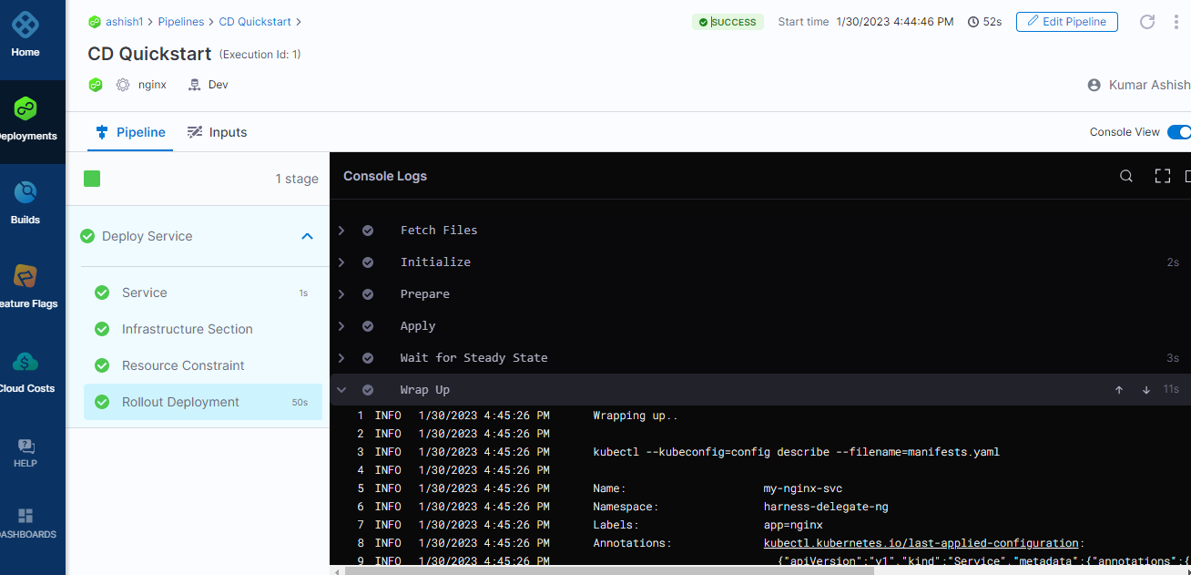

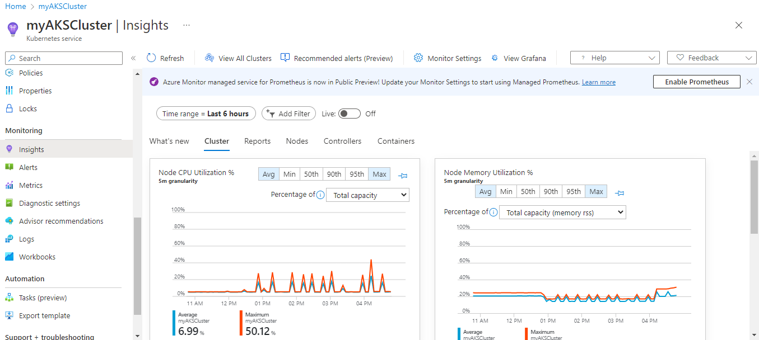

Read more - <https://developer.harness.io/docs/platform/connectors/ref-cloud-providers/kubernetes-cluster-connector-settings-reference/>