Project: Arduino - Quality of Water

Sub-Project : Water Temperature Sensor V001

|  |  |
| --- | --- |
| Autor: | Andrew Bassi Villela |
| Date: | 22/03/2017 |
| File | ProjWaterTempV001 |

* 1. Overview

This subproject aims to measure the actual water temperature.

The ideal of this project is to arrive at the parameterization of the ideal temperature to monitor preventive actions maintaining the necessary temperature.

* 1. Flow Design

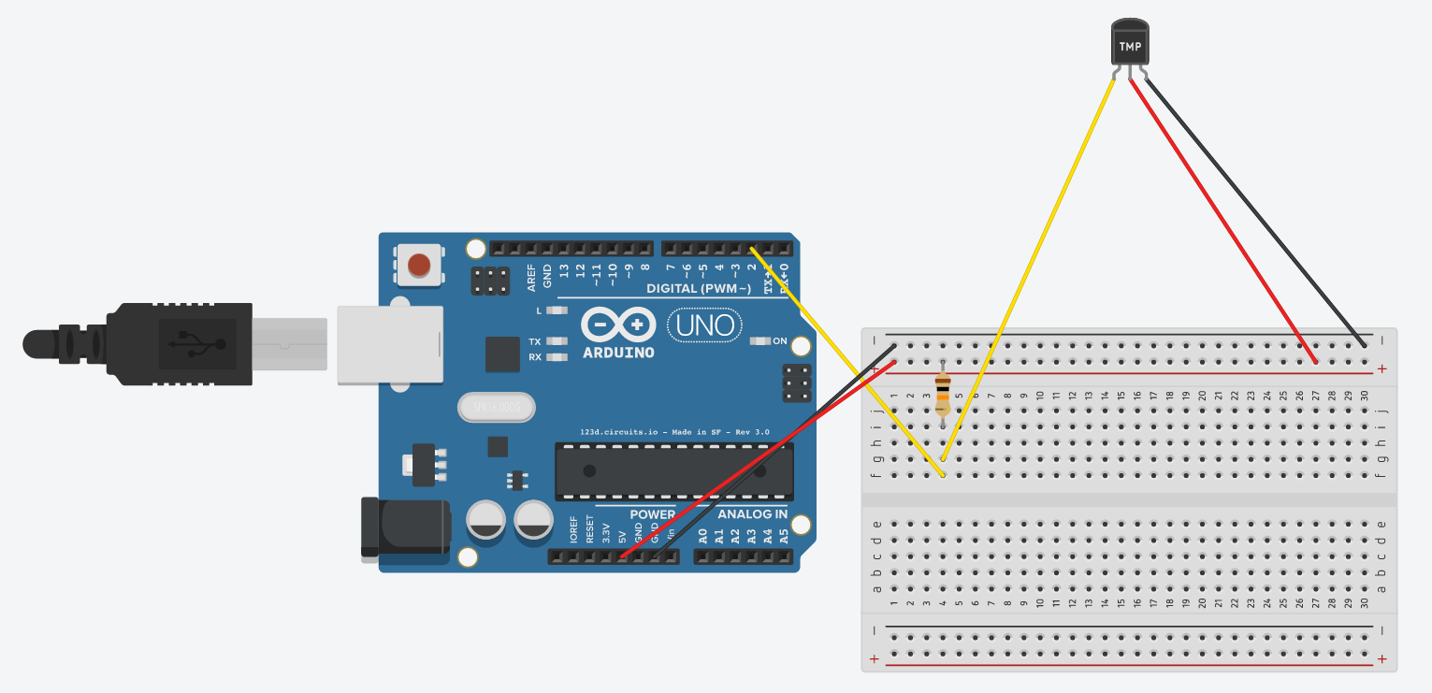

* 1. Source Code

<Inicial>

#include <OneWire.h>

#include <DallasTemperature.h>

#include <Wire.h> //Vem no Arduino já

//variavel do pino que esta plugado o Sensor

//Neste caso é o pino 2, mais pode usar qualquer pino digital

#define ONE_WIRE_BUS 2

//Instacia o Objeto oneWire e Seta o pino do Sensor para iniciar as leituras

OneWire oneWire(ONE_WIRE_BUS);

// Pass our oneWire reference to Dallas Temperature.

//Repassa as referencias do oneWire para o Sensor Dallas (DS18B20)

DallasTemperature sensor(&oneWire);

void setup(void)

{

//Inicia a Serial

Serial.begin(9600);

Serial.println("Sensor de temperatura Dallas DS18b20");

Serial.println("Regis e Andrew");

//Inicia o objeto da biblioteca do Dallas

sensor.begin();

}

void loop(void)

{

//Envia o comando para obter temperaturas

sensor.requestTemperatures();

// A temperatura em Celsius para o dispositivo 1 no índice 0 (é possivel ligar varios sensores usando a mesma porta do arduino)

float leitura=sensor.getTempCByIndex(0);

//Imprime na serial a varivel que recebe os dados do Sensor

Serial.println(leitura);

delay(100);

}<End>

* 1. Library:

<OneWire.h>

<DallasTemperature.h>

<Wire.h>

* 1. Hardware:

Sensor DS18B20

Resistor Pull Up. (4.7 to 10 Khom)

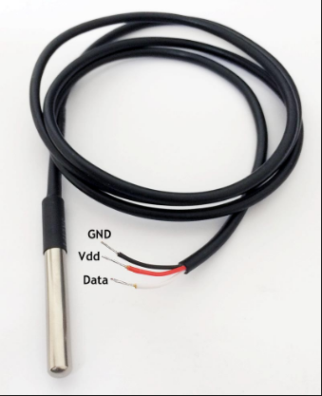

* 1. Future Update : Next Steps:

Alert when the temperature is outside the specified temperature.