

Practices for Secure Software Report

Table of Contents
Practices for Secure Software Report 1
Document Revision History 3
Client 3
Developer 4
1. Algorithm Cipher 4
2. Certificate Generation 4
3. Deploy Cipher 5
4. Secure Communications 6
5. Secondary Testing 6
6. Functional Testing 7
7. Summary 7
8. Industry Standard Best Practices 8
References 9

Document Revision History

Version | Date | Author | Comments
1.0 | October 17, 2026 | Regina Lineberry

Client



Developer
Regina Lineberry

Algorithm Cipher
For Artemis Financial, I recommend using the Advanced Encryption Standard (AES) with a 256-bit key to protect sensitive financial information. AES-256 is a symmetric encryption algorithm, meaning the same secret key is used to encrypt and decrypt information. This makes it an effective choice for protecting confidential customer data.
AES operates on 128-bit blocks of data and supports 128-bit, 192-bit, and 256-bit encryption keys. Using a 256-bit key provides strong protection against unauthorized access. AES itself is not a hash function, so I also recommend SHA-256 to generate checksums for data verification. SHA-256 produces a 256-bit hash value that can help identify whether information has been modified (National Institute of Standards and Technology [NIST], 2023; NIST, 2015).
Secure random numbers are important when generating encryption keys and initialization values. Symmetric encryption uses one shared secret key, while asymmetric encryption uses a public key and a private key. These approaches can work together in secure HTTPS communications to protect transmitted information.
Encryption has developed from simple substitution methods into advanced mathematical algorithms. The Data Encryption Standard (DES) was widely used in the past, but its 56-bit key is no longer considered secure. AES replaced DES as the modern encryption standard and remains widely used today (NIST, 2023).
For Artemis Financial, combining strong encryption, secure HTTPS communications, and SHA-256 checksum verification would provide multiple layers of protection for customer information.

Certificate Generation
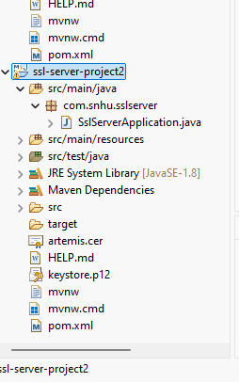
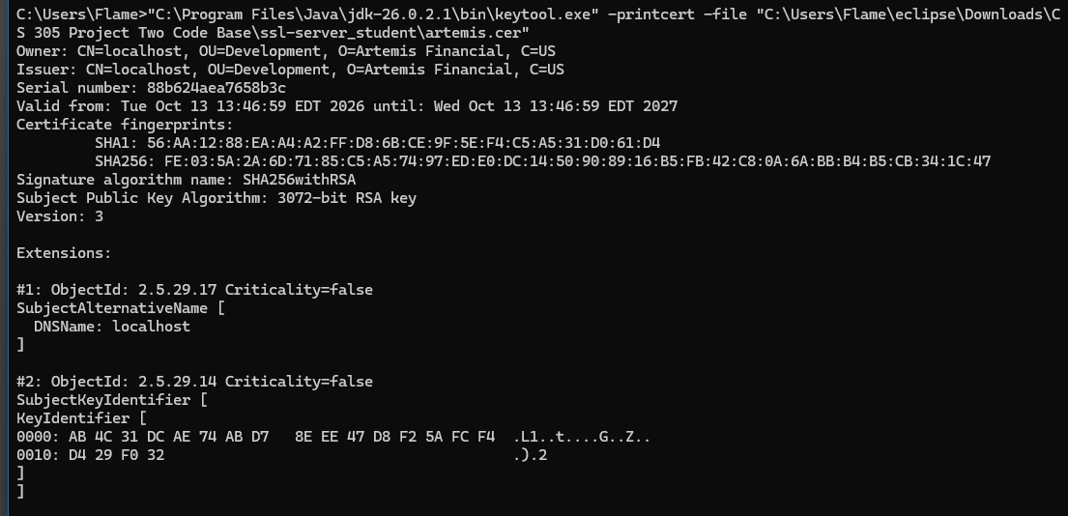

Deploy Cipher

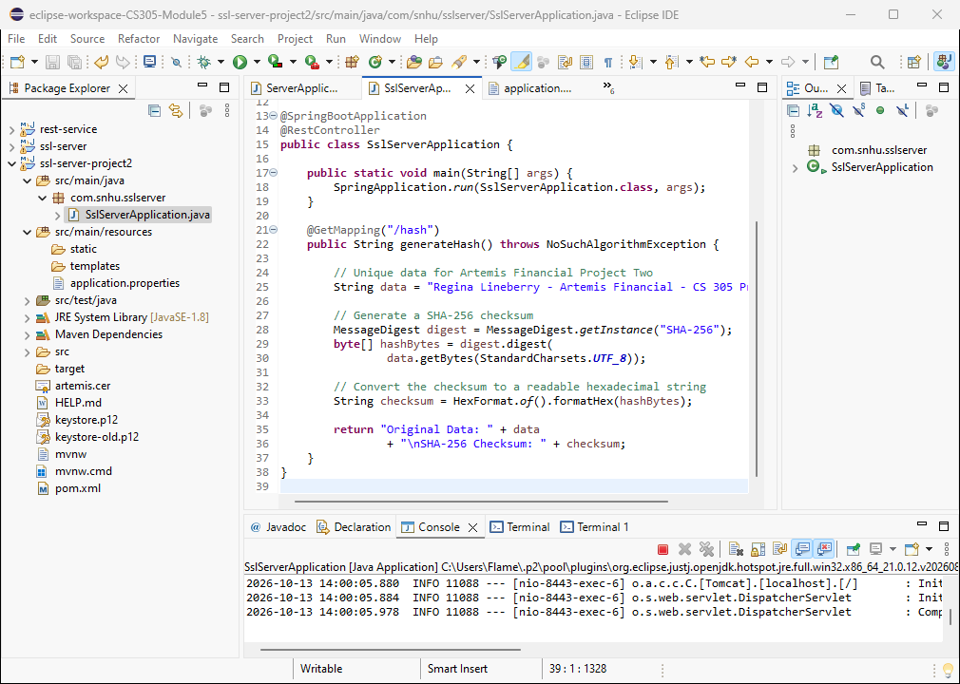

Secure Communications

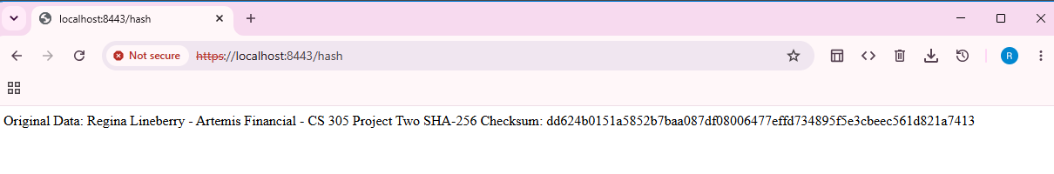

Secondary Testing

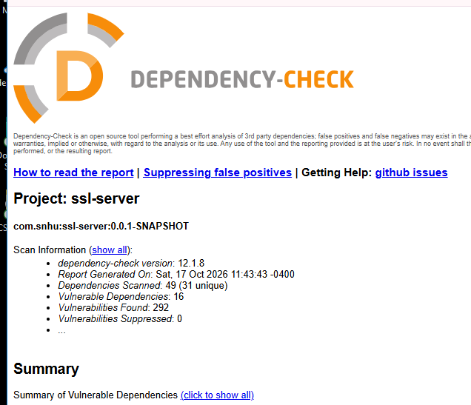

The OWASP Dependency-Check scan was completed successfully after updating the Dependency-Check Maven plugin. The scan identified 16 vulnerable dependencies and 292 potential vulnerability findings, with zero vulnerabilities suppressed. These findings indicate that several third-party libraries used by the application may contain known security weaknesses. The results should be reviewed to identify affected components, assess their severity, and determine which dependencies require updates. The findings have not yet been remediated, so additional testing and dependency updates are necessary before the application could be considered ready for production.

Functional Testing

Functional testing was performed on the Artemis Financial application to verify that the security enhancements worked correctly. The application was successfully launched in Eclipse, and the HTTPS connection was tested using port 8443. The application displayed the original data and its SHA-256 checksum when accessing the /hash endpoint. This

confirmed that the application could generate a checksum and respond to requests over an encrypted HTTPS connection. Because the certificate was self-signed, the browser displayed a security warning before allowing access. Additional testing would be required before deploying the application in a production environment.

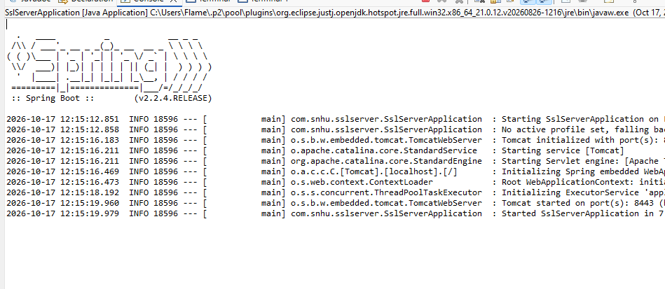

Summary

The Artemis Financial application was updated to improve the security of its communications and data integrity. HTTPS was enabled using a self-signed SSL/TLS certificate, allowing information exchanged between the browser and server to be encrypted. A SHA-256 hashing function was also implemented to generate a checksum that can be used to verify data integrity.

The security assessment followed a layered approach that included reviewing the application's dependencies, implementing secure communication, testing the checksum functionality, and performing a secondary vulnerability scan. These activities addressed different areas of application security rather than relying on a single protective measure.

The OWASP Dependency-Check scan identified 16 vulnerable dependencies and 292 potential vulnerability findings. Although the application started successfully and its HTTPS and checksum functionality were tested, these findings indicate that additional security improvements are necessary. Before production deployment, the vulnerable dependencies should be reviewed and updated, followed by another vulnerability scan and functional testing.

Industry Standard Best Practices

Secure software development requires multiple layers of protection throughout the software development life cycle. Developers should follow secure coding standards, validate user input, use established encryption algorithms, and avoid storing sensitive information in source code. These practices help reduce the risk of unauthorized access, data exposure, and application vulnerabilities.

Regular dependency updates and vulnerability scanning are also essential. Tools such as OWASP Dependency-Check help developers identify known vulnerabilities in third-party libraries. When vulnerabilities are discovered, developers should evaluate their severity, update affected dependencies and repeat testing to verify that the changes do not introduce new problems.

For Artemis Financial, additional improvements should include replacing the self-signed certificate with a certificate issued by a trusted certificate authority before production deployment, protecting the keystore password using secure configuration management, and updating outdated software dependencies. Combining these practices with regular security assessments and functional testing would help strengthen the application's overall security.

HTTPS Configuration Note: The application's keystore password is not stored directly in the application.properties file. Instead, the configuration uses the KEYSTORE_PASSWORD environment variable. To run the application, this variable must be configured with the password associated with the project's keystore.p12 file. This approach helps prevent the password from being exposed in the application's source code.

References

National Institute of Standards and Technology. (2015). Secure hash standard (SHS) (FIPS Publication 180-4). https://doi.org/10.6028/NIST.FIPS.180-4
National Institute of Standards and Technology. (2023). Advanced encryption standard (AES) (FIPS Publication 197). https://doi.org/10.6028/NIST.FIPS.197-upd1

