MemoryAI — AI Content Strategist
Northstar Brand Co.
Consumer Technology
AI + Persistent Memory + Campaign Intelligence
Repository: regondashiva/microsoft_hack
Final Technical & Product Submission | September 2026
Submission note: This document consolidates the verified product and engineering state through Task 10. Synthetic campaign data is explicitly identified. A production URL is not claimed until deployment is verified.

Table of Contents
1. Executive Summary
2. Problem Statement
3. Product Vision and Objectives
4. Brand and Demonstration Context
5. Core Innovation
6. System Architecture
7. Hindsight Memory Architecture
8. AI Content Strategist
9. Teach → Remember → Recall → Improve
10. Campaign Intelligence
11. Explainable Recommendations and WOW Demonstration
12. Production UI and User Workflows
13. Security, Responsible AI and Data Integrity
14. Technology Stack
15. Testing, Verification and Results
16. Deployment Readiness
17. Limitations and Future Scope
18. Conclusion
19. Appendix A. Verified Project Facts
20. Appendix B. Live Demonstration Script

1. Executive Summary
MemoryAI is an AI Content Strategist designed to help a brand make content decisions using persistent organizational memory rather than treating every AI request as a blank conversation. It combines Hindsight persistent memory, an OpenAI-compatible language-model service, query-aware retrieval, campaign intelligence, an explicit Teach → Remember → Recall → Improve learning loop, and explainability that connects recommendations to verified evidence.
The demonstration organization is Northstar Brand Co., a consumer-technology brand positioned around practical technology for focused work and living. Its objective is to build trust through useful, clear and practical content. Its voice is Clear, Confident, Approachable and Evidence-aware, with an explicit preference to avoid overly promotional messaging.
The product is designed around a persistent decision-support workflow: remember what the organization has taught, retrieve only relevant context, reason over that context and available campaign observations, explain why a recommendation fits, and improve through explicit feedback.
The final hardening state records 74 automated tests passing, zero TypeScript errors, clean linting, a successful production build, npm audit with zero reported vulnerabilities, responsive and accessibility verification, and live Hindsight + OpenRouter checks.

2. Problem Statement
Content teams must maintain consistent communication across channels while making decisions from fragmented brand knowledge, campaign history and team experience. A conventional LLM can generate fluent ideas, but without persistent organizational context it may repeat generic suggestions, forget established preferences, or produce unsupported performance claims.
MemoryAI addresses the decision-support problem rather than simply the content-generation problem. The strategist should know the brand voice, audience priorities, content themes and relevant campaign history; it should distinguish remembered facts from new input; and it should show what evidence supports a recommendation.
Trust is treated as a functional requirement. Demonstration campaign data is synthetic. Financial forecasts are not invented. Prompt-injection attempts are treated as untrusted input. Memory writes require explicit confirmation. Explainability evidence is assembled from application-controlled facts.

3. Product Vision and Objectives
MemoryAI is a focused strategic workspace for content teams. The intended workflow is: understand the brand → inspect campaign context → teach or correct organizational knowledge → ask the strategist → inspect evidence → provide feedback.
Objectives: persistent brand and audience memory; query-aware retrieval; grounded recommendations; deterministic campaign intelligence; transparent evidence and provenance; explicit human control over learning; secure server-side credentials; and production-quality responsive, accessible workflows.
The verified scope does not include autonomous social publishing or silent memory updates. The product is a strategic assistant whose persistent knowledge changes only through controlled, user-confirmed actions.

4. Brand and Demonstration Context
Attribute | Northstar Definition
Organization | Northstar Brand Co.
Industry | Consumer Technology
Target | Young professionals and digitally engaged consumers
Positioning | Practical technology for focused work and living
Content Objective | Build trust through useful, clear and practical content
Voice | Clear, Confident, Approachable, Evidence-aware
Primary Audience | Young Professionals, 22–34
Secondary Audience | Small Business Owners, 28–48
Content Themes | Practical education; Product use cases; Industry insights; Customer stories
Organization: Northstar Brand Co. | Industry: Consumer Technology | Target: young professionals and digitally engaged consumers.
Positioning: Practical technology for focused work and living. Content objective: Build trust through useful, clear and practical content. Voice: Clear, Confident, Approachable, Evidence-aware. Promotional restraint: avoid overly promotional messaging.
Primary audience example: Young Professionals, 22–34, interested in Productivity, Technology and Career growth, preferring practical educational content. Secondary audience example: Small Business Owners, 28–48, interested in Automation, Business software and Growth, preferring case studies and actionable guides.
Content themes: Practical education, Product use cases, Industry insights and Customer stories. Demonstration campaigns: Productivity Without the Noise, Work Smarter, Not Louder, The Practical Tech Guide, and Behind the Workflow.
All campaign performance figures are synthetic demonstration records and are not verified real-world business performance.

5. Core Innovation: Teach → Remember → Recall → Reason → Explain → Improve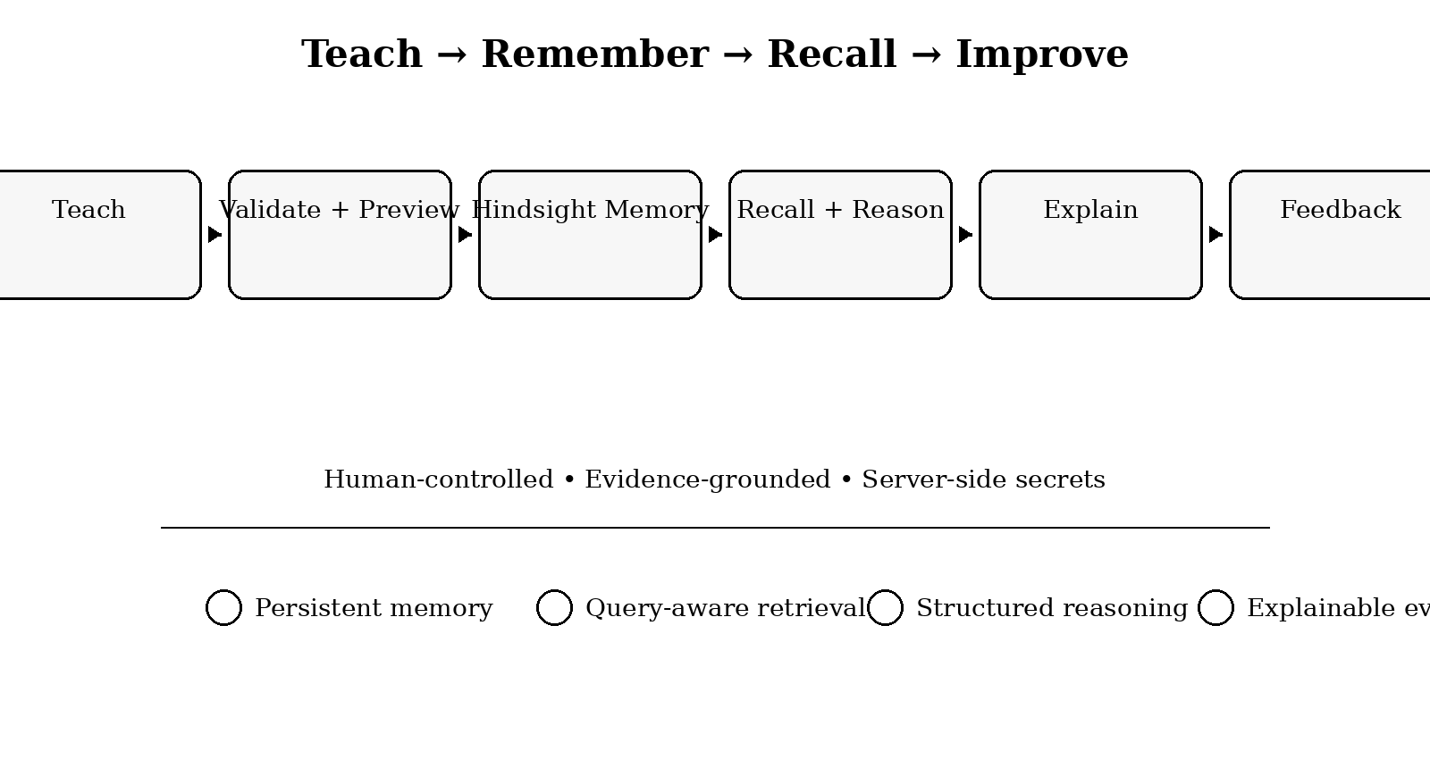
Stage | What Happens | Human Control
Teach | User enters a strategic preference | User chooses what to teach
Validate | Input is sanitized and checked | Invalid or unsafe content is rejected
Remember | Approved knowledge is retained in Hindsight | Explicit Save to Memory confirmation
Recall | Relevant memories are retrieved for a query | Only selected context is used
Reason | LLM generates structured strategy | Model output is schema-validated
Explain | Evidence chain shows why the recommendation fits | Evidence comes from verified application state
Improve | Feedback becomes a proposed memory update | No silent writes
The core innovation is a controlled learning loop. A user teaches a strategic preference. The application validates and sanitizes it, shows a preview, and requires confirmation before retaining it in Hindsight. A later query recalls relevant memories and builds bounded context. The strategist reasons over that context and selected campaign evidence. Explainability shows the evidence chain. Feedback can become another explicit teaching action.
This separates persistent organizational knowledge from transient conversation and separates facts from interpretation. Provenance, evidence counts, selected memories and campaign metrics are application-controlled; strategic wording is generated by the model within a structured schema.
Demonstration: the user teaches that Northstar's LinkedIn audience prefers concrete workflow examples over generic productivity advice. Hindsight stores the preference as user-taught audience knowledge. A later LinkedIn query retrieves it, selects relevant LinkedIn campaigns, generates a grounded recommendation, attributes the supporting memory, and allows explicit feedback.

6. System Architecture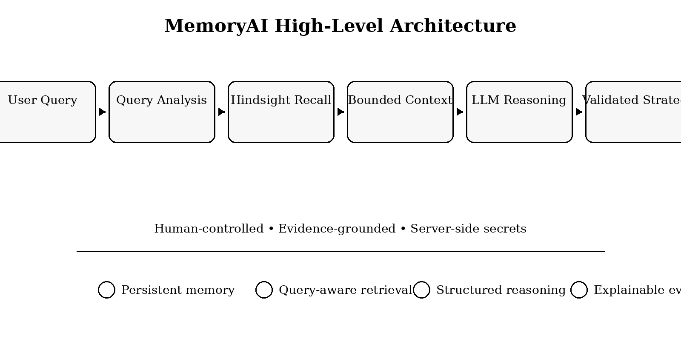
Layer | Responsibility | Primary Technology
Presentation | Responsive workspace, campaigns, audience, memory, strategist | Next.js + React + Tailwind CSS
Application API | Validation, orchestration, campaign endpoints | Next.js server routes + TypeScript
AI Reasoning | Structured recommendation generation | OpenAI-compatible LLM service
Persistent Memory | Retain and recall strategic knowledge | Hindsight Cloud
Campaign Intelligence | Deterministic metrics and query-aware selection | Typed application data layer
Validation & Safety | Schemas, sanitization, security controls | Zod + server-only configuration
MemoryAI is implemented as a Next.js application with server-side service boundaries. Hindsight provides persistent strategic memory. An OpenAI-compatible LLM provides reasoning. Campaign records are structured synthetic demonstration data in the application layer. No traditional SQL database is required by the current scope.

High-level pipeline: USER QUERY → QUERY ANALYSIS → HINDSIGHT RECALL → NORMALIZE / DEDUPLICATE / CATEGORIZE / BUDGET → OPTIONAL CAMPAIGN SELECTION → STRUCTURED PROMPT → OPENAI-COMPATIBLE LLM → ZOD RESPONSE VALIDATION → STRATEGY + EVIDENCE + EXPLANATION → USER FEEDBACK / EXPLICIT TEACHING.
External failures remain explicit. If Hindsight is unavailable, strategist generation does not proceed to the LLM. If the LLM provider fails, the API returns a sanitized service-unavailable response rather than fabricating an answer.

7. Hindsight Memory Architecture
The verified Hindsight bank is northstar-content-strategist, displayed as Northstar Content Strategist. Persistent knowledge includes brand identity, audiences, positioning, voice, content preferences, content themes and campaign-related strategic history.
The memory layer uses retain for persistence and recall for relevant retrieval. The strategist does not depend on Reflect for its core recommendation pipeline.
Provenance is explicit: Seeded Brand Knowledge, User Taught, User Feedback and Campaign History. Provenance is carried through retrieval and shown in the explainability UI.
Retrieval analyzes channel, audience, intent and keywords; categorizes memories as BRAND, AUDIENCE, CONTENT, CAMPAIGN or STRATEGIC; removes duplicates; and limits selected context to six memories. Genuine Hindsight relevance information is preserved when available; invented relevance numbers are not shown.
Memory safety includes 5–600 character constraints, secret detection, prompt-injection checks, script/style/XML/HTML stripping, duplicate detection and conflict handling. Conflicting guidance does not erase historical records; current guidance is preserved alongside history.

8. AI Content Strategist
The strategist pipeline is User Query → Hindsight Recall → Bounded Context Construction → LLM Reasoning → Zod Output Validation → Workspace UI.
The structured response contains a strategic summary, one to six recommendations, reasoning, memory-used references and caveats. memoryUsed is restricted to memories actually selected by retrieval.
Prompts place memory and user input inside explicit data boundaries. Memory is treated as data, not instructions. The system prohibits fabricated engagement rates, ROI percentages, conversion metrics and follower counts, and refuses unsupported future financial projections.
The AI service uses the official OpenAI TypeScript SDK as a provider abstraction while supporting OpenAI-compatible endpoints. The verified live configuration used OpenRouter through server-only environment variables.

9. Teach → Remember → Recall → Improve Learning Loop
The teaching workflow contains edit, category and context inputs, followed by a preview and explicit Save to Memory confirmation. Typing text does not silently create persistent memory.
Categories are restricted to BRAND, AUDIENCE, CONTENT, CAMPAIGN and STRATEGIC. Secrets such as API keys, tokens, private keys and passwords are rejected. Prompt-injection directives are rejected. Script/style/XML/HTML content is sanitized.
Exact and high-similarity duplicates are detected; near-duplicates at or above 0.85 Jaccard similarity are acknowledged instead of written again. Conflict handling preserves historical context and labels new direction as current strategic guidance.
Recommendation feedback is also explicit. Yes or No opens the teaching workflow with pre-populated content for review. This prevents silent writes and keeps the human in control of persistent strategic knowledge.

10. Campaign Intelligence
Campaign | Channel | Status | Reach | ER | CTR
Productivity Without the Noise | LinkedIn | Completed | 14,200 | 4.79% | 2.27%
Work Smarter, Not Louder | Instagram | Active | 26,500 | 2.79% | 0.97%
The Practical Tech Guide | LinkedIn | Completed | 11,500 | 5.30% | 2.64%
Behind the Workflow | Instagram | Active | 17,800 | 3.90% | 1.03%
Campaign intelligence is a structured application layer. Each campaign includes channel, status, dates, objective, audience, theme, format, summary, raw metrics, derived metrics and qualitative signals.
Four demonstration records: Productivity Without the Noise — LinkedIn — Completed — Reach 14,200 — ER 4.79% — CTR 2.27%; Work Smarter, Not Louder — Instagram — Active — Reach 26,500 — ER 2.79% — CTR 0.97%; The Practical Tech Guide — LinkedIn — Completed — Reach 11,500 — ER 5.30% — CTR 2.64%; Behind the Workflow — Instagram — Active — Reach 17,800 — ER 3.90% — CTR 1.03%.
Deterministic formulas: engagement rate = engagements / reach × 100; CTR = clicks / impressions × 100; conversion rate = conversions / clicks × 100. Division-by-zero is protected and client input cannot forge server-controlled campaign metrics.
Synthetic cross-campaign observations in the verified demonstration: average LinkedIn ER 5.04% vs Instagram 3.34%; average LinkedIn CTR 2.46% vs Instagram 1.00%; average Instagram reach 22,150 vs LinkedIn 12,850. These are demonstration observations only.
Campaign selection is query-aware: LinkedIn queries use LinkedIn context; Instagram queries use Instagram context; next-step queries can use both; tone/voice queries rely on brand memory; financial queries do not receive campaign context.

11. Explainable Recommendations and WOW Demonstration
Each recommendation includes Strategic Basis: why it fits Northstar, supporting memories, supporting campaigns and a natural-language strategic connection.
Memory evidence uses provenance labels such as User Taught, User Feedback, Campaign History and Seeded Brand Knowledge. Campaign evidence includes platform, status, deterministic metrics, key signals and a mandatory synthetic-data disclosure.
The architecture separates application-controlled facts from model interpretation. Evidence counts and evidence items come from verified state. The model cannot invent provenance, campaigns or metrics.
The WOW flow is a four-step chain: Memory → Campaign Evidence → Strategic Reasoning → Recommendation. It demonstrates the product's central value without exposing technical jargon such as vector distance or retriever scores.

12. Production UI and User Workflows
The interface uses a restrained dark SaaS visual system with readable typography, clear borders, visible focus states and responsive layouts. Navigation follows Overview → Campaigns → Audience → Memory → Strategist.
Overview explains the product and shows factual operational information without invented AI metrics. Campaigns provide list and detail views with synthetic disclosure. Audience shows primary and secondary context. Memory exposes provenance and teaching. Strategist provides query, recommendation, evidence and feedback workflows without chatbot-style conversation bubbles.
Loading, error, empty and not-found states are implemented. Desktop, tablet and mobile were manually verified. Keyboard navigation, Escape-key modal dismissal, focus behavior, semantic controls and touch targets were checked.

13. Security, Responsible AI and Data Integrity
Control | Implementation
Secret isolation | Hindsight and LLM keys remain server-only
Input validation | Zod schemas on API requests
Error safety | Sanitized 400 / 404 / 500 / 503 responses
Prompt injection | Untrusted memory/query boundaries and directive checks
Financial safety | Unsupported future revenue queries refused
Memory write safety | Preview + explicit confirmation + secret detection
Campaign integrity | Server-controlled deterministic records
Security headers | Nosniff, DENY framing, strict referrer policy, restricted permissions
Hindsight and LLM credentials are server-only. Sensitive variables are not exposed through client bundles or status endpoints. The final hardening report records zero secrets tracked in Git and .env.local ignored.
All POST APIs validate structure and types with Zod. Malformed or oversized requests return sanitized 400 responses; unknown campaign IDs return 404; unexpected errors return sanitized 500; external service failures return 503.
Logs do not record Authorization headers, API keys or raw confidential prompts. External calls use timeout handling. Security headers include X-Content-Type-Options nosniff, X-Frame-Options DENY, Referrer-Policy strict-origin-when-cross-origin and a restrictive Permissions-Policy.
Prompt injection is tested and neutralized. Financial queries such as “What will Northstar's 2027 revenue be?” are refused because no verified future revenue data exists. Campaign and explainability evidence remain application-controlled. Memory writes require confirmation.
Every campaign evidence view discloses that its performance data is synthetic demonstration data used to demonstrate campaign intelligence, not verified real-world business performance.

14. Technology Stack
Area | Technology / Component
Web Application | Next.js + React
Language | TypeScript
UI | Tailwind CSS + reusable components
AI Service | OpenAI TypeScript SDK / OpenAI-compatible endpoint
LLM Provider in Live Verification | OpenRouter
Persistent Memory | Hindsight Cloud
Validation | Zod
Testing | TypeScript / Node test suites
Deployment Target | Vercel or Node.js container
Frontend/application: Next.js, React, TypeScript, Tailwind CSS and reusable UI components. API/backend: Next.js server routes and typed service modules. AI: official OpenAI TypeScript SDK through an OpenAI-compatible provider abstraction. Persistent memory: Hindsight Cloud. Validation: Zod. Testing: TypeScript/Node test suites. Deployment target: Vercel or a standard Node.js container.
Key modules: src/lib/ai for LLM services; src/lib/hindsight for memory integration; src/lib/strategist for query analysis, retrieval, context and recommendations; src/lib/memory for teaching and learning; src/lib/campaigns for deterministic campaign intelligence; and strategist/explainability for evidence construction.
The current scope intentionally avoids a SQL database because persistent strategic memory is handled by Hindsight and campaign data is a controlled demonstration layer. A database becomes appropriate if later requirements include multi-user identity, organization tenancy, large-scale persistence, imports, billing or transactional workflows.

15. Testing, Verification and Results
Verification | Result
Automated tests | 74 / 74 passing; 0 failures; 0 skipped
TypeScript | 0 errors
Lint | 0 warnings; 0 errors
Production build | Passed with Next.js Turbopack
npm audit | 0 reported vulnerabilities
Live Hindsight + OpenRouter | Learning, recall, explanation and safety flows verified
Responsive QA | Desktop, tablet and mobile verified
Accessibility QA | Keyboard navigation, focus, semantics and touch targets verified
Final hardening records 74 automated tests across six suites: Task 5 retrieval 12; Task 6 teach 14; Task 7 campaigns 14; Task 8 UI workflows 9; Task 9 explainability 10; Task 10 hardening 15. Result: 74/74 passing, zero failures, zero skipped.
Static verification: npx tsc --noEmit passed with zero TypeScript errors; npm run lint passed with zero warnings/errors; npm run build passed using Next.js Turbopack; npm audit reported zero vulnerabilities.
Live Hindsight + OpenRouter verification taught a LinkedIn preference, recalled it, used it in strategist reasoning, exposed provenance, selected relevant LinkedIn campaigns and preserved historical campaign memories. Tone-query evidence handling, financial refusal and prompt-injection neutralization were also verified.
Responsive and accessibility QA covered desktop, tablet and mobile layouts, keyboard navigation, semantic controls, focus states, modal behavior and touch targets. Deployment-readiness verification supports standard Vercel or Node.js container deployment with no local filesystem persistence requirement.

16. Deployment Readiness
The codebase is prepared for Vercel or a standard Node.js container. Runtime configuration is externalized through HINDSIGHT_BASE_URL, HINDSIGHT_API_KEY, HINDSIGHT_BANK_ID, LLM_PROVIDER, LLM_API_KEY, LLM_MODEL, LLM_BASE_URL and LLM_TIMEOUT_MS.
Sensitive variables must not use NEXT_PUBLIC_. Production values should be configured in the hosting provider's environment settings. The Hindsight bank remains northstar-content-strategist.
Deployment readiness is not the same as proof of a live production URL. The actual Vercel URL should be inserted after deployment and post-deployment verification. Core customer workflows should be rechecked after deployment.

17. Limitations and Future Scope
Current limitations: campaign performance records are synthetic demonstration data; Hindsight Cloud can introduce approximately one-to-two-second remote indexing latency; and the product depends on external Hindsight and LLM service availability.
Future scope may include real social-platform integrations, live campaign imports, organization and user tenancy, authenticated roles, larger campaign histories, controlled analytics dashboards, content drafting and approval workflows, scheduled publishing and deeper production-data integrations.
The core design principle should remain: organizational memory must be inspectable, evidence must be authentic, model output must remain bounded by available context, and users must control what becomes persistent guidance.

18. Conclusion
MemoryAI demonstrates a practical approach to AI-assisted content strategy in which persistence and explainability are first-class capabilities. Instead of repeatedly asking an LLM for generic content ideas, the system remembers Northstar's context, retrieves relevant knowledge, combines it with selected campaign observations, produces structured recommendations and shows the evidence behind them.
The Teach → Remember → Recall → Reason → Explain → Improve loop turns organizational knowledge into reusable strategic context while maintaining explicit user control. Production-oriented validation, security boundaries, deterministic data handling, responsive UI, accessibility checks and automated regression testing support the implementation.
The verified engineering state is suitable as the technical foundation for a hackathon demonstration and continued product development. Submission packaging and insertion of the actual production URL remain separate from the engineering verification.

Appendix A. Verified Project Facts
Milestone | Verified State
Task 7 | Campaign intelligence complete; synthetic data disclosed
Task 8 | Production UI and complete workflows complete
Task 9 | Explainability and WOW evidence flow complete
Task 10 | Production hardening, security, testing and deployment readiness complete
Repository | regondashiva/microsoft_hack
Hindsight bank | northstar-content-strategist
Final hardening commit | 6f5c22a720590d7927117a939c5b80fbb8679376
Project: MemoryAI — AI Content Strategist. Organization: Northstar Brand Co. Repository: regondashiva/microsoft_hack. Hindsight bank: northstar-content-strategist. Primary LLM integration: OpenAI-compatible service; live verification used OpenRouter.
Final hardening commit recorded in Task 10: 6f5c22a720590d7927117a939c5b80fbb8679376. Task 9 explainability commit: 99069f7. Task 8 UI commit: 304383b. Task 7 campaign intelligence commit: 6e82fad.
Verified results: 74/74 automated tests passing; TypeScript zero errors; lint zero warnings/errors; production build passed; npm audit zero vulnerabilities; responsive and accessibility QA passed; live Hindsight + OpenRouter verification passed for learning, explanation and safety workflows.
Disclosure: campaign performance numbers are synthetic demonstration data and must not be represented as verified commercial performance.

Appendix B. Live Demonstration Script
1. Overview — introduce MemoryAI as a persistent AI Content Strategist for Northstar and explain that its key difference is memory-backed strategy.
2. Memory — show seeded knowledge and campaign history. Teach: “Northstar's LinkedIn audience prefers concrete workflow examples over generic productivity advice.” Preview and explicitly confirm.
3. Strategist — ask: “What should Northstar post next on LinkedIn?” Show the newly taught preference and relevant LinkedIn campaign context in the response.
4. Strategic Basis — demonstrate Memory → Campaign Evidence → Strategic Reasoning → Recommendation and point out User Taught provenance plus synthetic-data disclosure.
5. Feedback — choose Yes or No and show that feedback opens an explicit teaching workflow instead of silently changing memory.
6. Safety — ask “What will Northstar's 2027 revenue be?” and show the refusal. Then demonstrate a prompt-injection attempt and show that grounding and safety rules remain active.
Closing: “MemoryAI turns brand knowledge and campaign history into persistent, explainable content strategy while keeping the human in control of what the system learns.”

