Data Structure and Algorithm

Laboratory Activity No. 3

Translating Algorithm to Program

|  |  |
| --- | --- |
| *Submitted by:* | *Instructor:* |
| Regondola, Jezreel P. | Engr. Maria Rizette H. Sayo |

August 02, 2025

# Objectives

Introduction

Data structure is a systematic way of organizing and accessing data, and an algorithm is a step-by-step procedure for performing some tasks in a finite amount of time. These concepts are central to computing, but to be able to classify some data structures and algorithms as “good,” we must have precise ways of analyzing them.

This laboratory activity aims to implement the principles and techniques in:

* Writing a well-structured procedure in programming
* Writing algorithm that best suits to solve computing problems
* Writing an efficient Python program from translated algorithms

# Methods

• Design an algorithm and the corresponding flowchart (Note: You may use LucidChart or any application) for adding the test scores as given below if the number is even: 26,49,98,87,62,75

• Translate the algorithm to a Python program (using Google Colab)

• Save your source codes to GitHub

# Results

Present the visualized procedures done. Also present the results with corresponding data visualizations such as graphs, charts, tables, or image . Please provide insights, commentaries, or explanations regarding the data. If an explanation requires the support of literature such as academic journals, books, magazines, reports, or web articles please cite and reference them using the IEEE format.

Please take note of the styles on the style ribbon as these would serve as the style format of this laboratory report. The body style is Times New Roman size 12, line spacing: 1.5. Body text should be in Justified alignment, while captions should be center-aligned. Images should be readable and include captions. Please refer to the sample below:

Algorithm:

STEP 1: Start

STEP 2: Initialize a variable “Scores”(array of scores) and “Total = 0” (to store the sum of even scores)

STEP 3: Check each test score:

1. If the score is even, add it to the Total
2. If the score is odd, skip it

STEP 4:Print the Total

STEP 5: End

Flowchart:

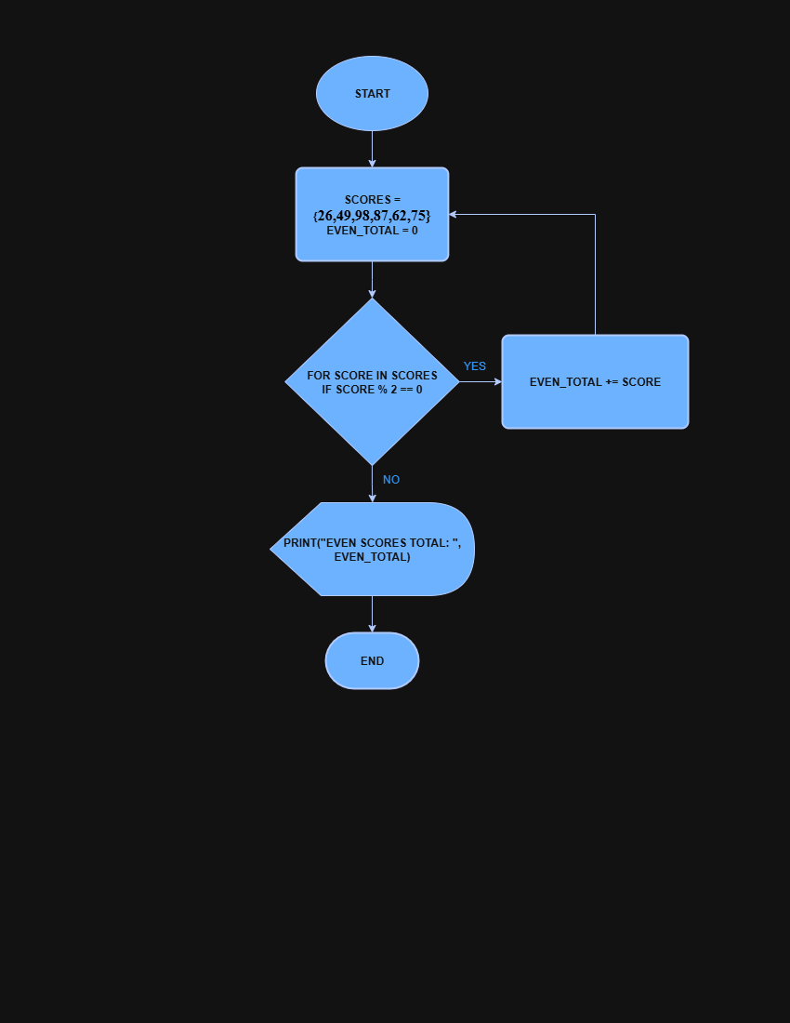

Figure 1 Screenshot of program

Source Code:

Please refer to this link: <https://colab.research.google.com/drive/1eEwBqfD48XQbWs4GQoH1Cg8DIzK-_yPC#scrollTo=U_EwkZzhydyl&line=1&uniqifier=1>

If an image is taken from another literature or intellectual property, please cite them accordingly in the caption. Always keep in mind the Honor Code [1] of our course to prevent failure due to academic dishonesty.

# Conclusion

The conclusion expresses the summary of the whole laboratory report as perceived by the authors of the report.

In conclusion, this activity helps us learn how to organize and solve problems using data structures and algorithms. This Laboratory Activity focuses on writing clear programs, writing and choosing the right algorithms, and creating efficient python code to solve problems.

**References**

[1] Co Arthur O.. “University of Caloocan City Computer Engineering Department Honor Code,” UCC-CpE Departmental Policies, 2020.