Project Manual

**IMAGE BASED ATTENDANCE MONITORING SYSTEM**

Group Number:23

1.Dhanush M Kuber 1PE12EC041

2.Chethan Kumar TJ 1PE13EC031

3.Bhagyashree 1PE13EC024

4.Mridula C 1PE13EC076

Guide: Dr. Subhash S Kulkarni

**PROJECT FUNCTION**

This is a real time system consisting of four phases- creating database, face detection, face recognition and marking attendance. The attendance is recorded by using a camera that captures group images of the students. The group image is then subjected to detection where individual faces are segmented and then compared with the stored database to perform recognition. The attendance is then marked on the Attendance sheet.

**BRIEF DESCRIPTION**

The system consists of a camera that captures the images of the students sitting in the classroom and subjects it to face detection which is achieved through Viola and Jones algorithm .The detected faces are then subjected to recognition where it is matched against the stored database using Eigen Faces and Principal Component Analysis(PCA).The Attendance is then marked on the Attendance sheet. The proposed method holds good only for non-overlapping faces in the group Image.

**REVISION HISTORY**

**Face Detection** –Initially used Skin Colour detection and then changed to Viola and Jones

**Database** – Tested on the orl standard Database in the initial stage , later implemented on the self-created database.

**Graphical User Interface (GUI)** – Initially Android environment , now changed to MATLAB GUI

**GENERAL DESCRIPTION**

Face recognition has been one of the most important and interesting research fields in the need of automatic recognition and surveillance systems. In this report we go through general ideas of detection and recognition in a group image. A near real time detection system is to be developed that uses skin-tone color model or using Haar wavelet decomposition for face detection and facial point detection method for face recognition.

 Detecting a face is simpler than recognizing a face of a specific person. In order to be able to determine that a certain picture contains a face (or several) we need to be able to define the general structure of a face. Luckily human faces do not greatly differ from each other; we all have noses, eyes, foreheads, chins and mouths; and all of these compose the general structure of a face. The difference between face detection and recognition is that in detection we just need to determine if there is some face in the image, but in recognition we want to determine whose face it is.

**PROJECT EVOLUTION**

* For face detection, Viola- Jones algorithm is preferred over the initially chosen skin detection method, as it consists of a scale and location invariant detector and better feature selection through which higher accuracy is achieved.
* The training database is created, which consists of 5 images of every individual under criterions like different facial elevations or positions. The lighting condition is not varied.
* The test image, initially, was a group image consisting of five people, which was replaced by an image consisting of twenty people.
* Face recognition is achieved through Eigen Face using Principle Component Analysis. The advantage of this approach over other face recognition systems is in its simplicity, speed and insensitivity to small or gradual changes on the face.
* Face detection and recognition was first carried out on MATLAB and then on Open CV.
* Integration of both the modules is carried out in MATLAB.

**PROJECT SPECIFICATION**

**Hardware** :

1. Capturing device - Camera with 13MP resolution has been used.

**Software :**

1. MATLAB R2012a , R2016a (Computer vision toolbox)
2. Open CV 3.2.0 using Python 2.7.1

**APPLICATION**

* **Attendance monitoring**

Image Processing Is widely used in various fields for automated detection and recognition of desired objects. The current project deals with a specific application which is recording the attendance of a class of students . Which greatly reduces the time along with the operation being performed at great ease .

**ALGORITHM**

**Image Detection** - Viola-Jones

* Creating an integral image.
* Feature extraction using Haar. The different types of features are shown-

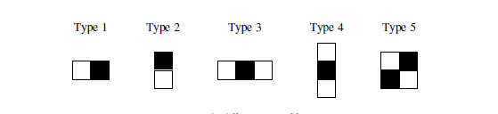

* Adaboost classifier
* Detected face region

**Recognition** – PCA

* Prepare a training set of face images.
* Subtract the mean from every individual Image
* Calculate the eigenvectors and eigenvalues of the covariance matrix
* Choose the principal components
* These Eigen faces can now be used to represent both existing and new faces to perform recognition

**FLOW CHART**

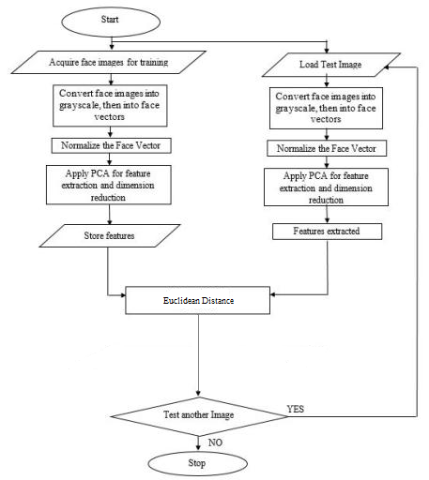

**SOFTWARE ENVIRONMENT DETAIL**

Operating System : Windows 10

Tools : Matlab–R2014 , OpenCv 3.2

**SOFTWARE TEST RESULTS**

We performed face detection and recognition using Eigen Faces and PCA

**Standard Database**

No of faces trained - Total 200 of 40 Individuals

Recognized correctly - 189

False Recognition - 11

Accuracy - 94.5%

**Own Database**

No of faces trained - 10

Recognized correctly - 7

False Recognition - 3

Accuracy - 70%

**SOFTWARE TEST SETUP**

* Processor : Intel core i5-5200 CPU @ 2.20 GHz
* Memory : 8.00 GB
* System Type : x64-based processor
* Standard Database : ORL Database(40*5 images)
* Own Database : 12 *4 images

**SOFTWARE PACKAGING**

Graphical User Interface :

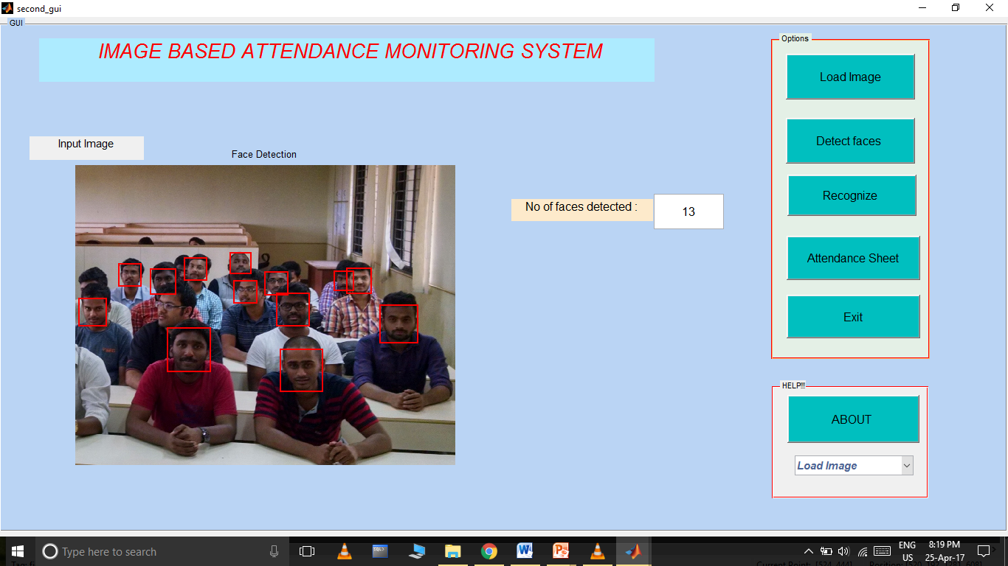

Attendance Sheet



**BLOCK DIAGRAM**

Detection

Training

Create Database

Input Group Image

Marking Attendance

Recognition

**PROJECT PLAN**

**GANTT CHART :**

