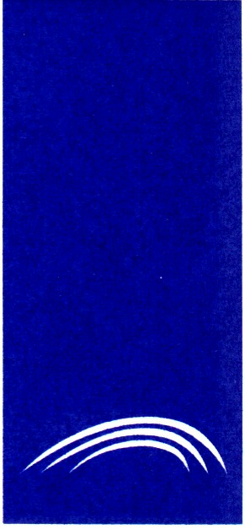 | THE MINISTRY OF TRANSPORT AND COMMUNICATIONS OF THE REPUBLIC OF LITHUANIA
 | LITHUANIAN ROAD ADMINISTRATION TRANSPORT AND ROAD RESEARCH INSTITUTE
 | REPORT ON COMBINED CENSUS OF MOTOR TRAFFIC AND INVENTOTY OF STANDARDS AND PARAMETERS ON MAIN INTERNATIONAL TRAFFIC ARTERIES IN EUROPE IN 2005
 | 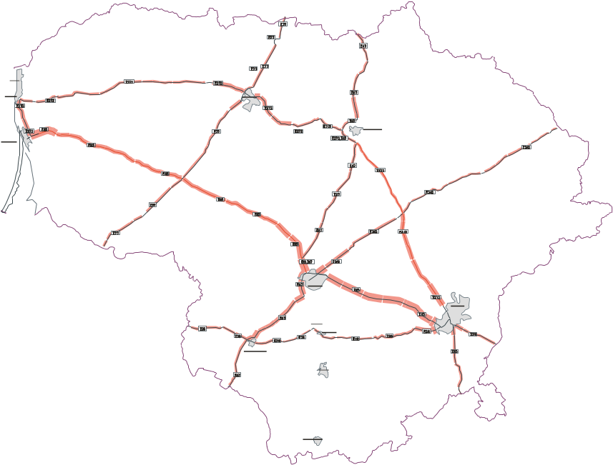
 | March, 2006

