General Directorate for National Roads and Motorways
„Transprojekt - Warszawa” Consulting Engineers Ltd.

The Census of Motor Traffic On Main
International Traffic Arteries
in Poland in 2005.

Warsaw, 2006
The Census of Motor Traffic On Main International Traffic Arteries in Poland in 2005.

The 2005 Census of Motor Traffic on Main International Traffic Arteries was carried out within the National Traffic Census which General Directorate for National Roads and Motorways designs and undertakes every five years over the whole national road network in Poland. Counting posts were located in such a way that each road section with homogeneous traffic would have at least one post. The direct counts were performed at 547 counting posts located on E Roads of total length 5024 km. Vehicles were recorded manually by trained observers under supervision of the local road administration. Additionally, data from 40 automatic traffic count stations were used for data elaboration.
For the census purposes, vehicles were divided into the following categories:
- motorcycles, scooters,
- passenger vehicles (up to 9 seats including driver) with or without trailer,
- light goods vehicles (vehicles with permissible maximum weight not higher than 3,5 t) with or without trailer,
- heavy goods vehicles with permissible maximum weight higher than 3,5 t without trailers, special heavy vehicles, tractors without semitrailers,
- heavy goods vehicles with permissible maximum weight higher than 3,5 t with one or more trailers, tractors with semitrailers, ballast tractors with standard or low chassis trailers,
- buses, coaches, trolley-buses,
- agricultural tractors with or without trailers, mobile machines (graders, excavators, rollers, etc.)
One-year cycle of counts covered 9 „day” periods from 6⁰⁰ to 22⁰⁰ and 2 „night” periods from 22⁰⁰ to 6⁰⁰ (at some selected locations only 9 “day” periods from 8⁰⁰ to 16⁰⁰). Periods of traffic counts were chosen in a way, which makes possible to define the annual average daily traffic with required accuracy. The schedule of traffic census in 2005 is presented in the table shown below.

Number of count | Date  of counting | Day of  the week | Character of counting
x₁ | 27 January | Thursday | day
x₂ | 15 March | Tuesday | day
x₃ | 18 May | Wednesday | day
x₄ | 14 July | Thursday | day
x₅ | 17 July | Sunday | day
x₆ | 23 August | Tuesday | day
x₇ | 28 August | Sunday | day
x₈ | 21 September | Wednesday | day
x₉ | 11 December | Sunday | day
x₁₀ | 18/19 May | Wedn./Thursday | night
x₁₁ | 21/22 September | Wedn./Thursday | night

Method used for calculation of daily averages

M_{R} x N₁ + 0,8 x M_{R} x N₂ + M_{N} x N₃
AADT = --------------------------------------------- + R_{N}
N

Where:

AADT - Annual Average Daily Traffic
M_{R} - average „day” traffic per workdays
M_{N} - average „day” traffic per Sundays and holidays
R_{N} - average „night” traffic
N₁ - number of working days in year, N₁ = 249
N₂ - number of Saturdays and pre-holidays days, N₂ = 56
N₃ - number of Sundays and official holidays, N₃ = 60
N - number of days in year, N = 365.

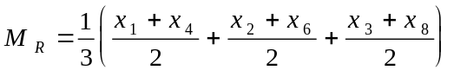
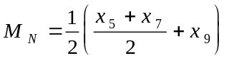
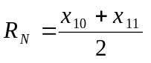

Where:

x₁, x₂ ...... x₉ - „day” traffic (6⁰⁰ - 22⁰⁰)
x₁₀, x₁₁ - „night” traffic (22⁰⁰ - 6⁰⁰)
on the days of counting.

INFORMATION ON E ROADS

