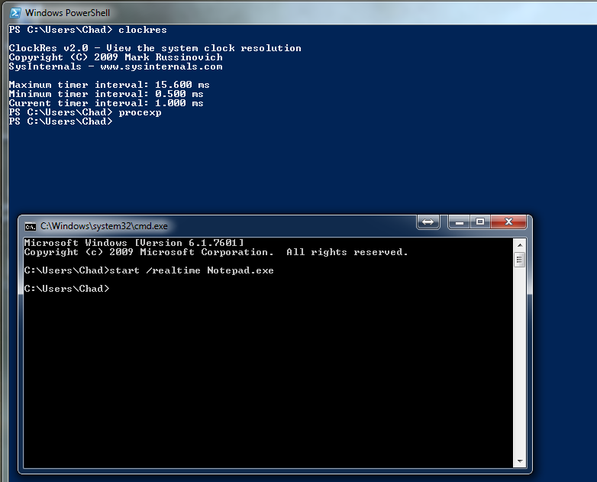
Homework 2
Chad Weigle

I noticed that the thread count and priority for the notepad.exe was different between the procexp and the task manager. The base priority in the task manager was 2 where as in the procexp program it was 13 which is a large difference.

I did not take a screen shot per step because some of these screen shots includes two of the steps. Also, I was not able to save in PDF format because I am using Libre Office and there was no option to.

