Software Requirement Specification

**TMSO-SRS-001**

Version 1.0

**Revision History**

|  |  |  |  |  |
| --- | --- | --- | --- | --- |
| **Date** | **Version** | **Description** | **Author** | **Revised by** |
| 18/02/2019 | 1.0 | First version | Nguyen Thi Nhu Quynh  Nguyen Hung Thang | Nguyen Thi Nhu Quynh |

**Table of Contents**

**Contents**

**1.** **Introduction** 3

**1.1** **Overview** 3

**2.** **Functional Requirements** 4

2.1 Feature/Component #1: **Main Screen** 4

2.1.1 User Interfaces 4

2.1.2 Functional Requirements 4

2.2 Feature/Component #2: **Mobile** 5

2.2.1 User Interfaces 5

2.2.2 Functional Requirements 5

2.3 **Feature/Component #3: Laptop** 6

2.3.1 User Interfaces 6

2.3.2 Functional Requirements 6

**2.4** **Feature/Component #4: Contact** 7

2.4.2 Functional Requirements 7

2.5 **Feature/Component #5: Infomation** 8

2.5.1 User Interfaces 8

2.5.2 Functional Requirements 8

2.6 Feature/Component #6: **Shopping-Cart** 9

2.6.1 User Interfaces 9

2.6.2 Functional Requirements 9

2.7 **Feature/Component #7: Detail** 10

2.7.1 User Interfaces 10

2.7.2 Functional Requirements 10

# **Introduction**

## **Overview**

This application allows users buy products electric on app easily

**Scope**

* Demo version
* Demo version is for display purpose only, not link to Database, not link to affiliated sites
* Android : from 4.0 +
* Android test devices: Smartphone, PC
* Android screen resolutions: Standard
* Support screen orientation in portrait mode only

# **Functional Requirements**

## 2.1 Feature/Component #1: **Main Screen**

### 2.1.1 User Interfaces

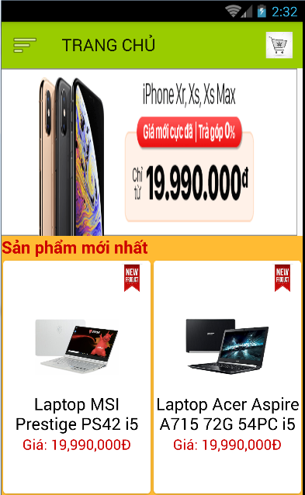

*Image 1: Main*

### Functional Requirements

|  |  |  |  |
| --- | --- | --- | --- |
| **Item** | **Description** | **Action** | **Response** |
| **Button “Page Main”** | Show all the latest products and run ads for other websites | When clicking on the application will run to the main screen interface | N/A |
| **Button “Mobile”** | show all products about mobile | When clicking on the application will run to the mobile screen | switch to another screen |
| **Button “Laptop”** | show all products about laptop | When clicking on the application will run to the laptop screen | switch to another screen |
| **Button “Contact”** | show all developer contacts | When clicking on the application will run to the contact screen | switch to another screen |
| **Button “Information”** | show all information of the buyer | When clicking on the application will run to the information screen | switch to another screen |

## Feature/Component #2: **Mobile**

### User Interfaces



*Image 2: Mobile*

### Functional Requirements

|  |  |  |  |
| --- | --- | --- | --- |
| **Item** | **Description** | **Action** | **Response** |
| **TextView: name, price, describ, type product** | display name, price, description, product type about mobile | N/A | N/A |
| **ImageView: image product** | display image product | N/A | N/A |

## **Feature/Component #3: Laptop**

### 2.3.1 User Interfaces



*Image 3 : Laptop*

### Functional Requirements

|  |  |  |  |
| --- | --- | --- | --- |
| **Item** | **Description** | **Action** | **Response** |
| **TextView: name, price, describ, type product** | display name, price, description, product type about laptop | N/A | N/A |
| **ImageView: image product** | display image product | N/A | N/A |

## **Feature/Component #4: Contact**

**2.4.1 User Interfaces**

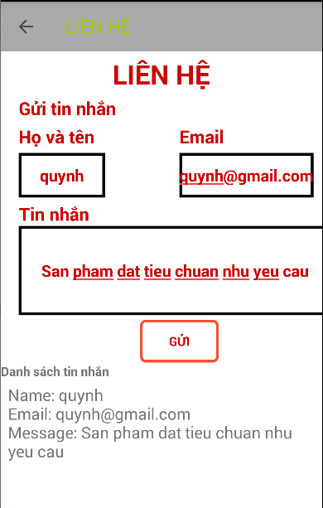

*Image 4 : Contact*

### Functional Requirements

|  |  |  |  |
| --- | --- | --- | --- |
| **Item** | **Description** | **Action** | **Response** |
| **TextView:name, email, message** | display name,email,message about customer | N/A | N/A |
| **EditText: name, email, message** | permission user input name, email,message about customer | input data | N/A |
| **ListView** | show information customer | show list | N/A |
| **Button** | action content on listview | action | N/A |

## **Feature/Component #5: Infomation**

### User Interfaces

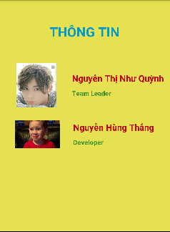

*Image 5: Information*

### Functional Requirements

|  |  |  |  |
| --- | --- | --- | --- |
| **Item** | **Description** | **Action** | **Response** |

|  |  |  |  |
| --- | --- | --- | --- |
| **TextView: Name, Position’s Team** | show name, position’s team | N/A | N/A |
| **ImageView** | show member’s image | N/A | N/A |

## 2.6 Feature/Component #6: **Shopping-Cart**

### 2.6.1 User Interfaces

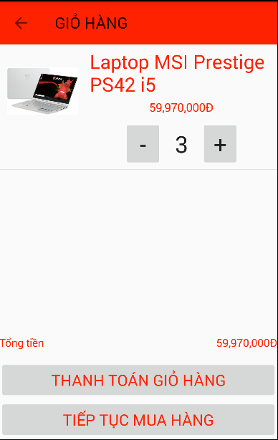

*Image 6 : Shopping-Cart*

### Functional Requirements

|  |  |  |  |
| --- | --- | --- | --- |
| **Item** | **Description** | **Action** | **Response** |
| **ListView** | show all product when user buy and save shopping-cart | switch to shopping-cart screen | N/A |
| Button:pay, continue buying | -pay: when user agree to buy product -continue buy: when user want to add product on shopping-cart | -cofirm successful  -switch to screen after | N/A |

## **Feature/Component #7: Detail**

### User Interfaces

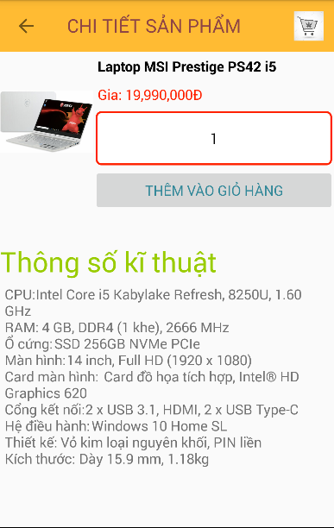

*Image 7: Detail*

### Functional Requirements

|  |  |  |  |
| --- | --- | --- | --- |
| **Item** | **Description** | **Action** | **Response** |
| **TextView: name, price ,describ product** | show all name, price, describ product | N/A | N/A |
| Spinner | Users have the right to purchase such products in large quantities | have a list quantities | dropdown list |
| ImageView | show image product | N/A | N/A |

***---------- End of Document ----------***