TRƯỜNG CAO ĐẲNG CÔNG NGHỆ THỦ ĐỨC
KHOA CÔNG NGHỆ THÔNG TIN
--------------------------------



BÁO CÁO KẾT THÚC MÔN HỌC
Di động 2

Buy Online

Giảng viên hướng dẫn: Tiêu Kim Cương
Sinh viên thực hiện:
- Nguyễn Hùng Thắng
- Nguyễn Thị Như Quỳnh

Ngành: Công nghệ thông tin Lớp: 18211CNC10731203 Khoá: 15

Tp. Hồ Chí Minh, ngày 5 tháng 05 năm 2019
NHẬT KÝ HOẠT ĐỘNG NHÓM

Stt | Họ và tên | Công việc đã thực hiện | Nhóm đánh giá  (Tính theo %) | Chữ ký
1 | Nguyễn Hùng Thắng | 1. Design and Depeloper  2. Test Report | 50%
2 | Nguyễn Thị Như Quỳnh | 1. Design and Depeloper  2. Test Report  3.Write report group  4.Team leader | 50%

CATEGORY

CHAPTER 1. PREAMBLE 4
1. Introduce subject and group implementation: 4
a) Introduce: 4
b) Group implementation: 4
2. Application description: 4
3. Necessity of application: 4
CHAPTER 2. ANALYSIS OF THE DESIGN SYSTEM 5
2.1 System Analysis: 5
2.1.1 Feature/Component #1: Main Screen 5
2.1.1.1 User Interfaces 5
2.1.1.2 Functional Requirements 5
Feature/Component #2: Mobile 5
1. User Interfaces 5
2. Functional Requirements 5
Feature/Component #3: Laptop 6
2.3.1 User Interfaces 6
2. Functional Requirements 6
Feature/Component #4: Contact 7
2. Functional Requirements 7
Feature/Component #5: Infomation 8
1. User Interfaces 8
2. Functional Requirements 8
2.6 Feature/Component #6: Shopping-Cart 8
2.6.1 User Interfaces 8
2. Functional Requirements 9
Button:pay, continue buying 9
-pay: when user agree to buy product 9
Feature/Component #7: Detail 10
1. User Interfaces 10
2. Functional Requirements 10
Spinner 10
Users have the right to purchase such products in large quantities 10
ImageView 10
show image product 10
4.Conclusions and recommendations: 11
REFERENCES 12

CHAPTER 1. PREAMBLE

1. Introduce subject and group implementation:

a) Introduce:

- Mobile 2: is a project of the Mobile Specialization in Software Engineering

b) Group implementation:

- Team Leader: Nguyễn Thị Như Quỳnh

- Mission: Assign and monitor the activity of the whole group

- Design and Depeloper:

+ Nguyễn Hùng Thắng:
- Design and programming
+ Nguyễn Thị Như Quỳnh:
- Design and programming
- Test Report Sprint.
- Mangager team activity

2. Application description:
- This application allows users buy product electric on app
** Scope
- Demo version
- Demo version is for display purpose only Web Service
- Android : from 4.0 ⁺
- Android test devices: Smartphone, PC
- Android screen resolutions: Standard
- Support screen orientation in portrait mode only

3. Necessity of application:
- The application makes it easy for users to buy product on app

CHAPTER 2. ANALYSIS OF THE DESIGN SYSTEM

2.1 System Analysis:

2.1.1 Feature/Component #1: Main Screen

2.1.1.1 User Interfaces

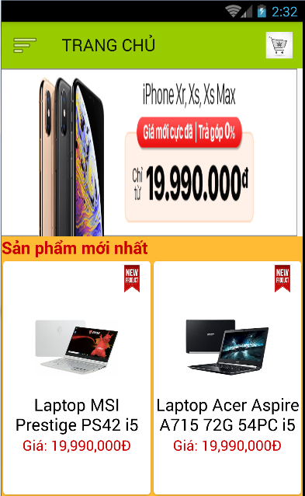
Image 1 : Main Screen

Functional Requirements

Item | Description | Action | Response
Button “Page Main” | Show all the latest products and run ads for other websites | When clicking on the application will run to the main screen interface | N/A
Button “Mobile” | show all products about mobile | When clicking on the application will run to the mobile screen | switch to another screen
Button “Laptop” | show all products about laptop | When clicking on the application will run to the laptop screen | switch to another screen
Button “Contact” | show all developer contacts | When clicking on the application will run to the contact screen | switch to another screen
Button “Information” | show all information of the buyer | When clicking on the application will run to the information screen | switch to another screen

Feature/Component #2: Mobile
    - User Interfaces

Image 2: Mobile

    - Functional Requirements
Item | Description | Action | Response
TextView: name, price, describ, type product | display name, price, description, product type about mobile | N/A | N/A
ImageView: image product | display image product | N/A | N/A

Feature/Component #3: Laptop

2.3.1 User Interfaces

Image 3 : Laptop
    - Functional Requirements
Item | Description | Action | Response
TextView: name, price, describ, type product | display name, price, description, product type about laptop | N/A | N/A
ImageView: image product | display image product | N/A | N/A

Feature/Component #4: Contact
2.4.1 User Interfaces
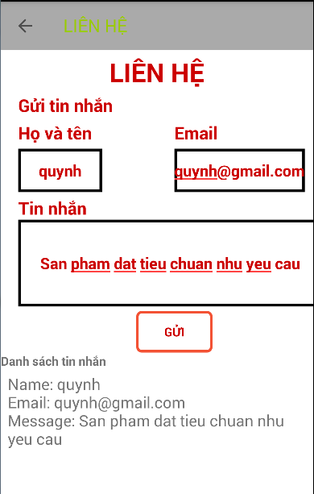
Image 4 : Contact
    - Functional Requirements
Item | Description | Action | Response
TextView | display information developer | N/A | N/A

Feature/Component #5: Infomation
    - User Interfaces

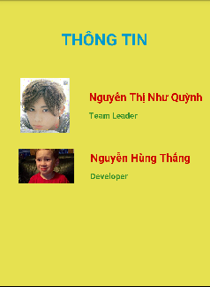

Image 5: Information
    - Functional Requirements
Item | Description | Action | Response

Edit Text : name, phone number, email | show name, phone number, email about user when user buy product on shopping-cart | switch to shopping-cart screen | N/A
Button: confirm ,back | -comfirm when user agree to buy product  -back: come back interface after | switch to information screen | N/A

2.6 Feature/Component #6: Shopping-Cart

2.6.1 User Interfaces
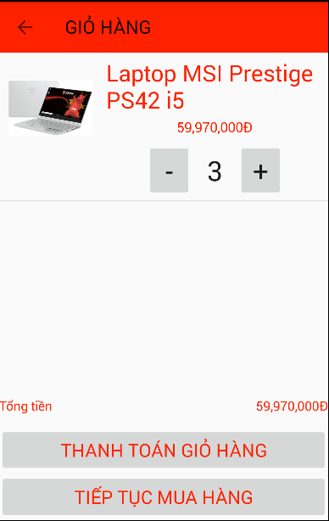
Image 6 : Shopping-Cart
    - Functional Requirements
Item | Description | Action | Response
ListView | show all product when user buy and save shopping-cart | switch to shopping-cart screen | N/A
Button:pay, continue buying | -pay: when user agree to buy product  -continue buy: when user want to add product on shopping-cart | -cofirm successful  -switch to screen after | N/A

Feature/Component #7: Detail
    - User Interfaces
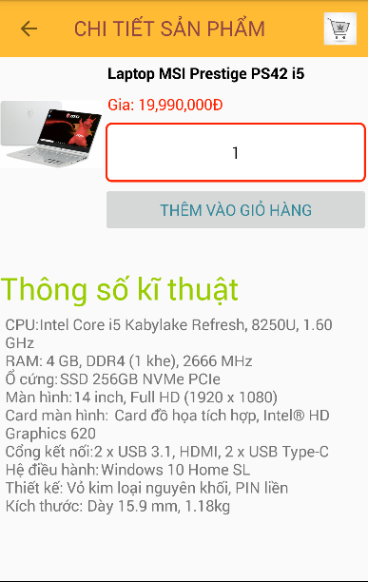
Image 7: Detail
    - Functional Requirements
Item | Description | Action | Response
TextView: name, price ,describ product | show all name, price, describ product | N/A | N/A
Spinner | Users have the right to purchase such products in large quantities | have a list quantities | dropdown list
ImageView | show image product | N/A | N/A

4.Conclusions and recommendations:
a)Points have been made:

- Citing news sources from different pages and integrating them through RSS.
- Stored user preferences into the database.
-Watch the news quickly without having to go to any news site

b)Points not yet done:
- Only use the firebase database without using web services

c) Additional functions if more time: voted, comment, evaluate…

REFERENCES

Cited Sources:
-http://online.khoapham.vn/android/31-xay-dung-ung-dung-ban-hang-online/263-android--app-ban-hang--bai-1--cai-dat-server-localhost.html?fbclid=IwAR30526PmWmSNuhBZpznz1bTcmkzvc0t9qcXPCntyOn1FT1qSEe3V1_f4Kc
………………………………………….END……………………………………………..

Link github:
https://github.com/regularly19071995/DiDong2

