Casellas Lab CRISPR Protocol

The “CRISPR sgRNA design” presentation complements this protocol with useful illustrations of steps.

Design and test 3-4 CRISPRs per targeted genomic region. Choose the CRISPR with the highest frequency of cutting, as assessed via the T7 Endonuclease assay, for actual genome editing experiment.

Updated Rules for sgRNA design.

1. 18-mer guide sequences are more sensitive to mismatches than a 20-mer sgRNA. Consequently, a shorter sgRNA induces low or undetectable off-targets with 1 or 2 mismatches while 20-mer sgRNAs cause higher levels of mutagenesis at off-targets with 4 or 5 mismatches (5).
2. sgRNA should target the non-transcribed strand (11).
3. sgRNA should target the earliest coding exons when possible (11).
4. SEED sequences of guide should be unique (6).
5. Target GGG PAM sequences may be ideal for conventional Cas9(6).
6. GC content of sgRNA should be within 40 to 60% (11).
7. For 20-mer sgRNA, the four last 3’ NTs should be :

5’-….NNN-R(17)-[R/Y](18)- R(19)-R(20)-3’ (11).

CRISPR sgRNA Design.

1. For strategies based on homologous recombination, select a genomic target from 23 to 250 nucleotides around the expected cutting site (sense strand or non-coding strand of genic sequence).
2. Verify that the selected target sequence is unique in the genome (e.g. use BLAT tool on UCSC genome browser and use Mappability or Repeat Masker tracks in browser).
3. In the CRISPR web tool: http://crispr.ybzhao.com enter “task description”, name and email address in “Information” section, select “Target sgRNA Size”, “PAM type”, designate target genome, and enter genomic sequence (Figure 1).
4. Once the CRISPR web tool has finished calculating scores for all discovered guide sequences, you will get a link to the result page by your email.

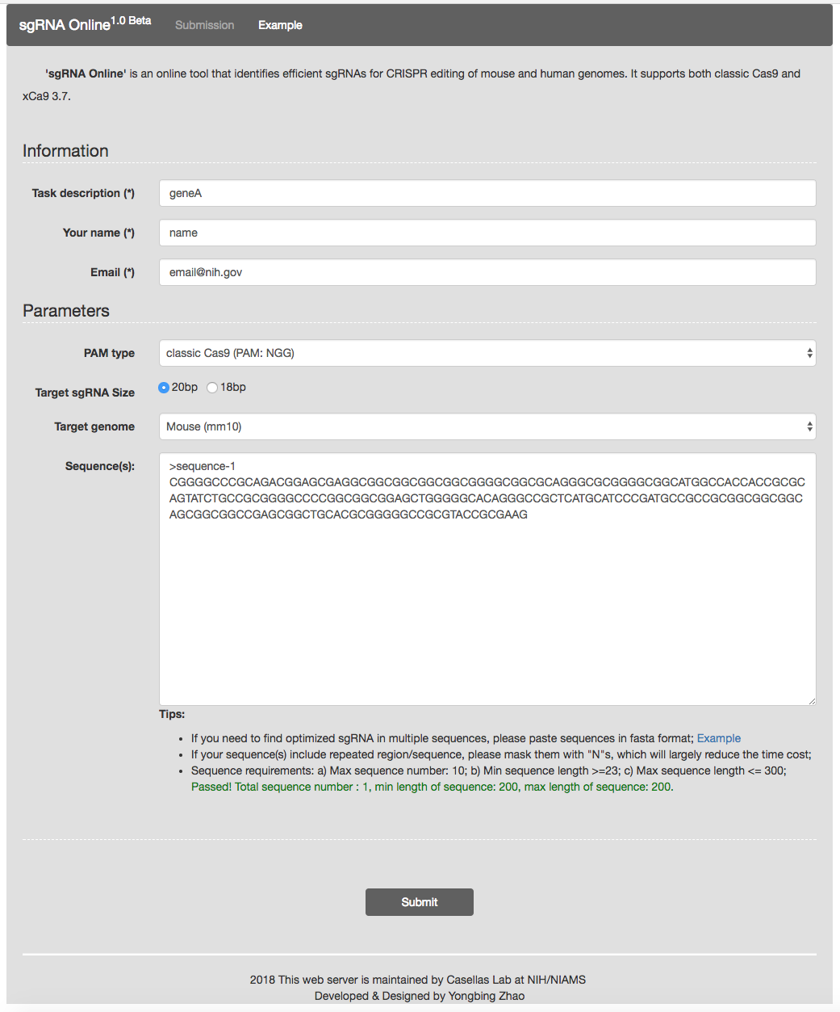

Figure 1. CRISPR web tool Input page at http://crispr.ybzhao.com

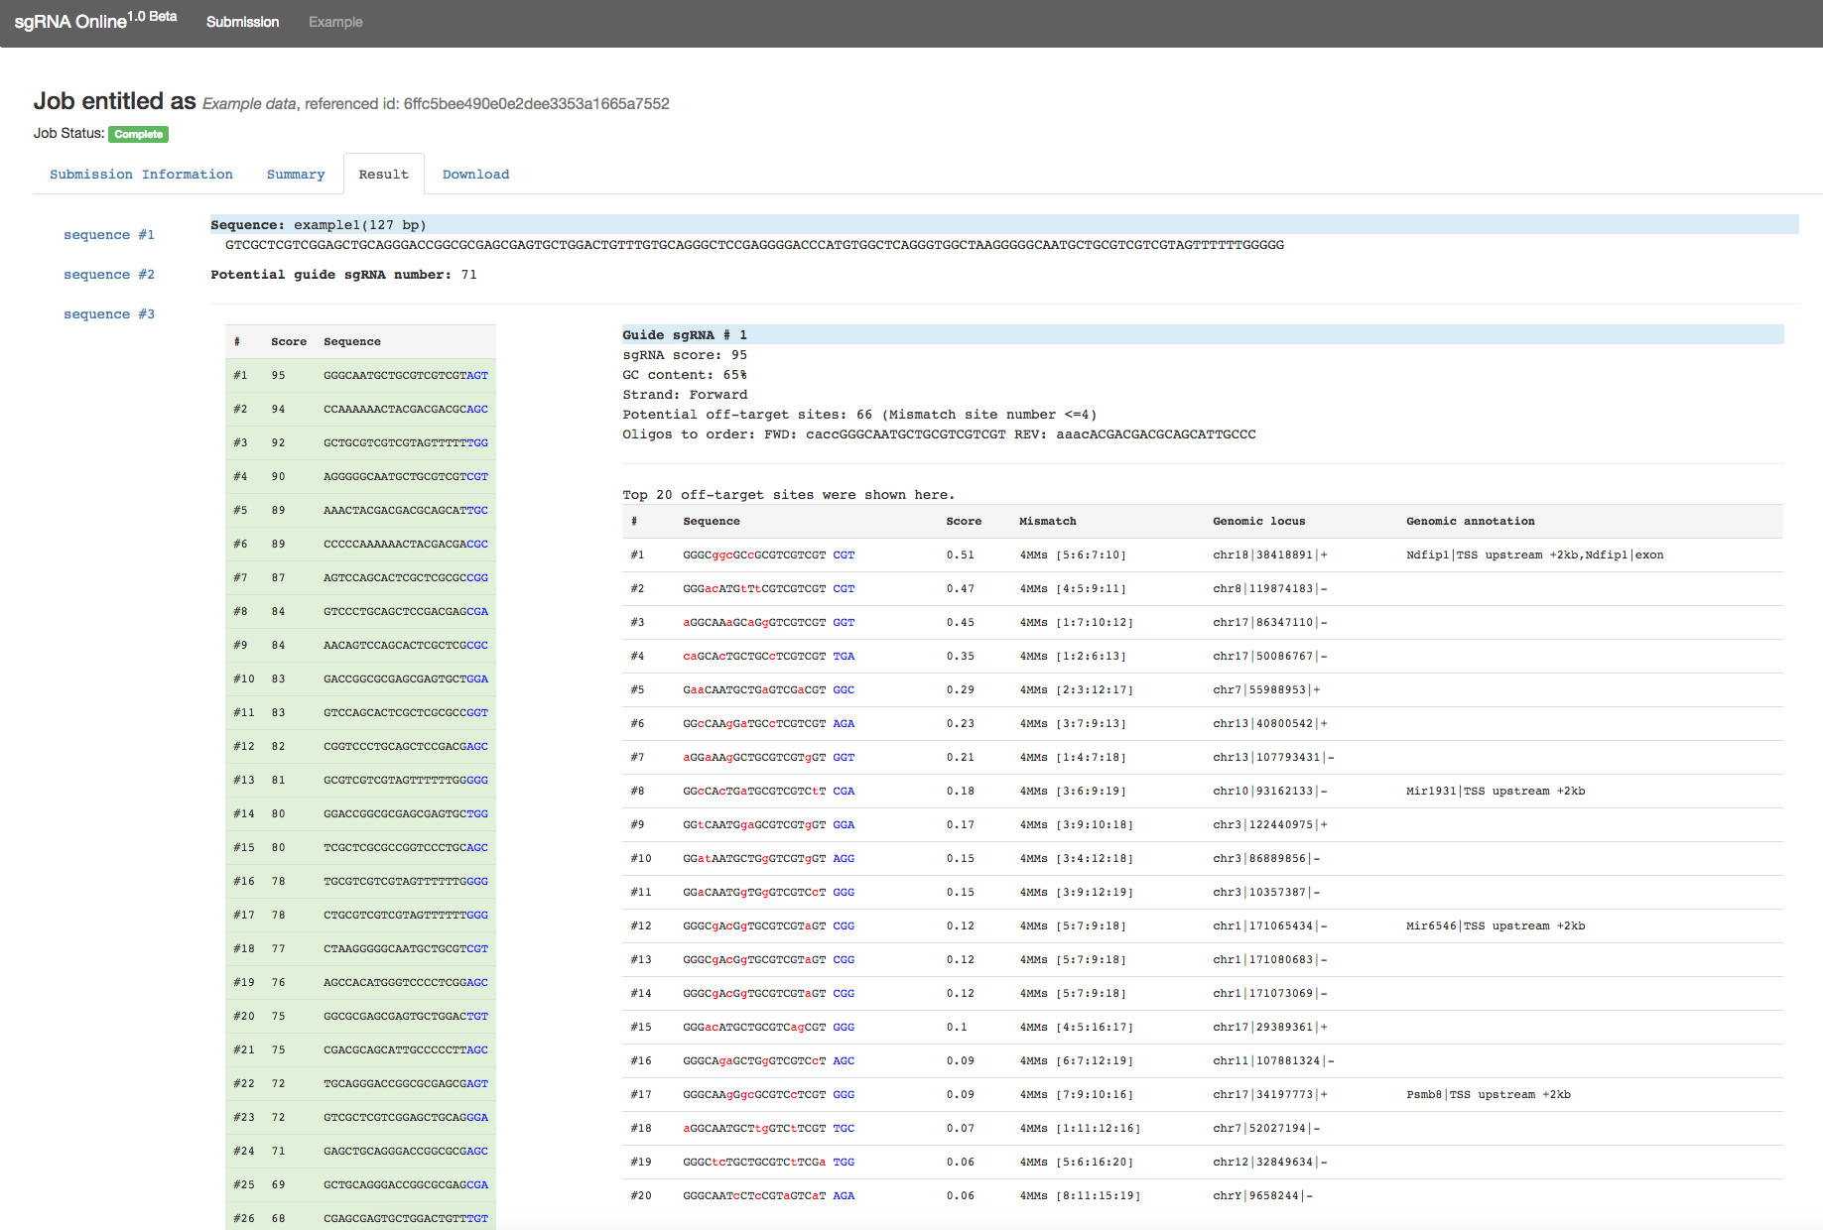

Figure 2. CRISPR web tool “Result” page.

1. In “Result” tab, you can find off target information for each sgRNA candidates.
2. Click “Download” tab to save all information .

Choose a sgRNA.

1. In “Result” tab, choose guide sequences with 1) the least number of off-targets, 2) high PAM Score, 3) 40-60% GC content, and 4) high Cas9 Loading score if possible.
2. Verify that the final guide candidates have a unique genomic binding site (e.g. by Blast).
3. Select the “Result” tab (third tab) and utilize off-target data to determine if any true off-targets of guide may be detrimental to later experiments.
4. Order oligos of candidate guides as given in the “Forward/Reverse oligo primer” column.

Note# 1: The number of off-targets given per each guide represents the number of off-targets identified by the CRISPR web tool that have a functional NGG PAM motif and 100% SEED homology to its respective guide. These are “true off-targets”.

Note# 2: The “Result” tab (third tab) identifies the guide sequence and guide number for each putative off-target. It designates the sequence, genome location (for target genome in UCSC browser), and strand for each off-target. In addition, it also designates if the off-target is in a genic (by UCSC gene code) or intergenic region, the number of mismatches its SEED sequence has with respect to its target guide, and if the off-target is a “true” off-target.

Cloning of the sgRNA into the px330 vector

Addgene plasmid number for px330 used here: #42230. Alternatively, a px330_pgk_puro plasmid may be used if selection is desired.

sgRNA linkers phosphorylation

1. Anneal primers by adding equal molar amounts of each primer to a single Ep. Tube (≈0.6nmoles), briefly vortex, spin and incubate for 10 minutes at 95 (thermomixer).
2. Immediately place into water bath (preheated at 85) and turn it off to allow slow annealing of the primers. Leave the reaction overnight or until it reaches room temp.
3. Use the following reaction to phosphorylate the annealed primers to be used as linkers in upcoming ligations:
   1. use 6 l of annealed primers (≈100 picomoles)
   2. add 1 l T4 ligase buffer
   3. add 1 l T4 polynucleotide kinase
   4. up to 10l of H2O

5. Incubate for 1 hr at 37oC.

px330 plasmid preparation

1. Digest 5  □ px330 vector in 50 l volume reaction with 50 U of BbsI (NEB) overnight.
2. Add 1 l of CIP to the digestion mix with the px330 vector and incubate at 37oC for 90 min.
3. Purify the digested vector with PCR purification column from Qiagen or Zymogen.

Ligation of sgRNA into px330 vector

1. Ligate 50 picomoles of annealed primers with 10 ng of Bbsi digested px330 vector.
   1. add 1 l of T4 ligase buffer
   2. add 1 l of T4 ligase
   3. up to 10l of H2O
2. Incubate overnight at 16 oC.

Confirm successful cloning via sequencing.

Sequencing Primer for CRISPR imaging:

|  |
| --- |
| CRISPR_imaging_seq REV: 5’-CTAATGCATGGCGGTAATACG-3’ |

Sequencing Primer for CRISPR genome editing:

px330_CP_rev : 5’-TATTGGCGTTACTATTGACGTCAATG-3’

T7E1+ampligase* assay to test sgRNA efficiency

* T7 has high degree of non-specificity depending on the template. Ampligase repairs non-specific cleavage of T7 to a certain extent. Always include non-targeted sample to compare.

1. Transfect your favorite cells with and without (WT, control) the CRISPR vector.
2. 48 hours later, harvest genomic DNA using Qiagen Blood and DNeasy kit.
3. From the gDNA, amplify a 500bp fragment around the CRISPR binding site by PCR (use 100 ng of gDNA as template in 50 ul with Phusion polymerase).
4. Verify amplification by running 5 l on a gel .
5. Purify the PCR product with Zymogen Clean and Concentrator kit and elute with 10-15 ul of 0.1xEB.
6. Measure OD.
7. Prepare 800 ng DNA in 20 l reaction of 1x ampligase buffer (2 l 10x ampligase buffer, DNA volume, and up to 18 ul dH2O).
8. Anneal using thermocycler: 95 oC for 5 min with 100% ramp rate, 95-85 oC at -2 oC/s (85oC at time 0 ramp rate at 80%), 85-25 oC at -0.1 oC/s (25oC at time 0 at ramp rate 3.7%); hold at 4 oC (4% at 100% ramp rate).
9. Take 10 l annealed DNA +2 l ampligase + 1l T7E1, incubate 40 min at 37oC.
10. Run on ≥2% agarose gel and verify additional bands in mutant wells compared to wildtype wells.

References & Further Reading

1. Chen B, et al. (2013) Dynamic Imaging of Genomic Loci in Living Human Cells

by an Optimized CRISPR/Cas System. Cell 155(7): 1479-1491.

1. Cong L, et al. (2013) Multiplex genome engineering using CRISPR/Cas

systems. Science 339(6121): 819-823.

1. Ding Q, et al. (2013) Enhanced efficiency of human pluripotent stem cell

genome editing through replacing TALENs with CRISPRs. Cell stem

cell 12(4): 393-394.

1. Fu Y, et al. (2013) High-frequency off-target mutagenesis induced by CRISPR-

Cas nucleases in human cells. Nature biotechnology 31(9): 822-826.

1. Fu Y, et al. (2014) Improving CRISPR-Cas nuclease specificity using truncated guide RNAs. Nature Biotechnology. 32 (3): 279-284.
2. Kuscu, C. et al. (2014). Genome-wide analysis reveals characteristics of off-target

sites bound by the Cas9 endonuclease. Nature Biotechnology. 332 (7): 677-683.

1. Hsu PD, et al. (2013) DNA targeting specificity of RNA-guided Cas9

nucleases. Nature biotechnology 31(9): 827-832.

1. Mali P, et al. (2013) RNA-guided human genome engineering via Cas9.

Science 339(6121): 823-826.

1. Ran FA, et al. (2013) Double nicking by RNA-guided CRISPR Cas9 for

enhanced genome editing specificity. Cell 154(6): 1380-1389.

1. Shalem O, et al. (2014) Genome-scale CRISPR-Cas9 knockout screening in

human cells. Science 343(6166): 84-87.

1. Wang H, et al. (2013) One-step generation of mice carrying mutations in

multiple genes by CRISPR/Cas-mediated genome engineering. Cell 153(4): 910-918.

1. Wang T, Wei JJ, Sabatini DM, & Lander ES (2014) Genetic screens in human

cells using the CRISPR-Cas9 system. Science 343(6166): 80-84.