ROSA GitLab DevSecOps Platform
Phase 1: Architecture, scope, implementation steps and Terraform foundation

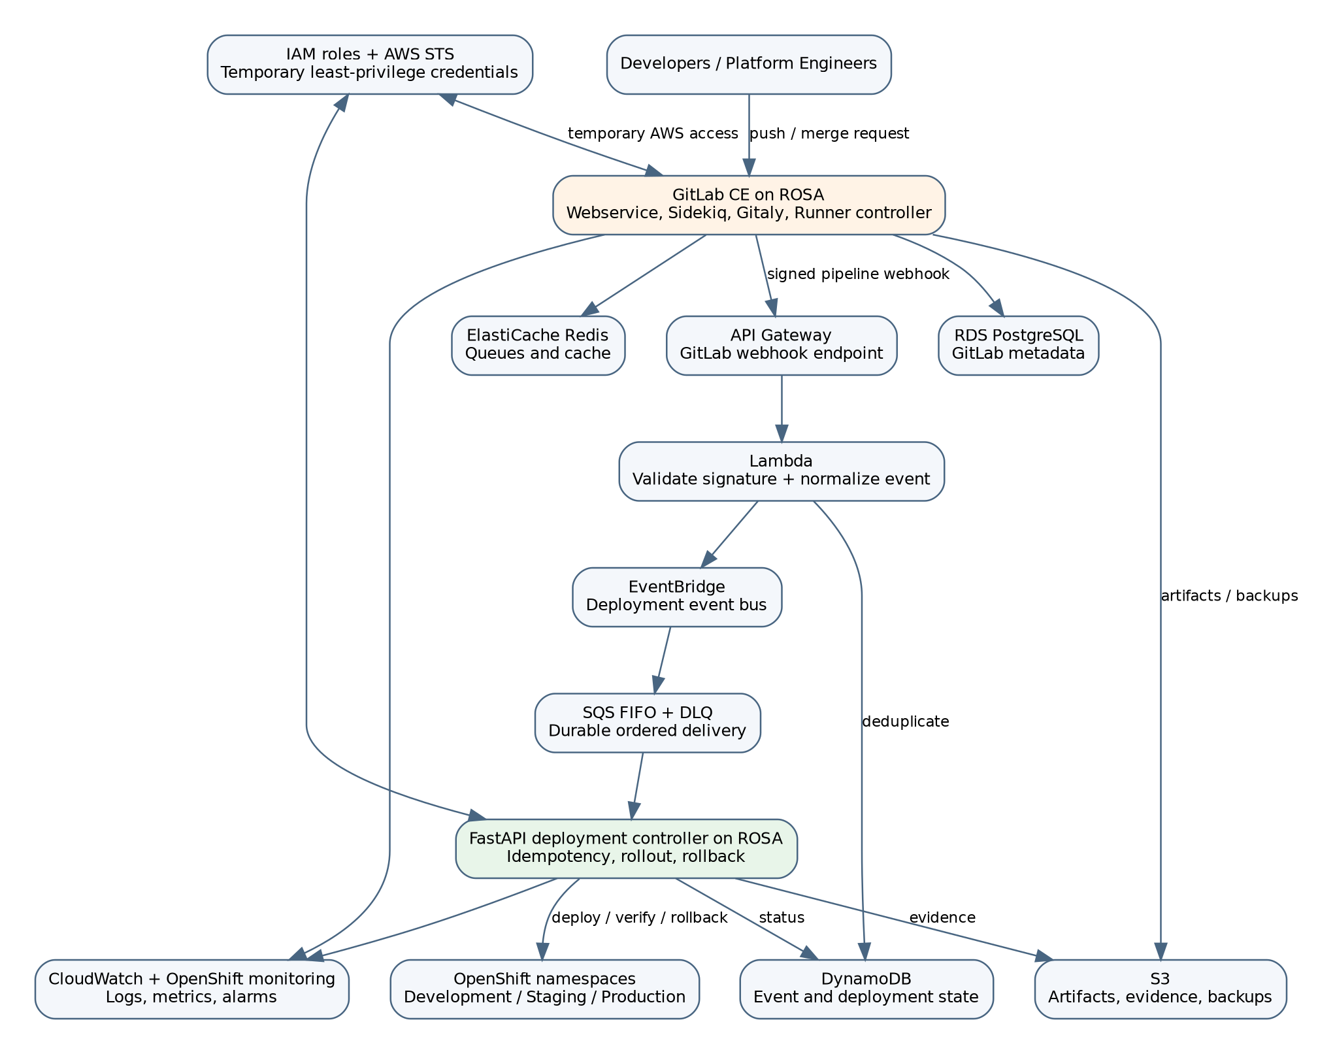
Target region: ap-southeast-1 (Singapore)
Document status: Initial controlled baseline
Date: 29 July 2026

1. Executive summary
This project builds a production-style GitLab Community Edition platform on Red Hat OpenShift Service on AWS (ROSA) and connects it to an AWS serverless deployment workflow. The platform is intended as a portfolio capstone that demonstrates OpenShift administration, AWS networking, temporary STS-based access, GitLab operations, event-driven systems, idempotency, failure recovery, infrastructure as code and observability.
The work is intentionally divided into controlled milestones. Phase 1 creates only the AWS foundation that is inexpensive, reversible and independently testable. ROSA, RDS, ElastiCache and GitLab are deferred until prerequisites, quotas, cost controls and architecture checks are complete.
Phase 1 deliverable | VPC, subnets, encrypted S3, DynamoDB idempotency table, EventBridge, SQS FIFO/DLQ, API Gateway and a webhook Lambda.

2. Problem statement
A regulated enterprise wants an internally controlled source-code and CI/CD platform. Development teams must be able to push code, run isolated build jobs and promote releases through development, staging and production. The platform must remain secure and auditable even when webhooks are delivered more than once, AWS services are temporarily unavailable, a deployment fails halfway through, or a production release requires human approval.
The implementation must solve the following hard engineering problems:
- Prevent duplicate GitLab webhook deliveries from creating duplicate deployments.
- Buffer deployment work when ROSA or the OpenShift API is unavailable.
- Separate stateful GitLab services from stateless event processors and autoscaled CI jobs.
- Use temporary IAM credentials and least-privilege roles instead of permanent AWS access keys.
- Provide an auditable path from commit SHA to build artifact, deployment event, approval and rollback.
- Recover safely from failed messages through retries, a dead-letter queue and controlled replay.
- Keep the initial learning environment affordable and fully destroyable.

3. Scope and requirements

3.1 Functional requirements
- Host GitLab CE on ROSA using the official GitLab Helm chart in a later phase.
- Receive a signed pipeline webhook through API Gateway.
- Validate and normalize the webhook in Lambda.
- Create a deterministic event identifier from project, commit and environment.
- Reject duplicate events using a conditional DynamoDB write.
- Route accepted events through EventBridge to an SQS FIFO deployment queue.
- Consume events in a FastAPI controller running on ROSA.
- Deploy, verify and roll back applications in separate OpenShift projects.
- Store artifacts, evidence and backups in encrypted S3 storage.
- Expose logs, metrics and alarms through CloudWatch and OpenShift monitoring.

3.2 Non-functional requirements
Area | Requirement
Security | No long-lived AWS access keys inside workloads; least privilege; encrypted storage; private subnets for cluster workloads.
Reliability | At-least-once event delivery with idempotent processing; DLQ after bounded retries.
Availability | Target multi-AZ worker placement for production architecture.
Recoverability | Git configuration in source control; database and repository backup plans; repeatable Terraform.
Observability | Structured logs, correlation IDs, queue depth, failure count and deployment status.
Cost control | Build locally first; create ROSA only for time-boxed milestones; destroy unused resources.

4. Target architecture
Figure 1. Target ROSA, GitLab and AWS serverless architecture.

4.1 Request flow
- A developer pushes code or merges a change in GitLab.
- GitLab runs a pipeline using an ephemeral Runner job pod.
- After a successful build, GitLab sends a signed deployment webhook.
- API Gateway invokes the webhook Lambda.
- Lambda verifies the signature and validates required fields.
- Lambda derives an event ID from project ID, commit SHA and environment.
- A conditional DynamoDB write records the event; duplicate requests return the existing event ID.
- Lambda publishes a normalized event to the custom EventBridge bus.
- EventBridge forwards the event to the SQS FIFO deployment queue.
- The FastAPI controller on ROSA receives the message, updates OpenShift and records status.
- Metrics decide whether to promote, pause for approval or roll back.
- Artifacts and evidence are written to S3; logs and metrics are sent to monitoring systems.

5. Component decisions
Component | Why it exists | Scale-to-zero?
GitLab Webservice | Serves UI and API requests. | Normally no; keep at least one replica for availability.
Gitaly | Serves Git repository reads and writes. | No for an available Git service; repository data is stateful.
Sidekiq | Executes GitLab background jobs. | Not normally; queued work must continue processing.
RDS PostgreSQL | Stores GitLab transactional metadata. | No in this design; continuously available managed database.
ElastiCache Redis | Caches data and supports queues/session-related functions. | No in this design.
GitLab Runner job pods | Execute individual CI jobs. | Yes; jobs are ephemeral and can fall to zero when idle.
Webhook Lambda | Validates one event and exits. | Yes.
FastAPI deployment controller | Maintains deployment processing and OpenShift integration. | Usually at least one replica; can later use event-driven scaling with safeguards.

6. Why ROSA rather than the alternatives
ROSA is selected because the learning objective is enterprise OpenShift platform engineering, not merely container hosting. ROSA with hosted control planes keeps the OpenShift control plane managed while worker nodes and application resources run in the customer AWS environment. ROSA uses OIDC and AWS STS so OpenShift operators can obtain temporary credentials for the AWS resources they require.
Option | Strength | Why not the primary target
ROSA with HCP | Managed OpenShift, enterprise controls, AWS integration and OpenShift-specific skills. | Higher cost; must be time-boxed and created only after prerequisites are ready.
Amazon EKS | Flexible managed Kubernetes and broad AWS ecosystem. | Does not teach OpenShift Routes, SCCs, Operators and ROSA operating model.
Amazon ECS/Fargate | Simpler AWS-native container operations. | Does not meet the OpenShift learning objective or GitLab-on-Kubernetes design goal.
OpenShift Local | Free local OpenShift learning environment. | Excellent for early testing but not a realistic AWS multi-AZ deployment.
Kind or Docker | Fastest and cheapest GitLab CE proof of concept. | Used for the first local build, not the final cloud architecture.

7. STS-based access model
AWS Security Token Service issues short-lived credentials after an approved role is assumed. The project must not place permanent AWS access keys in GitLab variables or Kubernetes Secrets. Separate roles will be created for the webhook Lambda, GitLab Runner, backup process, monitoring process and deployment controller.
Workload | Allowed actions | Explicitly denied by omission
Webhook Lambda | Write one DynamoDB table and publish to one EventBridge bus. | S3 deletion, cluster administration, database access.
GitLab Runner | Push to a defined image repository and write permitted artifacts. | RDS administration and unrelated S3 buckets.
Deployment controller | Receive from one queue, update status and call approved OpenShift APIs. | Broad AWS account administration.
Backup job | Write backup objects to a dedicated bucket path. | Application deployment permissions.

8. Resources required before starting
Resource | Required now? | Action
AWS account | Yes | Enable MFA, create a non-root administrative role and configure billing alerts.
Red Hat account | Not for Phase 1 | Create before ROSA prerequisite checks.
GitLab account | Yes | Create a free GitLab.com account for source control; GitLab CE remains the later self-hosted workload.
Local tools | Yes | Git, AWS CLI, Terraform 1.8+, Python 3.12+ and an editor.
Docker Desktop | Yes for local tests | Run GitLab CE or small service tests locally before ROSA.
ROSA service enablement | Later | Enable service, confirm Marketplace subscription and quotas before cluster creation.
Domain name | Optional initially | Needed later for stable GitLab and application routes.
Budget | Yes | Set alerts before any ROSA, NAT Gateway, RDS or ElastiCache deployment.

9. Step 1 implementation plan
Objective: create and validate the reversible AWS event foundation without deploying ROSA or GitLab.
Task | Estimated focused time | Proof of completion
Install and verify AWS CLI and Terraform | 45 min | `aws sts get-caller-identity` succeeds; `terraform version` succeeds.
Configure MFA-protected AWS access | 45 min | No root credentials used; active role/user is documented.
Create a billing budget and alerts | 30 min | Budget visible in AWS Billing console.
Review Terraform variables and CIDR plan | 45 min | No overlap with existing VPCs; Singapore AZs selected.
Run terraform init, fmt and validate | 30 min | All commands complete without errors.
Run terraform plan and inspect every resource | 60 min | Plan contains only expected foundation resources.
Apply foundation | 30-60 min | Outputs show VPC, queue, bucket, table, bus and webhook URL.
Test signed webhook and duplicate handling | 90 min | First request returns 202; repeated request returns duplicate response; SQS receives one event.
Destroy test stack or retain with budget guardrails | 30 min | Destroy succeeds or retained-resource decision is documented.

9.1 Commands
cd terraform\environments\dev
Copy-Item terraform.tfvars.example terraform.tfvars
notepad terraform.tfvars
terraform init
terraform fmt -recursive
terraform validate
terraform plan -out phase1.tfplan
terraform apply phase1.tfplan

9.2 Stop conditions
- Do not apply if Terraform proposes deleting or replacing an unrelated resource.
- Do not proceed when the active AWS identity is the root account.
- Do not create ROSA until quotas and expected daily cost are reviewed.
- Do not commit terraform.tfvars, access keys or webhook secrets to Git.
- Do not treat a successful apply as completion; the duplicate-event test is mandatory.

10. Remaining plan and estimated time
Milestone | Scope | Focused time | Cumulative
1. Foundation | AWS event path and idempotency test. | 8-10 h | 8-10 h
2. Local GitLab CE | Docker-based GitLab, Runner and sample pipeline. | 12-16 h | 20-26 h
3. OpenShift Local | Projects, Routes, SCC/RBAC, storage and Helm compatibility tests. | 16-22 h | 36-48 h
4. ROSA prerequisites | Service enablement, quotas, IAM roles, OIDC and network review. | 10-14 h | 46-62 h
5. ROSA cluster | Time-boxed HCP cluster, access, operators and baseline monitoring. | 12-18 h | 58-80 h
6. External GitLab data services | RDS, Redis, object storage, secrets and backups. | 18-24 h | 76-104 h
7. GitLab on ROSA | Helm values, Routes, Gitaly storage and Runner isolation. | 24-32 h | 100-136 h
8. Deployment controller | FastAPI consumer, OpenShift API, WebSockets and status model. | 28-40 h | 128-176 h
9. Reliability and security | Retries, DLQ replay, policies, threat tests and rollback. | 24-32 h | 152-208 h
10. Observability and final demo | Dashboards, failure drills, DR evidence and portfolio write-up. | 20-28 h | 172-236 h

At 8 focused hours per week, the complete project is approximately 22-30 weeks. At 15 focused hours per week, it is approximately 12-16 weeks. The first demonstrable milestone can be completed in one weekend or two evenings plus one weekend.

11. Terraform package included
The accompanying Terraform package creates:
- One VPC with DNS support and three public plus three private subnets.
- An internet gateway and public route table; private subnets intentionally have no NAT Gateway in Phase 1.
- An encrypted, versioned and private S3 artifact bucket.
- A DynamoDB table with TTL and point-in-time recovery for idempotency records.
- A custom EventBridge event bus and routing rule.
- An SQS FIFO deployment queue and FIFO dead-letter queue.
- A Python Lambda function with narrow IAM permissions.
- An HTTP API Gateway route for GitLab-style deployment webhooks.
ROSA, RDS, ElastiCache and GitLab are intentionally absent from this first package. Adding them before validating account prerequisites would increase both cost and failure surface.

12. Phase 1 acceptance tests
Test | Expected result
Terraform formatting and validation | No errors.
Infrastructure plan review | Only named project resources are created.
Unsigned webhook | HTTP 401.
Malformed signed webhook | HTTP 400.
Valid first webhook | HTTP 202 with event ID.
Repeated identical webhook | HTTP 200 duplicate response; no second event is queued.
EventBridge delivery | One message appears in deployment FIFO queue.
Forced routing failure | Failure is observable through metrics/logs.
Terraform destroy | Foundation resources are removed after bucket is empty.

13. Known risks and controls
Risk | Control
Unexpected AWS charges | Billing alerts, tagged resources, no NAT Gateway in Phase 1, time-box ROSA.
Secrets committed to Git | Use ignored tfvars locally; later move secrets to Secrets Manager.
Webhook spoofing | HMAC signature validation and later secret rotation.
Duplicate deployment | Conditional DynamoDB write plus FIFO deduplication.
Queue poison message | Bounded retries and DLQ with explicit replay process.
Overly broad IAM | Separate roles and resource-scoped policies.
Stateful GitLab data loss | External managed data services and tested backup/restore in later milestones.

14. Authoritative references
- AWS, “ROSA architecture” - ROSA with hosted control planes architecture model.
- AWS, “Create a ROSA with HCP cluster using the ROSA CLI” - HCP, STS and CLI prerequisites.
- Red Hat, “Creating ROSA with HCP clusters” - OIDC and STS authentication for operators.
- Red Hat, “Required IAM roles and resources” - account-wide STS roles and policies.
- GitLab Docs, “Installing GitLab by using Helm” - external PostgreSQL, Redis and object storage requirements for production chart installations.
- HashiCorp Terraform Registry, “AWS Provider” - current official provider documentation.
Implementation rule: complete and test one milestone before adding the next. Do not deploy ROSA merely because the Terraform foundation applies successfully.

