**Desigining Energy and Power Monitoring System On Solar Power Plant Using Raspberry Pi**

**Regy Roy Hidayat Putra, Didin Wahyudin Ph.D., Dr. Tasma Sucita**

Department of Electrical Engineering Education, Universitas Pendidikan Indonesia, Jalan Dr. Setiabudhi No. 207, Bandung, Indonesia 40154

E-mail: regy.roy.hidayat@student.upi.edu

**Abstract**. Recently, the application of Information Technology (IT) has been growing rapidly. The application could monitor flowing power and stored electrical energy which is generated by solar cell. This project explains how to build and design interface system. Electrical energy are required to be monitored in order to keep energy stored. Single Board Computer (SBC), microcontroller, sensors modul, and transceivers are used in logging electrical power for this project. These nodes are connected wirelessly. Raspberry Pi 2 B, Arduino Nano, NRF24L01, Voltage sensor module and ACS712 sensor are required to run this project. IDLE, Apache, BIND, hostapd, udhcpd, and highcharts are programs used in Raspberry Pi 2 B. The values of power are displayed into graphical chart and log energy table are accessible by using computer or smartphone. By connecting to local network via Wi-Fi and go to http://solmon.home to see measurement results.

1. **Introduction**

The current development of technology has been producing a tremendous number of electronic devices with its functionality. Electronic device for controlling and automating is one of the most developed technology. Electronic device is utilized in every aspect, such as in house as smart home [1]. Raspberry Pi has been used for multipurpose monitoring such for surveillance [2]. By integrating Raspberry Pi as a server in solar power plant system can be monitored both power and stored energy.

An independent home of producing electrical energy by installing solar panel. Using a solar panel, there is no any sound noise as mechanical electrical energy generator [3]. This energy production could be used for lighting or home appliance. Before energy are being used, it should flow first into battery. Monitoring of flowing energy is required in order to check whether the energy is available or not.

Microcontroller and single board computer (SBC) are already used for load monitoring on previous works [4][5][6][7]. However, there are some lacks, as the system is unable to be accessed in flexible range for its limitation by using wire for the media connection. Another consideration like, cost to build the systems are more pricey, rare or unavailability components to find, and complexity for user to use the system.

Our goal is to design a system for monitoring power and flowing energy from the solar panel through battery and monitoring a simulated load by using a Raspberry Pi 2 B as main component or server to display data and two Arduino Nano as data fetcher for power and energy [8]. The communication among server, data fetcher and user are wirelessly.

1. **Methods**

There are plenty of module communication to be picked to establish communication between Arduino Nano and Raspberry, yet using NRF24L01is a radio frequency module that only communicate between those two devices. NRF24L01 is chosen since its effectiveness and efficiently work for this proposed system. TP-Link TL725WN is attached to Raspberry Pi since Raspberry Pi 2 B does not have built-in Wi-Fi. Thus this module is chosen for its compatible with Raspberry Pi 2 B to work as hotspot and it is more familiar in several online forums.

The object is to monitor solar cell and a simulated load. We integrated to solar cell system at High Voltage Laboratory Universitas Pendidikan Indonesia. The simulated load is a single resistor with a DC supplied.

In order to make easier the system, we split into two parts. They are server side and node side. The research start by designing Arduino Nano script as node side to make sensors are working well. Compiled the script using Arduino IDE from PC. Calibration is in this step. Voltage sensor module is required to read voltage in parallel circuit and current sensor read current as in series circuit. Calibrating current sensor module also requires a special sampling. Current sensor module for this research is using ACS712 which manufactured by Allegro MicroSystems. It performs based on Hall effect means converting DC or AC current into proportional voltage output within 0-5 volt range. Magnetic field law is applied for this reading current sensor. This sensor should be programmed by using sampling data to get smooth value of reading current. Since Arduino Nano has an analogue pin input, it is just a common reading analogue pin. Then, configure networking of NRF24L01. Arduino IDE using C as a programming language. ACS712 and voltage sensor need to be calibrated in order to get good measurement.

Once sensor management is done, we move through the server side, Raspberry Pi. The server using Python programming language to run the script. The server establishes communication between user and nodes . The whole research system occur as shown in Figure 1.

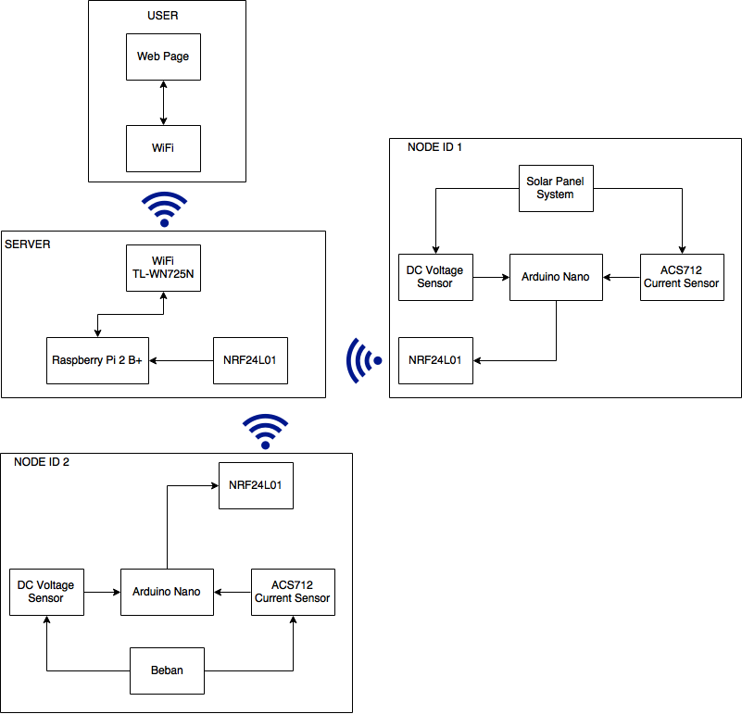

**Figure 1.** Block diagram of system

Programs are not packed in the raspberry Pi, thus need to be configured independently. Since this was integrating a group of programs, each program need to work well. For example if hotspot program is not working, user could not access data. The programs become a whole system to perform at the same time. The programs are installed on the server are driver on Raspberry Pi to communicate between Raspberry Pi and TL-725N, Raspberry Pi and NRF24L01; Apache2 for web server, MySQL and PHPmyAdmin for logging and configuring database, hotspot program which consist of udhcpd for giving IP address automatically to user’s device, hostapd for making wireless access point from server; and the last is DNS server for converting IP address into name domain.

To identify energy flow from solar panel, we log to database of the value which is sent by node side into server. After logging, the web server program performs a reading database and convert the value into a graphical display. In order to make easier to troubleshoot, figure 2 shows the flowchart of this designed system.

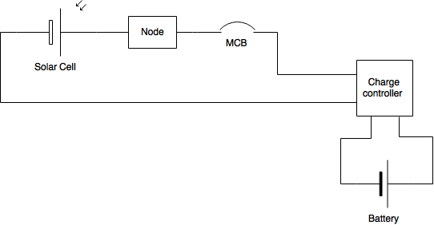

**Figure 2.** Node on solar cell circuit.

Figure 2 shows that Node is placed between solar cell and charge controller. The placement of node for real is shown in figure 4.

1. **Result and Discussion**

According to experiment from designing this system at High Voltage Laboratory FPTK UPI, we obtained the results:

1. A prototype of system logging power solar panel.
2. Designs and configuration programs to make this system.
3. The output which can be accessed by user in a local network.

The devices are connected each other could communicate as well as designed.

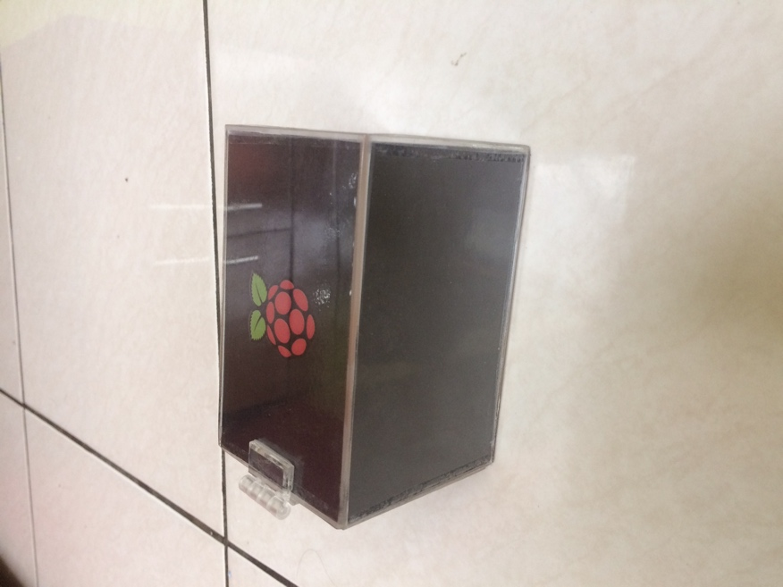

**Figure 3.** Raspberry Pi as a server is package in an acrylic with Raspberry Pi logo.

Raspberry Pi is bundled into a single acrylic box and only has one input power source from USB cable. Since Raspberry using wireless communication both to nodes and user, thus transceiver is inside the box. This device is the central unit of the system [9].

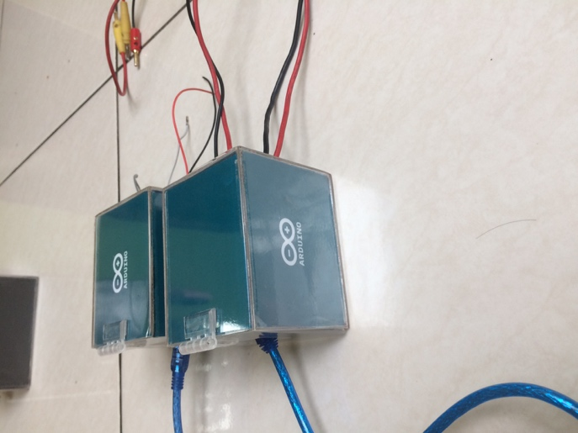

**Figure 4.** Arduino Nano as node in an acrylic box with Arduino Logo.

Two Arduinos as nodes is shown in Figure 4. Each has same two power input by using USB source cable. For reading media, using four cables connector. Two cables for reading voltage positive side and negative side; two others cable are used for reading current.

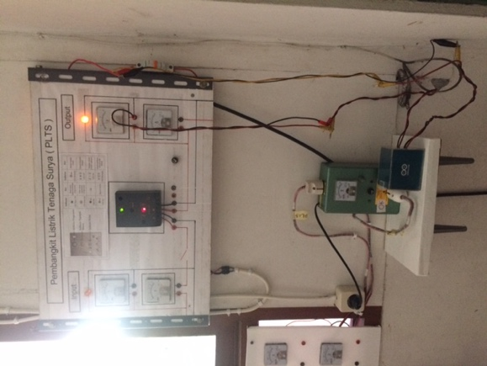

**Figure 5.** Integrated node in solar cell system in High Voltage Laboratory.

This sensor module is required to make sure the sensors are working in standard condition. Comparing the value result from 10 multimeters to a sensor voltage. The calibrating using an object which is a rheostat as load and DC power supply Set to 100Ω and 12V as the object. Table 1 shows the measurement.

**Table 1.** Voltage measurements

|  |  |
| --- | --- |
| Measurement Instrument series | Voltage (volt) |
| 1 | 10.22 |
| 2 | 10.17 |
| 3 | 10.21 |
| 4 | 10.22 |
| 5 | 10.24 |
| 6 | 10.25 |
| 7 | 10.26 |
| Voltage DC Sensor | 10.14 |
|

**Table 2**. Current measurements

|  |  |
| --- | --- |
| Measurement Instrument Series | Current (ampere) |
| 1 | 2.64 |
| 2 | 2.60 |
| 3 | 2.75 |
| 4 | 2.62 |
| 5 | 2.65 |
| Sensor ACS712 | 2.68 |
|

These calibrating results a low error. By using descriptive statistic, we figure out error on Voltage is 0.005% and current is 0.02%. This could be tolerated for some applications which requires error 0.1%-1% [10].

Once user access to network, the user’s device will obtain automatic IP address and by typing on address bar the IP address 10.1.30.1 or domain name http://solmon.home the server will redirect user into a web page which contains graphical information. There is also an option to access log which allow user to view the last value. It is possibly viewed per date. Figure 4 shows the result of web page accessed by personal computer. Figure 5 shows the result of web page accessed by mobile phone.

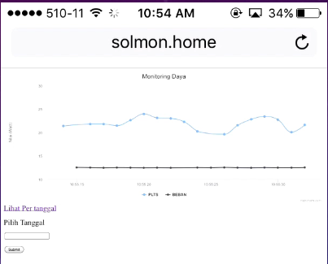

**Figure 6**. Main web page on phone.

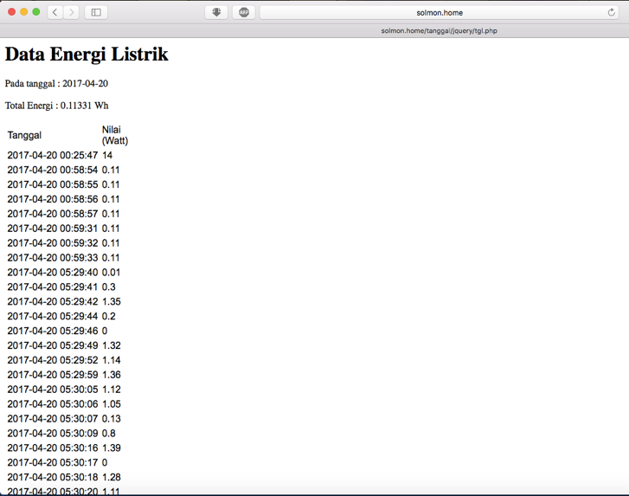

**Figure 7.** The result of log on web browser.

Raspberry Pi performs like a PC yet only using low voltage than a PC [11][12]. This device has a wide community and support. There are other sort of this device like Banana Pi, Intel Galileo, BeagleBone, Orange Pi, C.H.I.P, etc [13], yet the Raspberry Pi is almost available in any location.

Arduino Nano is node side has compact size. There are many sort of this circuit board such as Arduino UNO, MKR1000, etc. Arduino Nano coulbe be replaced by these circuit board for later works and development.

This system can monitor how much energy stored from solar cell. At the database server, energy values shown in a table as shown on figure 7. User could view by choosing date to show energy values at specific time.

1. **Conclusions**

This system logging for power and energy from solar panel and simulated load are built by node, server, and user. Nodes are connected to server to show values from sensors in graphical and stored to database in server. The sensors modul must be calibrated first. The goals for this research achieved.

1. **Acknowledgements**

This paper is based on Tugas Akhir Teknik Elektro which is guided by Didin Wahyudin, Ph.D and Dr. Tasma Sucita.

1. **References**

[1] J. C. Augusto and C. D. Nugent, *Designing Smart Homes The Role of Artificial Intelligence*. New York: Springer-Verlag Berlin Heidelberg, 2006.

[2] A. Jain, S. Basantwani, O. Kazi, and Y. Bang, “Smart Surveillance Monitoring System,” pp. 269–273, 2017.

[3] W. Palz, *The Emergence of Electricity from the Sun Power for the World*. Singapore: Pan Stanford Publishing Pte, Ltd., 2011.

[4] I. Firnandi, J. Kustija, and B. Trisno, “Rancang Bangun Sistem Kontrol Beban dan Akuisisi Data Berbasis Web dengan menggunakan Single Board Computer,” vol. 14, no. 1, 2016.

[5] R. Sulistyowati, D. D. Febriantoro, J. T. Elektro, and F. T. Industri, “PERANCANGAN PROTOTYPE SISTEM KONTROL DAN MONITORING PEMBATAS DAYA LISTRIK BERBASIS,” 2012.

[6] A. Setiono and Suharto, “Prototipe Aplikasi KWh Meter Digital Menggunakan Mikrokontroler ATMEGA8535 untuk Ruang Lingkup Kamar,” vol. 26, no. November, pp. 32–39, 2009.

[7] P. van Staden and B. Kotze, “Wireless Node Energy Monitor using common Development Platforms,” pp. 1514–1519, 2017.

[8] E. R. Melgar, C. C. Diez, and P. Jaworski, “Arduino and Kinect Projects Design, Build, Blow Their Minds,” 2012.

[9] M. Guleci and M. Orhun, “Android Based Wi-Fi Controlled Robot using Raspberry Pi,” pp. 5–9, 2017.

[10] R. Moghe, A. R. Iyer, S. Member, F. C. Lambert, S. Member, and D. M. Divan, “A Low-Cost Wireless Voltage Sensor for Monitoring MV / HV Utility Assets,” vol. 5, no. 4, pp. 2002–2009, 2014.

[11] V. Pardeshi, S. Sagar, S. Murmurwar, and P. Hage, “Health Monitoring Systems using IoT and Raspberry Pi - A Review,” no. Icimia, pp. 134–137, 2017.

[12] D. Sunehra and P. Ramakrishna, “Web Based Patient Health Monitoring System using Raspberry Pi,” pp. 568–574, 2016.

[13] M. Saari, S. Hyrynsalmi, and A. M. bin Baharudin, “Survey of Prototyping Solutions Utilizing Raspberry Pi,” pp. 991–994, 2017.