

PERLADENT SYSTEM AND MOBILE APPLICATION
Senior Project
By

Reham Issam Abou Taha

Submitted to the School of Arts & Science of the
Lebanese International University Bekaa, Lebanon

In part of fulfillment of the requirements for the degree of
BACHELOR OF SCIENCE IN
COMPUTER SCIENCE AND INFORMATION TECHNOLOGY

Supervised by: Prof. Haissam El-Aawar
Spring 2024-2025
Abstract
Belle Beads is a modern e-commerce platform dedicated to providing a seamless, elegant, and interactive shopping experience for customers seeking unique, handmade, and customizable accessories. Originally operating as a social media-based business, Belle Beads is expanding into a full-featured online marketplace. This transition allows for greater reach, streamlined product management, and improved customer engagement, enhancing the overall shopping experience.
What sets Belle Beads apart is its dual offering: a carefully curated collection of premium ready-made accessories and the ability for customers to personalize their own pieces. The ready-made accessories are crafted from high-quality materials such as stainless steel, sterling silver, and gold-plated finishes, ensuring both durability and aesthetic appeal. On the other hand, personalized pieces are designed with a focus on unique customization options, made from a variety of materials to suit individual preferences and styles.
At Belle Beads, customer satisfaction is a top priority. The platform values and actively incorporates feedback to refine product offerings, enhance services, and drive future collections. Custom orders are meticulously handled, reflecting the unique preferences and personal vision of each customer. Every piece is designed to be as unique as the individual wearing it.
Behind the scenes, Belle Beads is powered by a secure user account system and a robust administrative dashboard. From product listings and promotional campaigns to order tracking and payment processing, the admin interface ensures clear and professional e-commerce management.
By combining modern web design technologies like HTML, CSS, and JavaScript with PHP for flexible content management, Belle Beads has been developed as a dynamic and user-friendly e-commerce platform. It integrates Firebase for user authentication and verification, while XAMPP and MySQL handle the backend for secure data management and administrative functions. The platform is designed to be scalable, secure, and easy to use, ensuring a seamless experience for both customers and administrators.
Ultimately, Belle Beads combines the timeless appeal of handcrafted jewelry with the power of technology, delivering a personalized shopping experience that emphasizes creativity, individuality, and quality. With the expansion beyond social media, Belle Beads is set to grow into a fully-fledged online brand, offering convenience, customization, and quality to every customer.

Table of Contents:
Contents
Chapter 1 8
1.1.Introduction 8
1.2.Project Objectives: 8
1.3.Scope: 9
1.4.Project Software 9
1.4.1.Development Tools: 9
1.4.2.Frontend: 10
1.4.3.Backend: 10
1.4.4.Hardware Requirements: 10
1.4.5.Browser Testing: 10
1.5.Problematic: 10
1.6.Optimization: 11
Chapter 2: 12
2.1. Functional and Conceptual Study: 12
2.1.1 .Functional Requirements: 12
2.1.2 . Non-Functional Requirements: 16
2.2.Use case Diagram: 17
2.3.Use Case Narrative: 18
Chapter 3: 27
3.2.ER Diagram Figure: 28
3.2.1.The entities of Belle Beads: 28
3.3.Relational Diagram 30
Chapter 4: 31
4.1- Implementation: 31
4.2- Project`s Parts: 31
4.2.1.Index Page: 31
4.2.2.Login Page : 33
4.2.3.Forgot Password Page : 33
4.2.4.Enter New Password Page : 34
4.2.5.Creating New Account : 35
4.2.6.User Dashboard: 36
4.2.7.Shop: 39
4.2.8.Shop-List View: 40
4.2.9.Product Details: 40
4.2.10.About Us: 41
4.2.10.Contact Us: 41
4.2.12.Cart: 42
4.2.13.Checkout: 42
4.2.14.Placed Orders: 43
4.2.15.Admin Dashboard: 43
4.2.16.Manage Users: 44
4.2.17.Manage Messages: 44
4.2.18.Manage Subscribers: 45
4.2.19.Manage Orders: 45
4.2.20.Manage Payments: 46
4.2.21.Add Delivery person: 46
4.2.22.Manage Categories: 47
4.2.23.Manage Products: 47
4.2.24.Sales Report: 48
4.2.25.Manage Discounts: 48
4.2.26.View Delivery Reports: 49
4.2.27.Logout: 49
4.2.28.Delivery Dashboard: 50
4.2.29.View Orders: 50
4.2.30.Manage Payments: 51
4.2.31.Add delivery Report: 51
4.2.32.Delivery Logout: 52
Chapter 5: 52
5.1.Conclusion: 52
5.2.Future Work: 53

List of Figures:

Figure 1 :Use case Diagram 17
Figure 2– ER Diagram 28
Figure 3-Relational Diagram 30
Figure 4:Index Page 32
Figure 5-Login Page 33
Figure 6-Forgot Password 33
Figure 7-Enter New Password 34
Figure 8-Create Account 35
Figure 9-User Dashboard 36
Figure 10-Tracking Orders 36
Figure 11-Rewards 37
Figure 12-Addresses 37
Figure 13-Favorite Page 38
Figure 14-Shop 39
Figure 15-Shop List View 40
Figure 16-Product Details 40
Figure 17-About Us 41
Figure 18-Contact Us 41
Figure 19-Cart 42
Figure 20-checkout 42
Figure 21-order confirmation 43
Figure 22-Admin Dashboard 43
Figure 23-Manage Users 44
Figure 24-Manage Messages 44
Figure 25-Manage Subscribers 45
Figure 26-manage orders 45
Figure 27-Manage Payments 46
Figure 28-Add Delivery Person 46
Figure 29-Manage Categories 47
Figure 30-Manage products 47
Figure 31-Sales Report 48
Figure 32-Manage Discount Code 48
Figure 33-View Delivery Report 49
Figure 34 Admin Logout 49
Figure 35-Delivery Dashboard 50
Figure 36-View orders 50
Figure 37-Manage Payments 51
Figure 38-Delivery Report 51
Figure 39-Delivery Logout 52

List Of Tables:
Table 1-Manage Users 18
Table 2-Manage Orders 19
Table 3-User Registration 20
Table 4-Login 21
Table 5-Track Order Delivery 21
Table 6-Browse Products 22
Table 7-Add Items to Wishlist(Favorites) 23
Table 8-Save Delivery Address 24
Table 9-Place an Order 24
Table 10-Request a Refund 26
Table 11-Logout 26

Chapter 1
This chapter provides an overview of the Belle Beads project, tracing its evolution from a small Instagram-based business into a sophisticated e-commerce platform. It outlines the project’s goals, its intended scope, and the core technologies that support its functionality. The chapter also discusses the software used, challenges faced during development, and the strategies implemented to optimize performance, scalability, and the overall user experience.

1.1.Introduction
Belle Beads started with a simple idea: to create handcrafted, meaningful accessories that reflect personal style and individuality. The project originated on Instagram, where it quickly built a community that appreciated the beauty of personalized pieces. As the brand grew, so did the need for a more structured and accessible platform. This new website is the next step in that evolution, designed to make it easier for customers to explore collections, customize their own designs, and place orders.

1.2.Project Objectives:
- Provide a seamless and enjoyable shopping experience for customers who love unique, handmade accessories.

- Offer a range of products, including customizable pieces, a curated collection of ready-made designs, and a line of high-quality stainless-steel accessories.

- Allow users to personalize their jewelry by choosing from various styles, materials, and designs, giving them the freedom to express their individual taste.

- Ensure the platform is easy to navigate with clear categories for ready-made, handmade, and customizable products.

- Simplify the purchasing process with a straightforward cash-on-delivery (COD) payment system, allowing customers to pay upon delivery.

- Make the website mobile-friendly and accessible, providing customers with a seamless experience on any device.

- Maintain a secure shopping environment by implementing strong data protection measures for user accounts and transactions.
- Continuously engage with customers through feedback, using it to improve product offerings and the overall shopping experience.

- Provide exceptional customer service to ensure satisfaction with every purchase, from product selection to delivery.

1.3.Scope:

Belle Beads is designed to offer a straightforward experience for both customers and administrators. Customers can sign up, browse collections, personalize their accessories, and place orders easily. On the admin side, the dashboard allows for efficient management of inventory, promotions, orders, and customer messages. While the frontend is simple and user-friendly, the backend coding is more complex to ensure proper functionality and security. The focus is on making the platform easy to use for everyone.

1.4.Project Software

Belle Beads project uses a combination of software tools, hardware, and web technologies to ensure functionality and optimal performance. The following are the detailed technical specifications:

1.4.1.Development Tools:

- Visual Studio Code: used as the primary code editor for both frontend and backend development.
- XAMPP: is used in the Belle Beads project to run the website locally using Apache and PHP, and to manage the database with MySQL and phpMyAdmin during development.

1.4.2.Frontend:
- HTML
- CSS
- JavaScript
- jQuery
- Bootstrap

1.4.3.Backend:
- PHP
- XAMPP

1.4.4.Hardware Requirements:
Samsung Laptop:
- Processor: Intel(R) Core(TM) i5-3210M CPU @ 2.50GHz, 64-bit based processor.
- RAM: 8GB
- Storage: 256GB SSD
- System Type: 64-bit operating system.
- Operating System: Windows 11 Pro.

1.4.5.Browser Testing:
Google Chrome.

1.5.Problematic:
Several problems were encountered during the development of Belle Beads:
Tight Delivery Timeline: The project had a fast delivery deadline, which added pressure and required efficient time management to meet all the requirements.
Simplicity vs. Functionality: Striking the right balance between keeping the platform user-friendly and incorporating necessary features for both customers and admins was a challenge, especially with the more complex backend code.
Working Alone: Handling all aspects of the project by myself, from development to design, required wearing multiple hats and managing different tasks without external support.
Data Security vs. User Experience: Ensuring the platform was both secure and easy to use was difficult, particularly in terms of protecting user data (passwords and personal information) while keeping the interface simple and intuitive.
Responsive Design: Ensuring the website looked and functioned properly on various devices (mobile, tablet, desktop) using tools like CSS grids, flexbox, and media queries took careful attention to detail.

1.6.Optimization:
To ensure good performance, security, and user experience, several optimization techniques were applied:
Performance Optimization:
- Caching frequently accessed data to reduce database queries.
- Streamlining SQL queries for faster data retrieval.
- Utilized asynchronous data fetching (AJAX) to update page content dynamically without full reloads.

Security Measures:
- Password hashing using encryption for secure user authentication.
- Encrypted user sessions to protect data during browsing.
- Validating user inputs to prevent SQL injection and cross-site scripting .
- Using prepared statements (PDO or MySQLi) to prevent SQL injection.
User Experience Optimization:
- Ensuring a responsive design using Bootstrap and CSS for all devices.
- Organizing code into modules for easier maintenance and scalability.
- Displaying user feedback messages (e.g., form errors, success messages).

Responsive Design:
- Adaptive Layouts with Media Queries:
Belle Beads utilizes CSS media queries to adjust the layout based on the screen size. This ensures a seamless browsing experience for users on mobile phones, tablets, and desktops.
- Consistent Experience Across Browsers:
Cross-browser testing was conducted to ensure the design works reliably in popular browsers like Chrome and Firefox. CSS prefixes and compatibility fixes were applied to resolve any visual or functional discrepancies.
- Flexible Structure with Flexbox & Grid:
The site is built using Flexbox and CSS Grid, which provide a responsive and fluid layout. These systems allow content to scale and rearrange gracefully, maintaining a clean and consistent look across all devices.
- Optimized Content Flow and Readability:
Typography, spacing, and visual hierarchy are fine-tuned to maintain clarity and readability on all devices. Responsive font sizes and margins ensure the content remains accessible and visually appealing from small screens to large displays.

Chapter 2:
This chapter delves into the core functions and concepts of the system, outlining both functional and non-functional requirements. It focuses on the roles of the super admin, users, and delivery personnel, detailing their interactions with the system. Additionally, the chapter includes a UML use case diagram to visually represent the system's processes and interactions, along with use case narrations to provide further clarity on each scenario.

2.1. Functional and Conceptual Study:
The Belle Beads platform is designed to support all the key aspects of running the business, including product customization, inventory management, order processing, and customer interaction. Each part of the system contributes to making the experience organized and effective for both users and administrators. The Super Admin is responsible for managing these areas, ensuring that all platform features are working properly and efficiently. The system also includes interactive tools that allow customers to design their own jewelry, keep track of their orders, and engage with the brand in a more personalized way. This section outlines how these components come together to shape the overall Belle Beads experience.

2.1.1 .Functional Requirements:
User Account Management:
• Register a new account: Sign up to create your account.
• Login and logout: Access your account and log out when finished.
• Reset forgotten password: Reset your password if you forget it.
• Edit account details: Update your personal information and preferences.
Shopping & Browsing:
• Browse products by category: Explore products by different categories.
• View product details: Check detailed information about a product.
• Search for items: Quickly find items by searching.
• View trending products: Discover popular products trending among shoppers.
Wishlist & Favorites:
- Save favorite products for later: Save products you like to your Wishlist.

Cart & Checkout:
• Add/remove items to/from cart: Add or remove items from your shopping cart.
• View or update shopping cart: View your cart and make updates.
• Apply discount codes: Use discount codes for savings at checkout.
• Calculate total and taxes: See the total cost and applicable taxes.
• Checkout process: Complete your purchase with the checkout process.
• Select or edit shipping data: Choose or modify your shipping information.
• Receive order confirmation: Get confirmation after placing your order.
• Track orders with order details and tracking info: Monitor your order status and tracking info.
Customer Interaction:
• Contact via website message form: Send messages through the website form.
• Contact through WhatsApp, Instagram, and Email: Reach out via WhatsApp, Instagram, or email.
• Send and receive messages from the website: Communicate directly through the website's messaging feature.
• View and write product reviews: Read and submit reviews for products.

Customization:
Customize bracelets/necklaces: Personalize bracelets or necklaces.
Choose beads color: You can choose one or more beads color.
Choose beads material and size and hand size: Select your preferred bead material and size, and provide your hand size to ensure a perfect custom fit.
Enter customization options: Input your name if you want.
Upload reference images: Upload images for reference in your customization.
Add notes for personalization: Add special notes to personalize your order.
Save customization : Save your customization to add it to the cart.
Payment:
- Choose payment method (including cash on delivery): The payment now is only cash on delivery.
- View pending and completed payments: Track the status of your payments.
Loyalty & Promotions:
• Earn and redeem points: Earn points for purchases and redeem them for rewards.
• Receive and apply discount codes: Get and use discount codes for savings.
• Subscribe/unsubscribe to newsletters: Subscribe or unsubscribe from newsletters.
• Get promotional emails and offers: Receive promotional offers and emails.
Orders & Returns:
• View order history: See a record of all your past orders.
• Place new orders: Order new products from the platform.
• Request product refunds: Request a refund for returned items.
• Report delivery issues: Report any issues encountered during delivery.
• View order number and tracking details: Check your order number and tracking information.
Admin Functionalities:
• Manage users (add, edit, delete): Add, edit, or delete user accounts.
• View user details: View details for each user account.
• Manage products (add, update, delete): Add, update, or delete product listings.
• Assign categories and stock availability: Assign products to categories and manage stock.
• Manage categories (add, update, delete): Create, update, or remove product categories.
• Manage and update order statuses (pending, completed, out for delivery): Update the status of orders.
• View, delete orders: View and delete customer orders as needed.
• Approve or reject refunds: Decide whether to approve or reject refund requests.
• Monitor sales and payments: Keep track of sales performance and payment status.
• Manage newsletters and subscribers: Handle newsletters and subscriber lists.
• Approve/delete reviews and messages: Approve or remove product reviews and customer messages.
• View issued discount codes: See all discount codes issued to customers.
• Add/delete discounts: Create or remove discount offers.
• Edit account details: Edit admin account information.
Delivery Person Functionalities:
- View Assigned Orders: Check the list of orders assigned for delivery.
- Update Order Status: Update the status of orders in progress.
- Confirm Delivery: Confirm successful delivery of an order.
- Report Issues: Report any issues encountered during delivery.

2.1.2 . Non-Functional Requirements:

User-Friendly:
- Easy to use for all types of users.
- Clear buttons, labels, and navigation.
Mobile-Friendly:
- Fully responsive design for phones and tablets.
- All features work smoothly on small screens.
Fast Performance:
- Fast page loading.
- Handles multiple users at once without delays.
Secure:
- Passwords and payment data are encrypted.
- Protected from hacking and common online attacks.
Always Available:
- Website runs 24/7 with minimal downtime.
- Automatic data backups to prevent loss.
Scalable:
- Easily supports more users, products, and features in the future.
Accessible:
- Follows accessibility best practices (e.g., alt text, readable fonts, keyboard navigation).
Search Engine Friendly (SEO):
- Built to appear in Google search results.
- Uses clear page titles, descriptions, and links.

2.2.Use case Diagram:

The use case diagram consists of four actors: Admin, Guest User, Registered User, and Delivery Person. Each actor interacts with the system in distinct ways, reflecting their specific roles and responsibilities within the Belle Beads e-commerce platform. The diagram includes a total of 43 use cases, as illustrated in Figure 1.

Figure 1 :Use case Diagram

2.3.Use Case Narrative:

on this section, We will present the narration of 11 main use cases in the system. Each use case is described in a structured table, including the actors involved, a brief description, the basic and alternative flows, as well as the pre-conditions and post-conditions. This helps provide a clear understanding of how users and the system interact in various scenarios. See Table 1.
Table 1-Manage Users
Use Case Name: Manage Users
Actor(s): Admin
Brief Description:
This use case allows the admin to manage registered users.
Basic Flow:
- The admin navigates to the "Users" section.
- The system displays a list of registered users.
- The admin selects an action:
- View user details (order history, role, etc.).
- Add new user.
- Delete a user account.
Alternative Flow:
- If the admin tries to delete a user, the system shows a confirmation prompt to ensure the admin wants to proceed with the deletion.
Pre-conditions:
- The admin must be logged in.
- The user must be registered in the system and their account status must be active to appear .
Post-Conditions:
The system updates the user’s status in the database( deleted, or active).

Use Case Name: Manage Orders
Actor(s): Admin
Brief Description:
This use case allows the admin to view, update, or cancel orders.
Basic Flow:
- The admin navigates to the " Orders" section.
- The system displays a list of orders with statuses (Pending, Processing, Shipped, Delivered,).
- The admin selects an order and performs an action:
  - Updates order status
  - Cancels the order, or delete it.
  - Views order details, including customer information.
Alternative Flow:
- If an order is already shipped, it cannot be canceled.
Pre-conditions:
- The admin must be logged in.
- Orders must exist in the system.
Post-Conditions:
The order status is updated in the system if the admin edited it.
Table 2-Manage Orders

Table 3-User Registration
Use Case Name: User Registration
Actor(s): Guest Users
Brief Description:
This use case allows a new user to create an account on Belle Beads e-commerce website.
Basic Flow:
- The user clicks on the “Register Account".
- The system displays a registration form requesting: Full name, username, email address, and password.
- The user fills in the details and clicks “Register."
- The system sends a verification email.
- The user clicks the verification link, and the system activates the account.
Alternative Flow:
If the email is already in use, the system prompts the user to log in or reset the password.
Pre-conditions:
- The system must have internet connectivity to send the verification email.
- The user must have a valid email address.
Post-Conditions:
- The account is created and verified.
- The user can now log in and access their account.

Table 4-Login
Use Case Name: Login
Actor(s): Admin, Registered User, Delivery person
Brief Description:
This use case allows the admin, delivery person, and users to log in to their accounts.
Basic Flow:
- The actor clicks on "Login/register“ section.
- The system prompts the actor to enter their email and password.
- The actor provides credentials and clicks “Login."
- The system verifies the credentials and let them access.
Alternative Flow:
- If the password is incorrect, the system displays an error message.
- If forgetting the password, the system offers a "Forgot Password" option.
Pre-conditions:
- They must have a registered account.
- The system must have access to their accounts database.
Post-Conditions:
- They gain access to their account.
- The session is active until logout.

Table 5-Track Order Delivery
Use Case Name: Track Order Delivery
Actor(s): Registered User
Brief Description:
This use case allows registered users to track the status of their order after it has been placed using an order number.
Basic Flow:
- The user selects the "Track My Order" option on the website.
- The system directs the user to the tracking page which let the user enter the order number.
- The user enters their order number.
- The system validates the order number and displays the current delivery status of the order (Processing, Shipped, Out for Delivery, Delivered).
- If the order has already been delivered, the system provides the delivery date.
Alternative Flow:
If the order number is invalid, the system prompts the user to check the order number and try again.
Pre-conditions:
The user must have an order number to track(placed an order before).
Post-Conditions:
The user sees their order's delivery progress.

Table 6-Browse Products
Use Case Name: Browse Products
Actor(s): Guest User, Registered User
Brief Description:
This use case allows a user to browse through products on the Belle Beads website, view product details and price, and choose to add items to their cart, add favorites( if registered), or continue browsing.
Basic Flow:
- The user (guest or registered) visits the homepage.
- The system displays featured products and categories.
- The user selects a category.
- The system displays the products in that category.
- The user clicks on a product to view details.
- The user can:
- Add the product to their cart.
- Add the product to favorites (Only for registered users).
- Return to the homepage to browse more.
7.The user can directly show all products from shop page.
Alternative Flow:
Guest tries to add to favorites: The system prompts them to log in or register.
Pre-conditions:
The product database must be accessible
The user (guest or registered) must have an active internet connection..
Post-Conditions:
The user either adds a product to the cart, favorites, or continues browsing.

Use Case Name: Add Items to Wishlist(Favorites)
Actor(s): Registered User
Brief Description:
This use case allows users to save products for future reference.
Basic Flow:
- The user press on “shop” or any category .
- The user views products.
- The user clicks on the heart ,and when it turns black it means that it is in favorite.
- The system saves the product under the user’s Wishlist.
Alternative Flow:
If the user is not logged in, the system prompts them to sign in.
If the user presses two times on the heart it removes it from favorites.
Pre-conditions:
The user must be logged in.
Post-Conditions:
- The product is added to the wishlist.
- The user can view and manage saved items later.
Table 7-Add Items to Wishlist(Favorites)

Table 8-Save Delivery Address
Use Case Name: Save Delivery Address
Actor(s): Registered Users
Brief Description:
This use case allows a user to save their address for future purchases.
Basic Flow:
- The user logs in and goes to their profile “My Account”.
- The user selects “Addresses.”
- The user adds a new address.
- The system saves the address for future use.
- The user can add ,delete, or edit his addresses.
Alternative Flow:
If the user didn’t initialize address before, he must initialize it manually at the first time to save his address.
If the address is incomplete, the system will not save it until the required fields is filled.
Pre-conditions:
The user must be registered and logged in.
Post-Conditions:
The address is saved successfully and can be used in the future orders.

Table 9-Place an Order
Use Case Name: Place an Order
Actor(s): Registered User
Brief Description:
This use case allows a user to place an order after selecting products.
Basic Flow:
- The user must be registered and logged in to add items to the cart.
- The user clicks on the View Cart button and reviews the selected items.
- The user proceeds to Checkout, with a small link available to go back to the shop in case they forgot to add anything.
- The user provides their email address and shipping details.
- The user selects a delivery method (which is Standard Delivery).
- The user selects a payment method (Cash on Delivery).
- Only registered users earn loyalty points 10 points for every $1 spent, and upon reaching 1000 points, the user gets a 10% discount.
- The system calculates the total amount, and if the user applies a valid discount code, it is applied to the total.
- The system confirms the order and sends an email confirmation with all order details.
- The order appears to the admin and the delivery person for processing and fulfillment.
Alternative Flow:
If the guest user click on add to cart, system will ask him to register a new account or login if he already have.
Pre-conditions:
The user has items in their cart.
Post-Conditions:
After the order is placed, the system provides an order number, details of the items purchased, and the total amount, along with an estimated delivery date.

Use Case Name: Request a Refund or Exchange
Actor(s): Registered User
Brief Description:
This use case allows a user to request a refund or exchange via the "Contact Us" option if there is an issue with their order.
Basic Flow:
- The user logs in to their account.
- The user navigates to the “Contact Us” section.
- The user selects the option to request a refund or exchange.
- The system prompts the user to describe the issue and provide their order details.
- The user submits the request.
- The system forwards the request to the admin for review.
- The admin reviews the request and responds via email to the user.
Alternative Flow:
If the issue is invalid ,the system notifies the user.
Pre-conditions:
The order must be within the refund/exchange policy period.
Post-Conditions:
The refund/exchange request is either approved or denied.
Table 10-Request a Refund
Table 11-Logout
Use Case Name: Logout
Actor(s): Admin, Registered User, Delivery person
Brief Description:
This use case allows the admin, delivery person, or user to log out of the system, ending their session and securing the system from unauthorized access.
Basic Flow:
- The actor finishes their work in the system.
- The actor clicks on the "Logout" button.
- The system confirms if they want to log out.
- The actor confirms, and the system logs them out.
- The system clears session data and ends the session
Alternative Flow:
The actor can either proceed with the logout or cancel and continue their session.
Pre-conditions:
The actor must be logged into the system.
Post-Conditions:
The actor’s session is ended, and they are logged out.

Chapter 3:

This chapter describes the system design, including the database structure of our project, the related tables, and the relationships between them. It provides a detailed overview of how the system’s data is organized and interconnected to support the platform’s functionalities. The design is represented through an Entity-Relationship (ER) Diagram and a Relational Diagram, both of which illustrate the logical structure and relational mapping of the 25 entities involved. These diagrams serve as essential tools for understanding data flow, maintaining consistency, and guiding the development and implementation of the system.

3.1. ER Diagram Overview:

This ER diagram for the Belle Beads platform outlines a well-organized structure of 25 entities and their interactions, which are essential for efficiently managing the website’s features and operations. It represents the structured relationships between users, products, orders, customizations, payments, and other supporting components such as categories, colors, materials, and reviews. The system also includes entities for admin and delivery person enabling secure management, order coordination, and tracking throughout the platform. This design ensures accurate data flow, supports business logic, and enhances the overall functionality and user experience of the Belle Beads platform.

3.2.ER Diagram Figure:

Entity-Relationship Diagram of the Belle Beads system, depicting the 25 core entities and their interconnections. The diagram highlights key interactions between registered users, administrators, and delivery personnel covering processes such as product customization, order management, delivery tracking, and customer communication ensuring a streamlined and well-coordinated e-commerce workflow. See figure 2.
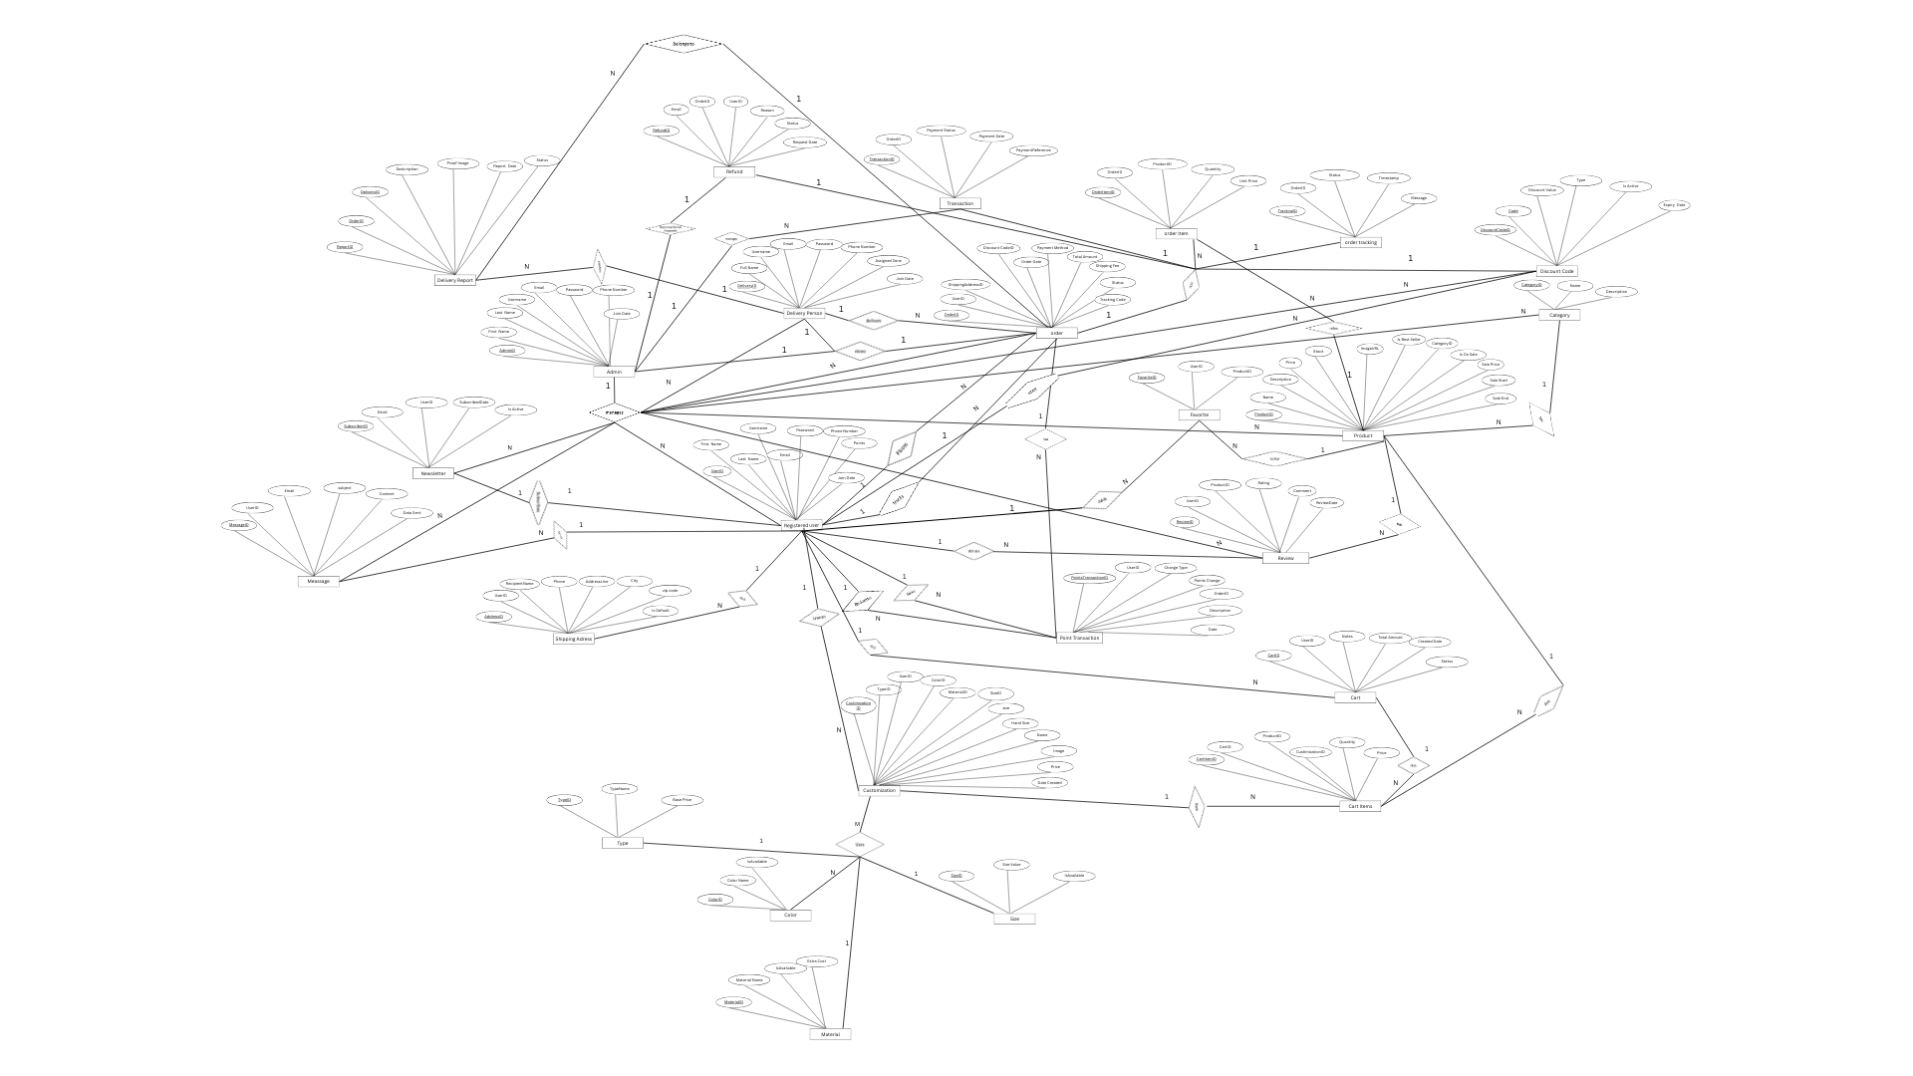

Figure 2– ER Diagram

3.2.1.The entities of Belle Beads:
- admin

- registereduser

- product

- category

- color

- material

- size

- type

- customization

- cart

- cartitem

- favorite

- order

- orderitem

- ordertracking

- deliveryperson

- deliveryreport

- shippingaddress

- transaction

- discountcode

- pointstransaction

- review

- message

- refundrequest

- newslettersubscriber

3.3.Relational Diagram
Relational Diagram of the Belle Beads system, showing selected attributes from each entity, including primary and foreign keys. The diagram highlights how foreign keys establish relationships between tables, ensuring data integrity across features such as product customization, order processing, user management, and delivery tracking. See Figure 3.
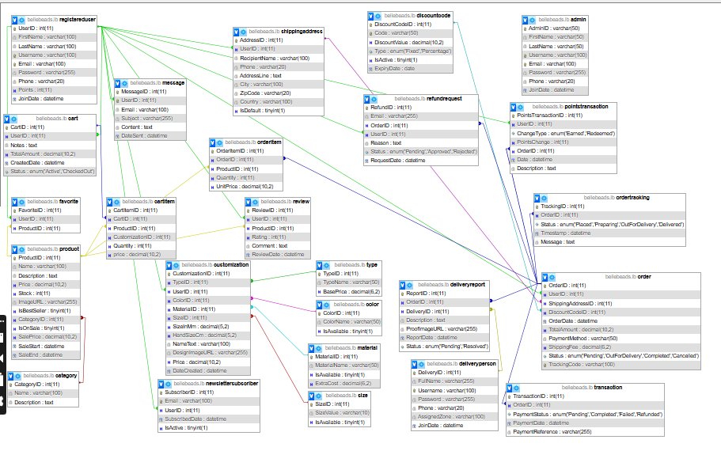

Figure 3-Relational Diagram

Chapter 4:

This chapter provides a comprehensive overview of our e-commerce website, Belle Beads. It presents the overall design of the project and outlines the primary purpose and function of each page and interactive element throughout the platform.

4.1- Implementation:
As part of the Belle Beads project implementation, the website is not only built to offer a smooth shopping experience for customers but also to support efficient management by admins and delivery personnel. The system displays all essential information—such as order IDs, customer contact details, shipping addresses, payment confirmations, and tracking codes clearly and in one place. This allows the admin to manage orders, monitor customer activity, and update order statuses quickly and easily. For delivery personnel, having all delivery details organized and accessible reduces confusion and saves time during the delivery process. The overall interface is simple, user-friendly, and avoids unnecessary complexity, ensuring that both administrative tasks and deliveries can be handled efficiently with minimal training or technical knowledge.

4.2- Project`s Parts:

4.2.1.Index Page:
The main page is the first page visitors see when they arrive at the website. It features a welcoming section that asks users if they are ready and encourages them to Shop Now. An attractive slider showcases the products and services offered. The page also includes an "About Us" section to introduce the brand. Navigation headers include Home Page, Login/Register, Shop, About Us, and Contact Us. Additionally, the page presents product categories, a newsletter subscription option, and a brief company history. The layout and design are illustrated in Figure 4.

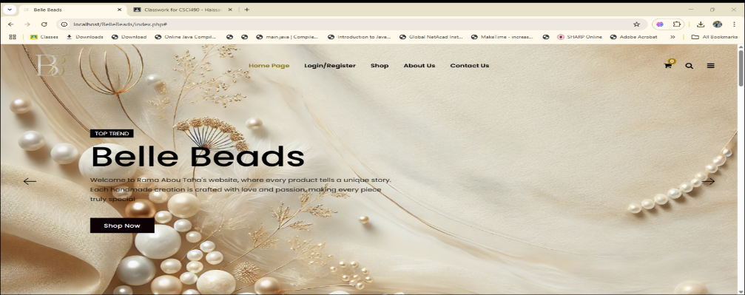

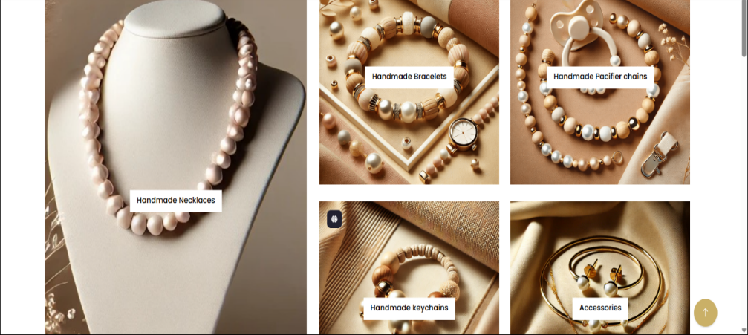

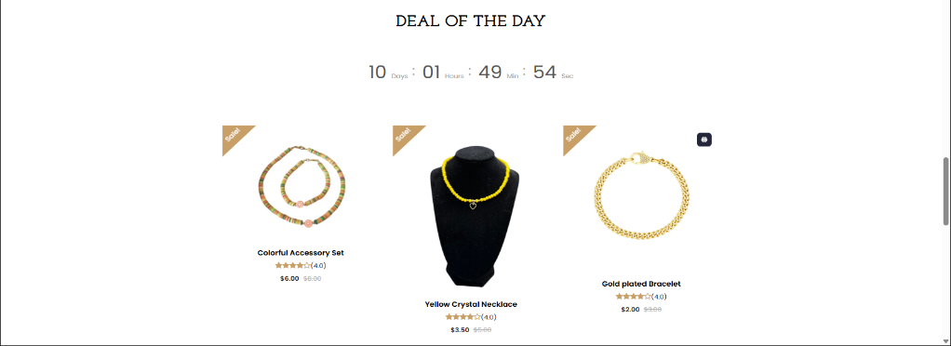
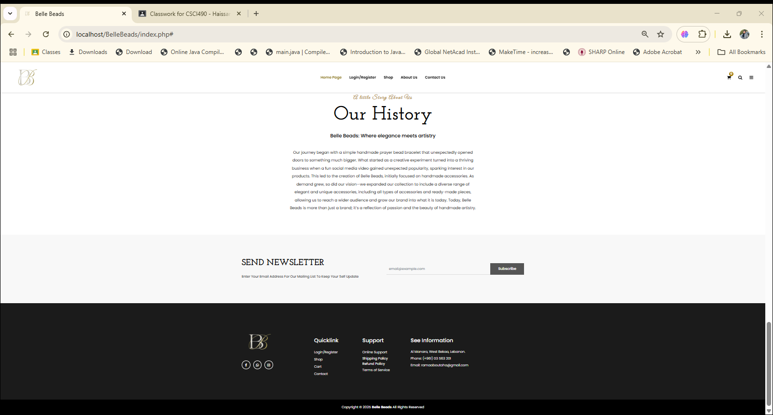
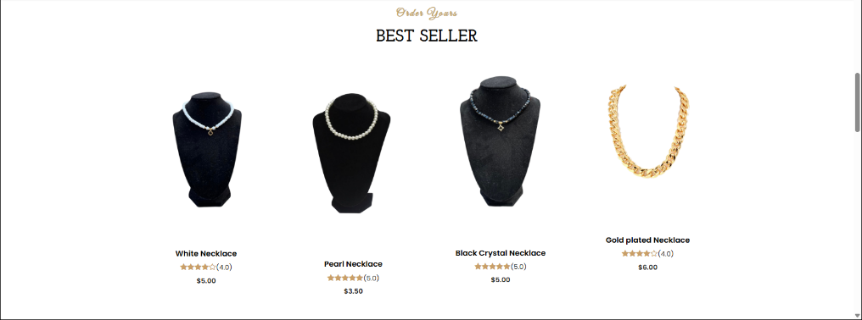

Figure 4:Index Page

4.2.2.Login Page :
The login page is used by all types of users :admins, registered customers, and delivery person. Each user can enter their information to log in if they already have an account. If they do not have an account, they can easily create one through the registration option ,and only registered users have the option to reset their password. The design is clear and easy to use, making the login process simple for everyone. See Figure 5.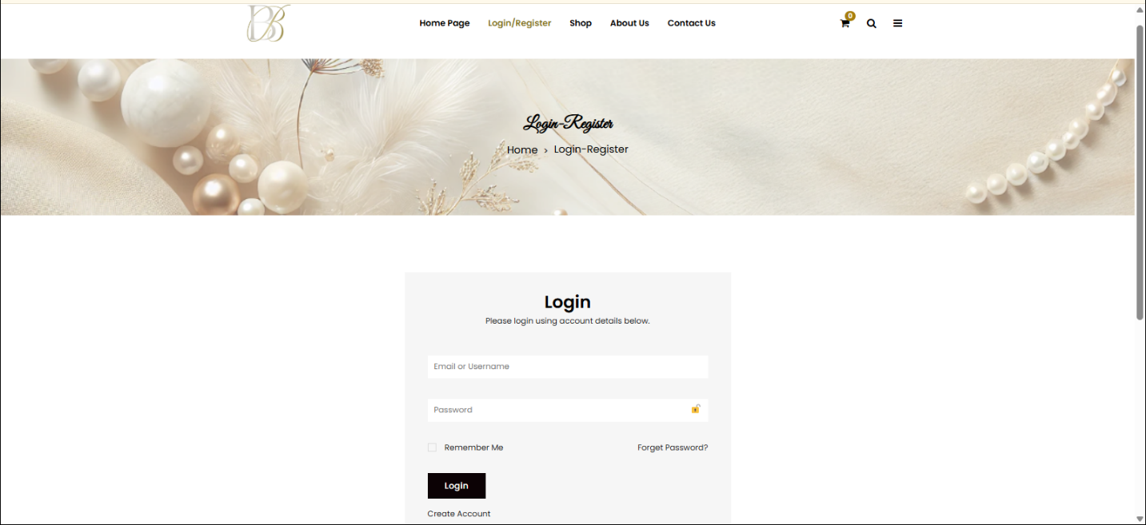
Figure 5-Login Page

4.2.3.Forgot Password Page :
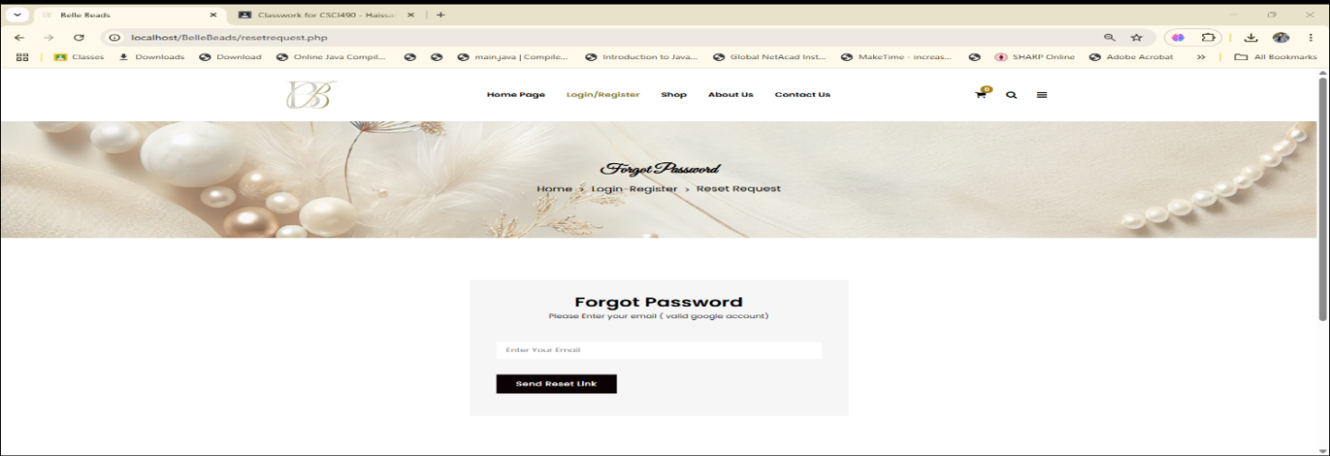
This page is specifically for registered users. If a user forgets their password, they can enter their email address. If the entered email is valid and exists in the system, a password reset link will be sent to their Gmail, allowing them to securely create a new password.See Figure 6.
Figure 6-Forgot Password

4.2.4.Enter New Password Page :
On this page, after the reset email is sent, the user enters a new password. Once submitted, the new password is securely updated in the database. See Figure 7.
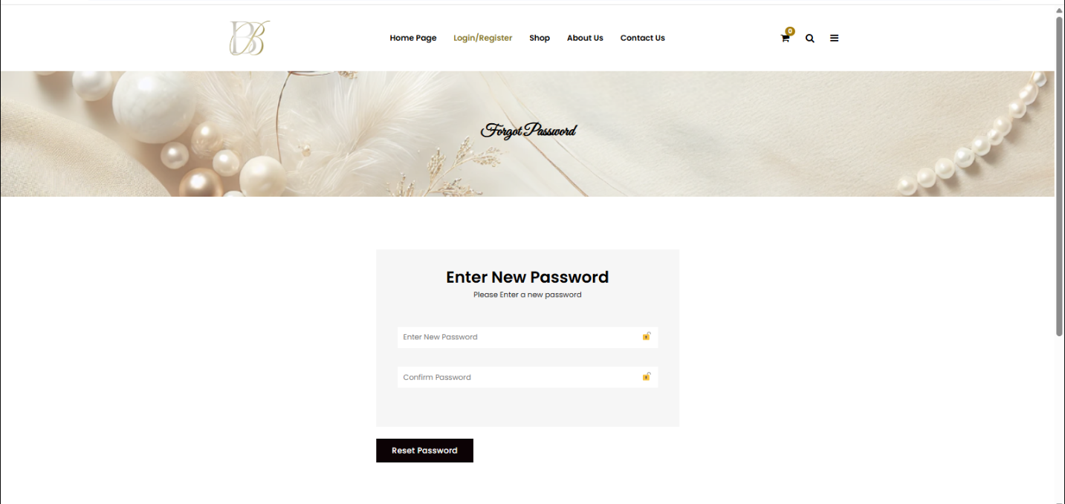

Figure 7-Enter New Password

4.2.5.Creating New Account :
On this figure, the user is required to fill in their first name, last name, phone number, username, email, and a password that must be at least 11 characters long and special characters. The password field includes a show/hide option for better usability. Only registered users can create an account through this form .Admin accounts already exist in the database, and delivery accounts can only be added by the admin. Additionally, only Lebanese phone numbers are accepted to ensure valid local contact information .See Figure 8.
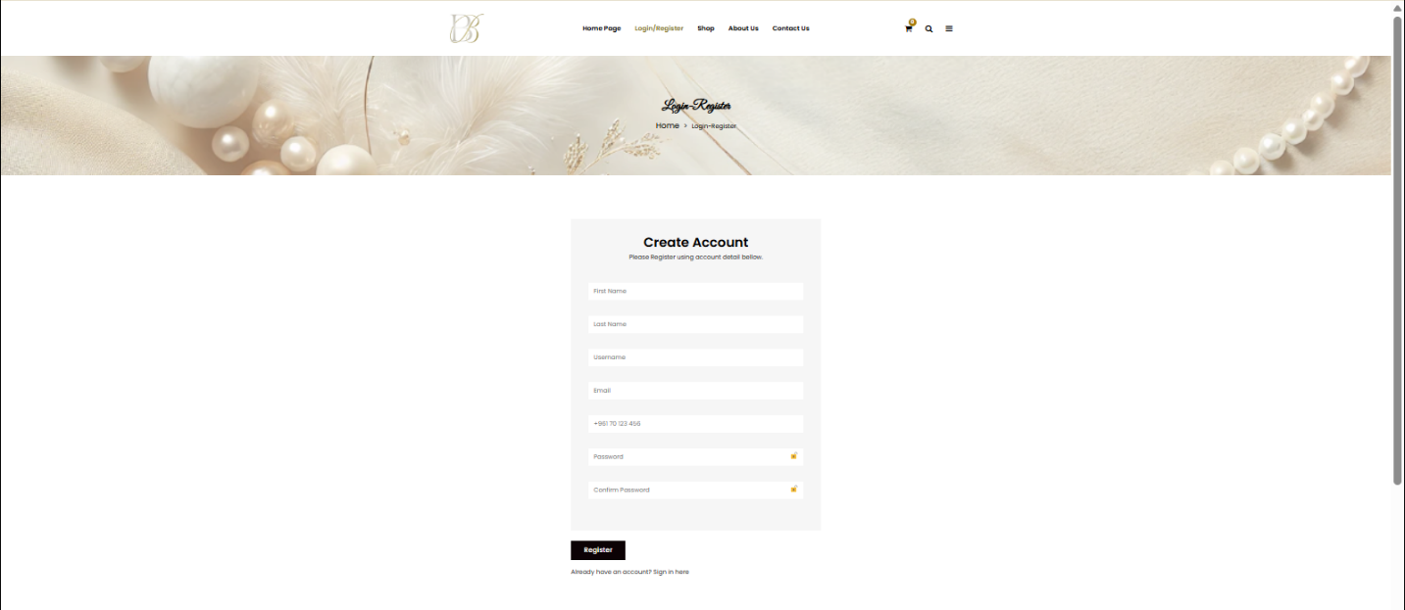

Figure 8-Create Account

4.2.6.User Dashboard:
This page appears after a registered user logs in. It displays their orders, saved addresses ,tracking orders, loyalty points, and favorite items .See Figure 9.
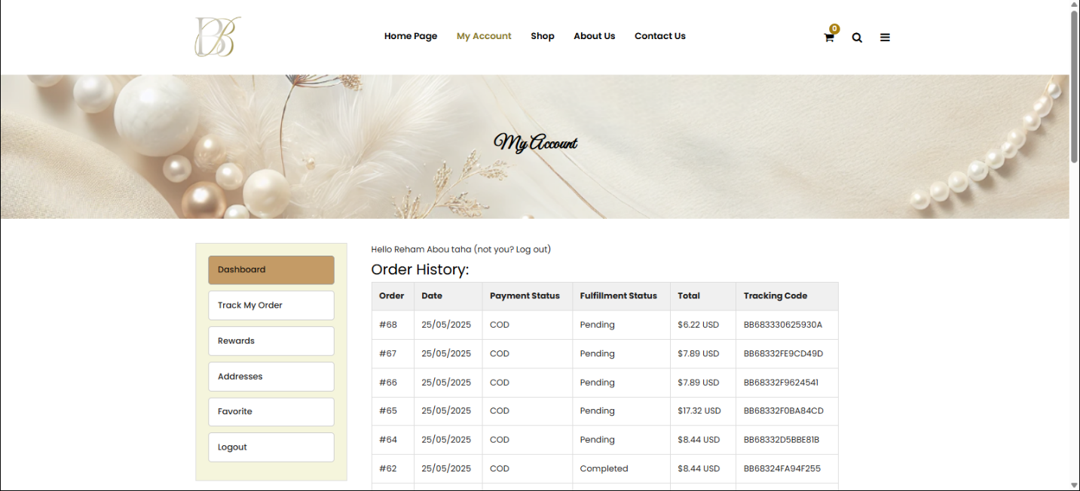
Figure 9-User Dashboard

4.2.6.1.Tracking Orders
On this page, the user can enter the tracking code from their order to view the latest updates and status of their orders. See figure 10.
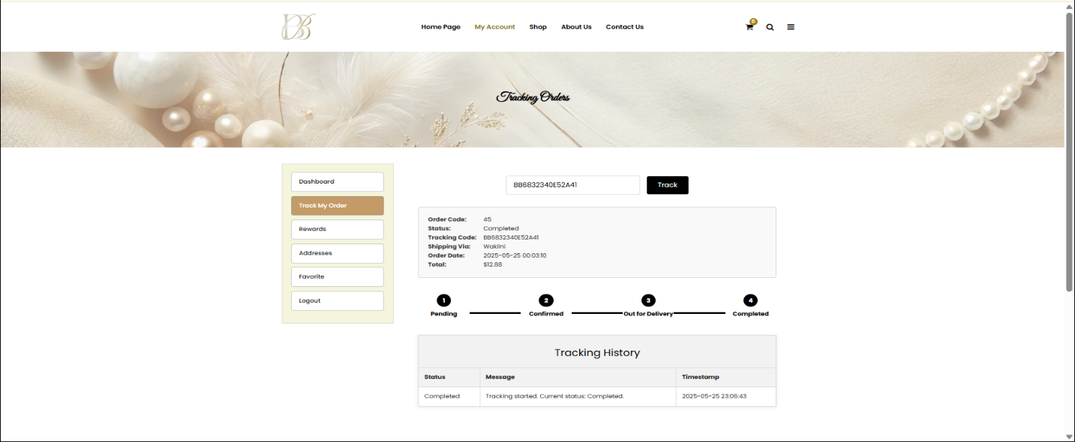
Figure 10-Tracking Orders

4.2.6.2.Rewards:
The system rewards users with 10 points for every $1 spent. On this page, the user can view the points they have earned from their orders. See Figure 11.
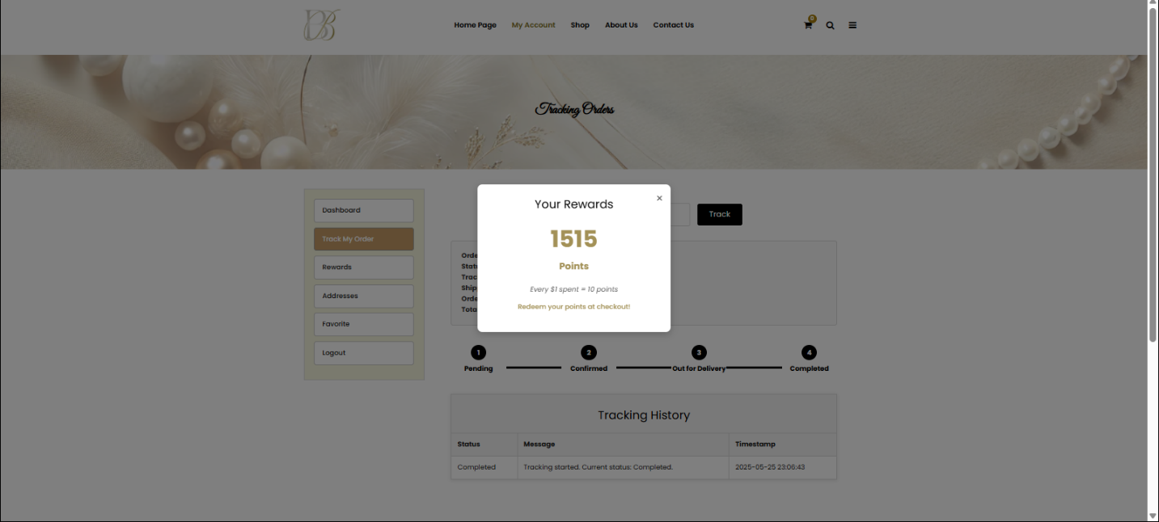
Figure 11-Rewards

4.2.6.3.Addresses:
On this page, the user can add their shipping addresses with a limit of up to three addresses. They can set only one as the default. When a default address is selected, it is automatically filled in during the checkout process for convenience. See Figure 12.
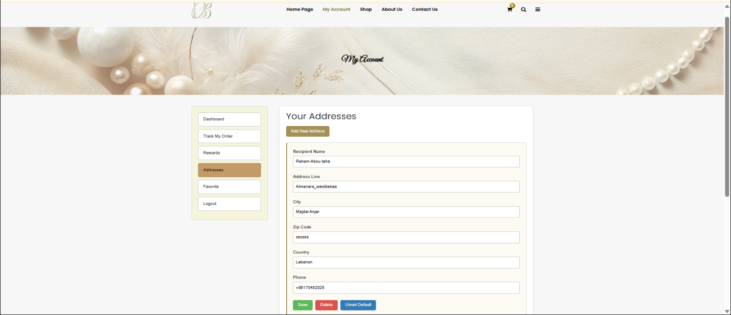
Figure 12-Addresses

4.2.6.4.Favorite:
On this page, only registered users can access the favorites section. Guest users cannot view or add items to favorites; if they try, they are redirected to the login page.See Figure 13.
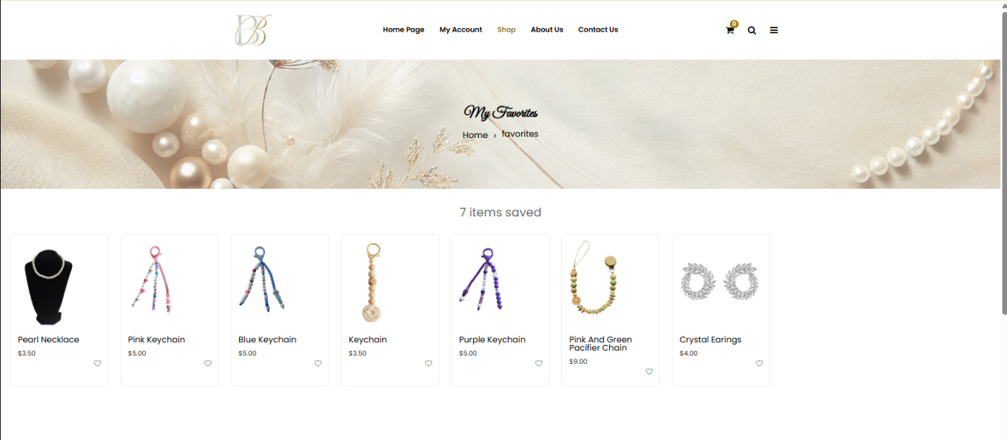
Figure 13-Favorite Page

4.2.6.5.Logout:
After finishing their shopping, the user can log out from the website to end their session securely.

4.2.7.Shop:
This page is the shop, where users can search for products, sort items, and browse by categories such as favorites, new products, and best sellers. Users can select items to add to their cart or save them to their favorites for later, and product ratings are also displayed on this page. All pages share the same styling and functionalities, but each category displays only the products assigned to it. Additionally, there is a list view option for browsing products. See Figure 14.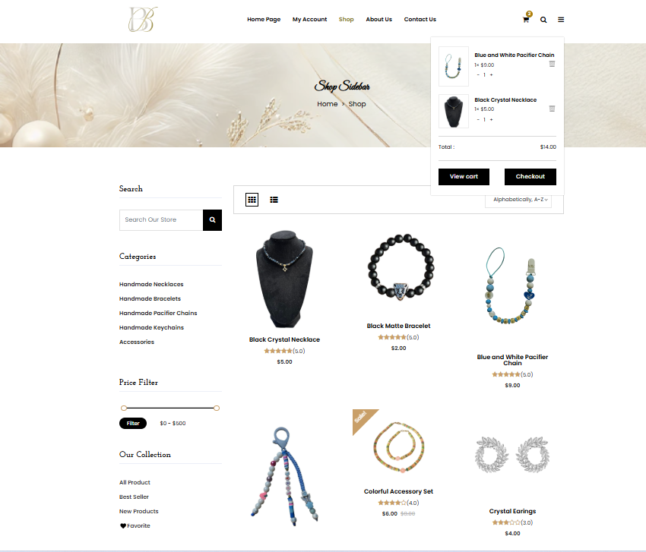
Figure 14-Shop

4.2.8.Shop-List View:
On this page, the products are displayed using a list view format .See Figure 15.
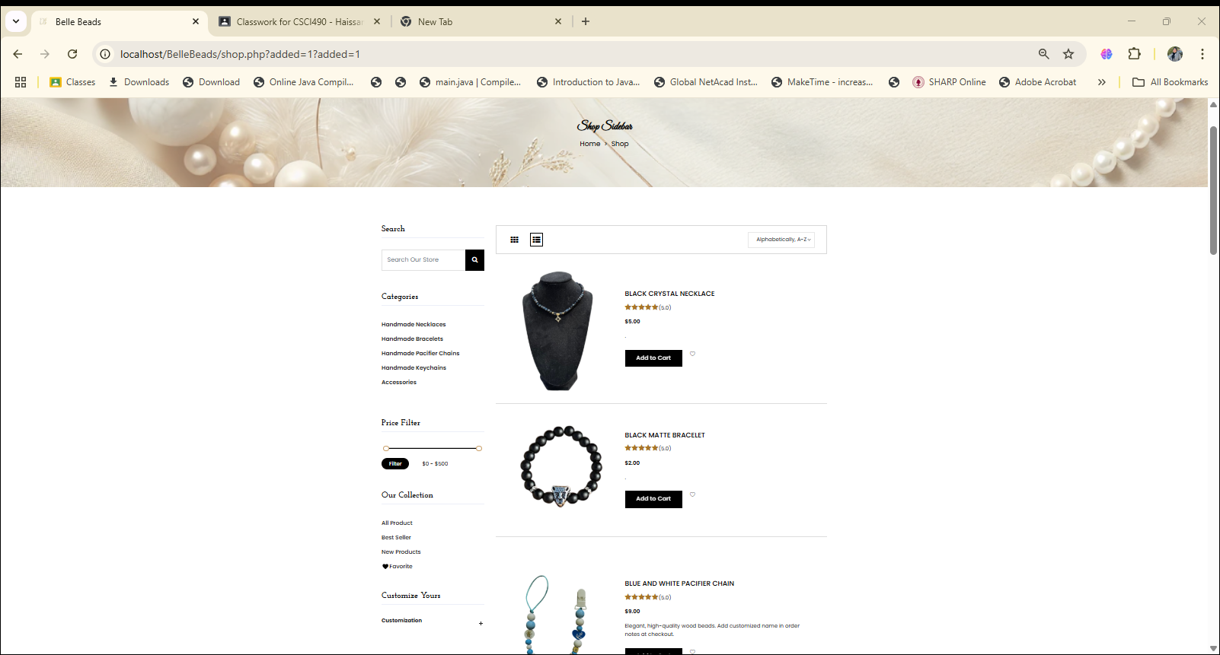

Figure 15-Shop List View

4.2.9.Product Details:
On this page, the product details are displayed, and the user can add the product to favorites, add it to the cart, or rate it. See Figure 16.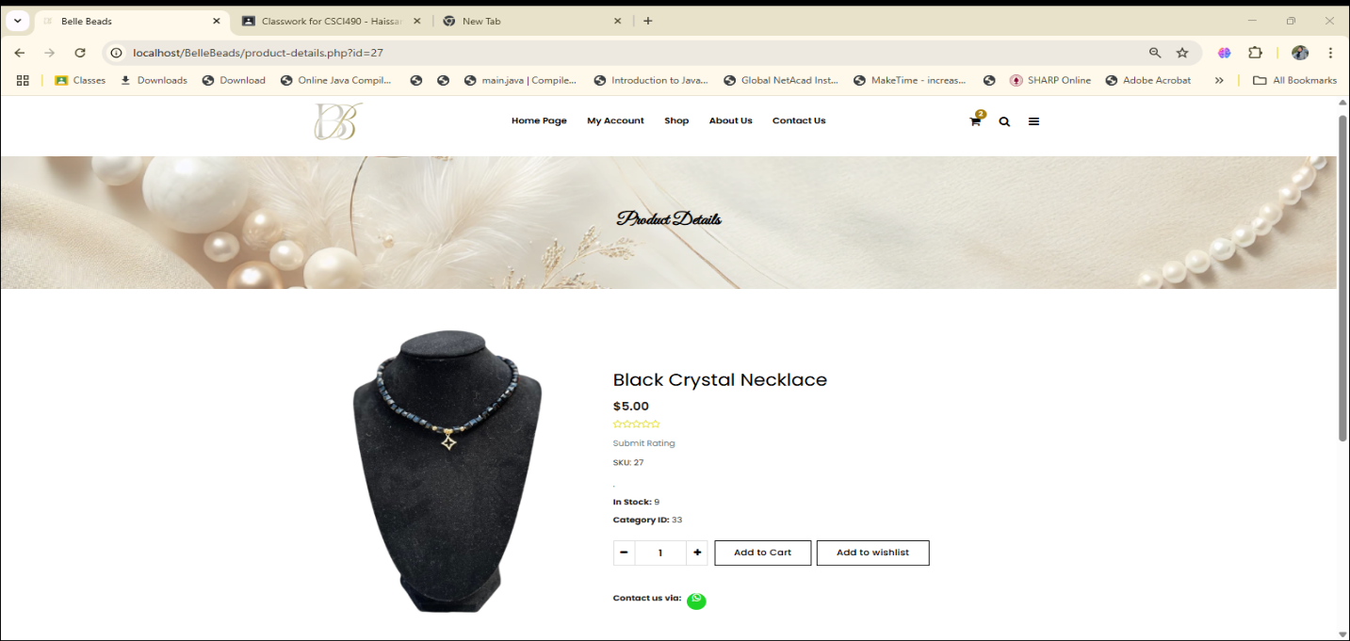
Figure 16-Product Details

4.2.10.About Us:
On this page, we introduce Belle Beads to let users know who we are .See Figure 17.
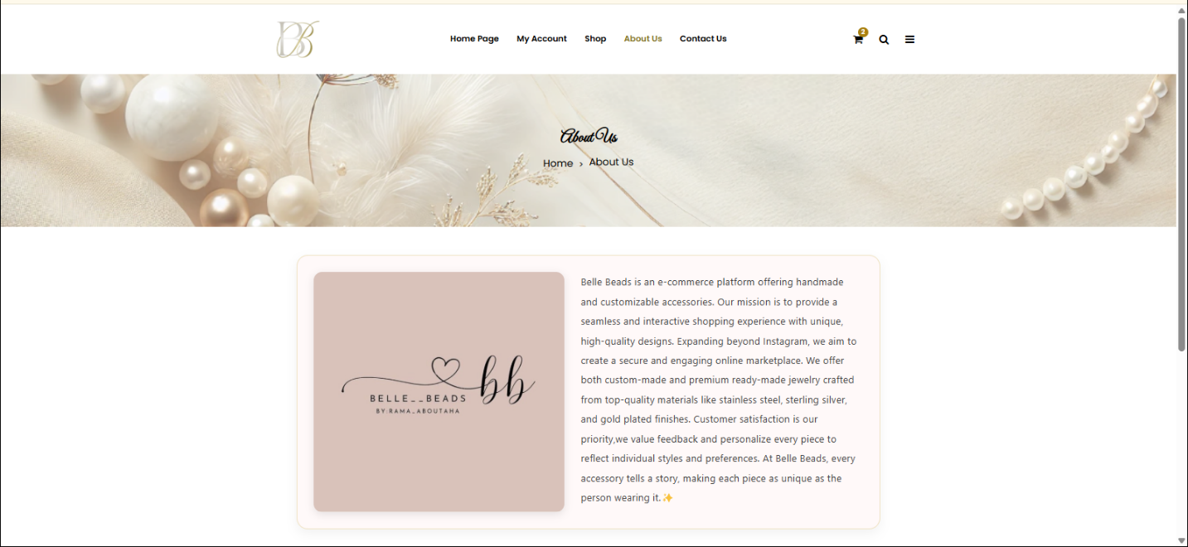
Figure 17-About Us

4.2.10.Contact Us:
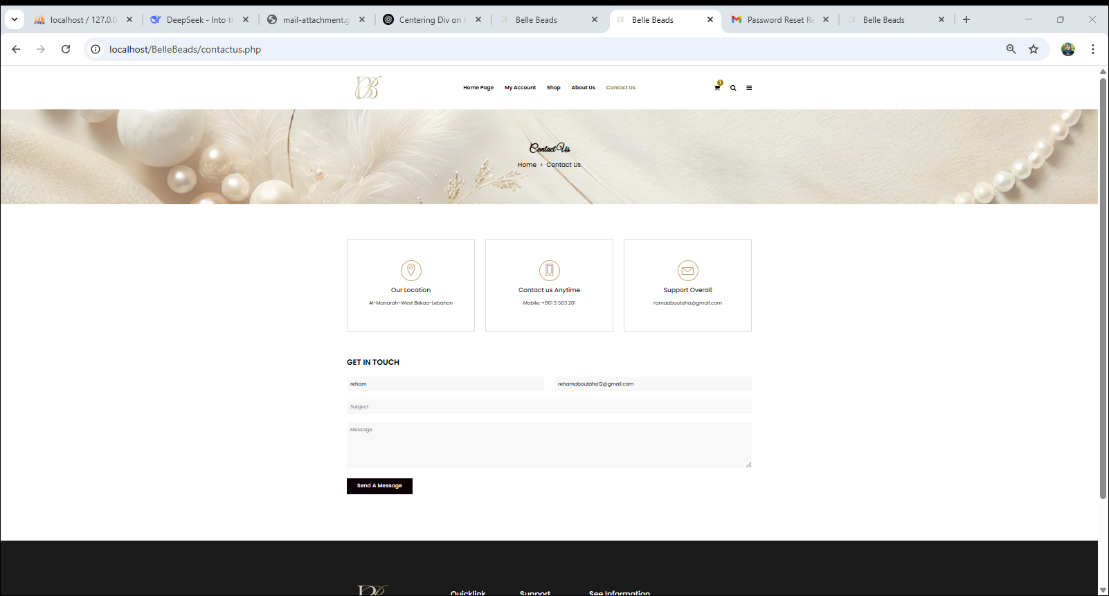
On this page, we provide our location, WhatsApp number, and email address so users can easily contact us. There is also a “Get in Touch” form that auto-fills user information if they are logged in, allowing them to send us messages directly, which the admin can then read and respond to. See Figure 18 .
Figure 18-Contact Us

4.2.12.Cart:
This page displays the items added to the user's cart, allowing them to proceed to checkout or return to shopping. It calculates the total amount and the points the user will earn .See Figure 19.
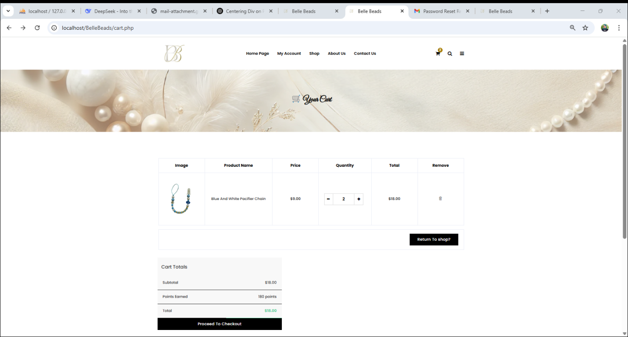
Figure 19-Cart

4.2.13.Checkout:
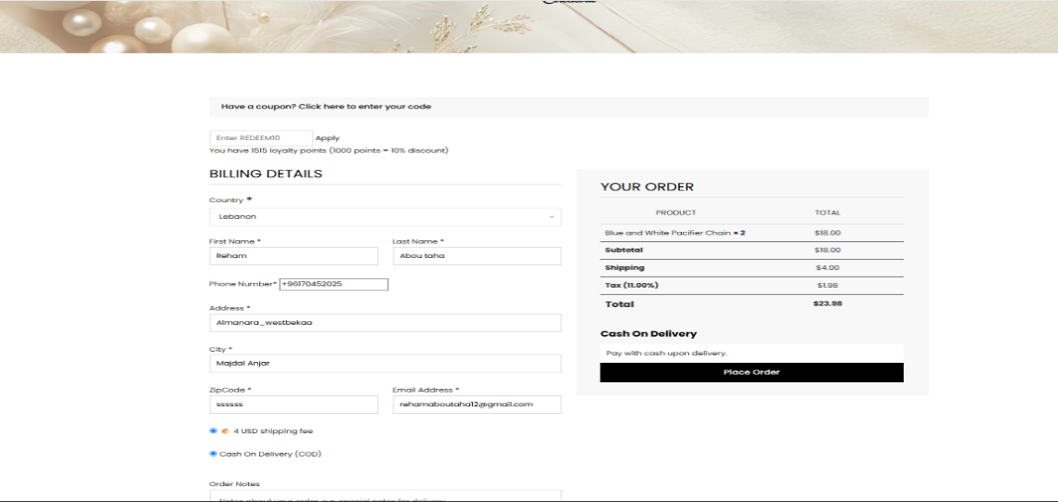
This checkout page allows registered users to complete their purchase. They can apply a discount code, earn points, and see the order total calculated based on the subtotal, 11% tax, and shipping fees. The user enters his shipping address details and notes. If the user has saved addresses from before, its autofill. Once everything is confirmed, the order is placed. See Figure 20.

Figure 20-checkout

4.2.14.Placed Orders:
After finishing and placing the order, a confirmation email with the order summary will be sent to your registered email (if it's valid). A confirmation message with the order details will also appear on the screen .See Figure 21.
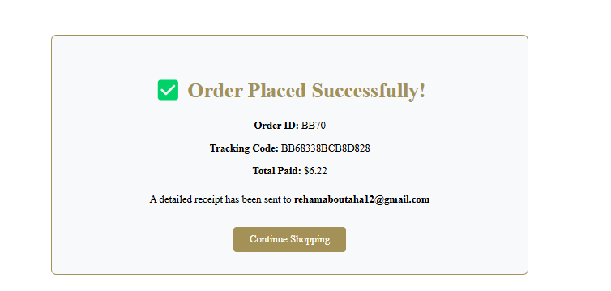
Figure 21-order confirmation

4.2.15.Admin Dashboard:
This page displays a quick overview of the system's key statistics, including the number of admins, users, delivery persons, pending orders, total sales, newsletter subscribers, categories, products, messages, and discount codes. It also provides access to the latest delivery reports. See Figure 22.
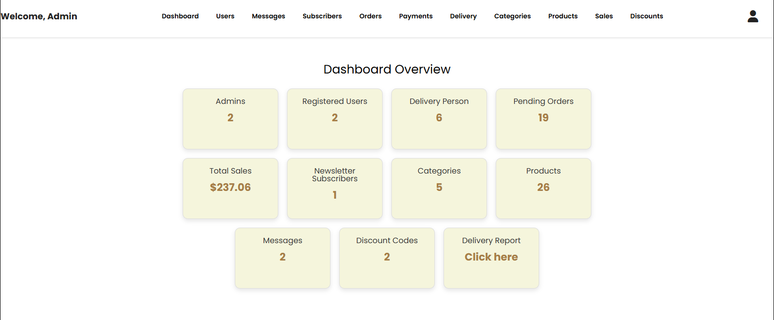
Figure 22-Admin Dashboard

4.2.16.Manage Users:
On this page, the admin can delete users unless they have an active order with the status "Out for Delivery." If a user has only completed orders, their user ID is set to NULL, but the orders and transactions remain in the database, while all other user information is deleted. However, if the user has pending or confirmed orders, all related data including orders, payments, and personal details is fully deleted. See Figure 23.
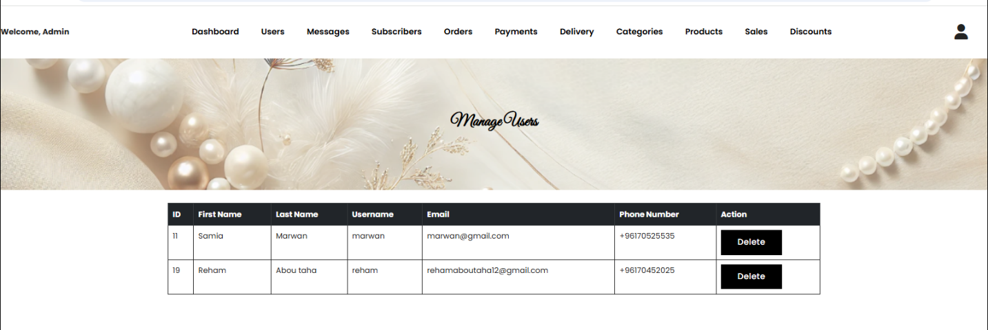

Figure 23-Manage Users

4.2.17.Manage Messages:
All messages from users in the 'Get in Touch' section of the Contact Us page will appear here. The admin has the ability to delete these messages. See Figure 24.
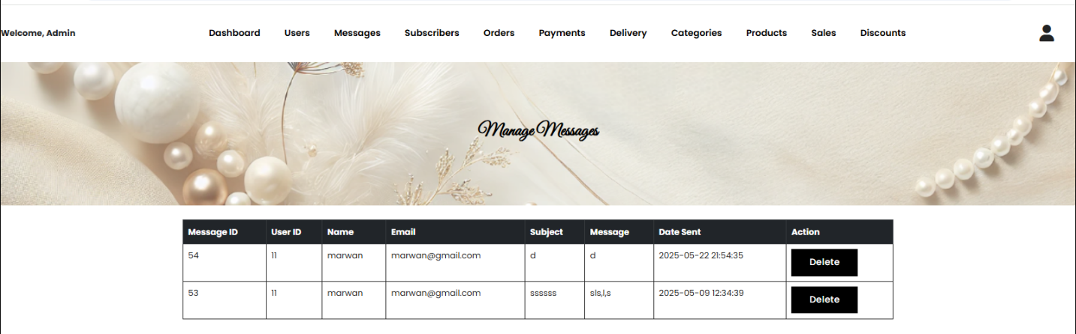
Figure 24-Manage Messages

4.2.18.Manage Subscribers:
All subscribers will appear on this page and the admin has the ability to delete them.See Figure 25:
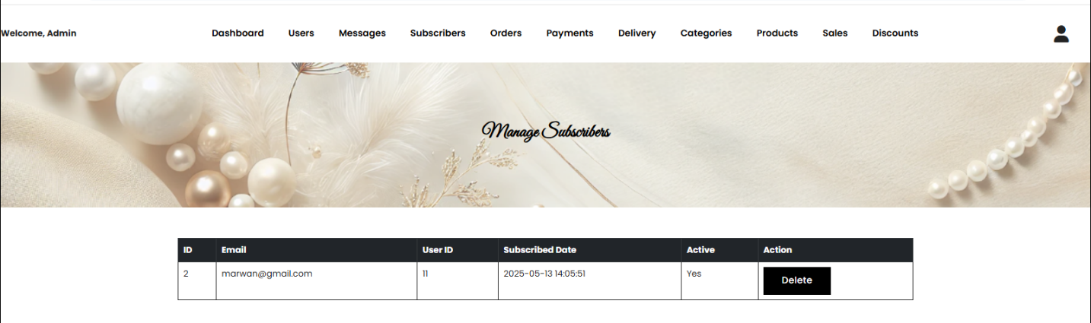
Figure 25-Manage Subscribers

4.2.19.Manage Orders:
On this page, the admin manages customer orders by assigning them to specific delivery persons and updating their status. Orders with a status of Pending or Confirmed can be deleted if needed. However, once an order is marked as Out for Delivery, it can no longer be deleted. If an order does not require delivery, the admin can directly mark it as Completed, but only if the payment status is set to Paid. See Figure 26.
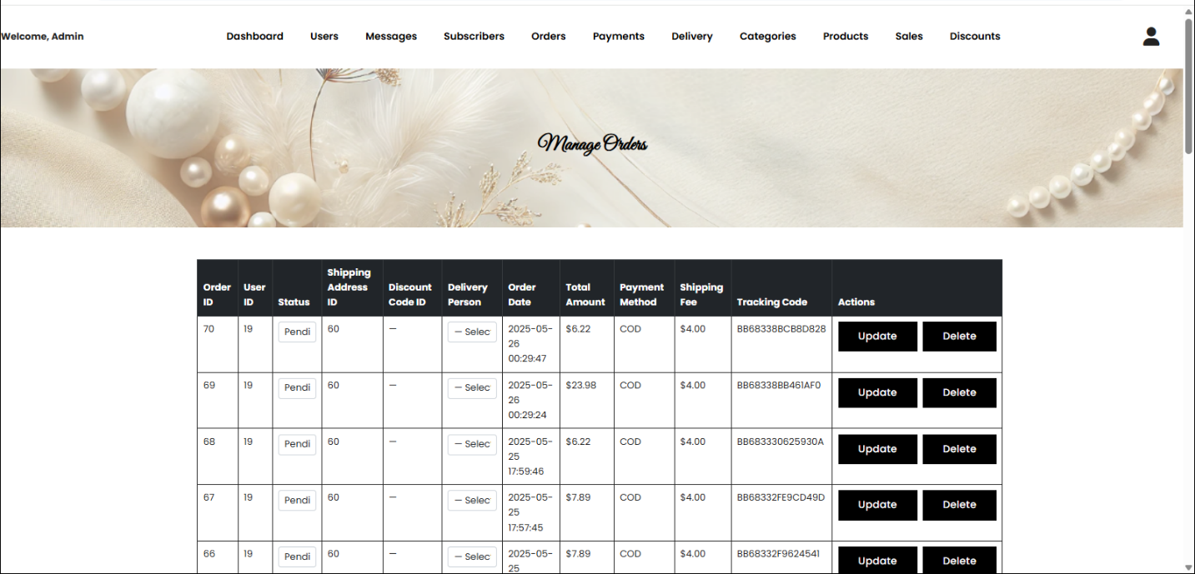
Figure 26-manage orders

4.2.20.Manage Payments:
On this page the Admin can update the payment status ,see figure 27.
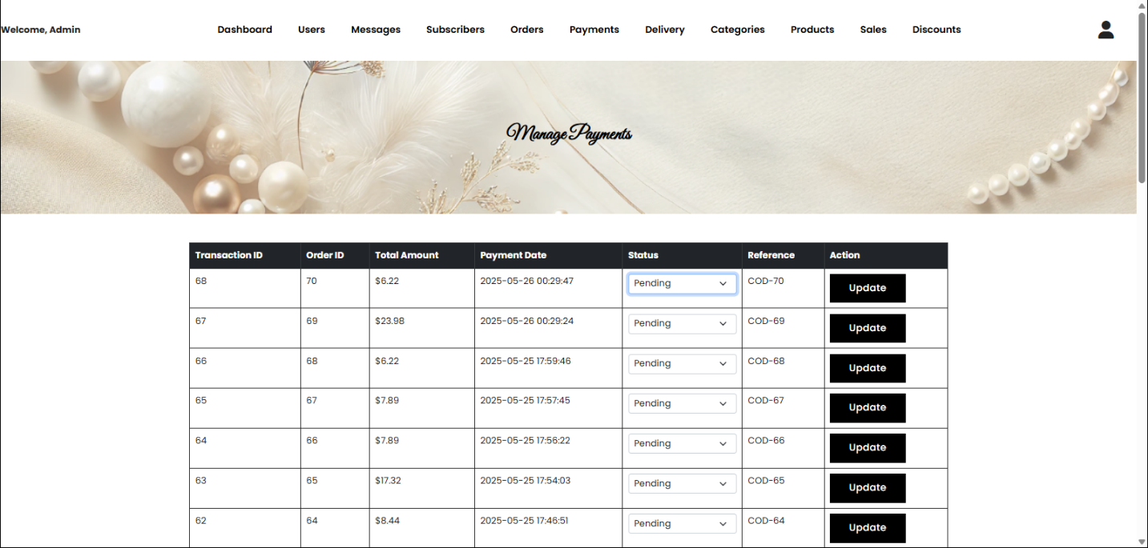
Figure 27-Manage Payments

4.2.21.Add Delivery person:
On this page admin can Add delivery person with his details and email, and he can delete them .See Figure 28.
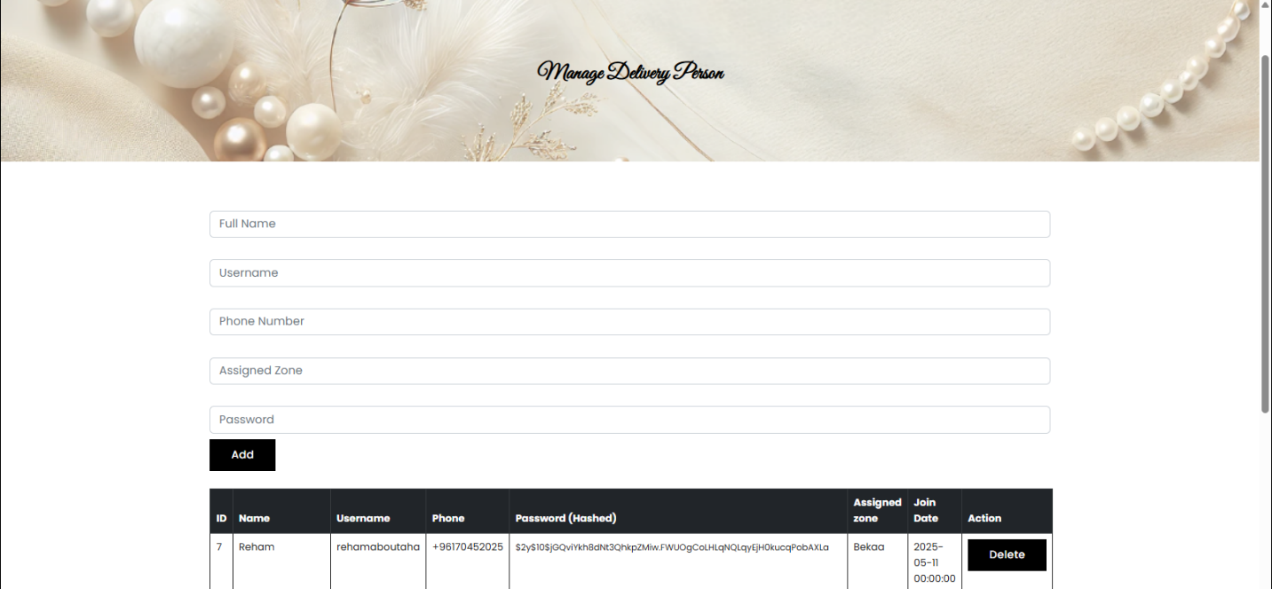
Figure 28-Add Delivery Person

4.2.22.Manage Categories:
On this page ,admin can add ,edit or delete categories. See Figure 29.
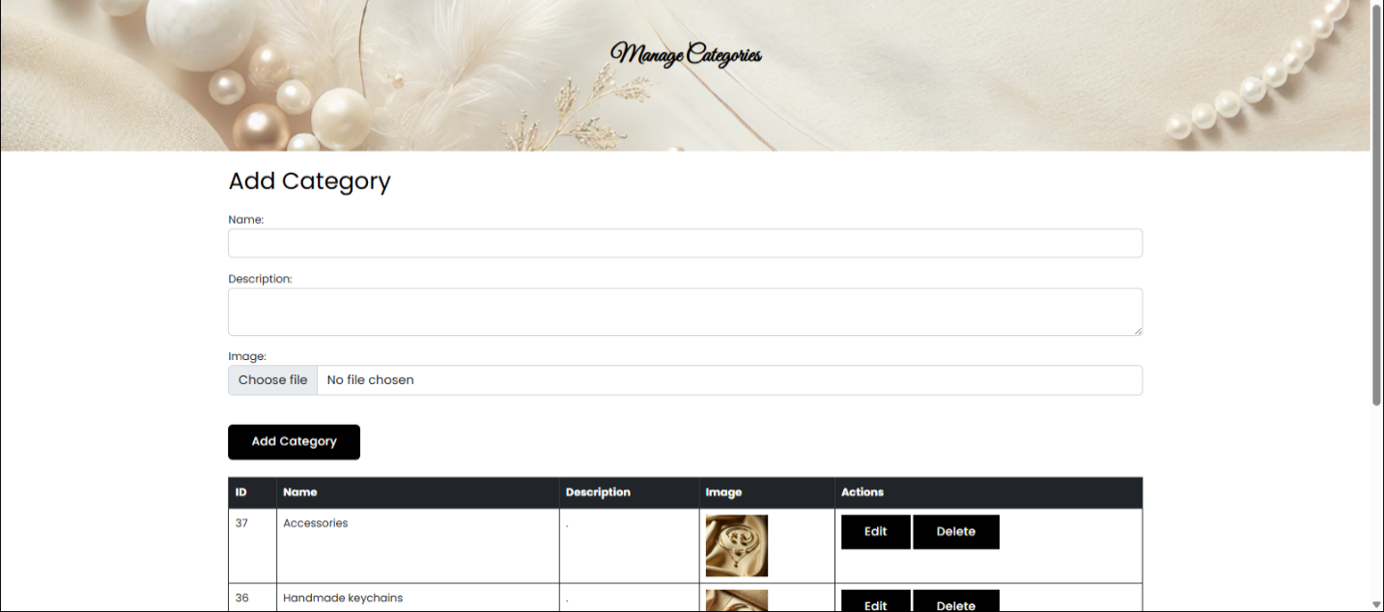
Figure 29-Manage Categories

4.2.23.Manage Products:
On this page, the admin can manage products and update their details. They can add, edit, or delete products. See Figure 30.
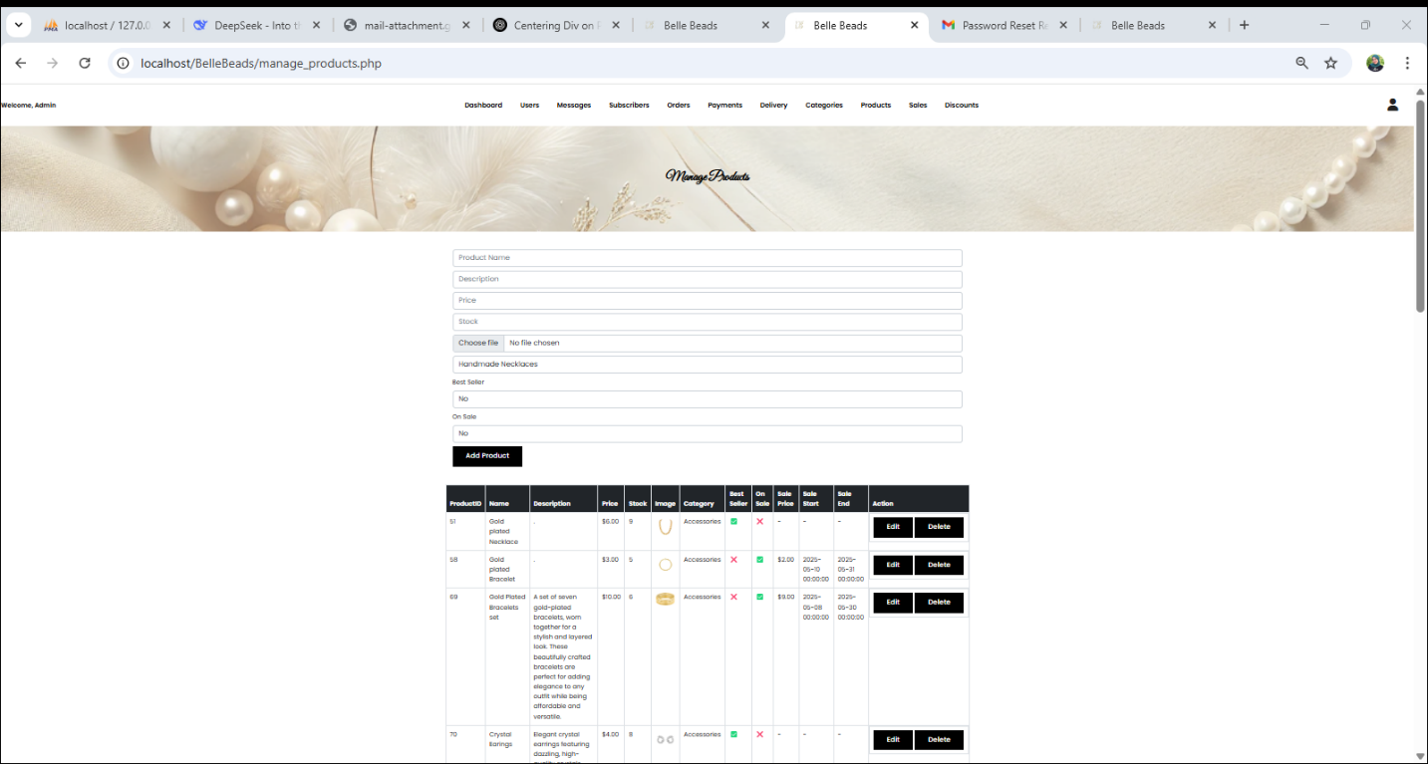

Figure 30-Manage products

4.2.24.Sales Report:
This sales report shows the sellers' performance along with the categories of their products. It includes detailed statistics for daily sales and monthly sales, helping track and analyze revenue over time. See figure 31.
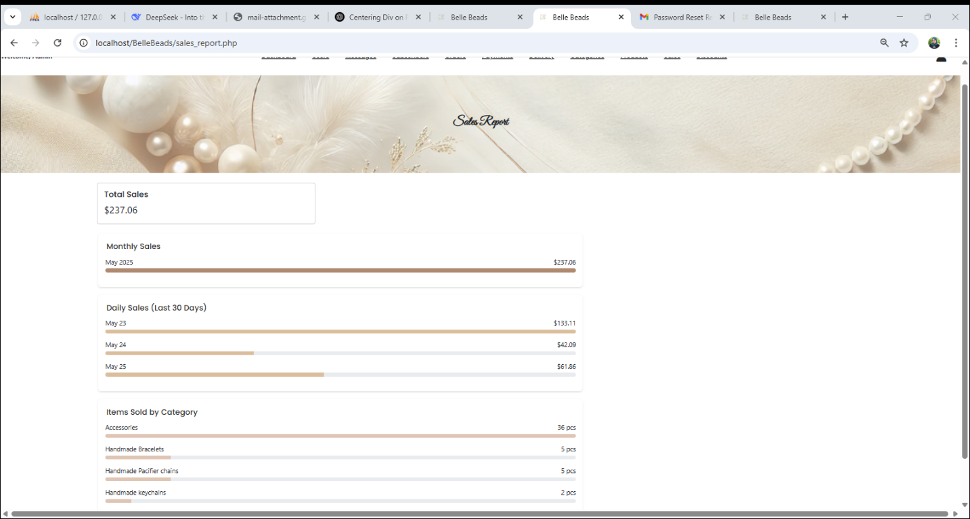
Figure 31-Sales Report

4.2.25.Manage Discounts:
On this page, the admin can add discounts by specifying their value and expiration date. They also have the option to delete existing discounts. See Figure 32.
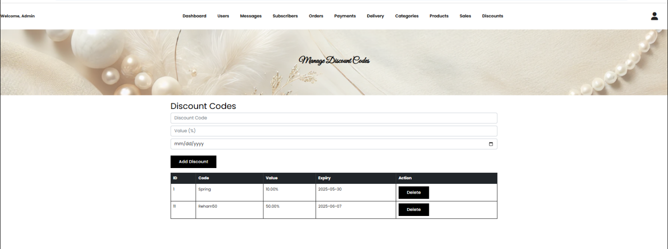
Figure 32-Manage Discount Code

4.2.26.View Delivery Reports:
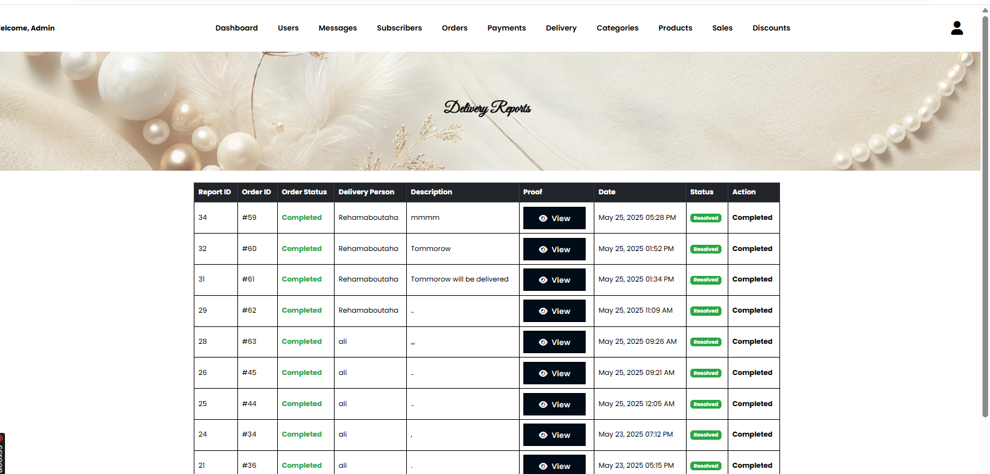
On this page, the admin can view all delivery reports for all delivery personnel. See Figure 33.

Figure 33-View Delivery Report

4.2.27.Logout:
When the admin finishes their tasks, they can log out securely to end the session. See Figure 34.
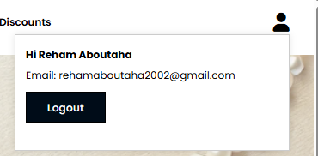

Figure 34 Admin Logout

4.2.28.Delivery Dashboard:
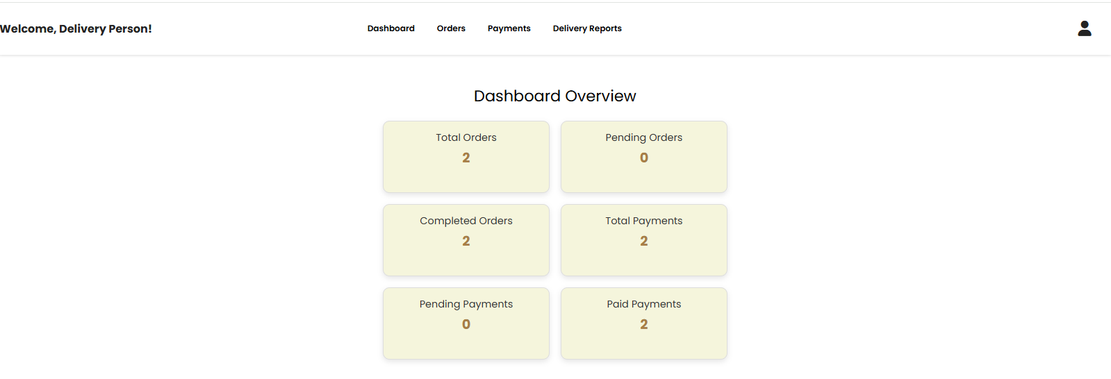
On this dashboard page, the delivery can view a summary of orders and payments, including totals, pending, and completed statuses for both. See Figure 35.
Figure 35-Delivery Dashboard

4.2.29.View Orders:
On this page, the delivery person can only view the status of orders assigned to them. They do not have access to orders assigned to other delivery personnel. They can see the current status of their orders but cannot update it directly. See Figure 36.
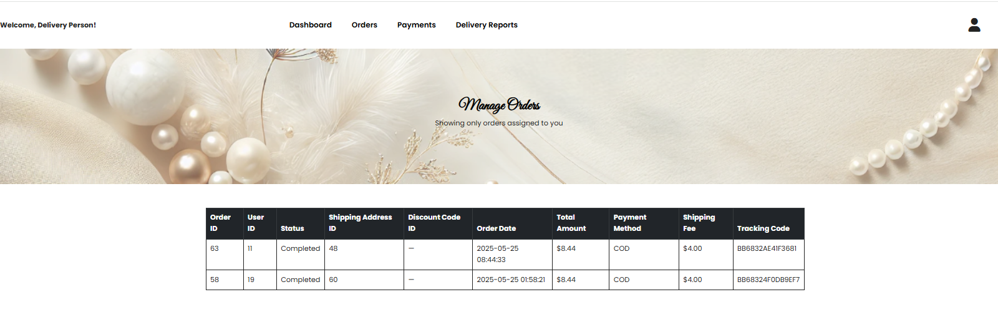
Figure 36-View orders

4.2.30.Manage Payments:
On this page, the delivery person can update the payment status of orders assigned to them only. They do not have access to orders handled by other delivery personnel. See Figure 37.
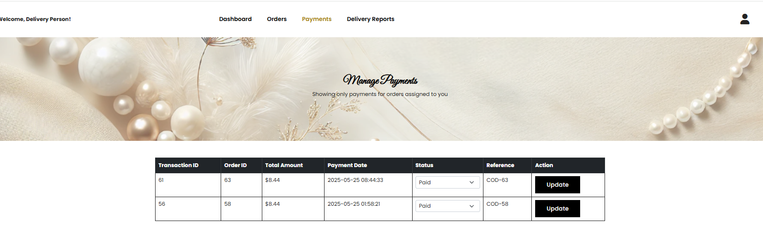
Figure 37-Manage Payments

4.2.31.Add delivery Report:
On this page, the delivery person can submit a delivery report for orders assigned to them. When they press "Resolve," the order status automatically changes from Out for Delivery to Completed. Only orders with the status Out for Delivery appear in the delivery report list. See Figure 38.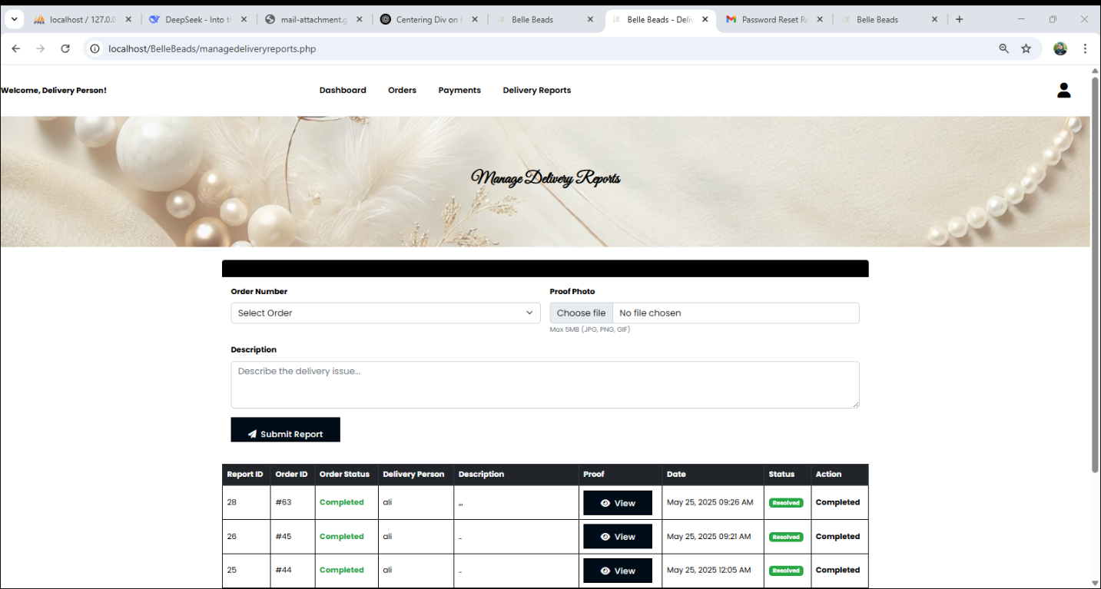
Figure 38-Delivery Report

4.2.32.Delivery Logout:
When the delivery finishes their tasks, they can log out securely to end the session. See Figure 39.
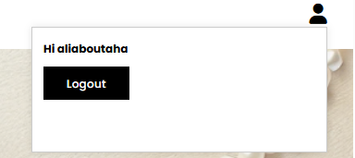

Figure 39-Delivery Logout

Chapter 5:

5.1.Conclusion:
The Belle Beads e-commerce system demonstrates how a well-structured online platform can streamline business operations and enhance customer satisfaction. Through its organized admin dashboard, administrators can efficiently manage users, products, categories, orders, payments, and promotions. The system also ensures secure and accurate order handling, allowing admins to assign delivery personnel, track order status, and ensure payments are confirmed before completion.
For delivery persons, the platform offers a dedicated interface where they can view their assigned orders, update payment statuses, and submit delivery reports. This role-based access ensures clarity, accountability, and smooth delivery operations. Customers benefit from a user-friendly shopping experience with access to quality handmade products, clear order tracking, and timely updates.
By integrating order management, payment processing, delivery tracking, and reporting features, Belle Beads provides a reliable, scalable, and professional solution for running an online accessory store. The system not only supports day-to-day operations but also lays a solid foundation for future growth and customer engagement.

5.2.Future Work:
- Customization Section: A special page will let users design their own accessories by choosing materials, colors, and adding names or messages. This makes each item more personal and unique.

- Mobile App: We plan to create a mobile app for Android and iOS so users can shop easily from their phones, get notifications, and enjoy a faster experience.

- 24/7 Support: Users will be able to get help any time through live chat, email, or an FAQ page to solve any issues quickly.

- Refund Request: A new feature will let users request refunds directly from their account. They can upload proof and track the status of the request.

- Wishlist & Gift List: Users will be able to save their favorite items in a wishlist or create gift lists for events like birthdays or weddings.

- Notifications: We will send alerts through push notifications or SMS to keep users updated about new products, order status, discounts, and points.

- Better Admin Tools: The admin dashboard will be improved with better reports and easier tools to manage users, orders, and products faster and more clearly.

- Advanced Product Filtering: A more detailed filtering system will be added, allowing users to filter products by price range, material, category, rating, and availability. This will help users find what they need more quickly and efficiently.

- AI-Powered Chatbot: A smart chatbot will be integrated to provide 24/7 instant support. It will handle FAQs, assist with order tracking, guide users during checkout, and escalate issues to live support if needed.

References:
- Query Foundation. (n.d.). jQuery. Retrieved from https://jquery.com/
- Hilios. (n.d.). jQuery Countdown Plugin. GitHub. Retrieved from https://github.com/hilios/jQuery.countdown
- Font Awesome. (n.d.). Font Awesome Icon Toolkit. Retrieved from https://fontawesome.com/
- PHP Group. (n.d.). PHP Manual. Retrieved from https://www.php.net/
- Mozilla Developer Network. (n.d.). AJAX - Asynchronous JavaScript and XML. Retrieved from https://developer.mozilla.org/en-US/docs/Web/Guide/AJAX
- Bootstrap. (n.d.). Bootstrap – The most popular HTML, CSS, and JS framework. Retrieved from https://getbootstrap.com/
- Google Developers. (n.d.). Google APIs. Retrieved from https://developers.google.com/
- Linearicons. (n.d.). Linearicons – Line icon font. Retrieved from https://linearicons.com/
- SwiperJS. (n.d.). Swiper – Modern mobile touch slider. Retrieved from https://swiperjs.com/
- Animate.css. (n.d.). Animate.css – A cross-browser library of CSS animations. Retrieved from https://animate.style/
- jQuery UI. (n.d.). jQuery UI – Interactions and widgets built on jQuery. Retrieved from https://jqueryui.com/
- Nice Select. (n.d.). jQuery Nice Select plugin. GitHub. Retrieved from https://github.com/hernansartorio/jquery-nice-select
- Magnific Popup. (n.d.). Responsive Lightbox & Dialog Script. GitHub. Retrieved from https://dimsemenov.com/plugins/magnific-popup/
- PHPMailer. (2025). PHPMailer – A full-featured email creation and transfer class for PHP (v6.10.0) [Computer software]. GitHub. https://github.com/PHPMailer/PHPMailer
- jQuery AjaxChimp. (n.d.). Mailchimp AJAX plugin for jQuery. GitHub. Retrieved from https://github.com/scdoshi/jquery-ajaxchimp

