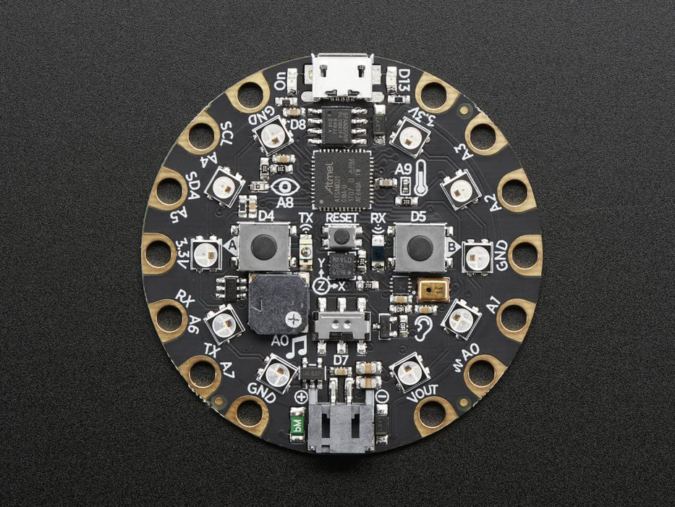

Starts game

Lights red when you lose

Target point

Stops light

Lights green when you win