Employee Sentiment Analysis – Final Report
Unlabeled employee e-mail dataset (test.csv) – sentiment labeling, EDA, monthly scoring, ranking, flight-risk detection and linear-regression modeling. Code: Employee_Sentiment_Analysis.ipynb.

Executive summary
- 2,191 e-mails from 10 employees (Jan 2010 – Dec 2011) were labeled with a RoBERTa transformer: 71.5% Neutral, 22.2% Positive, 6.3% Negative.
- Overall top 3 positive employees: johnny.palmer (total 51), sally.beck (49), lydia.delgado (48). Overall top 3 negative: rhonda.denton (16), john.arnold (22), don.baughman (25). Monthly top-3 tables for all 24 months are in Section 4.
- Flight risks (≥ 4 negative messages within a rolling 30-day window): john.arnold, patti.thompson and rhonda.denton. bobette.riner and lydia.delgado peak at 3 and form a watch list.
- Sentiment is stable over time and slightly better in 2011. Replies carry the most emotion, and negative messages are the shortest.
- A linear regression on message metadata explains about 20% of the variance in monthly score (test R² 0.18, CV 0.20, time split 0.25) and clearly beats the baseline. Message volume is the main driver.

1. Data and approach
The dataset has 2,191 rows and 4 string columns (Subject, body, date, from) with no missing values and no duplicates. There are 10 senders, each active in all 24 months. Dates are parsed as month/day/year. The bodies are raw Enron e-mails containing quoted-printable encoding artefacts, which are removed before modeling.

1.1 Sentiment labeling methodology (Task 1)
Cleaning: soft line breaks (=\n) and QP codes (=20, =01, …) are removed, URLs and e-mail addresses are stripped, and whitespace is collapsed. The subject is prepended to the body because it often carries tone.
Primary labeler: cardiffnlp/twitter-roberta-base-sentiment-latest, a RoBERTa transformer (PyTorch / Hugging Face) fine-tuned for 3-class sentiment. For every message the model outputs P(negative), P(neutral) and P(positive), and the label is the arg-max. The model runs in eval mode with no sampling, so labels are fully reproducible. Probabilities and confidence are stored next to the label in outputs/labeled_messages.csv.
Why: a transformer understands context and negation ("unfortunately … will not work", "not a problem") that lexicon methods miss, and it runs on a CPU in a couple of minutes without an API key.
Validation: two lexicon-based methods, VADER and TextBlob, labeled the same text independently. Both use a ±0.05 neutral band around a polarity score. Neither changes the final label.
Agreement with the transformer: VADER 42.9% (Cohen's κ 0.17), TextBlob 52.2% (κ 0.24). VADER and TextBlob agree with each other 65.3% of the time (κ 0.36), and all three agree on 33.9% of messages. The lexicon methods label far more messages Positive (VADER 1,574, TextBlob 1,165, transformer 487) because they treat polite business wording as positive. Most disagreements are transformer-Neutral vs lexicon-Positive (1,059 with VADER, 710 with TextBlob).
Opposite polarities (Positive vs Negative) are rare: 69 messages with VADER (3.1%) and 51 with TextBlob (2.3%). A manual review of those favours the transformer. Examples: "Unfortunately, today is not going to work…" (transformer: Negative, VADER: Positive) and "it wouldn't hurt to have another guy" (transformer: Positive, TextBlob: Negative). Mean transformer confidence is 0.81.
pair | agreement | cohen_kappa
Transformer (final) vs VADER | 0.429 | 0.173
Transformer (final) vs TextBlob | 0.522 | 0.238
VADER vs TextBlob | 0.653 | 0.355

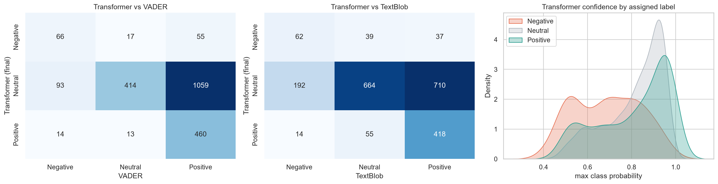
Figure 1 – Transformer labels vs VADER and TextBlob, and transformer confidence per label.

2. Exploratory data analysis (Task 2)
- Sentiment mix: Neutral 1,566 (71.5%), Positive 487 (22.2%), Negative 138 (6.3%).
- Time trend: there are 91–92 messages every month. Monthly net sentiment ranges from +6 (Feb 2010) to +22 (Oct 2011). 2011 is slightly more positive than 2010 (23.3% vs 21.1% positive; 5.7% vs 6.9% negative).
- Anomaly: the e-mail content refers to 2000–2001 but the dates are 2010–2011, they are spread evenly across months, and about 31% of messages fall on weekends. The dates were probably re-sampled, so day-of-week effects should not be read as behaviour.
- Employees: johnny.palmer (29% positive) and sally.beck (27%) are the most positive. bobette.riner (8.8% negative) and john.arnold (8.2%) are the most negative. don.baughman and rhonda.denton are the most neutral (~78%).
- Length: negative messages are the shortest (median 24 words vs 30 neutral and 38 positive).
- Message type: replies are the most emotional (9.6% negative, 33.4% positive). Forwards are almost all neutral (1.4% negative).
- Data quality: 30 empty bodies, 100 bodies under 20 characters, 141 "(No Subject)", and one automated notice repeated 26 times. They are kept because they are real messages.
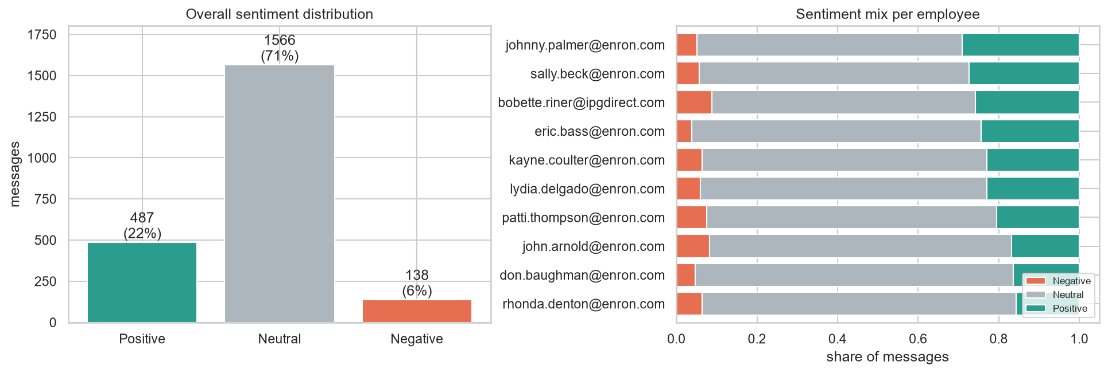
Figure 2 – Overall sentiment distribution and sentiment mix per employee.
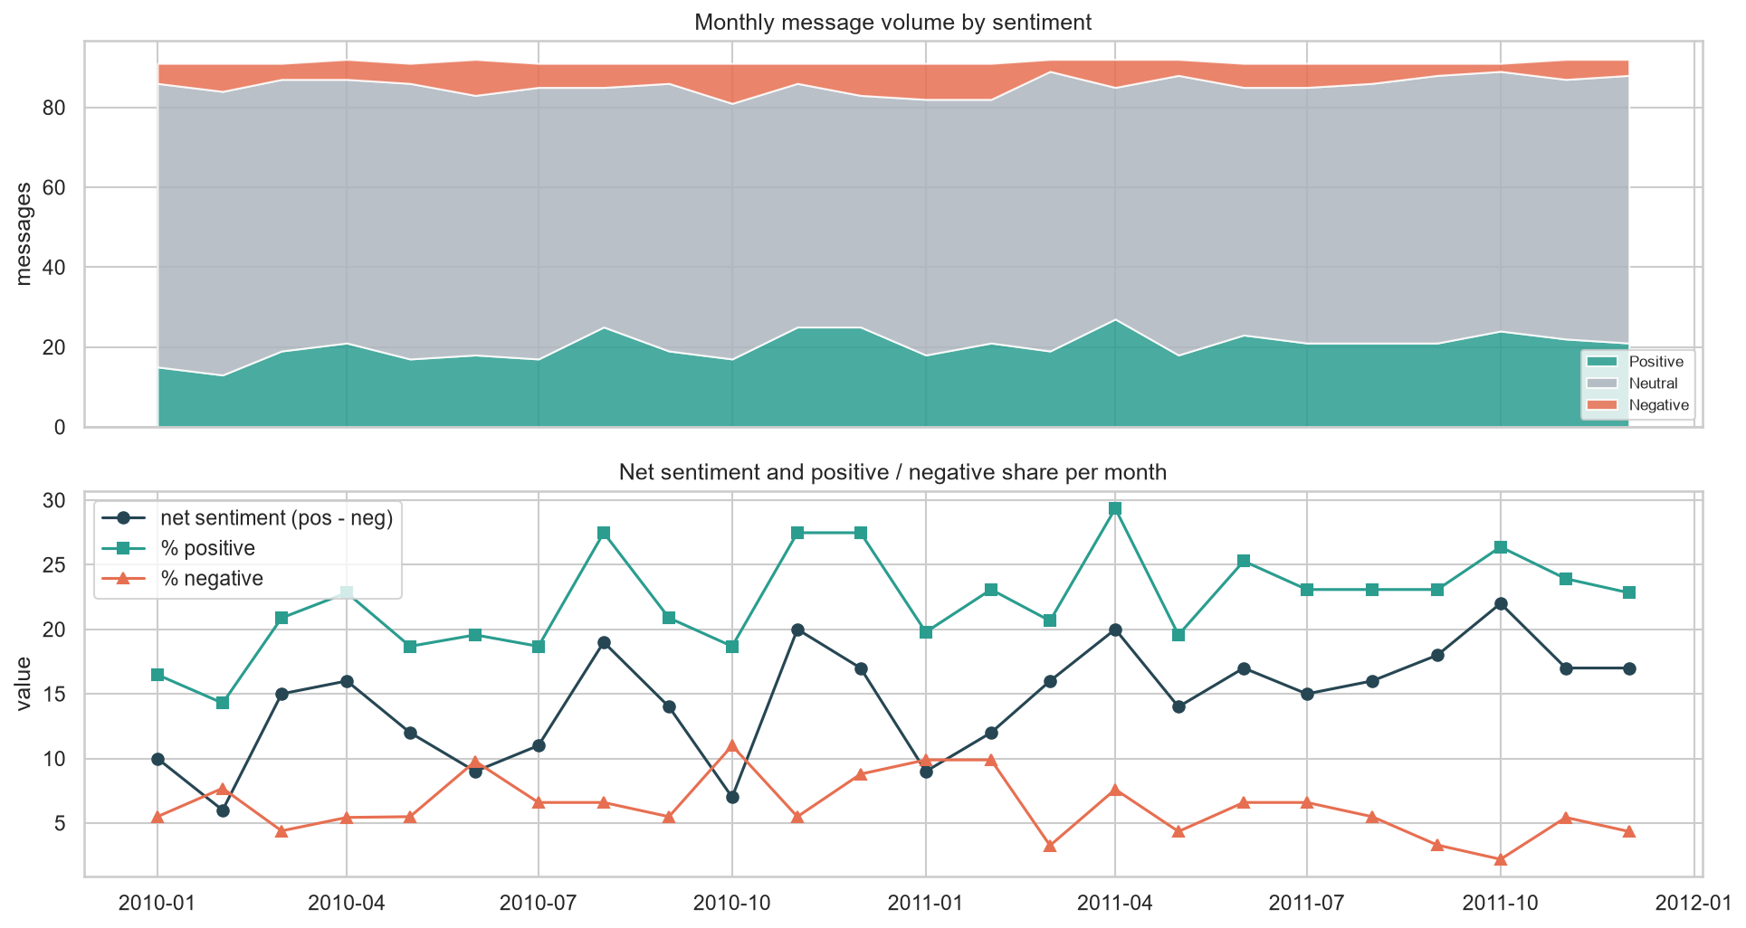
Figure 3 – Monthly volume by sentiment and monthly net sentiment.
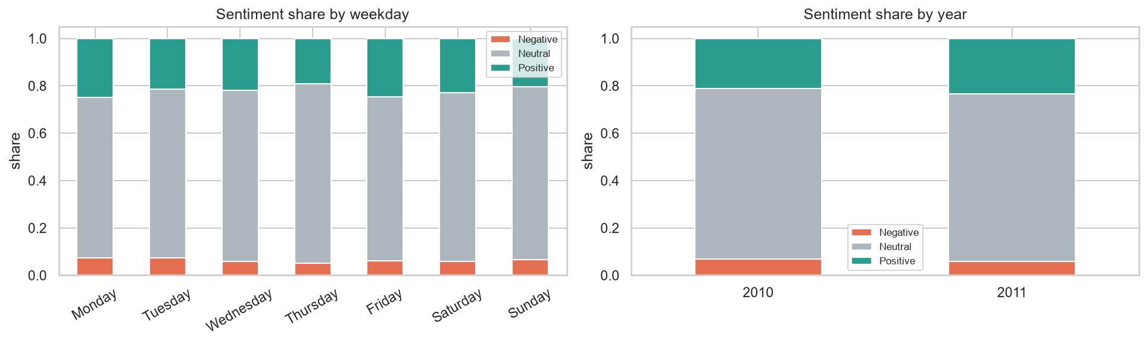
Figure 4 – Sentiment share by weekday and by year.
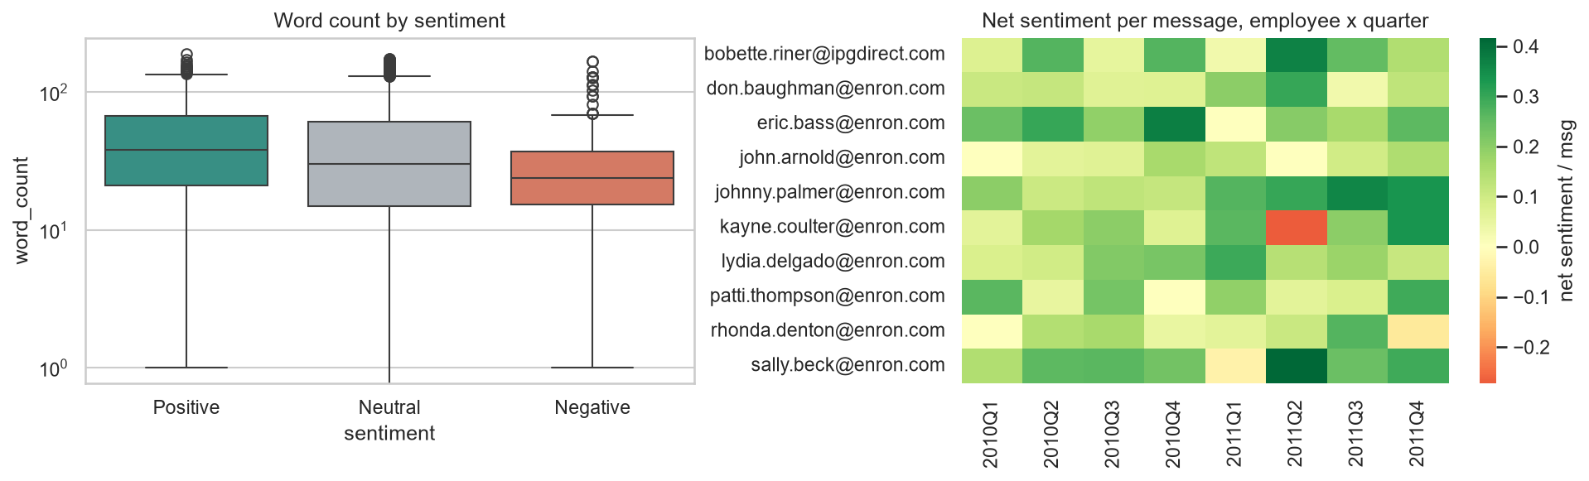
Figure 5 – Message length by sentiment; net sentiment per message by employee and quarter.

3. Employee scoring (Task 3)
- Each message scores +1 (Positive), −1 (Negative) or 0 (Neutral).
- Messages are grouped by employee and calendar month (pandas Period 'M'). The monthly score is the sum inside that month only, so it resets to 0 at the start of each month. A running total within the month is also kept for each message.
- Validation (assertions in the notebook): score = #positive − #negative, the last running total of each month equals the monthly score, the first message of each month starts a fresh total, and message counts add up to 2,191.
- Result: 240 employee-months. Scores range from −3 (patti.thompson, Oct 2010) to +8 (sally.beck, Aug 2010), the median is 1, and only 26 employee-months (11%) are negative.
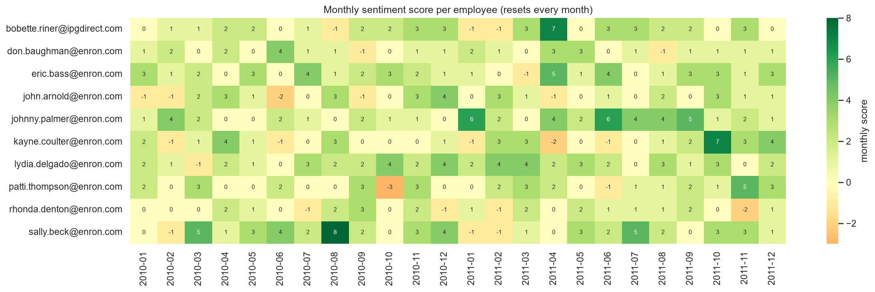
Figure 6 – Monthly sentiment score for every employee (resets each month).

4. Employee ranking (Task 4)
- For each month, the Task 3 scores are sorted. Top 3 positive: score descending, then employee name A→Z. Top 3 negative: score ascending, then name A→Z. Only employees active in that month are ranked (all 10 are active every month). The ordering and tie-breaks are verified by assertions.
- Because negative months are rare, the bottom-3 list often contains scores of 0 or above. It identifies the least positive employees of the month.
- Overall view: summing all monthly scores gives johnny.palmer (51), sally.beck (49) and lydia.delgado (48) as the most positive, and rhonda.denton (16), john.arnold (22) and don.baughman (25) as the most negative.
- Dec 2011 (latest month): positive – kayne.coulter (4), eric.bass (3), patti.thompson (3); negative – bobette.riner (0), don.baughman (1), john.arnold (1).

4.1 Monthly top 3 (all 24 months)
Month | Positive #1 | Positive #2 | Positive #3 | Negative #1 | Negative #2 | Negative #3
2010-01 | eric.bass (3) | kayne.coulter (2) | lydia.delgado (2) | john.arnold (-1) | bobette.riner (0) | rhonda.denton (0)
2010-02 | johnny.palmer (4) | don.baughman (2) | bobette.riner (1) | john.arnold (-1) | kayne.coulter (-1) | sally.beck (-1)
2010-03 | sally.beck (5) | patti.thompson (3) | eric.bass (2) | lydia.delgado (-1) | don.baughman (0) | rhonda.denton (0)
2010-04 | kayne.coulter (4) | john.arnold (3) | bobette.riner (2) | eric.bass (0) | johnny.palmer (0) | patti.thompson (0)
2010-05 | eric.bass (3) | sally.beck (3) | bobette.riner (2) | don.baughman (0) | johnny.palmer (0) | patti.thompson (0)
2010-06 | don.baughman (4) | sally.beck (4) | johnny.palmer (2) | john.arnold (-2) | kayne.coulter (-1) | bobette.riner (0)
2010-07 | eric.bass (4) | lydia.delgado (3) | sally.beck (2) | rhonda.denton (-1) | john.arnold (0) | kayne.coulter (0)
2010-08 | sally.beck (8) | john.arnold (3) | kayne.coulter (3) | bobette.riner (-1) | johnny.palmer (0) | patti.thompson (0)
2010-09 | patti.thompson (3) | rhonda.denton (3) | bobette.riner (2) | don.baughman (-1) | john.arnold (-1) | kayne.coulter (0)
2010-10 | lydia.delgado (4) | eric.bass (3) | bobette.riner (2) | patti.thompson (-3) | don.baughman (0) | john.arnold (0)
2010-11 | bobette.riner (3) | john.arnold (3) | patti.thompson (3) | kayne.coulter (0) | don.baughman (1) | johnny.palmer (1)
2010-12 | john.arnold (4) | lydia.delgado (4) | sally.beck (4) | rhonda.denton (-1) | johnny.palmer (0) | patti.thompson (0)
2011-01 | johnny.palmer (6) | don.baughman (2) | lydia.delgado (2) | bobette.riner (-1) | kayne.coulter (-1) | sally.beck (-1)
2011-02 | lydia.delgado (4) | john.arnold (3) | kayne.coulter (3) | bobette.riner (-1) | rhonda.denton (-1) | sally.beck (-1)
2011-03 | lydia.delgado (4) | bobette.riner (3) | kayne.coulter (3) | eric.bass (-1) | don.baughman (0) | johnny.palmer (0)
2011-04 | bobette.riner (7) | eric.bass (5) | johnny.palmer (4) | kayne.coulter (-2) | john.arnold (-1) | rhonda.denton (0)
2011-05 | don.baughman (3) | lydia.delgado (3) | sally.beck (3) | bobette.riner (0) | john.arnold (0) | kayne.coulter (0)
2011-06 | johnny.palmer (6) | eric.bass (4) | bobette.riner (3) | kayne.coulter (-1) | patti.thompson (-1) | don.baughman (0)
2011-07 | sally.beck (5) | johnny.palmer (4) | bobette.riner (3) | eric.bass (0) | john.arnold (0) | kayne.coulter (0)
2011-08 | johnny.palmer (4) | lydia.delgado (3) | bobette.riner (2) | don.baughman (-1) | eric.bass (1) | kayne.coulter (1)
2011-09 | johnny.palmer (5) | eric.bass (3) | bobette.riner (2) | john.arnold (0) | sally.beck (0) | don.baughman (1)
2011-10 | kayne.coulter (7) | eric.bass (3) | john.arnold (3) | bobette.riner (0) | rhonda.denton (0) | don.baughman (1)
2011-11 | patti.thompson (5) | bobette.riner (3) | kayne.coulter (3) | rhonda.denton (-2) | lydia.delgado (0) | don.baughman (1)
2011-12 | kayne.coulter (4) | eric.bass (3) | patti.thompson (3) | bobette.riner (0) | don.baughman (1) | john.arnold (1)

4.2 Overall ranking across the period
employee | total_score | avg_monthly_score | months_active | times_top3_positive | times_top3_negative
johnny.palmer | 51 | 2.120 | 24 | 8 | 6
sally.beck | 49 | 2.040 | 24 | 8 | 4
lydia.delgado | 48 | 2.000 | 24 | 9 | 2
eric.bass | 43 | 1.790 | 24 | 10 | 4
bobette.riner | 37 | 1.540 | 24 | 13 | 8
kayne.coulter | 29 | 1.210 | 24 | 8 | 11
patti.thompson | 29 | 1.210 | 24 | 5 | 6
don.baughman | 25 | 1.040 | 24 | 4 | 12
john.arnold | 22 | 0.920 | 24 | 6 | 11
rhonda.denton | 16 | 0.670 | 24 | 1 | 8

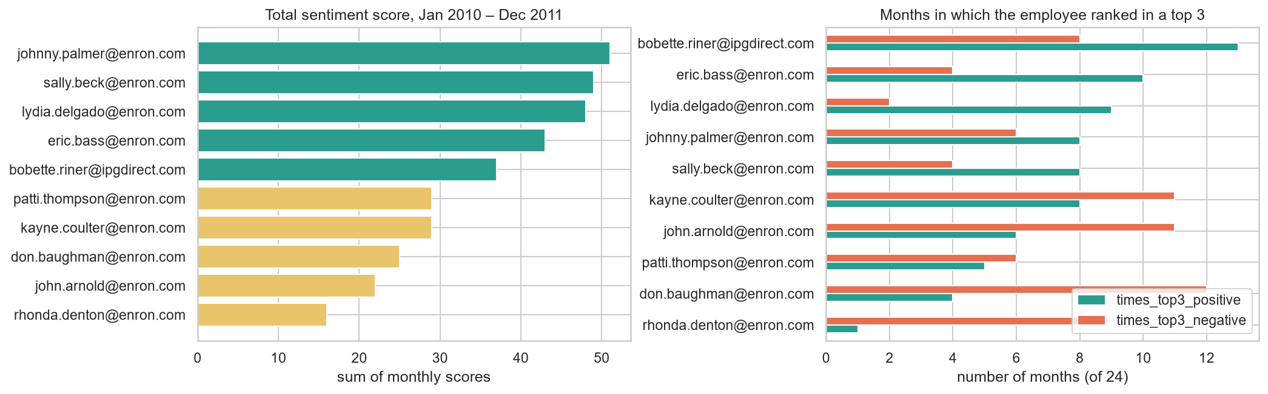
Figure 7 – Total score and number of months in a top-3 list.

5. Flight-risk identification (Task 5)
- Criterion: 4 or more Negative messages within any rolling 30-day window (30 calendar days inclusive, i.e. date_last − date_first ≤ 29 days). The window ignores calendar months and the score. Every message counts.
- Method: a two-pointer sliding window over each employee's sorted negative-message dates. It records the peak count, the peak window and the first date the threshold was reached. An independent brute-force check gives the same result.
- Flagged: john.arnold (peak window 2010-06-06 → 06-21), patti.thompson (2010-10-04 → 10-29), rhonda.denton (2010-12-24 → 2011-01-01). Rhonda Denton's window crosses a month and year boundary, so a calendar-month rule would have missed her.
- Sensitivity: a threshold of 3 would flag 5 employees (adding bobette.riner and lydia.delgado). A threshold of 5 flags none at 30 days. With 14 days, only 1 employee reaches 4.
employee | total_negative | max_negatives_in_30d | peak_window_start | peak_window_end | first_flagged_on | flight_risk
john.arnold | 21 | 4 | 2010-06-06 | 2010-06-21 | 2010-06-21 | True
patti.thompson | 17 | 4 | 2010-10-04 | 2010-10-29 | 2010-10-29 | True
rhonda.denton | 11 | 4 | 2010-12-24 | 2011-01-01 | 2011-01-01 | True
bobette.riner | 19 | 3 | 2010-08-26 | 2010-09-16 | - | False
lydia.delgado | 17 | 3 | 2011-04-16 | 2011-05-04 | - | False
don.baughman | 10 | 2 | 2010-04-13 | 2010-05-03 | - | False
eric.bass | 8 | 2 | 2011-05-17 | 2011-06-09 | - | False
johnny.palmer | 11 | 2 | 2010-02-09 | 2010-03-10 | - | False
kayne.coulter | 11 | 2 | 2010-12-31 | 2011-01-07 | - | False
sally.beck | 13 | 2 | 2010-01-23 | 2010-02-15 | - | False

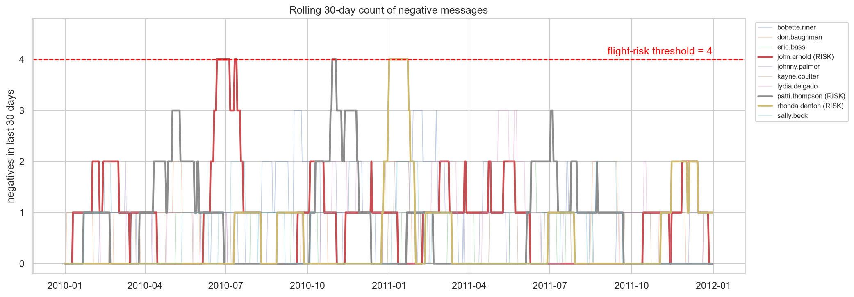
Figure 8 – Rolling 30-day count of negative messages; dashed line = threshold of 4.
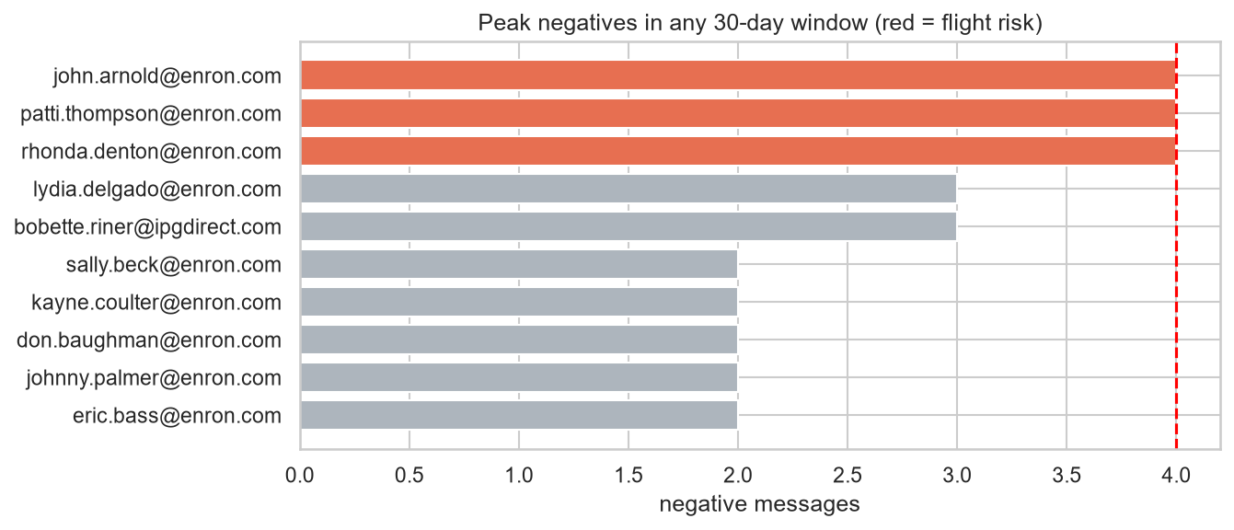
Figure 9 – Peak negatives in any 30-day window per employee.

6. Predictive model (Task 6)
- Target: the monthly sentiment score (Task 3). Unit: employee-month (240 rows).
- Features, chosen to avoid leakage (none uses the sentiment label): message count, average character length, average word count, total words, average subject length, reply ratio, forward ratio, exclamation marks and question marks per message, and weekend ratio.
- Model: StandardScaler + scikit-learn LinearRegression. Evaluation: 80/20 random split (seed 42), 5-fold cross-validation, a time-based split (train 2010 → test 2011) and a mean-only baseline. Metrics: R², MAE, RMSE. p-values come from OLS on standardized features.

6.1 Evaluation
Evaluation | R2 | MAE | RMSE
Linear reg - train | 0.270 | 1.104 | 1.480
Linear reg - test (random 20%) | 0.182 | 1.123 | 1.517
Baseline (mean) - test | -0.153 | 1.440 | 1.801
Linear reg - 5-fold CV (mean) | 0.204 | 1.140 | 1.523
Linear reg - time split (2011) | 0.245 | 1.195 | 1.579

6.2 Coefficients (standardized features, OLS on all rows)
feature | coef | std_err | t | p_value
intercept | 1.454 | 0.098 | 14.860 | 0.000
n_messages | 0.834 | 0.341 | 2.446 | 0.015
avg_char_len | 0.121 | 0.705 | 0.172 | 0.863
avg_word_count | -0.031 | 0.670 | -0.046 | 0.963
total_words | 0.001 | 0.363 | 0.002 | 0.998
avg_subject_len | 0.007 | 0.108 | 0.063 | 0.950
reply_ratio | 0.240 | 0.110 | 2.169 | 0.031
fwd_ratio | -0.049 | 0.113 | -0.436 | 0.663
exclaim_per_msg | 0.233 | 0.106 | 2.203 | 0.029
question_per_msg | -0.108 | 0.101 | -1.075 | 0.284
weekend_ratio | -0.115 | 0.100 | -1.152 | 0.250

- The model beats the baseline on every split (test MAE 1.12 vs 1.44). R² is 0.18 on the test set, 0.20 in CV and 0.25 on the time split, against 0.27 on training data, so the model generalizes with little overfitting.
- Message frequency is the strongest and statistically significant predictor (+0.83 per SD, p = 0.015). On its own it gives +0.14 score per message, which matches the dataset's average net sentiment per message (0.159). The monthly score therefore partly measures activity.
- Reply ratio (+0.24, p = 0.03) and exclamation marks (+0.23, p = 0.03) also raise the score: conversational, expressive e-mail is more positive. Question marks and weekend share have small negative, non-significant effects.
- The length features are collinear (r ≈ 0.99), so their individual coefficients are unstable and not significant.
- An R² of about 0.2 means most of the sentiment comes from content rather than metadata. The model is useful for explaining patterns and is a weak forecaster of individual scores. The residuals widen for higher predictions.
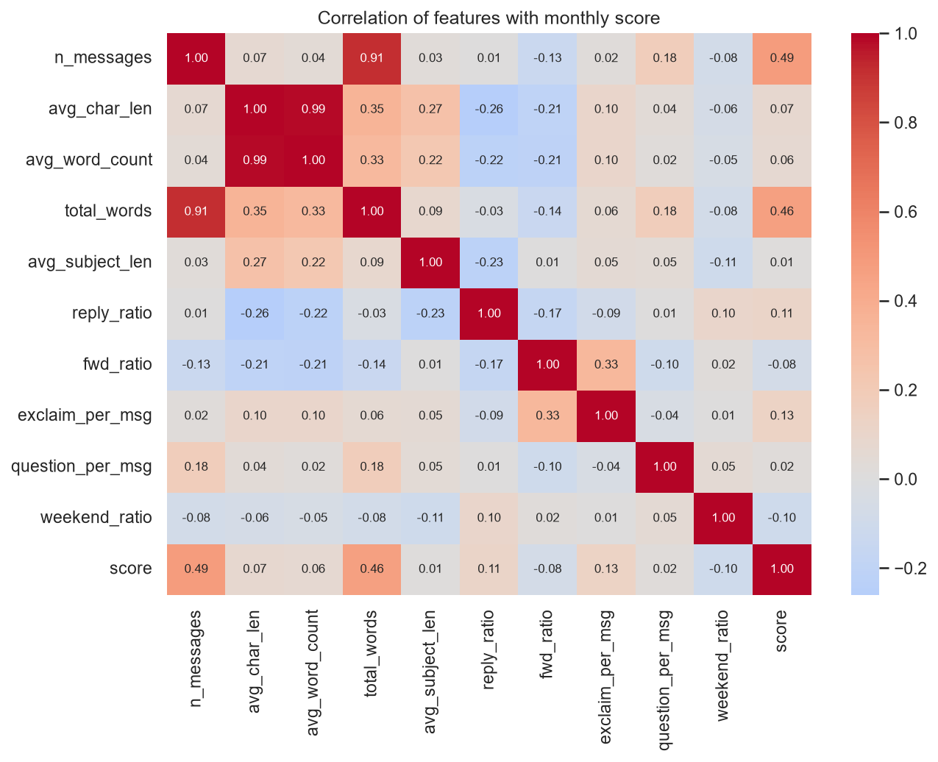
Figure 10 – Correlation of features with the monthly score.
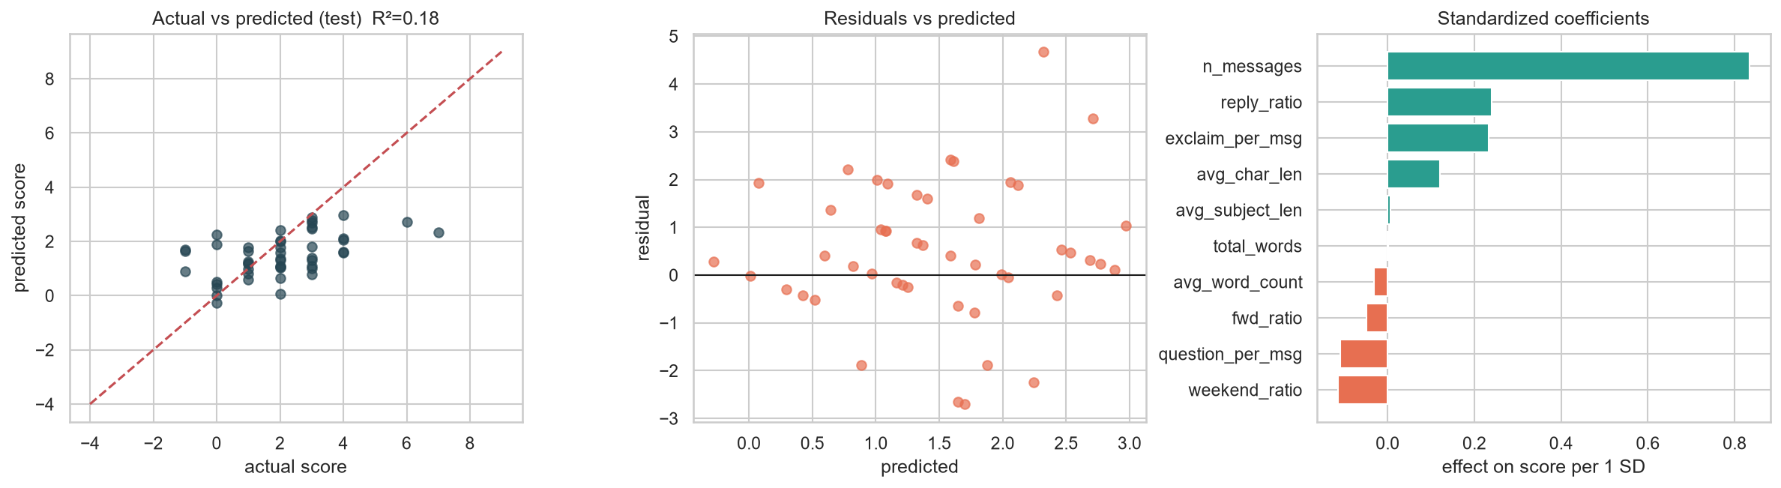
Figure 11 – Actual vs predicted, residuals and standardized coefficients.
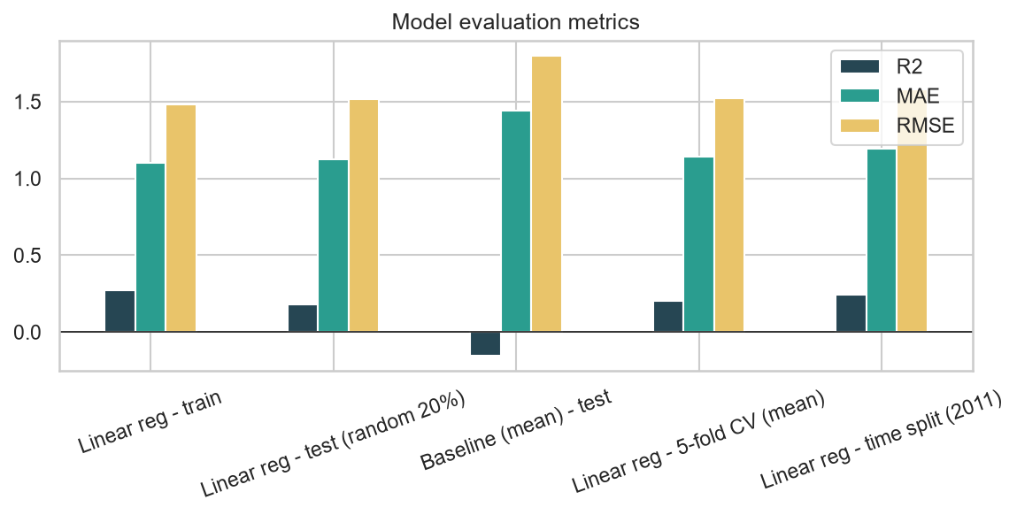
Figure 12 – Evaluation metrics across splits.

7. Recommendations
- Contact the three flight-risk employees (john.arnold, patti.thompson, rhonda.denton) through their managers or HR. Prioritise john.arnold, who has the most negative messages overall (21) and often appears in the monthly bottom 3.
- Keep bobette.riner and lydia.delgado on a watch list, since each reached 3 negatives within 30 days.
- Report a volume-normalized score (net sentiment per message) next to the raw score, so that low-volume employees are not ranked as negative only because they send fewer e-mails.
- Run the rolling-window check continuously (e.g. weekly) instead of once a month, because bursts that cross month ends would otherwise be missed.
- Look at the content of short reply chains, where most negative sentiment appears.

8. Assumptions and limitations
- Labels come from a model with no human-annotated ground truth. The transformer was trained on social-media text, and some business wording may be mislabeled. Spot checks and the VADER and TextBlob comparisons support the labels but do not prove them.
- Quoted or forwarded text inside a body is attributed to the sender.
- Dates appear to be synthetic (evenly spread, ~31% on weekends), so time-of-week findings are not interpreted.
- The regression has only 240 rows, and the target is a bounded count. A Poisson or ordinal model, or text embeddings as features, could perform better but are outside the linear-regression scope.

9. Reproducibility
pip install -r requirements.txt (the CPU build of torch is enough), then run Employee_Sentiment_Analysis.ipynb from top to bottom. Transformer labels are cached in outputs/labeled_messages.csv; delete that file to recompute them (about 5–10 minutes on a CPU, including the model download). Then run python src/build_report.py to rebuild this document. The random seed is 42 for all splits.

