## Application Tasks

1. Create REACT based layout container component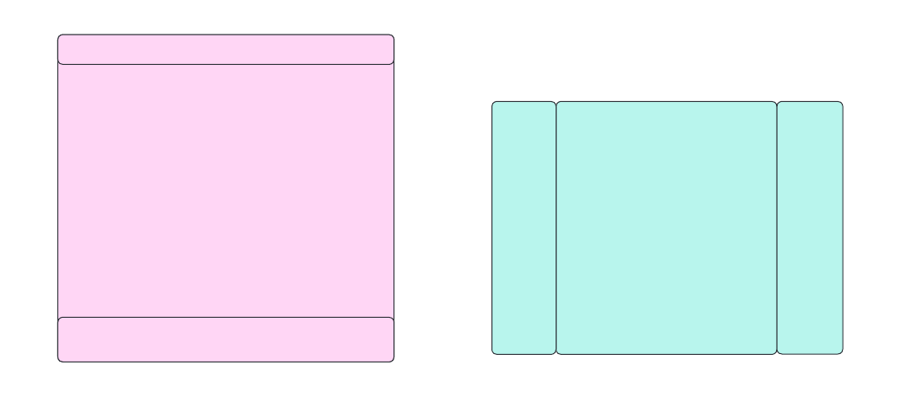
2. Add theme styles to container layouts components
3. Add theme style switch infrastructure.
4. Create Application Layout Container Component using the container components created above

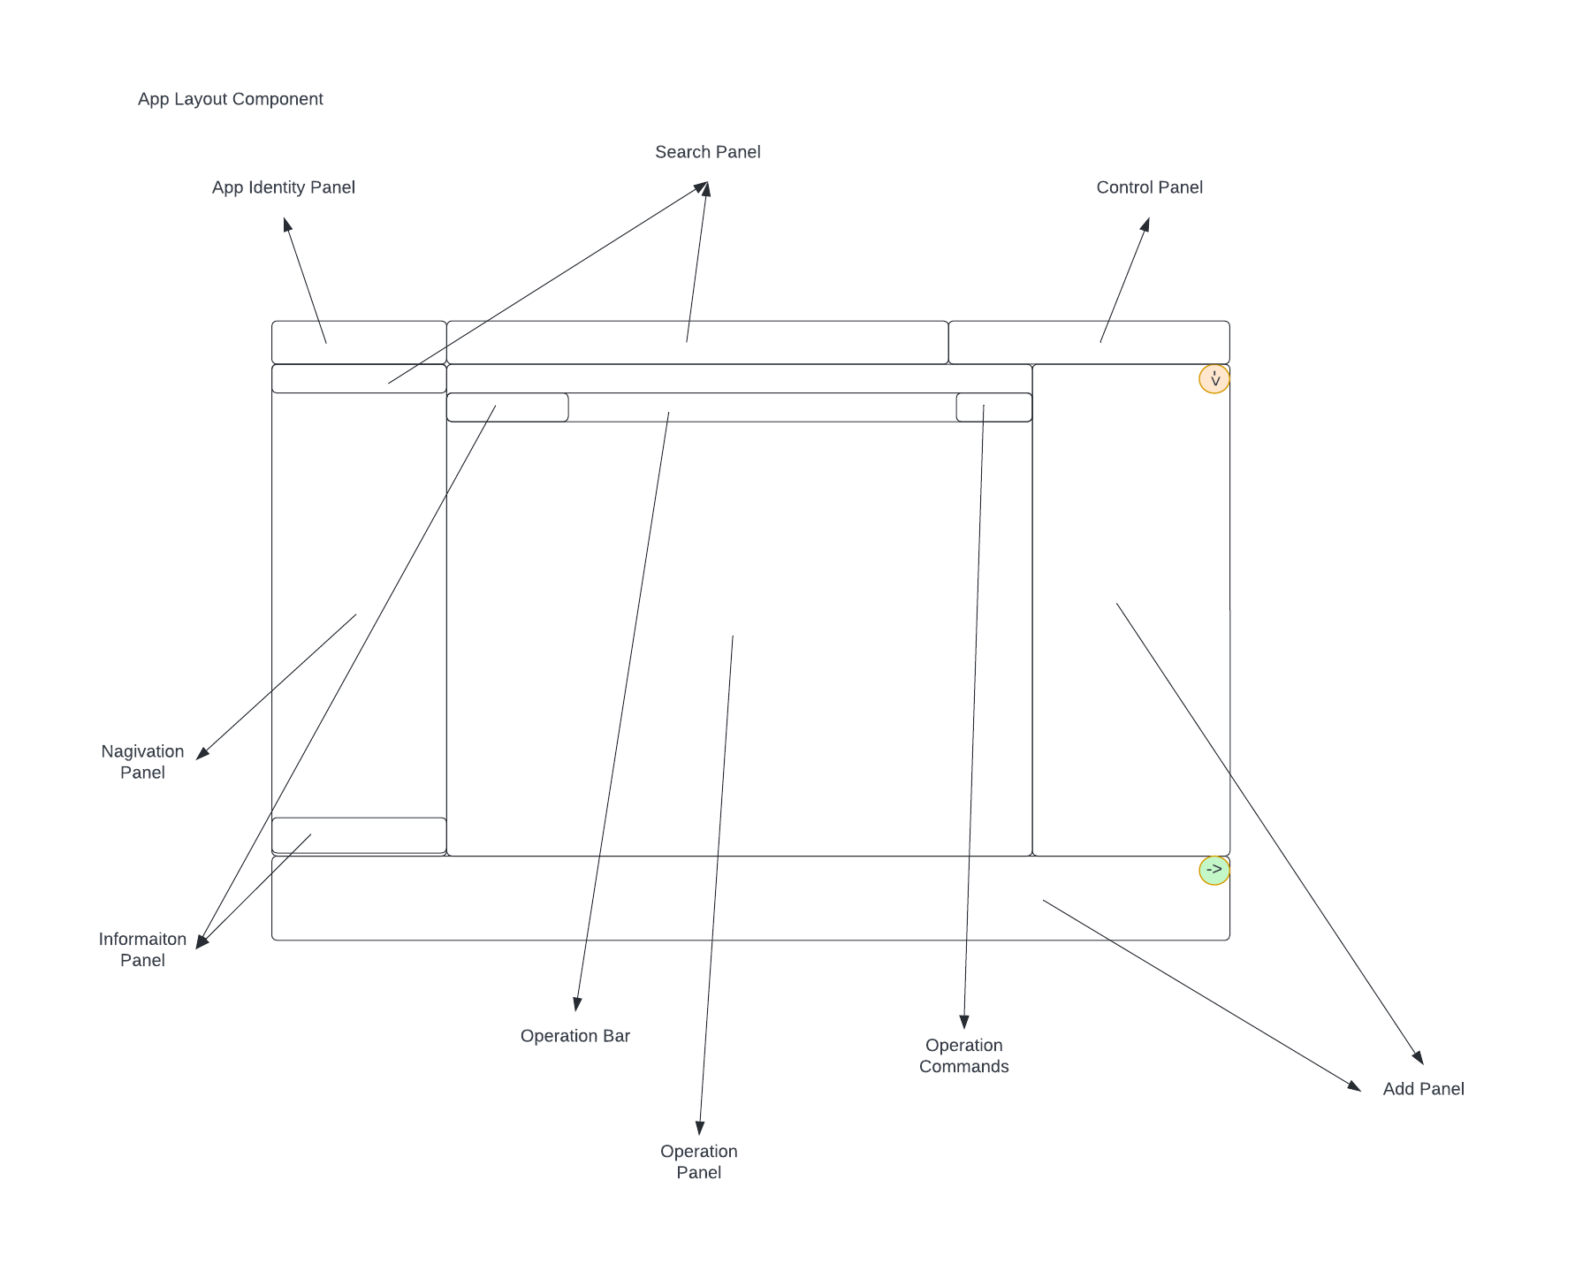

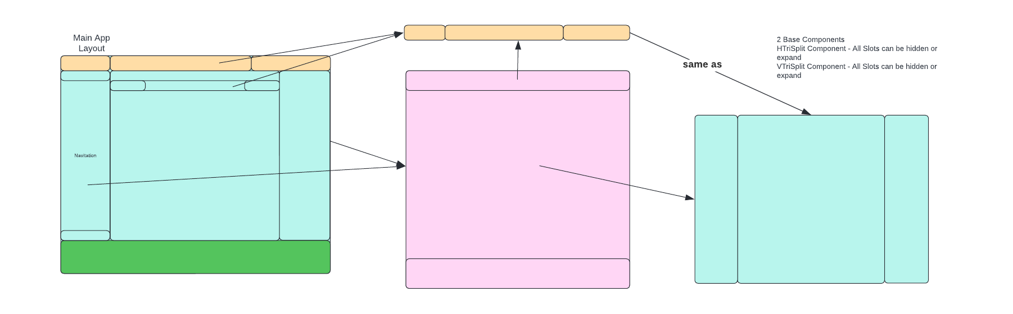

1. Integrating REACT Redux for managing and centralizing application state
2. Add Application Them Style Switching utilizing REACT Redux
3. Add Application Layout Component with layout change capability utilizing REACT Redux

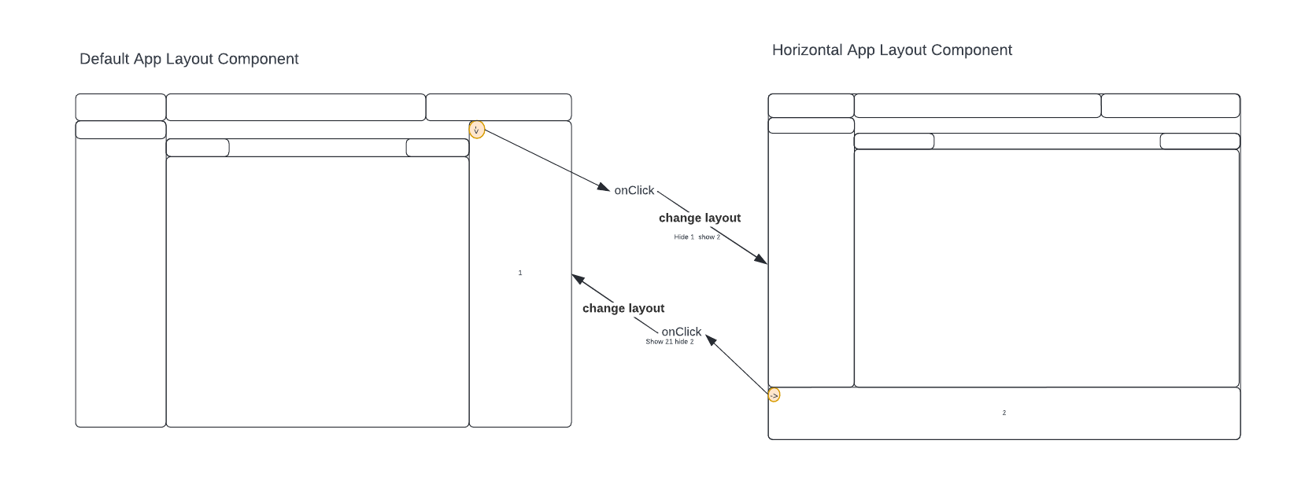

1. Create a shell REACT SPA implemented with Account Create & Login UIs and integrated with Google, Facebook, and Twitter accounts authentication or custom integration. like <https://managethebusiness.com/> page you have. Upon login, present Container in item 4

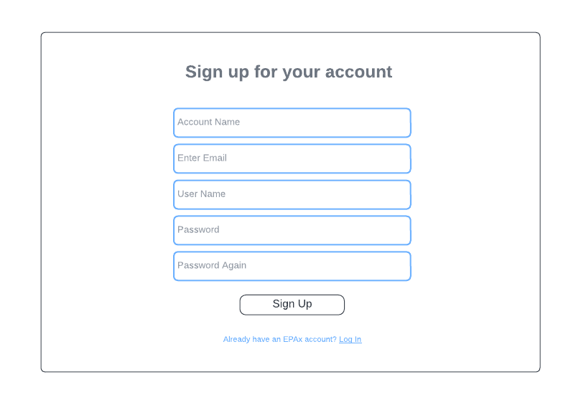

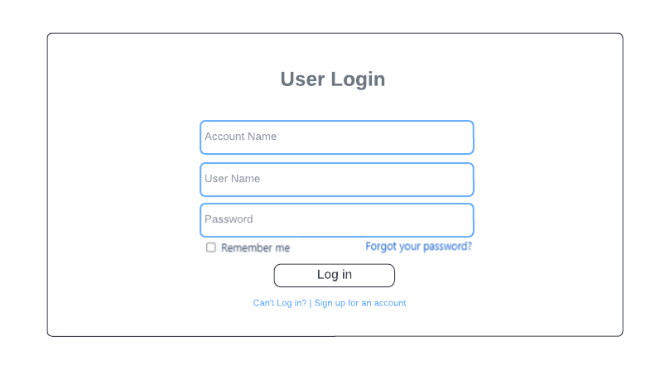

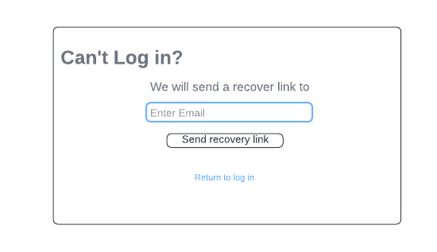



## Widget Building Tasks

1. Foundational Widget (Row Control Widget)
2. Building Search Widget
3. Navigation Widget
4. Operational Widget
5. Application Command Widget
6. Advertisement Widgets
7. Menu Widgets
8. Messaging Widgets
9. Alerts Widgets

….