WEAR RESISTANT MATERIALS

# Drilling advanced ceramics

John Bunting, Precorp Incorporated

Advanced composites used in new military aircraft designs need properly drilled fastener holes to prevent fatigue cracks from originating around fastener joints. New PCD drill designs cut composites without introducing flaws in the fastener holes, while reducing the cost of drilling.

he aircraft industry has from the beginning of modern air travel realised that aircraft structures should be constructed of light-weight materials with sufficient strength to withstand the dynamic forces encountered in flight. For the past 60 years, aircraft structures have been characterised by a thin walled sheet-stringer construction primarily of aluminium and in a few cases, steel and titanium.

In the 1960s, a new approach to aircraft construction was proposed using advanced composite materials promising excellent strength to weight ratios coupled with greater design latitude and lower visibility to radar. The promised advances, however, were slowed by the difficulties in developing fabrication technology that could be used with this new material.

Composites, unlike the aluminium it replaced, can take on many different properties by changes in the resin formulation, fibre type and content, orientation and build-up, and the method of forming and curing the materials. Finding the right combinations to achieve the desired properties in the composite structure has taken considerable time and effort to resolve. The solutions developed by the industry to the complex fabricating problems can be found din the AV-8B Harrier II, the F/A-18 Hornet, the F-14 Tomcat, and the latest model of the A-6E intruder.

The use of composite structures will increase significantly in the new military aircraft designs. Aircraft made of advanced composites share a similarity with their metallic counterparts in that they are constructed by attaching a thin skin of predominantly carbon-epoxy to a spar and rib frame, also made of a carbon-epoxy composite. Aluminium and titanium are often used in the frame in critical areas. These components are joined by the use of thousands of fasteners making hole drilling of composites an important manufacturing requirement.

Two drill designs evolved from this effort. The first PCD drill was developed strictly for composite materials and had a 62° point angle, a 26° helix angle, two flutes, and a four-facet point with special web thinning to preserve point strength. In carbon-epoxy materials tools of this design now routinely drill more than 2500, .191 diameter fastener holes in the Harrier II wing. The second drill configuration developed is an eight-facet style drill, with special web thinning conditions to preserve the point strength. This "double angle" drill is used in carbon-epoxy and aluminium structures to produce finished holes in a single operation cycle. In the combination composite and aluminium structures hole quantity capabilities average about 625 holes before reconditioning (resharpen) is required.

Cutting tool costs for hole producing

operations in the composite materials have been reduced by approximately 70 per cent through the use of the PCD diamond tools in the automated operations. This saving results from the reduction in tool changes, improved spindle up-time, reduction in supporting quantities of holders, collets, and so on required, and the reduction in changing of tools in these holders, the reduction in "pipeline" inventory and resharpening costs and related inspection expenses.

#### Limitations of present tools

The PCD tools at present have been limited to the automated operations where operation conditions are more suited to their use. It generally requires approximately 500 holes of a given size be present in the structure before their use is considered cost effective. This can vary between manufacturers, however, and depends on the costs of current **operations**

Because of their high initial costs, consideration must be given to the way PCD drills are distributed within the plant. Improved handling methods may be required to ensure that the tools are not prematurely damaged or lost. It may also be desirable to serialise the individual tools and assign the tools to the appropriate personnel to ensure that responsible usage occurs and to provide a means for evaluating both their initial usage and subsequent resharpened performance. It is important to provide protection to the drill point at all times to avoid gross damage that will render the drill useless. In the preset crib operations where tool/holder set length dimensions are established the point vulnerability must be considered in carriages used to transport the tools, storage devices or in carts the drill point must receive adequate protection.

A third problem can occur when drilling a structure consisting of two separate materials such as a carbon-epoxy and aluminium and the aluminium is located beneath the composite. If the two materials are not properly clamped together and gaps exist, the hole produced in the composite material can become oversize at the faying surface due to the inertia of the spiral aluminium chip rotating into the gap area, resulting in severe "backcounterboring" of the composite material. It is also important that the feed rate be controlled to maintain an aluminium chip that is not excessively thick or aggressive in order to prevent oversizing the entire hole in the composite material.

All three problems can contribute to a poor fit between the structural members of the aircraft and the fastener. However, with appropriate tooling and the correct speeds and feeds, these problems can be overcome.

Proper cutting tools for composites are not the same as those used when cutting metal materials. Initial efforts to use drills designed for aluminium or steel proved to be unsuccessful. High-speed drills dulled within the first few layers of the carbon-epoxy. This rapid wear increases drilling forces and increases the build-up of heat at the drill point. The result was serious damage to the composite, often resulting in separation between the fibre layers in addition to the unacceptable hole quality produced.

Tungsten carbide cutting tools worked much better, but standard drill designs wore quickly and generated excessive thrust. As a result tool engineers in the industry have developed various drill geometries. One such configuration is the McDonnell Douglas patented "dagger drill" which was one of the first configurations developed that enabled the composite structures to be drilled without the need for back-up on the drill exit side to prevent exit side delaminations. The dagger drill had an extremely small point angle (30°) to reduce chip thickness at reasonable feed rates. The drill was very thin at the point to reduce drilling thrust and was capable of producing holes within .003 of nominal size in a single pass. However, the drill was not suitable for use in composite/aluminium structures when the aluminium was thicker than .150in. Its use is generally limited to no more than 40 holes per sharpening.

With composites, the task of drilling a straight hole to size without damaging the part is made difficult due to the abrasive nature of graphite fibres and the moderately weak epoxy bond between fibre layers. Damage in drilling composites manifests itself in three ways. First, is the separation of layers or delamination: composites are made up of numerous thin layers bonded by epoxy resins. Excessive thrust from the drill can force the layers apart creating delaminations within the composite stack-up, as well as cause severe delamination as the drill exits the hole. In extreme cases, as many as four to six layers may separate and bulge out around the hole on the exit side. The hole entrance side can also be delaminated from excessive drill thrust, drill dulling, or improper drill geometry.

#### Fraying problems

Failure to cut the last composite layer cleanly contributes to the second problem: fraying as the drill exits the hole. Drilling with a backing material under the composite has often been used to prevent this condition. However, in aircraft structures, this is often impractical and sacrificial materials used to prevent its occurrence are undesirable due to the added manufacturing cost. Acceptable fraying limits are usually quantified, such as the number and length of frayed or splintered fibres permitted on the exit side of the hole before hole quality rejection occurs. Slight fraying of a few fibres is not uncommon. However, excessive fraving can interfere with the fit of the fastener within the hole.

Along with using new materials in building aircraft, the 1980s saw the introduction of automated systems by the industry to eliminate costly drill plates and the lengthy process of manually drilling aircraft wings having thousands of fastener holes. Tungsten carbide drills that were acceptable in hand drilling had less advantage when using automated drilling systems due to the constant tool changes required and the large number of holders and cutters required to support the overall operation.

Ken Luebbert, branch manager of the Machinability and Cutter Development branch of McDonnell Douglas' (St Louis) Advanced Manufacturing Fabrication Facility faced this problem in the mid-1980s. An automated drilling system (ADS) built by Ingersoll was acquired by McDonnell to produce the AV-8B Harrier wing. Luebbert's team had previously developed several innovative tungsten carbide drill configurations to accomplish the production of quality holes in various composite and composite metal stack-ups. However, the use of carbide tooling would greatly limit the productivity of the multimillion-dollar system due to the numerous tool changes needed. Aware of the wear resistance that polycrystalline diamond (PCD) afforded, Luebbert's team had been working to develop a PCD drill with a geometry capable of producing hole quality equivalent to that being produced with the current tungsten carbide drill. However, Luebbert found that the PCD material available to tool makers was not suitable for the fabrication of the desired twist drills.

A new development in the mid-1980s by Precorp resolved the problem. Precorp developed a process that allowed a thin vein of diamond to be formed within a tungsten carbide cylinder during the compression and sintering process. This unique drill material was based on form. ing two opposed veins of PCD within the tungsten carbide cylinder. Grinding away the carbide exposed the diamond cutting edges which were precisely positioned 180° apart. Precorp's develop. ment of the PCD circuit board drill down to .010 diameter provided the experience in manufacturing that was needed to ensure consistency of manufacture of precision tools. A joint development be. tween Precorp and Luebbert's team at McDonnell ensued.

#### **Operating considerations**

Operation considerations for the PCD drills are generally no different from those established for the carbide drills. The part being drilled should be ade. quately fixed to resist movement from drilling thrust and should be sufficiently clamped to prevent part vibration during drilling. Part movement conditions dur. ing drilling will contribute to exit side delaminations at drill breakthrough and excessive part vibration during drilling can cause point chipping that will reduce the PCD tool life and adversely affect hole quality.

The hole quality achieved with the PCD drill is superior to that achieved with carbide drills. This is attributed to the improved keenness that exists on the PCD cutting edge and the resulting improved shearing of the carbon-fibres that results from this cutting edge quality. It has been found that the PCD drill should be removed from service after a wear land of about .004 exists on the cutting edge. Wear lands greater than this tend to cause more splintering on the hole exit side. the resharpening process is greatly aided by limiting the wear land widths to the .004-wide condition and maximum use of the service life of the PCD drill is obtained.

Because of the large quantity of holes capable of being produced with the PCD drill in composite materials it is important to periodically verify drill performance during usage to minimise or otherwise limit the quantities of unacceptable holes that would be produced should premature point failure occur during operation. As cutting force values are relatively low in the composite materials, force sensors may be ineffective in determining cutter damage. At present, visual or physical inspection sequences at selected intervals have been the most effective means to ensure performance.

John Bunting is the president of Precorp. He holds a degree in chemical engineering from Brigbam Young University and an MBA from Southern Illinois University. He is listed as the inventor of three US patents related to PCD products.

## Higher productivity with carbide indexable-inserts

Marty Smith, GTE Valenite Corporation

In the past, quality has necessarily been the highest priority with aircraft/aerospace parts. Their characteristic complexity and intricacy makes machining requirements so demanding and extensive that parts production rates have understandably been less than a critical issue.

ntil recently, most cutting tools have been high-speed steel form tools custom-built in the shop. Given the lack of emphasis on production rates, these tools have been adequate to machine the broad cross-section of traditional aircraft materials, while meeting the tight tolerance requirements. At the same time, suppliers have felt little urgency to modernise production equipment, since conventional manual machines, copy machines and NC tape machines have been able to meet the capabilities of HSS tooling and also keep to accustomed delivery schedules.

This traditional picture is now beginning to change, largely because of the introduction of standard carbide indexable-insert tooling capable of machining high grade materials at dramatically higher metal-removal rates while maintaining precision tolerances. The new carbide tooling has had the further effects of shortening lead times on jobs through off-shelf availability, and of prompting and cost-justifying increased acquisition and use of CNC machine tools. It is therefore helping to markedly reduce both machine cycle times and floor-todoor delivery times, and making it possible to accommodate an expanding volume of production work. As a consequence, improved productivity is emerging for aircraft/aerospace suppliers as a significant new factor in overall profitability.

The importance of these developments is demonstrated in the case of one contract supplier of precision components. By combining CNC machining centres and lathes with a variety of carbide indexable-insert cutting tools, this manufacturer has been able to dramatically cut machining times over a range of operations. The result has been reduced floor-to-door delivery times for a number of components, and an increased overall production capacity.

Formerly limited to HSS tooling made largely in-house, the supplier now uses carbide indexable-insert cutting tools on components for aircraft landing gear and external engine mounts. The landing gear components, for commercial and military aircraft, are made from a variety

of tough alloy steels, including the standard 4340 grade, the ultra-high-strength 300-M aircraft grade and the AF1410 Air Force-standard grade. These materials pose varying degrees of machining diffi. culty, made even greater by the complex configurations and shapes of the forgings. The difficulties are now being overcome, however, through tool designs and insert cutting grades that can meet the special demands.

One of the first types of carbide indexable-insert cutting tools used by this contractor was the Valenite ball-nose end mill — a versatile tool that can be used to plunge, ramp, centre-cut and transversemill both in straight paths and contoured directions.

The supplier presently uses 15 of these

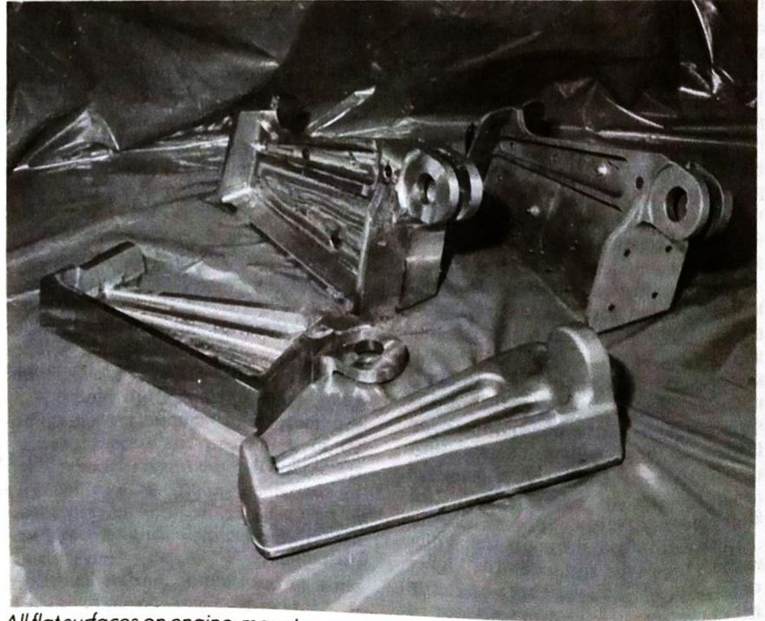

All flat surfaces on engine-mount components are rough- and finish-machined. Clockwise from bottom, raw forging made from aircraft steel, component after all flat surfaces are machined, two finished components bolted together, and pair of finished components after heat treating and secondary machining.

cutters $-$ in $\frac{1}{4}$ , 1, 1 $\frac{1}{2}$ , and 2 inch diameters. In one application run on a Mazak vertical machining centre, a 11/2 inch ball mill is used to machine fillet radii in an 80 inch-long landing gear brace. In these operations, machining by the ball mill and a variety of other indexable-insert cutters reduces the high-strength 300-M steel forgings from a weight of 750 pounds to just 150 pounds.

In another application run on a Mazak machine, a 1 inch ball-nose end mill generates a variety of three-dimensional contours in smaller components, also made of 300-M steel, produced for the F-18. In these operations, the CNC machine is programmed to take several series of duplicate cuts on four workparts that are fixtured side by side. The operations are run at a constant speed of 400sfm (at the tool outside diameter) and constant feed of 10ipm (.006 inch per revolution).

These machining rates compare to a speed of only 50sfm and feed of only 2iom with a HSS ball mill previously used. with the carbide indexable-insert ball mill, total cycle time for completion of the four parts has been reduced from 61/2 hours to just 1 hour and 16 minutes, a reduction of more than 80 per cent. Moreover, the five three-edge inserts used on the cutter (Valenite's V1N titanium nitride-coated carbide grade) typically provide 10 hours of cutting time before indexing is required.

This has served to substantially reduce tool maintenance costs, since labour time required for insert indexing and change represents only a fraction of the time previously required to grind the HSS ball mills. At the same time, the indexable-insert tools have served to greatly increase performance reliability by removing the risk of imprecise resharpening. Whereas incorrect grinding of the nose radius can result in the generation of an inaccurate three-dimensional surface, insert indexing of the indexableinsert ball mills insures radius repeatability within very close tolerances.

#### Why the performance increase?

Two explanations for the productive performance of the Valenite ball mill are offered. The first has to do with the quality of the V1N titanium nitride-coated carbide grade. Milling in general, and ball-nose milling in particular, places different demands on an insert grade from those created in turning. A tough carbide grade is essential, since milling of any kind involves constant interruptions and shocks. But in ball-nose milling, toughness alone is not enough.

Because of its shape, a ball-nose end mill is subjected to a range of different surface speeds, from zero at its centre to very high speeds at the outside diameter. In die and aircraft steels, for example, surface speeds can reach a level as high as



The Valenite carbide indexable-insert ball-nose end mill is capable of plunging, ramping, centre cutting and transverse milling, both in straight paths and contoured directions. Here it generates a variety of three-dimensional contours on landing gear components forged from ultra-high-strength 300-M grade aircraft steel. The constant feed rate of 10ipm contrasts with a rate of only 2ipm previously obtained with a HSS ball mill.

500sfm, with significant adverse effects on edge wear. The ideal carbide grade for ball-nose milling must therefore combine toughness with excellent heat and wear resistance - a difficult trick, since the three properties are not normally found together.

The V1N grade successfully combines a very tough carbide substrate with a thin titanium-nitride coating that is extremely hard and chemically inert. The carbide substrate is tougher than any uncoated carbide grade in the C1 to C8 categories. This makes it highly resistant to chipping, and permits it to withstand both milling interruptions and the low-speed/highforce dynamics at the tool's centre.

At the same time, the layer of titanium nitride helps resist wear normally caused by the high peripheral speeds at the outside diameter, and also provides a heat barrier to protect the substrate.

The other explanation for the excel-

lent performance involves its geometry, especially as it affects the radius inserts at the end, or nose, of the tool. These are the inserts that absorb the most stress in machining, since they are virtually at the bottom of the cut.

#### Rough and finish face milling

Another productive application of carbide indexable-insert tooling is the rough and finish face milling of flat surfaces on engine mount components made from British S-29 aircraft steel.

These operations, which are also run on a Mazak CNC vertical machining centre, are now performed by a new $45^\circ$ lead Shear-Mil shell mill, a high positive axial/negative radial geometry cutter specifically designed to provide a free cutting shearing action that reduces cutting temperatures and forces, as well as promoting longer tool life. Despite de-

manding interrupted cuts imposed by the components' thin-wall surfaces, the Shear-Mil cutter, operating at a speed of 300smf, easily takes the 200 inch doc roughing cuts and 100 inch doc finishing cuts at a constant feed of 25ipm. This represents a productivity increase of five times over the previously used negativerake indexable insert cutter. This took the same cuts at an identical speed, but managed a maximum feed of only 5ipm. Moreover, wear life of the V1N-grade inserts used with the Shear-Mil cutter a sure sign of cutting efficiency - has proved equally impressive.

In its first production run, the cutter produced 60 parts before the inserts were indexed and, even then, detectable wear was very slight. This contrasts with an average six to eight parts per index obtained with the previously used negative rake cutter.

The supplier is presently using three of the Shear-Mil cutters for a variety of face-milling applications, and in each case productivity has increased by at least three times when compared to previously-used indexable-insert tooling. Additional applications are also being considered for parts made from such high strength exotic materials as Inconel and titanium. A wide range of applications is possible, because the Shear-Mil cutter offers versatility for use on virtual-

ly any aircraft material, including those that are gummy and work hardenable. All that is needed is a simple interchange. All that is necessarilable in three carbide cutting grades. The cutter offers further economy mies of operation, since it uses square inserts that provide four indexes each and are secured by only a socket screw to minimise inventory requirements and therefore, costs.

This article first appeared in World Aerospace Profile 1988, published by Sterling Publications plc.

Marty Smith is Exhibits and Promotions Manager at GTE Valenite Corporation

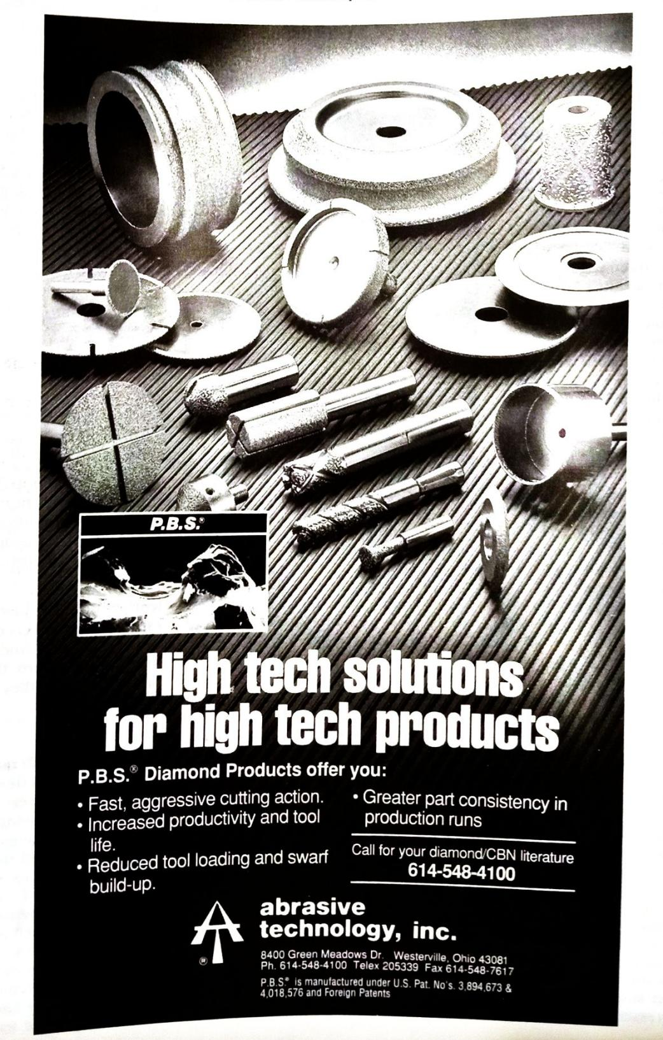

### WEAR RESISTANT MATERIALS

# Engineering applications of sialons

Ian Wilson, Vesuvius Zyalons (Midlands) Limited

modern industry continues to demand stronger, rder, more wear resistant and heat resistant materials nich will operate cost effectively in hostile vironments, it has become essential to seek ernative engineering materials.

The discovery of silicon nitride in

1857 by Deville and Wohler caused no excitement among the engineering fraternity of the day. Yet the announcement, more than a century later, in 1972, that an alloy of this same material had been found stimulated enormous interest and triggered off investigations on a worldwide scale. The reasons why the two events were heralded in such dissimilar ways give us an insight into the developments that have taken place in our major industries.

Modern industry requires stronger, harder, more wear resistant and heat resistant materials which will operate cost effectively in more hostile environments than ever before. Today's aircraft engines require increasing thrust to weight ratios which is generally achieved by both weight reduction and increased turbine inlet temperatures. The required operating temperatures of modern jet engines exceed the temperature limitations imposed by the metallic turbine components. It has, therefore, become essential to seek alternative engineering materials.

In metal forming, escalating labour and capital costs mean that forming dies and rollers have to produce higher tonnages to greater tolerances than before. In extrusion and drawing operations for example, surface finish and metallurgical properties, combined with the need for highly toleranced components, often means that traditional die materials are no longer cost effective.

Wear resistance and resistance to chemical attack are of prime importance for today's high-technology materials. Power stations which burn powdered fuel suffer severely from burner tip erosion. Coal dewatering plants require highly abrasive resistant materials for their filtration systems and super hard nitride ceramics are replacing the more traditional tungsten carbide in many of these applications.

Restrictions on emissions for automotive engines and higher fuel costs have stimulated an interest in the use of superhard light-weight inert materials in the automotive industry; in fact nitride ceramics have become accepted in most industries.

It became apparent in the 1960s and

early 1970s that silicon nitride had some remarkable engineering properties. It exhibited good thermal shock, high strengths could be achieved, the material was oxidation resistant and thermodynamically stable. This material was an obvious candidate for the arduous applications in modern industry.

Unfortunately, silicon nitride did not lend itself to ease of fabrication. The best properties were only obtained from hotpressed material, thus shapes could only be produced at extremely high cost by diamond grinding and even this material had relatively poor high-temperature properties. The discovery of an alloy of silicon nitride made independently in the UK by Jack and Wilson, and in Japan by Oyama et al, brought the advantages of a material based upon silicon nitride which was sinterable. Complex shapes could now be produced by conventional ceramic forming processes and then fired into high density products. These alloys, based upon silicon nitride, are known as

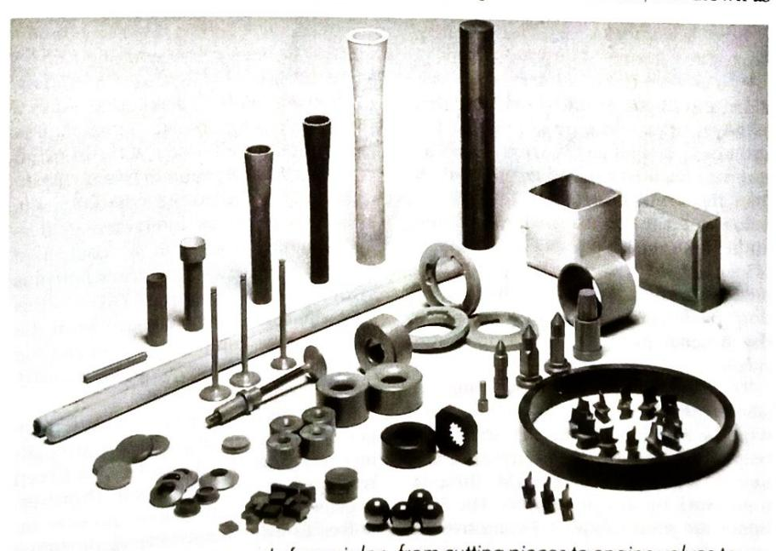

A range of components made from sialon, from cutting pieces to engine valves to ball bearings.

sialons. The current generation of sialons produced by Vesuvius Zyalons (Midlands) Limited are extremely sophisticated ceramics; they have grown through research and development from patents granted in the early 1970s into a product range which has outstanding engineering properties

Here the term "sialon" is reserved for the aluminium-silicon-oxynitride alloys of silicon nitride which have been sintered into hard, high-strength materials using yttrium oxide as a sintering aid. The density of sialon is low (3.2gm per cc), therefore the raw material cost of sialon is cheaper than tungsten carbide for example and sialon is often a cost-effective choice in engineering.

Sialon has an equivalent tensile strength approaching that of steel and a Youngs modulus which exceeds steel. The hardness of certain grades is of the order of 2000 Vickers (1kg load), which makes the material excellent for all kinds of abrasion resistant requirements. Sialon is strong, it is extremely rigid and maintains good mechanical properties to temperatures well in excess of 1000°C. The material is available in four grades, which include an electrically conductive type that can be cost-effectively machined into complex shapes by wire crosion.

Sialons have gained wide acceptance as cutting tips, particularly for nickelbased alloys. They are extremely useful dic materials for the extrusion or drawing of aluminium alloys, brass, copper, and steels for the manufacture of automotive valves. They are used in welding and they show excellent wear resistance as shot blast nozzles. They are used in the aerospace and automotive industry. Sialons have gained wide acceptance in the handling of molten metals, especially non-ferrous alloys, and are particularly useful when wear resistance is required.

As alloys of silicon nitride sialons exist in three basic forms. Each form is isostructural with one of the three forms of silicon nitride. The relationship between sialon and silicon nitride is similar to that between brass and pure copper. In the latter case, copper atoms are replaced by zinc to give a better and stronger alloy than the mother metal. In the case of sialon, substitution for silicon by aluminium with corresponding atomic replacement to satisfy valency requirements takes place and the resulting "solution" (sialon) has superior properties to the original pure solvent (silicon nitride).

The fundamental structural unit in silicon nitride is the SiN4 tetrahedron which is analogous to the SiO4 structural unit of the silicates. The tetrahedra are linked together into a rigid three-D framework by sharing corners. The Si-N bonds are short (about 1.74 angstroms) and they are very strong (440KJ mol). This strong, rigid, compact structure is

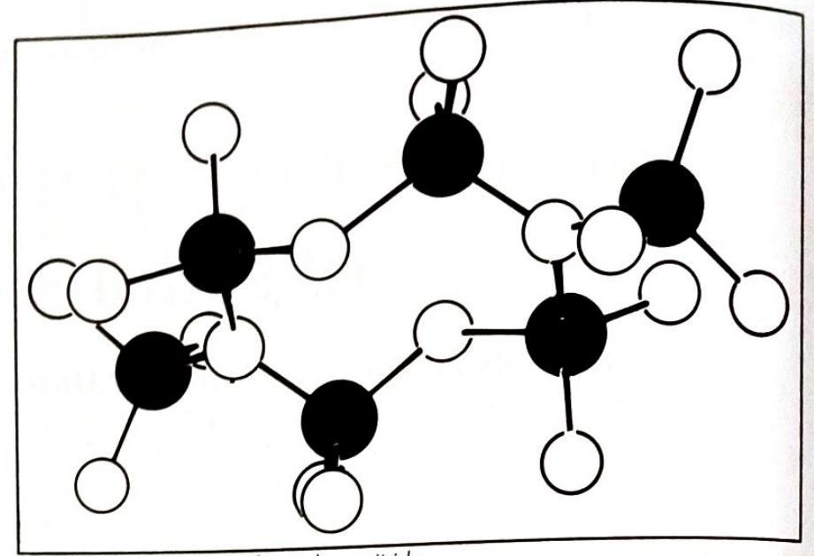

SiN4 tetrahedra linked to form silicon nitride.

responsible for many of the important properties of silicon nitride.

Beta sialon is based upon the atomic arrangement existing in beta silcon nitride. In this material silicon is substituted for aluminium with corresponding replacement of nitrogen by oxygen. In this way up to two-thirds of the silicon in beta silicon nitride can be replaced by aluminium without causing a change in structure. The chemical replacement is one of changing Si-N bonds for Al-O bonds. The bond lengths are about the same for the two cases but the Al-O bond strength is significantly higher than that of Si-N. In sialon the aluminium is co-ordinated as $AIO4$ and not as $AIO6$ as in alumina. Therefore in beta sialons the Al-O bond strength is 50 per cent stronger than in alumina. Thus sialons intrinsically have better properties than both silicon nitride and alumina.

Silicon nitride and sialon are essentially covalent materials and there is little self-diffusion at normal sintering temperatures. The beta syalons are produced by Vesuvius Zyalons (Midlands) Limited using vttrium oxide as a sintering aid to a sialon composition. At temperatures above 1400°C the oxide reacts to form an yttrium-silicon-aluminium-oxynitride liquid which is necessary for densification. This then forms an intergranular glass upon cooling which can, by controlled processing, be reacted to form sialon plus yttrium aluminium garnet (YAG). In this way, the silicon and nitrogen from the glass are taken up by the sialon and the remaining grain boundary phase is a hard. strong crystalline material.

This material, because of its crystalline grain boundary phase, retains its strength up to temperatures above 1300°C. Creep resistance is also very good. However, because the devitrification process involves a small volume change, the initial strength is lower. Vesuvius Zyalons designate this material as Syalon $201 - it$ it is

harder and is designed for use in hightemperature applications. Alternatively. syalon can be produced so that the intergranular liquid first formed remains as a glass upon cooling. This results in a material (Syalon 101) which is stronger at room temperature but which softens slightly at temperature in excess of 1000°C.

As a solid solution the vapour pressure of beta sialon is lower than that of silicon nitride and as a result the sialon will form more liquid at a lower temperature with yttrium oxide. Sialon is, thus, more easily densified using normal sintering techniques. Furthermore, it should be noted that the lower vapour pressure of sialon reduces decomposition at high temperature so that sialon is thermodynamically more stable than silicon nitride.

The sialons discussed so far are based upon the beta modification of silicon nitride but alpha-type sialons are also very important ceramics. The stacking sequence in the alpha silicon nitride structure is different from beta silicon nitride so that the long "channels" which run through the beta structure are blocked at intervals. This gives rise to a series of interstitial holes in the alpha structure and these holes are of great importance to the formation of sialons based on alpha silicon nitride.

In this case, silicon in the tetrahedral structure is replaced by aluminium with limited substitution of nitrogen by oxygen. Valency requirements are satisfied by modifying cations which occupy the interstices in the network. In this way cations of yttrium, calcium, lithium and neodymium for example, can be incorporated into the structure.

Hardness is an intrinsic property of a material and this can be simplistically related to "bond energy density". The bond energy density of alpha sialons is high and these materials are extremely hard. Hardness, and particularly hot hard-

ness, is an extremely important parameter for many wer applications.

The alpha sialon marketed by Vesuvius Zyalons is based upon yttrium as the modifying cation. These sialons incorporate almost 20 years of technology. They are produced in such a way that the liquid formed during sintering is, in the later processing stages, taken up into the structure. The result is a fully dense, extremely hard ceramic which is almost entirely free of a grain boundary phase. The material properties are retained to high temperatures (of the order of 1400°C). This is of great importance in wear mechanisms; hot hardness to above 1000°C is required for cutting tips for example.

An important added advantage is oxidation resistance. The absence of a grain boundary phase in this ceramic means that the transport of diffusing species necessary for oxidation to take place at higher temperatures is restricted (there is limited liquid phase to assist transport), so that oxidation resistance is improved. These sialons have excellent resistance to abrasive wear and are having an impact as nozzles for shot blasting, particularly for highly aggressive grits. However, the absence of grain boundary phases also makes them attractive candidates for high-temperature applications, such as in gas turbines.

#### Applications and case histories

Cutting tips: One of the earliest successful applications for sialon was as a cutting tip or throw-away insert. Metal removal generates tremendous heat and even when a coolant is used temperatures of 1000°C at the cutting edge are commonplace. If a cutting tip has poor thermal conductivity, then the heat generated cannot be easily dissipated. The thermal damage is exacerbated by high coefficient of thermal expansion and exaggerated crater wear develops leading to the rapid destruction of the cutting edge. This thermally induced wear is an important and neglected feature in metal removal.

Most turning operations involve "interrupted" cutting, whether by design or accident. For example, in the turning of a roll of chill-cast iron, the existence of pin holes and local asperities makes the cutting action intermittent. Many metal removal operations are by necessity discontinuous and as well as having suitable thermal properties, cutting tools must be tough. In addition, work pieces are often hard and can be abrasive so the cutting tip should have high hardness values. Finally, the metallurgical properties of the work piece may be such that at the high temperatures generated a chemical reaction takes place between the tool and the work piece. So chemical stability is also important.

One solution to some of these prob-

lems is to use very high surface speeds for the removal of the metal. In this way a lot of heat is generated so that the metal becomes plastic and under these conditions toughness and perhaps hardness are less important. Of course, chemical and thermal properties are still of consequence.

Unfortunately, the horse-power required for the generation of these high surface speeds is not generally available and in any case surface finish is often the main criterion for turning operations. Thus, toughness, hardness, thermal and chemical stability are all extremely important in this application.

The machining time for turbine discs for the Rolls Royce RB211 engine was reduced by 75 per cent by using sialon cutting tips.

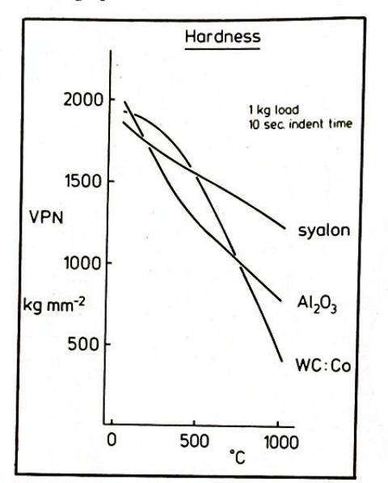

Variation in hardness with temperature.

Welding applications: In its most simple form a welding operation joins metal pieces together using a pool of molten metal. The first consideration of any welding operation is to create a weld which, as far as possible, has the same properties as the original metal. The join must also be created in such a way that minimum disturbance is caused in the area adjacent to the weld. Such welds are best done at high speed and in such a manner that the molten weld is completely shrouded from the atmosphere during the operation.

Welding today encompasses many different techniques and methods, however speed and protection of the weld area are required for all operations.

Weld locating devices are used in the resistance welding of captive nuts in automotive and commercial vehicle assembly.

Orbital welding, often used in aerospace, employs small diameter gas shrouds to weld curved or cylindrical components.

In tungsten inert gas (TIG), metal inert gas (MIG) and plasma welding, the arc

and weld pool are enveloped by inert gas which is delivered by a ceramic shroud The heat is contained and the metal protected and faster welding is achieved.

Welding lenses are used for the induction welding of plastic aluminium seams in, for example, the production of tooth. paste tubes.

Welding methods are diverse but they all require the same high standard of material performance. Ceramics in weld. ing must be able to withstand thermal shock at a variety of temperatures. They must have high strength to resist mechanical damage, which is often accidental They must be resistant to "weld spatter" and the consequent build-up of weld debris. They must also, for many applica. tions, be electrically resistant and stable at high temperatures.

As a material for welding applications. sialon has proved itself again and again as the following case histories attest:

Weld location devices A major Euro. pean manufacturer used steel pins for the location of nuts in a continuous resist. ance welding operation. On average, the steel pins lasted for 7000 operations, that is. a working shift, before wear and spatter build-up caused damage to the nut. By using Syalon 101 location pins over five million operations have been completed without wear or damage occurring.

Orbital welding Gas shrouds with a wall thickness of three-quarters of a millimetre are used in Lucas Aerospace for the orbital welding of aircraft fuel manifold inlet tubes. Several thousand cvcles have been achieved by sialon shrouds giving hundred-fold increases over conventional materials.

Deep bore welding In the TIG welding of steel tubes in heat exchanger cores, Syalon 101 nozzles have outlasted alumina nozzles by a factor of 10 to one. The confined space in this operation creates severe welding conditions and sialon's thermal shock properties and resistance to weld spatter are the key to the success of this operation.

Welding nozzles A major UK supplier of welding nozzles tested sialon nozzles in a plasma cutting operation. The nozzles had a life at least four times that of alumina and the spatter build-up on the nozzle was easily removed. In simple thermal quench tests and impact tests sialon was found to be more durable than both alumina and silicon nitride nozzles. Comparison between silicon nitride and Syalon 101 nozzles showed that sialon had at least twice the life of silicon nitride.

#### Extrusion and drawing applications

Wire drawing, open die extrusion and hydrostatic extrusion, whether performed hot or cold, are all examples of metal flow through converging conical dies. Three independent variables affect

the flow of material: the cone angle, the coefficient of friction, and the ratio between the original diameter and the extruded diameter. These parameters are independent of each other and have a strong influence on the extrusion or drawing force at any particular speed. Of course, other variables are influential in the flow of metal through conical dies, lubrication, temperature, and the thermal properties of the die itself are all important variables. Often the metallographic aspects are of great importance in drawing and extrusion. In special brasses, for example, the oxidation of those elements which form beta phase can lead to the formation of layers of alpha brass in the skin. These layers can cause exaggerated die wear and alternative die materials have sometimes to be found.

The material properties which make sialon an excellent candidate for extrusion are:

* Hot hardness
* · High strength
* · Low coefficient of thermal expansion
* · Relatively good thermal conductivity
* · Resistance to thermal shock
* · High rigidity
* **Excellent chemical stability, and**
* · Good frictional properties.

The use of sialon dies gives improved surface finish over metal dies because it does not contain metal binder phases and there is no pick-up on the die surface to produce scoring of the extrudate.

The rigidity of sialon dies, together with the absence of pick-up means that longer production runs are achievable before repolishing becomes necessary. Moreover, higher extrusion ratios are achievable.

Sialon dies last up to 120 times longer than tool steel dies when used to extrude nimonic alloys.

Single shot impact extrusion of nimonic 80 components using sialon 101 dies produced 30 000 components before excessive die wear was noticed. Tool steel dies had to be replaced at 750 components.

A major extruder of brass and copper in the UK operating in the container range of 150 to 250mm has found that using sialon 101 dies 250 tons of brass could be extruded compared to 100 tons of brass through conventional dies. For copper, sialon extruded 75 tons compared to 40 tons for a conventional die.

#### Shot blast nozzles

The benefits from the use of sialon dies include: improved surface finish, higher rates of extrusion, higher extrusion ratios, decreased die wear, increased extrusion speed, improved dimensional accuracies.

Grit blasting generally employs replaceable nozzles and traditionally tung-

sten carbide has been used to withstand the harsh abrasive conditions of blasting. A variety of grits are used but the most important of the more abrasive types are alumina and chill-cast iron. At the low angle impacts encountered in the majority of blasting operations excessive wear occurs in tungsten carbide nozzles due to the erosion of the relatively ductile cobalt used to cement the carbide grains together.

It is generally accepted that while the wear rate is influenced by the interaction between grit and nozzle, the angle of impact is also an important parameter. For relatively low angle impacts, such as occur in most nozzles, the resistance to erosion depends upon the hardness, fracture toughness and Youngs modulus of the material. The most important of these is hardness and perhaps the least important is fracture toughness. In the case of high angle impacts, fracture toughness assumes an important role. Alpha-type sialons have been tested in a variety of applications and the results have been excellent. The extreme hardness of the alpha-type sialons, together with high modulus figures and the absence of a grain boundary phase make this material an excellent candidate in shot blasting.

The nozzles are available through Moorex Limited of Sheffield. A standard 3/8 nozzle tested by Moorex using alumina 40/60 grade grit has performed for more than 600 hours at an air pressure of 80lb/in2. Volume loss is reported to be minimum and the nozzle is still in operation.

A standard 3/8 nozzle tested by Moorex

using G17 chill-cast iron grit and operating at 100lb/in2 has performed for more than 1000 hours without appreciable wear.

#### Molten metal handling devices

Sialon is used extensively in contact with molten metals and in particular with non-ferrous metals. Thermocouple sheaths used in molten aluminium are found to be extremely long lasting. Sialon appears to suffer no degradation in aluminium alloys; it is especially resistant to aluminium lithium alloys. Increasing use is now being found in the handling of molten copper and molten zinc.

Certain composites of sialon are now being used in handling molten steels and so on, and one particular application, that of "break rings" in foundry casting techniques, is stimulating great interest. $\Box$

Ian Wilson has worked in the field of technical ceramics for more than 20 years. He is a graduate from London University with a PbD in nitrogen ceramics. In 1969-70 be joined the staff of Newcastle University investigating silicon nitride and related systems under the direction of Professor KH Jack. Dr Wilson has been involved in key developments of super-bard industrial materials and in the development of ceramics for aerospace. He is currently managing director of Vesuvius Zyalons (Midlands) Limited.

Property

Syalon 101

Syalon 201 Syalon 501

Syalon 050

3 Point MOR at 25°C Specimen 3×3×50mm, span

19.05mm

945MP a

825MP 0

825MPo

800MP a

Weibull modulus

וו

$8 - 13$

$8 - 14$

$8 - 13$

Compressive strength at 25°C

>3500MPa

Youngs modulus at 25°C

288GPa

Hardness at 25°C

1370 **Vickers**

1715 Vickers

1370 **Vickers**

2000 **Vickers**

Density

$3.23$ gcm -3

$3.24$ gcm -3 3.95gcm -3

$3.25$ gcm -3

Thermal expansion coefficient (0-1200°C)

$3.04 \times 10^{-6}$ . K -1

Thermal conductivity at 25°C

$21Wm^{-1}K^{-1}$

$19Wm^{-1}K^{-1}$

Fracture toughness (KIC)

7.7MP $a.m/b$

$5.7MPa.m\frac{1}{2}$

3 point MOR at 140°C

600MP a

650MPa

Creep strain (77MPa)

$<$ 0.02% at 1277°C 100hrs

$0.1%$ at 1327°C 50hrs

Volume electrical resistivity

$7.24 \times 10^{-6}$ ohm.m

Table 1. Properties of the various sialon grades.

### **SURFACE ENGINEERING**

# Engineering application of chemical vapour deposition

NJ Archer, Archer Technicoat Limited

Chemical vapour deposition (CVD) is a versatile technique for depositing materials either to form thin adherent coatings, or free-standing shells. These materials are used in engineering for wear, corrosion and oxidation resistance

ost commonly, chemical vapour deposition (CVD) materials are refractory carbides, nitrides or oxides, for example, TiC, TiN, SiC, Si3N4, Al2O3, SiO2 or refractory metals. They are used to impart wear resistance to cutting and forming tools, corrosion resistance to turbine components and burner nozzles; and oxidation resistance to furnace parts and semiconductor manufacturing jigs.

Table 1 lists the materials which can be produced by chemical vapour deposition (CVD), both as adherent protective coatings and as thick deposits which are subsequently separated from their substrate and machined into a final product. This technique will deposit most materials, but is particularly suitable for refractory metals which are difficult to deposit by other methods. Most oxides, nitrides and carbides can be formed by CVD and make excellent wear resistant coatings on steel and carbide parts.

#### Limitation

A limitation of CVD is the high temperature usually required to produce useful coatings. Steel substrates must often be rehardened after coating to recover their mechanical properties, and some low melting point alloys cannot be coated at all. New forms of plasma-assisted CVD (PACVD) and metal organic CVD (MOCVD) are being developed to overcome this limitation. The high temperature of CVD has an advantage in that it results in coatings whose properties cannot be matched by other processes. For example, pyrolytic graphite, formed by CVD at 2000°C, is much stronger, denser,

and cleaner than other graphites. Coatings applied by CVD have the following features:

* They are well bonded to their substrate because a small amount of diffusion occurs at the interface during their deposition
* They are formed uniformly over complex shapes, including blind holes, and
* They have a high degree of cohesion and a freedom from pin-holes which is important for corrosion resistance.

CVD is well established as the standard method for coating carbide cutting tool inserts and as one of the methods for protecting gas turbine blades from corrosion. Many other applications are under development which exploit the characteristics of CVD coatings and the comparative ease with which large numbers of small components can be coated by this technique.

A further development of the CVD technique is known as chemical vapour infiltration (CVI). CVI is used to densify fibre composites to produce fully dense materials with remarkable properties. Carbon-carbon composites are the best known examples and are being used as structural and working parts in aircraft.

#### The CVD process

In CVD a reactive gas mixture is introduced into a chamber so that it surrounds the components to be coated. The components and the chamber are normally heated in order to initiate the chemical process which forms the coating. In some cases only the components are heated in

order to avoid coating the chamber. A plasma around the components will also initiate the chemical process and this is occasionally used to limit the temperature to which the components must be exposed.

The reactive gas mixtures flow easily around and into the most complicated components, particularly at low pressure, so that the CVD process gives extremely uniform coatings throughout complex work loads. Moreover, the rate of deposition is not particularly influenced by sharp corners so that there is no edge build-up as with electroplating. There is no theoretical limit to the size of a CVD reactor. In practice the largest ones are about 2m in diameter by 4m in length. They can accept large, single components or thousands of small components.

#### **Metal halides**

Many CVD processes are based on the use of metal halides. The best known example of this is the reaction between $TiC14$ and CH4 to give a coating of TiC and HCl as a by-product. Such by-products have to be neutralised in a scrubbing unit. These processes require rather high temperatures, mostly in the range 500-1000°C, some as high as 2000°C. More recently, organometallic-based processes have been developed which operate at less than 500°C and have by-products which are kinder (than HCl) to the electronic substrates for which they are intended.

CVD may be used both as a coating process and as a forming technique. The rate of deposition with some materials (for instance, tungsten) is so high that an extremely thick layer can be deposited on a mould. This layer is then released to give a hollow shape corresponding to the mould. It is a neat technique for forming shapes in materials which are difficult to machine.

The simplest type of CVD reaction is

**Material**

**Formation process**

Temperature (°C)

**Application**

TiC

$TiCl4 + CH4$

900-1000°C

Extensive use on carbide cutting tools. punches and dies; steel forming tools of all kinds, wear parts

TiN HfC ZrC Cr 3 C 7 W 2 C ZrN **HfN** Al 2 O 3 **SiC**

$TICI_4 + N_2 + H_2$ $HfCl4 + CH4$ $ZrCl4 + CH4$ $CrCl3 + CH4$ $WF_2 + C_6H_6 + H_2$ $ZrCl_4 + N_2 + H_2$ $HfCl_4 + N_2 + H_2$ $AICI_3 + CO_2 + H_2$

900-1000 1000-1200 1000-1200 1000-1200 300-500 1000-1200 1000-1200 900-1100 1000-1600

Some use on carbide cutting inserts Some use on carbide cutting inserts Wear coatings on steel parts Wear coatings on steel and non-ferrous alloys Carbide cutting inserts Carbide cutting inserts Extensive use in carbide cutting inserts Oxidation resistant coatings on graphite and

$B_4C$ **BN** Si 3 N 4 pyC Ta Nb Al Ni W

$CH_3SiCl_3 + H_2$ $BCI3 + CH4$ $BCI3 + NH3$ $SiCl4 + NH3$ CH 4 $TaCl5 + H2$ $NbCl5 + H2$ $Al(i-C_3H_7)_3$ Ni(CO) 4 $WF_6 + H_2$

1200-1900 1000-2000 1100-1400 1900-2200 700-900 700-900 200 200-400 400-600

carbon-carbon components Light-weight armament High temperature ceramic (free-standing) High temperature ceramic (free-standing) High strength graphite Corrosion resistance Corrosion resistance Corrosion resistance Free-standing components Free-standing components

Table 1. Materials available by CVD.

one which involves the thermal breakdown of a single compound. A good example of this is the "vapour plating" of nickel where nickel carbonyl is cracked in a heated chamber to form nickel deposits.

$Ni(CO)4 \rightarrow Ni + 4CO$

This is the basis of the Mond nickel refining process, which has been in operation for a number of years.

Hydrogen reduction of a volatile metal halide is much more common; corrosion resistant coatings such as tantalum, tungsten, and molybdenum can be formed in this way.

$TaCl5 + 5/2H2 \rightarrow Ta + 5HCl$ $WCl_6 + 3H_2 \rightarrow W + 6HCl$ $MoCl5 + 5/2H2 \rightarrow Mo + 5HCl$

More complicated reactions are used to produce carbides, nitrides, silicides, borides and oxides:

$4BCl3 + CH4 + 4H2 \rightarrow B4C + 12HCl$ $TiCl_4 + \frac{1}{2}N_2 + 2H_2 \rightarrow TiN + 4HCl$ $3SiCl_4 + 4NH_3 \rightarrow Si_3 N_4 + 12HCl$ $2AICl_3 + 3CO_2 + 3H_2 \rightarrow$ $Al_2O_3 + 6HCl + 3CO$

The chemical processes described so far yield overlay coatings, that is, the substrate does not play a chemical part in the formation of the coating since all the coating constituents are supplied by the gas stream. However, there is another group of CVD processes which depend upon the interaction of the substrate. These are the diffusion coating processes such as carburising, nitriding, boriding, aluminising and chromising. They are not commonly referred to as CVD processes, but their mechanism is very similar to the processes listed above.

#### **CVD** equipment

CVD processes are carried out in a uniformly heated chamber, although it is possible to induction-heat only the object to be coated. The gas flow system is arranged so that the volatile reactants are mixed as they enter the chamber. The by-products are swept out of the chamber in the same gas flow. Often, the reactants are solids or liquids which have low vapour pressure at ambient temperature. Such reactants are entrained in a carrier gas flow in an evaporator held at a specific temperature. In these cases it is important that the intervening pipework be held at a temperature above that of the evaporator to avoid condensation. Processes which are operated at sub-atmospheric pressure are pumped continuously so that the balance between the pumping rate and the incoming gas flows gives the required chamber pressure. The corrosive nature of the exhaust gases

often causes difficulty with the pumping equipment. A satisfactory solution to this problem is the use of a liquid ring pump which is circulated by a neutralising solution.

Industrial CVD reactors have been constructed up to 1m in diameter and 2m in length. Much care must be taken over the materials used in these reactors to avoid contamination. It is important to obtain an even distribution of gas throughout the chamber to obtain uniform coatings.

Corrosion problems mostly fall into two groups: low temperature aqueous corrosion, and high temperature gaseous corrosion.

Low temperature corrosion: The most important CVD coating for low temperature aqueous corrosion resistance is tantalum. Tantalum is highly resistant to acid attack and is used as a bulk material in critical parts of chemical plant. This is very expensive and a cheaper alternative is a tantalum coating. The CVD technique makes it possible to clad valves, pipes, and similar components with an impervious layer of tantalum. There is no difficulty with coating internal bores and the coatings have a dense columnar microstructure which is completely impervious to liquid attack. The greatest danger of failure comes from hair-line cracks caused by thermal cycling or poor handling. These do not occur frequently in coatings less than 50um thick



### Miller Thermal, Inc. a complete line of thermal spray products

Miller Thermal, Inc., a full line manufacturer of thermal spray products, has the solutions to your coating problems. From flame spray, arc spray and plasma spray equipment to powders and wires our Technical Sales Staff is ready to help you with the service and quality you want, at the price you need. Write or call us today!

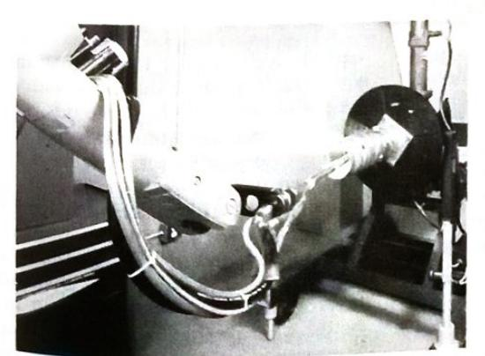

Miller Group Ltd. Compar

ller Thermal, Inc.

* Full line of thermal spray powders including tungsten carbide, ceramic, alloyed and blended metal powders and pure metal powders
* Flame and arc wire spray equipment with accessories and a complete line of wires
* A complete line of powder $\bullet$ spray equipment including plasma, combustion and spray and fuse...each with associated accessories
* A complete line of robotics with adaptation to spray equipment and turntable manipulation equipment
* **Hardfacing products** including tube rod, tungsten carbide cobalt pellets, cast tungsten carbide, crushedsintered tungsten carbide cobalt, sintered tungsten carbide parts

For FREE literature on these products in our **MOGUL**, **PLASMADYNE** and **ALLOYS INTERNATIONAL** lines, call 414-734-9292. Or, write to: Miller Thermal, Inc., P.O. Box 1081, Appleton, Wisconsin, USA 54912. Fax: 414-734-2160. Telex: 156-1485 MTTI MCA

A silica coating has been developed for the protection of steel. This is obtained by the pyrolysis of tetraethoxysilane and provides a good quality coating at low cost. As with tantalum, the corrosion resistance of the coating material itself is excellent so that its efficiency as a protective coating depends entirely on its structural defects. Silica is prone to mechanical damage, thus these coatings can only be used in well-protected environments. However, their low cost makes them interesting candidates for the corrosion protection of larger structures.

High temperature corrosion: Aluminising and chromising provide extremely good corrosion resistance for high temperature components such as gas turbine parts, burner units, and exhaust pipes. Earlier pack metallising was not recognised as an example of chemical vapour transport, but more recent variants of the process have shown conclusively that there is no need to have mechanical contact between the pack and the pieces to be metallised. In the normal pack aluminising process, the components are buried in a powder mixture of alumina, aluminium flake and a halide activator. The whole mixture is heated in an inert atmosphere to a temperature in the range 750-1050°C. The following sequence of reactions generates a vapour pressure of aluminium monohalide:

$NH_4X \rightarrow NH_3 + HX$ $2AI + 6HX \rightarrow 2AIX_3 + 3H_2$ $\text{AIX}_3 + 2\text{Al} \rightarrow 3\text{AIX}$

The aluminium monohalide diffuses through the gas phase until it reaches the component to be aluminised, usually a nickel or iron based alloy. The AIX species reacts to form an aluminide and AlX3. The AlX3 then diffuses back through the gas phase to the free aluminium in the pack to generate more AIX which repeats the process. The process continues because the system seeks to equalise the aluminium activities associated with the aluminium in the pack and the surface aluminide.

$$ 3AIX + 2Ni \rightarrow 2NiAI + AIX3 $$

* Al in pack

The diffusion layers formed by the process are equiaxed, but often have banded structures associated with the change in the aluminium concentration through the coating.

Pack aluminising is now being replaced by pure gas-phase processes which yield cleaner and more uniform coatings. This process is used as standard practice in many designs of aero gas turbine and probably represents the largest volume of CVD use after TiC coating of hard carbide tips.

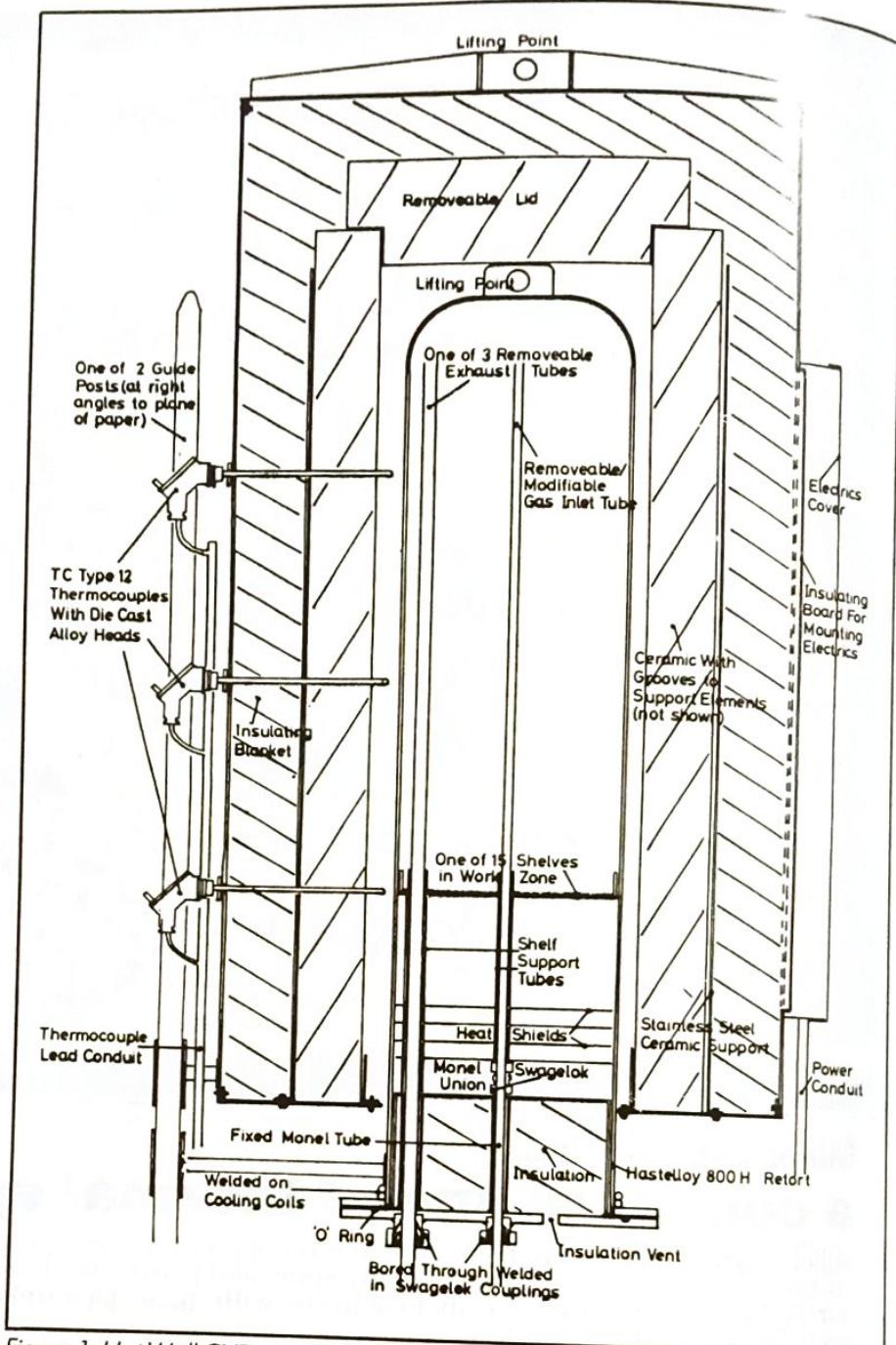

Figure 1. Hot Wall CVD reactor for TiC/TiN coatings.

Tungsten metal has excellent high temperature corrosion/erosion resistance. The thrust nozzles of rocket engines have been coated with tungsten by CVD to increase their life. These nozzles are made from graphite and this can be coated with an adherent layer of tungsten. The hydrogen reduction of tungsten hexafluoride is normally used to prepare this type of coating:

$$ WF_6 + 3H_2 \rightarrow W + 6HF $$

#### Water resistant coatings

Wear resistant coatings are particularly useful in protecting cutting edges. By far the most successful application of CVD has been in the coating of sintered

carbide tool inserts. These small inserts are coated in large numbers with combinations of titanium carbide, nitride, carbo-nitride and aluminium oxide. It is widely believed that the best results are obtained using a multi-layer coating of TiN and TiC. The rationale behind this combination is that TiN is more thermodynamically stable and resists crater formation on the rake face of the cutting insert, while TiC is harder and gives better wear resistance on the flank face. Aluminium oxide is also used in combination with TiC and TiN because it provides an even more inert surface to minimise interaction with the work piece.

Chromium carbide is another hard material which may be deposited by high

# **CVD PROCESSING SYSTEMS**

**BERNE**

### **BERNEX**

designs and manufactures vacuum CVD processing systems. Our CVD systems are used in an designative that the control of industries around the world every year.

### **BERNEX OFFERS**

a wide range of vacuum CVD systems. Equipment can be supplied for laboratory scale projects as well as large scale systems for production. The CVD systems are available with advanced controls, from rugged manual partial cycle control to highly sophisticated computer-controlled systems for repeatable, well documented mass production processing. Special purpose equipment can be designed to meet individual user requirements.

### **BROAD PROCESS COVERAGE**

Process which can be conducted in BERNEX CVD equipment include

* Low-Temperature CVD
* for Amorphous Diamond-Like Carbon (ADLC)
* Moderate-Temperature CVD for Titanium Carbonitride (MT-CVD)
* High-Temperature CVD for TiC, TiN, Ti(C,N), Al203, diffusion chromium, aluminiding, etc. (HT-CVD)
* Very High-Temperature CVD for SiC, Si3N4, B4C, BN, TiB2 (VHT-CVD/CVI)

### **AT YOUR SERVICE**

The world-wide acceptance of BERNEX CVD equipment for high performance applications in the

* manufacture of carbide cutting tools,
* steel tool production,
* automotive and related industries,
* manufacture of aircraft engines,
* manufacture of advanced composite materials,
* nuclear and other industries

reflects the leadership position BERNEX has attained.

#### For further information, please contact:



**Head Office:** BERNA AG OLTEN **BERNEX Division** Industriestrasse 36 CH-4600 Olten, Switzerland

Phone: (062) 25 22 44 Fax: (062) 26 17 94 Telex: 981 612

**RERNEX GmbH** Helmholtzstrasse 4-6 D-4018 Langenfeld 1 **West Germany** Phone: (02173) 7990 Fax: (02173) 819 70 Telex: 8515 843

**SYLVESTER & COMPANY** 24700 Highpoint Road Beachwood OH 44122, USA Phone: (216) 831 0880 Fax: (216) 831 0852

Telex: 980 486

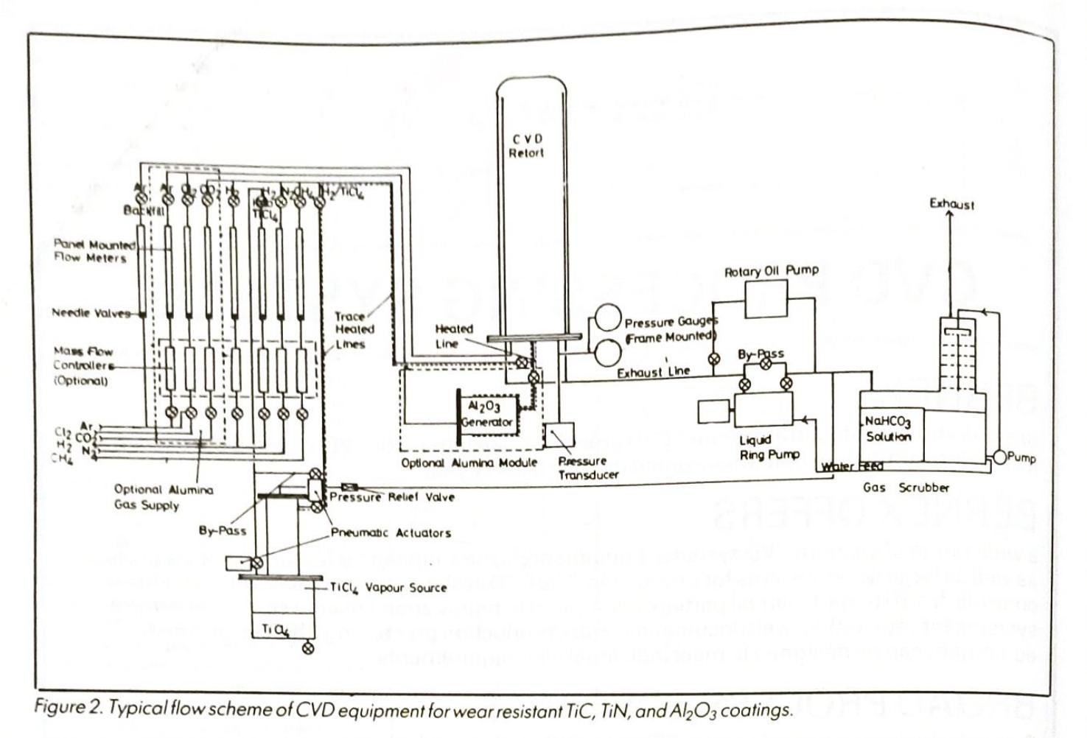

temperature CVD. It is less hard than TiC or TiN and may be deposited in thicker layers on steel. It has been applied very successfully in cases of sliding wear. For example, the locking devices in the free wheels found in bicycles and elsewhere have been coated with chromium carbide to give an increased wear life.

In general, the CVD hard coatings are much harder than those obtained by other methods. However, this also means that they are potentially brittle. Consequently, to achieve their optimum performance they can only be applied as thin coatings on already hard substrates.

#### **Steel components**

Titanium carbide and nitride coatings can also be applied to steel components. Dies, punches, and press tools have all been shown to have an increased life when coated. The deposition temperature of 900-1000°C necessary for these coatings results in steel components becoming soft during the coating process. Therefore it is necessary to re-harden these tools before use. This, in turn, restricts the choice of steels to those which can be re-hardened by inert atmosphere quenching. It also means that a certain amount of distortion is inevitable so that these coatings can be applied only to tools of moderate precision. Both these difficulties have caused research to be directed towards lower temperature processes.

The CVD of tungsten carbide at

temperatures of 350-550°C has been explored for tools as many tool steels can be coated without tempering at temperatures up to 550°C. Tungsten carbide is deposited as $W_2C$ from a mixture of $WF_6$ . benzene and hydrogen.

$$ WF_6 + C_6H_6 + H_2 \rightarrow W_2C + HF $$

These coatings give their best wear performance at a thickness of 10-20µm. Unlike the high temperature TiC/TiN coatings, these coatings fail by spalling because of the relatively weak bond between the coating and the substrate. However, they give good performance under low-load conditions. For example, $W2C$ has been used to increase the number of start-stops achieved by an air bearing. It has also been used on extrusion dies for aluminium with some success

Microwave powered PACVD has been developed for the formation of diamond and diamond-like coatings. The decomposition of simple hydrocarbons such as CH4 can be induced at low pressure by a microwave plasma so that diamond-like deposits can be "frozen" on a nearby cold substrate. These deposits have been characterised as having properties comparable with macroscopic diamond. These ultra-hard thin layers have not yet been successfully used in wear or cutting applications, but they are being used to impart scratch resistance to optical components

The use of a low pressure plasma to

reduce the deposition temperature of CVD reactions has also been explored. It has been demonstrated that in the presence of plasma, the deposition temperature for TiC and TiN can be reduced to around 400°C.

Gas-phase diffusion treatments for steel such as carburising and nitriding are long established and widely used. They provide wear resistant layers of lower hardness but of greater depth than the overlay coatings. Their use is widespread on small wear components. A recent addition to this group of treatments is boronising: this is carried out in a pack and a halide activator is used to transport boron to the surface of the steel components. A surface hardness of up to 1800 VPN can be achieved by this method. The depth of the boronising can be up to 200µm. It finds application as an erosion resistant coating because the depth of the coating gives a considerable life before failure. For example, the shanks of drills for rock cutting are boronised to reduce the erosion caused by the rock debris passing over them.

#### Vapour forming

CVD is an attractive method for forming components in materials which are otherwise very difficult to handle. It is possible to make thin wall tubes (<1mm wall) and components in tungsten and rhenium. The tungsten tubes are used in high temperature furnaces to carry samples. The CVD grain structure is reason.

ably stable even at about 2000°C and is more stable than the corresponding component rolled from tungsten sheet.

Rhenium is a very expensive material. but has been used in some space applications as a substitute for tungsten which is rather brittle.

silicon nitride can be deposited in layers several millimetres thick by CVD. Coatings of silicon nitride can easily be separated from graphite so that this provides a way of making shaped components of very high purity silicon nitride. **Pyrolytic boron nitride and pyrolytic** graphite are also deposited by CVD on graphite. In order to achieve the optimum properties for these materials, the deposition temperature must be in the region of 2000°C. Pyrolytic boron nitride is now used in the form of a thin walled crucible to contain the melt in 111-V semiconductor crystal pulling.

The very high purity (<50ppm total metallic impurity) which can be achieved by the CVD method coupled with the intrinsic inertness of PBN makes the material ideal. Plates of PBN can also be processed into thin rods which are used in microwave travelling wave tubes. PBN has an extremely suitable combination of properties for these devices. Pyrolytic graphite has a strongly oriented structure (like PBN) so that they both have anisotropic properties. Pyrolytic graphite is much stronger than conventional graphites and is also much cleaner. Thin wall cylinders are produced by CVD so that they can be perforated by laser into the form of a grid. These grids are then used in high power transmitter valves in place of tungsten. The secondary electron emission from the pyrolytic graphite is low and the whole structure is very stable at the high running temperature.

#### **Composite materials**

CVD coatings easily penetrate small cavities and this is used as the basis of the CVD infiltration process for fibre-filled composites. This process is known as chemical vapour infiltration (CVI). CVD pyrolytic carbon can be infiltrated into a porous mass of carbon fibres so that the whole assembly becomes a solid mass. High densities can be achieved in this way provided that the process is carried out slowly. This is the basis for the manufacture of carbon-carbon composites which are extremely strong materials, with a low density. They are used as the exhaust cones on some rocket motors and as the discs in aircraft brakes.

There is considerable scope for further work on infiltrating dissimilar materials into fibre-reinforced structures.

SiC-C fibre composites and SiC-SiC fibre composites have now been made. They have better oxidation resistance than C-C composites and look like good candidate materials for leading edges and nose cones on space vehicles which re-enter the earth's atmosphere.

#### Conclusion

As more is demanded of materials, new materials and surface modifying processes are certain to become increasingly important: CVD will be there among the processes providing these materials. $\Box$

DrNJ Archer was educated at the universities of Cambridge and the Manchester Institute of Science and Technology. He is managing director of Archer Technicoat Limited, which specialises in the development of equipment for chemical vapour deposition.

# Advanced coatings for steel strip

#### T J Goodwin British Steel Technical

The production and uses of a range of metallic and organic-coated steel products include hot-dip zinccoated, electroplated and plastisol-coated steels. There are product requirements for a number of different industries, including automotive, construction and general engineering and the current developments in the use of coated steels in these markets can be reviewed in this context.

ritish Steel is an established manufacturer of a wide range of metallic and organic-coated strip products. These products are supplied to a variety of manufacturing and construction industries including the automotive, domestic appliance, and building industries. While the performance of these coated products meets the current needs of manufacturing industry, steel-users are continually improving the design and performance of their finished products. This in turn means that British Steel, and other major steel manufacturers, must constantly improve and develop new products to satisfy the demands of the manufacturing industries.

The demands from steel-users arise from the expanding usage of coated steels in more sophisticated applications, such as satellite dishes, and increased expectations of the performance of the more "traditional" products, such as domestic appliances and building cladding, fabricated from coated steels.

#### **Current coated steel products**

Metallic-coated steel strip: Metalliccoated steel products are produced by depositing, either by hot-dipping or electroplating, a pure metal or alloy on the surface of the steel substrate. Hot-dip galvanised steel consists of a pure zinc layer on a mild steel base.

Other surface coatings include four

sets of combinations. First, 43.5 per cent zinc, 55 per cent aluminium, 1.5 per cent silicon (Aluzinc, Galvalume, Zalutite); second, 95 per cent zinc, 5 per cent aluminium and a small amount of mischmetal (Galfan); third, 92 per cent zinc, 8 per cent iron alloy (IZ or Galvanneal): finally, 92 per cent lead, 8 per cent tin (Terne). Electroplated metallic coatings include pure zinc (Zintec) and 87 per

cent zinc, 13 per cent nickel (Nizec).

The zinc and zinc-alloy coatings protect the steel substrate from corrosion by acting both as a barrier coat, and as a sacrificial layer which gives cathodic protection to the steel. For a given coat. ing, the corrosion protection is generally proportional to the thickness of the coating. However, some coatings are more corrosion resistant than others, for example, the aluminium/zinc coating in Zalutite is approximately 2-4 times more corrosion resistant than the same thickness of zinc in most external environments. Similarly, zinc/nickel is 2-4 times more corrosion resistant than the same thickness of zinc in the salt spray and other accelerated corrosion tests used by the automotive industry.

The corrosion performance of the coating is only one of a number of factors which must be considered before a particular coated steel is chosen for a specific application. For example, zinc/nickel

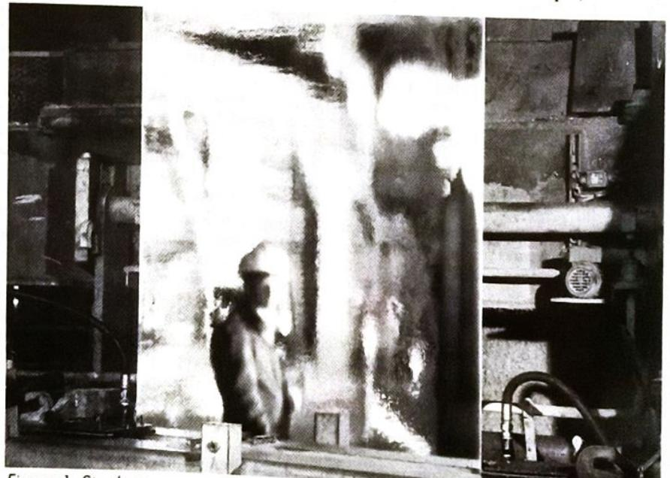

Figure 1. Steel strip emerging from the zinc pot on a hot-dip galvanising line (Note

Product

**Improvement Required**

**Application**

**Solution**

Hot Dip Zinc

Improved corrosion resistance

Building - cladding, roofing and components

Development of alloy coatings, like Zn/Al.

Improved formability

Automotive body manufacture

Improved steel bases including IF steels. Improved annealing cycles on the galvan- ising lines.

Improved surface finish Improved weldability

Automotive and domestic appliance

Improved gas/nitrogen knives. Improved mini- spangling techniques. Better strip cleaning prior to galvanising.

Automotive body

Improved zinc uniform- ity. Better gas knives. Improved IZ manufac- ture.

Need for wider strip

Automotive bodies

New lines at Shotton and Llanwern Works.

ne

Need for improved corrosion resistance

Automobile fuel tanks

Use of nickel flash on hot dip terne line. Pre- painted terne under consideration.

ectro- ١C

Improved corrosion resistance

Automobile bodies

Development of alloy coatings like zinc/nickel

Thicker coatings

Automobile industry

New line at Shotton Works with high current density plating.

Wider strip

Automotive bodies

New line at Shotton **Works**

Improved formability

Automotive industry

New line at Shotton Works with alloy plating capabilities.

Organic Coated

Improved performance and longer service life from product

Building cladding and roofing

Improved paints and use of alloy coated steel bases.

Wider strip

Automotive bodies

New line to apply paint systems required being built at Shotton Works.

Table 1. The process and product developments in coated steel manufacture.

coatings combine good corrosion resistance with good weldability and formability whereas thick zinc coatings give excellent corrosion resistance but greater care is needed during subsequent welding and forming. The wide range of available coatings does, however, mean that there is considerable freedom for the end-user in selecting coated steels which combine a number of desirable properties.

Hot-dip coated steel: The hot-dip, zincbased coatings are produced by a continuous coil coating process involving the use of strip accumulators and on-line welding and shearing to enable the strip to be continually processed, without stopping, while the feed and product coils are changed. The strip is cleaned and annealed prior to immersion in the hot metal; after dipping, the surface quality and finish is controlled by the use of air-knives, minimised spangle rigs (to produce matt finishes) and furnaces to make IZ or Galvanneal (Figure 1). The coated strip is then subjected to in-line

temper rolling and levelling to improve its shape and finish. Finally, the strip is chemically treated and oiled to improve its corrosion resistance during storage.

All aspects of production have been improved in recent years to meet the increased demand for a higher quality product. These developments include higher-grade steel bases, such as interstitial-free (IF) steels, and the use of improved annealing cycles which has produced more formable steels.

The use of gas knives and inert nitrogen wiping has facilitated closer control of the zinc coating mass and improved surface finish, and is an important improvement. This also applies to the improved spelter compositions and nucleation techniques, such as Heurtey powder spraying, which has allowed the production of minimised spangle finishes. The remaining production move concerns improved induction-heated Galvanneal furnaces which give better control of the alloying process.

The improvements have been com-

bined with an increased range of product specification; for example, hot-dip zinccoated steel strip is now available up to 1650mm wide and this will be increased in the near future to 1830mm from **British Steel**

Hot-dip coated steels are, in terms of their forming and fabricating properties, a versatile range of materials. In many cases, mild steel can be replaced with hot-dip coated steel with little or no modification to a production process. Cutting, blanking, brake-forming, rollforming, spinning, crimping, and lockforming are all possible on the coated steel provided the appropriate grade is chosen to match the specific forming and fabricating demands of the particular component and manufacturing process (Figure 2).

The forming performance of the hotdip coated steels is basically determined by the thickness and metallurgical properties of the steel substrate. The tool design for forming coated metal is the same as that for uncoated metal although it may be necessary to use hardened tool steel inserts to avoid an excessive pick up $of $zinc$$

Conventional fusion and resistance welding techniques can be used to weld the coated steel. Resistance welding is preferred because it minimises coating damage and so preserves corrosion resistance. Spot, seam, and projection welding are also used with only minor adjustments to the conditions applicable to mild steel. A wide range of commercially available fasteners provide unlimited choice for mechanical fixing.

Electroplated steel: Electroplated products are also produced on a continuous coil coating line, which includes preannealed temper-rolled strip as feedstock, and strip preparation by chemical cleaning and pickling. The same coating line also includes electro-deposition of the coating up to 10 microns thick on both sides of the strip and chemical treatment of the strip to improve corrosion resistance during storage and the adhesion of organic coatings.

#### **Higher quality electroplating**

As with the hot-dip processes, the electroplating process has been improved in recent years in order to produce a higher quality product by, among other things, the production of singlesided material for the automotive industry, and improved cell designs. These both facilitate high current density plating and simplify the production of thicker coatings. The electroplating process also uses insoluble anodes and the production of wider (1640m) electro-zinc coated strip which increases the versatility of the product for the automotive industry in particular. Further efficiencies have come with the production of alloy coatings, particularly nickel-zinc,

## **What's Often The Difference Between Parts Success Or Failure?**

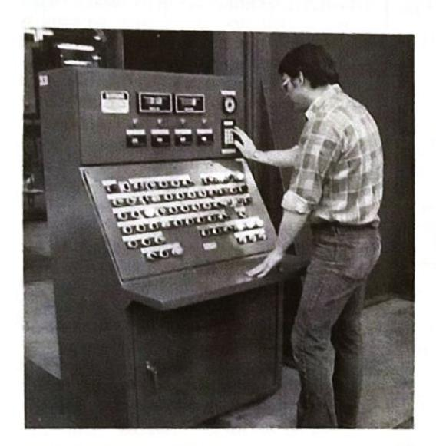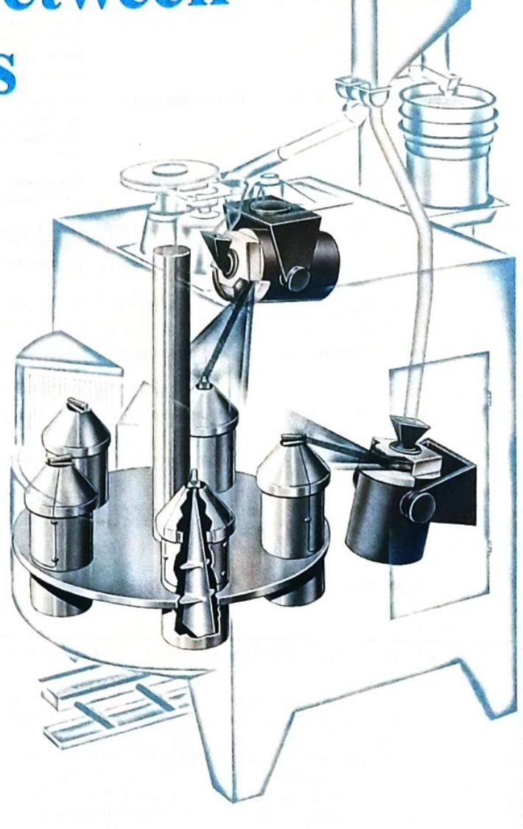

#### The RP Rotoblast® Wheel

Controlled shot peening with Pangborn RP Rotoblast® wheels effectively increases parts service life. Why? Because the process provides even surface compressive stress, while eliminating microscopic imperfections.

Improving the fatigue properties of cyclic loaded parts like gears, springs, drive shafts, axles and aircraft components is often the real difference between their success or failure in service. It's something we've been doing for years.

Our machine designs will vary with the application and can include the latest in programmable controls for complete automation. Discover how your parts can benefit from controlled shot peening with RP Rotoblast® wheels. Contact us at . . .



**CORPORATION Box 380** Hagerstown, MD 21741-0380 $(301)$ 739-3500 Telex: 89-3410 FAX: (301) 739-2279

© PANGBORN 1989

up to six microns thick.

The electroplating process does not affect properties (such as yield stress, work hardening characteristics, and anisotropy) which control the forming response of the steel. The choice of material grade can, therefore, be made on the same basis as cold-reduced steel. Thus, the range of electroplated steels can be subjected to all normal fabricating processes, such as cutting, blanking, brake. forming, roll-forming, stretch-forming, deep-drawing, pinning, and lock-forming. Experience has shown that switching to electro-zinc coated steels can be carried out with minimal adjustment to the press settings.

Electroplated materials can be readily welded by the usual techniques. Resistance welding is again the preferred technique in order to minimise surface damage. Fusion welding can also be used. provided the process and welding conditions are carefully selected to prevent excessive damage to the surface coating.

Organic-coated steel strip: Organic coatings are usually applied to metalliccoated products rather than straight forward, mild steel; the combination of the organic and metallic coatings ensures the optimum corrosion performance in the final product. Hot-dip, zinc-coated strip is the usual substrate for those organiccoated products (like plastisol and polyester-coated strip) produced for the Electrobuilding-cladding industry. plated substrate is the preferred substrate for the domestic appliance and automotive markets.

The organic coatings are applied as a liquid film or a solid laminate. In both cases the coated strip is passed through stoving ovens which raise the temperature of the strip and cure the paint or adhesive (in the case of the laminated products). The coil coating process features include:

* **Continuous processing of 5-10 tonne** coils
* · Cleaning and multi-stage chemical pretreatment of the strip prior to primer and topcoat application
* · Primer application to both sides of the strip
* **.** Stoving of the primer coats followed by cooling
* · Application of a backing coat to one side of the strip and a topcoat to the other, and
* • Stoving of the finishing coats followed by embossing in the case of plastisol coatings.

A variety of coatings are available to meet the demands of the different endusers. These include plastisol (PVC) and polyvinylidene fluoride (PVF2) for the building market. British Steel has developed, in conjunction with Hydro Polymers and Crown Paints, the HP200 formulation plastisol for application onto

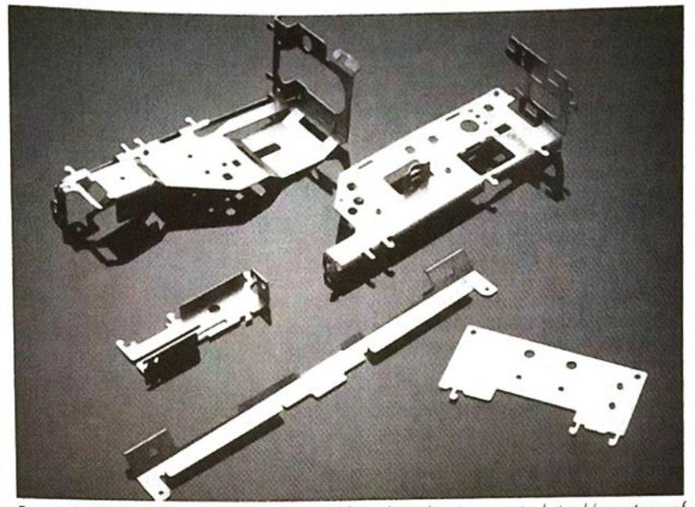

Figure 2. TV chassis components formed from hot-dip zinc-coated steel (courtesy of Hitachi)

metallic-coated steel substrates. This flexible plastisol coating (200 microns thick), which is available in a range of colours, is very durable and, given the correct maintenance after construction. is expected to have a lifetime of between 20 and 40 years on the building. The product lifetime is directly related to the climatic conditions experienced

The use of PVF2 coatings is restricted to the less aggressive environments, but they possess greater colour stability than the plastisol coatings. This stability coupled with the wide range of colours (such as metallic silver) means that PVF2coated cladding is frequently used for "hi-tech" buildings in mild urban en-Architectural silicone vironments. polyester-coated steel is the other major cladding product and, for historical reasons, is very popular throughout **Europe**

Organic-coated steels produced for the domestic appliance market usually contain a polyester coating over an electroplated (usually Zintec) substrate (Figure 3). This substrate is chosen because of its very smooth, high quality, surface finish. The organic coatings have evolved to meet the demands for high gloss. flexibility, and stain resistance from the appliance manufacturers.

The final class of organic-coated product is one which is rapidly growing, both in terms of production and technical development. This class covers the organic coatings which have been developed to meet customer requirements, like chip resistance and internal corrosion protection, in the automotive industry. They are therefore, applied to automotive steels, particularly electro-zinc and hot-dip zinc. The coatings are considerably thinner than the other organiccoated products with film thicknesses between seven microns and one micron depending on the final product requirements. They are intended as basecoats for coverage with conventional automotive electroprimers and topcoats.

The extent of post-finishing and decoration required for individual coated products is very dependent on the use of the product. Colourcoat organic-coated products are normally supplied fully finished; the end-user has no need to apply further paint systems over the organic coating.

The developing use of thin organic coatings on electrozinc or electrozinc/ nickel for automotive purposes means that these coatings would be painted during the normal electropainting of the car during the production process. They do not, however, have any treatment requirements during the automotive painting process.

Metallic-coated strip products for the building industry, with the exception of Zalutite for roofing applications, are normally coated for exterior usage. Hot-dip zinc-coated steel, the usual substrate for Colorcoat products, is usually given an amorphous oxide, zinc phosphate, or chromate pretreatment on-line; users who want to apply their own systems normally clean, pretreat and apply a special primer. The synergy of the zinc and paint coatings gives a much greater corrosion protection than could be expected from the lifetime of the individual components.

Powder painting has been used on Zintec and iron-zinc alloy coatings for microwave and other domestic appliance products. Zintec can be supplied pretreated at the steel mill or can be phosphated by the end-user. Similarly, iron-zinc, alloy-coated steel is tolerant of a wide range of user pretreatment and painting conditions.

In the automotive industry, the zinc and zinc-alloy coated products, when painted are finding increased usage because of their versatility and performance in preventing cosmetic and perforation corrosion. Products are now available for automotive panels which have good compatibility with the pretreatment and painting plants. They do not poison the phosphating bath and require only small modifications to the pretreatments and paints which are normally used.

Tri-cation pretreatments have also been developed to improve the corrosion resistance even further. These, combined with the thicker electropaints, give excellent corrosion performance, minimising any cratering, scabbing, and under-film corrosion. These improvements have been developed through active collaboration between the steel industry, car manufacturers, and paint suppliers.

Coated steel products are used in four major manufacturing industries, the automotive, domestic appliance, general engineering, and construction industries. Each industry is placing its own demands on the steel manufacturers to produce high quality products to meet their own individual needs. The one common theme is the customer expectation for improved technical performance (and products) at roughly the same price as current products. The steel manufacturers must, therefore, be capable of installing and modifying production lines to produce these new products at an economic cost to themselves and their customers

The increased use of coated steels in automotive bodies has resulted from the need to extend the expected lifetime of the car body. This can only be achieved by replacing the traditional body material, cold-reduced steel, with more corrosion resistant substrates, such as electrozinc. This replacement has taken place on condition that the coated steels were able to match the uncoated steel in terms of formability, paintability, and ease of fabrication. Modifications to the electroplating and hot-dipping lines has meant that with only minor modifications to press and lubrication specifications, all cold-reduced steel parts in a car body can be replaced with a coated steel alternative.

Automotive manufacturers are also wanting to reduce the overall weight of their products in order to improve their performance. High strength steels, including bake hardenable steels, are, therefore, being developed by the steel producers. The welding and forming characteristics of coated steels are very dependent on the nature of the surface layer. For example, Nizec (with a zinc/ nickel coating) welds easier than electrozinc with a zinc coating. Finally, there is a growing demand for organic-coated automotive steels.

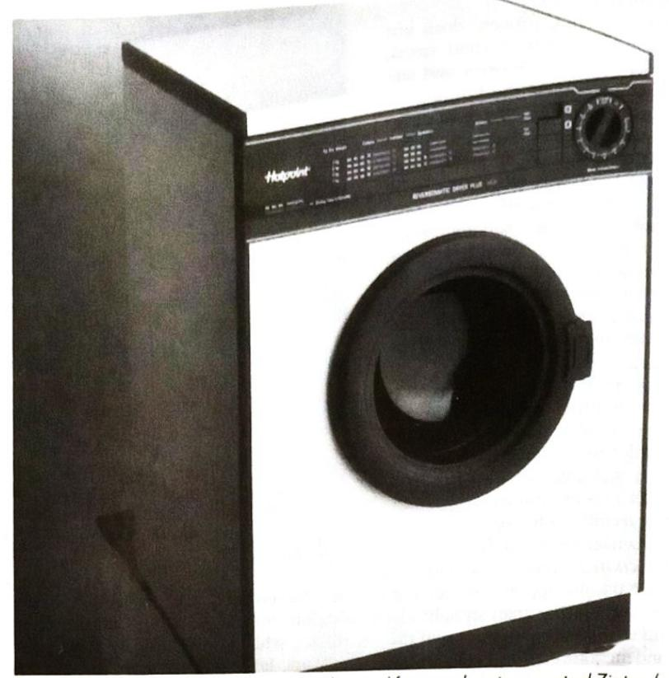

Figure 3. Washing machine wrapper formed from polyester-coated Zintec (courtesy of Hotpoint).

This demand falls into two categories. First, thin organic coatings, such as Durasteel, which are coil coated by the steel producer and are intended to improve either the internal corrosion performance or the exterior chip resistance of the car body. These coatings can already be applied to Nizec but their compatibility with bake hardenable steels needs to be resolved. Second, Pre-primed steels: unlike the previous category, these steels are coated with a two-part, 25 micron organic coating which is intended to replace the electropriming and surfacer primer stages of automotive finishing at the manufacturers

In terms of development, the first category coatings are ahead of the second category and are being used in a number of automotive bodies. The preprimed coatings must, at this moment in time, be considered as materials for the future.

The use of prepainted steel in domestic appliance manufacture is currently experiencing rapid growth, both in terms of volume and range of end-products. There has been sustained growth in the more traditional areas, such as washing machine and refrigerator manufacture. with a move to produce more sophisticated appliances, such as microwaves and satellite dishes, from prepainted steel strip. If prepainted strip is to make a significant impression on the microwave and teletronic industries (videos, televisions, and so on) then they must displace the laminated steel strip; this will only be

achieved by improving the surface finish of the prepaint material.

The wider range of end-uses for prepaint in the domestic appliance market has also resulted in a demand for more flexible coatings which have high stain and impact resistance. This need for a flexible, hard organic coating with a high quality finish is being met by collaboration between the steel and paint producers. The appliance manufacturers are also expecting a greater range of finishes, such as textured and patterned ones. This demand, at present, is mainly satisfied by laminated steel products.

The continued growth of the use of organic-coated steel in building cladding has resulted in architects asking for improved coatings with longer lives and extended colour ranges. Improved corrosion resistance and longer lifetime is claimed for the use of alternative metallic-coated substrates, such as Galfan. Zalutite is also being considered as a cladding material (particularly for roofing) in its own right. Improved colour stability has stimulated an active search for alternative resin and pigment systems amongst the paint suppliers. п

TJ Goodwin bolds a PbD in chemistry. He joined British Steel Technical in 1988 from the United Kingdom Atomic Energy Authority. He is the Principal Research Officer in the Coated Product Technology Department at Welsh Laboratories.

## somewhere along the line

most people stop at Struers

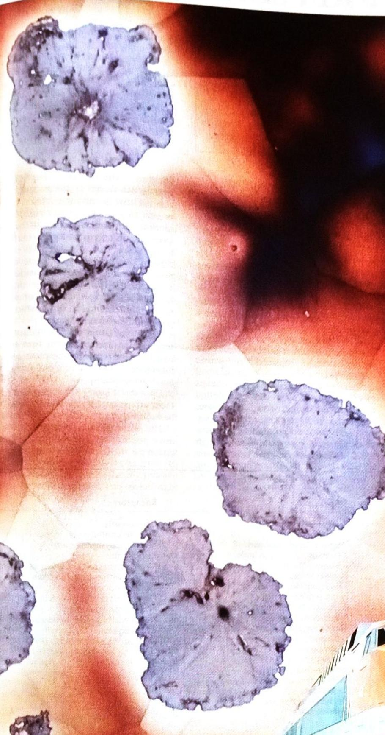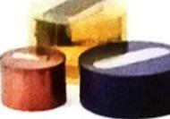

**SNCF** are responsible for the railway

service in France. They know that traffic standstills and delays are costly in terms of money as well as credibility.

That is why SNCF do not let just anybody supply the products to carry out essential materials control.

Struers make the world's best equipment for any type of metallographic control.

Struers also have a world-wide service network able to meet even the most stringent demands.

With the help of Struers, SNCF never have to worry about unsolved material problems.

For local representative please contact:



Valhøjs Allé 176 DK-2610 Rødovre/Copenhagen Denmark

## EMI/RFI shielding of plastics

### Robert M Gresham, E/M Corporation

The dominant finish today is nickel-laced, conductive organic coating, but electroless copper/nickel plating is becoming increasingly important for high-performance products such as those used in security and military hardware.

he fabrication of plastic cabinets for electronic equipment has been one of the fastest-growing industries in the US economy, resulting in tremendous growth potential for resin suppliers, moulders, and coaters. Although the industry has gone through a recent downturn, the direction of future growth will continue to depend on the need to shield parts or fully assembled units from electromagnetic interference (EMI). Electromagnetic radiation is one of the unfortunate byproducts of the rapid proliferation of electronic devices. EMI can interfere with the functioning of simple household appliances such as garage door openers and microwave ovens (Table 1) and can cause disastrous results in large-scale computers, aircraft guidance systems, and medical equipment such as pacemakers

In 1983, the Federal Communications Commission (FCC) issued regulations on EMI shielding, and more stringent ones are expected to follow. The impact of the US legislation has posed serious problems for producers of electronic equipment using plastic cases or cabinets. The industry has had to develop methods of shielding while maintaining an attractive exterior, durability, and protection of the electronic devices within.

Electronic cabinetry has been produced largely from injection-moulded and structural-foam-moulded plastics, which have provided design engineers with lightweight, versatile, aesthetically pleasing packaging for their products. Plastic enclosures have been steadily replacing metal cabinets in items such as typewriters and CRT terminals. Unlike conductive metals, though, plastics cannot be grounded to provide electrostatic control and EMI shielding. However, even metal enclosures pose the possibility of EMI at joints and apertures.2

Vent holes, cables, gaskets, and assembly techniques all play a role in developing an effectively shielded cabinet. The result is that no one form of shielding will dominate the market and metals will not completely replaced by plastic be cabinetry. However, as is the case in all industry, the most cost-effective means of controlling EMI for a specific design and application will become dominant. All producers in the chain must, therefore, maintain an awareness of new shielding developments as well as a high level of flexibility in their production facilities. There are several basic approaches design engineers can use to control EMI in plastic-enclosed equipment: (1) re-design the electronic equipment to reduce the strength of the electromagnetic energy or signal emitted to levels below the stipulated US regulations; (2) shield the electronic equipment directly to reduce or attenuate the signal emitted at the source through internal shielding enclosures or similar electronic techniques; or (3) shield the plastic cabinet or enclosure.

The first option involves controlling noise generation and is the least attractive because it affects the ultimate performance of the product and can influence susceptibility.

Options (2) and (3) have received the most attention, but the former tends to be relatively expensive.

The third option appears to be the most popular because the packaging decision has the least effect on the circuitry

#### **Sources**

Television and radio sets **Radar transmitters** Video cassette recorders **TV** games **CB** transmitters Electric motors **Relays and circuit breakers** Engine ignition systems AC power line leakage and corona Induction heating units Paging systems Electronic calculators and computers Static electricity Remote-control units Mobile communication transmitters Arc welders Electrical appliances Lighting

#### **Receptors**

**CB** receivers Remote-control units Sensitive test instruments Telephones Microprocessor-containing equipment Radio and television receivers Cardiac pacemakers Computers and large calculators Navigation equipment Audio and high-fidelity equipment Cash registers Duplicating equipment

Table 1. Common sources and receptors of EMI.

and design of the specific electronic equipment. Differences in the geometric and electrical output of equipment, as well as the length of the production run for building the cabinet itself, call for different shielding approaches. Furthermore, each shielding technique has inherent strengths and weaknesses that also affect selection.

Some of the various technologies which have been promoted for shielding plastic parts include arc and flame spray. vacuum metallisation, conductive paints. electroless plating, ion plating, conductive-filled plastics, and inherently conductive plastics (Table 2). However, the market is currently dominated by zinc arc spray, conductive coatings (nickel-. copper-, graphite-, or silver-based paints), and electroless plating.

#### The EMI problem2

Electromagnetic interference can emanate from any circuit or man-made device that carries electric current as well as lightning, solar energy, or any of a number of other natural resources.3 However, most commonly experienced electromagnetic radiation is generated by man-made sources. Electromagnetic radiation is composed of electrical and magnetic fields oriented at right angles to each other.4

For electronic cabinetry, shielding of the magnetic component is generally not a concern. At frequencies greater than 1mHz, the main concern is with radio frequency (RF) energy, which is attenuated by three basic mechanisms absorption, reflection and re-reflection.5 RF energy that is not attenuated is transmitted. The mechanisms can be added algebraically when using units of decibels to determine total attenuation. Absorption takes place when the energy enters the shield and is converted to thermal energy, as occurs in a microwave oven. Reflection is similar to that of light

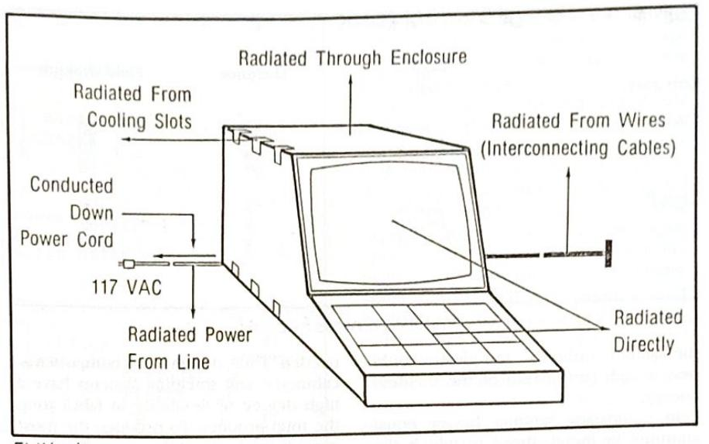

EMI leakage areas.

or sound waves; the energy is reflected off the shield on the source side. Rereflection is reflected energy reflected from a second side of the shield. All of these mechanisms are reasonably predictable: the degree to which each contributes to attenuate RF energy depends on the shielding material, source distance, frequency, and shield thickness. Shielding effectiveness is measured in decibels and is related to the level of attenuation.1

#### **FCC regulations**

In 1983, the US FCC published a technical standard that applies to all devices manufactured after 1 October 1983.6

Subpart J defines a computing device as "any electronic device or system that generates and uses timing signals or pulses at a rate in excess of 10 000 pulses (cycles)/sec and uses digital techniques; inclusive of telephone equipment that utilizes digital techniques or any device or system that generates and utilizes radio-frequency energy for the purpose

Method Zinc arc spray Zinc flame spray Nickel-acrylic paint Silver-acrylic paint Copper-acrylic paint Graphite-based paint Cathode sputtering Electroplating Electroless plating (nickel) Silver reduction Vacuum metallising lon plating Conductive plastics

Thickness (mil) $12 - 25$ 25 50 25 25 25 0.75 0.75 1.25 1.25 1.25 1.0

**Resistivity** (ohm/sq.) 0.03 4.0 $0.5 - 2.0$ $0.04 - 0.1$ 0.5 $7.5 - 20$ 1.5 0.1 0.03 0.5 $5 - 10$ 0.01 $75 - 100$

**Attenuation** (dB) $50 - 60$ $50 - 60$ $30 - 75$ $60 - 70$ $60 - 70$ $20 - 40$ 70-90 85 $60 - 70$ 70-90 $50 - 70$ 50 $40 - 60$

------------------------------------------------------------------------------------------------------------------------------------------------------------------------------------------------------------------------------------------------------------------------------------------------------

-----------------------------------------------------------------------------------------------------------

-------------------------------------------------------------------------------------------------------------------------------------------------------------------

-------------------------------------------------------------------------------------------------------------------------------------------------------------------------------

40% carbon filled nylon 6/6 produced by LNP.

Table 2. Electrical properties of selected EMI shielding methods1

of performing data-processing functions such as electronic computations, operations, transformations, recordings, filing, sorting, storage, retrieval, or transfer".

The US regulations list the following examples: business and personal computers, data processing equipment, digital weighing scales, switching power supplies, electronic games (including the coin-operated variety), electronic cash registers, digital watches, pocket calculators, and digital clocks. The list is not meant to be inclusive. The computing devices are divided into two categories: Class A for use in commercial or business environments, and Class B for personal use in residential areas.

Restrictions on Class A business systems have actually been relaxed by the rules as the incidence of interference has been found to be minimal. For selfbusiness protection and security, machines are normally shielded from outside interference (Table 3). Stricter limits have been imposed on Class B computers for personal use as the commission considers them to be more apt to disrupt reception without built-in safeguards. A Class A computing device must be tested and verified by the manufacturer as complying with US FCC regulations and must bear a warning as to the potential for interference if used in a residential area. By contrast, Class B personal computing devices require US FCC certification and provisions for providing pertinent information to the user.

#### **Shielding effectiveness**

Due to the relative high cost and technical difficulty of surface resistivity to RF attenuation. Resistivity measurements unfortunately only give an average value for system conductivity, which is not necessarily related to shielding effectiveness. It is not truly an effective quality control tool either. Depending on the conditions of frequency and source to shield distance, thin coatings on areas of

Category

Frequency (mHz)

**Distance**

Field strength

Class A

$30 - 88$

30

30

88-216

30

50

$216 - 1000$

30

70

Class B

$30 - 88$

3

100

88-216

3

150

$216 - 1000$

3

200

Table 3. Radiation limits for computing devices by class6.

the system applied to the plastic could pass a high proportion of the incident energy.

In comparing samples having equal amounts of metal, those in which the metal is evenly dispersed will result in higher attenuation than those where uneven dispersions prevail. However, cither type of sample could result in essentially equal resistivity measurements.

Resistivity is, therefore, not recommended for determining the degree of attenuation of a system although it is widely used in industry as the test equipment is relatively inexpensive and lends itself to on-line quality control. The conductivity test is performed according to ASTM D-257. To eliminate some of the variability, both customer and vendor must measure conductivity in the same location on a part using like brands of volt-ohm meters and electrodes.

Compliance is determined by testing US FCC test equipment.6 The electronics under test are located in a shielded environment and operated under normal conditions. An antenna is located at a specified distance from the equipment to monitor RFI emissions. The electronic equipment is considered to comply if the emissions fall within the specified requirements. The US FCC regulates total RF emissions and is not concerned with the effectiveness of a given shielding system. Only enough shielding to reduce the emitted signal to the required level is

needed. Thus, designers of components, cabinetry, and shielding systems have a high degree of flexibility in fabricating the total product. To produce the most cost-effective product, manufacturers must interplay various design considerations.

Therefore, ASTM Section D9 12 14 was established to develop a test method for the industry. An emergency standard, ES-7-83, has been approved. The method, which initially incorporated a dual-chamber apparatus, compares parts being tested against appropriate standards. It is satisfactory for providing data on relative attenuation but does not necessarily provide absolute values. Although less expensive than many electronic procedures, it is still relatively expensive for the moulder or coater and therefore has not been widely accepted.

Any system for metallising on plastic substrates should conform to the requirements of Underwriters Specification $746-C$ , which requires removal of no more than 5 per cent of the metallised material when a tape is applied to a cross-hatched section of the coating (per ASTM D-3359) following thermal cycling, temperature, and humidity tests $(Table 4)$

The final key test performed on shielding coatings involves thickness measurement. Coating thickness of conductive paints can be measured conveniently with a micrometer or Tooke gauge. These are also applicable to zinc are

#### Procedure*

Conditioning

Thermal cycling

Temperature exposure Humidity conditioning

relative humidity (RH) $50 \pm 5%$ 1hr at 85°C Ihr at $23.0 \pm 2^{\circ}$ C and RH 50 $\pm$ 5% 1hr at $29.0 \pm 2^{\circ}$ C 1hr at $23.0 \pm 2^{\circ}$ C and RH 50 $\pm$ 5% Repeat cycle 3 times 85°C for 56 days 35 ± 2°C and RH 90 ± 5% for 56 days

**Conditions**

40hr at 23.0 ± 2.0°C and

*Samples tested for adhesion (SATM) D-2259B) after treatment.

Table 4. Environmental test method.7

spray. However, electroless copper/nick el plating, by virtue of its extreme thin. ness, (normally less than 100µ), requires more sophisticated techniques (betbackscatter per ASTM B-567). These methods require careful calibration but provide outstanding data readily amerable to plant operation and statistical process control.

#### **Shielding systems**

There are seven relatively common systems proposed for EMI/RFI shielding However, only conductive organic coat. ings, zinc arc spray, and electroless cop. per/nickel plating have emerged as commercially significant.

Conductive coatings are heavily filled with nickel, graphite, copper, or silver particles. These products include sol. vent-based or waterborne systems which may contain an acrylic, polyurethane, or epoxy-binder systems. Nickel is the most common material used in these coatings. The coatings provide an excellent shield that is environmentally stable. Acrylic binders are most commonly used with nickel and generally provide the most cost-effective shielding. Depending on the application technique and quality of the coating, shielding performance can range from 30 to 60 decibels.

Graphite-containing conductive coatings are generally used against electrostatic discharge (ESD) due to the less effective conductivity of graphite and its lower shielding capability. In some lowpower applications the graphite coatings can provide adequate EMI shielding. Graphite has the advantage of possessing superior environmental stability.

Copper-containing coatings provide excellent shielding against EMI8 but copper is readily oxidised and, therefore, is not environmentally stable. New technology has greatly improved the environmental stability of these coatings. Nevertheless, copper conductive coatings have not been used in great volume.

Silver-containing coatings provide superior shielding and environmental stability. Shielding can be as high as 70 to 80 decibels, but, because of the high cost of silver, this type of coating is only used in rare applications requiring extreme shielding not achievable by other methods.

The application of any conductive coating is critical to the success of the overall system. The first step, surface preparation, is of key importance. The surface of the part must be clean and free of grease and other contaminants. The coating is most commonly applied by spray with special attention to assure that the paint is properly mixed because the conductive pigments tend to settle rapidly. A preferred system is a propelleragitated pressure pot.

After application, the coating should be allowed to cure for at least 30 mins

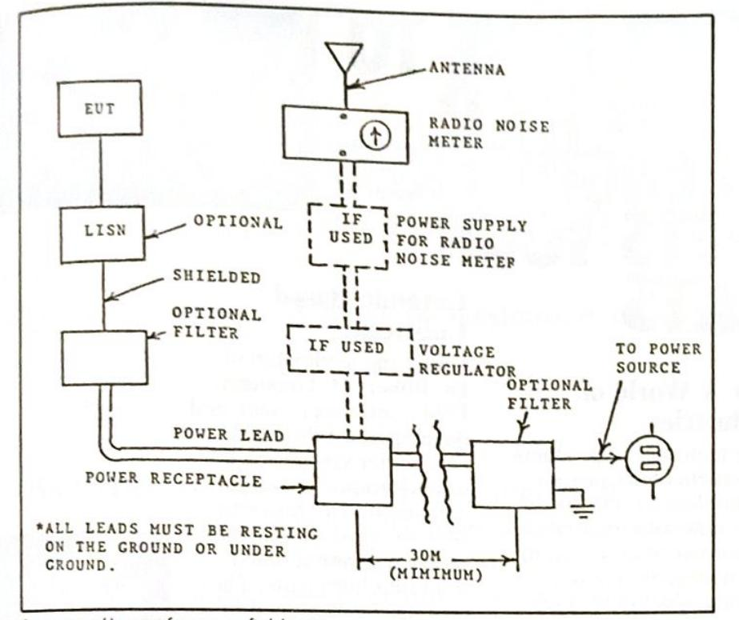

Suggested layout for open-field tests.

before testing. Acrylic coatings usually develop their full shielding and conductivity capability after 24 hours. Urethane coatings can take as long as three to seven days

In general, surface resistivity is used as a measure of quality control. The criteria are generally agreed upon between purchaser and vendor. High surface resistivity generally indicates inadequate coating thickness, poor paint mixing, or dry spray application. Poor adhesion is generally due to surface contaminants or improper selection of solvents. Cracking and similar discontinuities in coatings are generally caused by improper solvent selection or excessive film thickness. Quality control checks should therefore include checks for coating adhesion and, of course, visual inspection for cracks, crazing, and similar indications of a noncontinuous coating.

Shielding is also provided by zinc metal, which is deposited on the prepared substrate by flame or arc-spray methods. In the case of zinc arc spray, the most common, two metal wires are fed through an electric arc, which melts the ends causing a layer of metal to be sprayed on the part. Flame spray involves a metal powder or wire that is melted by contact with superheated inert gas and, using a special spray gun, atomised on to the part. Flame or arc spray provides good conductivity and a hard, dense coating and is effective over a wide frequency range. However, poor coating adhesion caused by differences in the thermal expansion coefficients of plastics can result in flaking of metal on the electronic components beneath. Careful attention to the application technique and the end use of the electronic device can control this problem effectively.

Electroless plating involves autocatalytic deposition of a metallic material on the surface of the plastic cabinet. Most commonly, a layer of electroless copper is plated on the plastic to provide the primary shielding metal. This process is usually catalysed by palladium and is the result of the chemical reduction of cupric ions by formaldehyde. This reduction is followed by additional catalyst and chemical reduction of nickel ion using hypophosphite. The nickel layer is added to provide environmental stability and, in some cases, wear resistance and solderability. In most cases, all surfaces of the plastic are plated. A number of techniques have been developed for masking these parts; however, some result in large increases in unit costs, often with little practical advantage.

The electroless copper/nickel plating technique appears to be the most promising emerging technology, particularly for high-performance products requiring extreme shielding. Plating baths can be controlled so that as much copper as is necessary is deposited to shield the signal encountered. Electroless copper/nickel plating is used in security and military applications as well as the production of business machines.

There are a variety of commercially available shielding techniques. It is incumbent on the OEM supplier to develop working relationships with moulders, platers, painters, other finishers, and assemblers to develop the most cost- $\Box$ effective product.

#### **Acknowledgements**

Portions of this paper were presented at the 12th Annual Structural Foam Conference and Parts Competition, Society of Plastics Industry, San Francisco, CA (May 1984); the finishing '85 Conference, AFP/SME (Sept 1985); and SUR/FIN '87, Chicago (July 1987).

#### **References**

1. P Mooney, Plastics EMI shielding: materials, equipment, markets, GB:066, Business Communications Co, Stamford, CT. 2. LP Fenockitti (1982) Conductive plastics for EMI solutions, RETEC Conf. Soc of Plastics Eng. 3. LC Oberholtzer (1982) The theory and mechanisms employed to attenuate RF energy. **RETEC Conf, Soc of Plastics Eng.**

* F Starbird, Starbird Graphics, Champaign, IL. 5. J C Volkers (1982) Ion plating for EMI shielding.
* RETEC Conf, Soc of Plastics Eng.
  1. FCC (1981) Rules and regulations, Vol II, Part 15.
  2. Standard for safety (1987) UL 746C,
* **Underwriters Laboratories**
  1. Atlantic Research Corp Report (1986) E/M Corp shielding effectiveness

Dr Robert M Gresbam has been with E/M Corporation since 1981 and is currently responsible for new product development, quality control, pilot plant production, and the manufacture of grease and oil products. Previously. be worked at DuPont for 12 years in manufacturing, customer service, and research. Dr Gresbam b olds a PbD degree from Emory University and serves on ASTM Committee D-9 on EMI/ **RFI** shielding.

# **Lubricants**

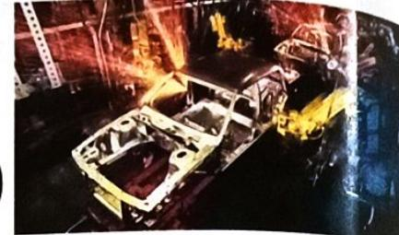

#### **Engineered to Perform**

For over 30 years, E/M has led in the development and manufacture of dry film lubricants and other engineered coatings to meet specific military, government and manufacturer's requirements for lubrication, wear resistance, 46io corrosion resistance, anti-seize properties, electrical insulation or conductive capability. and EMI/RFI shielding.

#### For A World of **Industries**

The hundreds of products we created have proven themselves so versatile they now solve multiple performance problems in aerospace, automotive, marine, electronic, appliance and other industries.

#### **Under Adverse Conditions**

Our high performance products work under the most adverse conditions. Some perform in temperatures ranging from cryogenic to ultra high (1100°C). Others are compatible with liquid oxygen, perform in a hard vacuum, withstand high frequency fretting wear and loads up to 100,000 psi.

## **Ceramic-Based**

Under the leadership of Dr. Robert M. Gresham, E/M continues to seek and develop new lubricants and binder systems capable of performing in ever more demanding environments. Now we have an innovative series of ceramic-based solid film lubricants. These coatings are designed to

withstand ultra-high temperatures and at the same time provide lubricity, outstanding load-carrying ability, endurance life, chemical resistance, thermal stability, chip resistance and flexibility.

#### **E/M** Corporation

World leader in the development, manufacture and application of dry film lubricants and engineered coatings. Let us help find solutions to your most challenging problems. Call or write our corporate offices for technical assistance backed by more than 30 years of experience.

$3.162$

$3 - 49_A^{\circ}$

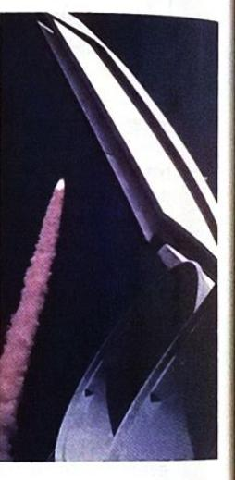

A SUBSIDIARY OF GREAT LAKES CHEMICAL CORP

P.O. Box 2400 2801 Kent Avenue West Lafayette, Indiana 47906 USA

Telephone 1-317-497-6346 Facsimile 1-317-497-6348

Dr. Robert M. Gresham **Vice President-Technology**

## Advanced solid lubrication for tribological control

Robert M Gresham, E/M Corporation

The US Department of Energy has identified and quantified significant losses in energy due to friction and wear. In conjunction with Department of Defense objectives, a number of government sponsored programmes have been initiated to study these losses and identify means of overcoming them.

n 1980 the Energy Conversion and Utilisation Technologies Division of the US Department of Energy sponsored a study which was released in late 1985. This programme identified over four quadrillion BTUs of energy loss in the USA due to simple friction and wear. The DOE/ECUT programme was initiated to assess market needs and later to study friction and wear as a science. Prior to this study tribology research emphasised component development, fluid film, and elastohydrodynamic lubrication. Since the report was issued the emphasis has shifted dramatically. Research efforts now concentrate on lubricants, materials, coatings and friction and wear mechanisms. Most current tribology research is related to Department of Defense objectives of longer life, low maintenance, failure-free machinery and a basic understanding of friction, wear, materials and coatings.

High-temperature lubrication continues to be a major objective in tribology research. The effects of new materials and solid lubricants in current temperature environments are also being studied. Coatings are receiving considerable attention in materials development programmes. The study concluded that the US Government-sponsored high-temperature lubrication work is the most applicable to energy conservation goals. Specific projects in this area include developing new tribological materials, and research to determine physical and chemical interactions and processes in tribological systems. Liquid and solid lubricants, tribological coatings and surface modifications, and ceramic and cermet materials are specific topics under consideration.1

At one time solid lubricants were used almost entirely in aerospace applications. Today there is a pronounced trend to use them in a much wider range of applications. New directions for solid lubricant technology growth have been identified. In recent years solid lubricants have been used extensively in the automotive, metal working, computer/office machine industries and throughout industry in general.

Three basic solid lubricant materials have been used historically: molybdenum disulfide, graphite, and polytetrafluoroethylene. However, the variety of

coating and composite formulations in which these three basic materials are used is very large and can be confusing. The trend in advanced technology is to use solid lubrication for high-temperature applications. The driving force for these applications comes from the Department of Defense particularly in engine systems currently under development (the adiabatic diesel engine, small gas turbine engine, and the upgraded rotary engine). These advanced solid lubricants are required in the hightemperature areas of these engines which preclude the use of conventional grease and oils. It is anticipated that the temperatures encountered in the adiabatic diesel and the ceramic gas turbine are so high that conventional solid lubricant materials will not be suitable. Temperatures well in excess of 540°C may be encountered. Metallic structural and bearing materials will be replaced with ceramics. These ceramics must be either self-lubricating or coated with a solid lubricant

Thus the trend of future solid lubricant use can be summarised as follows: (1) a continued use of molybdenum disulfide. graphite and PTFE lubricants throughout

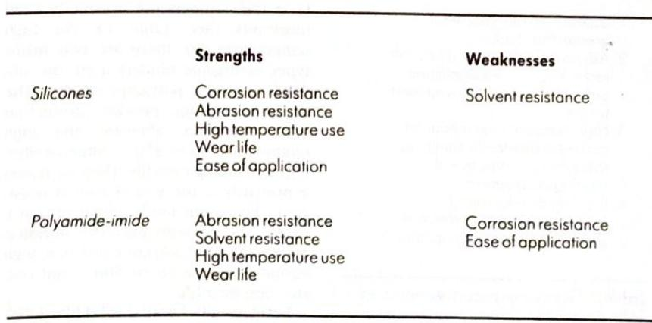

Table 1. High-temperature organic bonded lubricants.

**Binder type**

Strengths

Weaknesses

Impingement

Thin film $(<.0001$ in) Dimensional stability Solvent resistance Radiation resistance Vacuum outgassing High-temperature use LOX compatibility

Corrosion resistance Durability Load carrying Ease of application

Ceramics/Cermets

**Extreme hardness** Corrosion resistance Solvent resistance Vacuum outgassing High-temperature use

Impact resistance Machinability Lubricity Ease of application

Physical vapour deposition (PVD)

Thin films $(<.0001$ in) Dimensional stability Solvent resistance Vacuum outgassing High-temperature use Corrosion resistance

Load carrying Ease of application



general industry; (2) the expanding use of self-lubricating composites; (3) emphasis on multi-functional coatings which provide corrosion protection as well as lubrication; and (4) creation of high temperature solid lubricants for advanced technology engines, especially those with ceramic hot section structural and bearing materials.

Bonded solid-film lubricants contain proprietary mixtures of solid lubricating materials bound to the surface of the part by some kind of "binder" material. High temperature failure of bonded solid-film lubricants results from lack of oxidative or thermal stability of either the solid lubricating materials or the binder material; some environments cause failure of both. The most common solid lubricating materials, as mentioned earlier, are

#### **US Department of Energy Conclusions**

1. Losses from material wear greater than friction. 2. Advanced surface modification technologies have significant potential for reducing wear and friction 3. High-temperature lubrication and wear resistance continues to be a major objective of tribological research. 4. Coating development is receiving the most attention in general material development.

Table 3. From energy conversion and utilisation technologies programme, 1985.

graphite, molybdenum disulfide and PTFE. Graphite is stable to >815°C. Molybdenum disulfide is stable to 650°C in vacuum or non-oxidative environments and to 400°C in oxidative atmospheres. PTFE begins to soften at $>$ 270°C.

There are other solid lubricating materials which are used for high-temperature applications, such as indium, silver, graphite fluoride, niobium selenide, antimony trioxide and lead oxide. These materials are often blended into proprietary mixtures which exhibit synergy for exceeding the properties of the individual components.

The binder materials and the method of application have a dramatic effect on the high-temperature performance of bonded solid-film lubricants. While bonded solid-film lubricants contain proprietary mixtures of solid lubricants, they are often classified into types by the binder chemistry or mechanism used to adhere the solid lubricants to the bearing surface.

The first major class of solid lubricant coating binder types are described loosely as high-temperature organic bonded lubricants (See Table 1). For high temperature use there are two major types of organic binders used: the silicones and the polyamide-imides. The silicone coatings provide protection from corrosion, abrasion and high temperature up to 450°C while exhibiting outstanding wear life. Their weakness is primarily in the area of solvent resistance. Polyamide-imide chemistry provides coatings with excellent abrasion resistance, good solvent resistance, high temperature use up to 400°C and outstanding wear life.

Inorganically bonded solid-film lubricants are the next class of high-tempera-

ture bonded solid-film lubricants. These materials can be used for temperatures as high as $650^{\circ}$ C. They have outstanding oxidation resistance, radiation resist. ance, and compatibility to materials such as dimethylhydrazine and liquid oxygen (LOX). However, these materials exhibit less effective wear life and durability and are more difficult to apply. Additionally. in the area of inorganic bonded solid lubricants, a new class of coating has been developed to provide resistance to high frequency fatigue in the root section of rotor vanes in jet engines. This mate. rial is not designed to have typical lubricating capability but is resistant to ther. mal shock and oxidation, and it is ex. tremely stable to very high temperatures.

Table 2 shows additional classes, by binder type, of high-performance, high. temperature coatings. The first of these are coatings applied by impingement processes while using a proprietary cera. mic binder. In this case, graphite, molybdenum disulfide or tungsten disulfide is applied by a proprietary impingement process to provide a very thin, dimensionally stable film with outstanding solvent resistance, vacuum outgassing resistance and compatibility with liquid oxygen. There is currently a military specification being written around these processes (MIL-L-85645).

Ceramics and cermets make up the next class of solid lubricant materials designed for high-temperature application. These materials are applied either as a spray coating, which is subsequently fired in a high-temperature oven, or as a plasma spray. These coatings exhibit extreme hardness, corrosion resistance, solvent resistance, vacuum outgassing

Usable temperature range

$-54^{\circ}$ C to

Pencil hardness (ASTMD- 3363)

400°C 4H

Taber abraser (ASTM D-4060)

$6.4 \text{mg}/$

1Kg load, CS-10 calibrase wheel

1000 cycles

LFW-1 endurance (ASTM D- 2714) 630 1 bfload

257 000

Coefficient of friction (ASTM D-2714) 630 1bfload at 5000

cycles 0.05

cycles Thermal shock stability (ASTM

Pass

D-2511) Fluid resistance (ASTM D-

2510, Method C) TT-S-735 test fluid

Pass

MIL-L-2104 lube oil

Pass

MIL-L-23699 turbine lube oil MIL-T-5624A, JP-4 jet fuel

Pass

MIL-H-8446, non-

Pass

petroleum hydraulic oil

Pass

O-T-634, trichloroethane

Pass

1,1,1-trichloroethylene

Pass

Methyl ethyl ketone Toluene

Pass

Pass

Table 4. Typical physical properties of a silicone-based bonded lubricant.

stability and temperature application at least as high as 650°C. Their weaknesses are impact resistance, machinability, lubricity, and difficulty of application.

One of the emerging technologies for high-temperature coating processes involves physical vapour deposition of extremely thin films of very hard, wearresistant materials such as titanium nitride, halfnium nitride, tungsten carbide and so on. These coatings, in addition to their thinness, provide outstanding solvent resistance, wear resistance, vacuum resistance and temperature stability as high as 1100°C. Additionally, these materials are extremely resistant to oxidation; however, they are expensive to apply and have certain part conformation limitations.

These PVD-applied coatings have now been used in conjunction with impingement processes to provide lubricity. The result is a new generation of coatings synergistically combining these advanced technologies to provide the properties required for this emerging market.

In summary, there are a variety of technologies being advanced for use in high-temperature applications. The lubricant systems while still based on molybdenum disulfide and graphite, involve new proprietary systems, or in some cases the actual coefficient of friction requirements have been minimised in

Jsable temperature range

$-185^{\circ}$ C

Pencil hardness (ASTM D- 3363)

to 400°C 6H

[aber abraser (ASTM D-4060)

$2.3$ mg/

l kg load, CS-10 calibrase wheel

1000 cycles

LFW-1 endurance life (ASTM D-2714) 630 1bf. load

416 000

Coefficient of friction (ASTM D-2714) 630 1bf load, @ 5000 cycles

0.06

Thermal shock stability (ASTM $D-2511$

Pass

Fluid resistance (ASTM D- 2510, Method C)

TT-S-735 test fluid

Pass

MIL-L-2104 lube oil

Pass

MIL-L-23699 turbine lube oil

Pass

MIL-T-5624A, JP-4 jet fuel

Pass

MIL-H-8446, non-petroleum hydraulic oil

Pass

O-T-634, trichloroethane

Pass

1,1,1-trichloroethylene

Pass

Methyl ethyl ketone

Pass

Touene

Pass

Table 5. Typical physical properties of a polyamide-imide based bonded lubricant.

lieu of wear resistance and temperature stability. In the earlier solid film lubricant products, the low coefficient of friction was a means of reducing overall temperature allowing for use of materials with less temperature stability. In hightemperature applications, incremental increases in temperature due to frictional forces is of reduced significance. However, friction at all temperatures must be overcome by energy, and for that reason there will always be a need for solid materials which can impart a lower coefficient of friction in a given environment.

No single technology has emerged. We believe that ceramic components, coated with the appropriate coating for lubricity, will result in a major material classification. Another will be high-temperature corrosion resistant alloys coated with thin, physical vapour deposited films for lubricity and wear resistance. $\square$

Dr Robert M Gresham has been with E/M Corporation since 1981 and is currently responsible for new product development, quality control, pilot plant production and the manufacture of grease and oil products. Previously be worked with DuPont for 12 years in manufacturing, customer service and research. He holds a PhD from Emory University and serves on ASTM Committee D-9 on EMI/RFI shielding.

## **NEVER HAVE SURFACE TREATMENTS PERFORMED** SO WELL.



**RSCG LANGUEDOC PROVENCE**



## **SNMI THE EXPERTS** IN THERMAL SPRAYING.

Unbeatable in the battle against corrosion, in engine heat insulation and electromagnetic shielding, SNMI, the expert in spraying processes, also offering construction and installation of spraying equipment, has rapidly spread beyond France, attracting some of the world's largest international constructors : TRW THOMPSON, DAIMLER BENZ, CSM/UNI DI TRENTO, FIAT, FERRARI, M.A.N., VW, RENAULT, CEA/CENG, ECAN, AEROSPATIALE, SNECMA, ALSTHOM, IBM...

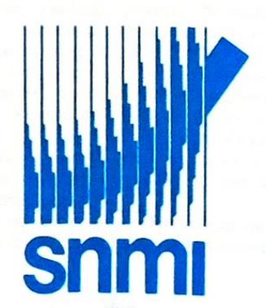

Société Nouvelle de Métallisation Industries Z.I. Courtine Ouest - B.P.166 - 84008 Avignon Cedex FRANCE Tél.: 90.85.85.00 - Télex : 432 048F - Télécopie : 90.82.94.52

# The plasma transferred arc process of metal depositing

S Cler and M Ducos, Société Nouvelle de Métallisation Industries

Metal deposition using the transferred arc process offers fine control, improved efficiency and relative freedom from unwanted heat transfer effects.

lasma is a state of matter resulting from the ionisation of a gas; it is composed of positive ions and free negative electrons but, from an electrical point of view, it remains neutral. Yet its ionised condition enables it to conduct an electric current.

The transformation of a gas into a plasma requires energy and the ionisation level increases according to temperature, ranging from 6000 to 20 000°C. Since the pressure approximates to that of the atmosphere, the impacts of the quick-moving particles on one another are numerous enough for the transformation of their kinetic energy into heat to result in a considerable rise in temperature

Two types of arc are used in plasma torches: the transferred arc, which is the source of heat for the filler metal and the substrate, and the pilot arc, which is occasionally used to improve the stability of the transferred arc and thus the reliability of the process. The workpiece is anodically connected while the cathode is in the torch, so the plasma jet is entirely traversed by current between the torch and the substrate, providing the latter with the energy required for the heating and localised melting of the area to be surfaced.

In principle, the surfacing operation is related to the deposition of a weld bead, in that the filler metal is fused on the work surface to form a molten pool, which is constantly renewed as the work moves under the torch. The surface melting of the substrate ensures a metallurgical bond identical with that taking place in welding.

Surfacing equipment includes a plasma torch, a control cabinet, a powder feeder and a torch-holder system. The torch is a converter, in which the electrical energy is transformed into heat within the plasma whose conductivity ensures a lowresistance electrical continuity between the torch and the work. The torch is therefore the active part of the system, and the resulting coating quality depends to a great extent on its design. This design has also a preponderant effect on the service life of the torch, on the protection of the electrodes (cathode, anode) and on their pickup resistance.

The power of the plasma torches now marketed can reach 10kW (300A, 35V)

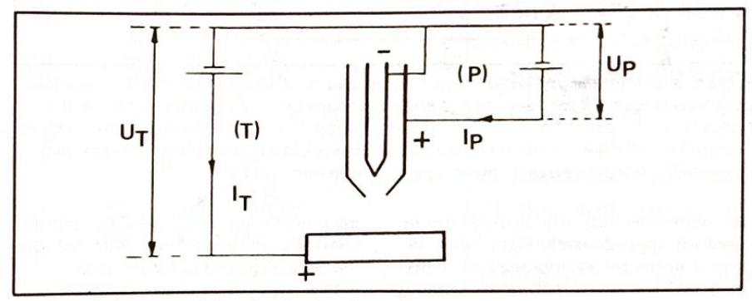

Figure 1. Schematic of the electric circuits.

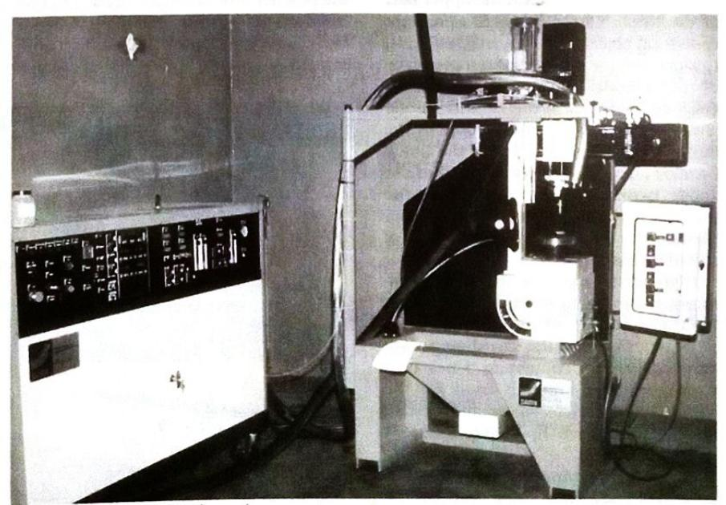

Figure 2. Plasma transferred arc equipment.

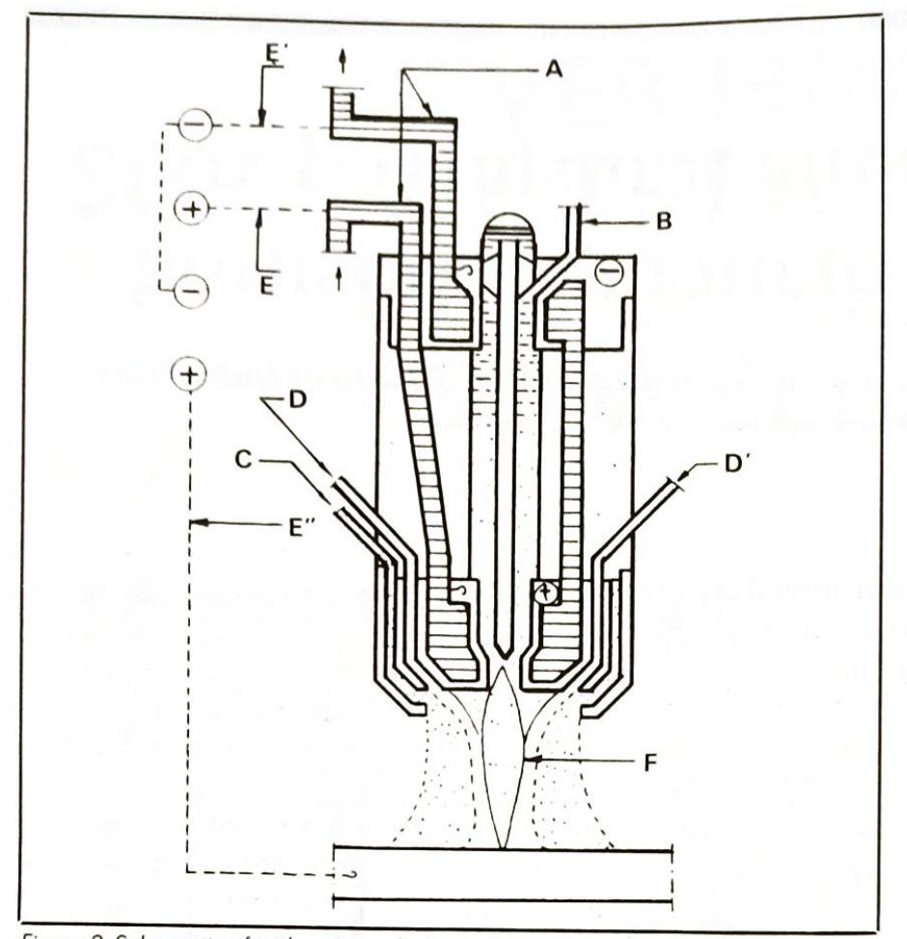

Figure 3. Schematic of a plasma torch. A=water cooling circuit; B=plasma gas inlet; $C$ =shielding gas inlet; $D$ =powder and carrier gas inlets; $E$ =electric supply to the anode, positive polarity of pilot arc power source; E'=electric supply to the cathode, negative polarity of both power sources; E"=work lead connected to the positive pole of the transferred arc power supply; F=plasma cone.

in continuous duty. The cathode can be used for approximately eight hours before it needs reconditioning (30° tapering), and the anode 120 hours without any possible reconditioning.

The gas is directed into the upper part of the torch, where it enters a pressure reduction chamber out of which it flows to surround the cylindrical outer surface of the cathode, thus contributing to its cooling. It arrives in the cathode-anode annulus where it becomes ionised by the electric arc. It is constricted by the anode orifice (nozzle). At the outer end of the anode, two convergent injectors feed the powder to the plasma column, supplemented by an auxiliary source of shielding gas.

High-purity argon is the most commonly used plasma gas. Up to 5 per cent hydrogen may be added to it. The powder carrier gas and the shielding gas are generally argon, containing 5 per cent hydrogen. Pure argon is used for the surfacing of certain steels and certain pure metals when hydrogen additions are not advisable.

The control cabinet contains: the power, control and monitoring units for the plasma system; the control and monitor-

ing units for the powder feeder; and the control and monitoring units for the mechanical torch holder actuator.

One type of powder feeder is presented. It permits steady and reproducible powder flow rates ranging from a few hundred grams to several kilograms per hour. A given adjustment ensures a constant flow rate for a powder of a given type and a given particle size distribu. tion

In the torch-holder system, when sur. facing plates or rotating parts, a mecha. nical actuator is used: as a matter of fact, it is a co-ordinate system (one vertical axis and one horizontal axis), provided with a separate travel speed adjustment for each axis. The horizontal travel permits oscillatory movement of the torch around a given position and at a given speed. The movement accords to a given amplitude, with a possible time-delay at each oscillation end and, this, in an independent way.

For parts with more complex shapes. the torch can be attached to a robot arm programmed to follow their contours.

The deposited bead looks like a weld bead and the operation requires two simultaneous motions. First, the torch mounted on a X-Y actuator, is provided with an oscillatory movement in X. As already mentioned, its speed and travel are adjustable; in addition, at each end of the motion, it can be fitted with a time. delay system so as to ensure a smooth tying-in of the bead being deposited to the previously deposited beads. Second. the workpiece moves perpendicular to the torch oscillation plane.

The high-frequency striking of the pilot arc between cathode and anode ensures the perfect stability of the main arc. Melting is quite localised and the resulting distortion very small.

It should be noted that, owing to the too low plasma gas flow rate that ensures adequate shielding of the molten pool, additional annular gas shielding is required. The fluidised powder mixed with a carrier gas is accelerated so as to enter the plasma gas and be propelled by it. The deposit thickness can exceed 6mm and the bead width ranges from 2 to 40mm. The beads may be deposited side by side or in successive layers.

The shape, diameter and length of the nozzle orifice influence to a large extent the operation of the plasma torch. The experimentally determined nozzle

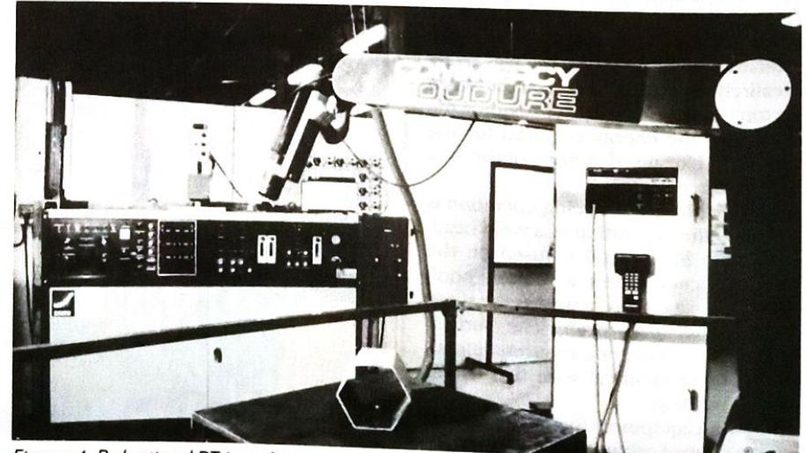

Figure 4. Robotised PTA surfacing equipment.

# **The Most Advanced Plasma Spray Process** in the World

Tungster Cathode

*Transfer Arc Plasma Spray Process

Inert Gas

Coppe

. High Velocity Molten Particles

Coating

Substrate

Electro-Plasma, Inc. has been at the forefront of plasma spray research and development for over fifteen years. As a result of this leading

Main Power Supply

Transfer Arc Power Supply

Plasma

substrate if the substrate is an electrical conductor. This requires a separate transfer arc power supply. In the LPPS®vacuum, the trans-

edge, EPI has developed a Low Pressure Plasma Spray that coats with higher densities and bonding strengthsfaster and more economically than ever before.

This Process of Low Pressure Plasma Sprav has been acknowledged as the most advanced plasma spray process in the world and has opened

up many new and exciting avenues in production plasma spraying.

**O**ne of the key features of the process is the transfer arc function. As the plasma stream is electrically conductive, a secondary or transfer arc can be generated from the gun to the

EPI is represented in Asia by: Nippon Steel Corporation Plant & Machinery Division 6-3 Otemachi, 2-Chome Chiyoda-Ku, Tokyo 100 Japan Tel. (03) 242-4111 FAX 03-246-0372 Telex J22291

In Western Europe by: Leybold-Heraeus GmbH, P.O.B. 1555 D-6450 Hanau 1 **Federal Republic of Germany** Tel. 06181/340 FAX 06181/34690 Telex 4152060 lh d

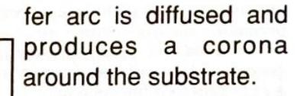

The polarity of the transfer arc can also be reversed. If the substrate is positive, the energy of the arc is concentrated on the substrate. This allows rapid preheating of the substrates and control of process temperatures for large parts.

If the substrate is negative, the energy of the arc removes or sputter cleans the substrate creating a metallurically clean surface. This unique and important phenomenon is covered by EPI patent 4328257 and many other foreign patents.



16842 MILLIKEN AVENUE **IRVINE, CA. 92714 U.S.A.** TEL. (714) 863-1834 FAX. (714) 863-6906

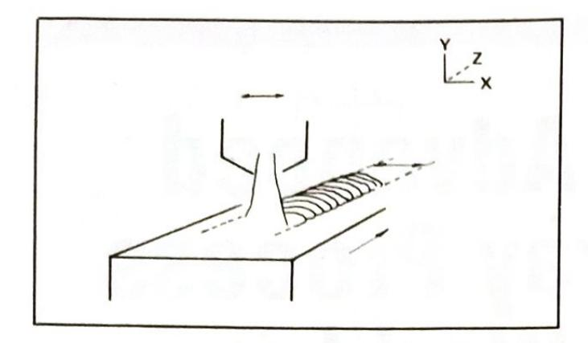

length and diameter are based on the knowledge acquired in the field of gas properties at high temperatures.

A gauge is used to check the adequacy of the electrode gap: it is inserted in the anode orifice and must be tangent to the cathode tip if the gap is adequate. In fact, small gap variations may lead to large arc voltage fluctuations and can result in a difficult striking of the arc as well as premature electrode wear.

The anode is made of electrolytic copper, and the cathode of tungsten with a 2 per cent thorium content.

The powdered materials are generally introduced at the nozzle outlet or directly into the nozzle bore using injectors located close to the plasma column. The finer the particles, the stronger the plasma resistance to their penetration, owing to its viscosity. But if the kinetic energy suplied to the particles on injection is sufficient, this resistance is broken down. On the other hand, if the injection velocity is too high, the particles just go through the plasma jet and are not melted. The particle size distribution of the materials used in PTA surfacing ranges from 40 to 160 microns. A finer size must be ruled out because it can initiate porosity in the deposit.

The deposited bead characteristics are on the one hand the width (w), the

thickness (t), the deposition efficiency (n) and the dilution (D) and hardness values. The parameters likely to alter these five values by changing the plasma power or temperature are: transferred arc current $(I_t)$ ; pilot arc current $(I_p)$ ; plasma gas flow rate $(Q_g)$ ; and torch height above workpiece (h). Note also that the displacement speed of the work $(W_s)$ , though not altering the plasma power, is instrumental in any variation in the bead characteristics.

As a matter of fact, the plasma power includes both that of the pilot arc and that of the transferred arc. Thus, the pilot arc power is dependent on $I_p$ and $Q_g$ and the transferred arc power varies with It, $Q_g$ , $Q_m$ (powder flow rate) and h.

It should be noted that the plasma gas flow rate $(Q_g)$ influences both arcs at the same time, yet the transferred arc is much more affected by the variations. The powder flow rate $(Q_g)$ does not affect the pilot arc insofar as the powder (when externally injected) meets the plasma column at the torch outlet.

Concerning the evolution of bead shapes and deposition efficiency, it is worth noting that: the torch height and the pilot arc current have no special effects on either the bead shape or the deposition efficiency when the transferred arc current increases; the bead be-

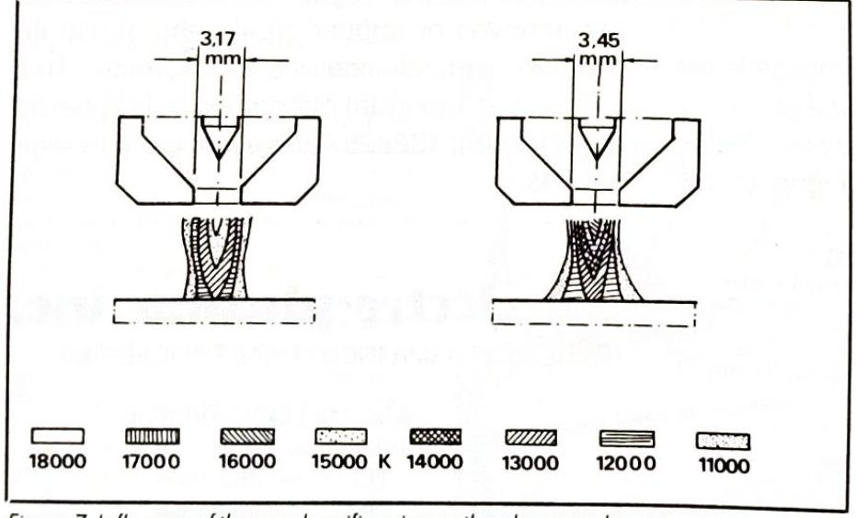

Figure 7. Influence of the nozzle orifice size on the plasma column temperature (after Evrard and Blanchet). I=180A, $Q_q = 4$ litres/min, gas=argon.

Figure 5 (left). Schematic of the respective movements of the plasma torch and the workpiece. The torch moves side to side as the workpiece travels longitudinally.

Figure 6 (above). At left, multilayer deposit. At right, single layer deposit.

comes wider and thinner and the deposition efficiency increases; and an increase in the powder flow rate essentially means a thicker bead and a drop in the deposition efficiency.

Hardness and dilution are important properties in overlays. The PTA process is particularly interesting for the low dilution percentage it produces. The bead shapes for various values of It and $Q_m$ permit estimation of the dilution by examining the fusion zone.

It should be noted that for lower transferred arc currents, the dilution value is very low while the hardness value is at its greatest. But on the other hand, when It increases, the substrate

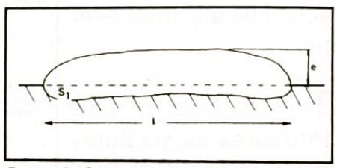

Figure 8. Cross section of a bead.

fusion increases too and the hardness value decreases. This phenomenon is more particularly evidenced in the case of cobalt-base or nickel-base alloys deposited on steels. The change in the filler material element percentages by admixture of the substrate in the deposited bead lead to this decrease. Yet it should be added that the surfacing of highcarbon metals may produce the reverse process, namely the hardening of the diluted zone caused by carbide precipitation.

It should also be noted that when $I_t$ is constant, the effects are reversed according to the powder flow rate. Moreover, the work displacement speed acts in the same direction, with the exception of the bead thickness.

To sum up, four parameters affect the shape and quality of the deposits: transferred arc current $(I_t)$ ; powder flow rate $(Q_m)$ ; work displacement speed $(W_s)$ ; and plasma gas flow rate $(Q_g)$ . As a final point, the transferred arc power (Pt) varies in inverse ratio to the powder flow rate. These parameters can be expressed as $(P_t/Q_m)$ called energy per weight) and

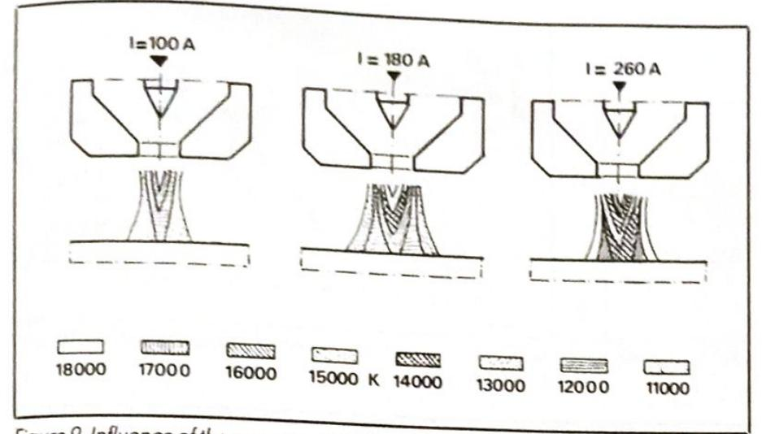

Figure 9. Influence of the amperage on the plasma column temperature (after Evrard and Blanchet). Anode $\emptyset$ =3.45mm, gas=argon, $Q_g$ =4 litre/min.

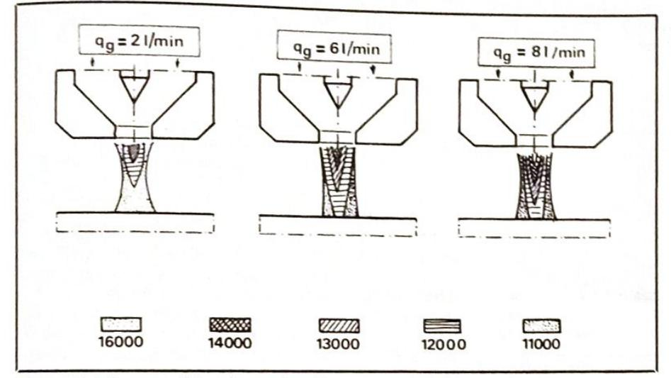

Figure 10. Influence of the plasma fast flow rate on the plasma column temperature (after Evrard and Blanchet). Anode Ø=3.45mm, gas=argon, I=100A.

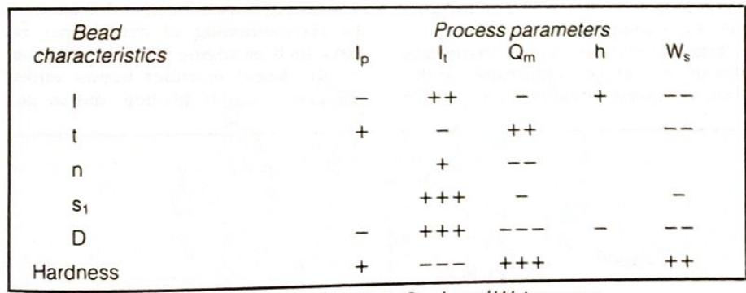

Evolution of bead characteristics when $I_p$ , $I_t$ , $Q_m$ , $h$ and $W_s$ increase.

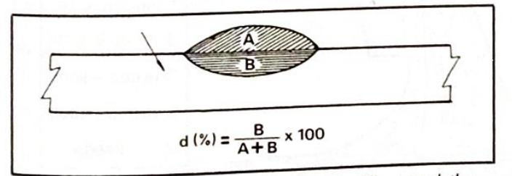

Figure 11 (above). Definition of dilution. A=filler metal; the arrow shows the substrate.

Figure 12 (right). Variations in bead section as a function of amperage and transferred arc power $|Q_m = 43g/min$ .

indicated in kl/g. When Pr/Qm increases, the hardness value decreases and dilution becomes greater.

PTA surfacing consists in depositing one or more metal or alloy layers on a metal workpiece. The powders are atomised using a gas, and their oxygen content must be lower than 200ppm.

There may be two possible reasons for the operation. First is the restoration of a worn or corroded piece so as to put it back into its original form. When the filler metal is judiciously seected, it is possible to provide the restored piece at the same time with a better wear or corrosion resistance than initially. Second is the strengthening on a new part of those zones requiring particular hardness and corrosion properties.

The plasma transferred arc hardfacing process is capable of depositing powdered materials on steels, cast irons, nickel-base metals and other metals. The filler metals used are corrosion- and high-temperature resisting hard alloys, mainly cobalt-, nickel- and iron-base alloys, with possible carbide or boride additions in the pool.

A comparison with another surfacing method, such as the GTA process, which in principle bears a resemblance to the PTA process, clearly shows the advantages of the latter. The advantages of the PTA process over the GTA process are:

* The performance of a 30A operating PTA is equivalent to that of a 100A operating GTA
* In the PTA process, the shorter weld time is associated with a lower amperage, whence a lower operating cost
* The coating properties are not much affected by torch height variations
* The cathode is, by its very location, protected against any kind of contamination and the service life of the electrodes is much longer
* The thinner workpieces are more easily surfaced and the execution of fine beads is easier
* The quantity of rejects is quite small, and
* · Since the plasma arc is very well guided, there is a sharp localisation of the heat release, the width and depth of the heat affected zone are smaller and the dilution quite limited.

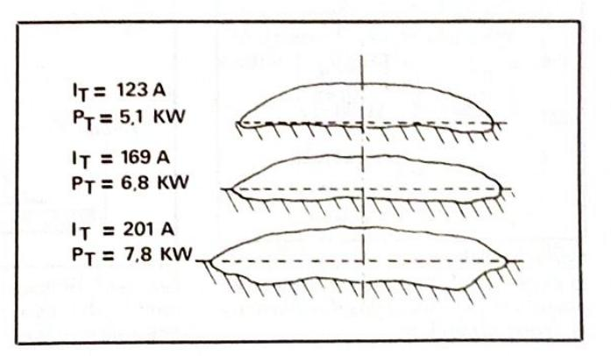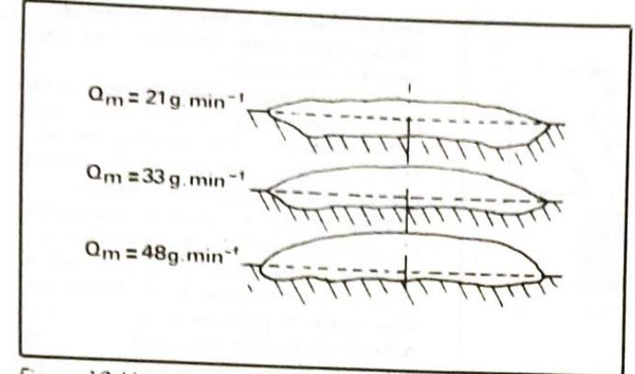

Figure 13. Variations in bead section as a function of powder flow rates.

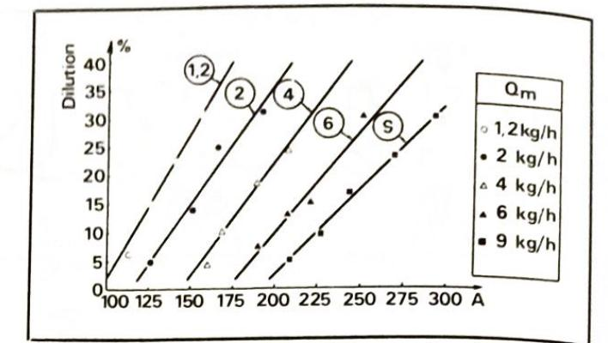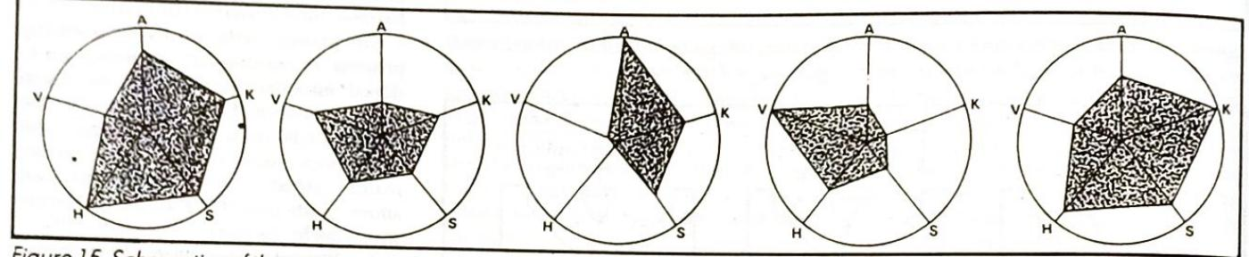

Figure 15. Schematics of the main properties of coatings. V=wear resistance; A=friction resistance; K=corrosion resistance; H=refractoriness; S=impact strength. From left: cobalt-base deposit; iron base deposit; copper-base deposit; carbide deposit in a metallic matrix; nickel-base deposit.

A precise example will illustrate the comparison between these two processes, namely surfacing using Stillite grade F or Renault internal combustion engine valves (Table 1).

### Dilution:

GTA: 8 to 13 per cent PTA: 2 to 3 per cent Deposited material per pass: GTA: 7.5g $PTA: 4.5g$

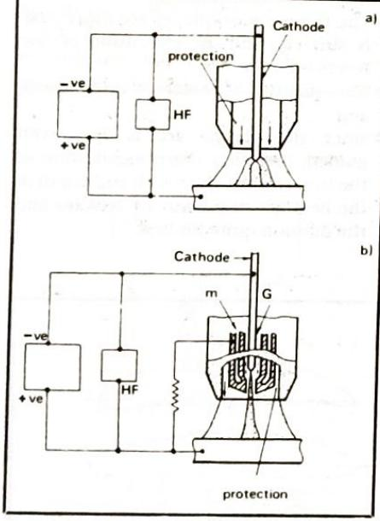

Figure 16. Schematics of (a) a GTA torch and (b) a PTA torch. Protection is provided by shielding gas, G=plasma, $m =$ coolant medium.

**GTA**

**PTA**

$20^\circ$

440

420

$725^\circ$

235

275

800°

140

205

Table 1. Hot hardness (HV).

Since 700 000 valves are hardfaced every year, the saving on material amounts to $700,000x3g=2.1$ metric tons per year, costing FF270 000 a year.

Emphasis must also be given to the fact that the PTA process can be used in the form of microplasma for surfacing or

welding operations on pieces which allow no distortion at all. Amperage values ranging from 1 to 15A can be used without any risk or arc instability.

The fields of application of the process are quite numerous, and include mechanical engineering, shipbuilding, the automotive industry, aeronautical engineering, and chemical and nuclear engineering.

Surfacing is used for the fabrication or the reconditioning of many types of parts, such as: engine valves (hardfacing of valve faces), extruder screws, valves and gates, turbine blading, and so on.

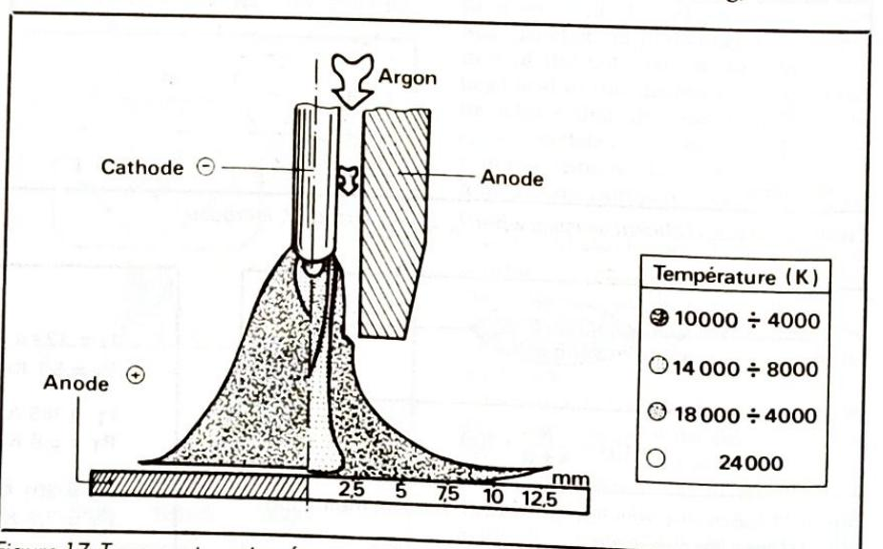

Figure 17. Temperatures in a free arc (GTA torch) and in a constricted arc (PTA torch). GTA : flow rate 18 litres/min; V=14.5V; I=200A. PTA : diameter=4.8mm; flow rate=18 litres/min.; V=29V; I=200A

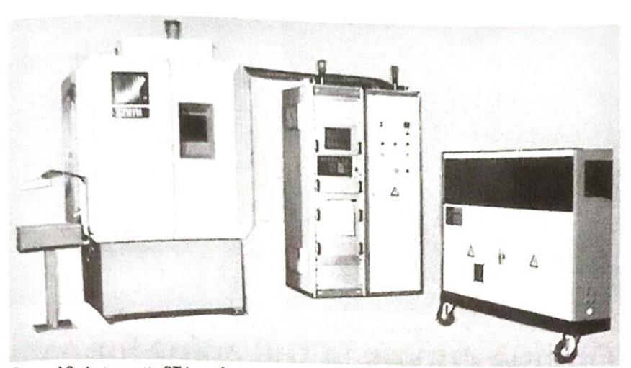

Figure 18. Automatic PTA surfacing equipment for internal combustion engine valves.

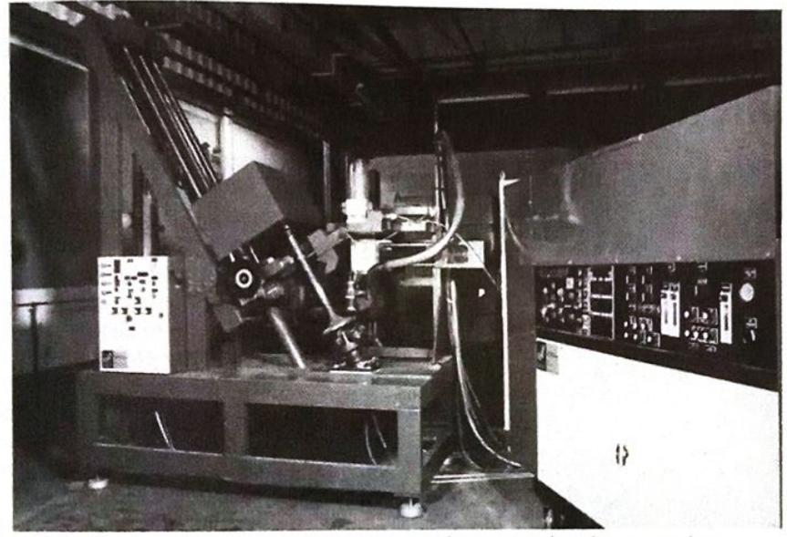

Figure 19. Automatic PTA surfacing equipment for marine diesel engine valves.

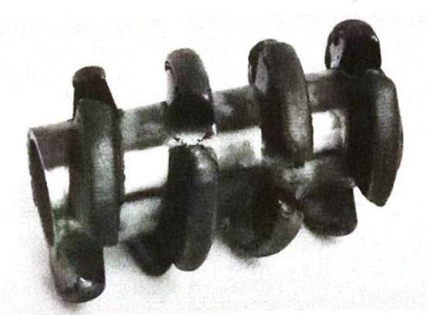

Figure 20. PTA surfacing of extruder screw threads.

With engine valves, the automation of the PTA process greatly increases productivity since for 34mm Ø valve heads, four surfacing operations can be carried out every minute.

Finally, if the filler material is generally in the form of powder then solid filler wires, flux-cored wires or filler rods can also be used, and the material processing comes cheaper with wires than with powder. Other feasible methods consist of using hot wires to increase the surfacing speed, or in using the pulsed wire technique when very thin overlays are required. Filler wires can also be used together wth powder to apply composite coatings.

Although the foregoing deals only with the surfacing applications of the PTA process, it is worth mentioning that the transfered arc technique is also used in heat treatments, owing to the localisation of the produced heat. The PTA treatment of a cast iron camshaft can illustrate this point.

The plasma process has found many applications in welding and in precision surfacing but, thanks to its wide operating range from microplasma up to currents of 100A or more, it can be used for welding or surfacing operations previously carried out by other processes. $\square$

#### References

Dehaut P and Rochette P, Etude paramétrique du procédé de rechargement par plasma à arc transféré, Note téchnique, CENG, Section génie des matériaux.

Kishor M and Vidlui A (1984) Overvlew of hardfacing materials and processes, Metal powder coatings and hardfacing, International Powder Metallurgy Conference 17-22 June, Toronto, p1-20. Richardson S (1984) New developments in plasma transferred arc bardfacting. Metal powder coatings and hardfacing, International Powder Metallurgy Conference, 17-22 June, Toronto, p21-30 Marconi M, Technologie del plasma, I reporti duri con polveri saldate mediante procediment of PTA, Transwelditalia

Lucas W (1978) TIG and plasma welding - the present state of the art, TIG and plasma welding. The Welding Institute p2-7

NorrishJ (1978) Recent applications in plasma welding. TIG and plasma welding. The Welding Institute, p32-36.

Evrard M and Blanchet B (1970) Etude des plasmas d'arc du point de vue du soudage, Soudage et Téchniques Connexes, 7/8, p261-298.

This article first appeared in Automotive Technology International 1988.

M Ducos is director of research, and S Cler a research and development engineer, for SNMI.

Epoxy Curing T iso:160.0 °C

160

arison

30

50

160

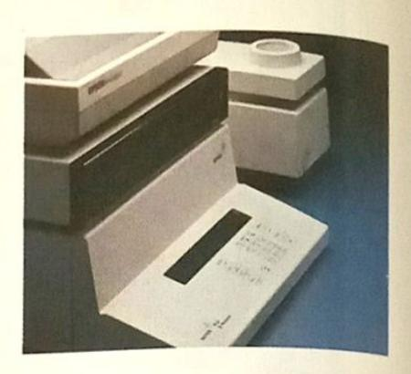

### On-line curves in full color for easier evaluation of multiple transitions -**METTLER TA72 GraphWare displays** thermal analysis data as it develops.

...................................... 150 C 130 10. F3 F4 F5 F F2 Param Zoom Eval Mu' aph Data

The new METTLER TA72 GraphWare software supports the processing of thermoanalytical measured values and curves as determined by the METTLER TA4000 System and prepared and transferred by the TC10A TA processor. The broad application area of this evaluation software covers not only the checking of materials and their development but also the investigation of thermal effects of new compounds. In all these investigations, the TA72 GraphWare offers the possibility to compare and simultaneously process several thermoanalytical curves.

**Mettler Instrumente AG**

CH-8606 Greifensee, Switzerland Tel. 01-944 2211 Telefax 01-9443010 **Telex 826150**

**METTLER**