Project Report submitted on 07-01-2026

Project title – Tic Tac Toe
A Partial fulfilment of the requirement for the Award of the Degree of
BACHELOR OF TECHNOLOGY

IN

COMPUTER SCIENCE AND ENGINEERING

(ARTIFICIAL INTELLIGENCE & MACHINE LEARNING)

SUBMITTED
By

Rehan Alam – 25671A66B9 (CSM)
Sneha Sunerkar – 25671A66C8 (CSM)
Darakshan Tabarak – 25671A0203 (EEE)

Under the esteemed guidance of
Ms. Debapriya Chakraborty

ASSISTANT PROFESSOR

DEPARTMENT OF COMPUTER SCIENCE AND
ENGINEERING

J.B. INSTITUTE OF ENGINEERING & TECHNOLOGY

UGC AUTONOMOUS
(Accredited by NAAC & NBA, Approved by AICTE & Permanently affiliated by JNTUH)

Yenkapally, Moinabad mandal, R.R. Dist-75 (TG)
2025 – 2026

J.B. INSTITUTE OF ENGINEERING & TECHNOLOGY

UGC AUTONOMOUS
(Accredited by NAAC & NBA, Approved by AICTE & Permanently affiliated by JNTUH) Yenkapally, Moinabad mandal, R.R. Dist-75 (TG)

DEPARTMENT OF COMPUTER SCIENCE AND ENGINEERING



CERTIFICATE

This is to certify that the Project report entitled “Tic Tac Toe” submitted to the Department of Computer Science and Engineering, J.B Institute of Engineering & Technology, in accordance with Jawaharlal Nehru Technological University regulations as partial fulfilment required for successful completion of Bachelor of Technology is a record of bonafide work carried out during the academic year 2025-2026 by,

Rehan Alam – 25671A66B9
Sneha Sunerkar – 25671A66C8
Darakshan Tabarak – 25671A0203

Internal Guide Head of the Department
Ms. Debapriya Dr. G SREENIVASULU
ASSISTANT PROFESSOR ASSOCIATE PROFESSOR

J.B. INSTITUTE OF ENGINEERING & TECHNOLOGY

UGC AUTONOMOUS
(Accredited by NAAC & NBA, Approved by AICTE & Permanently affiliated by JNTUH) Yenkapally, Moinabad mandal, R.R. Dist-75 (TG)

DEPARTMENT OF COMPUTER SCIENCE AND ENGINEERING


DECLARATION

We hereby declare that the Project report entitled “Tic Tac Toe” carried out under the guidance of , Ms. Debapriya Chakraborty, Assistant Professor is submitted in partial fulfilment of the requirements for the award of the degree of Bachelor of Technology in Computer Science and Engineering. This is a record of Bonafide work carried out by us and the results embodied in this Project report have not been reproduced or copied from any source. The results embodied in this Project report have not been submitted to any other university or institute for the award of any other degree or diploma.

Date: 07-01-2026

By

Rehan Alam – 25671A66B9
Sneha Sunerkar – 25671A66C8
Darakshan Tabarak – 25671A0203

TABLE OF CONTENTS
- Introduction
- Rules to be Followed
- Objectives of the Project
- System Requirements
- System Design
- Module Description
- Implementation Details
- Advantages and Limitations
- Applications
- Conclusion
- Bibliography
- Source code
- Sample output

INTRODUCTION
  - This mini project implements the classic Tic Tac Toe game in C as a practical application of Problem Solving and Programming Skills (PPS) concepts, where two players compete on a 3×3 grid to align three marks consecutively.
  - To develop an interactive console-based game demonstrating core programming fundamentals including arrays, loops, conditionals, functions, and logical thinking while creating an engaging two-player experience. The program utilizes 2D arrays for board representation, modular functions for game operations (board display, move validation, win checking), and structured logic to manage game flow from start to finish.
  - Reinforces essential PPS concepts such as problem decomposition, algorithm design, control structures, data handling, and debugging while solving a real-world problem through systematic programming approaches. It is a beginner-friendly project spanning 150-250 lines of code that balances simplicity with functionality, making it ideal for demonstrating first-year programming proficiency and logical problem-solving abilities.

RULES TO BE FOLLOWED
  - The "No Cheating" Rule: The program checks if a spot is already taken. If you try to play on an occupied square, it tells you to try again.
  - The "Switch" Rule: It keeps track of whose turn it is. If "X" just went, it automatically prepares "O" for the next move.
  - The "Scanner" Rule: It scans the board horizontally, vertically, and diagonally. If it finds three identical symbols in a line, the game stops.

OBJECTIVES OF THE PROJECT
- The main objectives of developing the Tic Tac Toe Program using C language are as follows:
To design and develop a fully functional two-player Tic Tac Toe game in C that demonstrates practical application of Problem Solving and Programming Skills through structured coding and logical implementation.
- To implement 2D arrays for game board representation and efficient data management.
- To develop algorithms for move validation, win detection, and draw condition identification.
- To create modular functions demonstrating structured programming and code reusability.
- To apply conditional statements and loops for game flow control and turn management.
- To design a user-friendly console interface with clear board display and input prompt.

SYSTEM REQUIREMENTS
Hardware Requirements:
  - Processor: Intel i3 or above
  - RAM: Minimum 2 GB
  - Hard Disk: 10 GB free space Software Requirements :
  - Operating System : Windows / Linux
  - Compiler : GCC
  - Editor: VS Code
  - Language Used : C Programming Language

SYSTEM DESIGN

- System Architecture : The game follows a modular design with distinct components including board management, player interaction, game logic, and result evaluation, ensuring clear separation of concerns and maintainable code structure.
- Data Structures : A 3×3 character array serves as the primary data structure to represent the game board, storing player symbols (X, O) and empty cell indicators, with additional variables tracking current player and move count.
- Board Initialization Module : Initializes the game board with empty cells (typically numbered 1-9 or marked with spaces), sets the starting player, and resets all game state variables to prepare for a new game session.
- Display Module : Renders the current board state in a formatted grid layout on the console, clearly showing cell positions, player marks, and visual separators for enhanced readability and user experience.
- Input Handler Module : Captures player moves through console input, converts user entries into array indices, and passes validated inputs to the game logic for processing while maintaining smooth interaction flow.
- Move Validation Module: Verifies that player inputs correspond to valid cell positions within bounds (1-9 or 0-8 indices), checks if the selected cell is unoccupied, and returns appropriate success or error status.
- Board Update Module: Marks the selected cell with the current player's symbol after successful validation, updates the game board array, and increments the move counter to track game progression.
- Win Detection Module: Implements checking algorithms that examine all eight possible winning combinations (three rows, three columns, two diagonals) by comparing cell values to identify if any player has achieved three consecutive marks.
- Turn Management System: Alternates between players after each valid move, updates the current player indicator (X to O or vice versa), and maintains consistent turn order throughout the game session.
- Game Loop Controller: Orchestrates the overall game flow by repeatedly executing display, input, validation, update, and checking cycles until a win or draw condition is detected, then terminates gracefully.
- Result Announcement Module: Displays the final game outcome by announcing the winning player with their symbol, declaring a draw if applicable, and showing the final board state for review.
- Error Handling System: Manages invalid inputs such as occupied cells, out-of-range positions, or non-numeric entries by displaying informative error messages and prompting users to re-enter their moves without crashing.
- Control Flow Logic: Utilizes nested loops for continuous gameplay, conditional statements for decision branching, and function calls to maintain organized execution sequence from game start to completion.
- Memory Management: Employs stack-allocated arrays and local variables for efficient memory usage, avoiding dynamic allocation complexities while maintaining optimal performance for the small-scale game application.

MODULE DESCRIPTION
- Handles initialization of the 3×3 game board with empty cells, maintains the current board state throughout gameplay, and provides functions to reset the board for new game sessions.
- Implements the core game mechanics including turn alternation between players, board updates after valid moves, win detection by checking all eight possible winning combinations (rows, columns, diagonals), and draw condition identification when the board is full.
- Captures player move inputs from the console, validates entries to ensure they correspond to valid unoccupied cells within the grid, and handles error cases with appropriate messages for invalid or occupied positions.
- Evaluates game outcomes after each move, announces the winner when a player achieves three consecutive marks, declares a draw when applicable, and displays the final board state with game-over messages.
- Orchestrates the overall game flow by coordinating all modules, managing the game loop from start to finish, ensuring proper execution sequence, and terminating the program gracefully upon game completion.

IMPLEMENTATION DETAILS :

  - Programming Language and Environment : Implemented in C programming language using standard libraries (stdio.h, stdlib.h), compiled with GCC or any C compiler, and executed in a console/terminal environment for cross-platform compatibility.
  - Data Structure Implementation : Game board represented as a 3×3 character array (char board[3][3]), initialized with numeric characters ('1'-'9') or spaces for empty cells, with integer variables tracking current player turn and total move count.
  - Core Functions : Program structured with modular functions including initializeBoard() for setup, displayBoard() for rendering, getPlayerMove() for input, isValidMove() for validation, updateBoard() for marking cells, checkWin() for victory detection, and checkDraw() for tie conditions.
  - Win Detection Algorithm : Uses nested loops or direct indexing to check all winning patterns—three horizontal rows (board[i][0-2]), three vertical columns (board[0-2][j]), and two diagonals (board to board, board to board)—comparing if three consecutive cells contain the same non-empty symbol.
  - Game Flow Control: Main game loop (while loop) continues until win or draw condition is met, executing sequence of display board → get input → validate move → update board → check outcome → switch player, with appropriate break statements terminating the loop upon game completion.

ADVANTAGES AND LIMITATIONS
Advantages:
  - Helps understand core PPS concepts like variables, arrays, loops, conditionals, and functions through a simple game.
  - Strengthens logical and algorithmic thinking by designing win-checking, turn-handling, and input-validation logic.
  - Encourages modular programming by dividing the program into functions such as display, validation, and result checking.
  - Has a small, manageable codebase that is easy to implement, test, and debug within mini project timelines.

Limitations:
  - Game logic is simple and may not adequately demonstrate advanced PPS or data structure concepts.
  - The project is primarily educational and entertainment-based with limited real-world application.
  - Uses a fixed 3×3 grid, making scalability to larger boards or variants non-trivial.
  - Often excludes computer-AI logic, so it may not involve advanced algorithms like minimax.
  - Typically relies on a console-based interface, offering little exposure to graphical or event-driven programming.
  - Small input size and low computational demand mean it does not address performance or optimization challenges.

APPLICATIONS
  - Used as a teaching tool to practically demonstrate PPS concepts like arrays, loops, conditionals, and functions.
  - Helps students practice algorithm design through game flow, win detection, and input validation logic.
  - Serves as a foundation for learning game development and extending to larger boards or complex games.
  - Acts as a base project to introduce basic AI concepts like computer opponents or minimax algorithms.

CONCLUSION

The project effectively implements core game logic with move validation, win detection across all combinations, draw handling, and turn management through systematic algorithmic approaches.
The implementation showcases clean code organization with proper function modularization, error handling, and user-friendly console interface design. This project serves as an excellent foundation for understanding game development principles and can be extended with features like AI opponents, score tracking, or graphical interfaces. Overall, the Tic Tac Toe mini project achieves its educational objectives by providing hands-on experience with structured programming while creating a functional, interactive application.

BIBLIOGRAPHY
- CodewithFaraz.com
- LLM’s
- Online C Programming Documentation

C SOURCE CODE

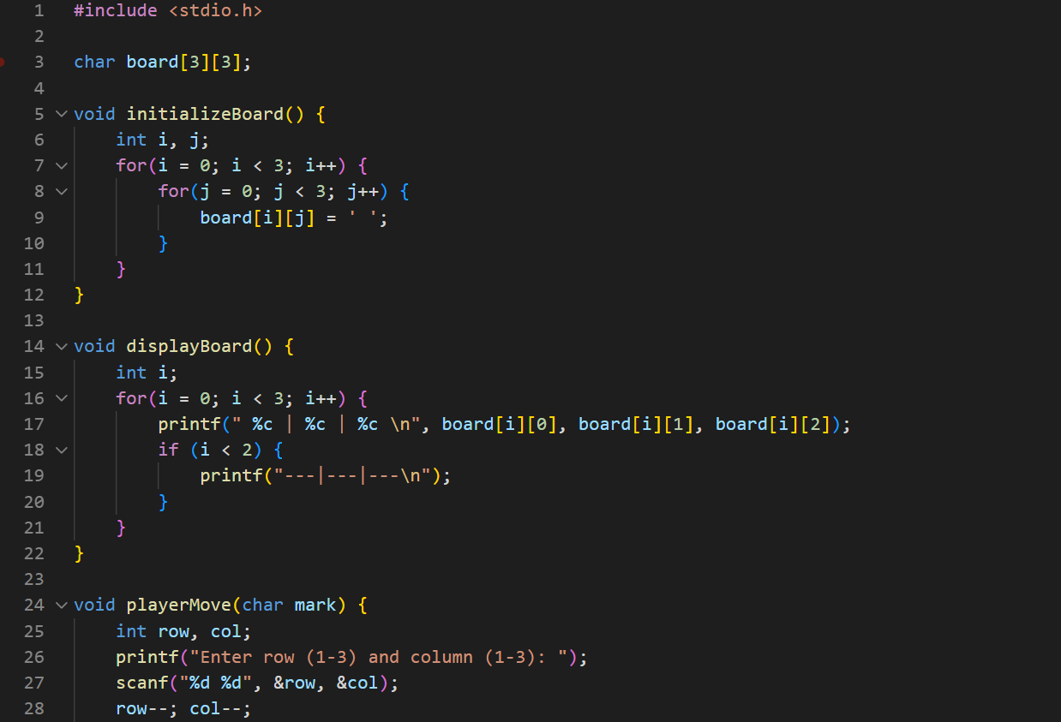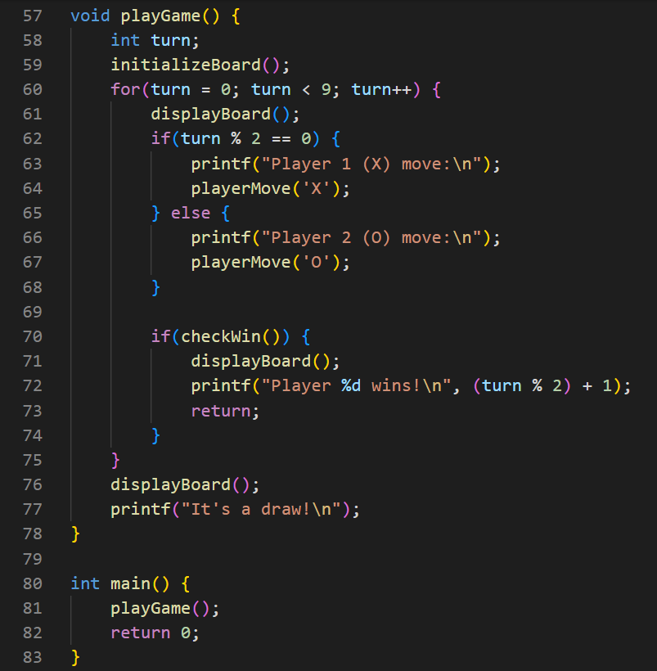

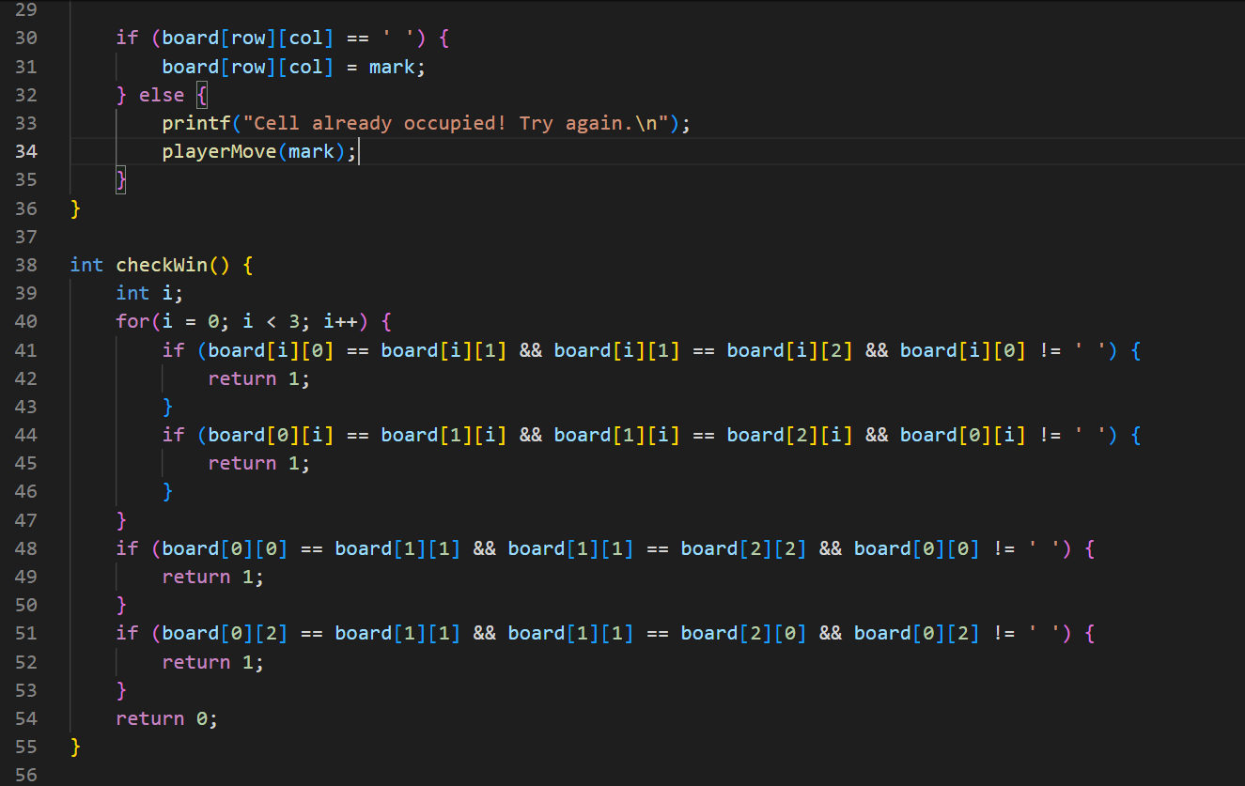

SAMPLE OUTPUT (SCREENSHOT)

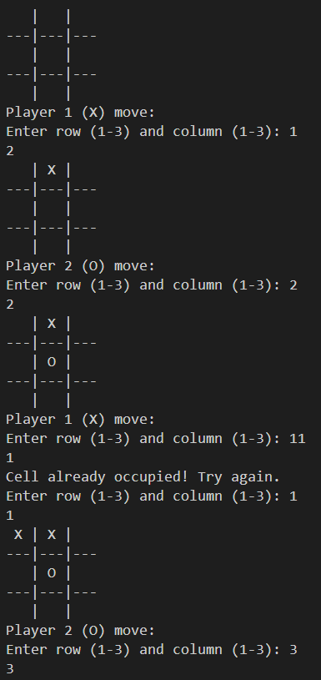

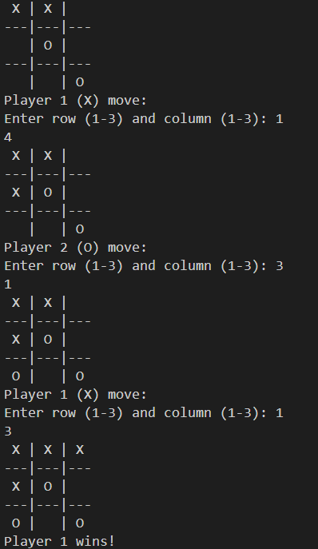

xv

