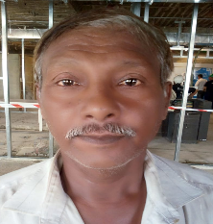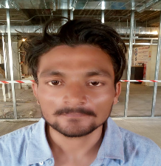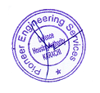

**Company Identity Card**

**Name: Rauf Ahmed**

**Site: Unilever Avari Tower**

**Des: Super Visor**

**CNIC: 44201-5921875-7**

**Company Identity Card**

**Name: Shoaib Khadim**

**Site: Unilever Avari Tower**

**Des: Helper**

**CNIC: 44203-9375842-5**

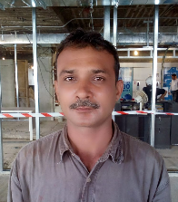

**Company Identity Card**

**Name: Nazim Hussain**

**Site: Unilever Avari Tower**

**Des: Super Visor**

**CNIC: 44203-7801314-3**

**Company Identity Card**

**Name: Nadeem Abbas**

**Site: Unilever Avari Tower**

**Des: Welder**

**CNIC: 44204-8233104-1**



**Company Identity Card**

**Name:**

**Site:**

**Des:**

**CNIC:**

**Company Identity Card**

**Name:**

**Site:**

**Des:**

**CNIC:**