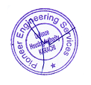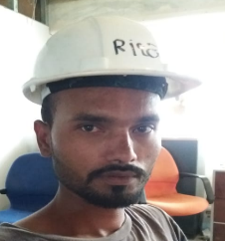

**Company Identity Card**

**Name: Shariq Baig**

**Site: Unilever Avari Tower**

**Des: Helper**

**Company Identity Card**

**Name: Faizan Baig**

**Site: Unilever Avari Tower**

**Des: Fabricator**

**CNIC: 42101-7641374-3**



**Company Identity Card**

**Name: Umair**

**Site: Unilever Avari Tower**

**Des: Helper**

**CNIC: 42101-8109593-9**

**Company Identity Card**

**Name: Muzammil Baig**

**Site: Unilever Avari Tower**

**Des: Fabricator**

**CNIC: 42101-7758404-3**

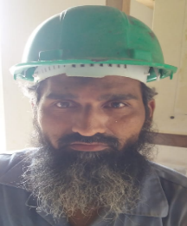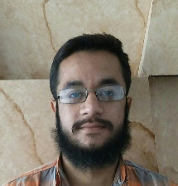

**Company Identity Card**

**Name: Munawwar uz Zaman**

**Site: Unilever Avari Tower**

**Des: Fabricator**

**CNIC: 421011-665245-7**

**Company Identity Card**

**Name: Umar Zahid**

**Site: Fakhri Trade Center**

**Des: AC Technician**

**CNIC: 42201-2674413-9**