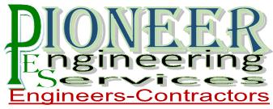

Air Conditioning, Electrical, Plumbing, Mechanical Engineers & Contractors

2-C Sunset Lane 1st floor

Phase II EXT D.H.A Karachi