PES/EBM/003-003/01/15.

January 5, 2015.

M/S English Biscuit Manufacturing,
Plot 1–4, Sector 23, Korangi Industrial Area,
Karachi,

Att: Mr. Shehzad.

Sub: Names of the Staff at EBM, K.I.A.

Dear Sir,

S.# Name CNIC # Designation.

- Mr. Imran 42201-0261299-9 Site Supervisor.
- Mr. Abid 34603-6182803-9 Welder.
- Mr. Khalid. In process Plumber.
- Mr. Kamran. 42201-2544219-5 Electrician.
- Mr. Mehmood 42201-0510875-1 Helper.
- Mr. M. Ali 42201-1769895-1 Fabricator.
- Mr. Abbas 42401-5545438-1 Plumber.
- Mr. Azeem. 42501-4190508-1
- Mr. Kamran. 42201-3148833-7
- Mr. Faizan. 42101-7641374-3

Thanking you,

Sincerely yours,
For PIONEER ENGINEERING SERVICES.
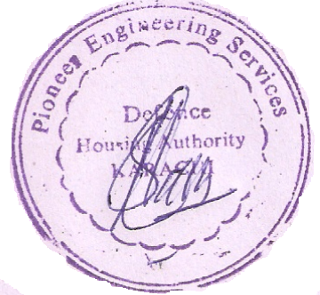

M. HABIB-UR-REHMAN.

