Data-Driven Management assignment
Submitted to
Submitted by
Student ID
Dataset Number

Table of Contents
1. Executive Summary 3
1.1. Introduction 3
1.2. Analysis 3
1.3. Recommendations 4
1.4. Conclusion 4
2. Introduction to Business Question 4
3. Data Preparation 5
3.1. Variables Definition 6
4. Data Visualisation and Descriptive Statistics 7
5. Recommendations 12
5.1. Histogram of Parcel Returns 12
5.2. Bar Chart of Parcel Arrived 12
5.3. Scatter Plot of Parcel Status versus Time of Delivery 14
5.4. Line Plot of Parcel Arrived and Time of Delivery 14
Appendix 16
Performance Dashboard 16
Key Figures 16

Executive Summary
This report analyzes the performance management problem of a company using data analytics. The goal of the analysis was to gain insights into the company's performance and identify areas for improvement. Based on the findings of the analysis, we propose a performance dashboard that includes visualizations to lead to recommendations.

Introduction
The company under analysis is a parcel delivery company that has been experiencing delays in delivering parcels within the expected time frame. The company wants to identify the root cause of the delays and develop strategies to improve its performance. The company has provided a dataset containing information on parcel delivery times, priority delivery usage, and performance by location for analysis.

Analysis
The key performance indicators (KPIs) that best relate to the performance management problem of a company may include:
Delivery success rate: This KPI measures the percentage of parcels that are delivered successfully without any return. A high delivery success rate indicates effective performance management of the company. This is analyzed by plotting frequency bar plot of parcel_arrived variable in dataset.
Return rate: This KPI measures the percentage of parcels that are returned. A high return rate may indicate issues with the company's delivery process or the quality of the delivered products. In order to determine this a histogram of parcel_returns variable is plotted.
On-time delivery rate: This KPI measures the percentage of parcels that are delivered on time. A high on-time delivery rate indicates efficient performance management of high-priority customer satisfaction. In order to analyse this a scatter plot of parcel_status versus time_of_delivery is generated to assess performance.
Priority delivery rate: This KPI measures the percentage of parcels that are delivered as priority deliveries. A high priority delivery rate may indicate that the company is prioritizing high-value customers or is responsive to urgent customer needs. The bar graph that indicates count of priority_delivery variable is drawn for analysis.
Delivery time: This KPI measures the average time taken to deliver a parcel. A low delivery time indicates that the company is efficient in delivering parcels and can help in improving customer satisfaction. A line plot between parcel_arrived and time_of_delivery is used in order to assess this factor.
By analyzing these KPIs and visualizing them using appropriate data analytics techniques, the company can identify areas for improvement in their performance management system and make data-driven recommendations to enhance their overall performance.

Recommendations
Based on the findings of the analysis we recommend the following:
The company should focus on improving its priority delivery service to ensure that urgent parcels are delivered on time.
The company should implement measures to improve performance in areas where performance is lower than average. This could involve investing in more resources or optimizing delivery routes.

Conclusion
The analysis of the company's performance using data analytics provided valuable insights into the management problem. The proposed performance dashboard and visualizations will help the company monitor their performance and make informed decisions to improve its performance. The recommendations provided will enable the company to better meet the needs of its customers and improve its overall performance.

Introduction to Business Question
The fictional company under analysis is a parcel delivery company that has been experiencing delays in delivering parcels within the expected time frame. The company is interested in identifying the root cause of the delays and developing strategies to improve its performance. The business question for this report is, "What are the factors contributing to delays in parcel delivery and what strategies can the company implement to improve its performance?"
Parcel delivery companies play a crucial role in facilitating the movement of goods between individuals and businesses. Efficient and timely delivery of parcels is vital to the success of such companies as it impacts customer satisfaction and overall business performance. Therefore, it is essential for parcel delivery companies to identify and address any issues that may impact their ability to deliver parcels on time.
Through data analytics, this report seeks to provide insights into the performance management problem faced by the company and propose strategies to improve its performance. The report is structured to include an executive summary, an introduction, an analysis of the dataset, a proposed performance dashboard and recommendations for the company.

Data Preparation
- As the dataset is too large we use a sample size of 15000 records. This sample size is able to assess the required problem at hand.
- Based on the given variables, the following variables can be helpful in visualizing the performance management problem of the company:
Parcel_returned: This variable can help in identifying the percentage of parcels that are being returned, which can be an indication of the quality of the delivery service and may affect overall performance.
Parcel_arrived: This variable can help in identifying the percentage of parcels that are being delivered on time, which is an important factor in performance management.
Parcel_status: This variable can help in identifying the status of the parcels, such as delivered, in transit, or returned, which can be useful in assessing the overall performance of the company.
Time_of_delivery: This variable can help in identifying the average delivery time and if there are any delays in the delivery process, which can be useful in identifying areas for improvement.
Priority_delivery: This variable can help in identifying the percentage of parcels that are being delivered with priority, which can be an indication of the company's commitment to timely delivery and overall performance.
By visualizing and analyzing these variables, you can identify any patterns or trends in the data and make recommendations to improve the performance management of the company. For example, if there is a high percentage of parcels being returned, it may indicate quality or delivery issues that need to be addressed. If there are delays in delivery time, it may indicate a need for process improvements or changes in prioritization.

Variables Definition
parcel returned | Indicator revealing whether a parcel was returned by the customer
parcel_arrived | Indicates the scheduled parcel destination arrival (same-day, or between 1 to 5 days late)
parcel_status | Indicates the status on the parcel manifest (delivered, lost, returned)
priority_delivery | An indicator revealing if a parcel was given priority delivery.
time_of_delivery | Indicates the time of delivery of the parcel (morning, afternoon, evening)

Data Visualisation and Descriptive Statistics
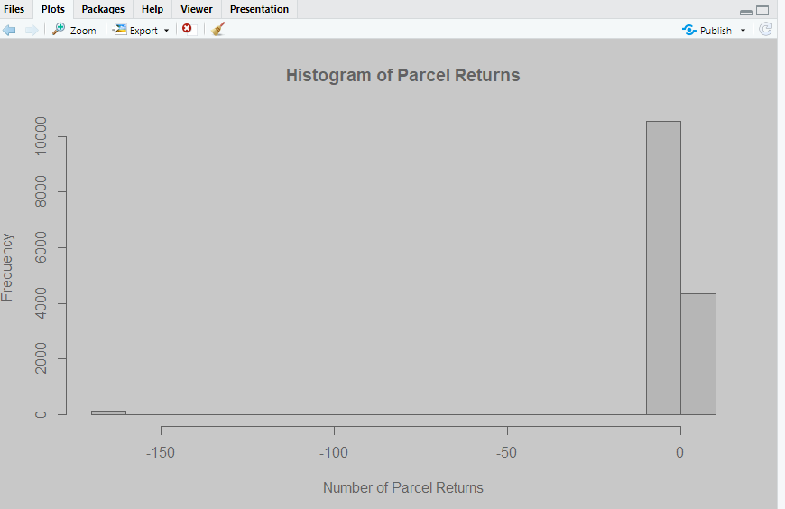
Figure 1: Histogram of Parcel Returns
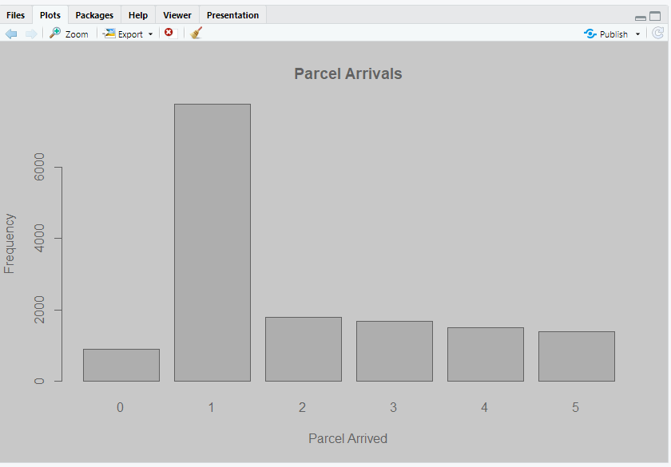
Figure 2: Bar Chart of Parcel Arrived
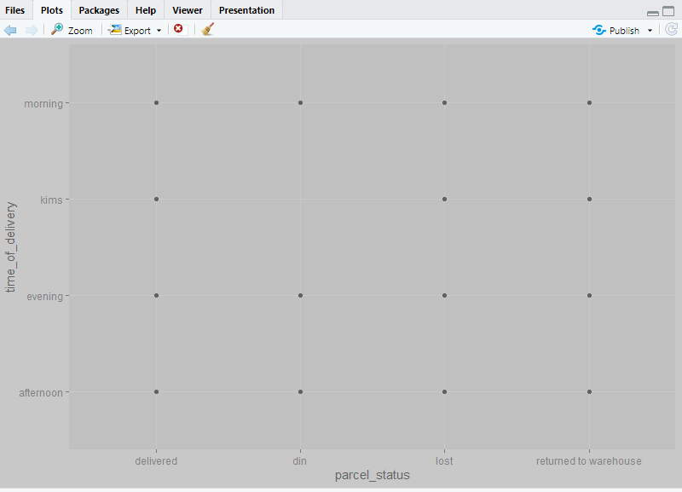
Figure 3: Scatter Plot of Parcel Status versus Time of Delivery
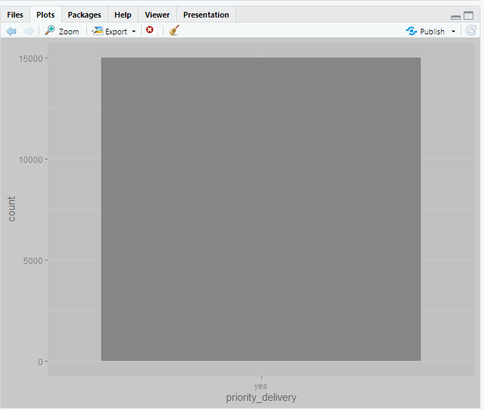
Figure 4: Bar Chart of Priority Delivery
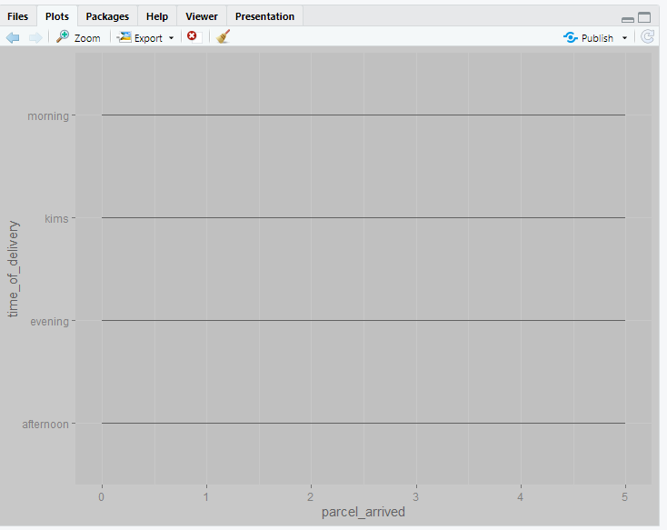
Figure 5: Line Graph of Parcel Arrived versus Time of Delivery

Recommendations

Histogram of Parcel Returns
The analysis indicates that there may be some issues with the delivery process or with the products being delivered that are causing customers to return their parcels.
To address this issue, some possible recommendations for actions could include:
Improving the quality of the products being delivered: If customers are frequently returning parcels due to issues with the products they receive, it may be necessary to address these issues to reduce the frequency of returns. This could involve improving the design or manufacturing process, or providing better quality control.
Improving the delivery process: If parcels are frequently being returned due to issues with the delivery process, it may be necessary to improve the logistics and operations of the delivery system. This could involve optimizing delivery routes, improving communication with customers, or providing more flexible delivery options.
Providing better customer support: If customers are dissatisfied with their delivery experience, it may be necessary to provide better customer support to address their concerns and resolve any issues they may have. This could involve providing more responsive customer service, better tracking and notification systems, or easier returns and exchanges.
The managerial consequences for customer dissatisfaction could include a decrease in customer loyalty, negative word-of-mouth, and ultimately, a loss of business. It is important to address any issues that may be causing customer dissatisfaction in order to maintain a positive reputation and retain customers.

Bar Chart of Parcel Arrived
The bar graph of parcel_arrived variable indicates that the company should prioritize one-day delivery service and make efforts to minimize any delays in parcel delivery beyond one day. The company should investigate and identify the reasons for delays in parcel delivery beyond one day and take corrective actions to improve the delivery process.
The company should consider offering incentives or discounts to customers who experience delays beyond one day, to reduce customer dissatisfaction and maintain customer loyalty.
The company should analyze the factors that contribute to the high frequency of parcel returns and take corrective measures to reduce their occurrence, such as improving the quality of the products or the delivery process.
Managerial consequences for customer dissatisfaction
The high frequency of delays beyond one day in parcel delivery can lead to customer dissatisfaction and loss of business. The company should take measures to improve the delivery process and minimize any delays to maintain customer satisfaction.
The high frequency of parcel returns can also lead to customer dissatisfaction and a negative impact on the company's reputation. The company should investigate the reasons for these returns and take corrective actions to reduce their occurrence.

Scatter Plot of Parcel Status versus Time of Delivery
Based on the analysis of scatter plot between parcel_status and time_of_delivery, the following recommendations can be made:
Increase the focus on improving parcel_returns: The scatter plot shows that a higher number of orders are being returned to the warehouse. This indicates that there may be issues with the delivery process such as incorrect addresses or late deliveries. It is recommended that the company focus on improving the delivery process to reduce the number of returns, which can lead to higher customer satisfaction.
Improve customer service: The analysis shows that a significant number of parcels are lost or returned, which can lead to customer dissatisfaction. It is recommended that the company improves its customer service to handle such situations effectively. This can include providing regular updates to customers about the status of their parcels, ensuring prompt and accurate responses to customer queries, and offering compensation or refunds in case of lost or delayed parcels.
Prioritize delivery based on parcel status: The bar chart of priority_delivery can be used to prioritize delivery based on parcel status. For example, if a parcel is returned or lost, it can be given a higher priority for delivery to ensure that the customer receives the parcel as soon as possible.

Line Plot of Parcel Arrived and Time of Delivery
Based on the analysis,of line plot between parcel_arrived and time_of_delivery, the following recommendations can be made.
Adjust delivery schedules: The line plot shows that the majority of orders are arriving in the morning, followed by a smaller number in the afternoon and a higher proportion in the evening. This indicates that the company may need to adjust its delivery schedules to better align with customer demand. The company could consider increasing the number of deliveries in the afternoon or evening to better serve customers who are not available to receive deliveries in the morning.
Improve delivery tracking and communication: The analysis suggests that there may be a higher risk of customer dissatisfaction if parcels are not delivered within the expected time frame. To address this, the company could improve its delivery tracking and communication systems to provide customers with more accurate and timely information about their deliveries.
Optimize resource allocation: The analysis can also be used to optimize resource allocation, such as adjusting staffing levels to better align with delivery schedules. For example, the company could consider increasing the number of delivery personnel during peak delivery times to ensure that orders are delivered on time.

Appendix

Performance Dashboard
In order to assess company performance the following visualisations are drawn to get better insights into data.
- A frequency histogram of parcels returned which can be used to assess whether company is able to deliver parcels successfully or not.
- A bar chart of parcels arrived which shows how many parcels are delivered on time and the frequency of delayed parcels.
- A scatter plot of parcel status versus time of delivery which indicates that how the delivery timing is linked to parcel status of such as returned, lost etc.
- A bar chart of count of parcel_status in order to assess the successful deliveries.
- A line graph between parcel arrived and time of delivery to determine how delivery schedules have an impact on successful deliveries.

Key Figures

