Title:
Factor Improvement (PFI) Project Using Micro-Controller with Simulation Proteus

Abstract
The executive summary of this report on "Power Factor Improvement (PFI) Project Using Micro-Controller with Simulation Proteus" introduces the important concept of power factor improvement and underscores its significance in enhancing the efficiency of electrical systems in industries and establishments. This report aims to present the methodology and findings of a PFI project that leverages microcontrollers and Proteus simulation software. The key findings of this project emphasize the substantial improvement achieved in power factor, attributed to the innovative integration of micro-controllers, while Proteus simulation played a pivotal role in project development and validation. The recommendations provided in this summary encourage practitioners to consider similar approaches for power factor improvement, call for continued research and development in this area, and underline the importance of addressing power factor issues to promote energy efficiency and sustainability in electrical systems.

Introduction

Background and Project Goal
Electricity is an indispensable cornerstone of modern society, powering industries, homes, and countless technological advancements. Ensuring the efficient generation, distribution, and utilization of electrical energy is paramount to sustainability and cost-effectiveness. At the heart of this endeavor lies the concept of power factor—a fundamental parameter in electrical engineering. The power factor, denoted by the cosine of the phase angle between voltage and current waveforms, represents the ratio of real power (in kilowatts) to apparent power (in kilovolt-amperes) in an electrical circuit (Rahman et al., 2020). The significance of the power factor cannot be overstated. It directly influences the efficiency and economic viability of electrical systems. When the power factor is close to unity (1.0), it indicates that the real power (used for useful work) is maximized while reactive power (non-productive and oscillatory) is minimized. However, in many practical scenarios, the power factor deviates from unity due to inductive loads, capacitive loads, and complex circuit configurations.

Purpose of the Project
The primary purpose of the "Power Factor Improvement (PFI) Project Using Micro-Controller with Simulation Proteus" is to investigate and demonstrate innovative methods for enhancing power factors within electrical systems. The project seeks to assess the feasibility and effectiveness of using micro-controllers to improve power factors. It aims to evaluate how micro-controllers can dynamically manage power factor correction components to ensure that they remain close to unity, even in the presence of varying load conditions (Kumar et al., 2020).

Methodology
The project commenced by conducting a thorough evaluation of the current electrical infrastructure, encompassing an analysis of load patterns, identification of power quality concerns, and measurement of power factor. Schematic diagrams were generated in order to visually represent the circuitry. The selected microcontroller was programmed to control and monitor the power factor correction components. The software code was designed to make real-time adjustments to maintain a power factor close to unity, even under varying load conditions. Proteus simulation software was utilized to replicate the designed power factor correction system in a virtual environment. The simulation setup included configuring the circuit, inputting load profiles, and defining performance parameters for analysis. Different load scenarios and conditions were simulated to assess the system's responsiveness and efficiency in optimizing the power factor (Sari and Murti 2021). The designed power factor correction system was implemented in a real-world setting following successful simulations. This phase included assembling the hardware components, connecting the microcontroller, and fine-tuning the system for optimal performance. Data on power factor improvement, energy consumption, and system performance were collected both in the simulation and real-world settings. Challenges encountered during the project, such as calibration issues or compatibility concerns, were systematically documented. Solutions and workarounds were devised and applied to address these challenges effectively.

Power Factor Improvement using Micro-Controller
The utilization of microcontrollers, specifically PIC microcontrollers, for power factor optimization is an innovative strategy aimed at enhancing the efficiency of electrical systems and mitigating energy expenses. This novel methodology utilizes the accuracy and adaptability of micro-controllers to actively regulate power factor correction apparatus and uphold power factor at near proximity to unity. The project commences by carefully choosing an appropriate PIC microcontroller that aligns with the precise specifications of the electrical system. PIC microcontrollers are used due to their notable attributes such as dependability, little energy usage, and comprehensive backing for embedded control applications. Sensors, such as current and voltage sensors, are employed in the electrical system for the purpose of monitoring real-time power factors and electrical parameters. The sensors facilitate the provision of input data to the PIC microcontroller, enabling subsequent analysis and control. According to Bhagavathy, Latha, and Thamizhmaran (2019), the PIC microcontroller performs a continuous data collection process from several sensors, encompassing voltage and current waveforms. It processes this data to calculate the instantaneous power factor and assess the deviation from the desired unity power factor. A control algorithm is implemented in the microcontroller to make real-time decisions regarding power factor correction. The algorithm calculates the required amount of reactive power compensation needed to bring the power factor closer to 1.0. The PIC microcontroller controls the switching of capacitor banks in and out of the electrical circuit as needed. Capacitor banks are added or removed in response to changing load conditions to offset the lagging or leading reactive power and maintain the desired power factor. Many PIC microcontrollers offer communication interfaces that can be used to connect to external monitoring systems or human-machine interfaces (HMIs). This enables real-time monitoring of power factors and system status. The microcontroller continuously monitors the power factor and adapts the control strategy as load conditions change. It adjusts the switching of capacitor banks to ensure that power factor correction remains effective even under dynamic load profiles. Before implementing the microcontroller-based power factor improvement system in a real-world scenario, extensive simulation and testing are conducted using software tools like Proteus. Simulation helps validate the control algorithm and fine-tune parameters for optimal performance. Once the system has been thoroughly tested and validated, it is implemented in the actual electrical system. The PIC microcontroller, sensors, and control circuitry are integrated into the existing infrastructure. The microcontroller-based power factor improvement system operates in real-time, continuously monitoring and adjusting power factor to maintain optimal efficiency. It contributes to reduced energy costs, increased electrical system capacity, and improved voltage stability.

Design and Circuitry
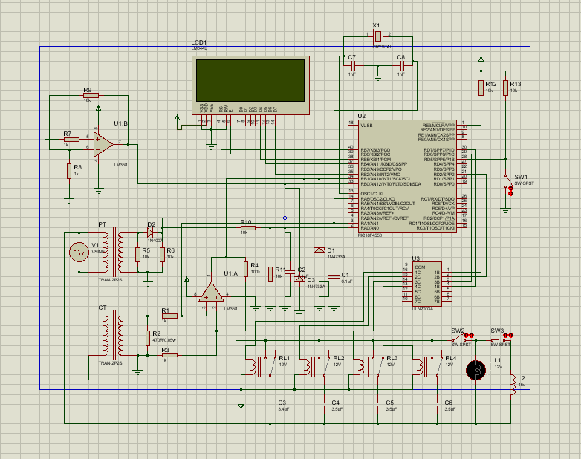
Figure 1: Proteus Circuit Diagram

Working Principle
The operational mechanism of power factor enhancement through the use of a microcontroller, such as a PIC microcontroller, entails the ongoing surveillance of crucial electrical parameters, encompassing voltage, current, and phase angles, through the deployment of sensors positioned inside the electrical system. The sensors in question provide the transmission of data in real-time to the PIC microcontroller. Subsequently, the microcontroller employs this data to determine the instantaneous power factor of the system by evaluating the phase correlation between voltage and current waveforms. The microcontroller utilizes the provided calculation to ascertain any deviations from the required unity value (1.0) of the power factor and to assess the necessity of power factor correction (Wijaya et al., 2021). If correction is deemed required, it should be noted that the microcontroller is responsible for regulating the activation and deactivation of capacitor banks in the circuit, so facilitating the provision or absorption of reactive power. This adjustment of the power factor is crucial in maintaining its proximity to unity. The aforementioned process is characterized by its dynamic and automated nature, operating in real-time. This enables the system to effectively adjust to varying load situations and uphold appropriate power factors, hence enhancing energy efficiency.

Results and Analysis

Data Collection
The process of data collecting is a vital aspect of acquiring, documenting, and recording information or observations from many sources or equipment. Effective data collecting is a crucial component in various disciplines, including science, research, business, and technology, as it plays a pivotal role in facilitating decision-making, analysis, and problem-solving endeavors. The process of data collection commences with the establishment of a well defined strategy that delineates the objectives, research questions, or hypotheses to be addressed. The plan additionally outlines the specific data that will be gathered, the sources from which the data will be obtained, and the methodologies that will be utilized. Data can be obtained from a multitude of sources, such as surveys, interviews, experiments, observations, papers, sensors, databases, or pre-existing records. The selection of data sources is contingent upon the study objectives and the characteristics of the desired information. In order to ensure precise and effective data collection, researchers frequently utilize specialized instruments or tools. The instruments employed in data collection may encompass a range of tools such as sensors, data loggers, questionnaires, cameras, or measurement devices that are customized to suit the specific data being gathered. Data can be acquired by quantitative techniques, such as organized surveys and numerical measures, or qualitative techniques, such as open-ended interviews, observations, and content analysis. In order to effectively pursue their research aims, researchers are required to carefully choose methods that are suitable and in alignment with their intended goals. The precise recording and organization of collected data is crucial. The process encompasses the utilization of timestamps, categorization, and the organization of data in a systematic manner to enhance its analyzability. Upon the completion of data collection, researchers have the ability to analyze the gathered data in order to draw conclusions, make well-informed judgments, or test hypotheses. Statistical analysis, data visualization, and qualitative coding are widely employed methodologies in several academic disciplines.

Power Factor Improvement Measurement
In order to assess the effects of power factor enhancement, it is necessary to establish the original or baseline power factor of the electrical system. The aforementioned value represents the power factor prior to the implementation of any corrective actions. The power factor is commonly represented as a dimensionless value ranging from 0 to 1, where a value of 1 signifies an ideal unity power factor. Once power factor correction steps, such as the incorporation of capacitor banks or active power factor correction devices, have been executed, a subsequent measurement of the power factor is conducted. The aforementioned value denotes the power factor attained subsequent to the implementation of corrective actions. The measurement of power factor is conducted with specialist equipment such as power analyzers, power meters, or digital multi-meters (DMM) that are equipped with the capability to measure power factor. These devices are utilized to ascertain the phase angle between voltage and current waveforms in order to precisely determine the power factor. In certain instances, the installation of continuous monitoring and data logging equipment is undertaken to document power factor values over a period of time. The authors of the study conducted an analysis of the gathered power factor data in order to evaluate the extent of power factor enhancement (Arunyagool, Chamnongthai, & Khawparisuth, 2021). The analysis may encompass the comparison of power factor values before and after improvement, the computation of the percentage of improvement, and the assessment of the effects on energy efficiency and the stability of the electrical system. Regular monitoring of the power factor is crucial to ensure the ongoing effectiveness of correction actions. The implementation of regular measurements facilitates the identification of potential deterioration in the power factor, enabling prompt corrective actions or maintenance interventions. The assessment of power factor improvement measures is frequently employed in cost-benefit assessments to assess the financial implications of corrective actions. The present analysis takes into account many elements, including the potential for energy cost reductions, the extension of equipment lifespan, and the mitigation of penalties associated with low power factors. Reports or records are commonly used to document measurement data and analytical outcomes. The aforementioned reports function as a valuable resource for individuals responsible for making decisions, offering a foundation for the continuous control and optimization of power factor.

Conclusion
In summary, the enhancement of power factor through the implementation of microcontrollers, specifically with the incorporation of PIC microcontrollers, is a modern and dynamic strategy for improving the effectiveness of electrical systems. This innovative method, characterized by real-time monitoring and control, ensures that the power factor remains close to unity, thereby optimizing energy utilization, reducing operational costs, and contributing to sustainability goals. The synergy between micro-controllers, sensors, and control algorithms enables precise adjustment of reactive power compensation, adapting seamlessly to fluctuating load conditions. The integration of micro-controllers into power factor correction systems not only enhances energy efficiency but also enhances voltage stability, reduces line losses, and extends the lifespan of electrical equipment. Furthermore, the ability to simulate and test these systems using tools like Proteus ensures robustness and reliability in their implementation (Delsy et al., 2022). As industries and organizations increasingly prioritize energy efficiency and sustainability, the relevance of micro-controller-based power factor improvement cannot be overstated, offering a pathway to responsible energy management and a greener future.

References
Rahman, M.A., Tahsin, S.M., Das, D. and Chowdhury, R., 2020, June. Power factor Controlling and Monitoring wirelessly through computer. In 2020 IEEE Region 10 Symposium (TENSYMP) (pp. 547-551). IEEE.
Kumar, N.K., Sikamani, K.T., Cornelius, K., Prasana, M.G. and Helen, A., 2020, March. An Efficient Dynamic Power Management of Household Energy Consumables. In 2020 6th International Conference on Advanced Computing and Communication Systems (ICACCS) (pp. 11-14). IEEE.
Sari, A.J. and Murti, M.A., 2021, November. Power Factor Correction Control Based on Internet of Things Using Lumped Compensation Capacitor Bank. In 2021 IEEE International Conference on Internet of Things and Intelligence Systems (IoTaIS) (pp. 247-253). IEEE.
Bhagavathy, P., Latha, R. and Thamizhmaran, E., 2019, July. Development of IoT enabled smart APFC panel for industrial loads. In 2019 10th International Conference on Computing, Communication and Networking Technologies (ICCCNT) (pp. 1-5). IEEE.
Wijaya, W., Priambodho, R., Munastha, K.A., Mulyadi, C.D., Nurba, H.P. and Savitri, P., 2021, November. An Integrated Realtime Power Consumption Monitoring Device for Smart Home System. In 2021 15th International Conference on Telecommunication Systems, Services, and Applications (TSSA) (pp. 1-4). IEEE.
Arunyagool, D., Chamnongthai, K. and Khawparisuth, D., 2021, October. Monitoring and Energy Control Inside Home Using Google Sheets with Line Notification. In 2021 International Conference on Power, Energy and Innovations (ICPEI) (pp. 99-102). IEEE.
Delsy, T.T.M., Williams, J., Krishnamoorthy, N.R., Rajalakshmi, G. and Riyaz, A.L., 2022, January. Power Parameter Detection and Monitoring using Wireless Communication. In 2022 International Conference on Advances in Computing, Communication and Applied Informatics (ACCAI) (pp. 1-5). IEEE.

