Chapter 4: Technical Feasibility Analysis

Table of Contents
4.1 Wind Resource Assessment in UK 3
4.1.2 The Accessibility of an Optimal Wind Resource Location 3
4.1.3 Weather conditions sufficient sound data 4
4.2 Roof Ridge Turbine Design and Specification 4
4.2.1 Installation Requirements and Procedures 7
4.2.2 Numerical Models and Computational Fluid Dynamics Simulation 8
4.2.3 Type Of Electrical Connection And Specific Inverter Needed. 8
4.2.4 Estimation of Wind Energy Captured By the Roof Ridge Turbine and Its Minimum Airflow Speed 10
4.4.1. Reduction of tip noise 17
References 19

List of figures
Figure 1 relation between wind speed and power of wind. Source: El Zein (2019) 3
Figure 2 Grid-Tied Wind Energy System with Battery Storage. Source: Kumar and Chatterjee, 2016 9
Figure 3 integration of MPPT charge controller with wind energy system. Source: Kumar and Chatterjee (2016) 10
Figure 4 Connection of WTG to the Grid in early stage type 1 WTG. Source: (Kashem et al., 2020). 14
Figure 5 Connection of WTG to the Grid in early stage. Type 2 WTG. Source: (Kashem et al., 2020). 15
Figure 6 type 3 wind turbine generator (WTG) connections. Source: (Kashem et al., 2020). 16
Figure 7 Type 4 wind turbine generator (WTG) connections. Source: (Kashem et al., 2020). 16

Chapter 4: Technical feasibility analysis

4.1 Wind Resource Assessment in UK

4.1.2 The Accessibility of an Optimal Wind Resource Location
The optimization of wind system performance is mostly contingent upon achieving an optimal average wind speed. It is noteworthy to mention that the generated power is directly proportional to the cube of the wind velocity. Hence, a marginal augmentation in the mean wind velocity leads to a substantial enhancement in the power generation capacity of a wind turbine. For example, when the wind speed increases by 10% (e.g., from 4 to 4.5 m/s), there is an approximate 30% rise in the power that can be harnessed. Therefore, the system's performance is directly correlated with the quality of the wind resource in the projected area (Shea and Howard, 2011) The relationship between wind speed and power is illustrated in Figure 1, displaying the cubic formula.

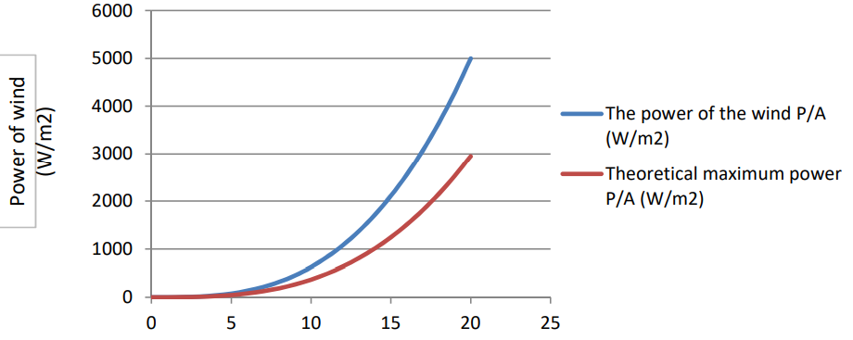
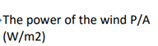
Figure 1 relation between wind speed and power of wind. Source: El Zein (2019)
The sequence of numbers provided includes the following values: 0, 1000, 2000, 3000, 4000, 5000, 6000, 0, 5, 10, 15, 20, and 25 in fig 1. The power generated by wind, denoted as P/A (W/m^2), the concept of theoretical maximum power refers to the highest amount of power that can be achieved within a given system or process, based on fundamental principles and constraints. The power of wind, denoted as P/A, is measured in units of watts per square meter (W/m^2). According to Shea and Howard (2011), there are 21 power outputs. The selection of a suitable terrain for the installation of wind turbines has consistently been a critical determinant.

4.1.3 Weather conditions sufficient sound data
This element holds significant importance as it not only facilitates the evaluation and forecasting of wind patterns and intensities over the course of a year, but also aids in determining the severity and occurrence of extreme weather phenomena in the designated area. The understanding of these specific features yields useful insights on the required durability of wind turbines (El Zein, 2019). Additionally, project developers have the capability to evaluate and forecast the duration of downtime and maintenance intervals for the turbines. The evaluation of logistics throughout the installation and operation & maintenance phases can be more effectively conducted if the designers and planners had a greater understanding of the prevailing weather conditions.
In general, mountainous terrain can offer more favorable conditions for the installation of wind turbines compared to valleys. Nevertheless, this assertion can not consistently hold true. High altitude regions can also possess certain drawbacks, particularly when considering logistical aspects. Highland regions can present challenges in terms of accessibility and distance from electricity demand centers. Furthermore, it is worth noting that certain regions inside these elevated elevations can experience turbulent atmospheric conditions. These factors can potentially lead to negative outcomes for both wind turbines and the intended objectives.

4.2 Roof Ridge Turbine Design and Specification

a. Design requirement

Air foil selection | GOE 623 | NACA 63415 |  | Comparison
Aerodynamic efficiency | Its L/D ratio can be represented as:  L/$D_{GOE623}$= $C_{ L}$/$C_{ D}$  Where:  L/$D_{GOE623}$= is lift to drag ratio for GOE623  $C_{ L}$is the coefficient of lift for GOE623.  $C_{ D}$ is the drag coefficnet of drag for GOE623 | Its L/D ratio can be represented as:  L/$D_{NACA 63415}$= $C_{ L}$/$C_{ D}$  Where:  L/$D_{NACA 63415 }$= is lift to drag ratio for NACA 63415  $C_{ L}$is the coefficient of lift for NACA 63415 .  $C_{ D}$ is the drag coefficnet of drag for NACA 63415 | The GOE 623 airfoil is symmetric and is often used for applications where a balanced lift-to-drag performance is desired. On the other hand, the NACA 63415 airfoil is cambered and designed to efficiently generate lift, particularly at positive angles of attack. In general, cambered airfoils like NACA 63415 tend to achieve higher $C_{ L}$​values at positive angles of attack, resulting in a more efficient lift generation. This characteristic often leads to a higher lift-to-drag ratio compared to symmetric airfoils like GOE 623. However, it's essential to note that the actual L/D ratios will depend on the specific airfoil dimensions, operating conditions, and Reynolds numbers, among other factors.  Therefore, when considering aerodynamic efficiency, the choice between GOE 623 and NACA 63415 should be based on the particular requirements of the wind turbine and its intended operating conditions. NACA 63415 may be preferred for applications where efficient lift generation is critical, such as variable-pitch or stall-controlled wind turbines, while GOE 623 may be suitable when balanced lift and drag performance is desired in specific wind conditions.
Lift Generation: | $$C_{L}-f{(α, R_{e} )}_{GOE 623}$$  Where  $$f{\left(α, R_{e} \right)}_{GOE 623}$$  represents the lift coefficient as a function of angle of attack and Reynolds number for GOE 623.  $C_{L}$ is the lift coefficient for GOE 623. | $$C_{L}-f{(α, R_{e} )}_{NACA 63415}$$  $${(α, R_{e} )}_{NACA 63415}$$  Represents the lift coefficient as a function of angle of attack and Reynolds number for GOE 623. |  | The GOE 623 airfoil is symmetric and designed for a wide range of applications. Its $C_{L}$ values can vary depending on the angle of attack (α) and the Reynolds number $R_{e}$. In practical terms, NACA 63415 typically exhibits higher $C_{L}$ values than GOE 623 at positive angles of attack due to its cambered shape. This characteristic allows it to generate lift efficiently, making it suitable for applications where lift is crucial, such as variable-pitch or stall-controlled wind turbines. However, it's important to note that the specific $C_{L}$ values and performance characteristics of both airfoils can vary based on factors such as Reynolds number, airfoil dimensions, and the specific operating conditions of the wind turbine
Drag Reduction: | The GOE 623 airfoil is symmetric, and its $C_{D}$ values depend on the angle of attack (α) and the Reynolds number $R_{e}$  $$C_{D}-f{(α, R_{e} )}_{GOE 623 }$$  $C_{D}$is the drag coefficient for GOE 623. | The drag coefficient for NACA 63415  $$C_{D}-f{(α, R_{e} )}_{NACA 63415 }$$  $f{(α, R_{e} )}_{NACA 63415 }$​ is the drag coefficient as a function of angle of attack and Reynolds number for NACA 63415.  $C_{D}$ the drag coefficient for NACA 63415. |  | The NACA 63415 airfoil, while cambered, is designed to maintain relatively low drag coefficients, especially at positive angles of attack $C_{D}$ values are typically competitive with symmetric airfoils like GOE 623. Comparing drag reduction between the GOE 623 and NACA 63415 airfoils involves examining their respective coefficients of drag $C_{D}$ at different angles of attack and Reynolds numbers. Lower $C_{D}$ values indicate better drag reduction and less resistance to airflow.

4.2.1 Installation Requirements and Procedures
The determination of the most suitable placement for roof-mounted wind turbines is contingent upon the several factors that influence the airflow patterns above the roof. According to Tummala et al. (2016) examines the impact of roof shape, wind direction, building height, and surrounding urban configurations on the wind flow above the roof. The objective is to identify the optimal mounting location, taking into account the accelerating effect that occurs on top of the roof. The study examined the impact of various roof shapes on wind flow patterns, turbulence intensities, and streamwise velocities, revealing distinct impacts for each shape. The optimal placement for placing the wind turbine on each roof was identified based on the findings of the inquiry. In all examined cases, it was observed that the area with the highest level of turbulence intensity extends from directly above the roof to a distance of 1.3 times the height of the building (Abohela, Hamza and Dudek, 2013). Consequently, it is recommended that a roof-mounted wind turbine be positioned at a height equal to or greater than 1.3H in order to optimize its performance. Regarding the streamwise velocity, it was observed that all examined roof shapes had a tendency to accelerate the wind velocity.
The installation of micro-wind turbines above isolated buildings is infrequently observed in the built environment, with the exception of high-rise structures where the impact of neighboring buildings on local wind flow above the roof is minimal. In order to address the intricacies of the constructed environment, it becomes necessary to employ simplification techniques in studies that focus on examining the impact of a single variable on local wind flow, while keeping all other factors constant. Nevertheless, in the case of low-rise structures, they can nevertheless induce an acceleration in the airflow over their roofs. Consequently, a comprehensive evaluation of the wind flow is necessary to identify suitable positions for installing wind turbines and harnessing the benefits of this acceleration phenomenon (Ledo, Kosasih and Cooper, 2011). The present analysis has demonstrated that strategic placement of a wind turbine on the roof, taking into consideration the specific shape of the roof, can optimize the extraction of energy from the increased wind velocity above the structure. Additional research is required to investigate the wind patterns occurring above various roof designs, encompassing buildings of varying heights, situated inside metropolitan environments.

4.2.2 Type Of Electrical Connection And Specific Inverter Needed

a. Inverter model and power source specification
The grid tie inverter and transformer are crucial elements in the area of electrical engineering. The grid tie inverter is responsible for converting the direct current (DC) generated by renewable energy sources, such as solar panels or wind turbines, into alternating current (AC). An inverter is a device that enables the incorporation of electrical power produced by different distributed power generation sources into a self-sufficient system, micro-grid, or the national grid (Nagliero et al., 2010). When a wind generator generates direct current (DC) output, a power inverter must be used to convert the DC power into alternating current (AC) before it can be distributed to AC appliances or injected into the grid.

b. Regulator and Charge Controller
An electronic device called a charge controller, sometimes referred to as a regulator, is in charge of controlling and limiting the current flow to the battery bank during the charging process. The major purpose of this device is to ensure that the electrical current provided to the battery bank stays within predetermined boundaries. Unlike the solar charge controller, which disconnects the connection between the source (solar panels) and the charge controller after the battery is fully charged, the wind turbine charge controller constantly monitors the battery voltage. When the voltage of the battery becomes close to the float charging voltage, the wind turbine charge controller triggers a dump load (also known as a shunt) instead of directly connecting the output of the wind generator, as shown in Figure 2.
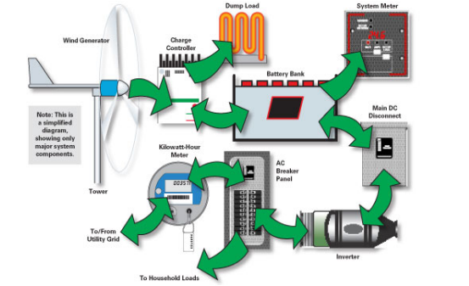
Figure 2 Grid-Tied Wind Energy System with Battery Storage. Source: Kumar and Chatterjee, 2016
In this case, a dump load could be used as an extra water heater or an underfloor heating system instead of a braking resistor, so that the energy that is produced is used as efficiently as possible. If a wind generator is spinning at a fast speed and the load suddenly disconnects, it can cause a significant surge of current. This power surge has the capacity to inflict injury on the charge controller and result in the turbine surpassing its safe operational velocity, so endangering the turbine itself. Two main charge controller technologies may be distinguished in the market: Pulse Width Modulation (PWM) and Maximum Power Point Tracking (MPPT). As shown in Figure 3 shows how a Maximum Power Point Tracking (MPPT) charge controller can be used in a wind energy system.
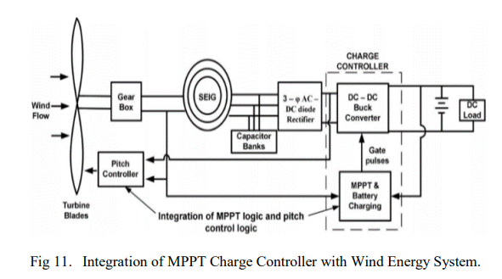
Figure 3 integration of MPPT charge controller with wind energy system. Source: Kumar and Chatterjee (2016)

4.2.3 Estimation of Wind Energy Captured By the Roof Ridge Turbine and Its Minimum Airflow Speed
Before making an estimation of the wind energy captured by an airfoil, such as the NACA 63415, it is imperative to consider both the design of the airfoil and the prevailing wind conditions. The NACA 63415 airfoil belongs to the NACA 63 series, which comprises a collection of airfoil profiles distinguished by a power curve exhibiting a maximum value at low wind velocities and decreasing as wind speeds increase. The NACA 63415 airfoil achieves its maximum thickness at a location corresponding to 34.9% of the chord length, while its maximum camber is achieved at a position equivalent to 50% of the chord length (Veludurthi and Bolleddu, 2021).
The structural integrity of the NACA 63415 airfoil for wind turbine blades has been substantiated by experimental investigation of its buckling behavior. Based on the available data, it is evident that the stresses encountered by the blades do not reach their yield strength. The critical buckling stresses exhibit variations based on the structural characteristics of the blades, such as their solid, hollow, or rectangular configuration. The utilization of computational fluid dynamics (CFD) analysis allows for the estimation of the drag coefficient under different wind velocities, hence enhancing comprehension of the flow properties surrounding a wind turbine blade employing the NACA 63415 airfoil.
The operation of a turbine is contingent upon local conditions, such as the velocity and orientation of the wind. Performing a computational fluid dynamics (CFD) analysis is of utmost importance in order to have a comprehensive understanding of the aerodynamic properties exhibited by the turbine blades under these specific circumstances. The utilization of this technology is crucial in order to generate dependable predictions regarding wind energy generation. The optimization of the design of wind turbines and the determination of the ideal angle of attack for the turbine blades are essential processes in order to achieve maximum energy capture and conversion from wind resources. Wind turbines commonly employ the NACA 63415 and GOE 623 airfoils due to their commendable efficiency and versatile characteristics. Hence, it is imperative to conduct a comparative analysis of their aerodynamic characteristics and examine the impact of these attributes on their efficiency in harnessing energy.
The NACA 63415 airfoil was created in conjunction with the other members of the 6-series airfoil family to achieve optimal performance in conditions characterized by low to moderate wind speeds. Nevertheless, it is important to acknowledge that in the presence of strong winds, the efficiency of these airfoils is diminished. The airfoil denoted as 63415 exhibits a maximum thickness equivalent to 15% of its chord length, positioned at a distance of 34.9% from the leading edge of the airfoil (Ajay and Venkateshwarlu, 2020). Additionally, the airfoil demonstrates a peak camber of 2.2% located approximately at the 50% mark of the chord length, in close proximity to the equidistant midpoint of the chord. The utilization of computational fluid dynamics (CFD) enables the determination of the drag coefficient under different wind velocities, hence facilitating the examination of the aerodynamic characteristics and power generation capacity of wind turbine blades.
The GOE 623 airfoil is extensively employed as the preferred profile for wind turbine blade design. The airfoil exhibits a thickness of 12% at a location that corresponds to 30% of the chord length. In addition, a camber of 3.8% is seen at a position corresponding to 40% of the length of the chord. As part of a broader research endeavor, an assessment was conducted to examine the efficacy of GOE airfoils, with particular focus on the 623 variant (Osei et al., 2020). The evaluation involved the utilization of rotor blades sourced from domestic wind turbines. The primary objective of this study was to ascertain and categorize airfoils that exhibit outstanding lift-to-drag ratios. The performance of the GOE 447 airfoil was found to be quite favorable in a comprehensive investigation. However, it is crucial to acknowledge that it bears resemblance to, but is not an exact replica of, the GOE 623 airfoil (Hasan et al., 2021). Based on the presented findings, it can be inferred that the GOE series airfoils exhibit considerable promise for application in wind energy systems.
The relative effectiveness of NACA 63415 and GOE 623 airfoil designs in the context of wind power extraction lacks comprehensive understanding. While there is a consensus that both designs share the objective of optimizing aerodynamic efficiency however the NACA airfoil demonstrates commendable performance across a broad range of wind velocities, encompassing both moderate and high speeds. However, the efficiency of the system may be negatively impacted in conditions characterized by higher wind speeds. On the other hand, the GOE airfoil exhibits favorable performance due to its heightened lift-to-drag ratio within a limited spectrum of wind velocities.
In practical scenarios, numerous variables influence the selection of an airfoil for a wind turbine. In addition to the mean wind velocity at the location, the physical size of the turbine, and the anticipated performance at various wind speeds, there are additional factors to be taken into account, such as noise levels, financial implications, and durability. As previously said, Computational Fluid Dynamics (CFD) analysis is commonly employed to simulate and assess the efficacy of various airfoil configurations across diverse scenarios, with the objective of ascertaining the optimal solution for a certain application.
4.2.5 Potential Energy Generation Achievable By the System
The assessment of airfoil efficiency in wind turbines commonly involves the evaluation of various aerodynamic factors, such as lift-to-drag ratios, which directly influence the effectiveness of wind energy conversion. The potential use of the GOE series airfoils in wind turbine applications has been supported by their strong lift-to-drag ratios. The NACA 63415 has optimal performance in wind conditions characterized by low to medium speeds, owing to its particular design parameters (Ajay and Venkateshwarlu, 2020). In comparison the GOE 623 airfoil, specifically designed for wind energy applications, possesses highly advantageous aerodynamic properties that enable it to generate substantial amounts of power (Osei et al., 2020). The GOE 623 airfoil exhibits a notable lift-to-drag ratio, rendering it a very suitable option for regions characterized by relatively low to moderate wind velocities, which are typically associated with the generation of a significant portion of wind energy. The incorporation of the GOE 623 airfoil in the design of a wind turbine's blade has the potential to enhance its power coefficient (Cp), hence enhancing the turbine's capacity to convert the wind's kinetic energy into valuable mechanical work. The amount of energy generated is influenced by various factors, such as the spatial variation of wind velocity, atmospheric density, turbine blade dimensions, and the holistic configuration and effectiveness of the turbine system. The utilization of the GOE 623 airfoil has the potential to enhance the annual energy production (AEP) of wind turbines by improving their performance across various operational scenarios (Hasan et al., 2021). In regions characterized by consistent wind patterns, this improvement in efficiency has the potential to solidify wind turbines as reliable elements in the endeavor for clean and renewable energy alternatives.
In order to effectively evaluate the energy generating capabilities of various airfoils, it is necessary to conduct a comprehensive aerodynamic analysis using computational fluid dynamics (CFD) or wind tunnel experimentation. This would enable us to obtain the necessary data pertaining to lift, drag, and power, which is essential for conducting a comparative analysis of the two.
4.2.6 Possibility of Integrating Power Generation from Wind and Solar PV Sources.
The optimization of renewable energy utilization in buildings is facilitated by the integration of power generation from solar photovoltaic (PV) systems with roof-mounted wind turbines. When employed in conjunction, solar and wind power enable a building to produce electrical energy by harnessing the sun's rays during daylight hours, when solar irradiance is at its peak, and by utilizing wind energy during other periods, such as nighttime or gloomy days, when solar power is less efficient. The complementary characteristics of both sources can mitigate their intermittent nature, leading to a synergistic combination that yields enhanced stability and productivity in energy generation. In addition, the integration of this combination has the potential to optimize the utilization of roof space by implementing a dual energy generating system, so contributing to enhanced energy self-sufficiency, reduced dependence on the electrical grid, and mitigation of carbon emissions. The viability of these integrated solutions has been enhanced by advancements in smart grid technology and battery storage systems, facilitating the storage or redistribution of surplus energy to the grid.
4.4 Grid Connection and Integration
The categorization of Wind Turbine Generators (WTGs) into various connection types with a power grid is based on their distinct speed control mechanisms. The wind turbine generators (WTGs) can be classified into four types: Type 1, Type 2, Type 3, and Type 4.

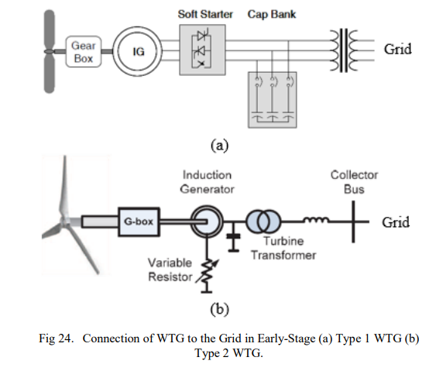
Figure 4 Connection of WTG to the Grid in early stage type 1 WTG. Source: (Kashem et al., 2020).

According to Kashem et al. (2020) Type 1 wind turbine generators (WTGs) are characterized by a set rotational speed that is synchronized with the power grid frequency. The connection of Type 1 WTGs to the power grid is illustrated in Figure 4. The typical approach involves the utilization of a squirrel-cage induction generator (SCIG) in conjunction with a soft starter and a parallel capacitor bank that is connected to the grid side via a step-up transformer. The utilization of a soft starter and parallel capacitor bank effectively mitigates the adverse consequences associated with reactive power consumption and the occurrence of high currents. This is achieved by the generation of an excitation field by the machine.
Figure 5 Connection of WTG to the Grid in early stage. Type 2 WTG. Source: (Kashem et al., 2020).

The rotational velocity of Type 2 wind turbine generators (WTGs) have the capacity for adjustment; nonetheless, it is subject to certain limitations. Figure 5 illustrates the configuration of a Type 2 wind turbine generator (WTG) connected to the primary power grid, commonly employed in the wound-rotor induction generator (Kashem et al., 2020).. The machine is equipped with a parallel connection that includes a variable resistor, which serves the purpose of regulating power during gusts. Additionally, a capacitor bank is incorporated to provide reactive power.
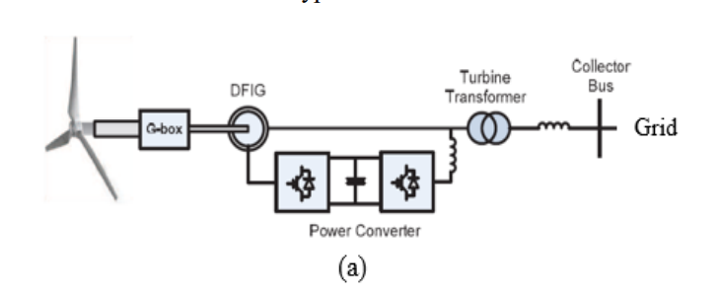
Figure 6 type 3 wind turbine generator (WTG) connections. Source: (Kashem et al., 2020).

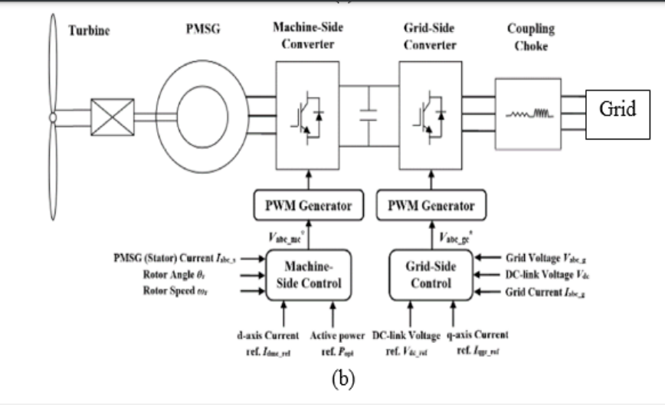
Figure 7 Type 4 wind turbine generator (WTG) connections. Source: (Kashem et al., 2020).

In recent years, there has been an increasing popularity in the utilization of Type 3 and Type 4 wind turbine generator (WTG) connections. Both Type 3 and Type 4 in figure 6 and 7 respectively wind turbine generators (WTGs) are equipped with variable speed control mechanisms. Type 3 wind turbine generators (WTGs) are commonly utilized in conjunction with a doubly-fed induction generator (DFIG), while Type 4 WTGs are typically integrated with a permanent magnet synchronous generator (PMSG). The distinction between Type 3 and Type 4 wind turbine generators is in the manner in which the power converter is connected and controlled. Figure 6 depict the interconnection of Type 2 and Type 3 wind turbine generators (WTG) with the electrical grid. Type 3 wind turbine generators (WTGs) exhibit partial control, while Type 4 WTGs demonstrate complete control. The control methodology and functionalities of Type 3 wind turbine generators (WTGs). Type 4 wind turbine generators (WTGs) as shown in figure 5 are configured in a series connection, wherein two inverters are coupled in a back-to-back arrangement, with a Direct Current (DC) link interposed between them, facilitating the connection of the WTGs to the power grid. Inverters play a crucial role in managing power supply by regulating voltage levels, hence facilitating the synchronization and stability of the power grid. Zou and He (2016) concur with the aforementioned assertion and put out a control model in their publication. The controller located at the machine side is responsible for managing the inverter's operation in order to generate power from the wind turbine. Conversely, the controller situated at the grid side is responsible for regulating the inverter's voltage output to ensure synchronization with the grid. The implementation of both Type 3 wind turbine generators (WTGs) and WTGs with variable speed control is prevalent due to their ability to regulate the rotational speed of the turbine, hence optimizing power generation. Ensuring an optimal power supply to the grid is crucial in mitigating instances of power fluctuation within the power grid. Putri et al. (2016) highlight the significance of achieving optimal power generation for Permanent Magnet Synchronous Generators (PMSG) and discuss a potential control mechanism.
4.5 Noise and Vibration Mitigation Measures
The implementation of noise reduction strategies is a common approach in various fields to mitigate the adverse effects of unwanted sound or interference. These approaches aim to enhance the quality of signals or several experimental and numerical strategies have been devised to mitigate noise by leveraging our comprehension of noise mechanisms, which offer valuable insights into the aero-acoustic properties of wind turbines. This section has addressed various aerodynamic noise mitigation approaches that show promise in targeting dominating noise sources.

4.2.4. Reduction of tip noise
Modifying the blade tip design and operational parameters of a turbine with NACA 63415 airfoils would be a good starting point for achieving measurable noise reductions. By designing the blade tips with sweeping or curved winglets, for instance, the tip vortex intensity can be lowered, resulting in a 1 to 3 dB reduction in noise. Depending on the specifics of the design, adding serrations or combs to the trailing edge could reduce aerodynamic noise by as much as 2 decibels. Since slower-moving tips produce less aerodynamic noise, optimizing operational factors like decreasing the rotational speed or the tip speed ratio (TSR) could result in an additional 1-2 dB reduction in noise. Finally, using vibration-damping advanced materials into the blade production process could result in an extra 2 dB of noise reduction (Volkmer, Kaufmann and Carolus, 2021). These focused adjustments can be vital for making the NACA 63415 airfoil more appropriate for residential locations where noise pollution is a serious concern.
The reduction of blade tip noise in turbines can be achieved through a combination of design revisions and operational adjustments, namely by implementing GOE 623 airfoils. The inclusion of winglets has been seen to yield noise reductions within the range of 1 to 3 dB. This is achieved through alterations in the airflow surrounding the blade tips, which subsequently diminishes vortex formation. The presence of serrations on the trailing edge, which can introduce disturbances to the otherwise laminar airflow and subsequently contribute to noise generation, has the potential to achieve a reduction in sound pressure levels by around 1-2 decibels. Noise reduction can be achieved by manipulating operational variables, such as the rotational speed of the blade. A decrease in rotational speed of around 10% corresponds to a reduction in noise level of approximately 1 decibel. Additionally, it is possible to construct the blades using materials that possess sound-absorbing properties, resulting in a potential reduction in noise levels of up to 2 decibels (dB). Collectively, these alterations have the potential to substantially diminish the acoustic characteristics of a wind turbine that is fitted with the GOE 623 airfoil, so rendering it a more favorable option for residential applications.

References
Abohela, I., Hamza, N. and Dudek, S., 2013. Effect of roof shape, wind direction, building height and urban configuration on the energy yield and positioning of roof mounted wind turbines. Renewable Energy, 50, pp.1106-1118.
Agrawal, B.R. and Sharma, A., 2016. Numerical investigations of bio-inspired blade designs to reduce broadband noise in aircraft engines and wind turbines. In 54th AIAA aerospace sciences meeting (p. 0760).
Ajay, V. and Venkateshwarlu, B., 2020. Aerodynamic Analysis of a 3D Small Wind Turbine Blade Using NACA 63415 Aerofoil with MRF. In Advances in Materials and Manufacturing Engineering: Select Proceedings of ICMME 2019 (pp. 29-42). Singapore: Springer Singapore.
Barone, M.F., 2011. Survey of techniques for reduction of wind turbine blade trailing edge noise.
Camm, E.H., Behnke, M.R., Bolado, O., Bollen, M., Bradt, M., Brooks, C., Dilling, W., Edds, M., Hejdak, W.J., Houseman, D. and Klein, S., 2009, July. Characteristics of wind turbine generators for wind power plants. In 2009 IEEE Power & Energy Society General Meeting (pp. 1-5). IEEE.
Deshmukh, S., Bhattacharya, S., Jain, A. and Paul, A.R., 2019. Wind turbine noise and its mitigation techniques: A review. Energy Procedia, 160, pp.633-640.
Deshmukh, S., Bhattacharya, S., Singh, V. and Kumar, R., 2018. Aerodynamic and aeroacoustic study of horizontal axis wind turbine with winglets. B. Tech (Doctoral dissertation, Thesis).
El Zein, M., 2019. Off-grid Wind Power Systems: Planning and Decision Making.
El Zein, M., 2019. Off-grid Wind Power Systems: Planning and Decision Making.
Erturk, E., 2018. Sizing a stand-alone off-grid wind turbine-battery power system for a remote house in Catalca Istanbul Turkey. International Journal of Renewable Energy Research (IJRER), 8, pp.1591-1603.
Finez, A., Jacob, M., Jondeau, E. and Roger, M., 2010, June. Broadband noise reduction with trailing edge brushes. In 16th AIAA/CEAS aeroacoustics conference (p. 3980).
Fleig, O., Iida, M. and Arakawa, C., 2004. Wind turbine blade tip flow and noise prediction by large-eddy simulation. J. Sol. Energy Eng., 126(4), pp.1017-1024.
Geyer, T., Sarradj, E. and Fritzsche, C., 2010. Measurement of the noise generation at the trailing edge of porous airfoils. Experiments in fluids, 48, pp.291-308.
Hansen, K., Kelso, R. and Doolan, C., 2010, June. Reduction of flow induced tonal noise through leading edge tubercle modifications. In 16th AIAA/CEAS aeroacoustics conference (p. 3700).
Hasan, A.S., Abousabae, M., Salem, A.R. and Amano, R.S., 2021. Study of Aerodynamic Performance and Power Output for Residential-Scale Wind Turbines. Journal of Energy Resources Technology, 143(1), p.011302.
Herr, M., 2007, May. Design criteria for low-noise trailing-edges. In 13th AIAA/CEAS aeroacoustics conference (28th AIAA aeroacoustics conference) (p. 3470).
Kashem, S.B.A., Chowdhury, M.E., Khandakar, A., Ahmed, J., Ashraf, A. and Shabrin, N., 2020. Wind power integration with smart grid and storage system: Prospects and limitations. International Journal of Advanced Computer Science & Applications, 11(5).
Kinzie, K., Drobietz, R., Petitjean, B. and Honhoff, S., 2013. Concepts for wind turbine sound mitigation. AWEA Wind Power.
Krishnan, B.P., Mathanbabu, M., Sathyamoorthy, G., Gokulnath, K. and Kumar, L.G.S., 2021. Performance estimation and redesign of horizontal axis wind turbine (HAWT) blade. Materials Today: Proceedings, 46, pp.8025-8031.
Kumar, D. and Chatterjee, K., 2016. A review of conventional and advanced MPPT algorithms for wind energy systems. Renewable and sustainable energy reviews, 55, pp.957-970.
Kumar, D. and Chatterjee, K., 2016. A review of conventional and advanced MPPT algorithms for wind energy systems. Renewable and sustainable energy reviews, 55, pp.957-970.
Ledo, L., Kosasih, P.B. and Cooper, P., 2011. Roof mounting site analysis for micro-wind turbines. Renewable energy, 36(5), pp.1379-1391.
Madsen, H.A. and Fuglsang, P., 1997. Numerical investigation of different tip shapes for wind turbine blades. Aerodynamic and aeroacoustic aspects.
Maizi, M., Mohamed, M.H., Dizene, R. and Mihoubi, M.C., 2018. Noise reduction of a horizontal wind turbine using different blade shapes. Renewable Energy, 117, pp.242-256.
Muljadi, E., Zhang, Y.C., Gevorgian, V. and Kosterev, D., 2016, September. Understanding dynamic model validation of a wind turbine generator and a wind power plant. In 2016 IEEE Energy Conversion Congress and Exposition (ECCE) (pp. 1-5). IEEE.
Nagliero, A., Mastromauro, R.A., Monopoli, V.G., Liserre, M. and Dell'Aquila, A., 2010, July. Analysis of a universal inverter working in grid-connected, stand-alone and micro-grid. In 2010 IEEE International Symposium on Industrial Electronics (pp. 650-657). IEEE.
Oerlemans, S., 2011. Wind turbine noise: primary noise sources.
Oerlemans, S., Fisher, M., Maeder, T. and Kögler, K., 2009. Reduction of wind turbine noise using optimized airfoils and trailing-edge serrations. AIAA journal, 47(6), pp.1470-1481.
Osei, E.Y., Opoku, R., Sunnu, A.K. and Adaramola, M.S., 2020. Development of high performance airfoils for application in small wind turbine power generation. Journal of Energy, 2020, pp.1-9.
Paruchuri, C., Joseph, P. and Ayton, L.J., 2018. On the superior performance of leading edge slits over serrations for the reduction of aerofoil interaction noise. In 2018 AIAA/CEAS Aeroacoustics Conference (p. 3121).
Paruchuri, C., Subramanian, N., Joseph, P., Vanderwel, C., Turner, J., Kim, J.W. and Ganapathisubramani, B., 2015. Broadband noise reduction through leading edge serrations on realistic aerofoils. In 21st AIAA/CEAS aeroacoustics conference (p. 2202).
Putri, R.I., Rifa'i, M., Jasa, L., Priyadi, A., Margo, P. and Mauridhi, H.P., 2016, October. Modeling and control of permanent magnet synchronous generator variable speed wind turbine. In 2016 International Conference on Smart Green Technology in Electrical and Information Systems (ICSGTEIS) (pp. 16-20). IEEE.
Shea, K. and Howard, B.C., 2011. Build your own small wind power system. McGraw Hill Professional.
Tummala, A., Velamati, R.K., Sinha, D.K., Indraja, V. and Krishna, V.H., 2016. A review on small scale wind turbines. Renewable and Sustainable Energy Reviews, 56, pp.1351-1371.
Veludurthi, A. and Bolleddu, V., 2021. Experimental buckling analysis of NACA 63415 aerofoil wind turbine blade. Materials Today: Proceedings, 46, pp.205-211.
Volkmer, K., Kaufmann, N. and Carolus, T.H., 2021. Mitigation of the aerodynamic noise of small axial wind turbines-methods and experimental validation. Journal of Sound and Vibration, 500, p.116027.
Williams, J.F. and Hall, L.H., 1970. Aerodynamic sound generation by turbulent flow in the vicinity of a scattering half plane. Journal of fluid mechanics, 40(4), pp.657-670.
Wizelius, T., 2015. Developing wind power projects: theory and practice. Routledge.
Zou, Y. and He, J., 2016, May. Comprehensive modeling, simulation and experimental validation of Permanent Magnet Synchronous generator wind power system. In 2016 IEEE/IAS 52nd Industrial and Commercial Power Systems Technical Conference (I&CPS) (pp. 1-9). IEEE.

