Task Simple Query MySQL bagian kedua

1. SELECT * FROM daftar_obat ORDER BY tahun_produksi DESC

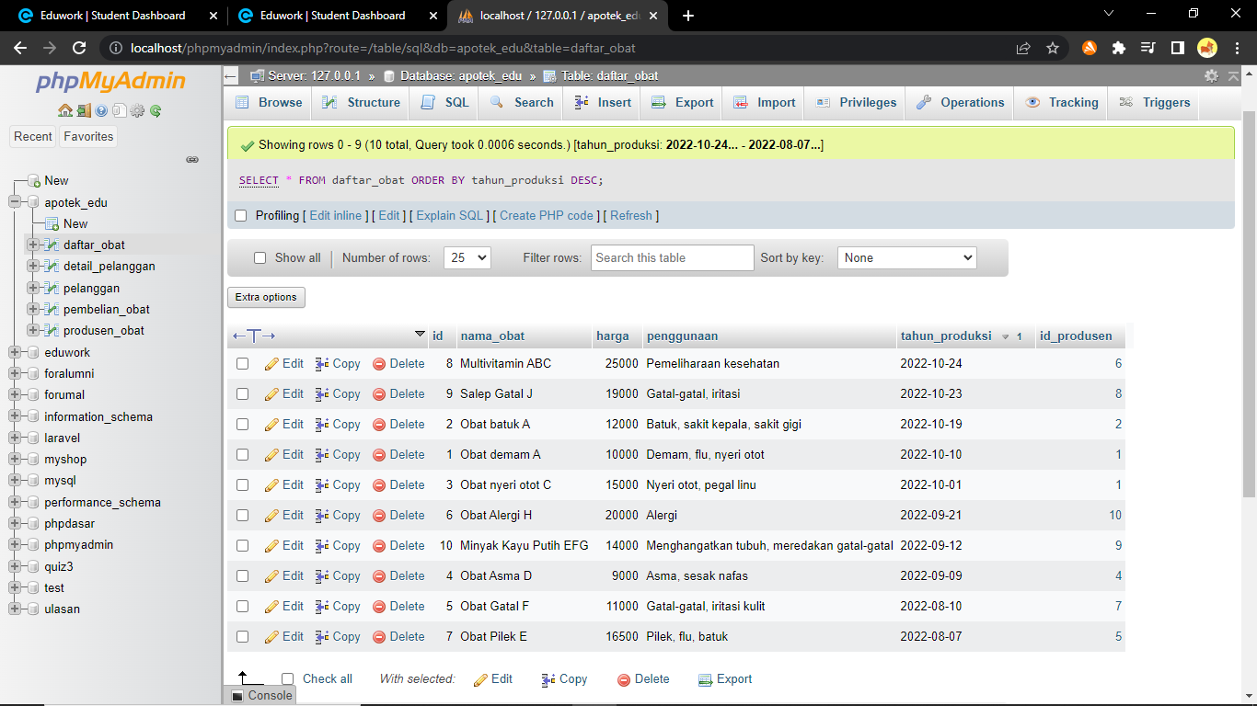

2. SELECT * FROM daftar_obat ORDER BY tahun_produksi ASC

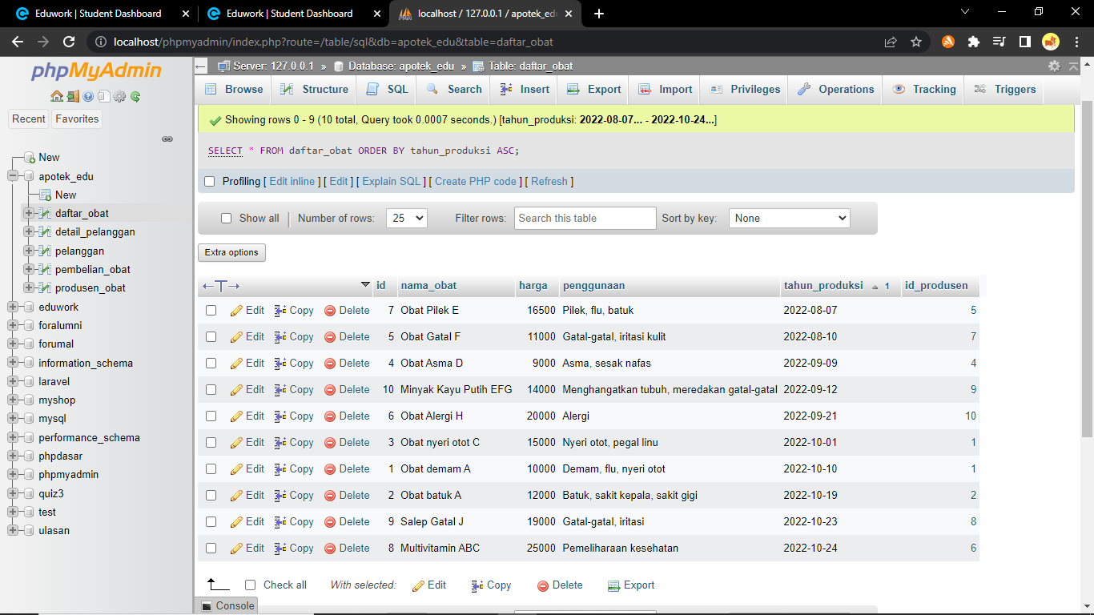

3. SELECT * FROM daftar_obat WHERE nama_obat LIKE ‘%gatal%’

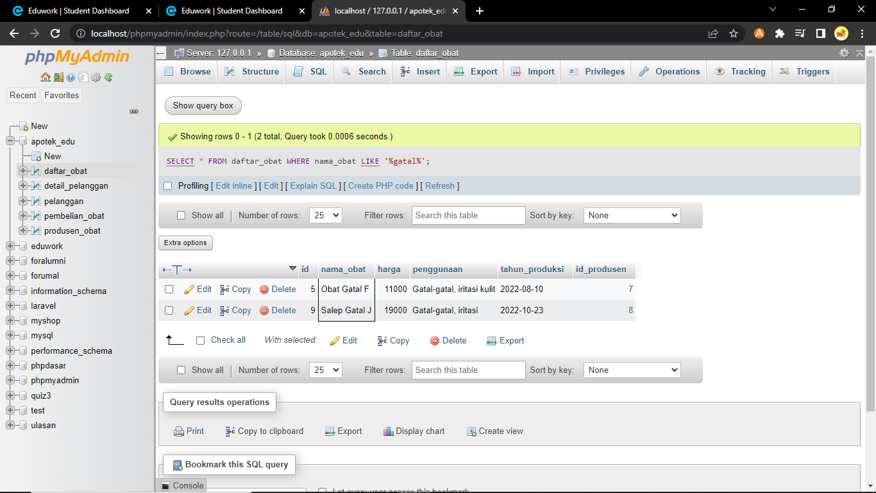

4. SELECT * FROM daftar_obat WHERE nama_obat LIKE ‘%obat%’

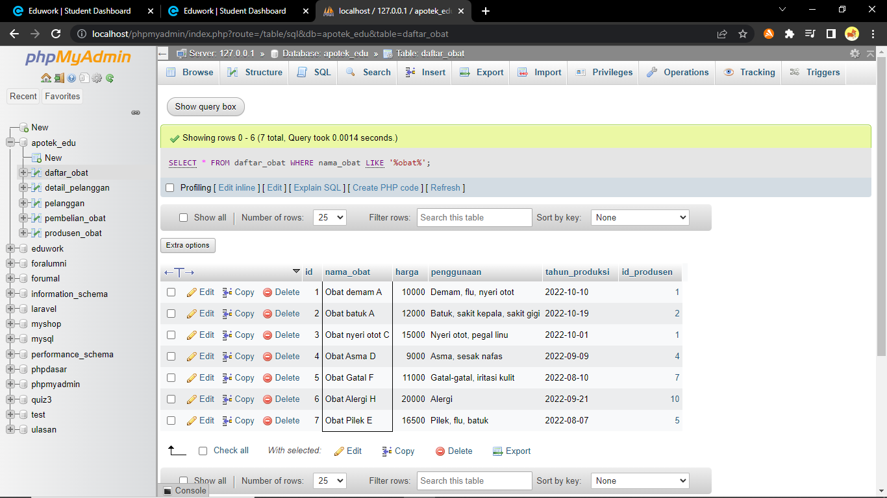

5. SELECT * FROM daftar_obat WHERE penggunaan LIKE ‘%gatal%’ GROUP BY id_produsen DESC

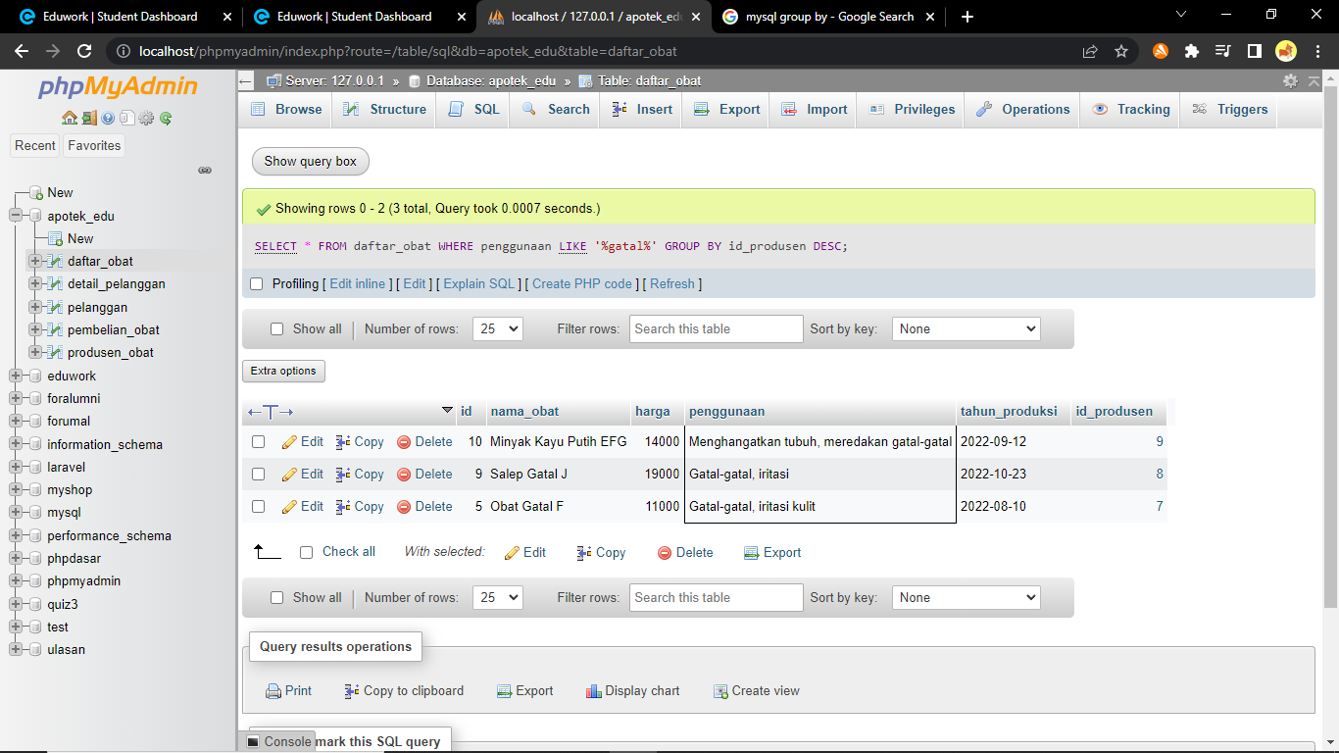

6. SELECT * FROM detail_pelanggan WHERE riwayat_penyakit LIKE ‘%kanker%’

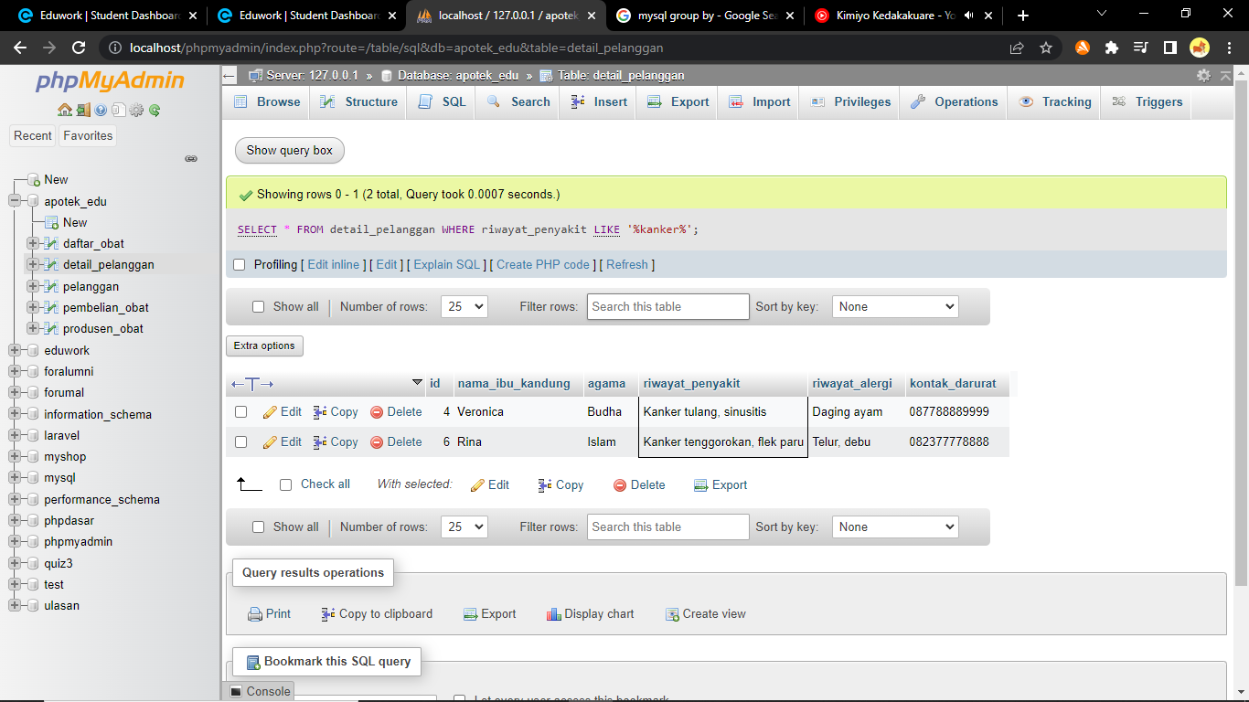

7. SELECT id_produsen, SUM(stok) as total_stok FROM daftar_obat GROUP BY id_produsen

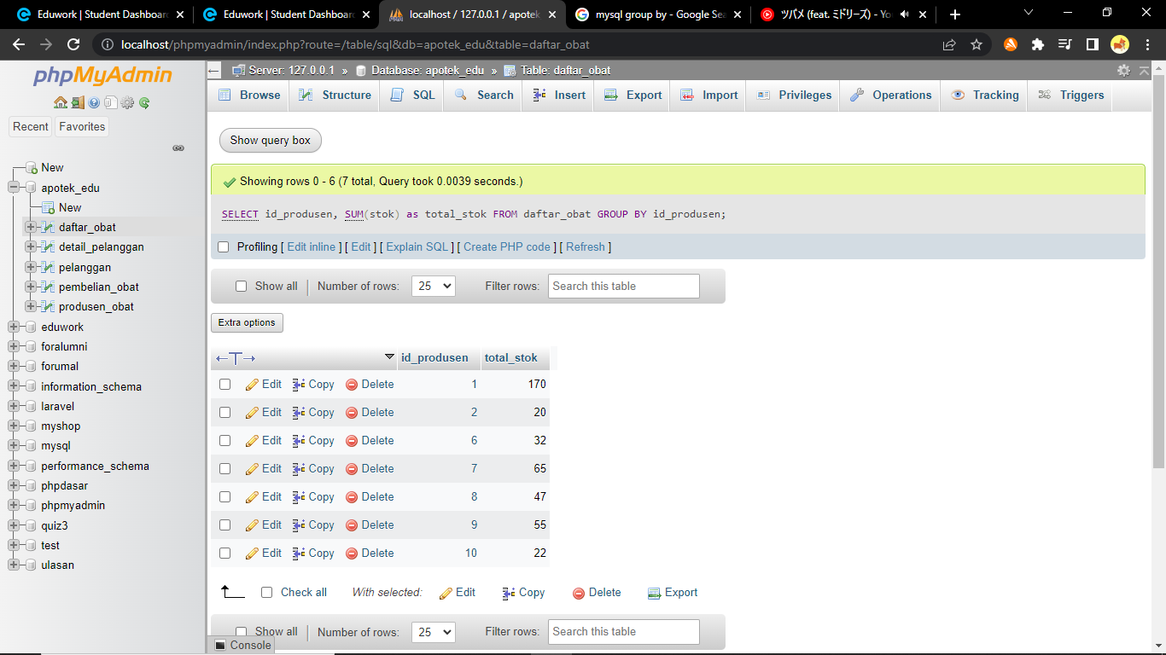

8. SELECT nama_obat FROM daftar_obat WHERE harga >= 10000 ORDER BY harga ASC

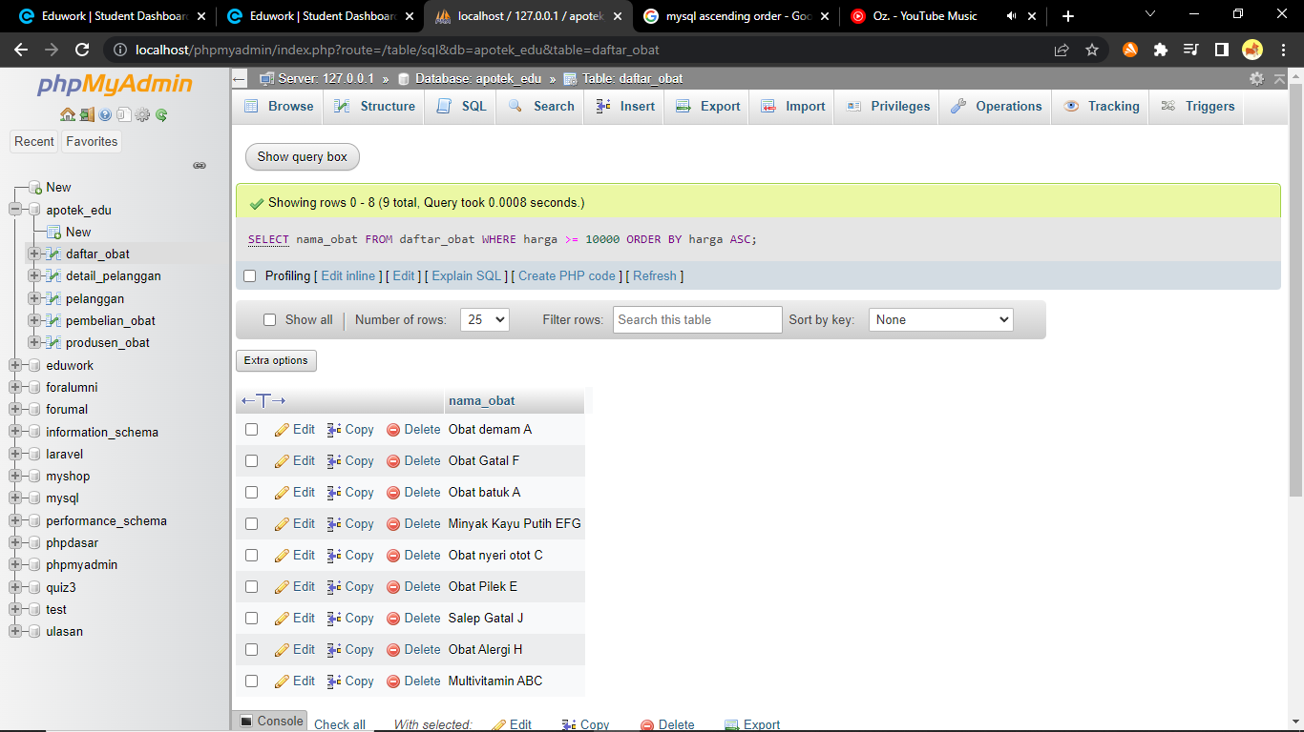

9. SELECT nama_produsen FROM produsen_obat WHERE tahun_berdiri < 2000 ORDER BY tahun_berdiri DESC

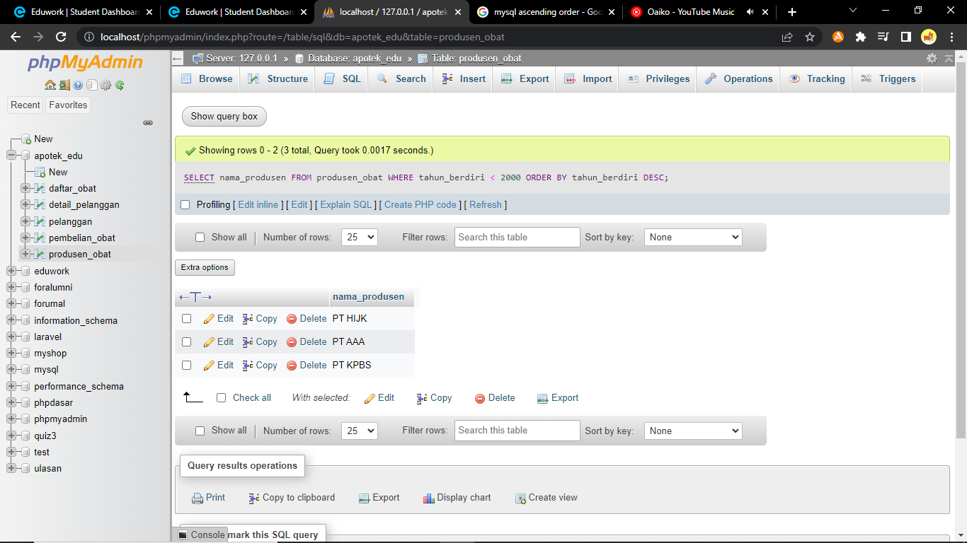

10. SELECT nama_pelanggan FROM pelanggan WHERE domisili LIKE ‘%Bandung%’ ORDER BY nama_pelanggan ASC

