Hands-on Exercise No. 01 – DigiSkills 3.0 Batch-04

Artificial Intelligence using Python
Name: Rehana Kausar

Task 1: Sales Tax Calculator

Code:

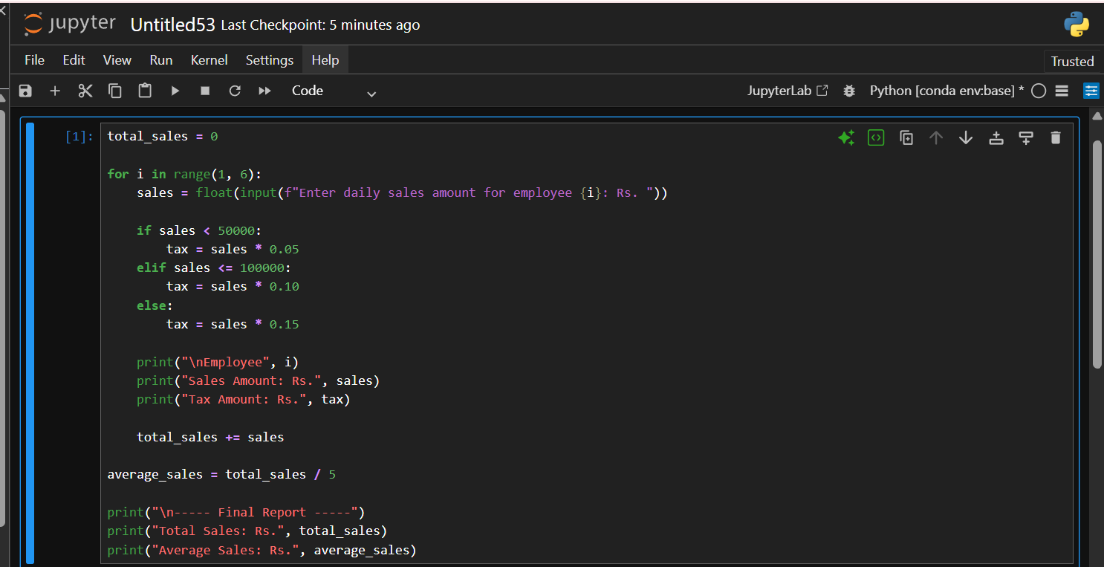

Output:

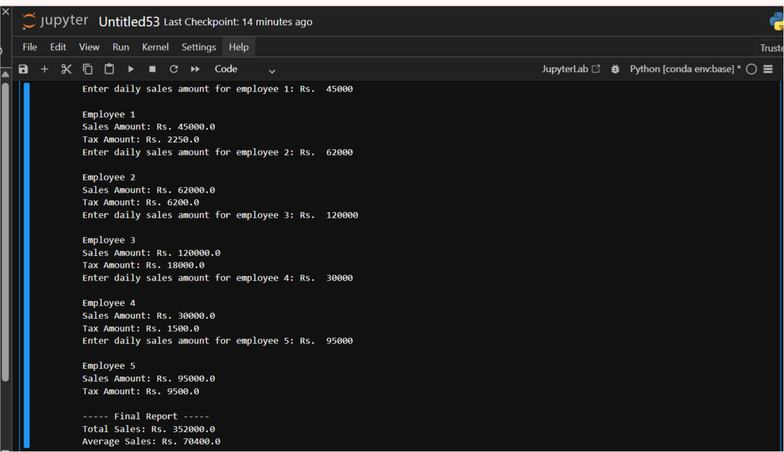

Task 2: NumPy Array Operations:

Code:

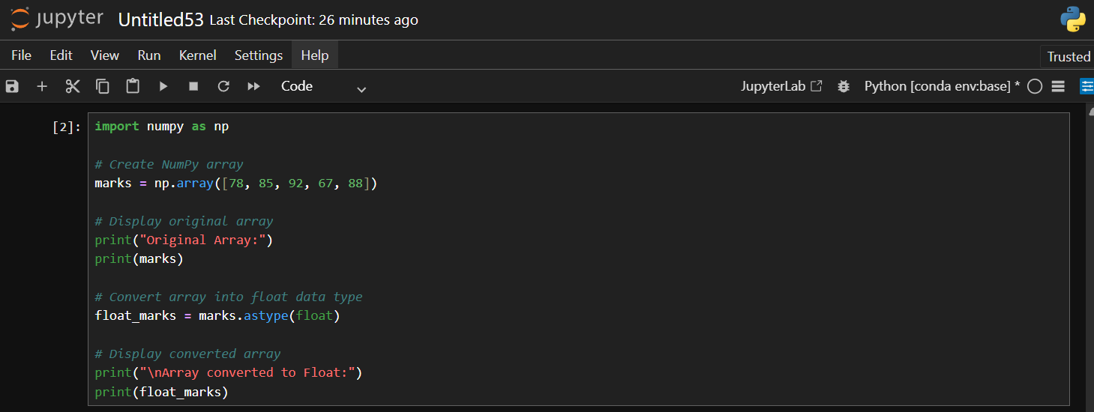

Output:

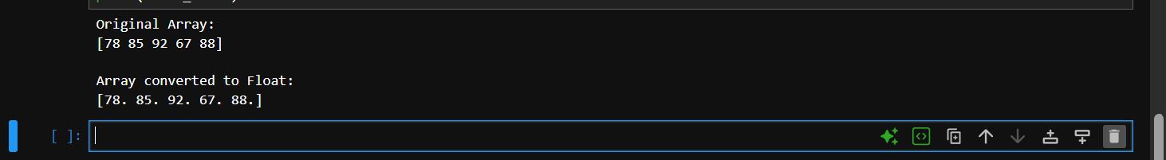

Task 3: Bank Account System (OOP):

Code:

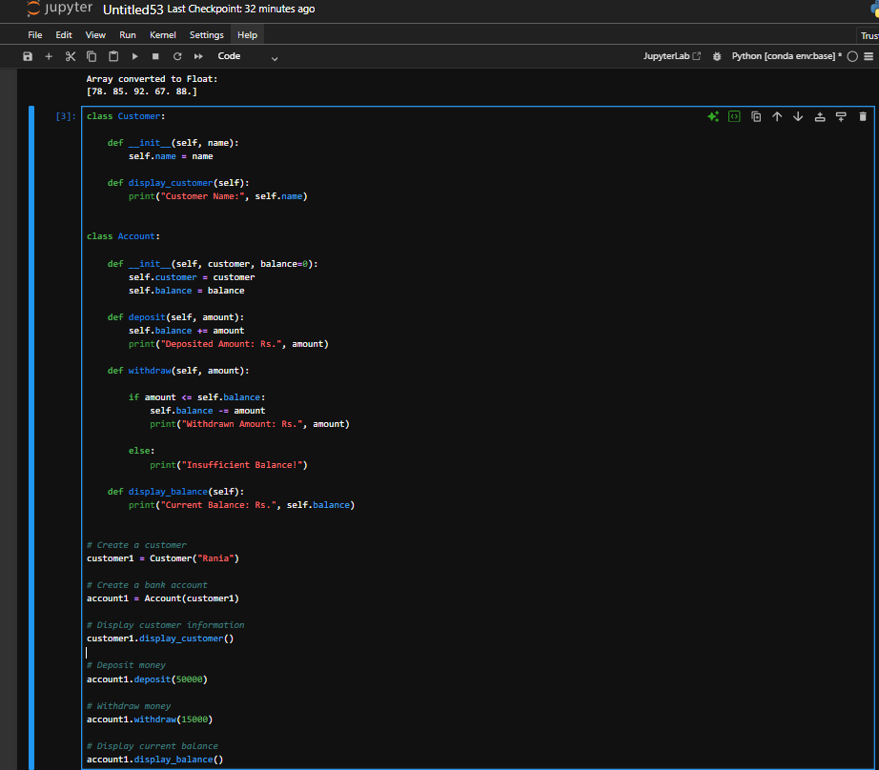

Output:

