Student Name: Rehana Kausar
Course: Artificial Intelligence using Python (AIP301)
Batch: DigiSkills 3.0 – Batch 04
Due Date: 10/09/2026

Setup — import libraries and load data:
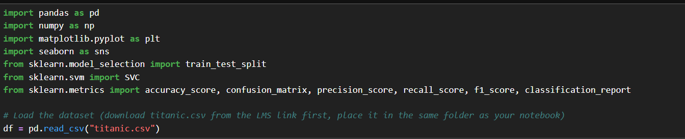
Task 1: Dataset Loading and Initial View:

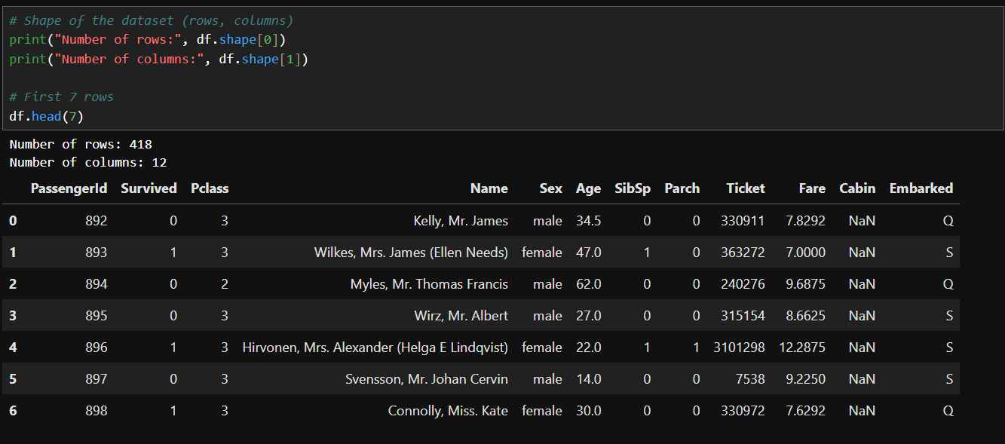

Task 2: Data Exploration:

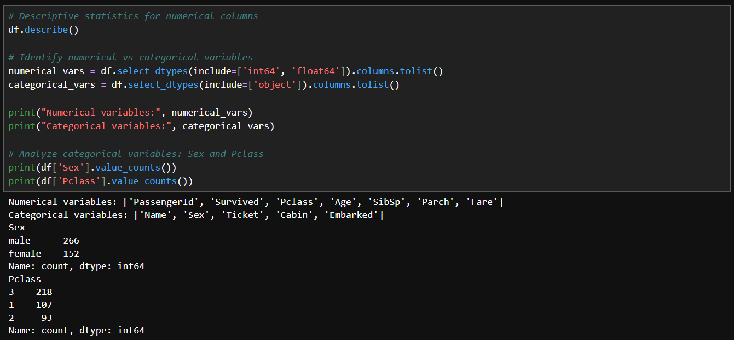

Task 3: Data Cleaning:

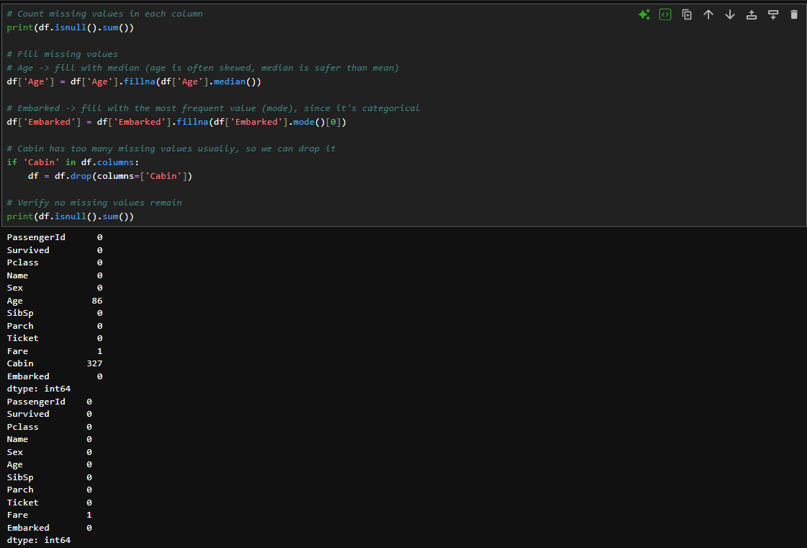

Task 4: Feature Selection & Renaming + Build SVC Model:

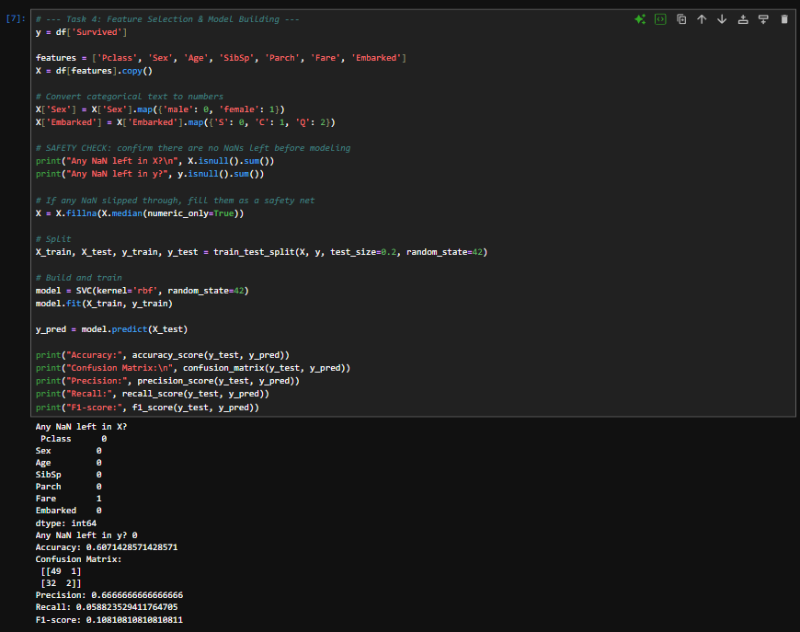

Task 5: Data Visualization:

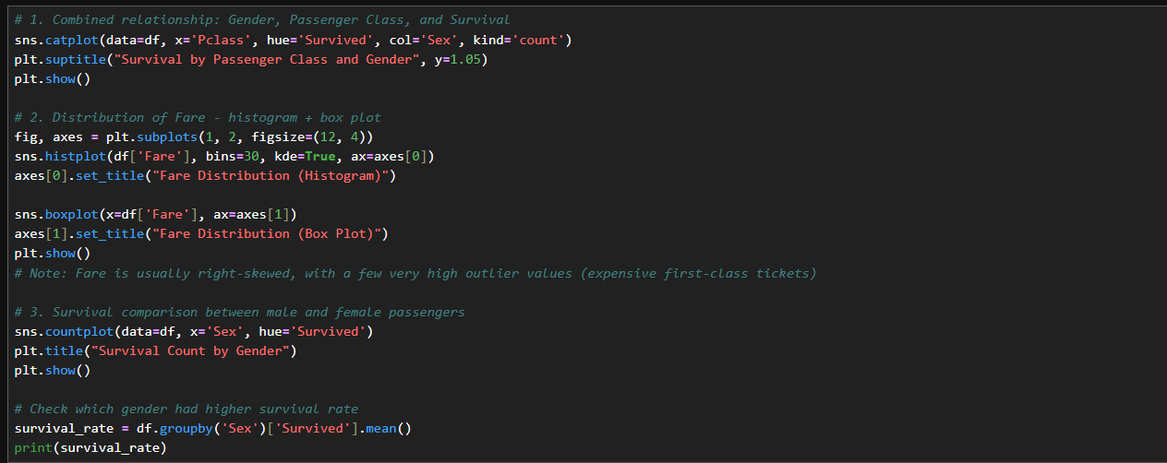

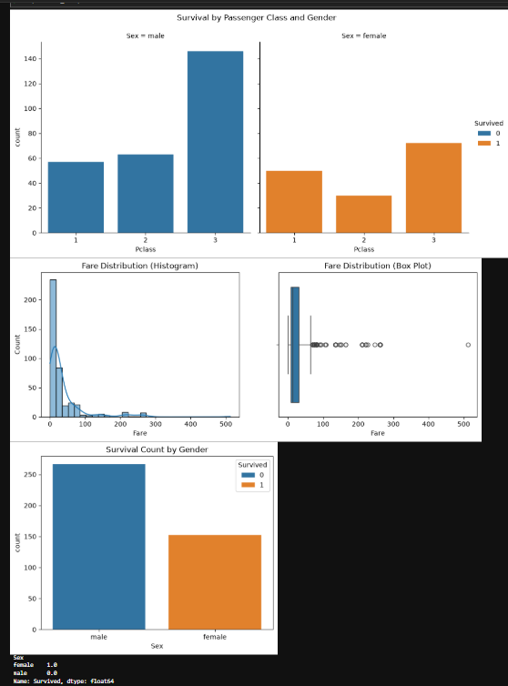

Results:
- Females had a noticeably higher survival rate than males — this matches the "women and children first" evacuation policy.
- 1st class passengers generally survived at higher rates than 2nd or 3rd class.
- Fare distribution is right-skewed — most tickets were cheap, but a small number of very expensive tickets pull the average up (these show as outliers in the box plot).

