TASK 2: HANDS-ON LAB IMPLEMENTATION
Cybersecurity / Network Security Lab Report
Submitted by: Rehan Ahmed
Lab platform: Kali Linux running in Oracle VM VirtualBox on a Windows host
Lab network mode: VirtualBox NAT (Network Address Translation), as configured during the exercise
Tools used: Nmap 7.99, Python 3.13.12, Linux networking and socket-inspection commands
Scope: Controlled checks on the user's own Kali Linux virtual machine and a temporary service bound to the loopback address.

1. Executive Summary
This practical exercise established a small cybersecurity lab in Kali Linux and used basic network checks, Nmap scans, a temporary Python HTTP server, and read-only firewall inspection to observe how network connectivity and listening services behave. The gateway and an external hostname both responded to four ping requests with zero packet loss at the time of testing. An initial Nmap scan of localhost reported the 1,000 scanned TCP ports as closed. A temporary Python web server was then started on 127.0.0.1, port 8000. Nmap identified that port as open and detected a Python SimpleHTTPServer service. After the server was stopped, a repeat scan reported port 8000 as closed. This provides a direct demonstration that a service which is running and listening can expose a port, and stopping an unneeded service removes that listener.
The firewall check showed the iptables default policies INPUT, FORWARD, and OUTPUT set to ACCEPT, with no additional rules displayed by the command used. The UFW command was unavailable, and an earlier nftables ruleset check displayed no rules. These observations are limited to the commands and time of inspection; they do not prove that every possible firewall or network control is absent. No vulnerability was confirmed by the evidence collected. The vulnerability-script check established that Nmap's vulners script is present, but a scan with no detected open service could not provide a meaningful service-version vulnerability result.

2. Objectives

1. Set up a lab environment for cybersecurity testing.
A Kali Linux virtual machine was used, and the working directory /home/rehan/cyber-lab was created and verified.

2. Install and configure security tools.
Nmap 7.99 was verified as available. Python 3.13.12 was available for a controlled local web-server exercise. The Nmap scripts directory was inspected and the vulners.nse script was found.

3. Perform practical security exercises and analyze results.
Connectivity was tested with ping; localhost ports were scanned with Nmap; a temporary HTTP service was detected on port 8000; and the scan was repeated after stopping the service.

4. Document findings and recommendations.
Commands, observations, interpretations, limitations, and recommendations are documented in this report and supported by the supplied terminal photographs.

5. Apply security measures to improve system security.
The temporary test service was stopped and a follow-up scan confirmed the port was closed. This is a safe, reversible example of reducing unnecessary service exposure.

6. Prepare a detailed report with evidence.
This report includes the lab scope, methods, observed results, analysis, recommendations, limitations, and available screenshot evidence.

3. Lab Environment and Scope
The lab ran inside Kali Linux in VirtualBox on a Windows computer. The recorded system information showed a Linux Kali kernel identified as 6.19.14+kali-amd64 and x86_64 architecture. The network interface inspection performed earlier showed the loopback interface at 127.0.0.1 and an Ethernet interface at 10.0.2.15/24, with the default gateway 10.0.2.2. The observed addresses are consistent with a typical VirtualBox NAT network. The loopback address 127.0.0.1 refers to the same Kali machine; traffic sent to that address stays local to the virtual machine.
The scans in this exercise targeted localhost (127.0.0.1), and the HTTP server was explicitly bound to 127.0.0.1. This kept the service available only on the local Kali system rather than deliberately exposing it on every network interface. No third-party host was subjected to port scanning. The ping test to google.com was a basic connectivity check only.

4. Methodology and Commands

Check the lab directory
Command(s): cd ~/cyber-lab ; pwd ; ls -la
Observed result and meaning: Confirmed the working directory was /home/rehan/cyber-lab. The screenshot shows the directory listing, including only the current and parent directory entries at that point.

Check system and tool versions
Command(s): uname -a ; nmap --version ; python3 --version
Observed result and meaning: Collected operating-system/kernel, architecture, Nmap version, and Python version information. The screenshots directly show Nmap 7.99 and Linux x86_64 kernel information; Python 3.13.12 was also shown by Nmap's service detection.

Test the VirtualBox gateway
Command(s): ping -c 4 10.0.2.2
Observed result and meaning: Four packets were transmitted and four received, with 0% packet loss. This confirms the gateway responded during this test.

Test DNS and external connectivity
Command(s): ping -c 4 google.com
Observed result and meaning: The hostname resolved to an IP address and four replies were received with 0% packet loss. This indicates hostname resolution and ICMP connectivity worked at the time of testing; it does not measure all aspects of internet performance or security.

Scan localhost's common TCP ports
Command(s): nmap -sT -sV 127.0.0.1
Observed result and meaning: Nmap reported the host was up and the 1,000 scanned ports were closed (connection refused). This is a snapshot of the default set of common TCP ports, not a scan of every possible TCP/UDP port.

Start a controlled local HTTP service
Command(s): python3 -m http.server 8000 --bind 127.0.0.1
Observed result and meaning: Python started a simple HTTP server on 127.0.0.1 port 8000. The explicit bind address restricted the listener to the loopback interface.

Detect the test service
Command(s): nmap -sT -sV -p 8000 127.0.0.1
Observed result and meaning: Nmap reported 8000/tcp open, service http, version SimpleHTTPServer 0.6 (Python 3.13.12). This demonstrates that Nmap can detect a service when it is listening.

Stop the test service and rescan
Command(s): Stop the Python server with Ctrl+C, then run: nmap -sT -sV -p 8000 127.0.0.1
Observed result and meaning: The second scan reported 8000/tcp closed. The change from open to closed matches the service being stopped.

Inspect firewall-related settings
Command(s): sudo iptables -S ; sudo nft list ruleset ; sudo ufw status
Observed result and meaning: iptables displayed default ACCEPT policies for INPUT, FORWARD, and OUTPUT and no additional rules in that output. The nftables command displayed no rules. UFW was not installed or available as a command. These are narrow observations, not proof that all firewall protections are absent.

5. Findings and Analysis

Finding 1 — Basic network connectivity worked
The gateway test to 10.0.2.2 and the hostname test to google.com each returned four replies from four requests, with 0% packet loss. This suggests the VM had working connectivity during the checks. Ping uses ICMP echo messages and is not a substitute for testing every network service.

Finding 2 — No common localhost TCP ports were open before the test service
The scan reported 1,000 closed TCP ports on 127.0.0.1. A closed port generally means the host responded but no application was accepting TCP connections at that port at scan time. This is a useful baseline, but it does not prove the machine is fully secure, and the scan did not cover every possible port or all UDP services.

Finding 3 — Nmap identified the temporary HTTP service
While the Python HTTP server was running, Nmap identified port 8000/tcp as open and recognised an HTTP service consistent with Python 3.13.12's SimpleHTTPServer. This is direct evidence that a listening service changes the result of a port scan.

Finding 4 — Stopping the service closed the port
After Ctrl+C stopped the Python server, the follow-up scan reported port 8000/tcp closed. This is the clearest practical security measure in the lab: stop services when they are not needed. Binding a test service to 127.0.0.1 also reduced exposure because it was not intentionally listening on the VM's Ethernet address.

Finding 5 — HTTP request logs included normal errors and a connection reset
The server log shows successful GET / requests with HTTP 200 responses, missing-file responses with HTTP 404, an unsupported POST request with HTTP 501, and a ConnectionResetError. A 404 means the requested file/path was not found; 501 means the simple server did not support that request method. A connection reset can occur when a client closes a connection unexpectedly. These messages alone are not proof of an attack or compromise.

Finding 6 — Firewall inspection showed permissive iptables default policies
The displayed iptables policies were INPUT ACCEPT, FORWARD ACCEPT, and OUTPUT ACCEPT. No explicit extra rules appeared in the shown output. The nftables ruleset command previously produced no visible rules, and UFW was unavailable. This suggests there were no restrictive rules visible through those particular checks, but firewall state can involve other tools, backends, network layers, or VirtualBox NAT behaviour. A more complete system audit would be needed before making a definitive claim.

Finding 7 — Vulnerability-script availability was confirmed, not vulnerabilities
The screenshots show the Nmap scripts directory and a list of filenames containing 'vuln', including vulners.nse. This proves the script file is present. The earlier scan did not find an open service to evaluate, so no vulnerability finding should be claimed from that attempt.

6. Security Recommendations

Keep services stopped when they are not required.
The lab demonstrated that stopping the Python server changed port 8000 from open to closed. On a real system, review running services and disable only those that are genuinely unnecessary.

Bind development/test servers to localhost when remote access is not needed.
Using --bind 127.0.0.1 makes the service available only to the local machine. Avoid binding to 0.0.0.0 or a network-facing address unless remote access is intentionally required and protected.

Use a deliberate firewall policy for the intended environment.
The observed iptables defaults allow traffic by default. On a real system, a firewall policy should be designed around required services and access needs. Do not blindly change firewall rules on a working machine: first confirm the active firewall backend, preserve current configuration, and ensure a recovery path. This report does not claim firewall settings were changed.

Repeat scans after configuration changes.
The before/after port-8000 scans provided evidence that the service state changed. Similar checks can verify whether a service is actually no longer listening after it is stopped or disabled.

Perform vulnerability checks only against identified services and with permission.
A vulnerability script needs service/version information or a suitable target to evaluate. First identify open services on systems you own or are authorised to test; then use a suitable script and record the exact output. Do not infer vulnerabilities solely because a script is installed.

Maintain evidence and record limitations.
Save terminal output or screenshots with the command, target, date/time, and result visible. Explain what a test can and cannot prove, and avoid claiming that a limited scan establishes that a system is completely secure.

7. Limitations and Responsible Testing
- The work was a small introductory lab, not a full penetration test or formal security audit.
- The Nmap localhost scan covered the default 1,000 common TCP ports. It did not test every TCP port, UDP ports, external interfaces, or other machines.
- Ping results reflect only the time of testing and do not guarantee continuous connectivity.
- The vulnerability-script screenshots prove availability of the script, not that any vulnerability was detected.
- The firewall checks were read-only. The report does not claim that firewall rules were modified or that all firewall layers were exhaustively inspected.
- The Python HTTP server was a simple test service. The 404, 501, and connection-reset messages are interpreted as observed protocol/server behaviour and are not labelled as security incidents without additional evidence.

8. Conclusion
The exercise met the practical intent of the six supplied objectives at an introductory lab level: a Kali lab was used, security tools were verified, connectivity and ports were tested, a local service was identified, and a follow-up scan verified the port closed after the service stopped. The most important demonstrated lesson is that running services create listening ports, and unnecessary services should be stopped or restricted. The tests also showed why results must be interpreted carefully: a closed-port scan is not a guarantee of security, and a script being present is not the same as discovering a vulnerability. Further testing should be limited to authorised systems and supported by clear evidence.

Appendix A — Evidence Screenshots
The following supplied photographs are included as evidence. They are photographs of the terminal screen, so some text may be affected by angle or glare. Captions describe only what is visibly supported.
Evidence A1 — Lab folder verification: cd ~/cyber-lab, pwd and ls -la; the path /home/rehan/cyber-lab is visible.
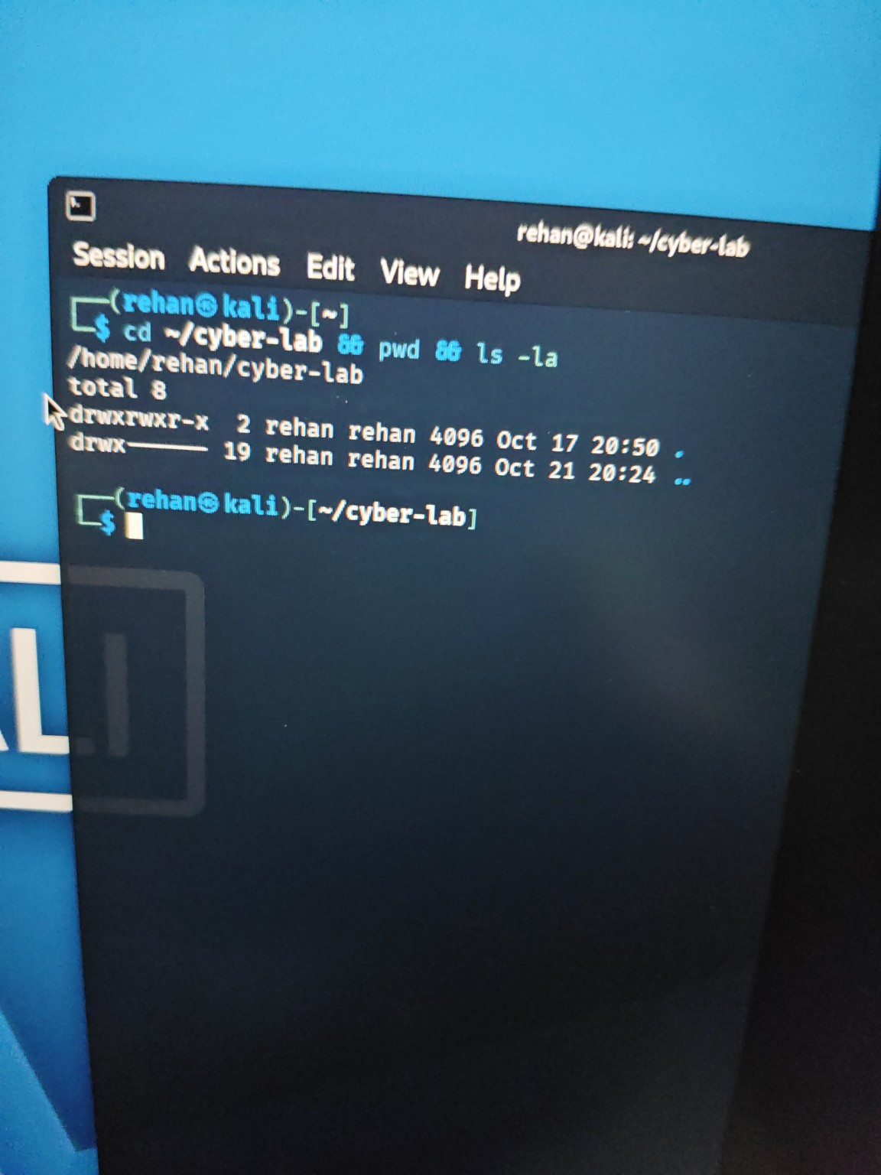
Evidence A2 — Nmap scripts directory listing; demonstrates the installed Nmap script collection.
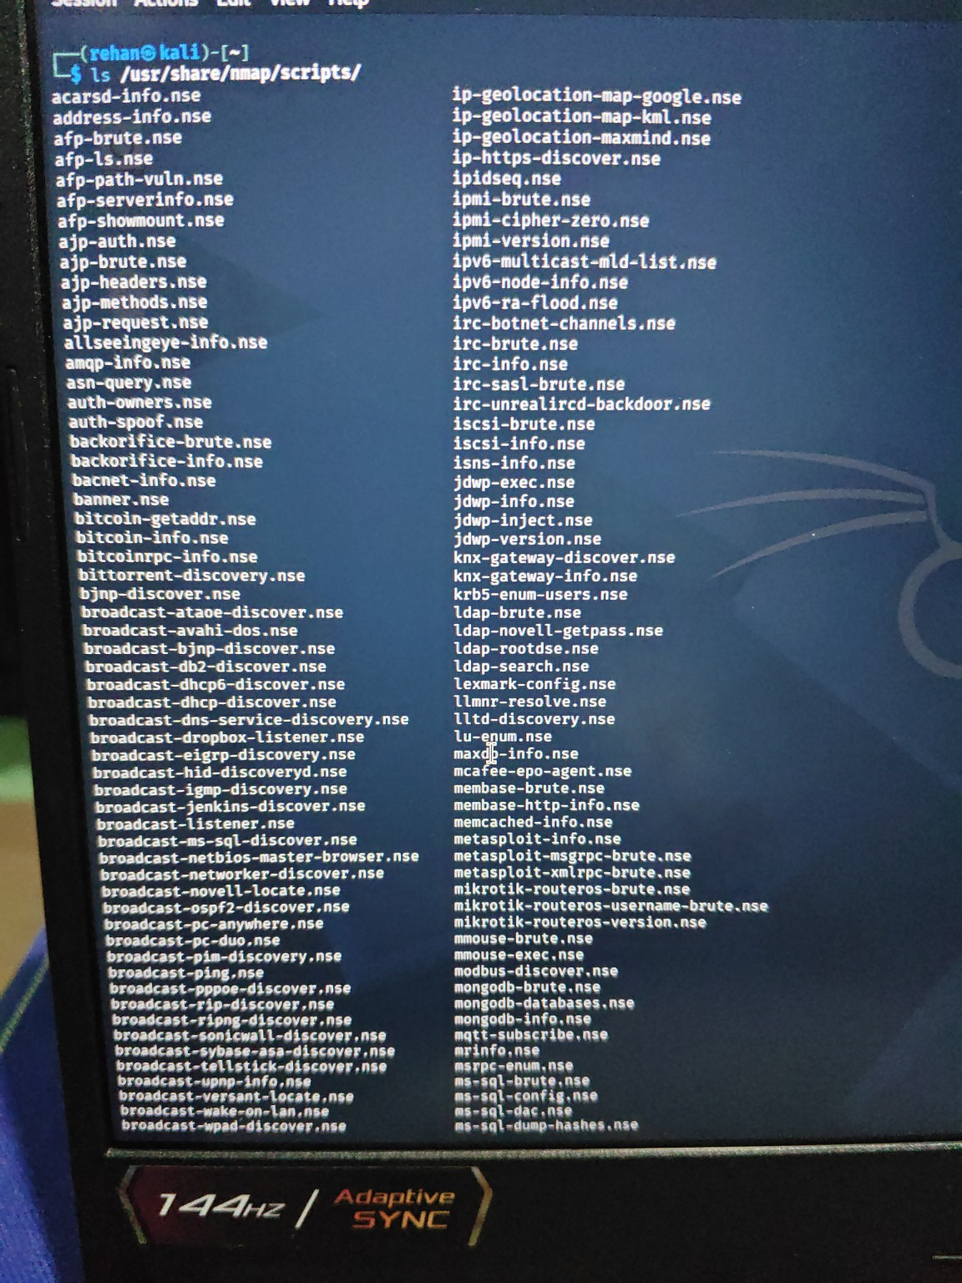
Evidence A3 — Filtered list of vulnerability-related Nmap script filenames, including vulners.nse.
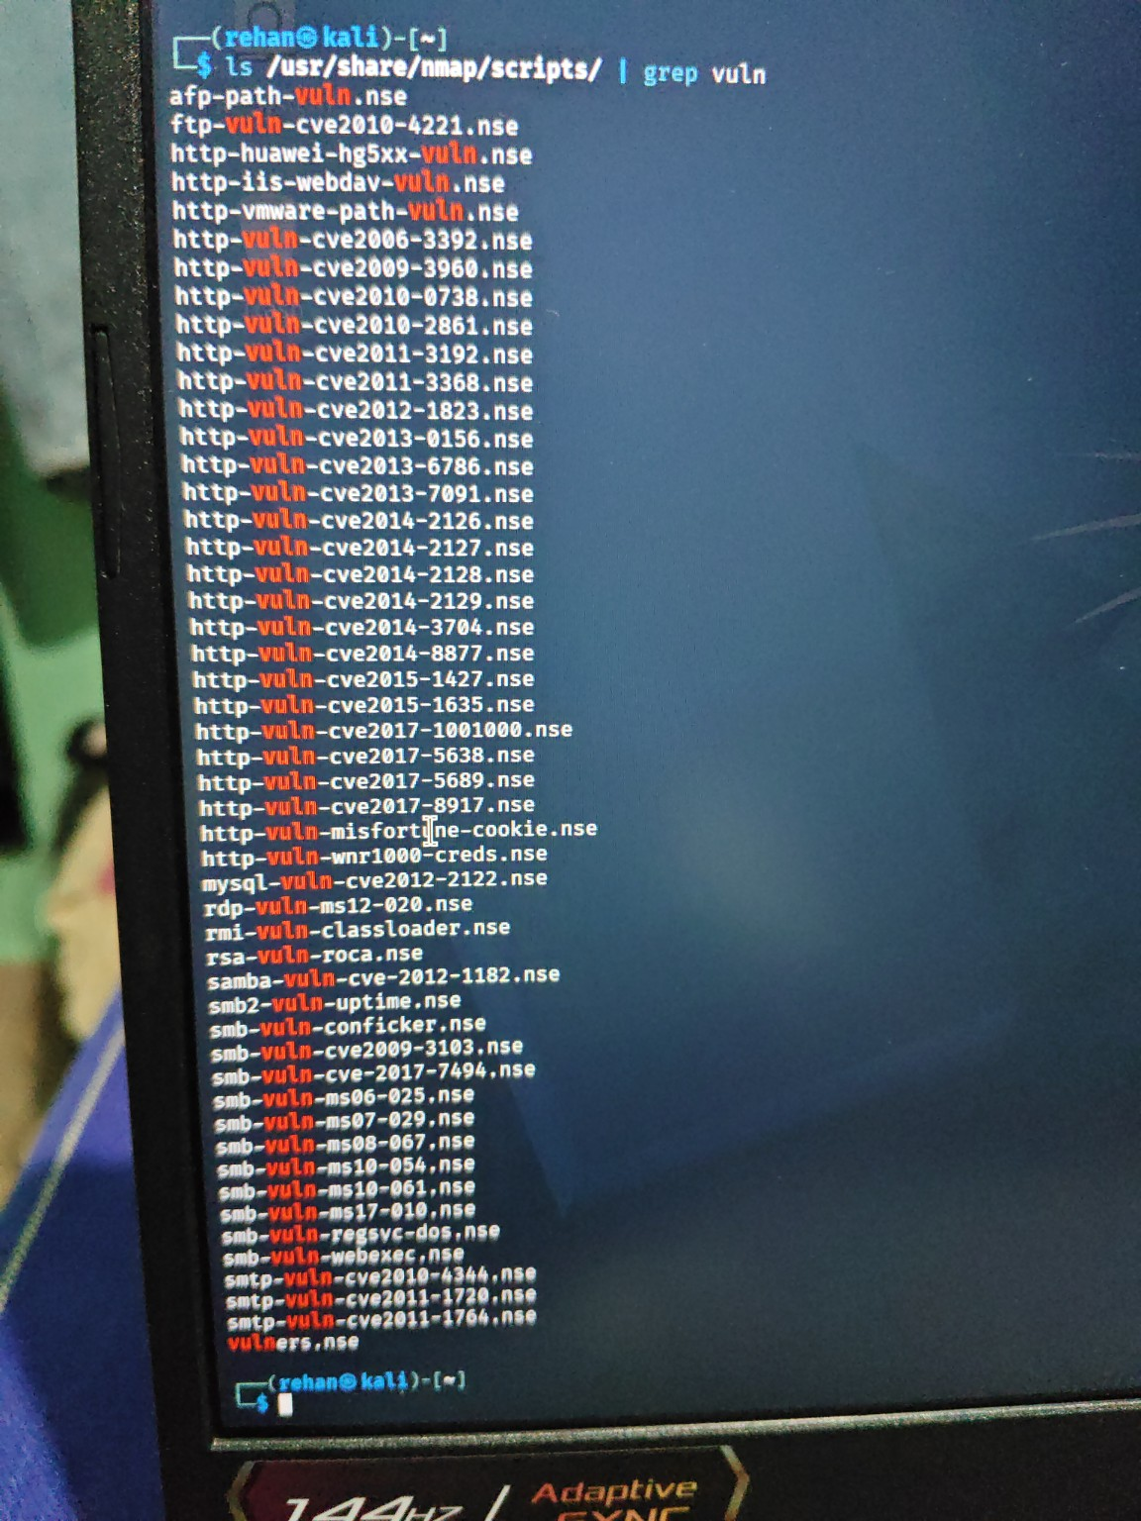
Evidence A4 — Python HTTP server running on 127.0.0.1:8000 alongside Nmap detecting port 8000/tcp as open.
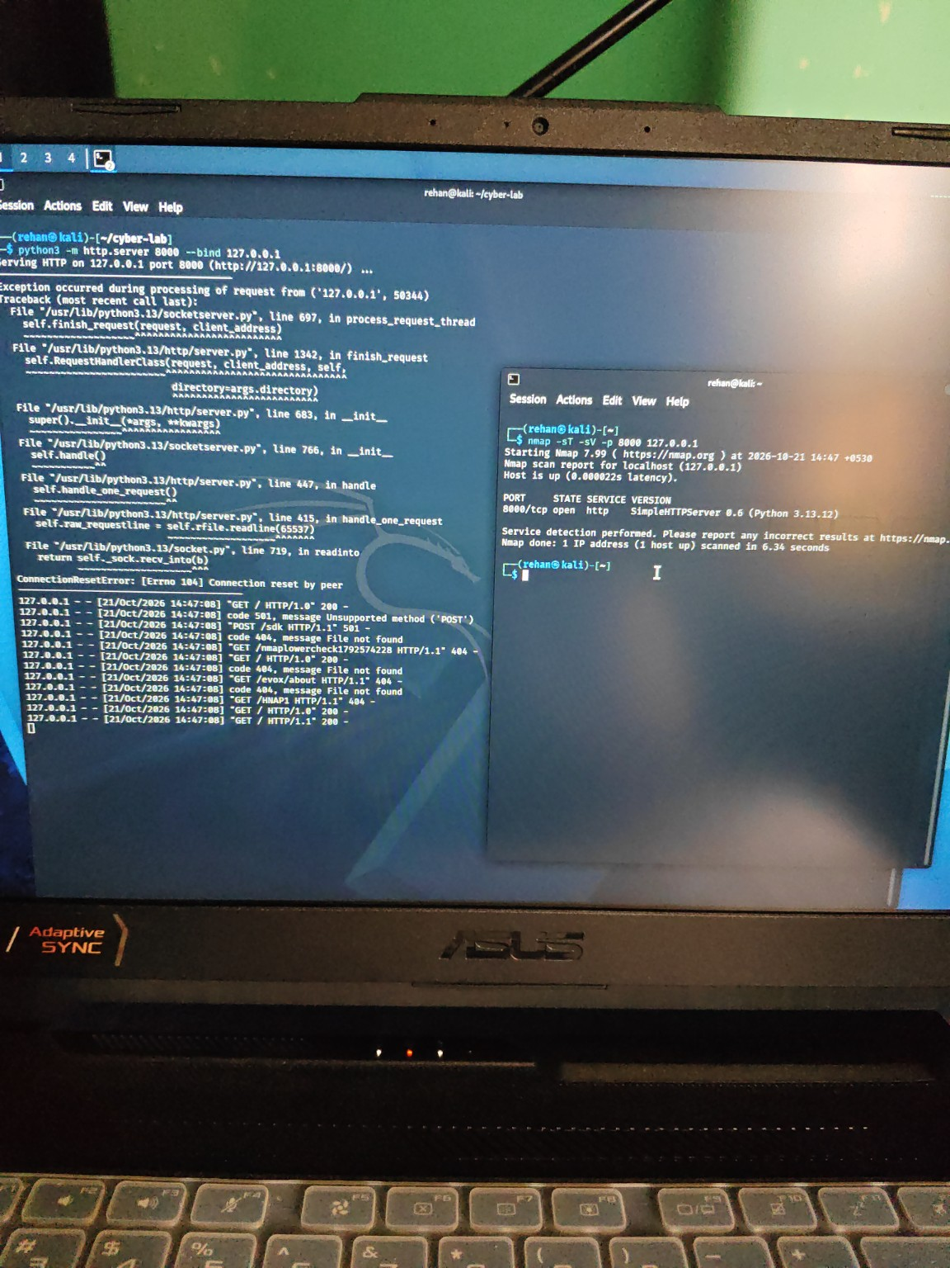
Evidence A5 — Python server request log, including HTTP 200, 404, 501 and connection-reset output; the server is stopped with Ctrl+C.
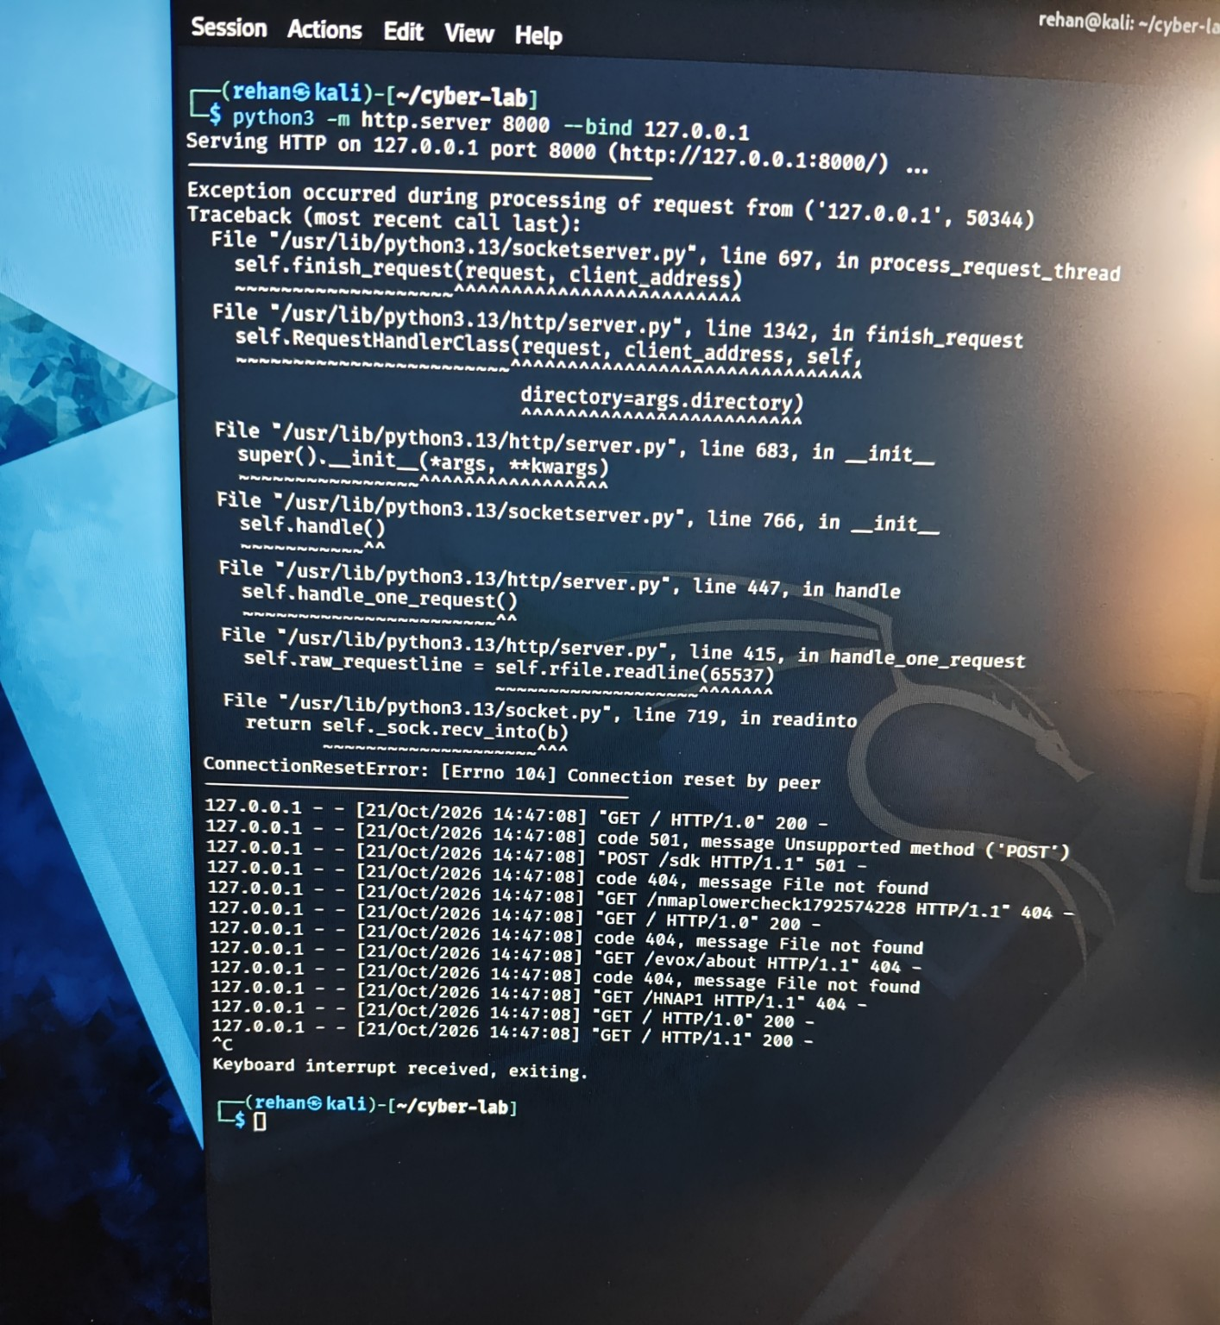
Evidence A6 — Nmap scan showing port 8000 open while the Python HTTP service is running and closed after the service is stopped.
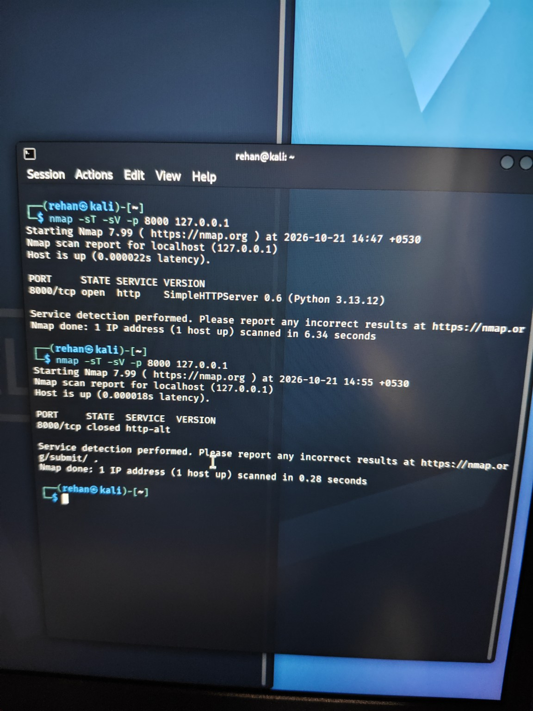
Evidence A7 — Ping to the VirtualBox gateway 10.0.2.2: four packets received and 0% packet loss.
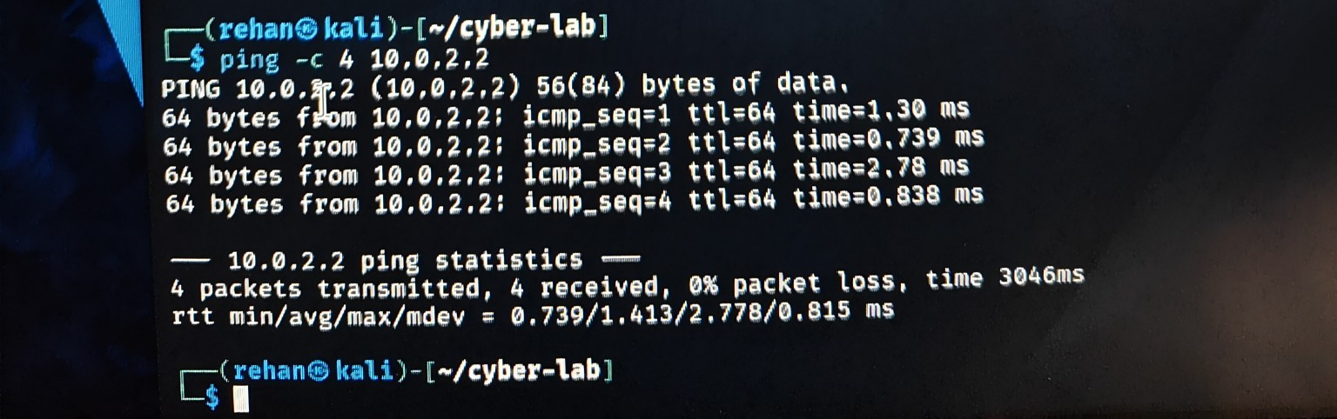
Evidence A8 — Ping to google.com: hostname resolution and four replies with 0% packet loss.
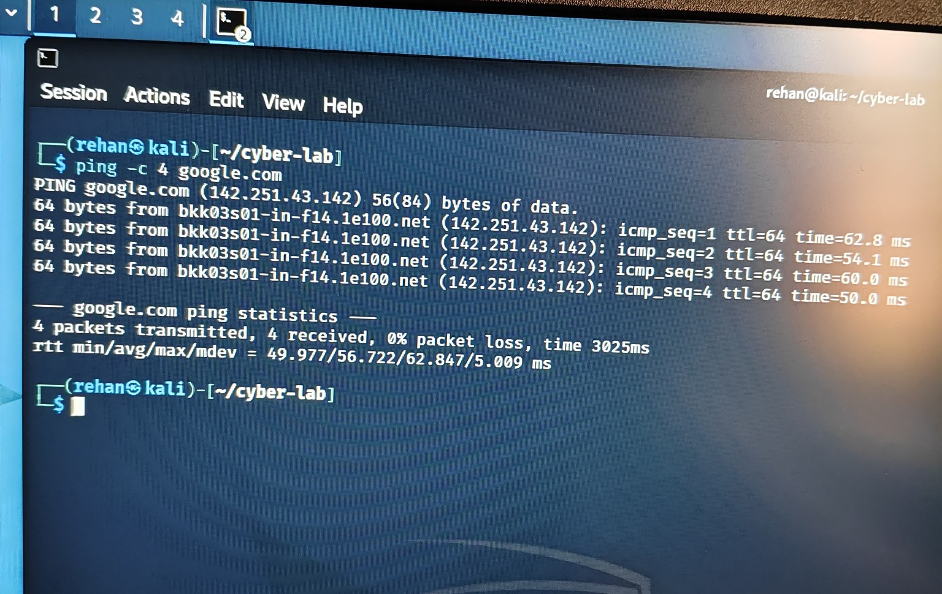
Evidence A9 — Nmap 7.99 version information and localhost scan showing 1,000 closed TCP ports.
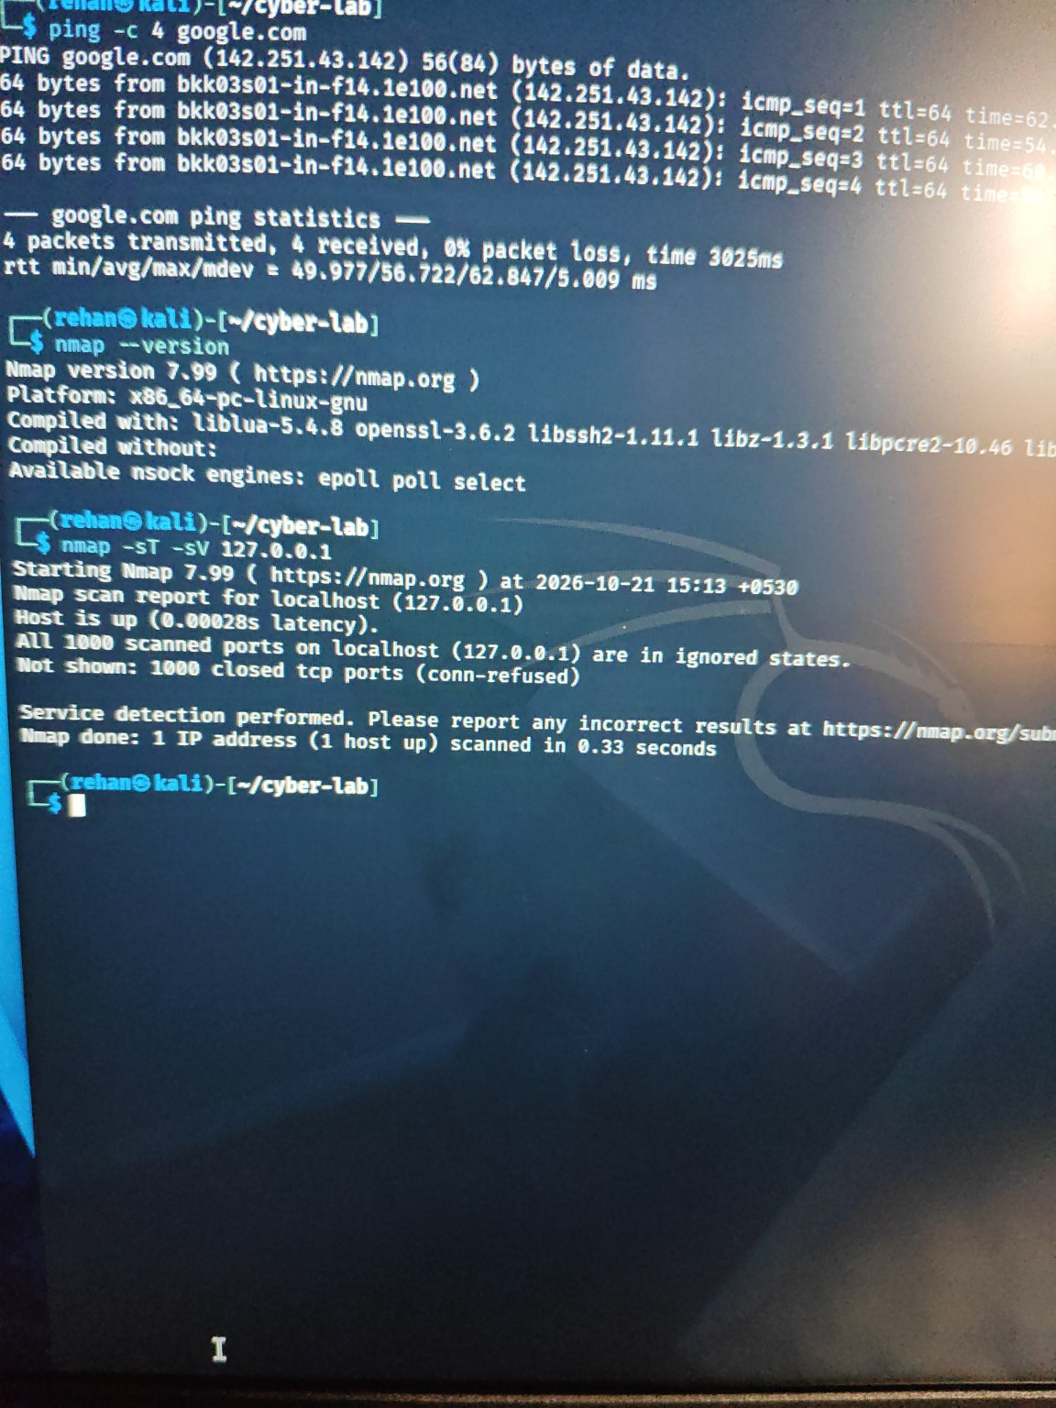
Evidence A10 — TCP listening-socket inspection with ss -lnt and sudo ss -lntp; no listening entries are shown in the captured output.
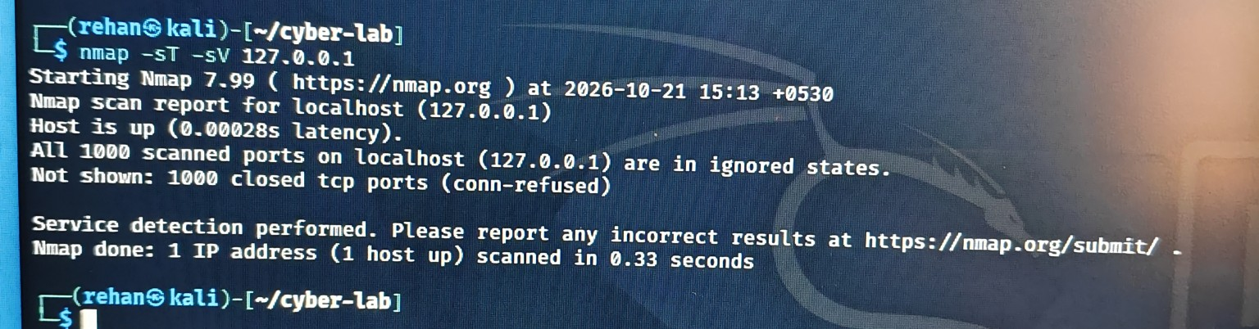
Evidence A11 — UFW status check returns 'command not found', showing that the ufw command was unavailable.
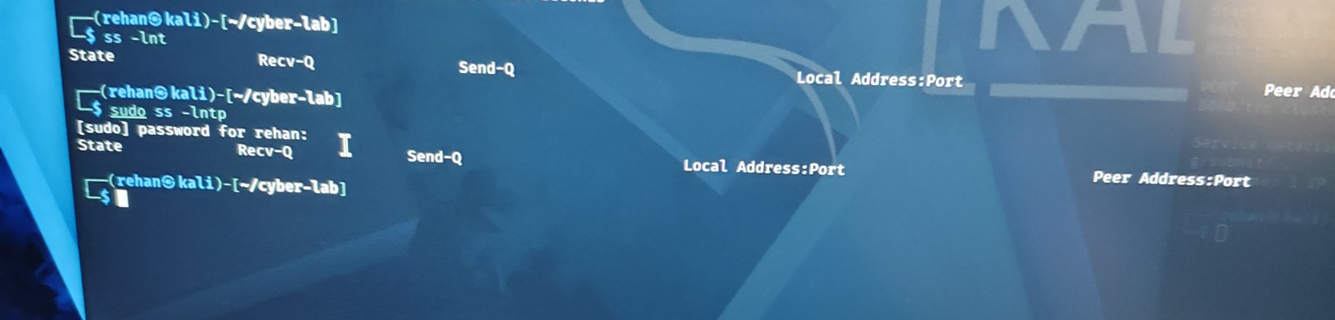
Evidence A12 — Linux kernel and x86_64 architecture information from uname -a.
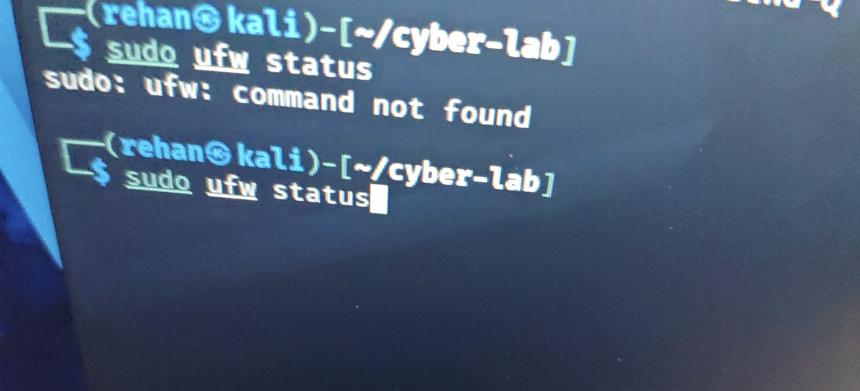
Evidence A13 — iptables -S output: default INPUT, FORWARD and OUTPUT policies are ACCEPT, with no additional rules displayed.
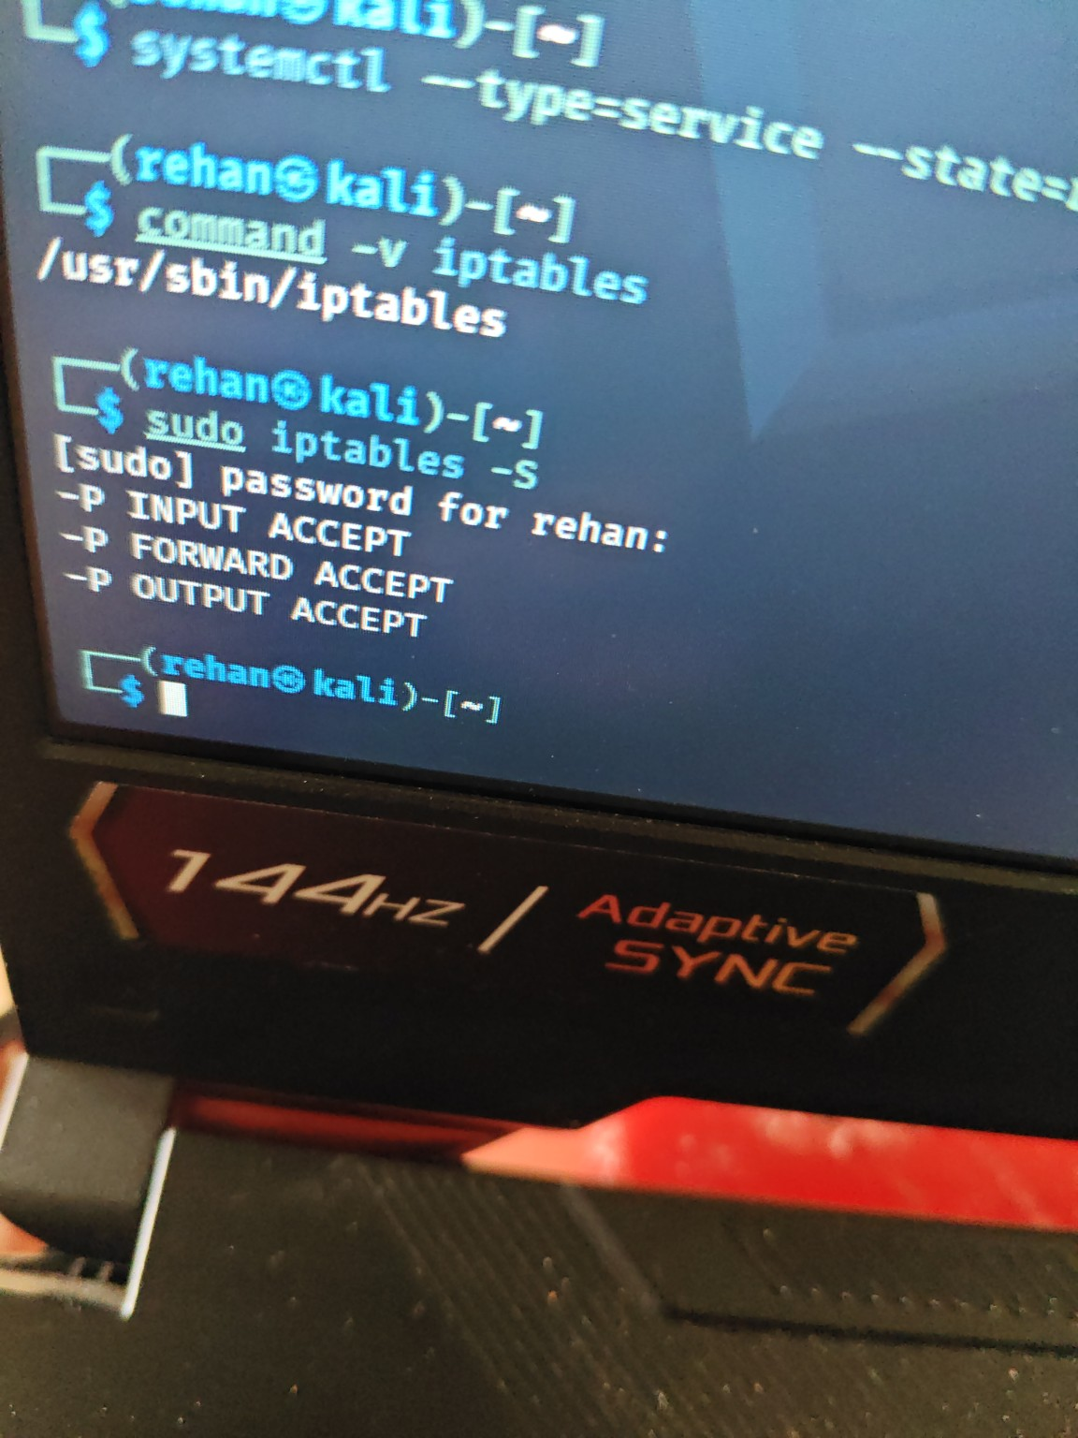
Embedded evidence images available in this document: 13. Other screenshots mentioned in the conversation should be retained with the submission if they are not embedded here.

Appendix B — Key Results Summary
Test | Observed result | Interpretation
Ping 10.0.2.2 | 4 sent, 4 received, 0% loss | Gateway responded during test.
Ping google.com | 4 sent, 4 received, 0% loss | Name resolution and ICMP connectivity worked during test.
Nmap localhost baseline | 1,000 common TCP ports closed | No listener was found on those scanned ports at that time.
Nmap while server ran | 8000/tcp open; HTTP / Python 3.13.12 | Temporary local web service was listening.
Nmap after Ctrl+C | 8000/tcp closed | Stopping the service removed the listener.
iptables -S | INPUT/FORWARD/OUTPUT default policies ACCEPT | Default policies allow traffic; no extra rules shown in this output.
UFW check | command not found | UFW command unavailable; not evidence by itself of total firewall status.
vulners script | vulners.nse present | Script availability confirmed; no vulnerability finding confirmed.

Declaration of accuracy: This report is based on the commands and results visible in the supplied screenshots and the user's stated observations. No unobserved vulnerability, successful exploitation, or firewall configuration change is claimed.

