1.) Assume that the functions Thread1() and Thread2() run in separate threads. Suppose argv[1] = “Hello, world!” . What does this code print? Make note of any errors with the program. Assume any #include s are provided such that the program compiles.
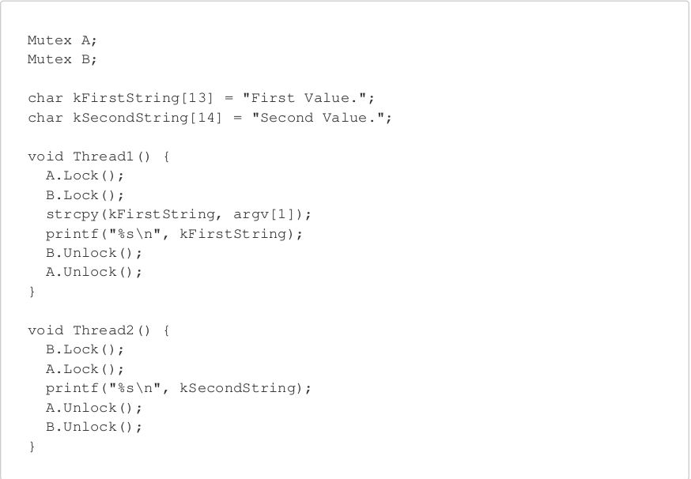

2.) Assume you have 12 bytes of heap memory. In C/C++, give a sequence of malloc and free such that the final malloc fails with ENOMEM , even though enough memory is theoretically available.

int32_t* m1 = (int32_t *) malloc(sizeof(int32_t));
int32_t* m2 = (int32_t *) malloc(sizeof(int32_t));
int32_t* m3 = (int32_t *) malloc(sizeof(int32_t));
free(m1);
free(m3);

int64_t* m4 = (int64_t *) malloc(sizeof(int64_t));

m4 requires 8 bytes of heap memory. Theoretically we have 8 bytes available but still it would return ENOMEM because 8 bytes are not contiguous to allocate memory block for m4.

3.) Suppose a 16-bit memory-mapped system register for your microcontroller is located at address 0xabcd1234 . Write a C/C++ function that busy-waits until the register value is 0xfefe .

volatile uint32_t *ADDR = (uint32_t *) 0xABCD1234;
while(*ADDR != ( (uint32_t) 0xFEFE) ) );

4.) Write a C function that takes a null-terminated C-string ( char * ) and returns a dynamically allocated null-terminated C-string where every instance of the character 'a' is removed. For instance: “banana” would produce “bnn”. Assume strlen and malloc have been linked into your program.
char* char_remove(char * str){
char * rt_str = (char *)malloc(strlen(str)+1);
int j=0;
for(int i=0; i<(int)strlen(str); i++){
if(str[i] != 'a'){
rt_str[j++] = str[i];
}
}
rt_str[j] = '\0';
return rt_str;
}

5.) Please provide documentation for the following function:

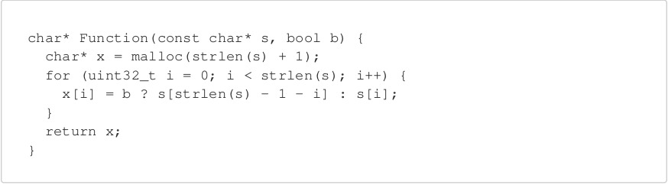
/*
* Stores original or reversed copy of input string at dynamically
* allocated Memory.
*
* @param s String copied to dynamically allocated Memory.
* @param b Option to copy original string or reverse the string.
* If b is 0, original string will be copied to dynamically
* allocated memory and if it's 1 then string would be
* reversed.
* @return A pointer to Dynamically Allocated Memory.
* */
char* Function(const char* s, bool b);

