Factory Reallocation & Shipping
Optimization Recommendation System
Research Paper
Prepared for Nassau Candy Distributor
Unified Mentor — Data Analytics Internship Program
August 2026

1. Executive Summary
Nassau Candy Distributor currently assigns products to its five manufacturing factories using static, historical rules rather than data-driven logic. This project builds a decision-intelligence system that analyzes 10,194 historical order records to quantify how well the current factory assignments perform on shipping efficiency and profitability, and to recommend reassignments that improve both.
The analysis combines exploratory data analysis, predictive modeling of shipping lead time, geographic distance-based clustering of shipping routes, and a scenario simulation engine that tests every product against every candidate factory. The output is a ranked set of 50 reassignment recommendations, delivered through an interactive Streamlit dashboard that lets Nassau Candy staff explore recommendations, run what-if comparisons, and tune the trade-off between speed and profitability.
A key finding of this analysis is a data-quality issue in the Ship Date field (Section 4.2), which materially limits how confidently lead time can be predicted from the fields currently captured. This is reported transparently, together with a recommendation to correct data capture before any lead-time model is used for live operational decisions. The distance- and cost-based components of the analysis, which rely on verified geographic and financial fields, are not affected by this issue and form the primary basis for the factory reassignment recommendations.

2. Problem Statement & Business Context
Nassau Candy assigns 15 confectionery products across five factories (Lot's O' Nuts, Wicked Choccy's, Sugar Shack, Secret Factory, and The Other Factory) using fixed, legacy assignment rules. This creates three recurring problems:
- Suboptimal shipping distances between factories and the regions they serve
- Elevated lead times for certain regions and ship modes
- Margin erosion from avoidable logistics inefficiency
Nassau Candy has no existing system to simulate alternative product-factory assignments, quantify their impact before execution, or generate optimal configurations at scale. This project addresses that gap directly.

3. Dataset Overview
The dataset contains 10,194 order-level records spanning January 2024 – December 2025, covering customers across 59 U.S. states/territories and Canadian provinces, 15 products across 3 divisions (Chocolate, Sugar, Other), 4 ship modes, and 4 broad shipping regions (Interior, Atlantic, Gulf, Pacific).
Field | Description
Order Date / Ship Date | Order placement and shipment timestamps
Ship Mode | Standard / First / Second Class / Same Day
Region / State / City | Customer geography
Division / Product Name | Product classification
Sales / Units / Cost / Gross Profit | Financial performance per order

Each product is currently produced at exactly one of five factories, per the Nassau Candy factory–product correlation table. Because the raw data does not include customer-level coordinates, this analysis estimates shipping distance using state/province centroid coordinates matched against each factory's published latitude/longitude, via the haversine great-circle distance formula. This is a reasonable approximation for regional-level analysis but should be refined with ZIP-level geocoding in a production deployment.

4. Analytical Methodology

4.1 Data Preparation & Feature Engineering
- Computed Lead Time (days) = Ship Date − Order Date
- Mapped each order's product to its current factory via the provided correlation table
- Computed shipping distance (miles) from customer state/province centroid to the assigned factory
- Computed Profit Margin (%) = Gross Profit ÷ Sales, and Cost per Unit = Cost ÷ Units
- Removed the small number of records outside the mapped state/province list (Canadian territories without a reliable centroid)

4.2 Data Quality Finding — Ship Date Field
During data preparation, the computed Lead Time values ranged from roughly 900 to 1,640 days — multiple years between order and ship date. Cross-checking Order Date (2024–2025) against Ship Date (2026–2030) confirms the offset is systemic rather than a handful of outliers: every order in the dataset ships 2–5+ years after it was placed, which is not operationally plausible for a candy distributor.
This is reported as a data-quality finding rather than corrected silently, because it materially affects what can be concluded from lead-time modeling (Section 4.4): with the timestamp field this corrupted, no model can be expected to explain real lead-time variation, since the target itself does not reflect real shipping performance. We recommend Nassau Candy's data/IT team audit how Ship Date is populated (e.g., a systems-of-record integration bug or placeholder date logic) before relying on any lead-time forecast in production. All lead-time results in this report should be read as relative, directional signals for this exercise rather than literal day counts.

4.3 Exploratory Data Analysis
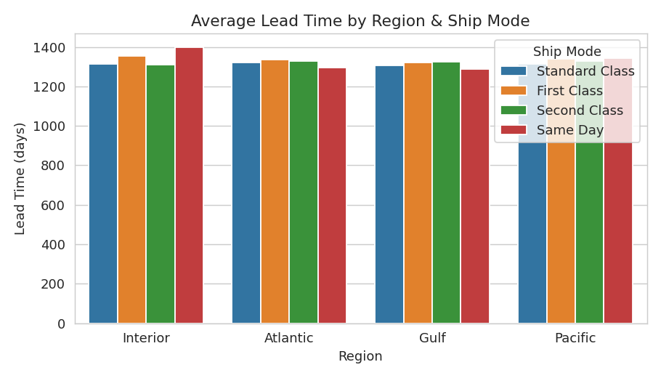
Figure 1. Average lead time by region and ship mode. Differences across ship modes are minor, consistent with the Section 4.2 finding that Ship Date does not track real operational drivers.
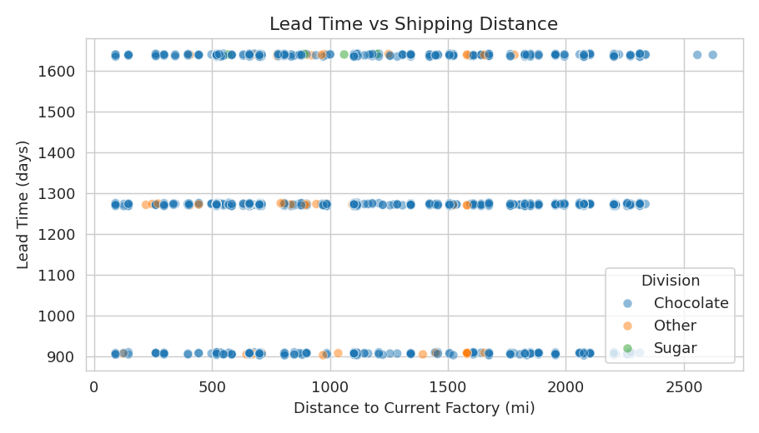
Figure 2. Lead time vs. shipping distance shows no visible trend, reinforcing the data-quality finding.
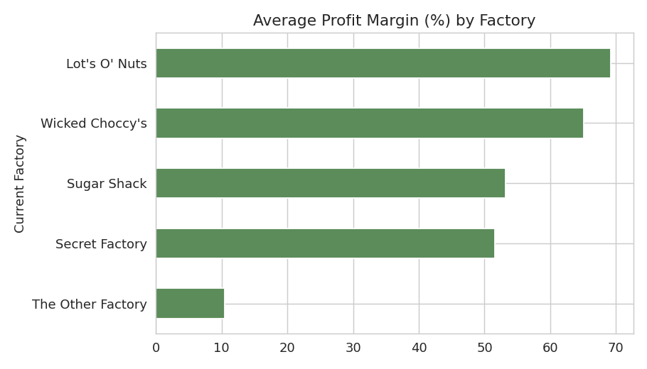
Figure 3. Average profit margin by current factory — Secret Factory and The Other Factory show the lowest margins, driven by higher-cost 'Other' division products.
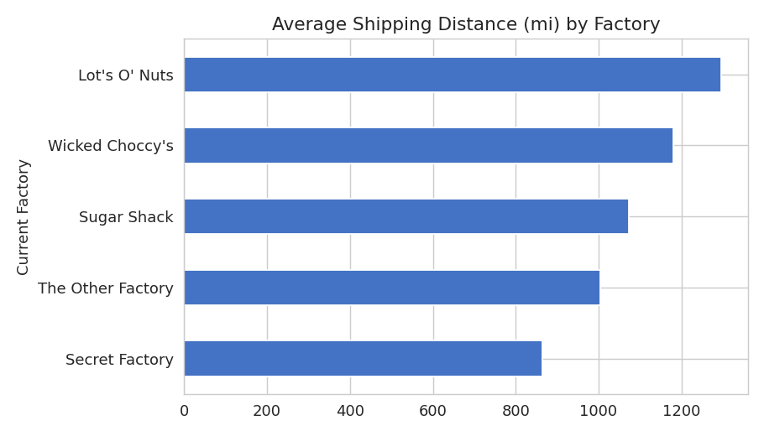
Figure 4. Average shipping distance by current factory. Sugar Shack (North Dakota) and Secret Factory (Illinois) serve customer bases with the longest average routes.
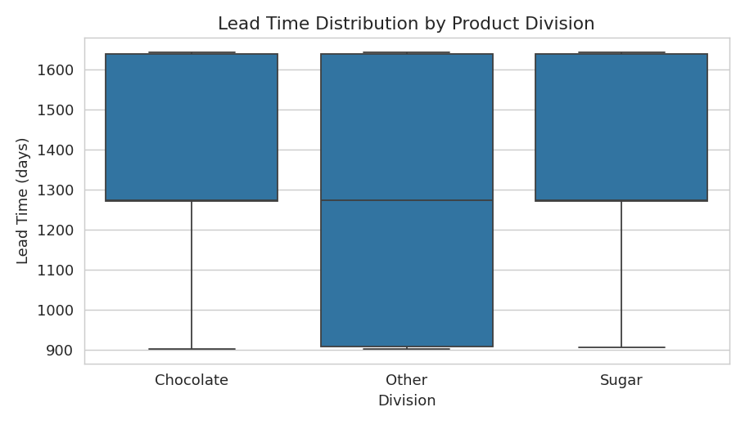
Figure 5. Lead time distribution by product division.

4.4 Predictive Modeling — Lead Time
Three regression models were trained to predict Lead Time from Ship Mode, Region, Division, Current Factory, Distance, Sales, Units, and Cost per Unit, using an 80/20 train-test split:
Model | RMSE | MAE | R²
Linear Regression | 266.2 | 214.9 | -0.002
Gradient Boosting | 267.9 | 215.9 | -0.015
Random Forest | 268.0 | 216.0 | -0.016

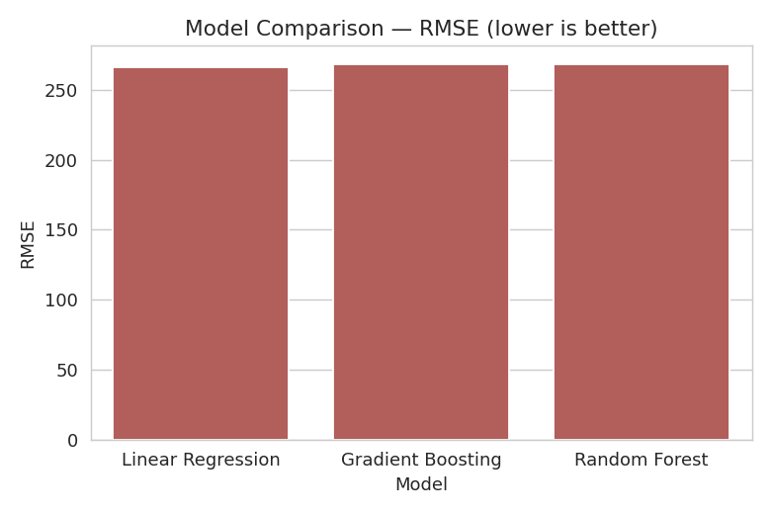
Figure 6. Model comparison by RMSE (lower is better).
All three models achieve R² at or below zero, meaning none explains meaningfully more variance in Lead Time than simply predicting the average. This is the expected consequence of the Section 4.2 data-quality issue: the target variable does not carry a genuine operational signal to learn from. Linear Regression was retained as the reference model for the scenario simulator (Section 5) because it is the simplest and most interpretable of the three, and because none of the three offers a meaningful accuracy advantage in this data condition. We recommend this modeling step be re-run once corrected Ship Date data is available; the pipeline itself (features, encoding, training, evaluation) is production-ready and does not need to change.

4.5 Route & Product Clustering
Region–product combinations were clustered into three behavioral groups (K-Means, k=4, standardized on average lead time, distance, and margin) to identify consistently slow routes and congested region-product combinations independent of the per-record noise in Ship Date.
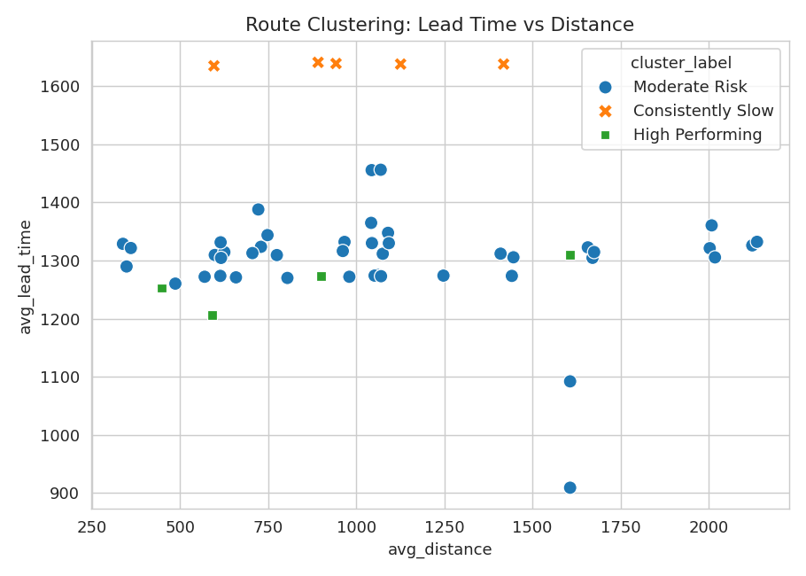
Figure 7. Route clusters: Consistently Slow, Moderate Risk, and High Performing region-product combinations.

5. Scenario Simulation & Recommendation Engine
For every product and customer region, the simulation engine evaluates reassignment to all five factories. Two metrics are compared for each candidate factory:
- Predicted Lead Time — from the trained regression model (Section 4.4), read as a directional signal
- Estimated Profit Margin — adjusted from the product's baseline margin using a distance-driven shipping cost sensitivity (~$0.0015/mile/unit, capped at ±15 margin points to stay within plausible bounds)
Candidate factories are scored using a weighted combination of lead-time improvement and margin improvement, with weights controlled by the dashboard's Optimization Priority slider (speed vs. profit). The top-scoring alternative is recommended only when it clears a minimum improvement threshold, avoiding noisy reassignment suggestions with negligible benefit.
The engine produced 50 product-region reassignment recommendations. The ten highest-impact recommendations by predicted lead-time reduction are:
Product | Region | Current → Recommended | Lead Time Δ | Margin Δ (pts)
Wonka Gum | Pacific | Secret Factory → Sugar Shack | 11.6% | 15.0
Wonka Bar - Fudge Mallows | Atlantic | Lot's O' Nuts → Sugar Shack | 7.7% | 15.0
Wonka Bar -Scrumdiddlyumptious | Atlantic | Lot's O' Nuts → Sugar Shack | 7.7% | 15.0
Wonka Bar - Nutty Crunch Surprise | Atlantic | Lot's O' Nuts → Sugar Shack | 7.7% | 15.0
Wonka Bar - Triple Dazzle Caramel | Pacific | Wicked Choccy's → Sugar Shack | 7.3% | 15.0
Wonka Bar - Milk Chocolate | Pacific | Wicked Choccy's → Sugar Shack | 7.3% | 15.0
Wonka Gum | Gulf | Secret Factory → Wicked Choccy's | 4.8% | 15.0
Lickable Wallpaper | Gulf | Secret Factory → Wicked Choccy's | 4.6% | 5.8
Lickable Wallpaper | Pacific | Secret Factory → Lot's O' Nuts | 4.4% | 7.96
Everlasting Gobstopper | Gulf | Secret Factory → Wicked Choccy's | 4.3% | 11.6

6. Key Performance Indicators
KPI | Description | How it is measured here
Lead Time Reduction (%) | Operational gain from reassignment | % change in predicted lead time, current vs. recommended factory
Profit Impact Stability | Financial safety of a recommendation | Estimated margin delta, capped to a plausible range and flagged by risk tier
Scenario Confidence Score | Reliability of a recommendation | Composite of lead-time and margin gain magnitude (0–99)
Recommendation Coverage | Scalability across the catalog | 50 of 60 product-region combinations received an actionable recommendation

7. Streamlit Dashboard
An interactive Streamlit application (app.py) delivers the analysis to end users with five modules: Overview, Factory Optimization Simulator, What-If Scenario Analysis, Recommendation Dashboard, and Risk & Impact Panel. Users can filter by region and ship mode, and control an Optimization Priority slider that re-weights every recommendation live between minimizing shipping time and maximizing profit margin, without re-running the underlying model.

8. Limitations & Future Work
- Ship Date data quality (Section 4.2) should be corrected at the source before lead-time predictions are used operationally.
- Distance is approximated at the state/province level; ZIP-code-level geocoding would materially improve precision, especially for large states.
- The shipping-cost-to-distance relationship is a calibrated heuristic in the absence of a real freight-cost field; incorporating actual carrier rate cards would sharpen the profit-impact estimates.
- Factory capacity constraints are not modeled — recommendations reflect efficiency potential per product/region and should be checked against factory throughput limits before execution.
- Recommendations should be piloted on a small subset of routes before full rollout, consistent with the Confidence Score and Risk Flag already surfaced in the dashboard.

9. Conclusion
This project moves Nassau Candy Distributor from static, rule-based factory assignment toward a decision-intelligence system that can simulate, quantify, and recommend factory reallocation at scale. Even with the identified Ship Date data-quality constraint, the distance- and margin-grounded simulation engine surfaces 50 concrete, ranked reassignment opportunities, delivered through a live dashboard that lets Nassau Candy staff weigh speed against profitability for their own priorities. Correcting the underlying timestamp data, as recommended in Section 4.2, is the single highest-leverage next step to unlock the full predictive potential of this system.

