Name: Rehan S. Bawakhan
SRN: PES2UG25CS820
SECTION: 5J

1. Links
https://github.com/rehanbawakhan/L5_62_voting-election-system
Commits: 13dfc47 Fix Bandit security issues · 0261ffa Fix Pylint issues and logic bugs · 94fe10d Fix Flake8 style issues

2. Summary of results
Tool | Before | After
Pylint score | 5.33 / 10 | 10.00 / 10
Bandit issues | 7 (2 High, 1 Medium, 4 Low) | 0
Flake8 warnings | 30 | 0

Tools used: Pylint 4.1.3, Bandit 1.9.4, Flake8 7.4.1. Pylint target was above 9.5; final score is 10.00/10.

3. Issue documentation table
Line numbers refer to the original file.
Issue | Type | Line(s) | Description | Fix Approach
Trojan-source bidi characters (B613, E2502) | Security (High) | 22 | Hidden U+202E/U+2066 characters made isOfficer look correct, but it returned True for every role, so a plain voter counted as an election officer. | Removed the bidi characters; return role in OFFICER_ROLES (allow-list).
MD5 hash for voter ID (B324) | Security (High) | 17 | MD5 is broken and collision-prone. | Switched to hashlib.sha256.
Unsafe XML parsing (B319, B409) | Security (Medium/Low) | 7, 75 | xml.dom.pulldom on untrusted postal-ballot XML allows entity-expansion (billion laughs) attacks. | Used defusedxml.pulldom; unsafe XML raises ValueError.
Hardcoded password (B105) | Security (Low) | 9 | ADMIN_PASSWORD = "Election@2026" stored in source code. | Read from ELECTION_ADMIN_PASSWORD env var.
random for receipts (B311) | Security (Low) | 72 | Predictable receipt numbers can be guessed or forged. | secrets.randbelow.
try/except/pass, bare except (B110, E722, W0702) | Bug / Security | 82-83 | All errors swallowed silently. | Catch only DefusedXmlException and raise a clear ValueError.
Late-binding lambda in loop (W0640) | Bug | 68 | Every lambda captured the same name, so announce() printed NOTA: 0 three times. | List comprehension evaluated per candidate.
Double voting, unvalidated candidates | Bug (logic) | 26-34, 80 | Ben voted twice; 'bob' became a separate candidate; postal ballots skipped all checks. | Shared record_vote() checks registration, voted flag and normalises candidate names.
Off-by-one age and poll-close checks | Bug (logic) | 16, 29 | age > 18 rejected 18-year-olds; hour > 18 accepted a vote at 18:30. | age >= MIN_VOTING_AGE and hour >= POLLS_CLOSE_HOUR.
Wrong turnout / percent, divide by zero | Bug (logic) | 52, 56 | Turnout showed 166.67% (counted ballots, not voters); // truncated; crash with no voters. | Count voters with voted=True, true division, guard empty cases.
Winner ignores ties | Bug (logic) | 42-49 | First-highest candidate returned even on a tie; NOTA missing from tally. | Tally lists every candidate; winner reports ties.
Unused imports/variables (F401, F841, W0611, W0612) | Style | 1-4, 32, 45, 55 | sys, json, random and variables receipt, total, now unused. | Removed; receipt now stored on the voter record.
Shadowed global (W0621) | Refactor | 58 | Parameter ballots in countFor shadowed the global list. | Renamed to ballot_list.
camelCase names (C0103) x7 | Convention | 15-74 | Functions not in snake_case. | Renamed to snake_case.
Missing docstrings (C0114, C0116) | Convention | 1, all | No module or function docs. | Added docstrings.
Blank lines, long lines, trailing whitespace (E302, E305, E501, W291, C0301, C0303) | Style | All | Need 2 blank lines around functions; lines up to 115 chars; trailing spaces; main() ran on import. | Added blank lines, wrapped lines, stripped whitespace, added __main__ guard.

4. Before and after screenshots

4.1 Program output
Command:
python election_system.py
Before fixing
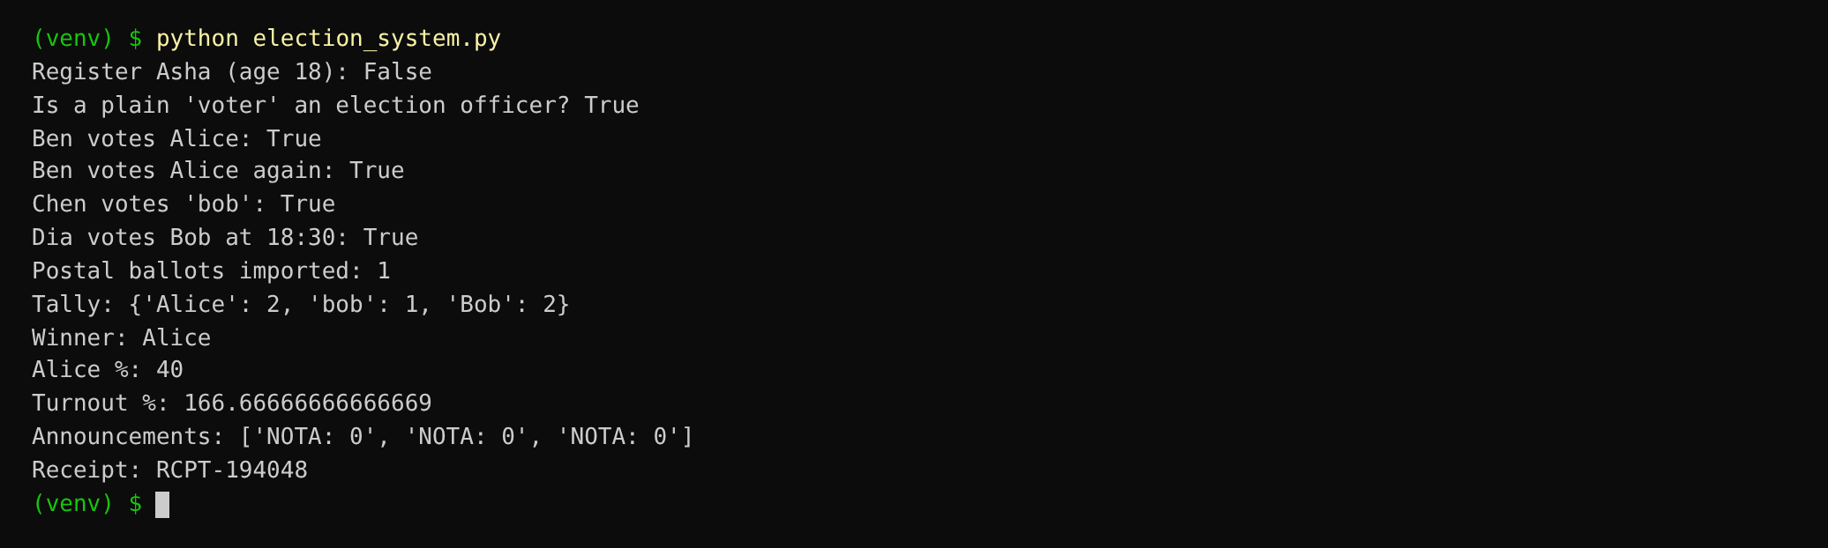
After fixing
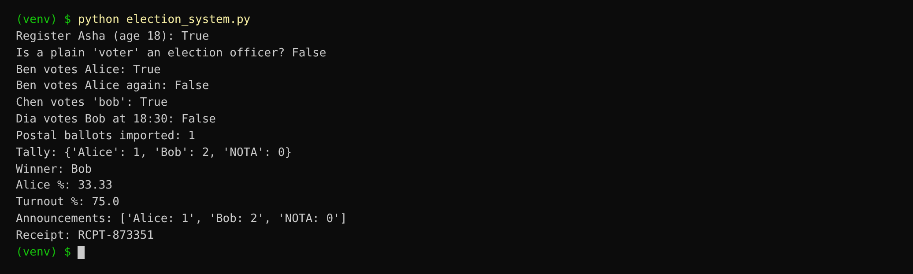

4.2 Pylint
Command:
python -m pylint election_system.py
Before fixing
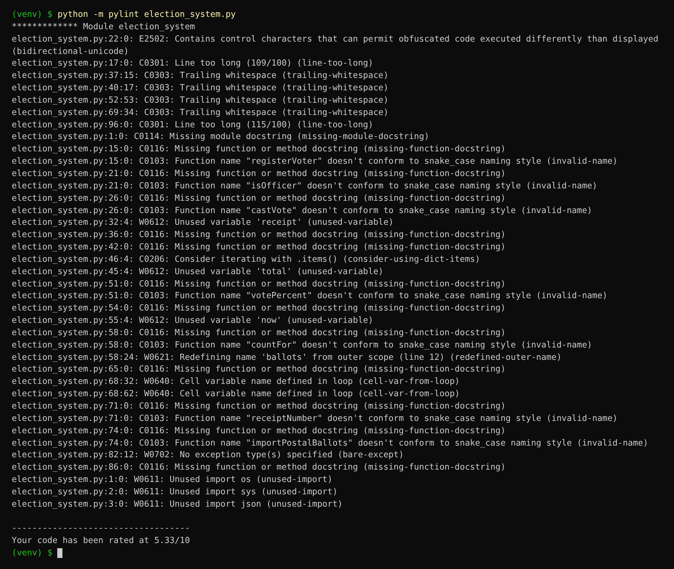
After fixing
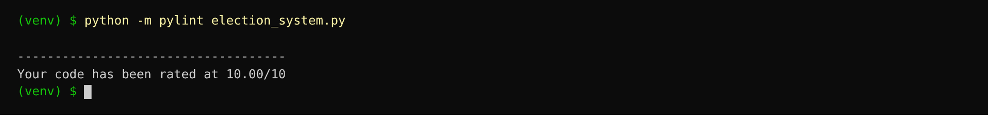

4.3 Bandit
Command:
python -m bandit -r election_system.py
Before fixing
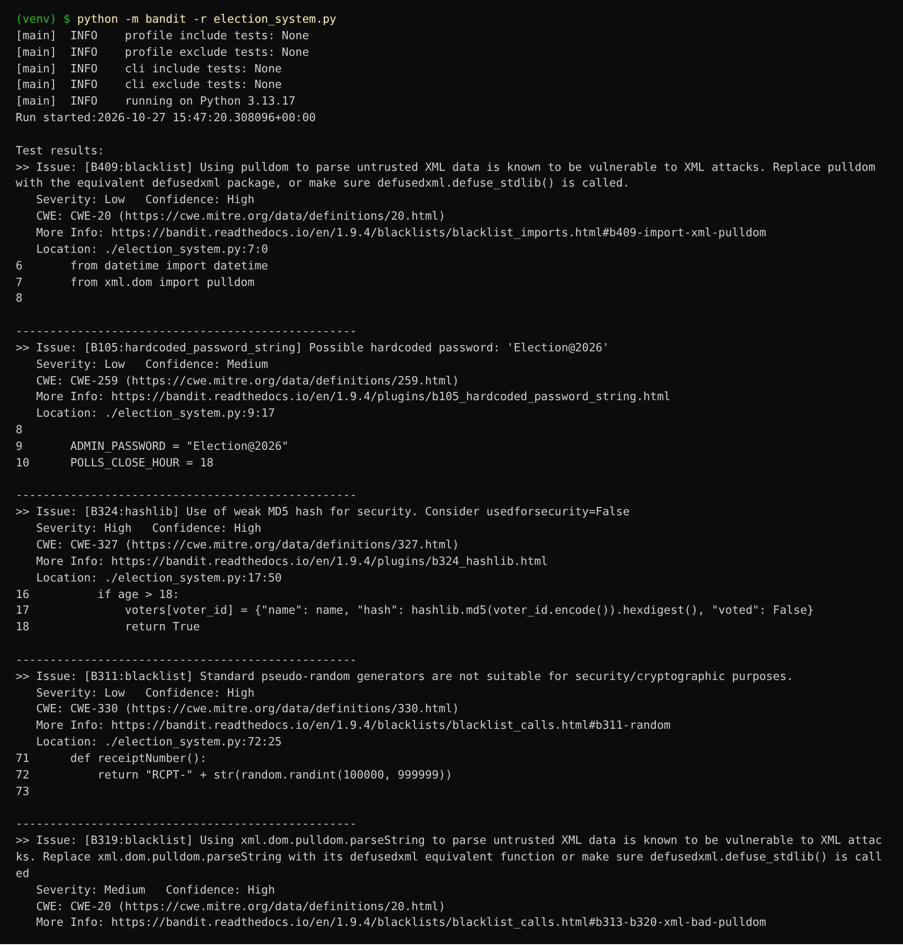
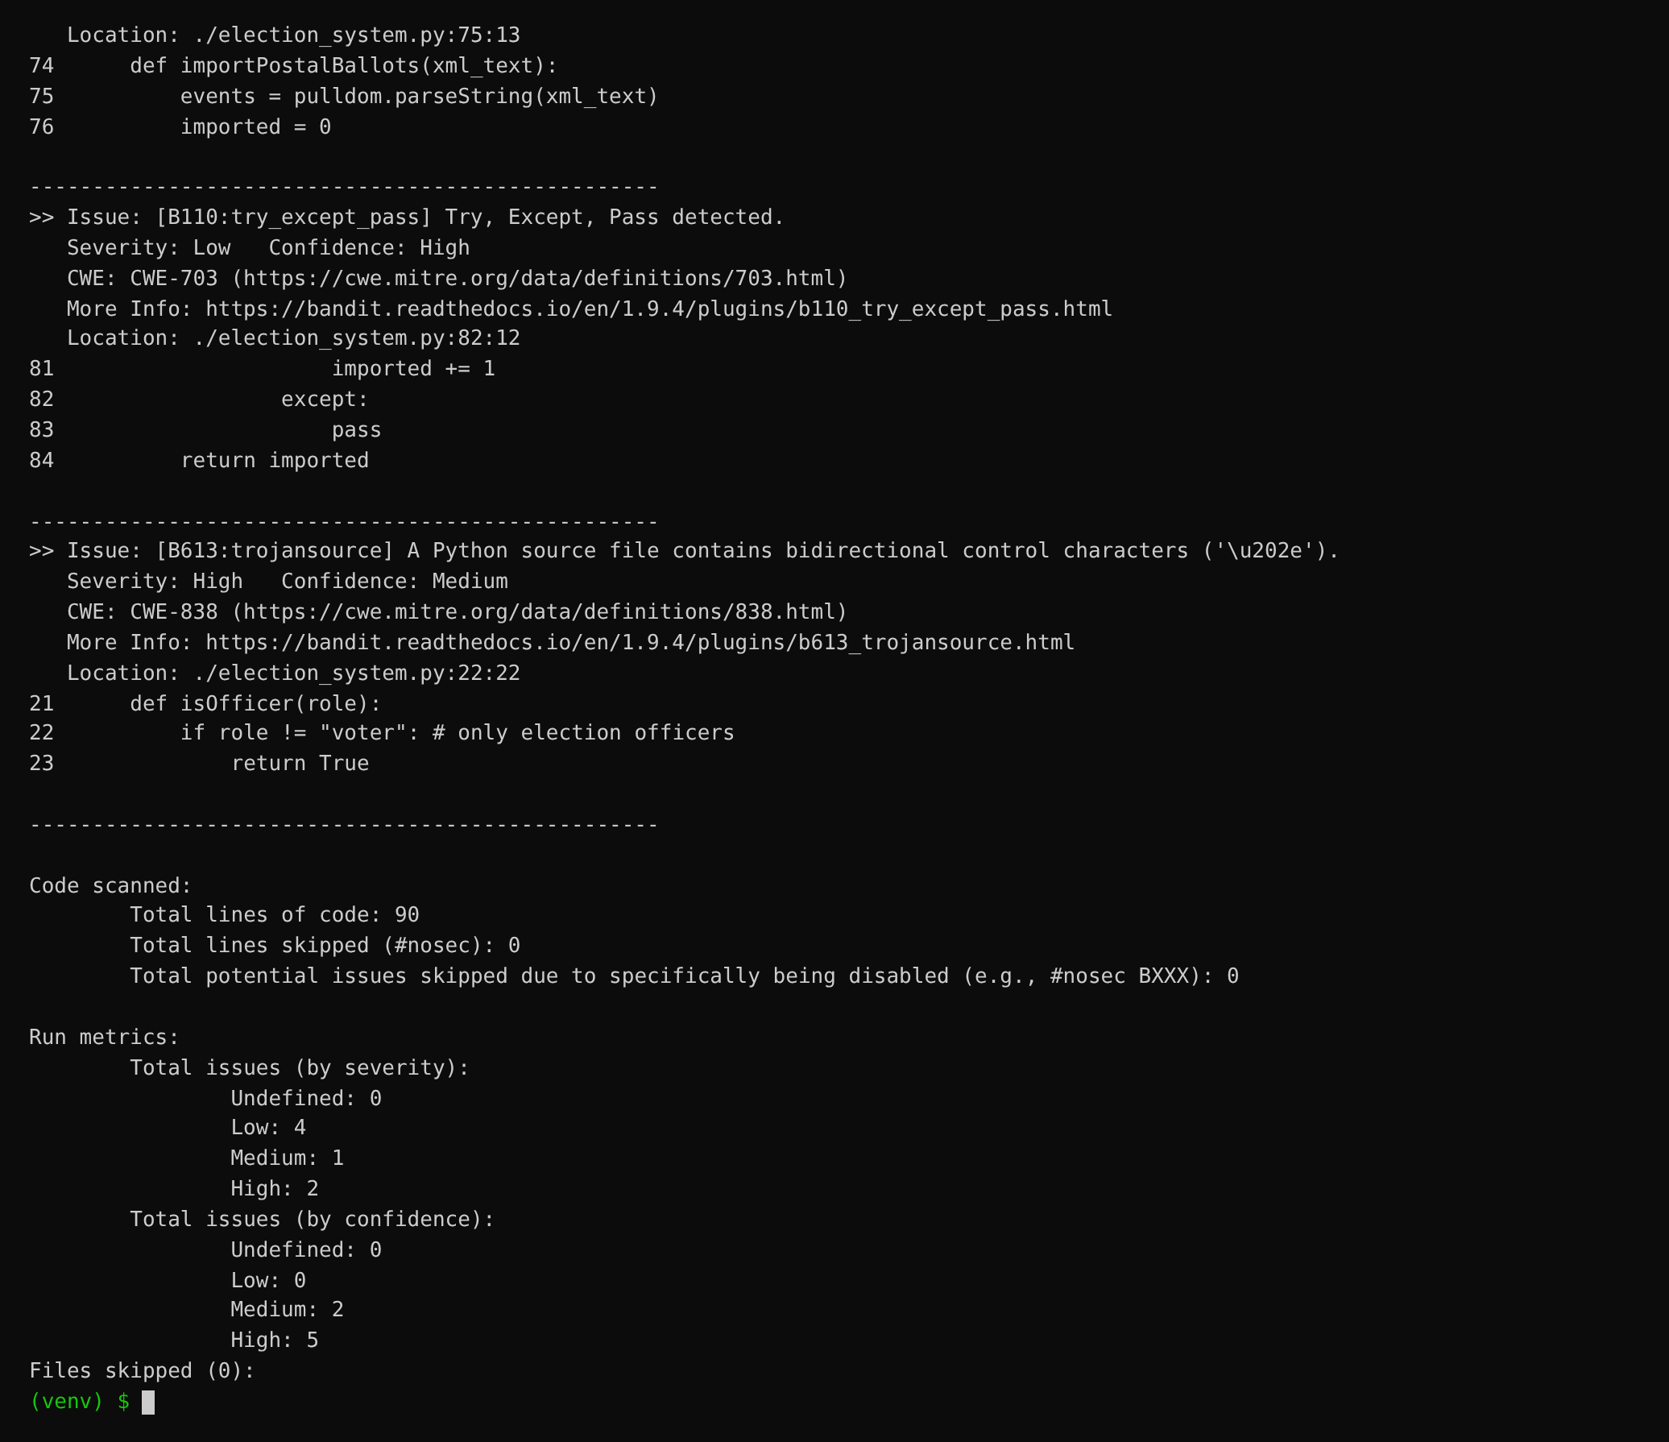
After fixing
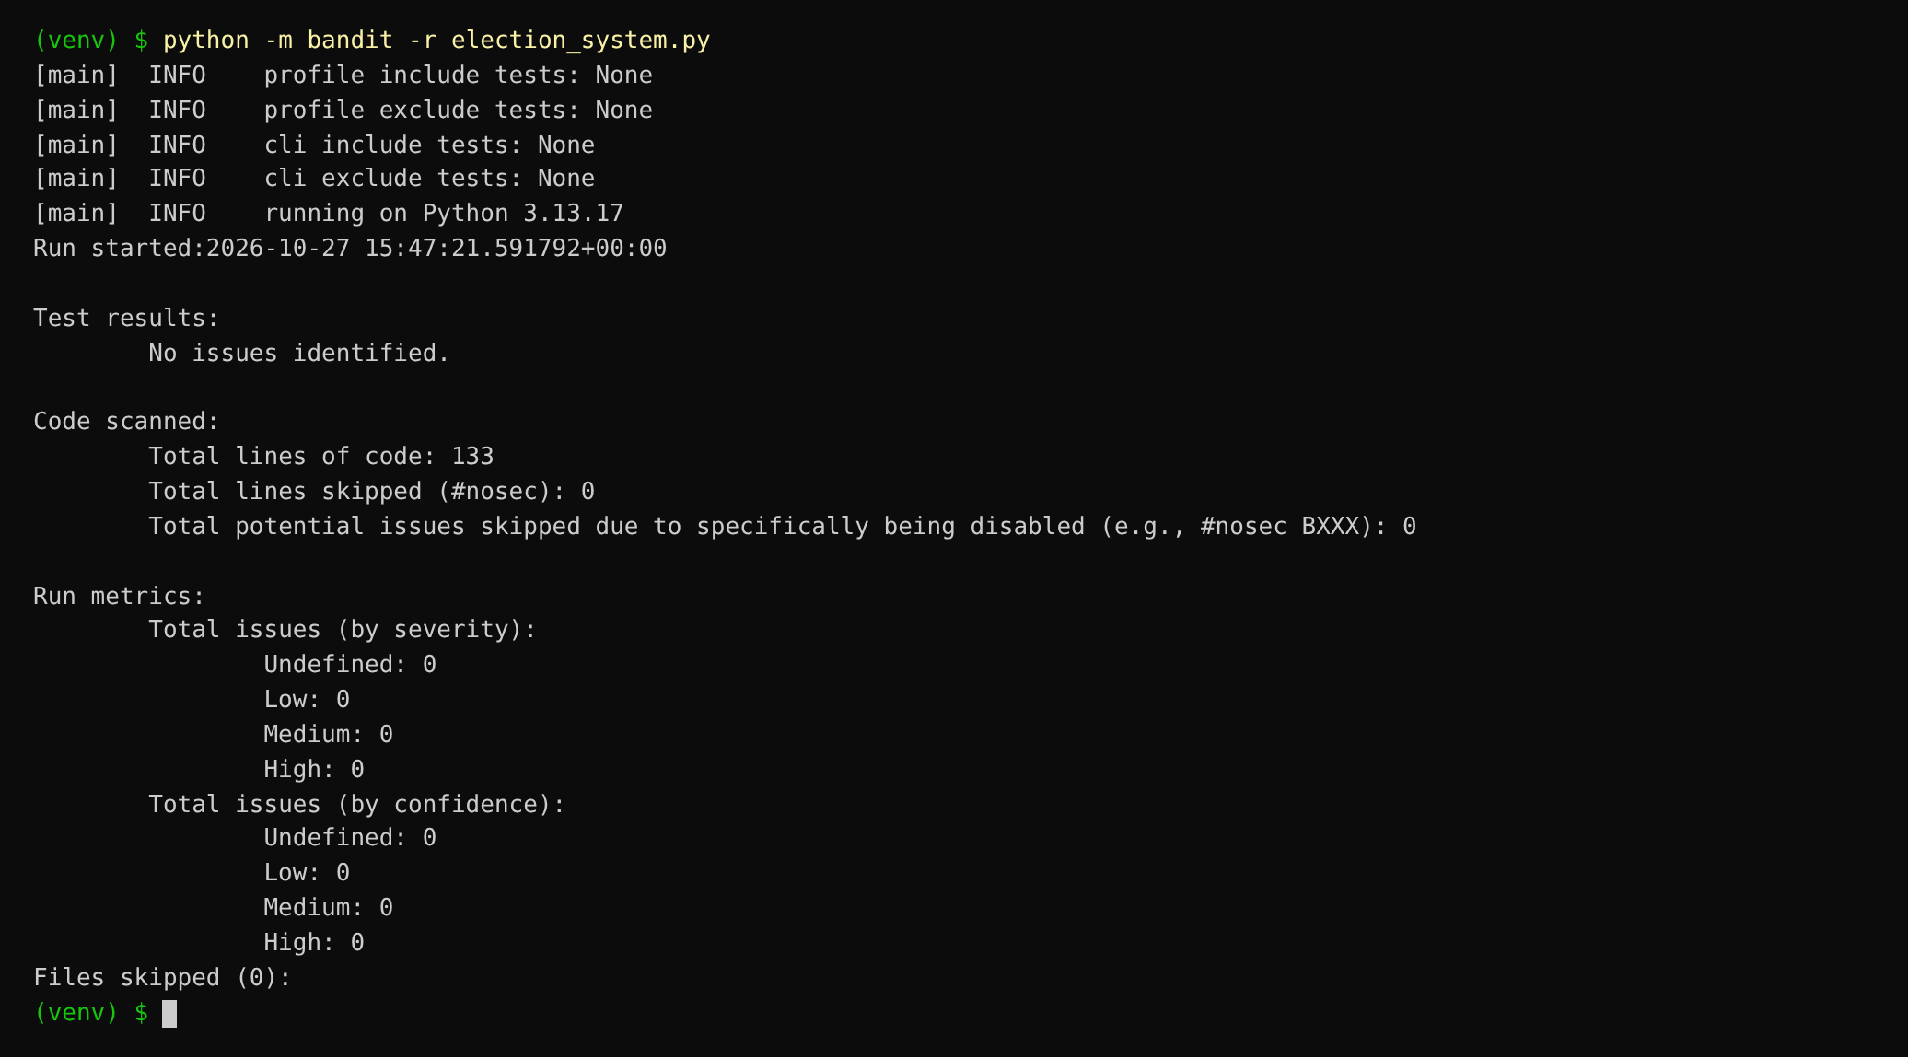

4.4 Flake8
Command:
python -m flake8 election_system.py
Before fixing
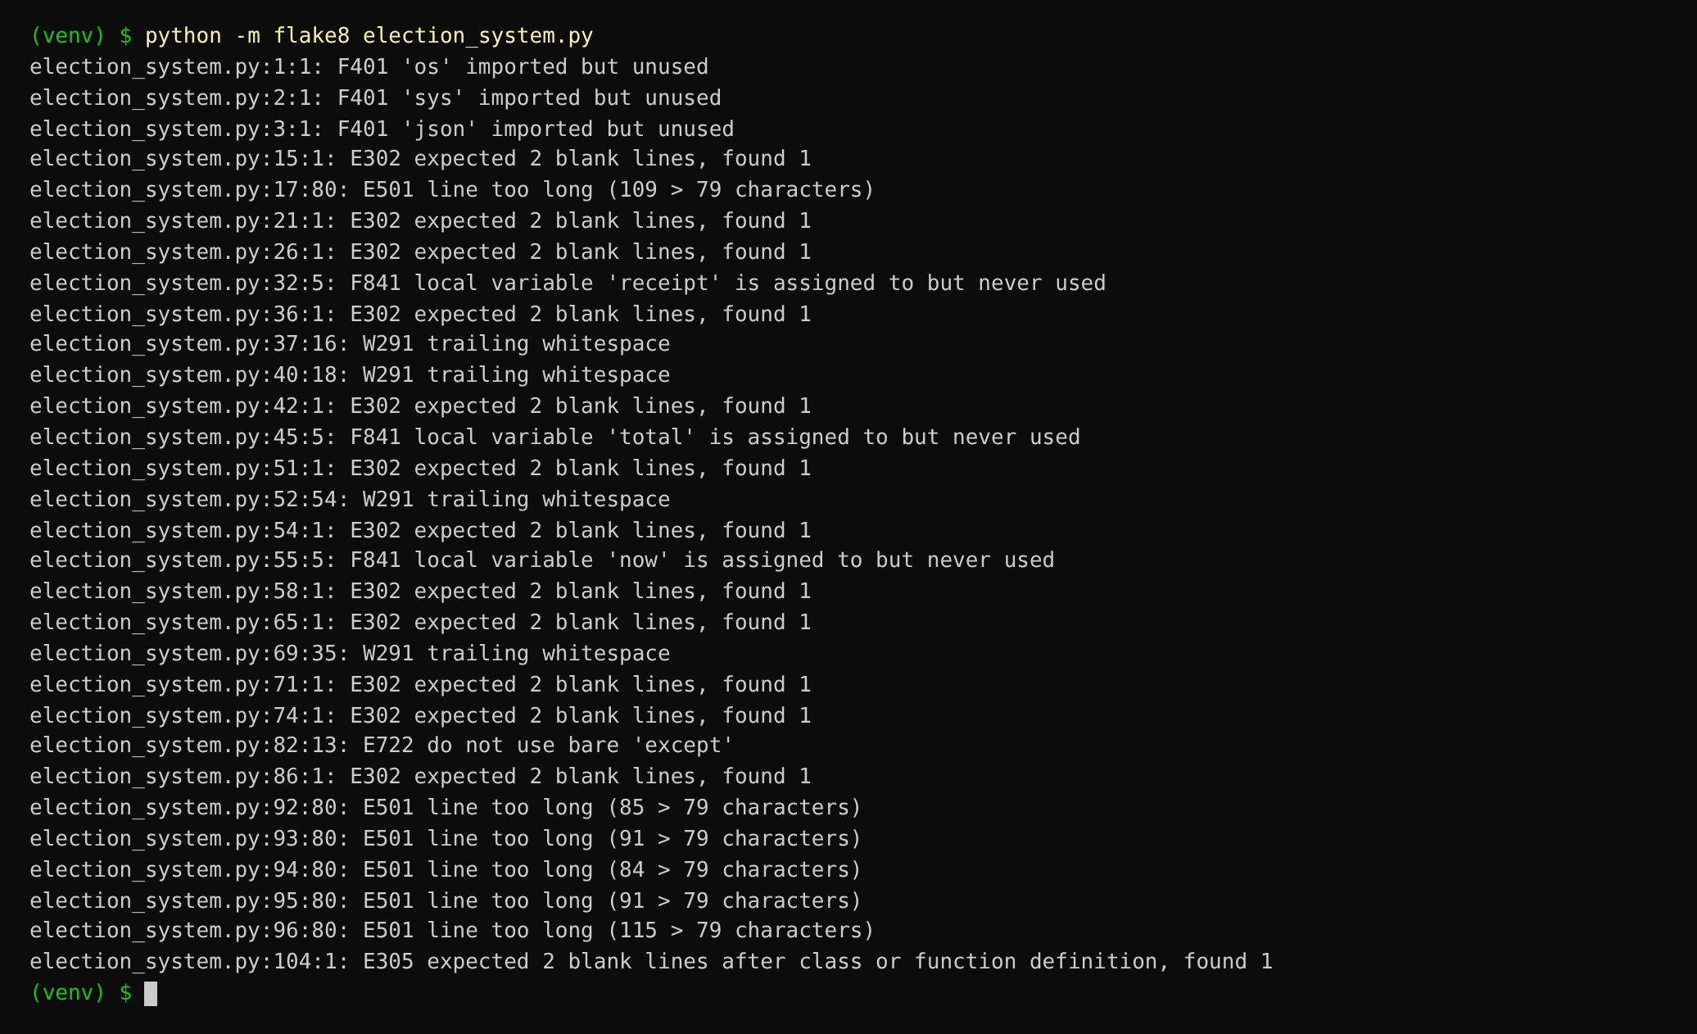
After fixing
Flake8 prints nothing when there are no violations.

5. Reflection questions

Q1. Which tool caught the most serious problem in election_system.py, and why was it hard to see by reading the code?
Bandit (B613) and Pylint (E2502) both flagged line 22 for bidirectional control characters. In the editor, isOfficer looked like a normal check with a comment saying only election officers pass. The hidden characters were actually inside the string, so the role was compared with "voter" plus invisible text, the two never matched, and every role came back as an officer. Anyone reviewing the file would have approved it. Printing the line with repr() exposes the \u202e and \u2066 codes. I replaced it with a check against an allow-list, OFFICER_ROLES = {"officer"}.

Q2. Which bugs did none of the tools detect, and how did you find them?
The tools check how code is written, not what an election is supposed to do, so every rule-breaking result got past them. Running the original program showed six: Asha, aged 18, could not register because the check was age > 18; Ben voted twice and both votes counted; 'bob' and 'Bob' were tallied as different candidates; Dia's vote at 18:30 was accepted after the polls closed; turnout was 166.67% because it divided ballots by voters; and Alice was declared winner in a 2-2 tie with Bob. I found each one by comparing a printed line with the voting rules, then fixed them with a shared record_vote() function and corrected comparisons.

Q3. Did any warning seem wrong, or rated at the wrong severity for this program?
Some ratings did not match the real damage here. Bandit marked MD5 as High, but in this file the hash only labels a voter record and protects nothing. The hardcoded ADMIN_PASSWORD was only Low, although anyone who can open the repo gets the admin password. The try/except/pass was also Low, yet it was silently hiding failed postal ballot imports. On the Pylint side, missing docstrings and camelCase names pulled the score down the most but changed no behaviour. So I fixed issues in order of actual impact, not by the label each tool gave them.

Q4. What would you do differently in your next project after this lab?
I would run the tools from the first commit instead of at the end. Most of the 30 Flake8 warnings were blank lines, long lines and trailing spaces that an auto-formatter such as black fixes on save. A pre-commit hook that blocks Bandit Medium and High findings would have stopped MD5, unsafe XML and the hidden characters from ever being committed, and a GitHub Actions job could run all three tools on every push. Since the logic bugs passed every tool, I would also write small tests for rules like "one vote per voter" and "no votes after 18:00". A clean Pylint score does not prove the election result is correct.

