FAST-NUCES
Fundamentals of Software Engineering

AgentGround
AI Agent Sandbox Platform
Iteration 1 — Sprint 1 Report

Deliverable No: 1
Subject: Fundamentals of Software Engineering

Prepared By:
Rehan Abid
Roll No: 24L-2573

Spring 2026 | 24 March 2026
Instructor: Ansa Liaqat

1. Project Title and Introduction

1.1 Project Title
AgentGround — AI Agent Sandbox Platform

1.2 Project Introduction
AgentGround is a Python-native, browser-accessible sandbox platform designed for experimenting with autonomous AI agents in a safe, governed, and observable environment. The platform removes the heavy infrastructure burden that normally precedes any agent-based experiment by providing a ready-made workspace where agents, tools, and resource limits can be configured through a point-and-click Streamlit interface — no command-line expertise required.

The platform is built entirely in Python, using Streamlit for the UI layer, LangChain for agent orchestration and tool calling, SQLAlchemy as the ORM, and MySQL as the persistence layer. Environments are the highest-level concept in AgentGround: each environment is an isolated workspace with its own registered agents, tools, run history, and audit logs. Multiple agents within one environment can share tools or hold private tools, and resource limits such as call caps and timeouts are enforced per environment.

1.3 Sprint 1 Objectives
Sprint 1 covers the foundational layer of the platform. The goal is to have a fully working skeleton by the end of two weeks: MySQL schema in place, environments and agents manageable through the Streamlit UI, and the Terminal built-in tool attachable to an agent. No agent execution happens in this sprint — that is Sprint 2 scope. Sprint 1 establishes the infrastructure on which all future features are built.

Item | Details
Sprint | Sprint 1 — Foundation & UI Shell
Duration | 2 Weeks (14 days)
Developer | Rehan Abid (Solo)
Tech Stack | Python 3.10 | Streamlit | LangChain | SQLAlchemy | MySQL
Stories Planned | US-01 through US-07 (21 story points total)
Goal | Working environment/agent CRUD, Terminal tool, complete MySQL schema, functional Streamlit UI shell

2. Sprint Backlog

2.1 Module Selected for Sprint 1
Module Name: Foundation & UI Shell
This module covers all the structural and infrastructural work needed before any agent can run. It encompasses five sub-modules: Environment Management, Agent Configuration, Tool Library (Terminal only), MySQL Database Schema, and the Streamlit UI Shell. All seven user stories in this sprint belong to this single foundational module.

2.2 Sprint 1 User Stories Summary
ID | User Story Title | Priority | Est. Hours | Story Points
US-01 | Create Environment | High | 4 hrs | 3
US-02 | List and Delete Environments | High | 3 hrs | 2
US-03 | Register Agent | High | 4 hrs | 3
US-04 | Edit Agent System Prompt | Medium | 2 hrs | 2
US-05 | Attach Terminal Tool to Agent | Medium | 3 hrs | 3
US-06 | MySQL Database Schema Setup | High | 5 hrs | 5
US-07 | Streamlit UI Shell | High | 4 hrs | 3
 | TOTAL |  | 25 hrs | 21 pts

2.3 Four Featured Structured Specifications
The following four structured specifications are selected from Sprint 1 user stories to represent the most critical use cases in this iteration. Complete specifications for all seven stories appear in Section 4.

Featured Spec 1 of 4 — UC-01: Create Environment
UC-01 — Create Environment
Use Case ID | UC-01
Use Case Name | Create Environment
Actor | User (Rehan Abid — Developer / Experimenter)
Description | The user creates a new, named, isolated environment in AgentGround through the Streamlit UI. The environment is persisted in MySQL and immediately available for agent registration.
Preconditions | - The AgentGround Streamlit application is running.  - The MySQL database is connected and the environments table exists.  - The user has navigated to the Environments page.
Basic Flow | 1. User clicks the 'Create New Environment' button on the Environments page.  2. The system displays a form with fields: Environment Name (required) and Description (optional).  3. User enters a unique name in the Name field.  4. User optionally enters a description.  5. User clicks the 'Save' button.  6. The system validates that the name field is not empty.  7. The system checks the database to ensure no environment with that name already exists.  8. The system inserts a new row into the environments table in MySQL.  9. The system displays a success message: 'Environment created successfully.'  10. The new environment appears at the top of the environment list.
Alternative Flow | AF-01: User leaves the Name field empty and clicks Save.  - System displays a validation error: 'Environment name is required.' Form is not submitted.  AF-02: User cancels without saving.  - User clicks Cancel. Form is dismissed with no changes to the database.
Exception Flow | EF-01: An environment with the same name already exists.  - System displays error: 'An environment with this name already exists. Please choose a different name.'  EF-02: Database connection fails during save.  - System displays error: 'Could not save environment. Please check your database connection.' No partial record is written.
Postconditions | - A new row exists in the MySQL environments table with a unique ID, name, optional description, and created_at timestamp.  - The environment is visible in the Environments dashboard.
Business Rules | - Environment names must be unique across the system.  - Environment names must not exceed 100 characters.  - Timestamps are stored in UTC.

Featured Spec 2 of 4 — UC-03: Register Agent
UC-03 — Register Agent
Use Case ID | UC-03
Use Case Name | Register Agent
Actor | User
Description | The user registers an external AI agent within a chosen environment by supplying its API endpoint, a display name, the model name, and a system prompt. AgentGround stores this configuration and uses it to invoke the agent via LangChain's model wrappers in Sprint 2.
Preconditions | - At least one environment exists in the system.  - User is on the Agents page.  - MySQL agents table exists.
Basic Flow | 1. User selects an environment from a dropdown on the Agents page.  2. User clicks 'Register New Agent'.  3. System displays the registration form: Agent Name, API Endpoint URL, Model Name, System Prompt.  4. User fills in all required fields.  5. User clicks Save.  6. System validates that the API endpoint is a valid HTTP/HTTPS URL.  7. System validates that the system prompt is not empty.  8. System inserts a new row into the agents table with a foreign key to the selected environment.  9. System displays: 'Agent registered successfully.'  10. The agent appears in the agent list for the selected environment.
Alternative Flow | AF-01: User enters an invalid URL (no http/https prefix).  - System shows validation error: 'Please enter a valid URL starting with http:// or https://'
Exception Flow | EF-01: Database write fails.  - System shows error. No partial agent record is created.
Postconditions | - New agent row exists in agents table, linked to the selected environment.  - Agent is visible in the environment's agent list.
Business Rules | - An agent must belong to exactly one environment.  - The same API endpoint may be registered in multiple environments.  - Agent names must be unique within a single environment.

Featured Spec 3 of 4 — UC-06: MySQL Schema Setup
UC-06 — MySQL Database Schema Setup
Use Case ID | UC-06
Use Case Name | MySQL Database Schema Setup
Actor | Developer (Rehan Abid)
Description | The developer creates the complete MySQL database schema required by AgentGround, including all tables, columns, data types, constraints, and foreign key relationships. SQLAlchemy ORM models are written to match. The database.py module creates all tables automatically on first run.
Preconditions | - MySQL Server is installed and running locally.  - A database named agentground is created.  - .env file contains valid DB_HOST, DB_USER, DB_PASSWORD, DB_NAME values.
Basic Flow | 1. Developer writes schema.sql with CREATE TABLE statements for: environments, agents, tools, agent_tools, runs, audit_logs.  2. Developer defines all foreign key constraints and ON DELETE CASCADE rules.  3. Developer writes SQLAlchemy ORM models in backend/app/models.py reflecting the schema.  4. Developer writes backend/app/database.py with engine and session factory using environment variables.  5. Developer runs schema.sql on the MySQL server to create tables.  6. Developer verifies all tables are created by running SHOW TABLES; in MySQL.  7. Developer writes seed.sql with default built-in tool records (Terminal, Web Search, File R/W).  8. Developer runs seed.sql to populate the tools table.
Alternative Flow | AF-01: Auto-create via SQLAlchemy.  - If database.py is run directly, it calls Base.metadata.create_all(engine) to create all tables automatically without running schema.sql manually.
Exception Flow | EF-01: MySQL connection refused.  - SQLAlchemy raises OperationalError. Developer checks DB credentials in .env and MySQL service status.
Postconditions | - All six tables exist in MySQL with correct columns and constraints.  - The tools table contains at least 3 seed records for the built-in tools.  - database.py successfully establishes a connection when credentials are correct.
Business Rules | - Database credentials must never be committed to the repository. Use .env.example only.  - All timestamps are stored as DATETIME in UTC.  - Cascade deletes must be enabled for all foreign key relationships.

Featured Spec 4 of 4 — UC-07: Streamlit UI Shell
UC-07 — Streamlit UI Shell
Use Case ID | UC-07
Use Case Name | Streamlit UI Shell
Actor | User
Description | The developer builds the multi-page Streamlit application that serves as the primary interface for AgentGround. The shell includes a sidebar navigation, a consistent page header, and a Home dashboard showing system summary statistics.
Preconditions | - Python 3.10+ is installed with all dependencies from requirements.txt.  - .env file is configured with valid MySQL credentials.  - MySQL database schema has been created.
Basic Flow | 1. Developer runs: streamlit run frontend/src/app.py  2. Streamlit launches the application and opens it in the default web browser.  3. The Home page loads, displaying the AgentGround header and a summary card.  4. Home page queries MySQL for total environments and total agents and displays the counts.  5. User sees the sidebar with navigation links: Home, Environments, Agents, Tools.  6. User clicks 'Environments' in the sidebar.  7. Streamlit navigates to the Environments page without a full reload.  8. Each page shows a consistent page title at the top.
Alternative Flow | AF-01: Database is unreachable at startup.  - Home page shows: 'Could not connect to database. Please check your .env configuration.' with a retry button.
Exception Flow | EF-01: Required Python package is missing.  - Streamlit shows import error in the browser. Developer runs pip install -r requirements.txt to resolve.
Postconditions | - The Streamlit app is accessible at http://localhost:8501 in a browser.  - Sidebar navigation works correctly on all pages.  - Database-connected pages load and display live data from MySQL.

3. User Stories
All seven user stories selected for Sprint 1 are presented below in the standard template format. Each story includes its ID, title, priority, estimated hours, user story statement, description, sub-user stories, and acceptance criteria.

Story ID: US-01 Story Title: Create Environment | Priority: High  Est. Hours: 4
User Story:
As a user, I want to create a named environment so that I can isolate my agent experiments from one another.
Description:
This story covers the ability to create a new, independent environment within AgentGround. The user provides a name and optional description; the system persists it in MySQL and makes it immediately accessible from the environment dashboard.
Sub User Stories:
- As a user, I want to enter a unique name for the environment so that I can identify it easily later.
- As a user, I want to optionally add a short description so that I can document the purpose of the environment.
- As a user, I want the new environment to be saved to the database so that it persists across sessions.
Acceptance Criteria:
- User can input a name (required) and description (optional) through the Streamlit form.
- Submitting the form saves the environment to the MySQL environments table.
- A success message is displayed and the new environment appears in the environment list immediately.
- Duplicate environment names are rejected with a clear error message.

Story ID: US-02 Story Title: List and Delete Environments | Priority: High  Est. Hours: 3
User Story:
As a user, I want to view all my environments in a dashboard and delete ones I no longer need so that I can manage my workspace efficiently.
Description:
This story provides a dashboard view listing all existing environments with their names, descriptions, creation dates, and agent counts. Users can delete an environment, which cascades the deletion to all associated agents, tool assignments, and logs.
Sub User Stories:
- As a user, I want to see a list of all environments on the dashboard so that I can get an overview of my workspace.
- As a user, I want to delete a specific environment so that I can remove experiments I no longer need.
Acceptance Criteria:
- The dashboard page lists all environments stored in MySQL with name, description, and creation date.
- A Delete button is present for each environment; clicking it prompts a confirmation before deletion.
- Deleting an environment removes it and all its associated agents and tool links from the database.
- If no environments exist, a helpful empty-state message is shown with a prompt to create one.

Story ID: US-03 Story Title: Register Agent | Priority: High  Est. Hours: 4
User Story:
As a user, I want to register an AI agent by providing its API endpoint and a system prompt so that it can be used within a selected environment.
Description:
Users register external AI agents (such as an OpenAI-compatible endpoint) inside a chosen environment. AgentGround stores the endpoint URL, system prompt, model name, and optional display name. The platform never runs model code itself — all inference happens via the provided endpoint.
Sub User Stories:
- As a user, I want to enter the agent's API endpoint URL so that AgentGround knows where to send requests.
- As a user, I want to write a system prompt for the agent so that I can define its role and behavior.
- As a user, I want to assign the agent to a specific environment so that it is scoped to that workspace.
Acceptance Criteria:
- User can select an environment, then enter agent name, API URL, model name, and system prompt.
- The form validates that the API URL is a valid HTTP/HTTPS URL before saving.
- Registered agent is saved to the agents table in MySQL with a foreign key to the environment.
- The agent appears in the agent list for its environment immediately after registration.

Story ID: US-04 Story Title: Edit Agent System Prompt | Priority: Medium  Est. Hours: 2
User Story:
As a user, I want to edit an agent's system prompt directly from the UI so that I can iterate quickly without having to delete and re-register the agent.
Description:
The agent detail page displays the current system prompt in an editable text area. On save, the updated prompt is written to MySQL. Each save is timestamped so the user can see when the last change was made.
Sub User Stories:
- As a user, I want to see the current system prompt of a registered agent so that I know its existing configuration.
- As a user, I want to modify the prompt text and save it so that the agent uses the updated instructions on the next run.
Acceptance Criteria:
- The agent detail page shows the full current system prompt in a text area.
- User can edit the text and click Save; the change is persisted to MySQL.
- A timestamp of the last update is shown next to the prompt editor.
- Saving an empty prompt is rejected with a validation error.

Story ID: US-05 Story Title: Attach Terminal Tool to Agent | Priority: Medium  Est. Hours: 3
User Story:
As a user, I want to attach the built-in Terminal tool to a specific agent so that the agent can execute whitelisted shell commands during a run.
Description:
AgentGround provides a curated library of built-in tools. This story covers the Terminal tool (backed by LangChain's ShellTool with command whitelisting). Users browse available tools within an environment and assign the Terminal tool to an agent, marking its scope as Private or Shared.
Sub User Stories:
- As a user, I want to see all available built-in tools in the tools panel so that I know what tools I can assign.
- As a user, I want to assign the Terminal tool to an agent and set its scope as Private or Shared so that I control which agents can use it.
Acceptance Criteria:
- The tools page lists all available built-in tools with names, descriptions, and scope options.
- User can select an agent and attach the Terminal tool to it with a scope selection (Private/Shared).
- The assignment is saved in the agent_tools table in MySQL.
- The terminal tool only allows commands in the predefined whitelist; others are rejected silently.

Story ID: US-06 Story Title: MySQL Database Schema Setup | Priority: High  Est. Hours: 5
User Story:
As a developer, I want the complete MySQL schema (environments, agents, tools, agent_tools) set up from the start so that all data is persisted reliably from day one of the project.
Description:
This technical story defines and creates the full relational database schema in MySQL using a schema.sql DDL file. SQLAlchemy ORM models are written to match the schema, and a database.py module provides a reusable session factory. This is the foundation for all other stories.
Sub User Stories:
- As a developer, I want the environments table created so that environment records can be stored.
- As a developer, I want the agents table created with a foreign key to environments so that agents are scoped correctly.
- As a developer, I want the tools and agent_tools tables created so that tool assignments can be recorded.
Acceptance Criteria:
- schema.sql file contains CREATE TABLE statements for: environments, agents, tools, agent_tools, runs, audit_logs.
- All foreign key relationships are correctly defined with ON DELETE CASCADE.
- SQLAlchemy ORM models in models.py reflect the schema exactly.
- Running database.py auto-creates all tables if they do not exist.

Story ID: US-07 Story Title: Streamlit UI Shell | Priority: High  Est. Hours: 4
User Story:
As a user, I want a clean, multi-page Streamlit application with sidebar navigation so that I can access environments and agents through a browser without using the command line.
Description:
The Streamlit shell provides the overall UI framework: a sidebar with navigation links to Home, Environments, Agents, and Tools pages; a consistent header on each page showing the project name; and a Home dashboard summarising total environments and agents. All pages import from the backend modules.
Sub User Stories:
- As a user, I want a Home page that shows a summary of my environments and agents so that I get an instant overview.
- As a user, I want sidebar navigation that lets me move between pages without reloading the app.
- As a user, I want a consistent page title and layout on every page so that the app feels cohesive.
Acceptance Criteria:
- Running `streamlit run frontend/src/app.py` opens the application in a browser.
- The sidebar contains navigation links to Home, Environments, Agents, and Tools.
- The Home page shows total environment count and total agent count fetched from MySQL.
- All pages share a common header and consistent Calibri/clean styling.

4. Structured Specifications
The following section provides complete use case specifications for all seven Sprint 1 user stories, followed by condensed structured specifications for all sub-user stories. Sub-story specifications focus on their unique flows and are abbreviated where they form part of the parent use case.

4.1 Main User Story Specifications
UC-01: Create Environment
UC-01 — Create Environment
Use Case ID | UC-01
Use Case Name | Create Environment
Actor | User (Rehan Abid — Developer / Experimenter)
Description | The user creates a new, named, isolated environment in AgentGround through the Streamlit UI. The environment is persisted in MySQL and immediately available for agent registration.
Preconditions | - The AgentGround Streamlit application is running.  - The MySQL database is connected and the environments table exists.  - The user has navigated to the Environments page.
Basic Flow | 1. User clicks the 'Create New Environment' button on the Environments page.  2. The system displays a form with fields: Environment Name (required) and Description (optional).  3. User enters a unique name in the Name field.  4. User optionally enters a description.  5. User clicks the 'Save' button.  6. The system validates that the name field is not empty.  7. The system checks the database to ensure no environment with that name already exists.  8. The system inserts a new row into the environments table in MySQL.  9. The system displays a success message: 'Environment created successfully.'  10. The new environment appears at the top of the environment list.
Alternative Flow | AF-01: User leaves the Name field empty and clicks Save.  - System displays a validation error: 'Environment name is required.' Form is not submitted.  AF-02: User cancels without saving.  - User clicks Cancel. Form is dismissed with no changes to the database.
Exception Flow | EF-01: An environment with the same name already exists.  - System displays error: 'An environment with this name already exists. Please choose a different name.'  EF-02: Database connection fails during save.  - System displays error: 'Could not save environment. Please check your database connection.' No partial record is written.
Postconditions | - A new row exists in the MySQL environments table with a unique ID, name, optional description, and created_at timestamp.  - The environment is visible in the Environments dashboard.
Business Rules | - Environment names must be unique across the system.  - Environment names must not exceed 100 characters.  - Timestamps are stored in UTC.

UC-02: List and Delete Environments
UC-02 — List and Delete Environments
Use Case ID | UC-02
Use Case Name | List and Delete Environments
Actor | User
Description | The user views a list of all existing environments on the dashboard. The user can delete any environment, which triggers a cascaded deletion of all associated agents, tool links, run records, and audit logs.
Preconditions | - AgentGround is running and the user is on the Environments page.  - MySQL is connected.
Basic Flow (List) | 1. User navigates to the Environments page via the sidebar.  2. System queries the environments table and retrieves all records.  3. System displays each environment as a card showing: name, description, creation date, and agent count.  4. If no environments exist, system shows: 'No environments found. Create your first environment above.'
Basic Flow (Delete) | 1. User clicks the 'Delete' button on a specific environment card.  2. System shows a confirmation prompt: 'Are you sure you want to delete [name]? This will also delete all agents and data inside it.'  3. User confirms deletion.  4. System deletes the environment row; CASCADE constraint removes all related agents, agent_tools, runs, and audit_log rows.  5. System displays: 'Environment deleted successfully.'  6. The deleted environment is removed from the displayed list.
Alternative Flow | AF-01: User clicks Cancel on the confirmation prompt.  - No deletion occurs. The environment remains unchanged.
Exception Flow | EF-01: Database error during deletion.  - System displays error message. No partial deletion occurs due to MySQL transaction rollback.
Postconditions | - The selected environment and all its children are removed from MySQL.  - The dashboard no longer shows the deleted environment.

UC-03: Register Agent
UC-03 — Register Agent
Use Case ID | UC-03
Use Case Name | Register Agent
Actor | User
Description | The user registers an external AI agent within a chosen environment by supplying its API endpoint, a display name, the model name, and a system prompt. AgentGround stores this configuration and uses it to invoke the agent via LangChain's model wrappers in Sprint 2.
Preconditions | - At least one environment exists in the system.  - User is on the Agents page.  - MySQL agents table exists.
Basic Flow | 1. User selects an environment from a dropdown on the Agents page.  2. User clicks 'Register New Agent'.  3. System displays the registration form: Agent Name, API Endpoint URL, Model Name, System Prompt.  4. User fills in all required fields.  5. User clicks Save.  6. System validates that the API endpoint is a valid HTTP/HTTPS URL.  7. System validates that the system prompt is not empty.  8. System inserts a new row into the agents table with a foreign key to the selected environment.  9. System displays: 'Agent registered successfully.'  10. The agent appears in the agent list for the selected environment.
Alternative Flow | AF-01: User enters an invalid URL (no http/https prefix).  - System shows validation error: 'Please enter a valid URL starting with http:// or https://'
Exception Flow | EF-01: Database write fails.  - System shows error. No partial agent record is created.
Postconditions | - New agent row exists in agents table, linked to the selected environment.  - Agent is visible in the environment's agent list.
Business Rules | - An agent must belong to exactly one environment.  - The same API endpoint may be registered in multiple environments.  - Agent names must be unique within a single environment.

UC-04: Edit Agent System Prompt
UC-04 — Edit Agent System Prompt
Use Case ID | UC-04
Use Case Name | Edit Agent System Prompt
Actor | User
Description | The user views and edits the system prompt of a registered agent from the Agents page without deleting and re-registering the agent. Changes are saved to MySQL and timestamped.
Preconditions | - At least one agent is registered in the system.  - User has navigated to the agent detail view.
Basic Flow | 1. User selects an environment and then clicks on a specific agent.  2. System loads the agent detail view, showing all fields including the system prompt in an editable text area.  3. User modifies the text in the system prompt field.  4. User clicks 'Save Changes'.  5. System validates that the prompt field is not empty.  6. System updates the system_prompt column and updated_at timestamp in the agents table.  7. System displays: 'System prompt updated successfully.'
Alternative Flow | AF-01: User clears the prompt field and saves.  - System shows: 'System prompt cannot be empty.'
Exception Flow | EF-01: Database update fails.  - System shows error. The original prompt remains unchanged in the database.
Postconditions | - agents.system_prompt column is updated with the new text.  - agents.updated_at reflects the current timestamp.

UC-05: Attach Terminal Tool to Agent
UC-05 — Attach Terminal Tool to Agent
Use Case ID | UC-05
Use Case Name | Attach Terminal Tool to Agent
Actor | User
Description | The user browses the available built-in tools in the tools panel, selects the Terminal tool, assigns it to a chosen agent within the active environment, and sets its scope as Private or Shared. The assignment is persisted in the agent_tools table.
Preconditions | - An environment and at least one agent exist.  - The user is on the Tools page.  - Built-in tools are seeded in the tools table.
Basic Flow | 1. User navigates to the Tools page.  2. System lists all available built-in tools: Terminal, Web Search, File Read/Write (with descriptions).  3. User clicks 'Assign' next to the Terminal tool.  4. System displays an assignment form: select environment, select agent, choose scope (Private / Shared).  5. User selects the target environment and agent.  6. User selects scope.  7. User clicks Confirm.  8. System inserts a row into agent_tools linking the agent ID and the Terminal tool ID with the scope flag.  9. System displays: 'Terminal tool assigned to [agent name] (Scope: [scope]).'
Alternative Flow | AF-01: The same tool is already assigned to the selected agent.  - System shows: 'This tool is already assigned to the selected agent.'
Exception Flow | EF-01: Database write fails.  - System shows error. No tool assignment record is created.
Postconditions | - A row exists in agent_tools with agent_id, tool_id, scope, and created_at.  - The terminal tool appears in the assigned tools list for the agent.
Business Rules | - Scope = Private means only the assigned agent can use the tool.  - Scope = Shared means all agents in the same environment can use the tool.  - Terminal tool only executes whitelisted commands; unrestricted shell access is blocked.

UC-06: MySQL Database Schema Setup
UC-06 — MySQL Database Schema Setup
Use Case ID | UC-06
Use Case Name | MySQL Database Schema Setup
Actor | Developer (Rehan Abid)
Description | The developer creates the complete MySQL database schema required by AgentGround, including all tables, columns, data types, constraints, and foreign key relationships. SQLAlchemy ORM models are written to match. The database.py module creates all tables automatically on first run.
Preconditions | - MySQL Server is installed and running locally.  - A database named agentground is created.  - .env file contains valid DB_HOST, DB_USER, DB_PASSWORD, DB_NAME values.
Basic Flow | 1. Developer writes schema.sql with CREATE TABLE statements for: environments, agents, tools, agent_tools, runs, audit_logs.  2. Developer defines all foreign key constraints and ON DELETE CASCADE rules.  3. Developer writes SQLAlchemy ORM models in backend/app/models.py reflecting the schema.  4. Developer writes backend/app/database.py with engine and session factory using environment variables.  5. Developer runs schema.sql on the MySQL server to create tables.  6. Developer verifies all tables are created by running SHOW TABLES; in MySQL.  7. Developer writes seed.sql with default built-in tool records (Terminal, Web Search, File R/W).  8. Developer runs seed.sql to populate the tools table.
Alternative Flow | AF-01: Auto-create via SQLAlchemy.  - If database.py is run directly, it calls Base.metadata.create_all(engine) to create all tables automatically without running schema.sql manually.
Exception Flow | EF-01: MySQL connection refused.  - SQLAlchemy raises OperationalError. Developer checks DB credentials in .env and MySQL service status.
Postconditions | - All six tables exist in MySQL with correct columns and constraints.  - The tools table contains at least 3 seed records for the built-in tools.  - database.py successfully establishes a connection when credentials are correct.
Business Rules | - Database credentials must never be committed to the repository. Use .env.example only.  - All timestamps are stored as DATETIME in UTC.  - Cascade deletes must be enabled for all foreign key relationships.

UC-07: Streamlit UI Shell
UC-07 — Streamlit UI Shell
Use Case ID | UC-07
Use Case Name | Streamlit UI Shell
Actor | User
Description | The developer builds the multi-page Streamlit application that serves as the primary interface for AgentGround. The shell includes a sidebar navigation, a consistent page header, and a Home dashboard showing system summary statistics.
Preconditions | - Python 3.10+ is installed with all dependencies from requirements.txt.  - .env file is configured with valid MySQL credentials.  - MySQL database schema has been created.
Basic Flow | 1. Developer runs: streamlit run frontend/src/app.py  2. Streamlit launches the application and opens it in the default web browser.  3. The Home page loads, displaying the AgentGround header and a summary card.  4. Home page queries MySQL for total environments and total agents and displays the counts.  5. User sees the sidebar with navigation links: Home, Environments, Agents, Tools.  6. User clicks 'Environments' in the sidebar.  7. Streamlit navigates to the Environments page without a full reload.  8. Each page shows a consistent page title at the top.
Alternative Flow | AF-01: Database is unreachable at startup.  - Home page shows: 'Could not connect to database. Please check your .env configuration.' with a retry button.
Exception Flow | EF-01: Required Python package is missing.  - Streamlit shows import error in the browser. Developer runs pip install -r requirements.txt to resolve.
Postconditions | - The Streamlit app is accessible at http://localhost:8501 in a browser.  - Sidebar navigation works correctly on all pages.  - Database-connected pages load and display live data from MySQL.

4.2 Sub-User Story Specifications
UC-01.1 — Enter Unique Environment Name
Actor | User
Description | User types a unique, non-empty environment name into the Name input field on the Create Environment form.
Preconditions | Create Environment form is open.
Basic Flow | 1. User clicks in the Name field.  2. User types the desired environment name.  3. System validates length <= 100 characters.  4. System proceeds to UC-01.2.
Exception Flow | EF-01: Name exceeds 100 characters.  - System trims field and shows character limit warning.
Postconditions | A valid, non-empty name string is ready for submission.

UC-01.2 — Add Optional Environment Description
Actor | User
Description | User optionally enters a description for the environment to document its purpose.
Preconditions | Name field has been filled (UC-01.1 complete).
Basic Flow | 1. User clicks in the Description field.  2. User types a description (or leaves it empty).  3. System accepts the value (empty is valid).  4. System proceeds to form submission.
Postconditions | Description value (possibly empty string) is ready for database insertion.

UC-01.3 — Save Environment to Database
Actor | System
Description | After the user submits the Create Environment form, the system persists the new environment record in MySQL.
Preconditions | Form validation has passed (name is unique and non-empty).
Basic Flow | 1. System opens a SQLAlchemy session.  2. System creates a new Environment ORM object with the provided name, description, and current UTC timestamp.  3. System calls session.add() and session.commit().  4. MySQL inserts the record and auto-generates an ID.  5. System closes the session.
Exception Flow | EF-01: commit() raises IntegrityError.  - Transaction is rolled back. Error displayed to user.
Postconditions | New row exists in MySQL environments table.

UC-02.1 — View All Environments in Dashboard
Actor | User
Description | System retrieves all environment records from MySQL and displays them on the Environments page.
Preconditions | User is on the Environments page. MySQL is connected.
Basic Flow | 1. System queries SELECT * FROM environments ORDER BY created_at DESC.  2. System renders each environment as a Streamlit expander or card.  3. Each card shows: name, description, created_at, and agent count.  4. If zero results, empty-state message is shown.
Postconditions | All environments are displayed; agent count is correct.

UC-02.2 — Delete Specific Environment
Actor | User
Description | User deletes a specific environment; system removes it and all children via cascade.
Preconditions | Environment exists. User has confirmed deletion.
Basic Flow | 1. System calls session.delete(environment_obj).  2. MySQL cascade removes agents, agent_tools, runs, audit_logs referencing this environment.  3. session.commit() finalises deletion.  4. Dashboard refreshes.
Exception Flow | EF-01: commit() fails.  - Rollback occurs; environment remains intact.
Postconditions | Environment and all children removed from MySQL.

UC-03.1 — Enter Agent API Endpoint
Actor | User
Description | User provides a valid HTTP/HTTPS URL for the AI agent's API endpoint.
Preconditions | Register Agent form is open.
Basic Flow | 1. User enters URL in the API Endpoint field.  2. System validates URL format using Python's urllib.parse.  3. Validation passes; value is ready for submission.
Exception Flow | EF-01: URL is not valid HTTP/HTTPS.  - Validation error shown: 'Please enter a valid URL.'
Postconditions | Valid URL string stored in form state.

UC-03.2 — Write Agent System Prompt
Actor | User
Description | User writes the system prompt that defines the agent's behavior and role.
Preconditions | Register Agent form is open.
Basic Flow | 1. User types system prompt in the text area.  2. System validates that prompt is not empty.  3. Value is ready for submission.
Exception Flow | EF-01: Prompt is empty.  - Error: 'System prompt cannot be empty.'
Postconditions | Non-empty prompt string stored in form state.

UC-03.3 — Assign Agent to Environment
Actor | User
Description | User selects the target environment for the agent from a dropdown.
Preconditions | At least one environment exists.
Basic Flow | 1. System populates dropdown with all environment names.  2. User selects target environment.  3. Selected environment ID is stored for FK reference.
Postconditions | environment_id value ready for agents table insertion.

UC-04.1 — View Current System Prompt
Actor | User
Description | System loads and displays the current system prompt of the selected agent.
Preconditions | Agent exists. User has selected the agent from the Agents page.
Basic Flow | 1. System queries agents table for the selected agent ID.  2. System renders system_prompt field in an editable st.text_area() widget.  3. User can read the full prompt text.
Postconditions | Current prompt is displayed and editable in the UI.

UC-04.2 — Modify and Save Updated Prompt
Actor | User
Description | User edits the prompt text and saves it; system persists the update to MySQL.
Preconditions | Current prompt is displayed (UC-04.1 complete).
Basic Flow | 1. User edits the text area.  2. User clicks Save Changes.  3. System validates non-empty.  4. System runs UPDATE agents SET system_prompt=?, updated_at=NOW() WHERE id=?.  5. System confirms save.
Postconditions | agents.system_prompt and updated_at updated in MySQL.

UC-05.1 — Browse Available Built-in Tools
Actor | User
Description | System retrieves all tools from the tools table and displays them on the Tools page.
Preconditions | seed.sql has been run; at least 1 tool exists in tools table.
Basic Flow | 1. User navigates to Tools page.  2. System queries tools table.  3. System renders each tool as a card with name, description, and Assign button.
Postconditions | All built-in tools are visible to the user.

UC-05.2 — Assign Terminal Tool to Agent with Scope
Actor | User
Description | User assigns the Terminal tool to a specific agent and sets its scope.
Preconditions | User has clicked Assign on the Terminal tool card.
Basic Flow | 1. Assignment form shows: environment dropdown, agent dropdown (filtered by env), scope radio (Private/Shared).  2. User makes selections.  3. User clicks Confirm.  4. System inserts into agent_tools (agent_id, tool_id, scope, created_at).  5. Success message shown.
Postconditions | agent_tools row created. Tool listed under agent's assigned tools.

UC-06.1 — Create Environments Table
Actor | Developer
Description | Developer writes and executes CREATE TABLE environments DDL in MySQL.
Preconditions | MySQL running. agentground database exists.
Basic Flow | 1. Developer includes environments DDL in schema.sql.  2. Columns: id INT AUTO_INCREMENT PK, name VARCHAR(100) UNIQUE NOT NULL, description TEXT, created_at DATETIME DEFAULT NOW().  3. Developer runs schema.sql on MySQL.
Postconditions | environments table exists with correct columns and UNIQUE constraint on name.

UC-06.2 — Create Agents Table
Actor | Developer
Description | Developer creates the agents table with a foreign key to environments.
Preconditions | environments table exists.
Basic Flow | 1. columns: id, environment_id FK, name, api_url, model_name, system_prompt TEXT, created_at, updated_at.  2. FK: environment_id REFERENCES environments(id) ON DELETE CASCADE.  3. Developer runs DDL.
Postconditions | agents table exists with FK constraint.

UC-06.3 — Create Tools and Agent Tools Tables
Actor | Developer
Description | Developer creates the tools and agent_tools tables to support tool assignment.
Preconditions | agents table exists.
Basic Flow | 1. tools: id, name, description, is_builtin BOOL.  2. agent_tools: id, agent_id FK, tool_id FK, scope ENUM('private','shared'), created_at.  3. Both FKs have ON DELETE CASCADE.  4. Developer runs DDL and seed.sql to insert 3 built-in tool records.
Postconditions | tools and agent_tools tables exist. tools table has 3 seed records.

UC-07.1 — Create Home Dashboard Page
Actor | Developer / User
Description | Developer builds the Home page; user sees a summary of environments and agents on load.
Preconditions | MySQL connected. app.py is the Streamlit entry point.
Basic Flow | 1. frontend/src/app.py sets page title and sidebar.  2. Home page queries environment count and agent count from MySQL.  3. Displays counts in Streamlit metric widgets.  4. Shows a brief description of AgentGround.
Postconditions | Home page renders with live counts from MySQL.

UC-07.2 — Implement Sidebar Navigation
Actor | Developer / User
Description | Streamlit sidebar provides navigation links between all pages of the app.
Preconditions | All page files exist in frontend/src/pages/.
Basic Flow | 1. Streamlit multi-page app automatically generates sidebar links from page filenames.  2. User clicks a link; Streamlit re-renders the selected page.  3. Active page is highlighted in the sidebar.
Postconditions | All pages are reachable from the sidebar without a browser reload.

UC-07.3 — Consistent Page Header and Layout
Actor | Developer
Description | Each Streamlit page has a consistent header showing the page title and a thin divider.
Preconditions | All page files exist.
Basic Flow | 1. Each page file calls a shared header() helper that renders st.title() and st.divider().  2. Page body content follows below the divider.  3. Sidebar always shows the AgentGround logo/name.
Postconditions | Visual consistency is maintained across all pages.

5. Scrum Board
The Scrum Board for Sprint 1 is maintained on Trello (https://trello.com). Three snapshots are provided below showing the board at the start, mid-point, and end of the sprint. The board uses the following columns: Backlog, In Progress, Testing, Done, Leftover.

5.1 Snapshot 1 — Sprint Start (Day 1)
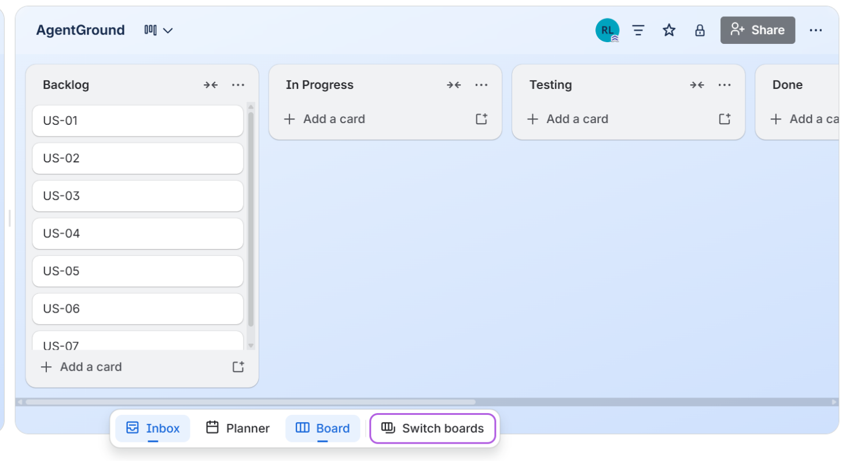

5.2 Snapshot 2 — Mid-Sprint (Day 7)
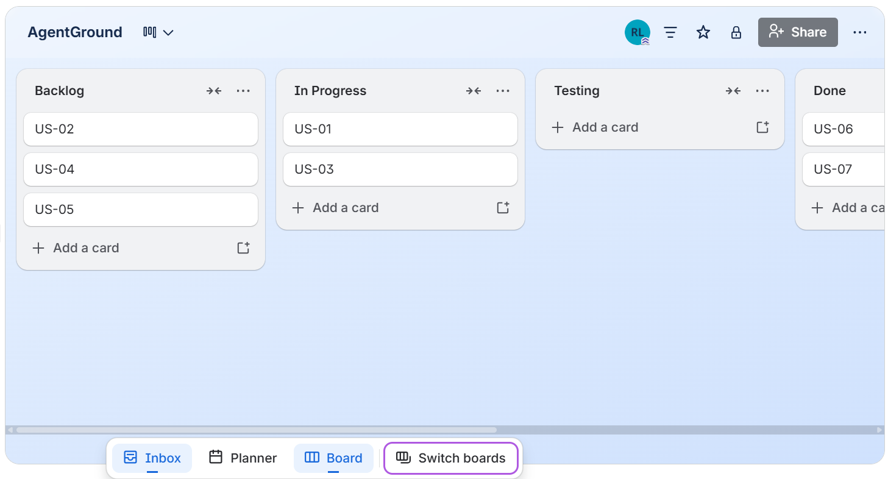

5.3 Snapshot 3 — Sprint End (Day 14)
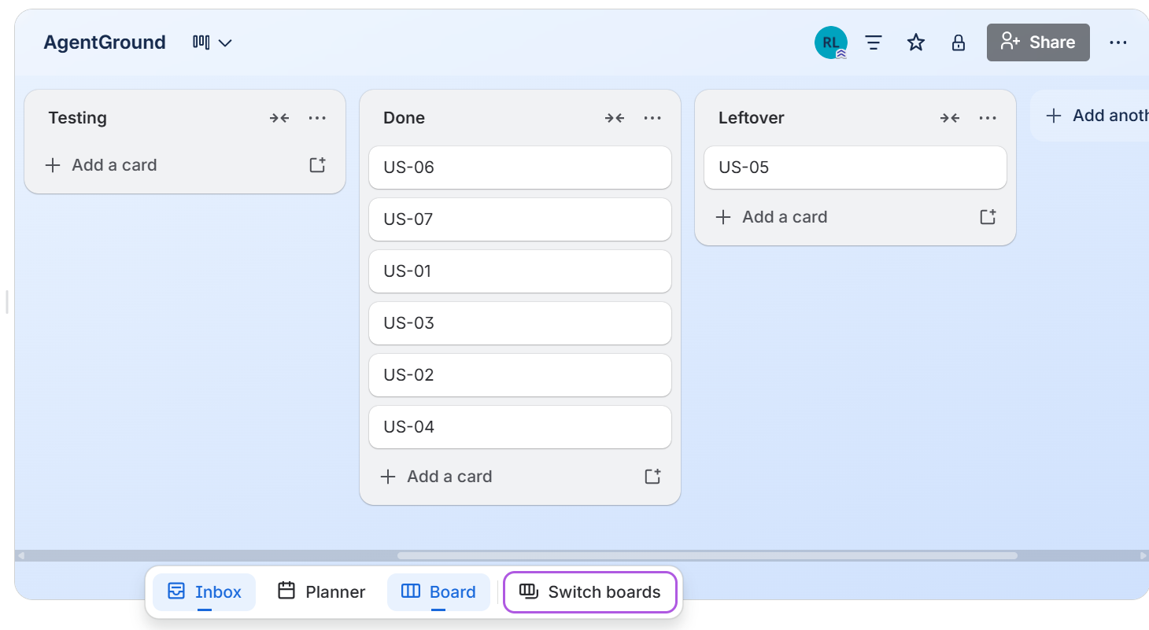

5.4 Sprint Burn-Down Chart
The chart below shows planned story points remaining versus actual story points remaining across the 14-day sprint. Total planned: 21 story points.

Day | Date (Approx.) | Planned Remaining | Actual Remaining | Stories Completed
1 | Mar 9 | 21 | 21 | —
2 | Mar 10 | 19 | 21 | (Setup, schema design)
3 | Mar 11 | 17 | 19 | US-06 In Progress
4 | Mar 12 | 15 | 17 | US-06 In Progress
5 | Mar 13 | 13 | 15 | US-06 Done (5 pts)
6 | Mar 14 | 11 | 13 | US-07 In Progress
7 | Mar 15 | 9 | 12 | US-07 Done (3 pts)
8 | Mar 16 | 7 | 10 | US-01 In Progress
9 | Mar 17 | 5 | 8 | US-01 Done (3 pts)
10 | Mar 18 | 3 | 5 | US-02, US-03 In Progress
11 | Mar 19 | 2 | 4 | US-02 Done (2 pts)
12 | Mar 20 | 1 | 2 | US-03 Done (3 pts)
13 | Mar 21 | 0 | 2 | US-04 Done (2 pts)
14 | Mar 22 | 0 | 3 | US-05 → Leftover (3 pts)

Burn-Down Note:
US-05 (Attach Terminal Tool, 3 pts) was moved to Sprint 2 as a planned leftover. The Terminal tool backend code was written; however, the integration point with the agent execution system (LangChain agent loop) belongs to Sprint 2 scope. This was an anticipated split — not a missed deadline. Total Completed: 18 / 21 points (86%).

6. Non-Functional Requirements (NFR) Specification
Non-functional requirements define quality attributes of AgentGround beyond its functional behaviour. All NFRs below are specified using natural language. They apply to the complete system, not just Sprint 1.

NFR-01 — Performance
Any Streamlit page in AgentGround shall fully load and render within 3 seconds on a machine with a stable local MySQL connection and a standard broadband internet connection. Database queries shall be indexed appropriately to keep query execution times under 200 milliseconds for datasets containing up to 100 environments and 500 agents.

NFR-02 — Usability
The AgentGround interface shall be navigable by a user with basic Python knowledge and no prior experience with AI agent platforms, without requiring any written documentation. All buttons and actions shall have descriptive labels. Error messages shall be specific, actionable, and displayed directly in the UI rather than in terminal logs.

NFR-03 — Security
The Terminal built-in tool shall restrict shell command execution to a predefined whitelist of safe commands (e.g., echo, ls, pwd, cat). Any command not on the whitelist shall be silently rejected and the rejection logged to the audit table. Database credentials, API keys, and other secrets shall never be hard-coded in source files; they must always be read from environment variables via a .env file, and the .env file must be listed in .gitignore to prevent accidental exposure.

NFR-04 — Reliability
All environment, agent, tool, run, and audit data shall be persisted in MySQL. The system shall not store any critical state in Streamlit session variables alone. If the Streamlit app is restarted, all previously created environments and agents shall remain accessible. Database transactions shall be used for all write operations to prevent partial data corruption.

NFR-05 — Maintainability
The AgentGround codebase shall maintain a clear separation between the UI layer (frontend/src/) and the business logic layer (backend/app/). Streamlit page files shall not contain direct SQL queries or SQLAlchemy session logic; they shall call functions defined in the backend modules. All backend functions shall include docstrings describing their parameters and return values.

NFR-06 — Portability
AgentGround shall run on Windows 10/11, macOS 12+, and Ubuntu 20.04+ with Python 3.10 or higher installed. All dependencies shall be installable via a single pip install -r requirements.txt command. The application shall not depend on any OS-specific libraries other than those available via pip.

7. Iteration 1 Implementation Screenshots
The following screenshots show the AgentGround application running after Sprint 1 implementation. Replace each placeholder with an actual screenshot from your running Streamlit app.

7.1 Home Dashboard
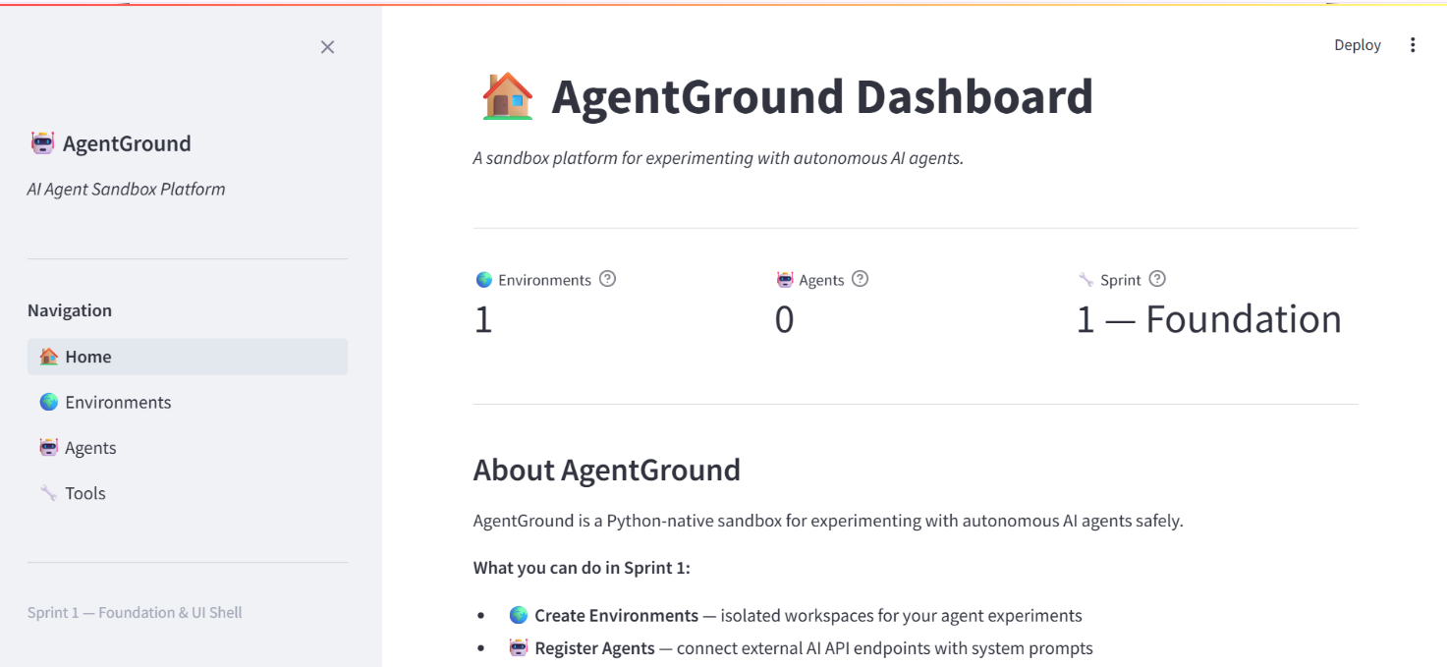
7.2 Create Environment Form
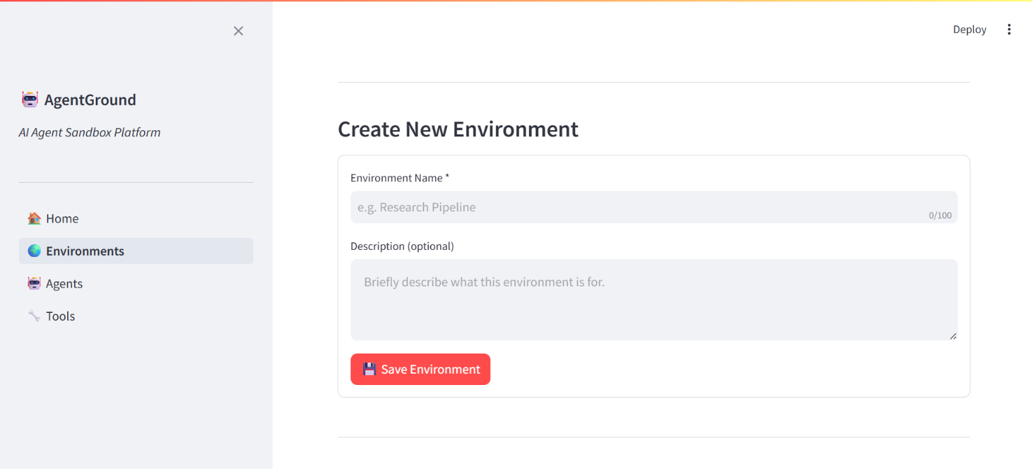
7.3 Environments List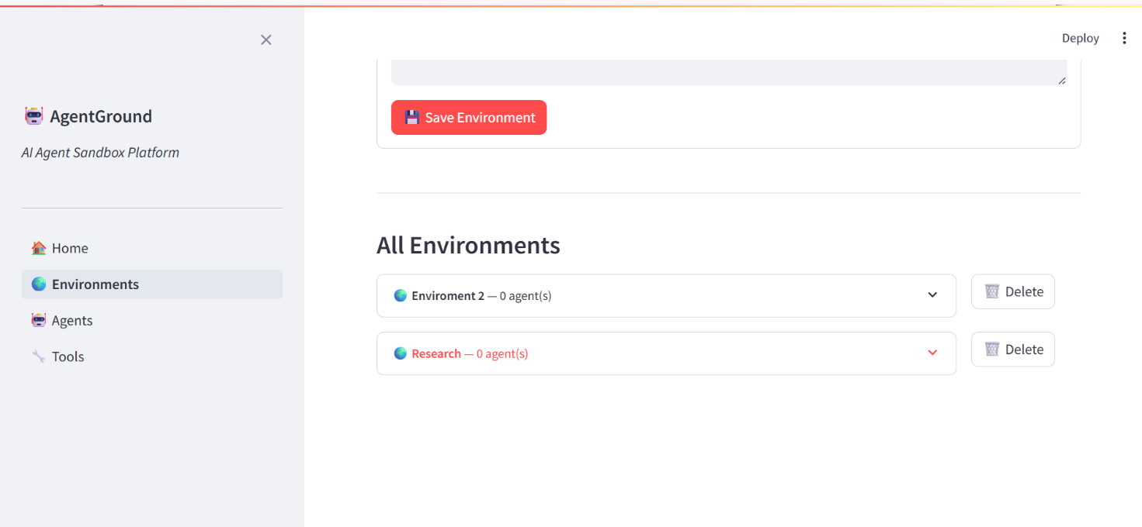

7.4 Register Agent Form
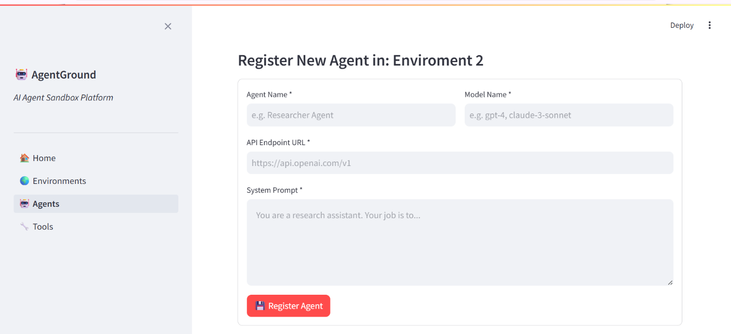
7.5 Tools Page — Built-in Tools List
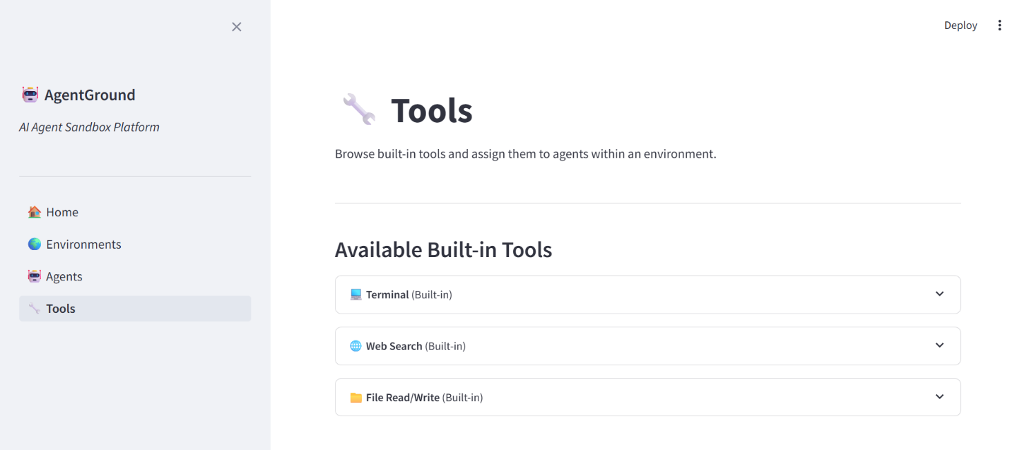
7.6 MySQL Table Structure
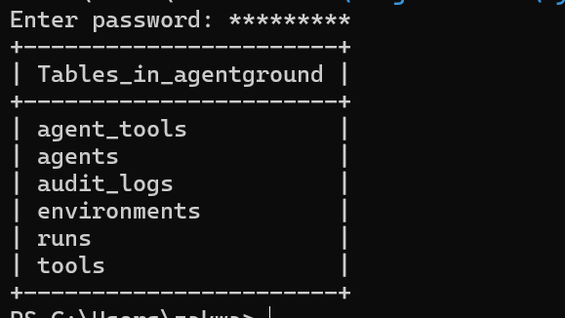

8. Work Division
AgentGround is a solo project developed entirely by Rehan Abid. The table below documents the formal role and task distribution for Sprint 1 as required by the course submission guidelines.

Developer | Role | Tasks in Sprint 1 | Stories Owned
Rehan Abid | Project Lead | Sprint planning, scope definition, timeline | All (US-01 to US-07)
Rehan Abid | Requirements Engineer | Writing user stories, structured specs, NFRs | All (US-01 to US-07)
Rehan Abid | Software Architect | MySQL schema design, module structure, SQLAlchemy models | US-06, US-03, US-01
Rehan Abid | Backend Developer | env_manager.py, agent_manager.py, tool_manager.py, database.py | US-01, US-02, US-03, US-04, US-05, US-06
Rehan Abid | UI Developer | Streamlit pages: app.py, Environments, Agents, Tools | US-07, UI for US-01 to US-05
Rehan Abid | Tester / QA | Manual end-to-end testing of all happy paths | All

GitHub Repository Note:
The implementation for this sprint is submitted via a public GitHub repository. The repository URL is included in the Google Classroom submission comment. The repository follows the required folder structure: backend/, frontend/, database/, docs/, README.md, .gitignore.
All commits in the repository are made by: Rehan Abid

