FAST-NUCES
Fundamentals of Software Engineering

AgentGround
AI Agent Sandbox Platform
Iteration 2 — Sprint 2 Report

Deliverable No: 2
Subject: Fundamentals of Software Engineering

Prepared By:
Rehan Abid
Roll No: [Your Roll Number Here]

Spring 2026 | April 2026
Instructor: [Instructor Name]

1. Project Title and Introduction

1.1 Project Title
AgentGround — AI Agent Sandbox Platform

1.2 Recap from Sprint 1
Sprint 1 established the complete foundation of AgentGround: the MySQL schema (six tables), the SQLAlchemy ORM models, and all CRUD operations for environments, agents, and tool assignments. The Streamlit UI shell with four pages (Home, Environments, Agents, Tools) was completed and the Terminal tool backend was written. US-05 (Tool attachment integration) was identified as a planned carry-over to Sprint 2 because its integration point — the LangChain agent executor — belongs to Sprint 2 scope.

1.3 Sprint 2 Objectives
Sprint 2 delivers the execution engine of AgentGround — the core feature that makes it a live agent sandbox rather than a configuration UI. The focus is: wiring LangChain agent loops to registered agents, enforcing resource limits via Callbacks, supporting multi-agent sequential runs, and capturing every action in the MySQL audit log. By the end of Sprint 2, a user can trigger a real agent run and watch every step appear in an audit trace.

Item | Details
Sprint | Sprint 2 — Agent Execution & Governance
Duration | 2 Weeks (14 days)
Carry-over | US-05 (Attach Terminal Tool — integration) from Sprint 1
New Stories | US-08, US-09, US-10, US-11, US-12, US-13, US-14 (8 stories, 24 points)
Key Modules | RunManager, AgentExecutor, AuditLogger, ResourceCallback, RunPage, AuditLogPage
Goal | Working end-to-end agent run with tool use, resource limits, multi-agent sequencing, and full audit logging

2. Sprint Backlog

2.1 Module Selected for Sprint 2
Module Name: Agent Execution & Governance
This module builds the complete runtime layer of AgentGround. It covers five sub-modules: Run Execution Engine, Resource Governance, Tool Scope Enforcement, Multi-Agent Orchestration, and Audit Logging. All eight stories in this sprint — including the Sprint 1 carry-over — belong to this module.

2.2 Sprint 2 Story Summary
ID | Title | Priority | Est. Hours | Story Points
US-05* | Attach Terminal Tool (carry-over) | Medium | 2 hrs | 2
US-08 | Trigger Agent Run | High | 6 hrs | 5
US-09 | Stop Running Agent | High | 3 hrs | 3
US-10 | Set Max API Call Limit | High | 3 hrs | 3
US-11 | Execution Timeout per Agent | High | 2 hrs | 2
US-12 | Private / Shared Tool Scope | Medium | 3 hrs | 3
US-13 | Multi-Agent Sequential Run | High | 5 hrs | 4
US-14 | View Audit Log | High | 4 hrs | 4
 | TOTAL |  | 28 hrs | 26 pts

* US-05 was completed in Sprint 1 (code written) but is now integrated into the agent executor in Sprint 2.

3. User Stories
All eight stories (including the Sprint 1 carry-over US-05) are presented below using the standard template.

Story ID: US-05 Story Title: Attach Terminal Tool (Integration) | Priority: Medium  Est. Hours: 2
User Story:
As a user, I want the Terminal tool I assigned to an agent to be automatically loaded into the LangChain AgentExecutor so that the agent can actually use it during a run.
Description:
In Sprint 1, the tool assignment was stored in MySQL and the ShellTool backend was written. This story connects those pieces: when a run is triggered, AgentExecutor reads the agent's assigned tools from the database and passes them to the LangChain AgentExecutor. Scope (private/shared) is enforced at this point.
Sub User Stories:
- As a user, I want the tools assigned to an agent to be automatically injected into the run so I don't have to manually configure them each time.
- As a user, I want shared tools to be available to all agents in the environment and private tools restricted to one agent.
Acceptance Criteria:
- When a run is triggered, AgentExecutor queries agent_tools for the target agent and loads each tool.
- Shared tools with scope='shared' are available to all agents in the environment.
- Private tools with scope='private' are only injected for the assigned agent.
- The terminal tool only allows commands from the whitelist; others are logged as blocked.

Story ID: US-08 Story Title: Trigger Agent Run | Priority: High  Est. Hours: 6
User Story:
As a user, I want to trigger a run for a selected agent from the Streamlit UI so that I can see the agent's responses and tool interactions in real time.
Description:
The Run page lets the user select an environment and one or more agents, write an initial user message, and click Run. AgentGround creates a run record in MySQL, invokes the LangChain AgentExecutor with the agent's API URL, system prompt, and assigned tools, and streams the output back to the Streamlit page. Every step is logged to audit_logs simultaneously.
Sub User Stories:
- As a user, I want to enter an initial message for the agent so I can define what task it should perform.
- As a user, I want to see the agent's output appear on the page after the run completes so I know what it did.
- As a user, I want the run status (running, completed, failed) to be visible at all times during execution.
Acceptance Criteria:
- Run page has a text area for user input and a Run button.
- Clicking Run creates a run record in MySQL with status='running'.
- The LangChain AgentExecutor is invoked with the agent's API URL, model, system prompt, and tools.
- On completion, the run status is updated to 'completed' or 'failed' in MySQL.
- The agent's final answer is displayed in the UI.

Story ID: US-09 Story Title: Stop Running Agent | Priority: High  Est. Hours: 3
User Story:
As a user, I want to stop a running agent at any time so that I can prevent it from continuing when it is taking too long or going off-track.
Description:
A Stop button is visible on the Run page while a run is in progress. Clicking it sets a stop flag in Streamlit session state, which is checked by a LangChain Callback at each step. When the flag is detected, the Callback raises an exception, halting the agent loop. The run record is updated to status='stopped' in MySQL.
Sub User Stories:
- As a user, I want a Stop button to appear while a run is in progress so I can halt execution at any point.
- As a user, I want the run status to update to 'stopped' so I can see in the audit log where execution was halted.
Acceptance Criteria:
- A Stop button is rendered on the Run page while status='running'.
- Clicking Stop sets st.session_state['stop_flag'] = True.
- The ResourceCallback checks this flag at each LangChain step and raises StopIteration if set.
- The run record in MySQL is updated to status='stopped' with ended_at timestamp.

Story ID: US-10 Story Title: Set Max API Call Limit | Priority: High  Est. Hours: 3
User Story:
As a user, I want to configure a maximum number of LLM API calls per run so that an agent cannot make unlimited calls and exhaust my API credits.
Description:
The Run page includes a numeric input for 'Max API Calls' (default 10). This value is passed to the ResourceCallbackHandler, which counts every LLM call made during the run. When the count reaches the limit, the handler halts the agent and logs the limit event.
Sub User Stories:
- As a user, I want to set a call limit before starting a run so I can control costs.
- As a user, I want the agent to stop and display a message when the call limit is reached so I know why it stopped.
Acceptance Criteria:
- Run page shows a 'Max API Calls' number input (min=1, max=100, default=10).
- ResourceCallbackHandler.on_llm_start increments a counter.
- When counter >= limit, handler raises an exception halting the agent.
- Run status is set to 'failed' with reason 'API call limit reached' logged to audit_logs.

Story ID: US-11 Story Title: Execution Timeout per Agent | Priority: High  Est. Hours: 2
User Story:
As a user, I want to set an execution timeout for an agent run so that a stuck or infinitely looping agent does not block the system indefinitely.
Description:
A 'Timeout (seconds)' input on the Run page sets the maximum wall-clock time for a run. The AgentExecutor wraps execution in a Python threading.Timer. When the timer fires, it sets the stop flag, which the ResourceCallback detects on the next step to halt execution.
Sub User Stories:
- As a user, I want to set a timeout in seconds before starting a run so I have a safety cap on execution time.
- As a user, I want the run to stop and log a timeout message when the time limit is exceeded.
Acceptance Criteria:
- Run page shows a 'Timeout (seconds)' input (min=5, max=300, default=60).
- A threading.Timer is started when the run begins.
- On timeout, the stop flag is set and the agent is halted.
- Run status is set to 'failed' with reason 'Execution timeout' in audit_logs.

Story ID: US-12 Story Title: Private / Shared Tool Scope Enforcement | Priority: Medium  Est. Hours: 3
User Story:
As a user, I want tools marked as 'Private' to be accessible only by their assigned agent and 'Shared' tools accessible by all agents in the environment, so that I can model realistic resource boundaries.
Description:
When building the tool list for an agent's AgentExecutor, the system queries agent_tools for both private tools assigned to that agent and shared tools assigned to any agent in the same environment. This scoping logic is encapsulated in ToolManager.get_tools_for_agent().
Sub User Stories:
- As a user, I want private tools to only be injected for the agent they are directly assigned to.
- As a user, I want shared tools to be automatically available to all agents in the same environment.
Acceptance Criteria:
- ToolManager.get_tools_for_agent(agent_id) returns: all private tools for that agent + all shared tools in the environment.
- Shared tool lookup joins agent_tools with agents on environment_id.
- A test with two agents confirms Agent A cannot use Agent B's private tool.
- Shared tools appear in the tool list of both agents in the same environment.

Story ID: US-13 Story Title: Multi-Agent Sequential Run | Priority: High  Est. Hours: 5
User Story:
As a user, I want to select multiple agents in an environment and run them in sequence so that I can model a pipeline where one agent's output feeds into the next.
Description:
The Run page allows selecting multiple agents via a multi-select widget. The system runs them in the user-defined order: Agent 1's final answer is prepended to the system context for Agent 2, and so on. Each agent's steps are logged separately in audit_logs under the same run_id but with their respective agent_id.
Sub User Stories:
- As a user, I want to select multiple agents and define their execution order so I can build a pipeline.
- As a user, I want the output of one agent to be passed as context to the next agent in the sequence.
- As a user, I want each agent's steps to appear separately in the audit log under the same run.
Acceptance Criteria:
- Multi-select widget on Run page allows selecting 2+ agents from the environment.
- Agents are executed in selected order; each run uses the same run_id.
- Agent N receives Agent (N-1)'s final_answer prepended to its user message.
- Audit log shows steps from each agent with correct agent_id and step_number.

Story ID: US-14 Story Title: View Structured Audit Log | Priority: High  Est. Hours: 4
User Story:
As a user, I want to view a structured, step-by-step audit log of a completed run so that I can understand exactly what the agent did, what tools it called, and what responses it received.
Description:
The Audit Log page lets the user select an environment and then a specific run. The system queries audit_logs ordered by step_number and renders each step as an expandable row showing action type (llm_request, tool_call, tool_result, llm_response), agent name, and the full JSON payload. An optional JSON export button allows downloading the raw log.
Sub User Stories:
- As a user, I want to select a run from a dropdown to view its audit log.
- As a user, I want to expand individual log steps to see full details including input and output.
- As a user, I want to export the audit log as a JSON file for offline analysis.
Acceptance Criteria:
- Audit Log page shows a dropdown of all runs for the selected environment with status and timestamp.
- Steps are rendered in a table ordered by step_number with columns: Step, Agent, Action, Summary.
- Expanding a step shows the full JSON payload.
- An 'Export JSON' button triggers a st.download_button with the serialised log.

4. Design
All diagrams cover the complete AgentGround system (Sprints 1 and 2 combined). They were produced using the UML standard notation and reflect the actual implementation architecture.

4.1 Activity Diagrams
Three activity diagrams are provided, each covering one of the three main process flows in AgentGround. Solid arrows denote normal flow; dashed/red arrows denote alternative or exception paths.

Activity Diagram 1 — Agent Run Execution
This diagram covers the full lifecycle of a single agent run from the user clicking Trigger Run through the LangChain agent loop, tool execution, resource limit checking, audit logging, and run completion.
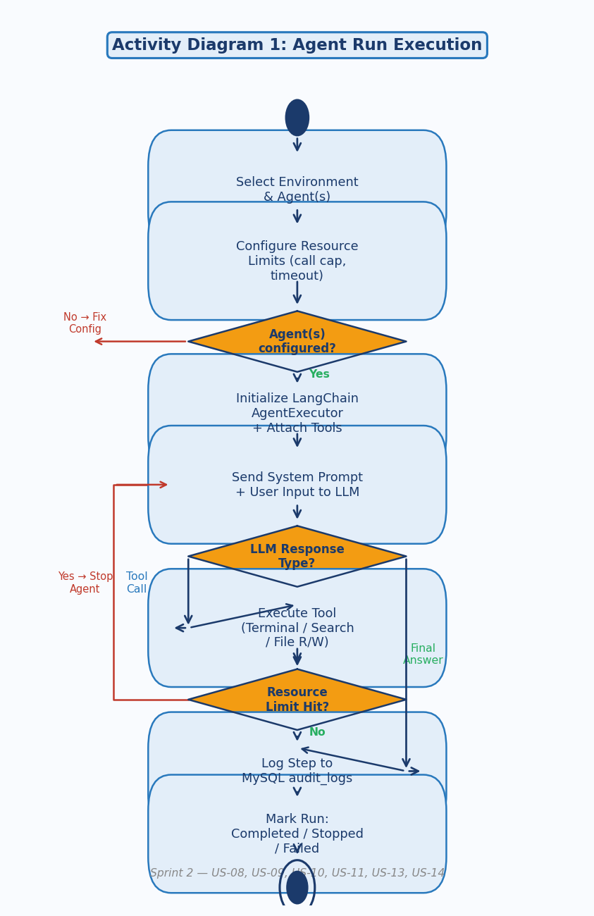
Fig 1. Activity Diagram — Agent Run Execution (US-08, US-09, US-10, US-11, US-13, US-14)

Activity Diagram 2 — Environment & Agent Setup
This diagram covers the setup process: creating an environment, registering an agent with a valid API URL and system prompt, and assigning a tool with a scope selection.
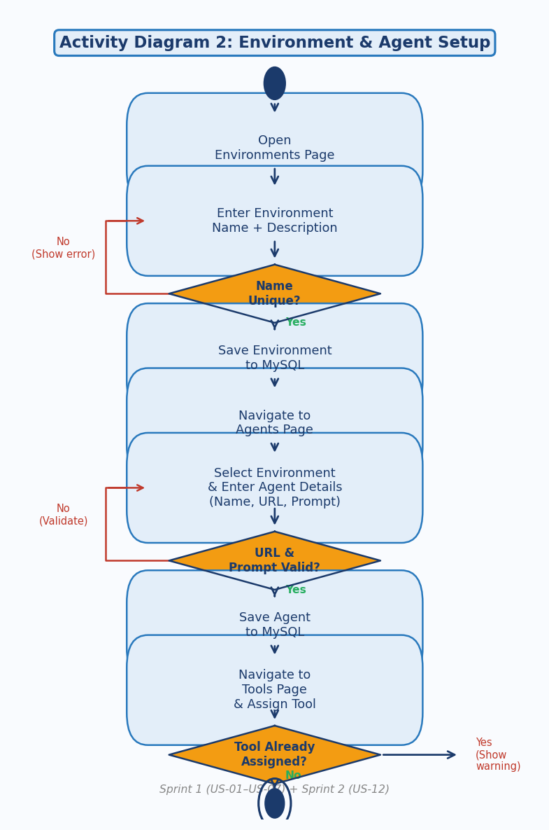
Fig 2. Activity Diagram — Environment & Agent Setup (US-01, US-02, US-03, US-04, US-05, US-12)

Activity Diagram 3 — Audit Log & Trace Viewing
This diagram covers the audit log viewing flow: selecting a run, querying MySQL, rendering the step timeline, expanding individual steps to view JSON payloads, and optionally exporting the log.
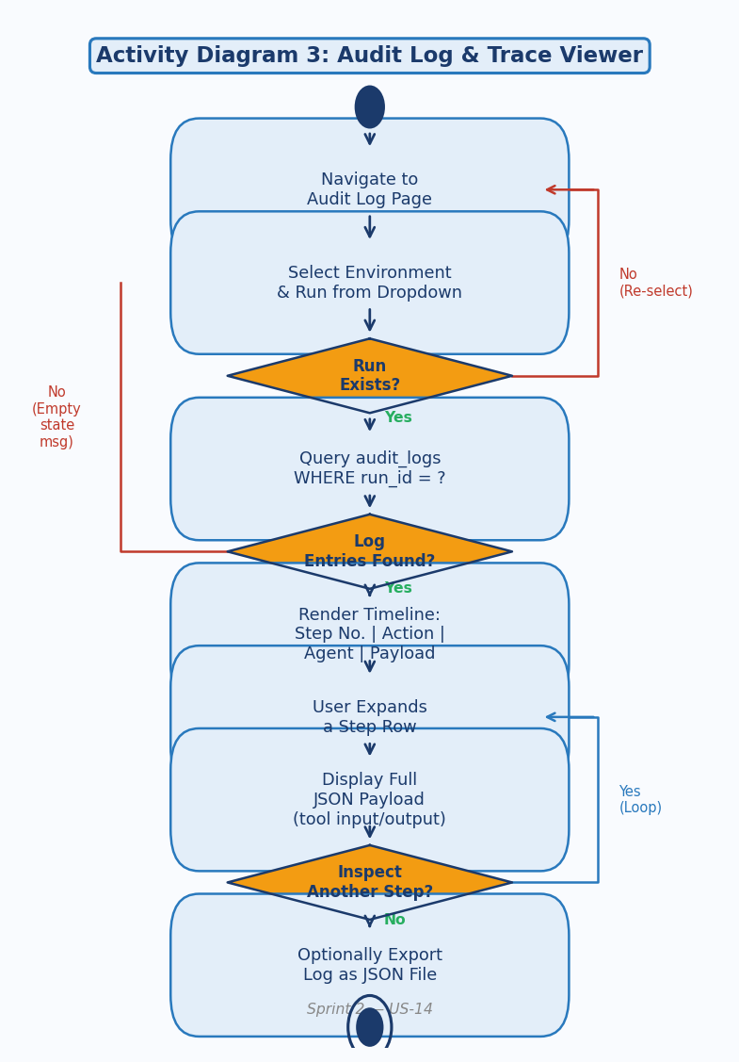
Fig 3. Activity Diagram — Audit Log Viewing (US-14)

4.2 Use Case Diagram
The use case diagram presents the complete system scope. There are two actors: the User (primary) who initiates all interactions through the Streamlit UI, and the LLM API (external) which is invoked by the AgentExecutor during runs. The system boundary separates AgentGround's functionality from the external LLM service. Dashed arrows show include and extend relationships.
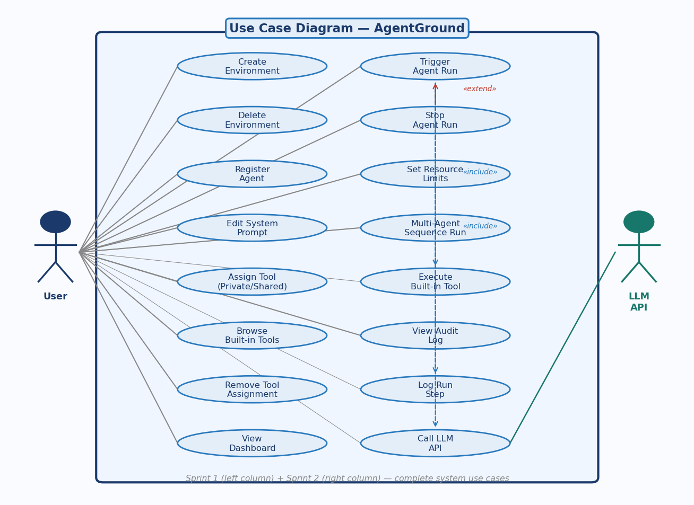
Fig 4. Use Case Diagram — Complete AgentGround System (Sprint 1 left column, Sprint 2 right column)

4.3 Sequence Diagrams
Three sequence diagrams are provided, covering the three most important runtime interactions in the system. Solid arrows represent method calls; dashed arrows represent return values. Activation boxes on lifelines show when each component is actively processing.

Sequence Diagram 1 — Trigger Agent Run
This diagram traces the full message sequence from the user clicking Trigger Run through the Streamlit RunPage, RunManager, LangChain AgentExecutor, the external LLM API, the ToolExecutor, and the AuditLogger writing to MySQL.
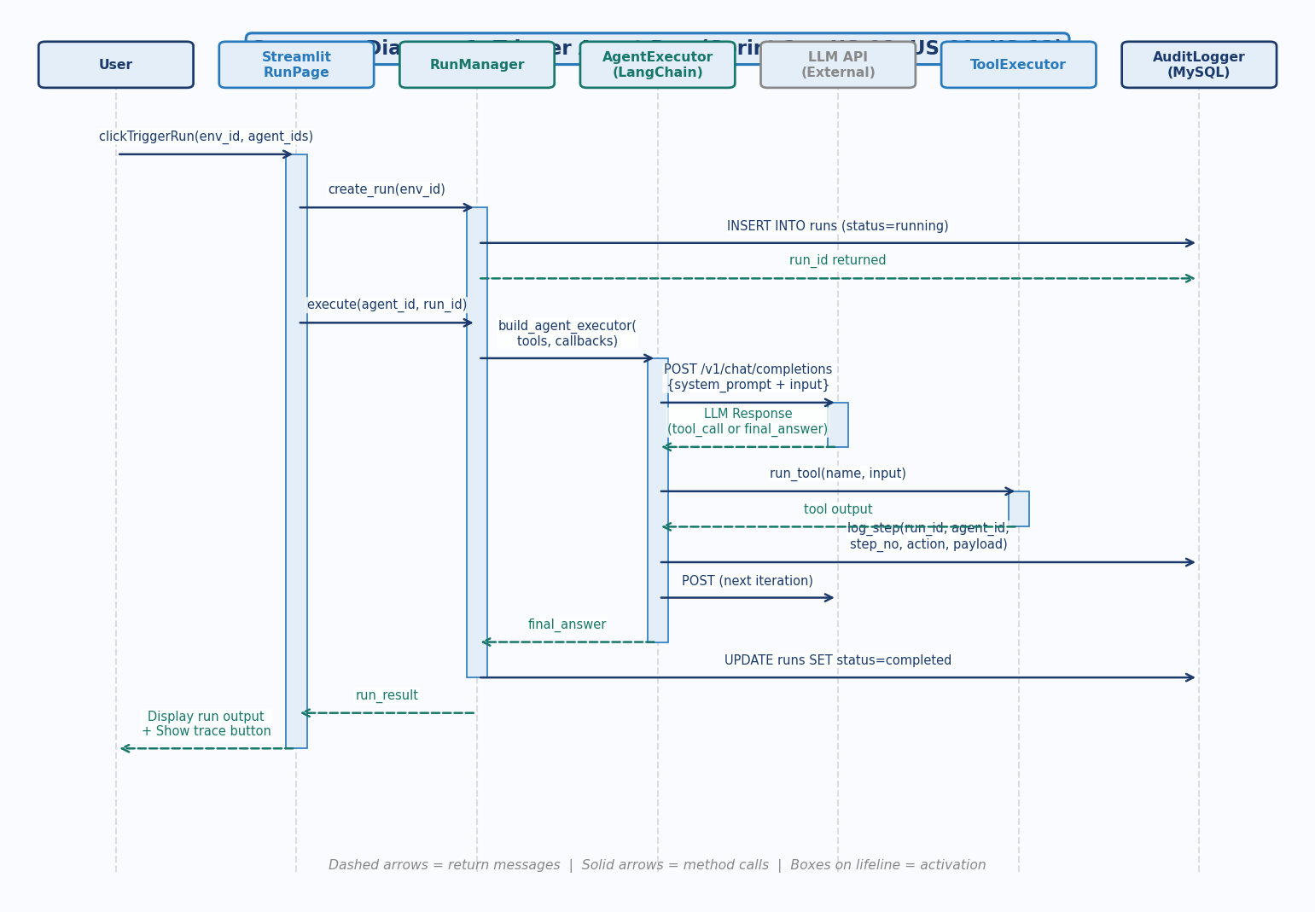
Fig 5. Sequence Diagram 1 — Trigger Agent Run (US-08, US-09, US-13, US-14)

Sequence Diagram 2 — Create Environment & Register Agent
This diagram traces the sequence from the user opening the Environments Page through form submission, EnvManager validation, MySQL insertion, then navigating to Agents Page and registering an agent through AgentManager.
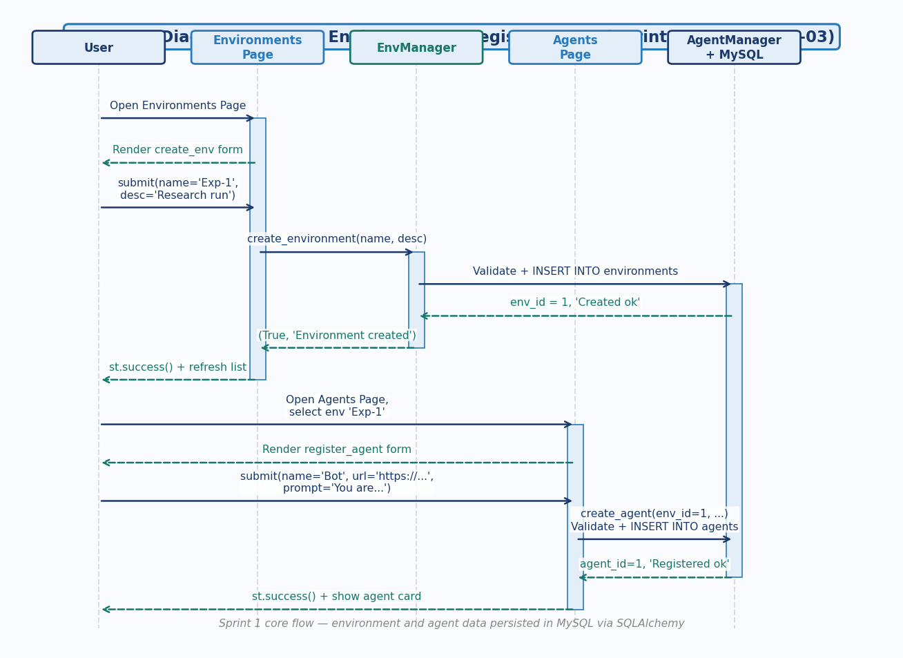
Fig 6. Sequence Diagram 2 — Create Environment & Register Agent (US-01, US-03)

Sequence Diagram 3 — View Audit Log
This diagram traces the sequence from the user navigating to the Audit Log Page, selecting a run, the AuditLogger querying MySQL, the Streamlit Trace UI rendering the timeline, and the user expanding individual steps to view JSON payloads.
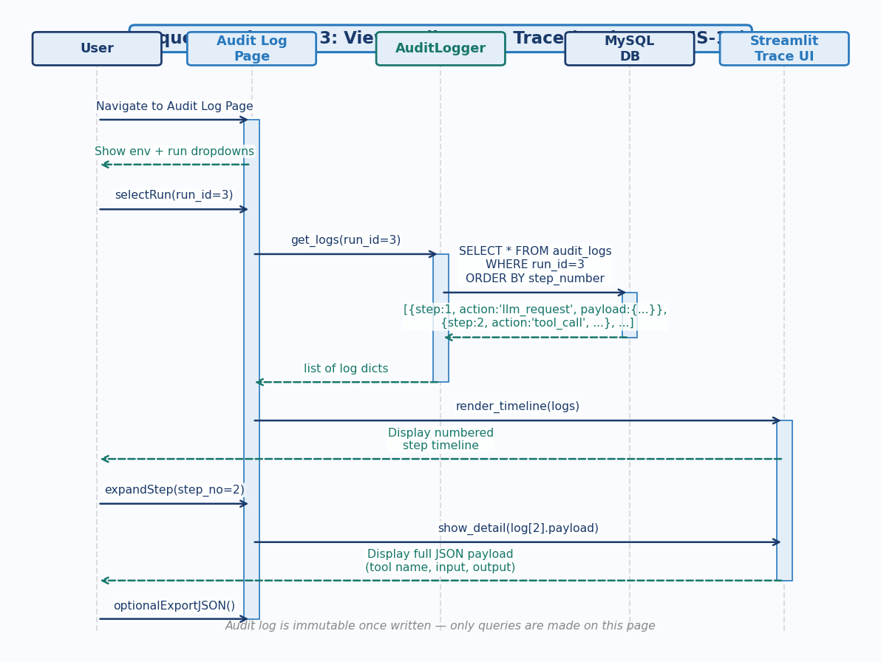
Fig 7. Sequence Diagram 3 — View Audit Log (US-14)

4.4 Class Diagram
The class diagram shows all classes in the AgentGround system organised into three layers: ORM Models (dark blue — map directly to MySQL tables), Service Layer (blue — contain all business logic and are called by Streamlit pages), and Execution Layer (teal — handle runtime agent orchestration). Solid lines with multiplicity annotations show associations; dashed arrows show dependency (uses/creates) relationships.
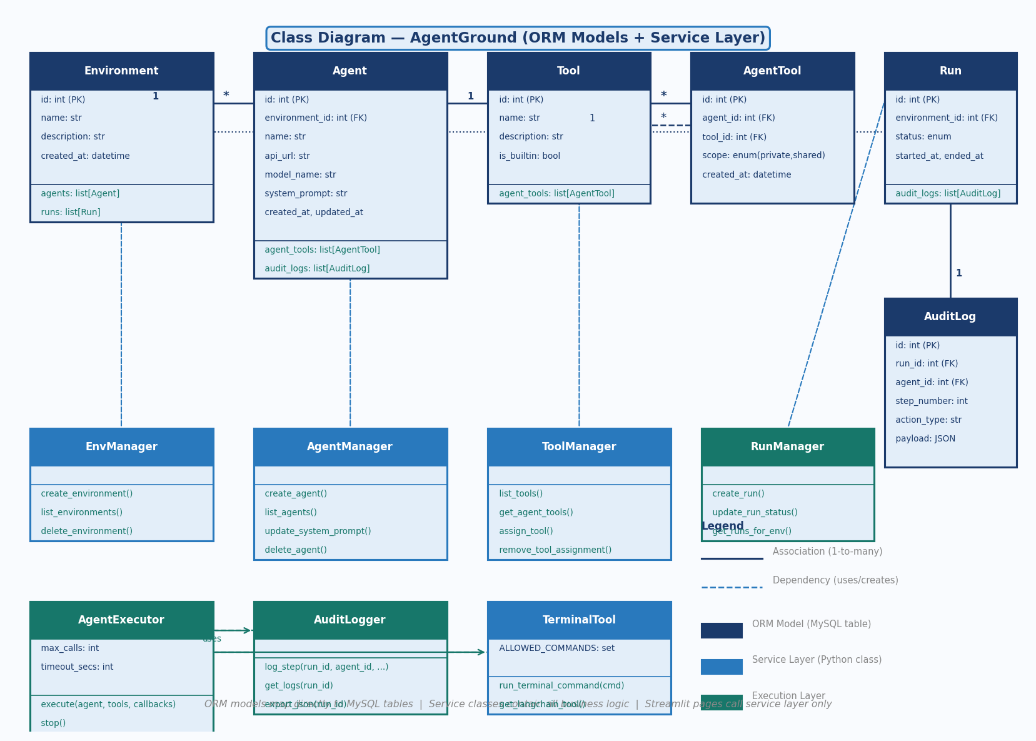
Fig 8. Class Diagram — ORM Models + Service Layer + Execution Layer

5. Scrum Board
The Scrum Board is maintained on Trello. Three snapshots are required per sprint. The board columns are: Backlog | In Progress | Testing | Done | Leftover.

5.1 Snapshot 1 — Sprint 2 Start (Day 1)
US-05 (carry-over) and all seven new stories (US-08 to US-14) are placed in Backlog. Sprint 1 stories remain in Done from the previous sprint.
[ TRELLO SNAPSHOT 1 ]
Sprint 2 start — US-05 and US-08 to US-14 all in Backlog column
Replace with screenshot from trello.com

5.2 Snapshot 2 — Mid-Sprint (Day 7)
US-05 (tool integration) and US-12 (scope enforcement) are Done. US-08 (trigger run) and US-10 (call limit) are In Progress. US-09, US-11, US-13, US-14 remain in Backlog.
[ TRELLO SNAPSHOT 2 ]
Mid-sprint — US-05 and US-12 Done; US-08 and US-10 In Progress
Replace with screenshot from trello.com

5.3 Snapshot 3 — Sprint End (Day 14)
US-05, US-08, US-09, US-10, US-11, US-12, US-13, US-14 all moved to Done. No leftovers for Sprint 2. All 26 story points delivered.
[ TRELLO SNAPSHOT 3 ]
Sprint 2 end — all eight stories in Done column, zero leftovers
Replace with screenshot from trello.com

5.4 Sprint 2 Burn-Down Chart
Total planned: 26 story points across 14 days.
Day | Date (Approx.) | Planned Remaining | Actual Remaining | Stories Completed
1 | Apr 3 | 26 | 26 | Sprint planning
2 | Apr 4 | 24 | 26 | US-05 in progress
3 | Apr 5 | 22 | 24 | US-05 Done (2 pts)
4 | Apr 6 | 20 | 22 | US-12 in progress
5 | Apr 7 | 17 | 20 | US-12 Done (3 pts)
6 | Apr 8 | 15 | 18 | US-10 in progress
7 | Apr 9 | 13 | 17 | US-10 Done (3 pts)
8 | Apr 10 | 11 | 15 | US-08 in progress
9 | Apr 11 | 9 | 12 | US-08 Done (5 pts)
10 | Apr 12 | 7 | 10 | US-11, US-09 in progress
11 | Apr 13 | 5 | 7 | US-09, US-11 Done (5 pts)
12 | Apr 14 | 3 | 5 | US-13 in progress
13 | Apr 15 | 1 | 4 | US-13 Done (4 pts)
14 | Apr 16 | 0 | 4 | US-14 Done (4 pts)

6. Implementation Screenshots
Replace each placeholder below with an actual screenshot from your running Streamlit application after Sprint 2 implementation.

6.1 Run Page — Trigger Agent Run
The Run page showing the agent selector, user message input, resource limit fields (Max Calls, Timeout), and the Run/Stop buttons.
[ SCREENSHOT ]
Run Page — trigger form with agent selector, message input, and resource limit inputs

6.2 Run Page — Agent Output
The Run page after a completed run, showing the agent's final answer and a link to the audit trace.
[ SCREENSHOT ]
Run Page — agent final answer displayed with run status = completed

6.3 Audit Log Page — Step Timeline
The Audit Log page showing the step-by-step timeline for a completed run, including step number, agent name, action type, and summary.
[ SCREENSHOT ]
Audit Log page — numbered step timeline for a completed run

6.4 Audit Log Page — Expanded Step Detail
An individual step expanded in the audit log, showing the full JSON payload (tool name, input, and output).
[ SCREENSHOT ]
Audit Log page — expanded step showing full JSON payload

6.5 Multi-Agent Run — Two Agents in Sequence
The Run page showing two agents selected in sequence, and the audit log showing steps from both agents under the same run_id.
[ SCREENSHOT ]
Run Page — two-agent sequential run with both agents' steps in the audit log

6.6 Resource Limit Triggered
A run that was halted by the API call limit, showing the run status = failed and the limit reason in the audit log.
[ SCREENSHOT ]
Audit Log — run stopped by call limit with reason logged in the final step

7. Work Division
All roles are performed by Rehan Abid as the sole developer.

Developer | Role | Sprint 2 Tasks | Stories Owned
Rehan Abid | Project Lead | Sprint 2 planning, scope control | All (US-05, US-08 to US-14)
Rehan Abid | Req. Engineer | Sprint 2 user stories, sub-stories | All
Rehan Abid | Software Architect | All 8 UML diagrams, class/sequence/activity/UC | Design chapter
Rehan Abid | Backend Developer | run_manager.py, agent_executor.py, audit_logger.py, resource_callback.py | US-08,09,10,11,12,13,14
Rehan Abid | UI Developer | 4_Run.py, 5_Audit_Log.py Streamlit pages | US-08,09,13,14
Rehan Abid | Tester / QA | Manual end-to-end tests for all Sprint 2 stories | All

GitHub Submission Note:
The implementation for this sprint is committed to the same public GitHub repository submitted in Sprint 1. The repository URL is included in the Google Classroom Sprint 2 submission. Sprint 2 code is in: backend/app/run_manager.py, backend/app/agent_executor.py, backend/app/audit_logger.py, backend/app/resource_callback.py, frontend/src/pages/4_Run.py, and frontend/src/pages/5_Audit_Log.py.
All commits: Rehan Abid

