**RGJREX O.S.**

**Contents**

**Chapter 1**

1.1 Introduction*……………………………………………………………………………………*1

**Chapter 2**

2.1 Scope of the project……………………………………………………………………….1

2.2 User wise Functionalities………………………………………………………………..2

**Chapter 3**

3.1 Design diagrams……………………………………………………………………………..2

**Chapter 4**

4.1 Software requirement………………………………………………………….…….....3

4.2 Hardware Requirement………………………………………………………………….4

**Chapter 5**

5.1 Results and discussion*……………………………………………………………………*4

5.2 Future Scope….………………………………………………………………………………6

**Chapter 6**

6.1 Conclusions ……………………………………………………………………………….....6

**Chapter 1**

**1.1 Introduction**

RGJREX O.S. is a 16-bit Operating System which boots from a floppy disk. But using emulators (VMware or QEMU) and disk imaging software’s it can be loaded to CD-R as well as pen drives.

RGJREX O.S. supports FAT12 floppy drives here we have used IBM floppy format 1.44 MB, 3.5" diskette.

IBM floppy gives us right to set few parameters like Disk Format, Disk Label, Disk Type, etc. using Assembly Level Coding.

**Chapter 2**

**2.1 Scope of the project**

Objective and motivation of the project RGJREX O.S. are as follows:-

* Gathering knowledge about Assembly Level coding X86
* How does memory management works at low level
* How to use BIOS calls in the assembly level coding
* Understanding the basic functionality of the O.S.

**2.2 User wise Functionalities**

RGJREX O.S. is a single user single processing 16-bit operating system which opens with root access. And it focuses on executing Assembly Files (*.asm) after converting them into Binary Files (*.bin) using NASM or MASM. And it also executes BASIC files (*.bas) with the help of BASIC Command Interpreter.

**Chapter 3**

**3.1 Design diagrams**

* Memory Map

|  |
| --- |
| **0 - 24575 (hex: 0h - 5FFFh)** 24K kernel executable code  - - - - - - - - - - - - - - -  **24576 - 32767 (hex: 6000h - 7FFFh)** 8K kernel disk operation buffer |
| **32768 - 65535 (hex: 8000h - FFFFh** 32K space for external programs |

Fig. 1 – Memory Distribution

RGJREX O.S.’s programs are loaded in a memory of 32KB point segment with maximum size of 32KB (Fig 1).

**Chapter 4**

**4.1 Software requirement**

* End Users
  + Emulators
* VMware Player/Workstation
* QEMU
* Virtual Box
* Operating System Developers
  + NASM/MASM
  + Text Editor
  + Imdisk
  + Partcopy or File Copier softwares

**4.2 Hardware Requirement**

* Real PC’s

Minimum Requirement

* Hard Disk- 8MB
* RAM- 4MB

- PC Speaker

* Emulator

Minimum Requirement

* Hard Disk- 1GB
* RAM- 16 MB

**Chapter 5**

**5.1 Results and discussion**

Functionalities completed so far

* Basic command line interface with commands like
  + Ver (version)
  + Time (current CPU clock time) from BIOS
  + Date (current CPU date) from BIOS
  + Clr (clear screen)
  + Cat (display contents of the file)
  + Etc.
* An option screen which displays the loaded program in the operating system including the KERNEL file.
* Dedicated BASIC (Beginner’s All-purpose Symbolic Instruction Code) Interpreter with 60 instruction codes.

Screenshots:-

* Home Screen

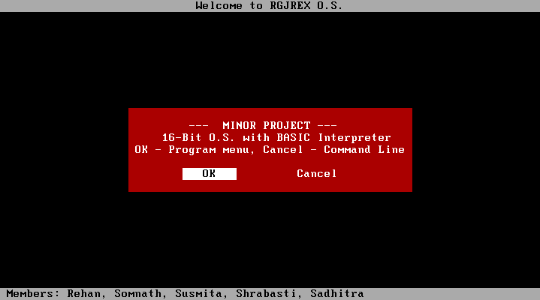

* Menu

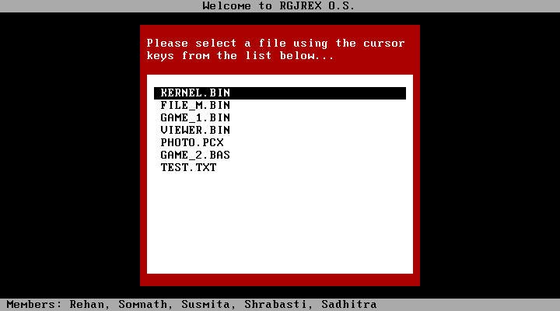

* Command Line

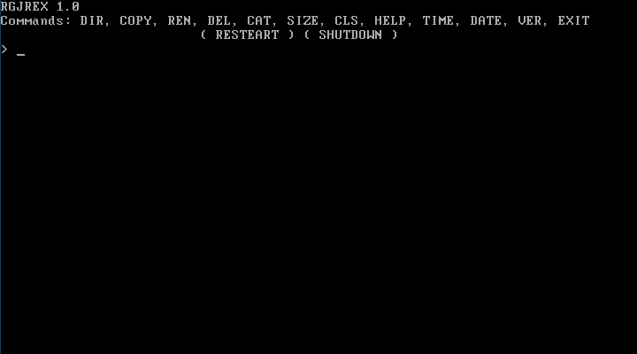

**5.2 Future Scope**

Functionalities which we want to complete for this minor project.

* The whole operating system will be structured using folders
* O.S. will have all kind of drivers (mouse, graphics, etc.)
* Convert this O.S. to 64-bit from 16-bit (current) with GUI

**Chapter 6**

**6.1 Conclusions**

This is a 16 bit Operating System with a dedicated BASIC (Beginner’s All-purpose Symbolic Instruction Code) Interpreter which helps to execute *.bas file. RGJREX is capable to execute Binary as well as BASIC files.