**Rehan Kadiwala**

**Part 3-**

What is GitHub? When was it created? Why? By who? What similar platforms exist? Why would you use such a platform?

**Answer-** Github is an open source where you can store codes and many other documents. You can share these documents with your friend, professor, classmate, or total stranger.

Tom Preston- Werner, Chris Wanstrath and PJ Hyett created it on February 8, 2008.

Platforms such as SourceForge, Bitbucket, Redmine, Gitlab, Launchpad, Codeplex and many more.

It is a platform for developers to share and develop codes where they can use others codes or suggest them improvements in their codes. It is also use to share documents. It is like a social network for developers.

**Part 4-**

Press enter to submit commands

> git init

$ git status

$ git status

$ git add octocat.txt

$ git status

$ git commit -m "Add cute octocat story"

$ git add '*.txt'

$ git commit -m 'Add all the octocat txt files'

$ git log

$ git remote add origin https://github.com/try-git/try_git.git

$ git pust -u origin master

$ git push -u origin master

$ git pull origin master

$ git diff HEAD

$ git add octofamily/octodog.txt

$ git diff --staged

$ git reset octofamily/octodog.txt

$ git checkout -- octocat.txt

$ git branch clean_up

$ git checkout clean_up

$ git rm '*.txt'

$ git commit -m "Remove all the cats"

$ git commit -m "Remove all the cats"

$ git commit -m "Remove all the cats"

$ git checkout master

$ git merge clean_up

$ git branch -d clean_up

$ git push

>

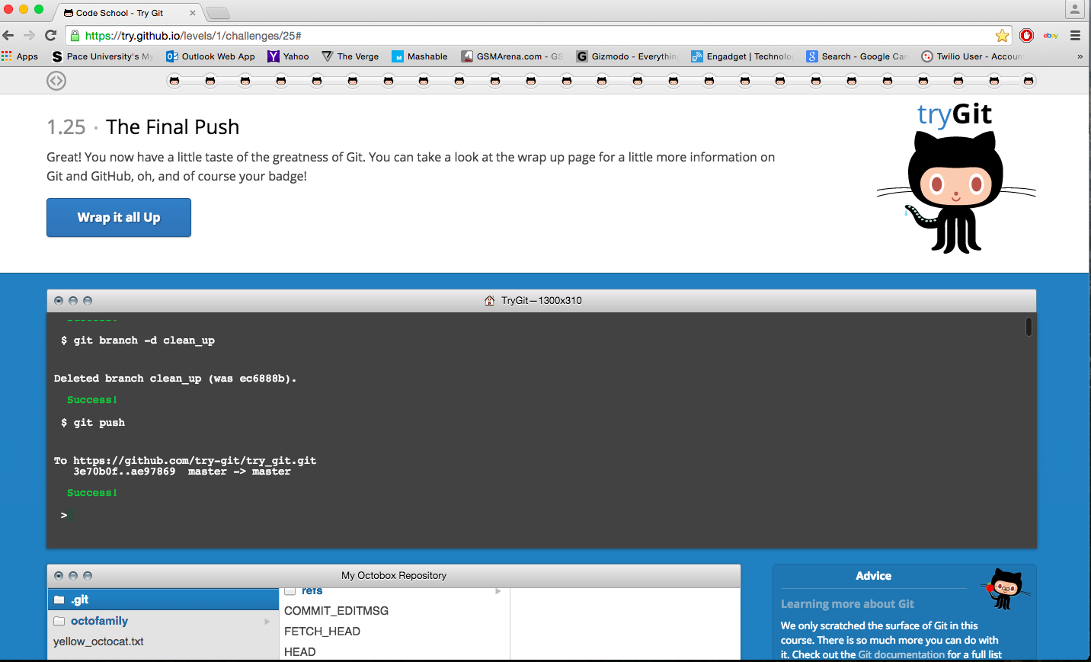

**Part 5-**

* Repository- Git stores information of a file and manages a project as they change over time. It stores these information in a data structure called Respository.
* Commit- Commit records and adds the changes in the local repository.
* Push- Push transfers the last commits that are made to a remote server.
* Branch- Branch is a pointer that points to the commit. As new commits are made it automatically moves the pointer to the recent commit we made.
* Fork- Fork is a copy of repository. You can edit and experiment on the copied files and the original project wont get affected.
* Merge- After using fork, if we want to add these changes to the original project then we use merge.
* Clone- Clone is a copy of the project and is made available to you locally so you can view or edit the file as per your need.
* Pull- Pull automatically mergers the commits you make into the branch without letting you know.
* Pull request – Pull request informs other persons the change that you have made in your project so they can review the changes in the file.