Create Two Nodes In AWS EKS Elastic Kubernetes Service CLUSTER

What is Amazon EKS
Amazon EKS is a managed service that is used to run Kubernetes on AWS. Using EKS users don’t have to maintain a Kubernetes control plan on their own. It is used to automate the deployment, scaling, and maintenance of the containerized application. It works with most operating systems.

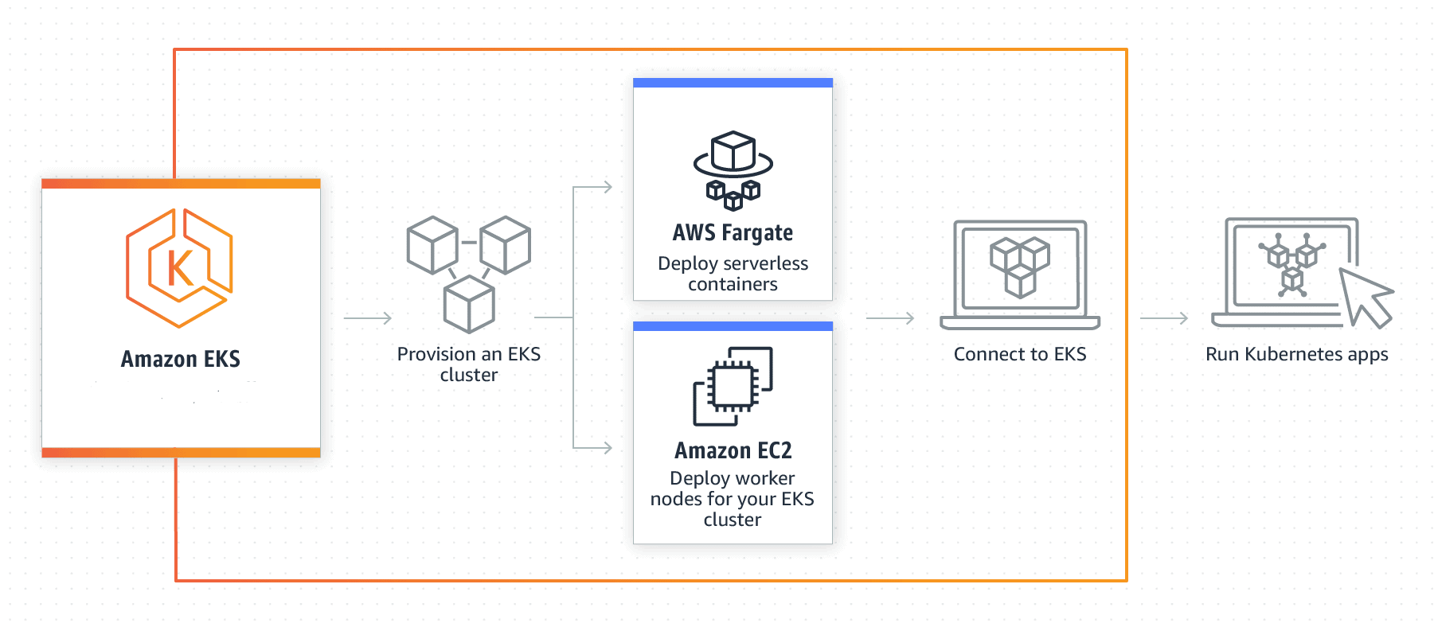
Architecture of EKS
EKS is integrated with various AWS services:
- ECR (Elastic Container Registry) for container images.
- Elastic Load Balancer for distributing traffic.
- IAM for providing authentication and authorization.
- VPC (Virtual Private Cloud) for isolating resources.
How Amazon EKS Works
The most basic explanation for EKS is that it is AWS’ solution for Kubernetes-as-a-service. EKS, as previously stated, greatly simplifies the management and maintenance of highly available Kubernetes clusters in AWS.

Amazon EKS Components

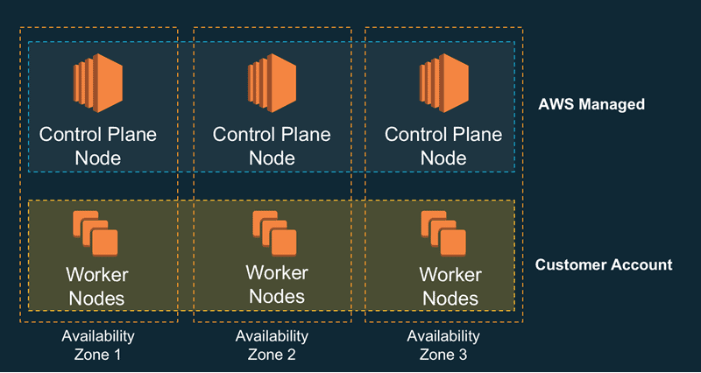
1) Nodes: A node is a physical or virtual machine. In EKS both Master Node and Worker Node are managed by EKS. There are two types of nodes.

- Master Nodes: A Master Node is a collection of components like Storage, Controller, Scheduler, and API server that make up the control plan of Kubernetes. The EKS itself creates the Master Node and manages it.

  - API Servers: It controls the API servers whether it is kubctl (Kubernetes CLI) or rest API.

  - Etcd: It is a highly available key-value store that is distributed among the Kubernetes cluster to store configuration data.

  - Controller Manager: Cloud Controller Manager is used to manage the VMs, storage, databases, and other resources associated with the Kubernetes cluster. It makes sure that you are using as much as the container needed at a point in time. It keeps a count of containers used and also records the state.

  - Scheduler: It validates what and when the work needs to be done. It integrates with the Controller manager and API servers.

  - Worker Nodes: The worker nodes in a cluster are the machines or physical servers that run your applications. The user is responsible for creating and managing worker nodes.

  - Kublet: It controls the flow to and fro from the API. It makes sure containers are running in the pod.

  - Kubproxy: It includes networking rules and access control. It is like a firewall.

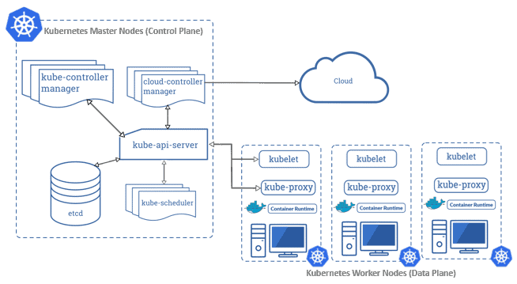
2) Pods: A group of containers is called pods. They share networking, storage, IP address, and port spaces.

3) DaemonSet: It makes sure that all node runs a copy of a certain pod. It is like a monitoring tool.
Learn more about Kubernetes Architecture

Master Nodes or Control Plane

The Control Plane consists of three K8s master nodes that run in three different availability zones (AZs). All incoming traffic to K8s API comes through the network load balancer (NLB). It runs on the virtual private cloud controlled by Amazon. So, the Control Panel can’t be managed directly by the organization and is fully managed by AWS.

Check out: All you need to Know about Docker Storage

Worker Nodes or Data Plane
Worner Nodes run on the Amazon EC2 instances in the virtual private cloud controlled by the organization. A cluster of worker nodes runs an organization’s containers while the control plane
manages and monitors when and where containers are started.

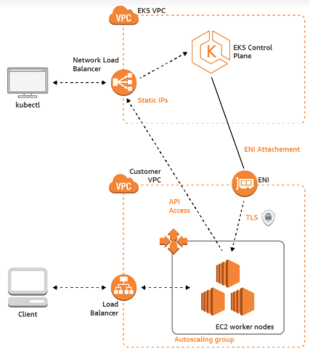
Control Panel & Worker Node Communication

Amazon EKS Workflow

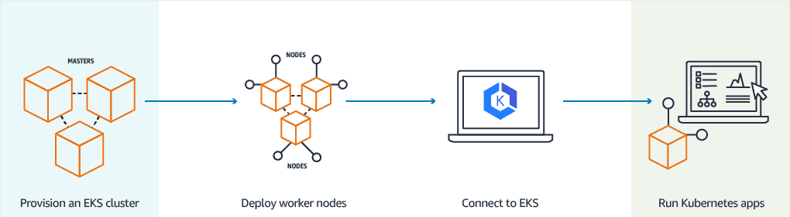
- Provision EKS cluster using AWS Console, AWS CLI, or one of the AWS SDKs.
- Deploy worker nodes to the EKS cluster. There is already a predefined template that will automatically configure nodes.
- Now we configure Kubernetes tools such as kubctl to communicate with the Kubernetes cluster.
- We are now all set to deploy an application on the Kubernetes cluster.

Create EKS Kubernetes Cluster Using GUI

The important steps involved are:
1) Creating a Master Node
2) Installing and Configuring AWS CLI & kubectl
3) Creating a Worker Node
1- Create an AWS free tier account
2-Create a Master Node
3-Install and Configure AWS CLI
4-Install and Configure kubectl
5-Create Worker Nodes
6-Configure Worker Nodes Networking
7-Verifying the Worker Node by Kubectl
8-Delete the Worker and Master Node via GUI

Step 2: Create a Master Node, follow the below steps to create one.

a) Log in to the AWS portal, find the Kubernetes Service by searching for EKS and click on Create

Kubernetes Cluster and then specify the name for the Cluster.

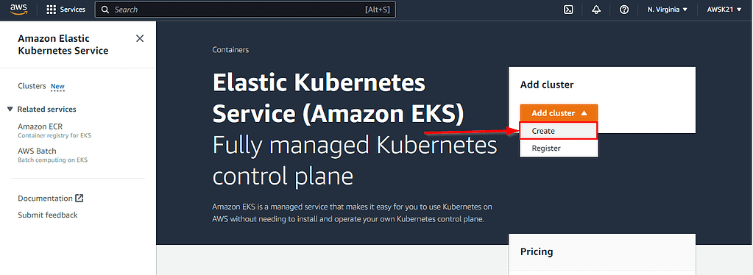
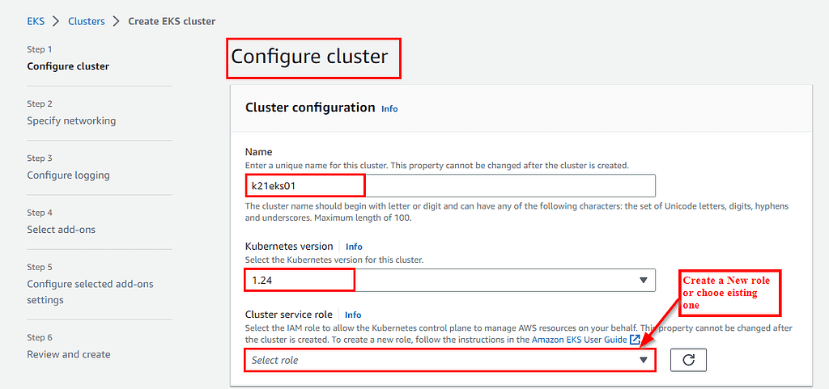
b) Next is to create the role, click on “Create role” -> AWS Service -> EKS (from AWS Services) -> Select EKS Cluster -> Next Permissions.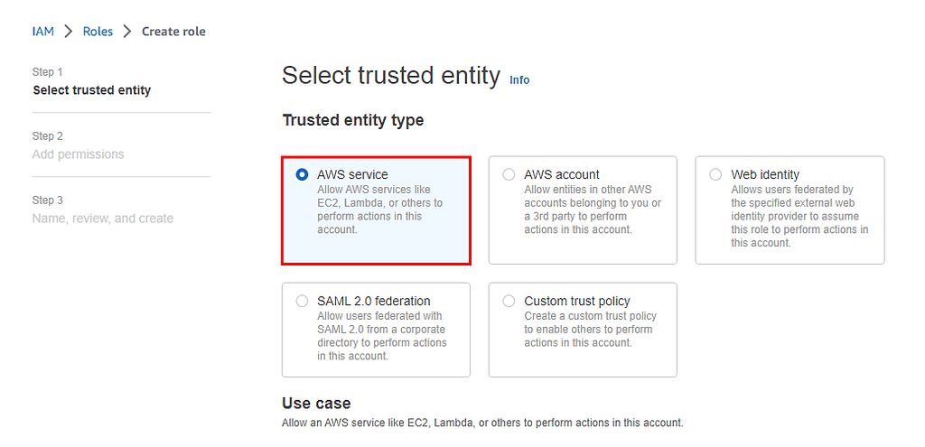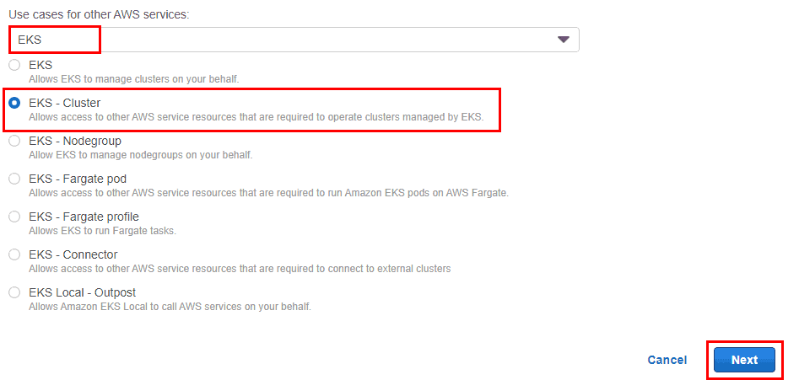
c) Leave the selected policies as-it-is and click on Review Page.

d) Enter a name for the role (e.g. eksClusterRole) and hit the Create role button at the bottom of the page to create the IAM role. The IAM role is created.
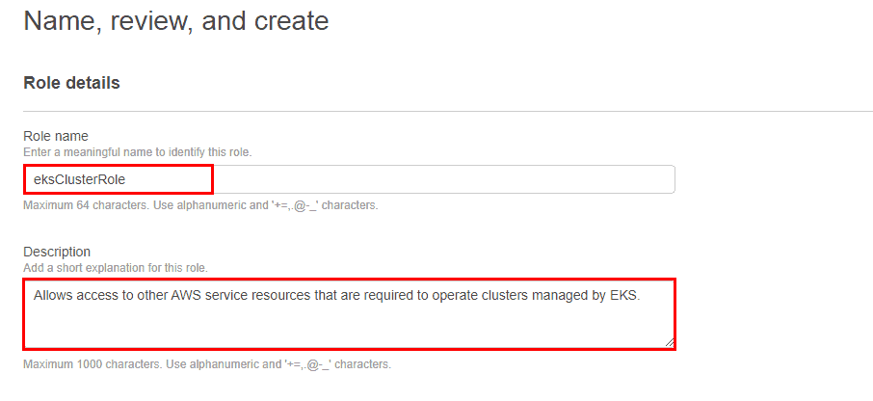
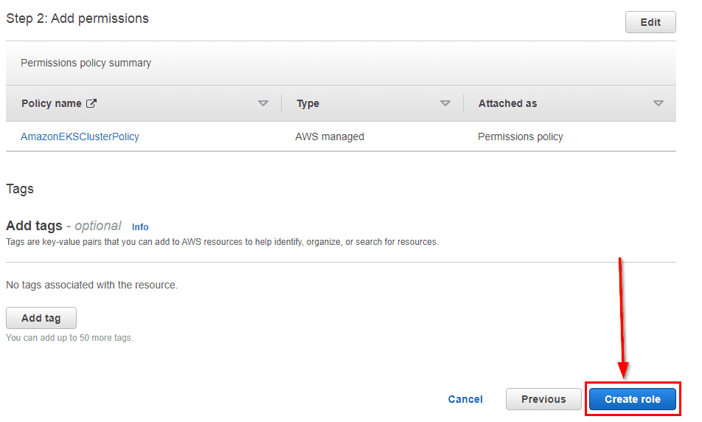
e) Now Master node will be created in approximately 5- 10 minutes.
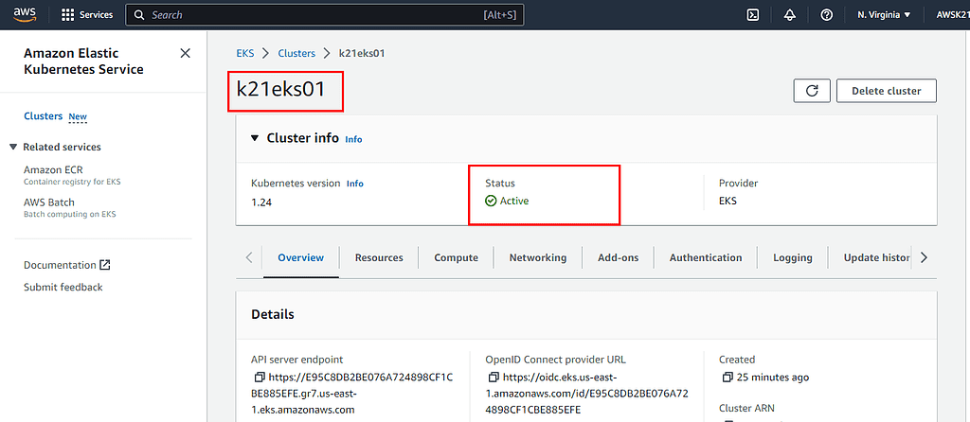Step 3: Next step is to Install & configure AWS CLI on the EC2 instance. Follow the below links and steps for the same;

- To complete this step you need to create an Amazon Linux Instance first, click here.
- To get the Latest EKS UserGuide visit Getting Started AWS Console, click here.
- Know more about the CLI UserGuide from CLI Configure Quickstart, click here.

a) Click the account name and select Security Credentials. scroll down and Click on Create Access key.
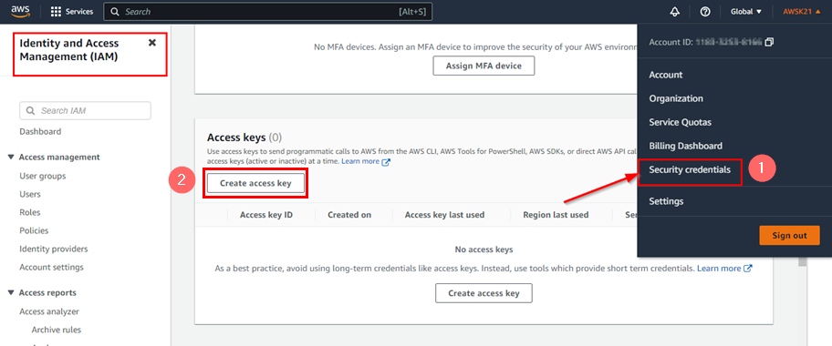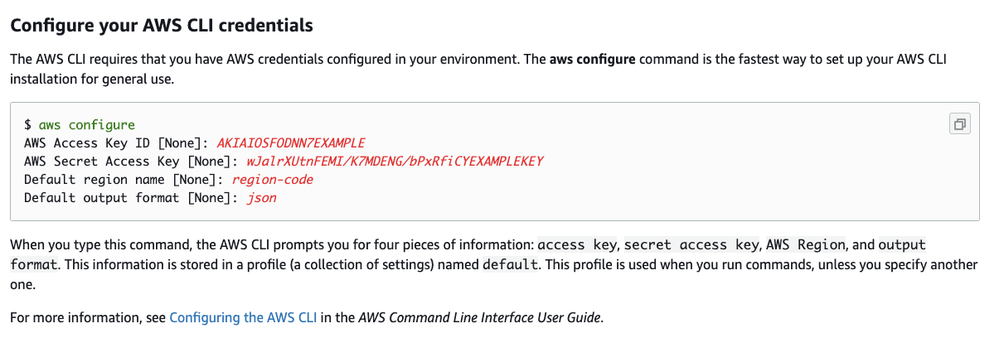
AWS CLI Credentials Configuration

Step 4: Next is to install & configure the kubectl, by checking your Cluster Name & Region Name where the EKS Master node is running from the console. Check the status of Cluster and Configure kubectl with EKS API Server and validate kubectl configuration to master node.
To know more go through the blog Install and Configure kubectl, click here

Step 5: The final step is to create the Worker Node.

a) On the cluster page, select the Compute tab, and then choose Add Node Group.

b) On the Configure node group page, fill out the parameters accordingly, and then choose Next.

- Name – Enter a unique name for your managed node group.

- Node IAM role name– Choose the node instance role to use with your node group. For more information, see the Amazon EKS worker node IAM role, click here.

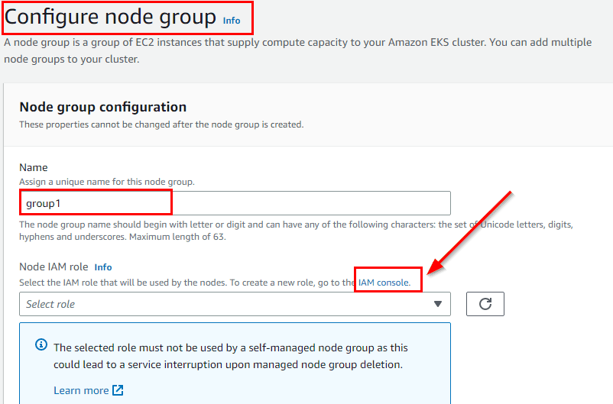To Create an IAM role follow the below-given steps, and to open the IAM Console, click here
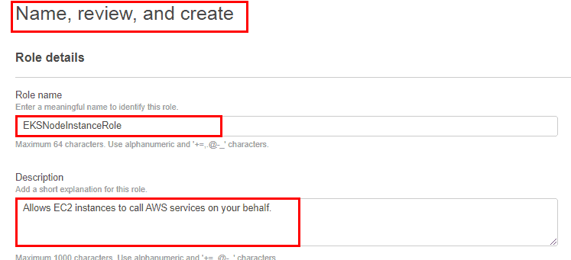
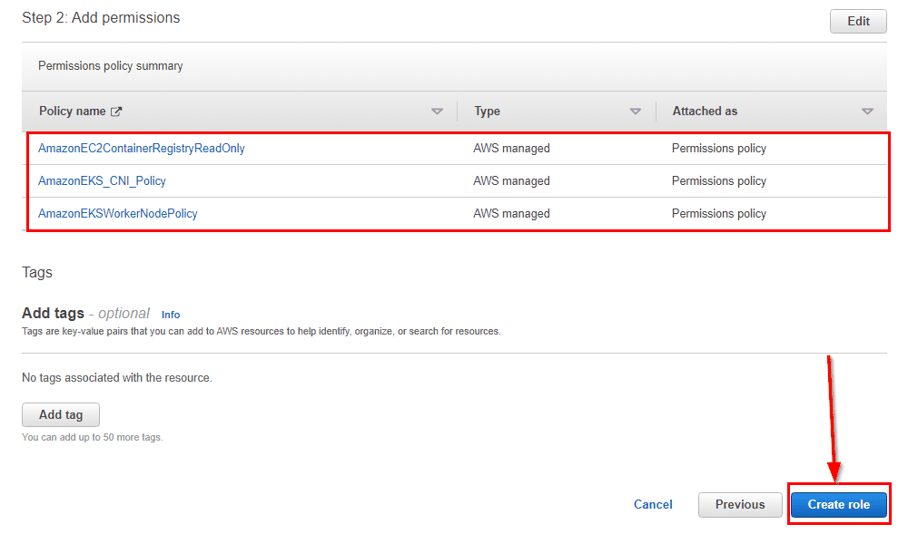
After following all the above steps, leave the other settings to default and proceed further.

Step 6: Next is to configure the Compute & scaling of Worker Nodes.

a) In this step we are providing the compute configurations. Follow the images below and complete the process:

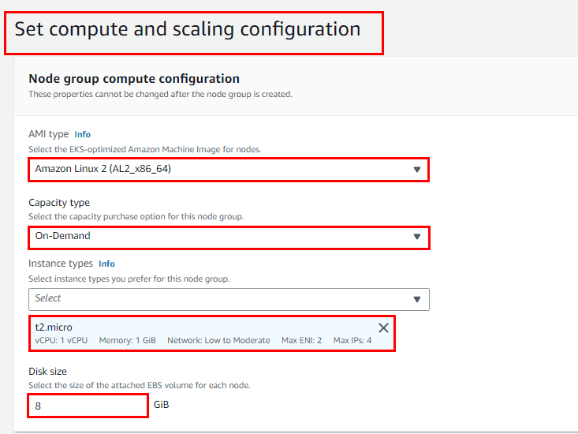
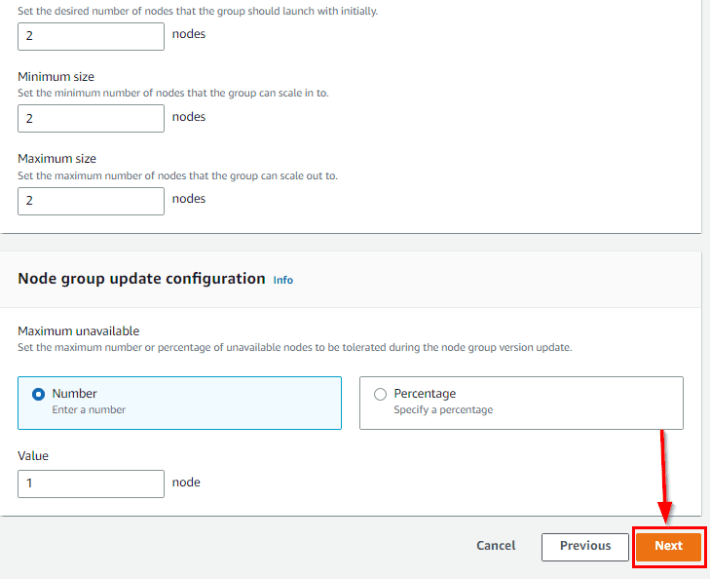b) Keep rest as default. On the Review and Create page, review your managed node group configuration, and choose to Create. Worker Node Group is under creation so wait for 2-3 minutes for workers nodes to be up and running.
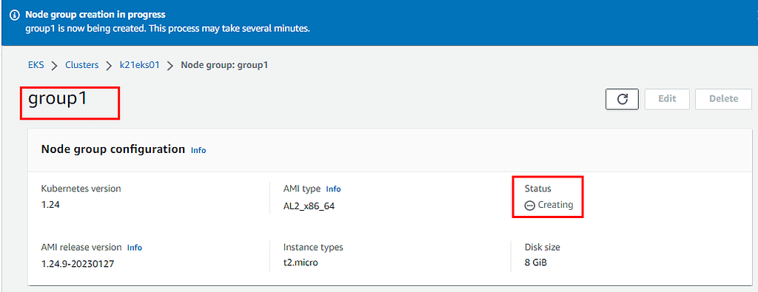
Step 7: The final step is to verify the Worker node status from Kubectl. For the same perform the given command:

$ kubectl get nodes --watch

Step 8: Delete all EKS cluster configurations manually. In the first step delete the worker Node, once worker nodes are deleted then Delete the Master Nodes.
