Exploratory Data Analysis (EDA) and Visualization Framework for Customer Churn Prediction

- Introduction to Exploratory Data Analysis (EDA)
- Exploratory Data Analysis (EDA) is an important stage of the Data Science process used to understand the structure, characteristics, and patterns present in a dataset. Before applying Machine Learning algorithms, it is necessary to explore the data carefully to identify useful information, unusual observations, missing values, and relationships between different variables.
- In this project, EDA will be applied to the proposed Customer Churn Prediction dataset. The analysis will focus on understanding customer characteristics and identifying patterns that may be associated with customer churn. Variables such as customer tenure, monthly charges, contract type, payment method, internet service, total charges, and churn status will be explored.
- EDA will involve both statistical analysis and data visualization. Numerical variables will be examined using measures such as mean, median, minimum, maximum, standard deviation, and distribution analysis. Categorical variables will be analyzed using frequency counts and proportions. Visualizations will be used to make important patterns and relationships easier to understand.
- The main purpose of EDA in this project is not to make final predictions, but to understand the data and prepare it for further analysis and Machine Learning. EDA findings will help identify relevant features, detect data quality issues, understand customer behavior, and select appropriate visualization and modeling strategies.
- A systematic EDA process will therefore improve the quality of the overall Customer Churn Prediction project and provide a strong foundation for the subsequent stages of feature engineering and Machine Learning.
2. Data Exploration Techniques
Data exploration will be performed systematically to understand the structure and characteristics of the Customer Churn Prediction dataset. Different exploration techniques will be used depending on the type of variable and the analysis objective.
2.1 Initial Data Inspection
The dataset will first be inspected to understand its overall structure. The number of rows and columns, column names, data types, sample records, and basic statistical information will be examined. This initial inspection will help identify potential data quality problems before detailed analysis begins.
2.2 Univariate Analysis
Univariate analysis focuses on studying one variable at a time. Numerical variables such as Age, Tenure, Monthly Charges, and Total Charges will be analyzed using summary statistics and distribution plots. Histograms and box plots will be used to understand the distribution, spread, and potential outliers of numerical variables.
For categorical variables such as Contract Type, Payment Method, Internet Service, and Churn, frequency counts and bar charts will be used to understand the distribution of different categories.
2.3 Bivariate Analysis
Bivariate analysis will examine the relationship between two variables. The relationship between customer attributes and churn will be analyzed to identify factors that may be associated with customers leaving the service.
Examples include analyzing Churn versus Contract Type, Churn versus Tenure, Churn versus Monthly Charges, and Churn versus Payment Method. Suitable charts such as grouped bar charts, box plots, and scatter plots will be considered.
2.4 Multivariate Analysis
Multivariate analysis will examine relationships among three or more variables simultaneously. This will help identify complex patterns that may not be visible through individual or two-variable analysis.
Correlation analysis and heatmaps will be used to examine relationships among numerical variables. Multiple features may also be analyzed together to understand their combined relationship with customer churn.
2.5 Missing Data Analysis
The dataset will be checked for missing or null values. The number and percentage of missing values in each column will be identified. Depending on the type and amount of missing data, appropriate methods such as removing records or replacing values using mean, median, or mode may be considered.
2.6 Outlier Detection
Outliers are observations that differ significantly from the general pattern of the data. Numerical variables such as Monthly Charges and Total Charges will be examined for unusual values using box plots and statistical methods.
Detected outliers will be investigated before deciding whether they should be retained, transformed, or removed. The decision will depend on whether the values represent genuine customer behavior or data quality problems.
2.7 Data Quality Checks
Additional checks will be performed to identify duplicate records, inconsistent values, incorrect data types, and invalid entries. These checks will ensure that the dataset is reliable enough for further visualization and Machine Learning analysis.
- Visualization Strategies
Data visualization will be used to represent important patterns, distributions, relationships, and trends in the Customer Churn Prediction dataset. The choice of visualization will depend on the type of data and the analysis objective. Proper visualization will make complex information easier to understand and will help identify patterns that may not be visible through numerical analysis alone.
3.1 Histogram
Histograms will be used to understand the distribution of numerical variables such as Age, Tenure, Monthly Charges, and Total Charges. They will help identify the range, concentration, and overall distribution of customer-related numerical data.
3.2 Bar Chart
Bar charts will be used for categorical variables such as Contract Type, Payment Method, Internet Service, and Churn. They will help compare the number of customers in different categories.
3.3 Grouped Bar Chart
Grouped bar charts will be used to compare churn across different categories. For example, Contract Type can be compared with Churn status to identify which contract categories have higher churn rates.
3.4 Box Plot
Box plots will be used to compare the distribution of numerical variables across different churn categories. For example, Monthly Charges can be compared between customers who churned and customers who did not churn. Box plots will also help identify potential outliers.
3.5 Scatter Plot
Scatter plots will be used to examine relationships between two numerical variables. For example, Tenure and Monthly Charges can be plotted to identify possible relationships and patterns between these variables.
3.6 Line Chart
Line charts can be used when analyzing ordered or time-related data. If future versions of the dataset contain monthly customer behavior or churn trends over time, line charts can be used to identify changes and trends.
3.7 Heatmap
A correlation heatmap will be used to visualize relationships between numerical variables. It will help identify strongly related features and may assist in selecting relevant variables for further analysis.
3.8 Pie Chart
Pie charts may be used for simple categorical distributions when the number of categories is small. For example, the overall proportion of churned and non-churned customers can be represented using a pie chart. However, bar charts will generally be preferred when precise comparison between categories is required.
3.9 Visualization Selection Strategy
The visualization method will be selected based on the data type and analytical objective. Numerical distributions will primarily use histograms and box plots, categorical comparisons will use bar charts, relationships between numerical variables will use scatter plots, and correlation analysis will use heatmaps.
All visualizations will include clear titles, axis labels, legends where necessary, and appropriate formatting so that the results can be easily interpreted and documented.
- Tools & Python Libraries
The proposed EDA process will use Python and commonly used Data Science libraries for data exploration, statistical analysis, and visualization. Each library will be selected according to its specific role in the analysis workflow.
4.1 Python
Python will be used as the primary programming language because it provides a large ecosystem of libraries for Data Science, statistical analysis, and visualization.
4.2 Pandas
Pandas will be used for loading, inspecting, cleaning, filtering, and manipulating the dataset. It will also be used to calculate descriptive statistics and prepare data for visualization.
4.3 NumPy
NumPy will support numerical calculations and array-based operations. It will be useful for statistical calculations and numerical data processing during EDA.
4.4 Matplotlib
Matplotlib will be used to create basic and customizable visualizations such as histograms, bar charts, line charts, scatter plots, and other analytical graphs.
4.5 Seaborn
Seaborn will be used for statistical visualization. It will be particularly useful for creating attractive and informative box plots, distribution plots, categorical plots, and correlation heatmaps.
4.6 Plotly
Plotly may be considered for interactive visualizations. Interactive charts can allow users to explore data points and patterns more effectively, especially when presenting EDA findings through dashboards or interactive reports.
4.7 Jupyter Notebook
Jupyter Notebook will be used as the development environment for conducting EDA. It will allow data processing, Python code, visualizations, and observations to be maintained together in a structured document.
4.8 Tool Selection Strategy
Pandas and NumPy will primarily handle data processing and numerical analysis, while Matplotlib, Seaborn, and Plotly will be used for visualization. Jupyter Notebook will provide the environment for combining the analysis and documenting the findings.
The selected tools will support a reproducible and organized EDA workflow that can later be extended to feature engineering and Machine Learning.
- Reporting & Documentation Strategy
The findings obtained from Exploratory Data Analysis will be documented in a clear and structured format. The purpose of reporting will be to communicate important patterns, relationships, data quality issues, and observations obtained during the analysis.
5.1 Documentation of Data Quality
The report will document the number of records, number of features, data types, missing values, duplicate records, and identified inconsistencies. Any preprocessing decisions made during EDA will also be recorded with their reasons.
5.2 Documentation of Statistical Findings
Important statistical observations will be summarized using descriptive statistics such as mean, median, minimum, maximum, and standard deviation. These statistics will help explain the distribution and characteristics of numerical variables.
5.3 Documentation of Visualizations
Each important visualization will be presented with a meaningful title, labeled axes, and a short explanation of the observation. The report will explain what the chart shows and why the identified pattern is relevant to the Customer Churn Prediction problem.
5.4 Key Findings
Important findings from EDA will be summarized separately. For example, the analysis may identify customer groups with higher churn rates based on contract type, tenure, monthly charges, or payment method.
5.5 Visualization Standards
All charts will follow consistent formatting and will use appropriate titles, labels, legends, and readable scales. Unnecessary visual elements will be avoided so that the main analytical insight remains clear.
5.6 Reproducibility
The EDA process will be documented using Jupyter Notebook and Python. The analysis steps, code, visualizations, and observations will be maintained together so that the analysis can be reproduced or updated when new data becomes available.
5.7 Final EDA Report Structure
The final EDA documentation will follow this structure:
- Dataset Overview
- Data Quality Analysis
- Univariate Analysis
- Bivariate Analysis
- Multivariate Analysis
- Outlier Analysis
- Visualization Results
- Key Findings
- Recommendations for Further Analysis
This structured reporting approach will make the EDA findings easier to understand and will provide a clear foundation for the next stages of feature engineering and Machine Learning.
- EDA Workflow / Framework
The proposed Exploratory Data Analysis workflow will follow a systematic sequence to ensure that the customer dataset is properly understood before Machine Learning is applied. Each stage will contribute to identifying data quality issues, patterns, relationships, and useful features.
The EDA workflow will follow these stages:
Data Loading
↓
Dataset Structure & Summary
↓
Data Quality Check
↓
Missing Value Analysis
↓
Duplicate & Data Type Check
↓
Univariate Analysis
↓
Bivariate Analysis
↓
Multivariate Analysis
↓
Outlier Detection
↓
Correlation Analysis
↓
Visualization & Key Findings
↓
Feature Insights for Machine Learning
The process will begin by loading and inspecting the dataset. Basic information such as the number of records, features, data types, and summary statistics will then be examined.
Data quality checks will identify missing values, duplicates, inconsistent values, and potential errors. After the data quality assessment, univariate, bivariate, and multivariate analyses will be performed to understand individual variables and relationships between multiple variables.
Outlier detection and correlation analysis will then be performed to identify unusual observations and relationships between numerical features. Finally, important findings will be documented through appropriate visualizations and observations.
The insights obtained from EDA will be used as a foundation for feature engineering and subsequent Machine Learning model development.
- EDA Visualization Mapping
Different visualization techniques will be selected according to the type of data and the analytical question being investigated. The following mapping will be used for the proposed Customer Churn Prediction analysis.
Analysis / Question | Visualization | Purpose | Expected Insight
How is customer age distributed? | Histogram | Understand numerical distribution | Identify common age ranges
How is customer tenure distributed? | Histogram | Analyze customer tenure | Identify new and long-term customers
How are customers distributed by contract type? | Bar Chart | Compare categories | Identify the most common contract types
What is the overall churn distribution? | Bar Chart / Pie Chart | Compare churn and non-churn customers | Understand target class distribution
Does churn vary by contract type? | Grouped Bar Chart | Compare churn across categories | Identify contract types with higher churn
Does monthly charge differ by churn status? | Box Plot | Compare numerical distributions | Identify charge patterns associated with churn
Does tenure relate to monthly charges? | Scatter Plot | Analyze two numerical variables | Identify possible relationships or trends
Which numerical variables are correlated? | Heatmap | Visualize correlations | Identify strongly related features
Are there unusual monthly charge values? | Box Plot | Detect outliers | Identify potential extreme observations
How does payment method relate to churn? | Bar Chart | Compare churn across payment categories | Identify payment groups with different churn patterns
The selected visualizations will be created using Python libraries such as Matplotlib and Seaborn. Each visualization will be accompanied by a short interpretation explaining the key observation and its relevance to the Customer Churn Prediction problem.
The visualization mapping will ensure that charts are not created randomly. Each chart will have a specific analytical purpose and will contribute to understanding customer behavior, identifying important features, and preparing the dataset for future Machine Learning modeling.
- Time Allocation & Work Plan
The proposed Exploratory Data Analysis and Visualization work will require approximately 32 hours. The available time will be divided across different activities to ensure that data exploration, visualization, analysis, and documentation are completed systematically.
Activity | Estimated Time
Understanding the Dataset and EDA Requirements | 2 Hours
Initial Dataset Inspection | 2 Hours
Data Quality and Missing Value Analysis | 3 Hours
Duplicate, Data Type and Consistency Checks | 2 Hours
Univariate Analysis | 4 Hours
Bivariate Analysis | 4 Hours
Multivariate Analysis and Correlation Study | 3 Hours
Outlier Detection and Analysis | 3 Hours
Visualization Creation and Selection | 4 Hours
Findings, Reporting and Documentation | 3 Hours
Final Review and Organization | 2 Hours
Total | 32 Hours
The work plan provides sufficient time for both technical analysis and documentation. More time is allocated to univariate, bivariate, and visualization activities because these stages are central to understanding customer behavior and identifying patterns related to churn.
The timeline may be adjusted during actual implementation depending on the size and quality of the dataset and the complexity of the findings.
- Expected EDA Findings & Insights
Since this project is currently at the planning stage and no actual dataset has been analyzed yet, the following are expected areas of investigation rather than confirmed findings. The actual results will depend on the dataset used during implementation.
9.1 Customer Tenure
The analysis may reveal differences in churn behavior between new customers and long-term customers. Tenure distribution will be examined to determine whether customers with shorter service periods show different churn patterns.
9.2 Contract Type
Different contract types may show different churn rates. Customers with shorter-term contracts may potentially have a different churn tendency compared with customers having longer-term contracts.
9.3 Monthly Charges
Monthly charges will be analyzed to determine whether customers paying higher or lower amounts show different churn patterns. Box plots and distribution charts will be used to compare charges between churn categories.
9.4 Payment Method
Payment methods will be examined to identify whether particular payment categories are associated with different churn proportions. This may provide useful information for further customer behavior analysis.
9.5 Internet Service
Different types of internet services will be compared with churn status to identify possible differences in customer retention patterns.
9.6 Numerical Feature Relationships
Correlation analysis will be used to identify relationships among numerical variables such as Age, Tenure, Monthly Charges, and Total Charges. Strong correlations will be considered during feature selection.
9.7 Outliers and Data Quality Issues
EDA may identify unusual values or extreme observations in numerical features. These observations will be investigated to determine whether they represent genuine customer behavior or data quality problems.
9.8 Expected Business Insights
The EDA process is expected to provide a clearer understanding of customer characteristics associated with churn. These insights can guide feature engineering, Machine Learning model development, and future customer-retention strategies.
All findings will be validated using the actual dataset during implementation. No assumptions will be treated as confirmed results until they are supported by data.
- Challenges & Mitigation Strategies
During the Exploratory Data Analysis and visualization process, several challenges may affect the quality and interpretation of the analysis. These challenges will be identified and addressed systematically.
10.1 Missing Values
Missing values can reduce the reliability of statistical analysis and visualizations. The dataset will be checked for missing values, and appropriate techniques such as removal or statistical imputation will be considered based on the amount and nature of missing data.
10.2 Imbalanced Churn Classes
The number of customers who churn may be significantly different from the number of customers who do not churn. Churn distribution will therefore be analyzed carefully, and proportions will be considered instead of relying only on raw counts.
10.3 Outliers
Extreme observations can significantly affect statistical summaries and visualizations. Box plots and statistical techniques will be used to identify potential outliers, which will then be investigated before deciding on appropriate treatment.
10.4 High Number of Categories
Categorical variables with many unique categories may make charts difficult to interpret. Appropriate grouping or alternative visualization techniques will be considered to maintain readability.
10.5 Correlated Variables
Highly correlated numerical features may provide overlapping information. Correlation analysis will be performed to identify such relationships and guide future feature selection.
10.6 Misleading Visualizations
Poorly selected scales, excessive categories, or inappropriate chart types can lead to incorrect interpretations. Each visualization will therefore be selected according to the data type and analytical question, with clear titles, labels, and scales.
10.7 Large Dataset Size
If the dataset contains a very large number of records, some visualizations may become difficult to interpret. Aggregation, sampling, filtering, or interactive visualization techniques may be considered where appropriate.
10.8 Incorrect Interpretation
EDA findings should not be treated as proof of causation. Observed relationships will be interpreted carefully, and conclusions will be supported by statistical evidence and actual data.
By identifying these challenges in advance and applying suitable mitigation strategies, the EDA process can produce more reliable, clear, and useful insights.
- Conclusion
Exploratory Data Analysis is an essential stage of the Data Science workflow because it helps in understanding the structure, quality, distribution, and relationships within a dataset before applying Machine Learning techniques.
For the proposed Customer Churn Prediction project, the EDA framework provides a systematic approach for examining customer characteristics and identifying patterns that may be associated with churn. The planned analysis includes initial data inspection, data quality checks, univariate analysis, bivariate analysis, multivariate analysis, missing value analysis, outlier detection, and correlation analysis.
A range of visualization techniques, including histograms, bar charts, grouped bar charts, box plots, scatter plots, line charts, and heatmaps, will be selected according to the analytical objective. Python libraries such as Pandas, NumPy, Matplotlib, Seaborn, and Plotly will support the planned analysis.
The EDA findings will be documented using clear visualizations, statistical observations, and structured reporting. These findings will provide useful guidance for feature engineering and future Machine Learning model development.
Since this project is currently a conceptual framework, the expected findings will be validated only after an actual dataset is analyzed. The proposed methodology therefore provides a reliable foundation for conducting EDA and developing a more effective Customer Churn Prediction solution in future stages.
- References
The following official documentation and learning resources will be used as references for the concepts, tools, and techniques discussed in this EDA and Visualization Framework:
- Python Documentation — Python programming language and standard library reference.
- Pandas Documentation — Data manipulation, data cleaning, and exploratory data analysis.
- NumPy Documentation — Numerical computing and array-based operations.
- Matplotlib Documentation — Data visualization and chart creation.
- Seaborn Documentation — Statistical data visualization and analytical charts.
- Plotly Documentation — Interactive data visualization and graphical analysis.
- Scikit-learn Documentation — Data preprocessing, feature analysis, and Machine Learning concepts.
These resources will support the future implementation of the proposed EDA workflow and provide technical guidance for data exploration, visualization, and subsequent Machine Learning analysis.
- GitHub Repository
The project documentation and related files will be maintained in a GitHub repository to provide organized access to the project work and support version control.
GitHub Repository:
https://github.com/rehmanmansuri780/customer-churn-prediction
The repository will contain the project documentation and supporting resources related to the Customer Churn Prediction project. The Week 2 EDA and Visualization Framework will be added to the same repository so that the work from different project stages remains connected and organized.
The repository structure will be maintained clearly so that the project plan, EDA documentation, visualization framework, and future implementation files can be accessed and managed systematically.
- EDA Workflow Diagram
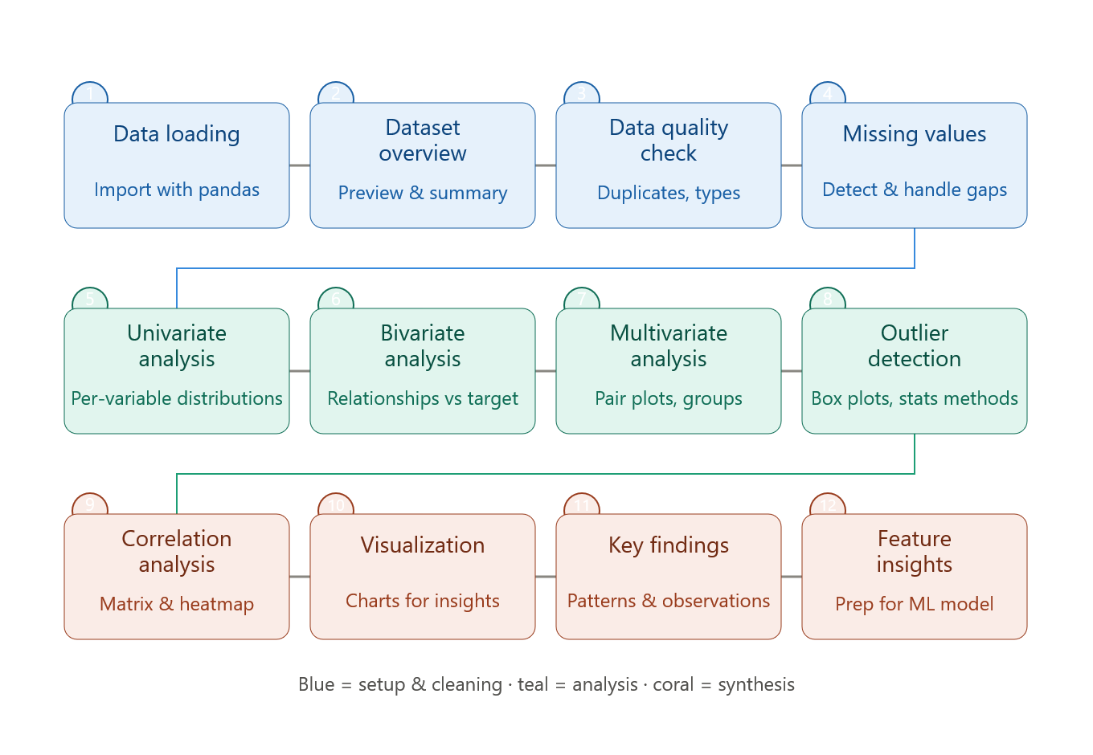
The following workflow diagram represents the proposed Exploratory Data Analysis process for the Customer Churn Prediction project. It shows the sequence from initial data loading and quality checking to statistical analysis, visualization, identification of key findings, and preparation for future Machine Learning.

- Final Review and Quality Checklist
- Before final submission, the EDA and Visualization Framework will be reviewed for completeness, clarity, consistency, and technical accuracy. All major EDA stages, visualization techniques, Python libraries, workflow steps, expected insights, challenges, and documentation methods will be checked.
- The report will be reviewed to ensure that headings and subheadings are properly organized and that tables and visualizations are clearly labeled. The workflow diagram will be checked to ensure that it correctly represents the proposed EDA process. Technical terminology and descriptions will also be reviewed for accuracy.
- Finally, the document will be saved in DOCX format and the final version will be uploaded to the project GitHub repository along with relevant supporting files.

