# OBJECTIVE

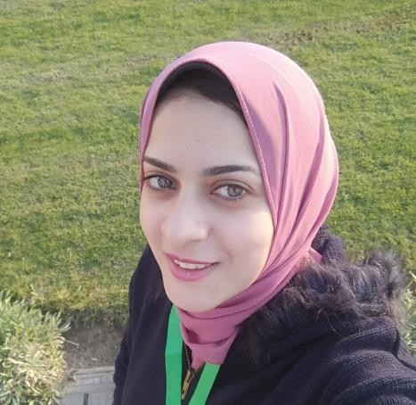

I Have 2 Years Experience In Front End And One Year In Back End Developer . I Have Good Information In Full Stack Developer . I Made

Many Projects In Front End Developer And . I Made Two Projects In Back End And Full Stack Developer . I Joined Full Master Diploma In It Share Cources And . I Joined Intership In Nti 6 Month Track Web Technology . I Work On Git , Github . I Have A Bachelor's Degree In Information Management Systems 2017.

# EDUCATION

**Bachelor • MIS • High Institute • 2017**

REHAN MOHAMED

Email : [rehan4295.rm@gmail.com](mailto:rehan4295.rm@gmail.com)

Phone : **01098127874 -- 01147459343**

## Address : cairo

**Skills :**

* Technical Courses,
* English Courses ,
* Soft Skills Courses

**front end :**

### photoshop ,

* html5 ,
* css3,
* bootstrap4
* js ,
* jquery,
* json ,
* ajax

**back end :**

* php ,oop,

## mysql,

* Laravel
* gitbash.

I Have A Bachelor's Degree In Information Management Systems

.

**Diploma • Web Technology • NTI • 6 Month**

## **Smart Village 2020**

I Took Excellent Degree In Professional Tranining Program.

**Cources • Fullstack Devloper • It Share Academy**

I Took Cource Full Stack Developer In **It Share** And Make Many Projects And It Took 7 Month.

**EXPERIENCE**

## Full Stack Developer :

### Freelancer Developer Cairo

November 2017 – Present

**Customer Care Service**

Vodafone Account At Wasla Company Cairo

May 2017 - July 2018

**Sales Associate**

### Handled Stock Intakes And Helped To Redesign The Shop’s Layout

* Organize And Host VIP Events And Am Responsible For Handling ‘Exclusive’ Clients